Q1.Name 3 iterable objects in Python and WAP to elaborate each one.

Soln.

Iterable objects are those objects in which we can access or iterate each data element from the (collection of data )

1. List
2. String
3. Range

Program for List,String and Python

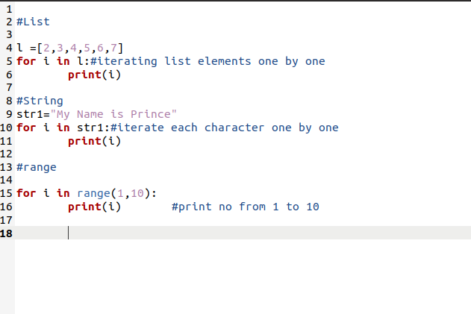

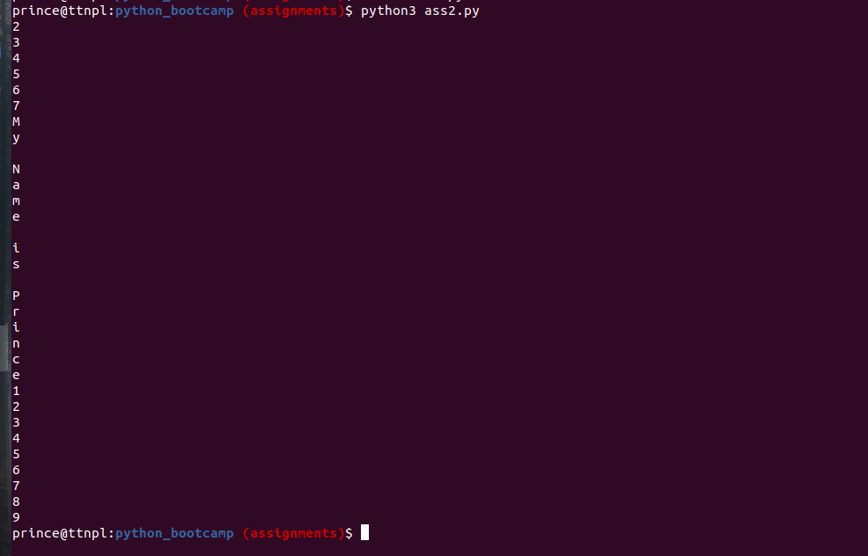

Q2.WAP to find the count of all even numbers in a list and then find the sum of all those even numbers.

Soln.

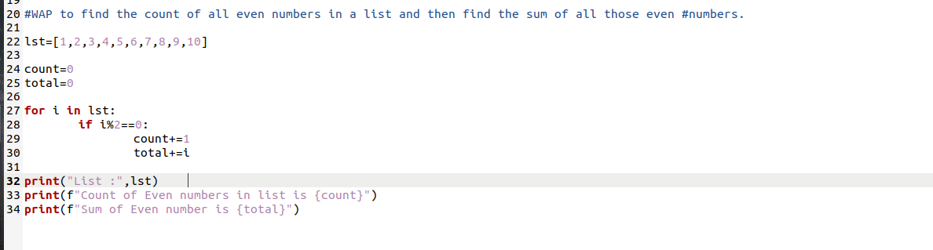

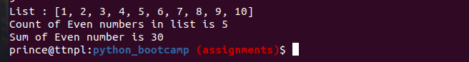

Q3.WAP to extract integer values from a tuple containing mixed data type values.

Soln.

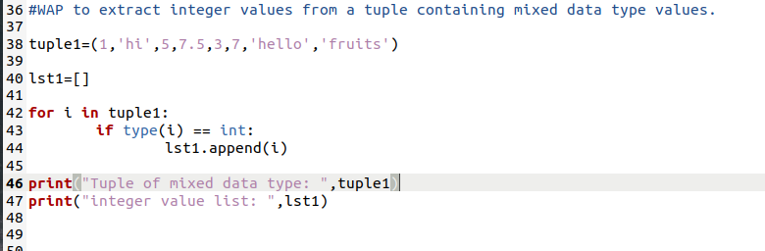



Q4.Create a dictionary with name of products as key and their price as it's value, include fruits and stationary objects in the products and then filter out name of all the fruits from the dictionary in a separate list.

Soln.

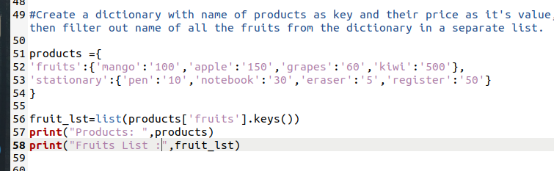

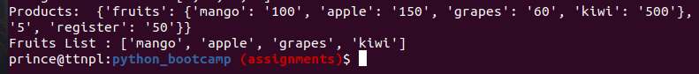

Q5.Iterate thorugh the sentence "Lorem ipsum dolor sit amet, consectetur adipiscing elit, sed do eiusmod tempor incididunt ut labore et dolore magna aliqua. Ut enim ad minim veniam, quis nostrud exercitation ullamco laboris nisi ut aliquip ex ea commodo consequat. Duis aute irure dolor in reprehenderit in voluptate velit esse cillum dolore eu fugiat nulla pariatur. Excepteur sint occaecat cupidatat non proident, sunt in culpa qui officia deserunt mollit anim id est laborum." and find the number of occurances of each character and list the character with most number of occurances.

Soln.

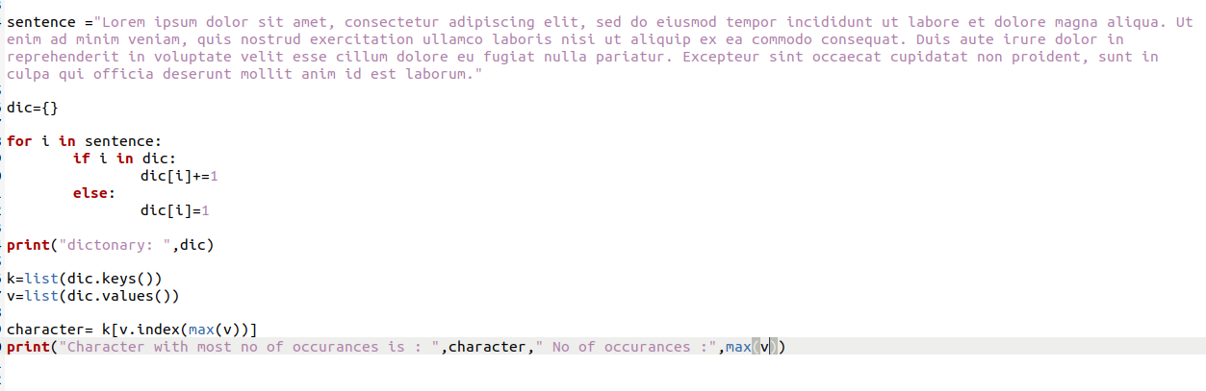



Q6.Accept three sides of a triangle from a user and identify whether it's an equilateral, isosceles or scalene triangle.

Note :

An equilateral triangle is a triangle in which all three sides are equal.

A scalene triangle is a triangle that has three unequal sides.

An isosceles triangle is a triangle with (at least) two equal sides.

Soln.

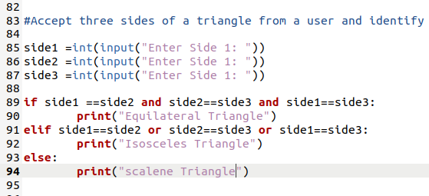

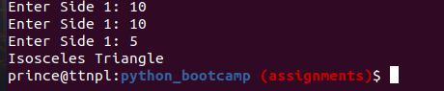

Q7.Create a simple Rock, Paper & Scissors game. For Player A and Player B, determine who wins each game and who wins the overall tournament. The game is a draw if both players choose the same item.

Explanation -

Paper wins over rock because paper covers rock. Scissors wins over paper because scissors cuts paper. Rock wins over scissors because rock breaks scissors. Print DRAW if tournament is a tie.

Input Format -

The first line in the data set is an integer that represents the number of datapairs that follow. The data begins on the second line. R represents rock, P represents paper, and S represents scissors.

Soln.

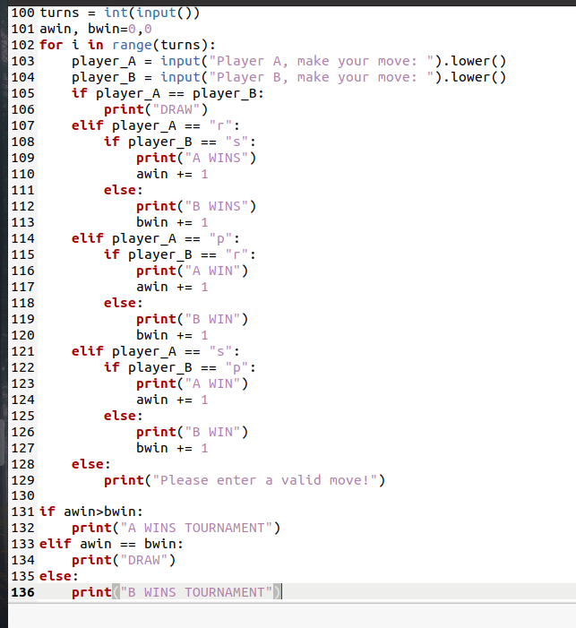

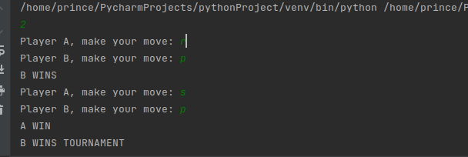

Q8.Create a number guessing game in which we accept a random input between 1-50 from the user and run the script until the user guesses the correct number. You can also give hints to the user if the guessed number is more/less than the actual number.

Soln.

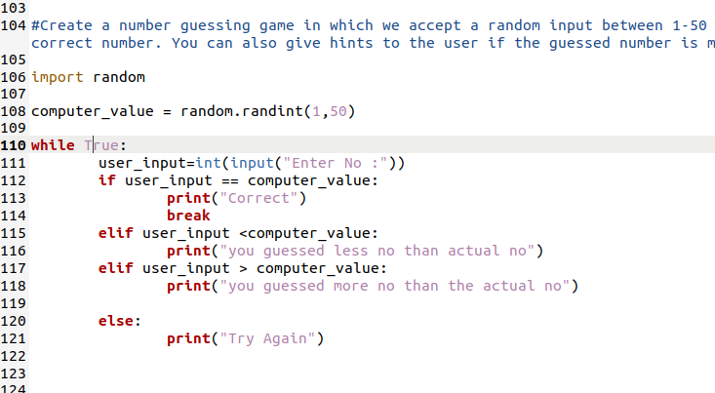

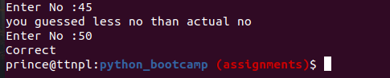

Q9.Suppose passing marks of a subject is 35. Take input of marks from user and check whether it is greater than passing marks or not.

Soln.

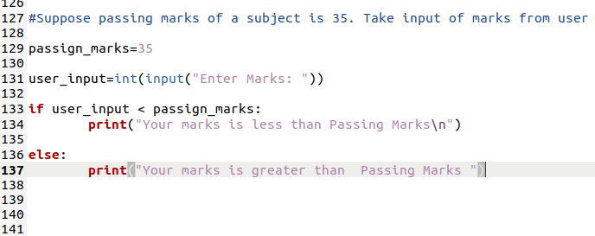



Q10.Take two number and check whether the sum is greater than 5, less than 5 or equal to 5.

Soln.

