Q1.Write few properties of list data structure in python.How does it compares to array.

Soln.

1. List can store homogeneous data as well as heterogeneous data.
2. List is ordered collection of data

Python arrays are also a collection but its items are stored at contiguous memory locations. It can store only homogeneous elements.

Q2.Name two builtin methods to sort a list.Explain the difference between the two and write a program to reverse the list of strings in reverse order.

Soln.

1.sort() : The sort() method sorts the elements of a given collection list in a specific order, either Ascending or Descending.

2. sorted(): it returns the new sorted list. The sorted() function does not edit or change the list on which it is called.

**Program:**

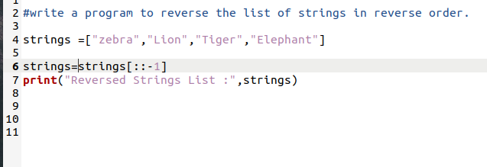

**Output:**



Q3.Name two ways to build a list containing five integer zeroes.

Soln.

1. By using For loop
2. By using list comprehensive

**Program**

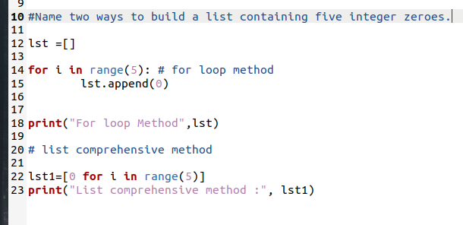

**Output:**

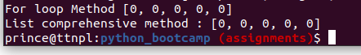

Q4.Name four operations that change a list object in place.

Soln.

reverse() - reverse the order of a list's members

remove(val) - delete the first member in the list that matches val

sort() - rearrange the order of a list based on a sorting algorithm

insert(x, val) - insert a new member, val, before the index at x

Q5.write a Python program to find the second largest number in a given list.

Soln.

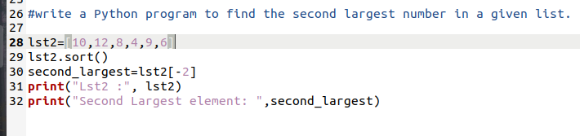

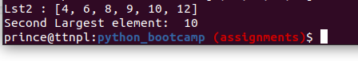

Q6.create cartesian product using 2 lists using list comprehension

For example consider two lists

colors = ['black', 'white']

sizes = ['S', 'M', 'L']

Expected output:

[('black', 'S'), ('white', 'S'), ('black', 'M'), ('white', 'M'), ('black', 'L'), ('white', 'L')]

Soln.

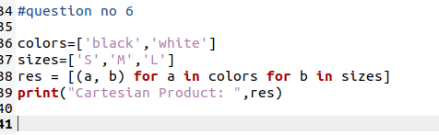



Q7.WAP to create a list of one million integers using

a.for loop

b.list comprehension

Calculate time taken by both the approach

Soln.

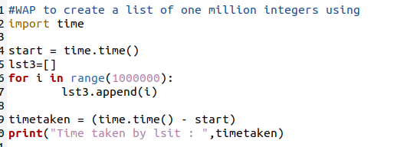



Time taken by list comprehensive

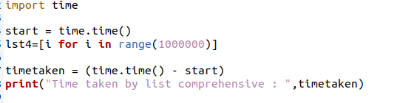



Q8.Use Python’s list comprehension syntax to produce

the list [ a , b , c , ..., z ], but without having to type all 26 characters.

Soln.

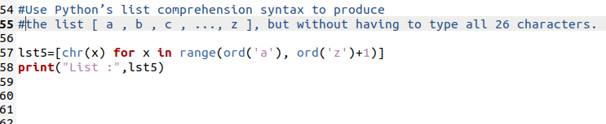

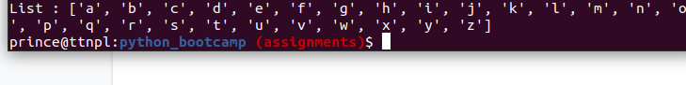

Q9.Consider two strings below

seq1 = "spam"

seq2 = "scam"

write a program to generate a list of all the common characters in the two strings using list comprehension.Expected output ['s', 'a', 'm']

Soln.

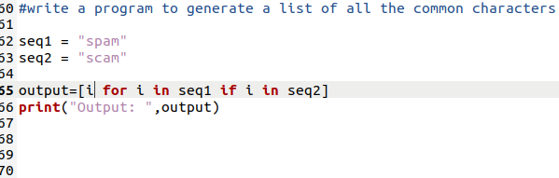

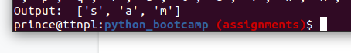

Q10.Use Python’s list comprehension syntax to produce

the list [0, 2, 6, 12, 20, 30, 42, 56, 72, 90].

Hint: this list is sum of increasing twos

Soln.

