Q1.What is the difference between a list and a tuple?

Soln.

List is mutable in nature that means we can change modified the list in future.

Tuple is immutable in nature, that means once we created tuple we cant change it in future.

Tuples are faster than list.

Tuples don't take extra space in memory. But list take extra space.

Q2.What is the difference between a set, dictionary and a list. How do we initialize each of them.

Soln.

**Set** - A Set is an unordered collection data type that is iterable, mutable and has no duplicate elements.

Set can be created using **set()** function

Ex - a = set(1,2,3) or a ={1,2,3}

**Dictionary** - It is an unordered collection of data values, used to store data in a key : value pair.

Dictionary is mutable. But Keys are not duplicated.

Dictionary can be created using **dict**() function.

Ex- a={“key”:”value”}

**List** -List is a non-homogeneous data structure which stores the elements in single row and multiple rows and columns.

List is mutable i.e we can make any changes in list.

We can use **list()**

Ex- a=[] #emptylist

Q3.Using Dictionary Comprehension, remove null items from the following dictionary.

dictionary = {'language': 'python', 'version': '3.8', 'app':None, 'ide': None}.

Soln.

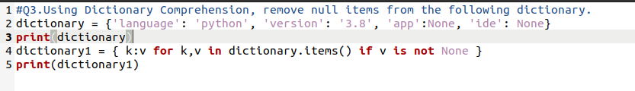

Output:

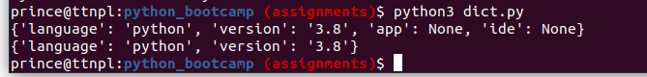

Q4.What will be the output of the following programs. Explain your solution.

a) a = {'a':1,'b':2,'c':3}

print (a['a','b'])

b) tup = (1,1,1,1)

tup[0] = tup[0] * 3

print(tup)

Soln.

1. It will show Key error because there is no such key present in the dictionary a like a[‘a’,’b’]

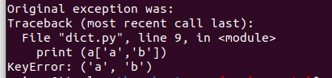

1. Tuple are immutable in nature we cant change the tuple once we created.

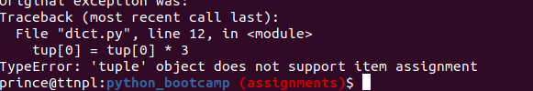

Q5.Create a Dictionary 'chars' such that chars[1] = 'a', chars[2] = 'b' ..... chars[26] = 'z'.

Given the following string l = '0abcdefghijklmnopqrstuvwxyz' and using only dictionary comprehension.

Soln.

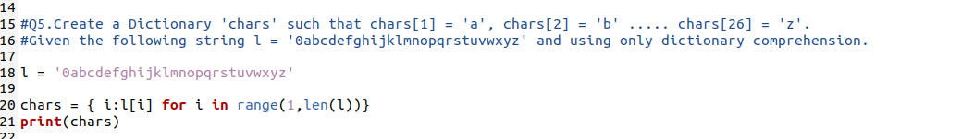

Output:

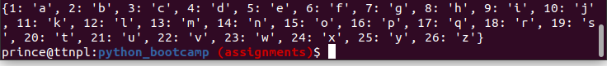

Q6.Modify the following print statement to generate the desired output:

a. Output: 'pythonpythonpython'

tup = ('python')

print(#YOUR CODE HERE#)

Soln.



b. Output: (1,1,1,1)

tup = 1,

print(#YOUR CODE HERE#)

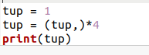

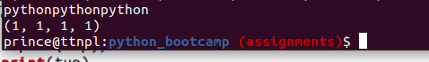

Q7.Sum the element at index 1 in each tuple in the list.

tup = [(0, 1), (1, 2), (2, 3)]

output -> 6

Soln.

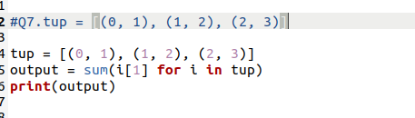



Q8.Given a list of tuples, tup = [(0, 1), (1, 2), (2, 3)]. Write a Dictionary Comprehension such that the key of the dictionary

is the value of the tuple and the values are the sum of the tuple keys. Ex: print(d[(2,3)] returns 5.

Soln.

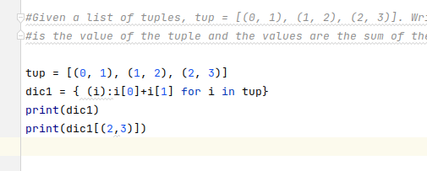

Output:

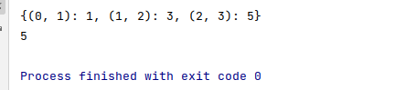

Q9.Modify the function such that it prints (age+50) when age is provided, otherwise it prints just 50.

def oldAge(d):

age = d['age']

print()

oldAge({"name": "Aayush", "age": 24}) # prints 74

oldAge({"name": "Aayush"}) # prints 50

Soln.

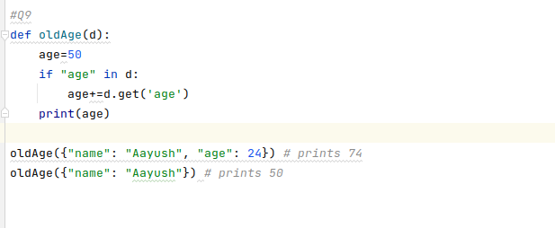

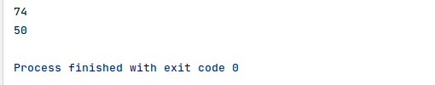

Q10.Combine the 2 dictionaries into a single dictionary. Provide atleast 2 ways to solve the problem and explain your solution.

d1 = {'1': 1, '2': 2, '3': 3}

d2 = {'4': 4, '5': 5, '6': 6}

Soln.

1. Use **update()** method:

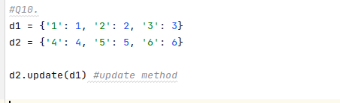



The above method combine the d1 with d2.

2.**dict () constructor** that uses a kwargs (**) operator to map one dictionary to another with the help of dict () method.

