Assignment 6 Report for Part A
1. Using the menu commands, set up the MDP for TOH with 3 disks, no noise, one goal, and living reward=0. The agent will use discount factor 1. From the Value Iteration menu select "Show state values (V) from VI", and then select "Reset state values (V) and Q values for VI to 0".
Use the menu command "1 step of VI" as many times as needed to answer these questions:
1a. How many iterations of VI are required to turn 1/3 of the states green? (i.e., get their expected utility values to 100).
4 iterations of VI are required.
1b. How many iterations of VI are required to get all the states, including the start state, to 100?
8 iterations of VI are required.
1c. From the Value Iteration menu, select "Show Policy from VI". (The policy at each state is indicated by the outgoing red arrowhead. If the suggested action is illegal, there could still be a legal state transition due to noise, but the action could also result in no change of state.) Describe this policy. Is it a good policy? Explain.
Most of the polices are move to the right. However, in some case, this policy is illegal. It is obviously a bad policy, because it can not show the path to the goal state. The main reason that makes this situation is because the discount factor is 1. No matter what the number of steps is, the states value would be same. That is why it cannot show the path.
2. Repeat the above setup except for 20% noise.
2a. How many iterations are required for the start state to receive a nonzero value.
8 iterations of VI are required.
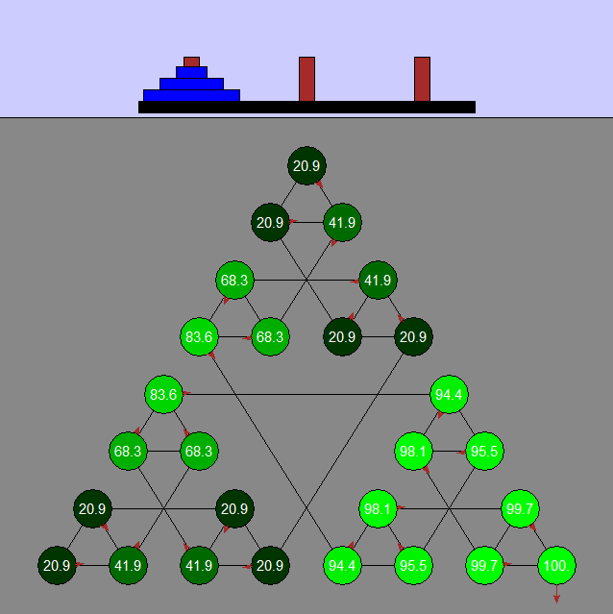
2c. At this point, view the policy from VI as before. Is it a good policy? Explain.
Move a disk from Peg 1 to Peg 3. It is a good policy.
2d. Run additional VI steps to find out how many iterations are required for VI to converge. How many is it?
25 iterations of VI are required.
2e. After convergence, examine the computed best policy once again. Has it changed? If so, how? If not, why not? Explain.
It does not change.

3. Repeat the above setup, including 20% noise but with 2 goals and discount = 0.5.
3a. Run Value Iteration until convergence. What does the policy indicate? What value does the start state have? (start state value should be 0.82)

3b. Reset the values to 0, change the discount to 0.9 and rerun Value Iteration until convergence. What does the policy indicate now? What value does the start state have? (start state value should be 36.9)

