VISVESVARAYA TECHNOLOGICAL UNIVERSITY
“JnanaSangama”, Belgaum -590014, Karnataka.



LAB REPORT
on

OPERATING SYSTEMS

Submitted by

PRINCE CHAUDHARY (1WA24CS220)

in partial fulfillment for the award of the degree of

BACHELOR OF ENGINEERING
in
COMPUTER SCIENCE AND ENGINEERING


B.M.S. COLLEGE OF ENGINEERING
(Autonomous Institution under VTU)
BENGALURU-560019
Feb-2026 to June-2026

B. M. S. College of Engineering,
Bull Temple Road, Bangalore 560019
(Affiliated To Visvesvaraya Technological University, Belgaum)
Department of Computer Science and Engineering


CERTIFICATE
This is to certify that the Lab work entitled “OPERATING SYSTEMS – 23CS4PCOPS” carried out by Prince Chaudhary (1WA24CS220), who is Bonafide student of B. M. S. College of Engineering. It is in partial fulfilment for the award of Bachelor of Engineering in Computer Science and Engineering of the Visvesvaraya Technological University, Belgaum during the year Feb-2026 to June-2026
. The Lab report has been approved as it satisfies the academic requirements in respect of a OPERATING SYSTEMS - (23CS4PCOPS) work prescribed for the said degree.

Dr. Seema Patil Dr. Kavitha Sooda
Assistant Professor Professor and Head
Department of CSE Department of CSE
BMSCE, Bengaluru BMSCE, Bengaluru

Index Sheet
Sl.  No. | Experiment Title | Page No.
1. | Write a C program to simulate the following CPU scheduling algorithm to find turnaround time and waiting time.  a) FCFS  b) SJF (Preemptive and Non-Preemptive)  c) Priority (Preemptive and Non-Preemptive)  d) Round Robin (Experiment with different quantum sizes for RR algorithm) | 1-18
2. | Write a C program to simulate multi-level queue scheduling algorithm considering the following scenario. All the processes in the system are divided into two categories – system processes and user processes. System processes are to be given higher priority than user processes. Use FCFS scheduling for the processes in each queue. | 19-22
3. | Write a C program to simulate Real-Time CPU Scheduling algorithms:  a) Rate- Monotonic  b) Earliest-deadline First  c) Proportional scheduling | 23-29
4. | Write a C program to simulate:  a) Producer-Consumer problem using semaphores.  b) Dining-Philosopher’s problem | 30-34
5. | Write a C program to simulate:  a) Bankers’ algorithm for the purpose of deadlock avoidance.  b) Deadlock Detection | 35-39
6. | Write a C program to simulate the following contiguous memory allocation techniques.  a) Worst-fit  b) Best-fit  c) First-fit | 40-42
7. | Write a C program to simulate page replacement algorithms.  a) FIFO  b) LRU  c) Optimal | 43-48

Course Outcomes:

C01 | Apply the different concepts and functionalities of Operating System
C02 | Analyse various Operating system strategies and techniques
C03 | Demonstrate the different functionalities of Operating System.
C04 | Conduct practical experiments to implement the functionalities of Operating system.

Program 1: Write a C program to simulate the following CPU scheduling algorithm to find turnaround time and waiting time.
- FCFS:

#include<stdio.h>
int main(){
int n;
printf("Enter number of processes: ");
scanf("%d",&n);
int pid[n], at[n], bt[n], ct[n], tat[n], wt[n];
printf("\nEnter Process ID, Arrival Time and Burst Time:\n");
for(int i=0;i<n;i++){
scanf("%d %d %d",&pid[i],&at[i],&bt[i]);
}
for(int i=0;i<n-1;i++){
for(int j=i+1;j<n;j++){
if(at[i] > at[j]){
int temp;
temp = at[i];
at[i] = at[j];
at[j] = temp;
temp = bt[i];
bt[i] = bt[j];
bt[j] = temp;
temp = pid[i];
pid[i] = pid[j];
pid[j] = temp;
}
}
}
int time = 0;
for(int i=0;i<n;i++){
if(time < at[i])
time = at[i];
ct[i] = time + bt[i];
time = ct[i];
tat[i] = ct[i] - at[i];
wt[i] = tat[i] - bt[i];
}
float avgTAT = 0, avgWT = 0;
printf("\nProcess AT BT CT TAT WT\n");
for(int i=0;i<n;i++){
printf("%5d %3d %3d %3d %4d %4d\n",
pid[i],at[i],bt[i],ct[i],tat[i],wt[i]);
avgTAT += tat[i];
avgWT += wt[i];
}
avgTAT /= n;
avgWT /= n;
printf("\nAverage Turnaround Time = %.2f",avgTAT);
printf("\nAverage Waiting Time = %.2f",avgWT);
return 0;
}

Output:
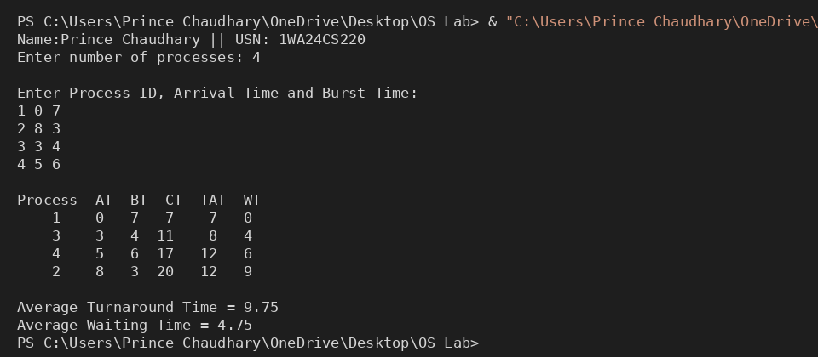
b) SJF
1. Preemptive:

#include <stdio.h>
int main(){
int n, completed = 0, curr_time = 0, pid[10], at[10], bt[10], remt[10],
ct[10], tat[10], wt[10], st[10], rt[10], i, j;
double tat_sum = 0, wt_sum = 0;
printf("Enter no. of processes: ");
scanf("%d", &n);
for (i = 0; i < n; i++) {
pid[i] = i + 1;
printf("Enter arrival time for process[%d]: ", i + 1);
scanf("%d", &at[i]);
printf("Enter burst time for process[%d]: ", i + 1);
scanf("%d", &bt[i]);
remt[i] = bt[i];
}
while (completed != n) {
int min = 99999999,
s = -1;
for (i = 0; i < n; i++) {
if (at[i] <= curr_time && remt[i] > 0 && remt[i] < min) {
min = remt[i];
s = i;
}
}
if (s == -1) {
curr_time++;
continue;
}
if (remt[s] == bt[s])
st[s] = curr_time;
remt[s]--;
if (remt[s] == 0) {
ct[s] = curr_time + 1;
tat[s] = ct[s] - at[s];
tat_sum += tat[s];
wt[s] = tat[s] - bt[s];
wt_sum += wt[s];
rt[s] = st[s] - at[s];
completed++;
}
curr_time++;
}
printf("\nP\tAT\tBT\tCT\tTAT\tWT\tRT\n\n");
for (j = 1; j < n + 1; j++) {
for (i = 0; i < n; i++) {
if (pid[i] == j)
printf("P%d\t%d\t%d\t%d\t%d\t%d\t%d\n", pid[i], at[i], bt[i], ct[i],
tat[i], wt[i], rt[i]);
}
}
printf("\nAverage TAT: %.2f\n", (tat_sum / n));
printf("Average WT: %.2f\n", (wt_sum / n));
}

Output:
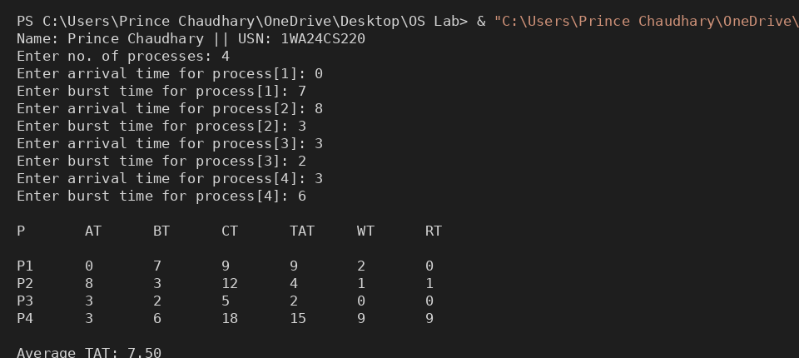

2. Non-Preemptive:

#include<stdio.h>
#include<stdlib.h>
#define max(a,b) ((a>b)? (a):(b))
int main(){
int a=4,b=6,temp,comp_count=0;
int sjf[a][b];
printf("Enter the Process, Arrival Time and Burst Time:\n");
for(int i=0; i<a; i++){
for(int j=0; j<3; j++){
scanf("%d",&sjf[i][j]);
}
}
for(int i=0; i<a-1; i++){
for(int j=0; j<a-i-1; j++){
if(sjf[j][1] > sjf[j+1][1]){
for(int k=0; k<3; k++){
temp = sjf[j][k];
sjf[j][k] = sjf[j+1][k];
sjf[j+1][k] = temp;
}
}
}
}
int curr_time =0, is_comp[4] = {0};
while(comp_count < a){
int best_index = -1, min_burst = 9999;

for(int i=0; i<a; i++){
if(sjf[i][1] <= curr_time && is_comp[i] == 0){
if(sjf[i][2] < min_burst) {
min_burst = sjf[i][2];
best_index = i;
}
}
}
if(best_index != -1){
curr_time += sjf[best_index][2];
sjf[best_index][3] = curr_time;

sjf[best_index][4] = sjf[best_index][3] - sjf[best_index][1];
sjf[best_index][5] = sjf[best_index][4] - sjf[best_index][2];
is_comp[best_index] = 1;
comp_count++;
}
else{
curr_time++;
}
}
printf("Process\tAT\tBT\tCT\tTAT\tWT\n");
for(int i=0; i<a; i++){
for(int j=0; j<b; j++){
printf("%d\t",sjf[i][j]);
}
printf("\n");
}
int sumTAT =0, sumWT=0;
for(int i=0; i<a; i++){
sumTAT += sjf[i][4];
sumWT += sjf[i][5];
}
printf("Average TAT: %2f",(float)sumTAT/a);
printf("Average WT: %2f",(float)sumWT/a);
}

Output:
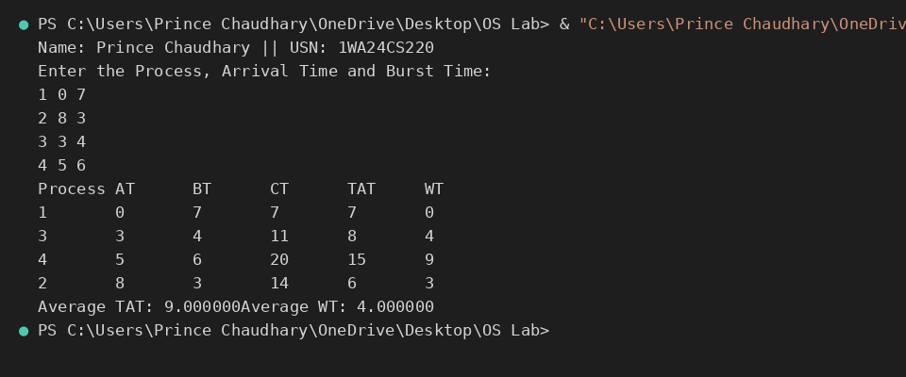

c). Priority (Preemptive and Non-Preemptive)
1. Preemptive:
#include <stdio.h>
int main() {
int n, i, time = 0, completed = 0;
int bt[20], at[20], pr[20], rt[20];
int wt[20], tat[20], ct[20];
int highest, min_pr;
int total_wt = 0, total_tat = 0;
printf("Enter number of processes: ");
scanf("%d", &n);
for(i = 0; i < n; i++) {
printf("\nProcess %d\n", i + 1);
printf("Enter Arrival Time: ");
scanf("%d", &at[i]);
printf("Enter Burst Time: ");
scanf("%d", &bt[i]);
printf("Enter Priority: ");
scanf("%d", &pr[i]);
rt[i] = bt[i];
}
while(completed < n) {
highest = -1;
min_pr = 9999;
for(i = 0; i < n; i++) {
if(at[i] <= time && rt[i] > 0 && pr[i] < min_pr) {
min_pr = pr[i];
highest = i;
}
}
if(highest == -1) {
time++;
continue;
}
rt[highest]--;
time++;
if(rt[highest] == 0) {
completed++;
ct[highest] = time;
tat[highest] = ct[highest] - at[highest];
wt[highest] = tat[highest] - bt[highest];
total_wt += wt[highest];
total_tat += tat[highest];
}
}
printf("\nPID\tAT\tBT\tPR\tCT\tWT\tTAT\n");
for(i = 0; i < n; i++) {
printf("%d\t%d\t%d\t%d\t%d\t%d\t%d\n",
i + 1, at[i], bt[i], pr[i], ct[i], wt[i], tat[i]);
}
printf("\nAverage Waiting Time = %.2f", (float)total_wt/n);
printf("\nAverage Turnaround Time = %.2f\n", (float)total_tat/n);
return 0;
}

Output:
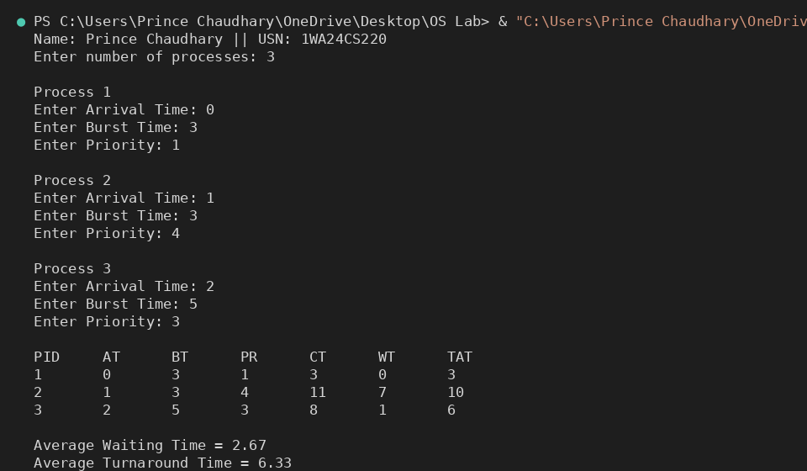

2. Non- Preemptive:

#include <stdio.h>
struct Process {
int pid;
int burst;
int priority;
int waiting;
int turnaround;
int completion;
};
int main() {
int n, i, j;
struct Process p[20], temp;

printf("Enter number of processes: ");
scanf("%d", &n);
for(i = 0; i < n; i++) {
printf("\nProcess %d\n", i + 1);
p[i].pid = i + 1;
printf("Enter Burst Time: ");
scanf("%d", &p[i].burst);
printf("Enter Priority: ");
scanf("%d", &p[i].priority);
}
for(i = 0; i < n - 1; i++) {
for(j = i + 1; j < n; j++) {
if(p[i].priority > p[j].priority) {
temp = p[i];
p[i] = p[j];
p[j] = temp;
}
}
}
p[0].waiting = 0;
for(i = 1; i < n; i++) {
p[i].waiting = 0;
for(j = 0; j < i; j++) {
p[i].waiting += p[j].burst;
}
}
for(i = 0; i < n; i++) {
p[i].turnaround = p[i].burst + p[i].waiting;
p[i].completion = p[i].turnaround;
}
float total_wt = 0, total_tat = 0;
printf("\nPID\tBT\tPR\tWT\tTAT\tCT\n");
for(i = 0; i < n; i++) {
printf("%d\t%d\t%d\t%d\t%d\t%d\n",
p[i].pid, p[i].burst, p[i].priority,p[i].completion,
p[i].waiting, p[i].turnaround);
total_wt += p[i].waiting;
total_tat += p[i].turnaround;
}
printf("\nAverage Waiting Time = %.2f", total_wt / n);
printf("\nAverage Turnaround Time = %.2f\n", total_tat / n);
return 0;
}
Output:
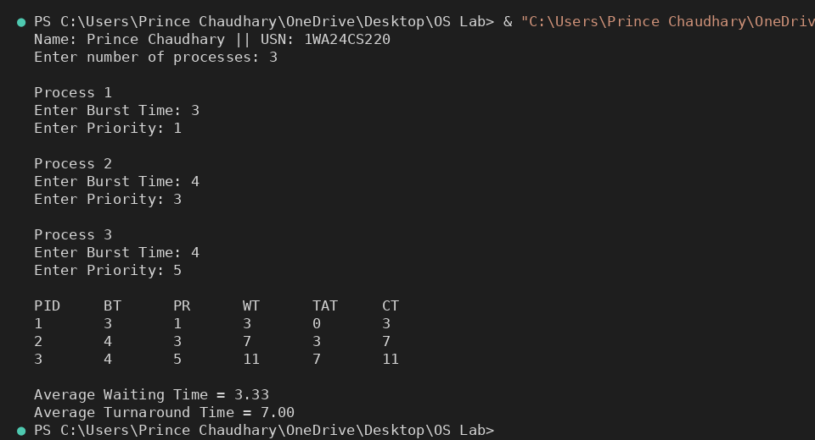

d). Round Robin (Experiment with different quantum sizes for RR algorithm)

#include <stdio.h>
int main() {
int n, tq;
int pid[20], at[20], bt[20], rt[20];
int wt[20] = {0}, tat[20] = {0}, ct[20];
int queue[100];
int front = 0, rear = 0;
int visited[20] = {0};
int current_time = 0, completed = 0;
float total_wt = 0, total_tat = 0;
printf("Enter number of processes: ");
scanf("%d", &n);
printf("Enter time quantum: ");
scanf("%d", &tq);
for(int i = 0; i < n; i++) {
printf("\nProcess %d\n", i + 1);
printf("Enter Process ID: ");
scanf("%d", &pid[i]);
printf("Enter Arrival Time: ");
scanf("%d", &at[i]);
printf("Enter Burst Time: ");
scanf("%d", &bt[i]);
rt[i] = bt[i];
}
while(completed < n) {
for(int i = 0; i < n; i++) {
if(at[i] <= current_time && visited[i] == 0) {
queue[rear++] = i;
visited[i] = 1;
}
}
if(front == rear) {
current_time++;
continue;
}
int p = queue[front++];
if(rt[p] > tq) {
current_time += tq;
rt[p] -= tq;
for(int i = 0; i < n; i++) {
if(at[i] <= current_time && visited[i] == 0) {
queue[rear++] = i;
visited[i] = 1;
}
}
queue[rear++] = p;
}
else {
current_time += rt[p];
ct[p] = current_time;
tat[p] = ct[p] - at[p];
wt[p] = tat[p] - bt[p];
rt[p] = 0;
completed++;
}
}
printf("\nPID\tAT\tBT\tCT\tWT\tTAT\n");
for(int i = 0; i < n; i++) {
printf("%d\t%d\t%d\t%d\t%d\t%d\n", pid[i], at[i], bt[i], ct[i], wt[i], tat[i]);
total_wt += wt[i];
total_tat += tat[i];
}
printf("\nAverage Waiting Time = %.2f", total_wt / n);
printf("\nAverage Turnaround Time = %.2f\n", total_tat / n);
return 0;
}

Output:

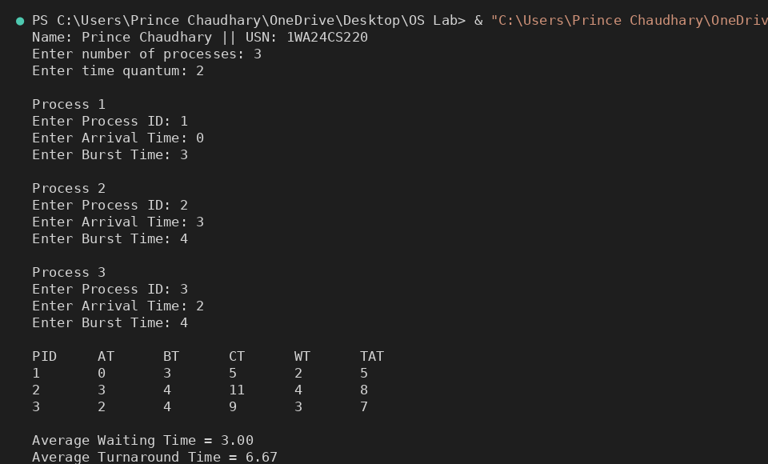
2. Write a C program to simulate multi-level queue scheduling algorithm considering the following scenario. All the processes in the system are divided into two categories – system processes and user processes. System processes are to be given higher priority than user processes. Use FCFS scheduling for the processes in each queue.

#include <stdio.h>
#include <string.h>
#define MAX 100
#define TQ 2
struct Process {
char pid[10];
int at, bt, rt, type;
int ct, tat, wt;
int done;
};
int main() {
struct Process p[MAX];
int n;
printf("Enter number of processes: ");
scanf("%d", &n);
for (int i = 0; i < n; i++) {
printf("\nProcess %d\n", i + 1);
printf("Enter PID: ");
scanf("%s", p[i].pid);
printf("Enter Arrival Time: ");
scanf("%d", &p[i].at);
printf("Enter Burst Time: ");
scanf("%d", &p[i].bt);
printf("Enter Type (1=System, 2=User): ");
scanf("%d", &p[i].type);
p[i].rt = p[i].bt;
p[i].done = 0;
}
int time = 0, completed = 0;
char ganttPID[MAX][10];
int ganttTime[MAX];
int gIndex = 0;
int lastSysIndex = 0;
while (completed < n) {
int executed = 0;
for (int i = 0; i < n; i++) {
int idx = (lastSysIndex + i) % n;
if (p[idx].type == 1 && p[idx].rt > 0 && p[idx].at <= time) {
ganttTime[gIndex] = time;
strcpy(ganttPID[gIndex], p[idx].pid);
gIndex++;
if (p[idx].rt > TQ) {
time += TQ;
p[idx].rt -= TQ;
} else {
time += p[idx].rt;
p[idx].rt = 0;
p[idx].ct = time;
p[idx].tat = p[idx].ct - p[idx].at;
p[idx].wt = p[idx].tat - p[idx].bt;
p[idx].done = 1;
completed++;
}
lastSysIndex = (idx + 1) % n;
executed = 1;
break;
}
}
if (executed) continue;
int earliest = -1;
for (int i = 0; i < n; i++) {
if (p[i].type == 2 && p[i].rt > 0 && p[i].at <= time) {
if (earliest == -1 || p[i].at < p[earliest].at) {
earliest = i;
}
}
}
if (earliest != -1) {
ganttTime[gIndex] = time;
strcpy(ganttPID[gIndex], p[earliest].pid);
gIndex++;
int nextSysArrival = 1e9;
for (int i = 0; i < n; i++) {
if (p[i].type == 1 && p[i].rt > 0 && p[i].at > time) {
if (p[i].at < nextSysArrival)
nextSysArrival = p[i].at;
}
}
if (time + p[earliest].rt <= nextSysArrival) {
time += p[earliest].rt;
p[earliest].rt = 0;

p[earliest].ct = time;
p[earliest].tat = p[earliest].ct - p[earliest].at;
p[earliest].wt = p[earliest].tat - p[earliest].bt;
p[earliest].done = 1;
completed++;
} else {
int execTime = nextSysArrival - time;
p[earliest].rt -= execTime;
time = nextSysArrival;
}
continue;
}
time++;
}
ganttTime[gIndex] = time;
printf("\n=========== MULTI-LEVEL QUEUE SCHEDULING ===========\n");
printf("+------+------+----+----+----+-----+----+\n");
printf("| PID |TYPE | AT | BT | CT | TAT | WT |\n");
printf("+------+------+----+----+----+-----+----+\n");
float total_tat = 0, total_wt = 0;
for (int i = 0; i < n; i++) {
printf("| %-4s | %-4s | %-2d | %-2d | %-2d | %-3d | %-2d |\n",
p[i].pid,
p[i].type == 1 ? "SYS" : "USR",
p[i].at,
p[i].bt,
p[i].ct,
p[i].tat,
p[i].wt);
total_tat += p[i].tat;
total_wt += p[i].wt;
}
printf("+------+------+----+----+----+-----+----+\n");
printf("\nAverage Turnaround Time = %.2f\n", total_tat / n);
printf("Average Waiting Time = %.2f\n", total_wt / n);
printf("\n============ GANTT CHART ============\n\n");
for (int i = 0; i < gIndex; i++) {
printf("| %s ", ganttPID[i]);
}
printf("|\n");
for (int i = 0; i < gIndex; i++) {
printf("+----");
}
printf("+\n");
for (int i = 0; i <= gIndex; i++) {
printf("%-4d", ganttTime[i]);
}
printf("\n");
return 0;
}

Output:
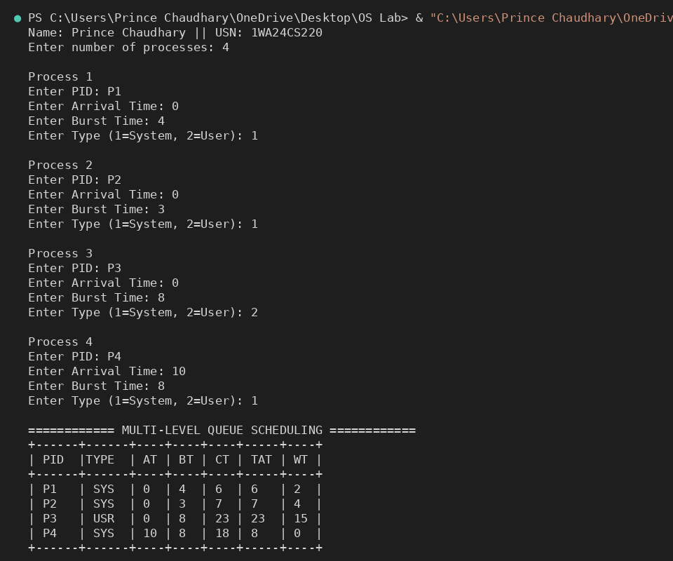
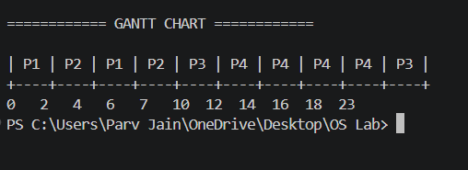

3.Write a C program to simulate Real-Time CPU Scheduling algorithms:
a) Rate- Monotonic
b) Earliest-deadline First
c) Proportional scheduling

a). RMS:
#include <stdio.h>
#include <math.h>
int gcd(int a, int b) {
if (b == 0)
return a;
return gcd(b, a % b);
}
int lcm(int a, int b) {
return (a * b) / gcd(a, b);
}
int main() {
int n;
printf("Enter number of processes: ");
scanf("%d", &n);
int Ci[n], Ti[n], remaining[n], original_id[n];
for (int i = 0; i < n; i++) {
printf("Enter execution time (C%d): ", i + 1);
scanf("%d", &Ci[i]);
printf("Enter period (T%d): ", i + 1);
scanf("%d", &Ti[i]);
remaining[i] = 0;
original_id[i] = i + 1;
}
double U = 0;
for (int i = 0; i < n; i++) {
U += (double)Ci[i] / Ti[i];
}
double U_bound = n * (pow(2, (double)1/n) - 1);
printf("\nCPU Utilization (U) = %.4f\n", U);
printf("Utilization Bound (U_bound) = %.4f\n", U_bound);
if (U > U_bound) {
printf("Not Schedulable under RMS\n");
return 0;
}
printf("Schedulable under RMS\n");
int hyperperiod = Ti[0];
for (int i = 1; i < n; i++) {
hyperperiod = lcm(hyperperiod, Ti[i]);
}
printf("\nLCM (Hyperperiod) = %d\n", hyperperiod);
for (int i = 0; i < n - 1; i++) {
for (int j = i + 1; j < n; j++) {
if (Ti[i] > Ti[j]) {
int temp;
temp = Ti[i]; Ti[i] = Ti[j]; Ti[j] = temp;
temp = Ci[i]; Ci[i] = Ci[j]; Ci[j] = temp;
temp = original_id[i]; original_id[i] = original_id[j]; original_id[j] = temp;
}
}
}
printf("\nRMS Table:\n");
printf("Process\tExecution Time\tPeriod\n");
for (int i = 0; i < n; i++) {
printf("P%d\t%d\t\t%d\n", original_id[i], Ci[i], Ti[i]);
}
int schedule[hyperperiod];
for (int t = 0; t < hyperperiod; t++) {

for (int i = 0; i < n; i++) {
if (t % Ti[i] == 0) {
remaining[i] = Ci[i];
}
}
int selected = -1;
for (int i = 0; i < n; i++) {
if (remaining[i] > 0) {
selected = i;
break;
}
}
if (selected != -1) {
schedule[t] = original_id[selected];
remaining[selected]--;
} else {
schedule[t] = 0;
}
}
printf("\nTimeline (Intervals):\n");
int start = 0;
for (int t = 1; t <= hyperperiod; t++) {
if (t == hyperperiod || schedule[t] != schedule[start]) {
if (schedule[start] == 0)
printf("Time %d to %d: Idle\n", start, t);
else
printf("Time %d to %d: P%d\n", start, t, schedule[start]);
start = t;
}
}
return 0;
}
Output:
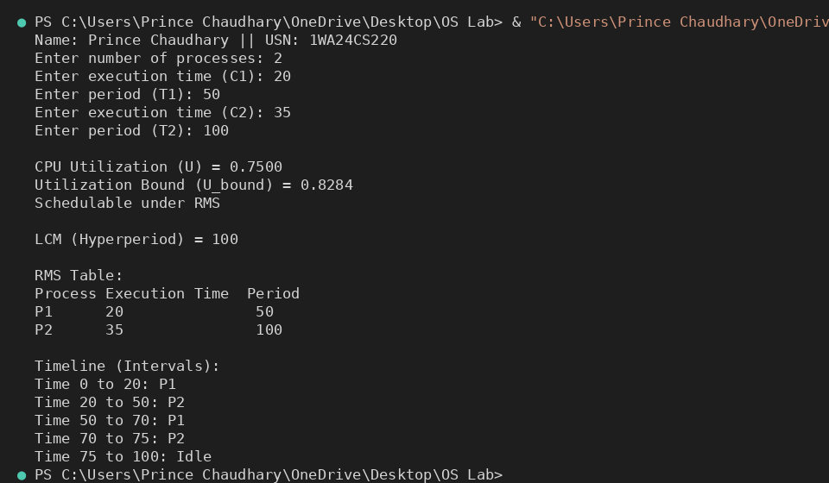

b). EDF:
#include <stdio.h>
#define MAX 10
int main() {
int n;
int burst[MAX], deadline[MAX], period[MAX];
int remaining[MAX];
int time = 0;
printf("Enter number of tasks: ");
scanf("%d", &n);
for (int i = 0; i < n; i++) {
printf("Task %d (burst deadline period): ", i + 1);
scanf("%d %d %d", &burst[i], &deadline[i], &period[i]);
remaining[i] = 0; // initially no job released
}
printf("\nPID\tBurst\tDeadline\tPeriod\n");
for (int i = 0; i < n; i++) {
printf("%d\t%d\t%d\t\t%d\n", i + 1, burst[i], deadline[i], period[i]);
}
int limit = 20;
printf("\nScheduling occurs for %d ms\n\n", limit);

while (time < limit) {
for (int i = 0; i < n; i++) {
if (time % period[i] == 0) {
remaining[i] = burst[i];
}
}
int min_deadline = 9999;
int selected = -1;
for (int i = 0; i < n; i++) {
if (remaining[i] > 0) {
if (deadline[i] < min_deadline) {
min_deadline = deadline[i];
selected = i;
}
}
}
if (selected == -1) {
printf("%dms : CPU is idle.\n", time);
} else {
printf("%dms : Task %d is running.\n", time, selected + 1);
remaining[selected]--;
}
time++;
}
return 0;
}
Output:
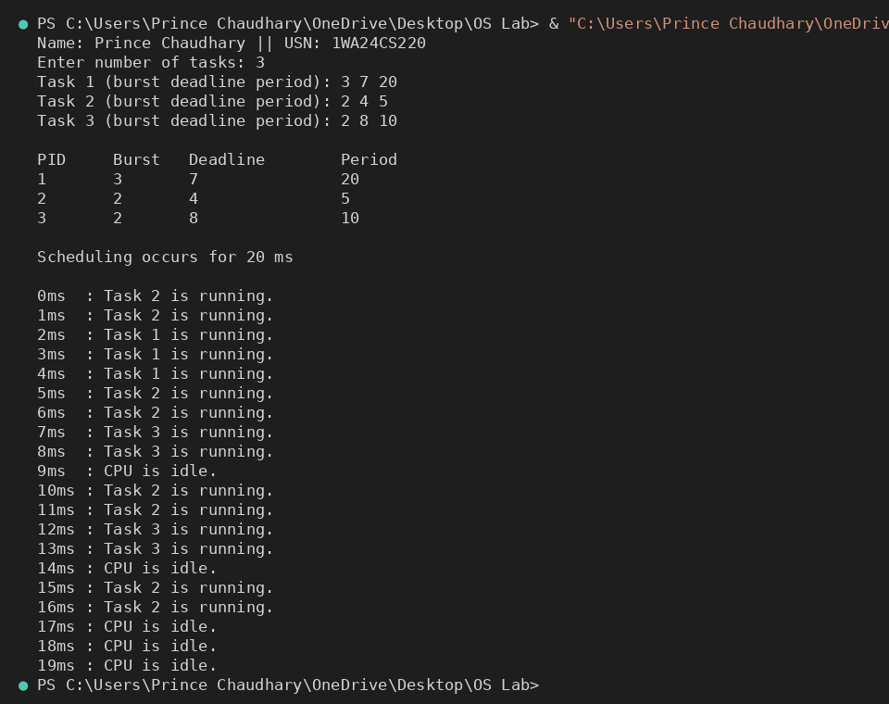

c). Proportional Share:
#include<stdio.h>
#include <stdlib.h>
#include <time.h>
typedef struct
{
char name[5]; int tickets;
}
Process;
int main() {
int n, total_tickets = 0; float total_T =0.0;
printf("Enter the number of Processes: ");
scanf("%d", &n);
Process p[n];
srand(time(NULL));
for (int i = 0; i < n; i++)
{
printf("\nProcess %d:\n", i + 1);
sprintf(p[i].name, "P%d", i + 1);
printf("Tickets: ");
scanf("%d", &p[i].tickets);
total_tickets += p[i].tickets;
total_T +=p[i].tickets;
}
printf("\n--- Proportional Share Scheduling ---\n");
printf("Enter the Time Period for scheduling: ");
int m;

scanf("%d",&m);
for (int i = 0; i < m; i++)
{
int winning_ticket = rand() % total_tickets + 1;
int accumulated_tickets = 0;
int winner_index;
for (int j = 0; j < n; j++)
{
accumulated_tickets += p[j].tickets;
if (winning_ticket <= accumulated_tickets)
{
winner_index = j; break;
}
}
printf("Tickets picked: %d, Winner: %s\n", winning_ticket,
p[winner_index].name);
}
for (int i = 0; i < n; i++)
{
printf("\nThe Process: %s gets %0.2f%% of Processor Time.\n", p[i].name,
((p[i].tickets / total_T) * 100));

}
return 0;
}
Output:
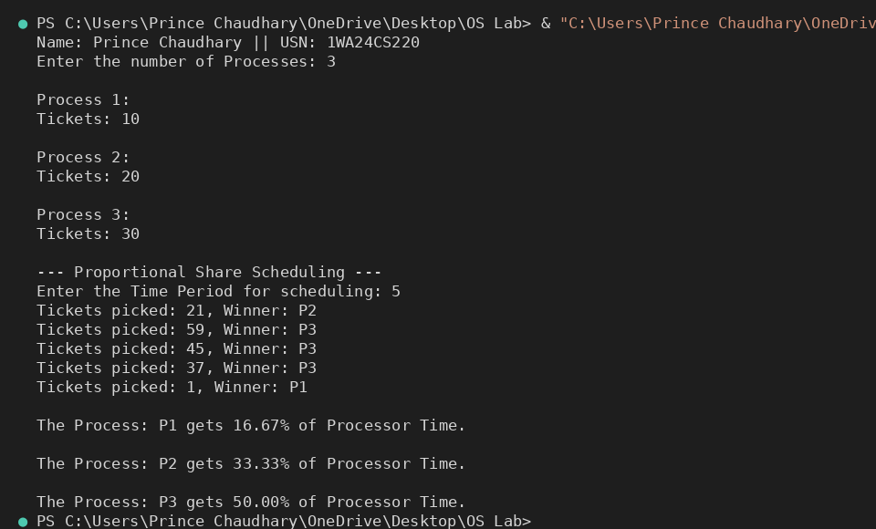

4. Write a C program to simulate:
a) Producer-Consumer problem using semaphores.
b) Dining-Philosopher’s problem

a). Producer-Consumer problem using semaphores.
#include <stdio.h>
#include <pthread.h>
#include <unistd.h>
#include <semaphore.h>
#define BUFFER_SIZE 5
int buffer[BUFFER_SIZE];
int in = 0, out = 0;
sem_t empty;
sem_t full;
pthread_mutex_t mutex;
void* producer(void* arg) {
int item, i = 0;
while (1) {
item = i++;
sem_wait(&empty);
pthread_mutex_lock(&mutex);
buffer[in] = item;
printf("Produced: %d at buffer[%d]\n", item, in);
in = (in + 1) % BUFFER_SIZE;
pthread_mutex_unlock(&mutex);
sem_post(&full);
sleep(1);
}
}
void* consumer(void* arg) {
int item;
while (1) {
sem_wait(&full);
pthread_mutex_lock(&mutex);
item = buffer[out];
printf("Consumed: %d from buffer[%d]\n", item, out);
out = (out + 1) % BUFFER_SIZE;
pthread_mutex_unlock(&mutex);
sem_post(&empty);
sleep(2);
}
}
int main() {
pthread_t prod, cons;
sem_init(&empty, 0, BUFFER_SIZE);
sem_init(&full, 0, 0);
pthread_mutex_init(&mutex, NULL);
pthread_create(&prod, NULL, producer, NULL);
pthread_create(&cons, NULL, consumer, NULL);
pthread_join(prod, NULL);
pthread_join(cons, NULL);
sem_destroy(&empty);
sem_destroy(&full);
pthread_mutex_destroy(&mutex);
return 0;
}

Output:
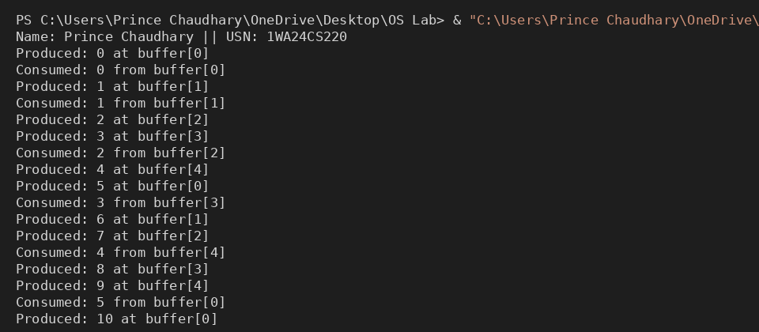

b) Dining-Philosopher’s problem
#include <stdio.h>
#include <pthread.h>
#include <unistd.h>
#define N 5
pthread_mutex_t forks[N];
pthread_t philosophers[N];
void* philosopher(void* num) {
int id = *(int*)num;
int left = id;
int right = (id + 1) % N;
while (1) {
printf("Philosopher %d is thinking.\n", id);
if (id % 2 == 0) {
pthread_mutex_lock(&forks[left]);
printf("Philosopher %d picked up left fork %d.\n", id, left);
pthread_mutex_lock(&forks[right]);
printf("Philosopher %d picked up right fork %d.\n", id, right);
} else {
pthread_mutex_lock(&forks[right]);
printf("Philosopher %d picked up right fork %d.\n", id, right);
pthread_mutex_lock(&forks[left]);
printf("Philosopher %d picked up left fork %d.\n", id, left);
}
printf("Philosopher %d is eating.\n", id);
sleep(2);
pthread_mutex_unlock(&forks[left]);
pthread_mutex_unlock(&forks[right]);
printf("Philosopher %d put down forks %d and %d.\n", id, left, right);
}
}
int main() {
int i;
int ids[N];
for (i = 0; i < N; i++) {
pthread_mutex_init(&forks[i], NULL);
ids[i] = i;
}
for (i = 0; i < N; i++) {
pthread_create(&philosophers[i], NULL, philosopher, &ids[i]);
}
for (i = 0; i < N; i++) {
pthread_join(philosophers[i], NULL);
}
for (i = 0; i < N; i++) {
pthread_mutex_destroy(&forks[i]);
}
return 0;
}

Output:
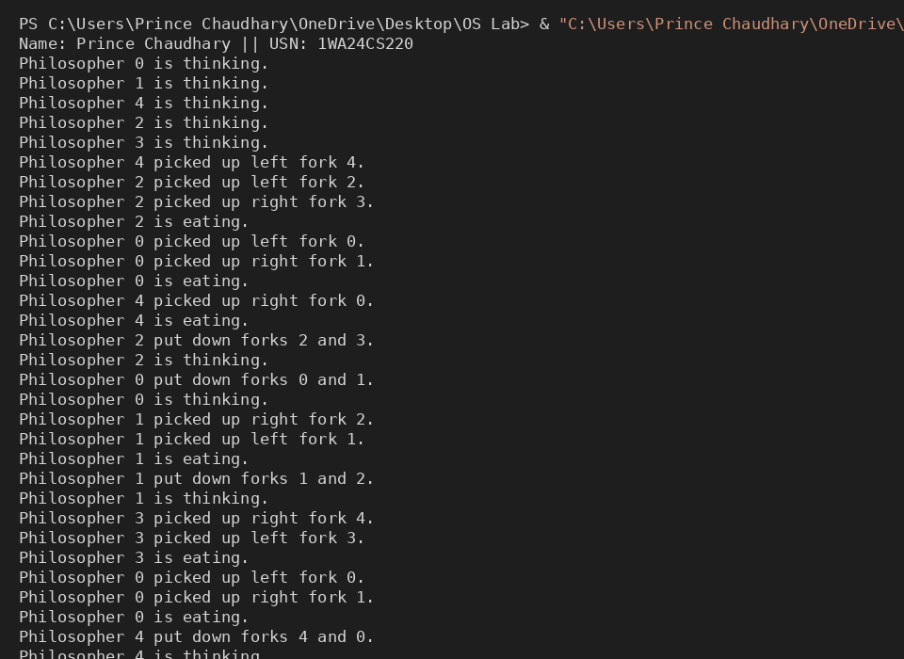

5.Write a C program to simulate:
a) Bankers’ algorithm for the purpose of deadlock avoidance.
b) Deadlock Detection

a). Bankers’ algorithm for the purpose of deadlock avoidance.
#include <stdio.h>
int main() {
int n, r;
printf("Enter number of processes: ");
scanf("%d", &n);
printf("Enter number of resources: ");
scanf("%d", &r);
int alloc[n][r], max[n][r], avail[r], need[n][r], safeSeq[n];
int finish[n];
printf("Enter Allocation Matrix:\n");
for (int i = 0; i < n; i++) {
for (int j = 0; j < r; j++) {
scanf("%d", &alloc[i][j]);
}
}
printf("Enter Maximum Demand Matrix:\n");
for (int i = 0; i < n; i++) {
for (int j = 0; j < r; j++) {
scanf("%d", &max[i][j]);
need[i][j] = max[i][j] - alloc[i][j];
}
}
printf("Enter Available Resources:\n");
for (int i = 0; i < r; i++) {
scanf("%d", &avail[i]);
}
for (int i = 0; i < n; i++) {
finish[i] = 0;
}
int count = 0;
while (count < n) {
int found = 0;
for (int p = 0; p < n; p++) {
if (finish[p] == 0) {
int j;
for (j = 0; j < r; j++) {
if (need[p][j] > avail[j])
break;
}
if (j == r) {
for (int k = 0; k < r; k++) {
avail[k] += alloc[p][k];
}
safeSeq[count++] = p;
finish[p] = 1;
found = 1;
}
}
}
if (found == 0) {
printf("\nSystem is not in a safe state.");
return 0;
}
}
printf("\nSystem is in a safe state.\n");
printf("Safe sequence is: ");
for (int i = 0; i < n; i++) {
printf("P%d", safeSeq[i]);
if (i != n - 1) printf(" -> ");
}
printf("\n");
return 0;
}

Output:
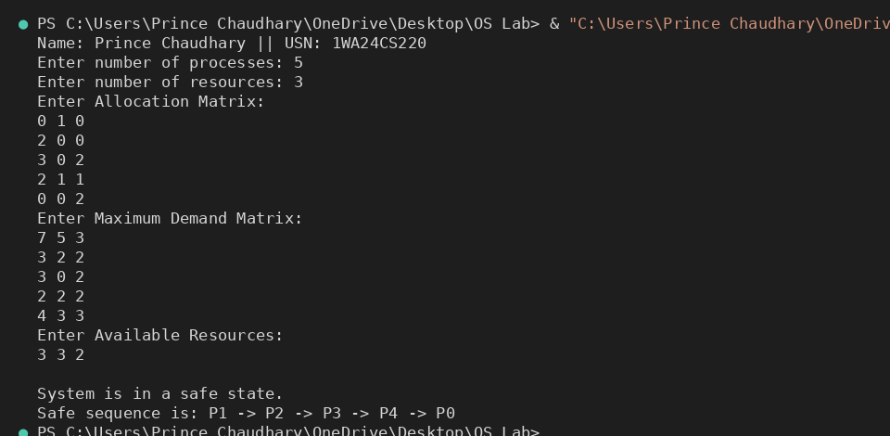

b). Deadlock Detection
#include <stdio.h>
int main() {
int n, r;
printf("Enter the number of processes: ");
scanf("%d", &n);
printf("Enter the number of resources: ");
scanf("%d", &r);
int alloc[n][r], request[n][r], avail[r], safeSeq[n];
int finish[n];
printf("Enter the allocation matrix:\n");
for (int i = 0; i < n; i++) {
printf("Process %d: ", i);
for (int j = 0; j < r; j++) {
scanf("%d", &alloc[i][j]);
}
}
printf("Enter the request matrix:\n");
for (int i = 0; i < n; i++) {
printf("Process %d: ", i);
for (int j = 0; j < r; j++) {
scanf("%d", &request[i][j]);
}
}
printf("Enter the available resources: ");
for (int i = 0; i < r; i++) {
scanf("%d", &avail[i]);
}
for (int i = 0; i < n; i++) {
finish[i] = 0;
}
int count = 0;
while (count < n) {
int found = 0;
for (int p = 0; p < n; p++) {
if (finish[p] == 0) {
int j;
for (j = 0; j < r; j++) {
if (request[p][j] > avail[j])
break;
}
if (j == r) {
for (int k = 0; k < r; k++) {
avail[k] += alloc[p][k];
}
safeSeq[count++] = p;
finish[p] = 1;
found = 1;
}
}
}
if (found == 0) {
printf("\nSystem is not in a safe state.\n");
return 0;
}
}
printf("System is in safe state.\n");
printf("Safe Sequence is: ");
for (int i = 0; i < n; i++) {
printf("P%d", safeSeq[i]);
if (i != n - 1) printf(" ");
}
printf("\n");
return 0;
}

Output:

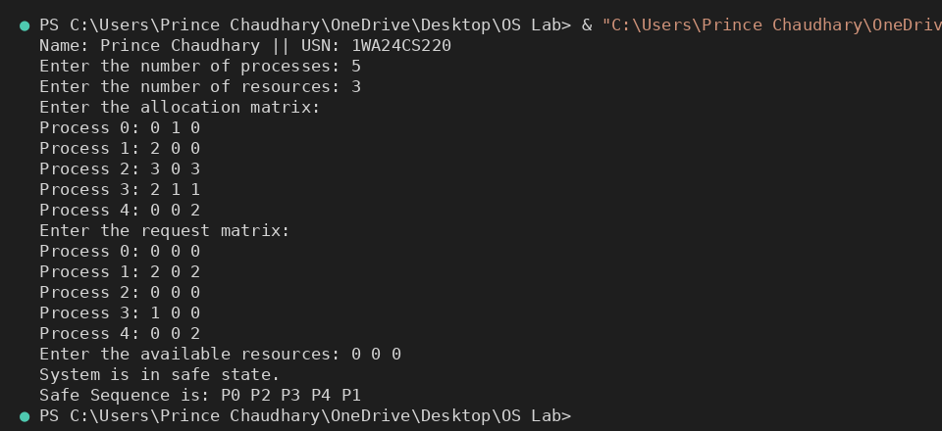

6. Write a C program to simulate the following contiguous memory allocation techniques.
a) Worst-fit b) Best-fit c) First-fit
#include <stdio.h>
#define MAX 20
void firstFit(int blocks[], int m, int processes[], int n) {
int allocation[MAX], occupied[MAX];
for (int i = 0; i < n; i++) allocation[i] = -1;
for (int i = 0; i < m; i++) occupied[i] = 0;
for (int i = 0; i < n; i++) {
for (int j = 0; j < m; j++) {
if (!occupied[j] && blocks[j] >= processes[i]) {
allocation[i] = j;
occupied[j] = 1;
break;
}
}
}
printf("\n--- First Fit ---\n");
printf("Process No. Process Size Block No.\n");
for (int i = 0; i < n; i++) {
printf("%d \t\t %d \t\t ", i + 1, processes[i]);
if (allocation[i] != -1)
printf("%d\n", allocation[i] + 1);
else
printf("Not Allocated\n");
}
}
void bestFit(int blocks[], int m, int processes[], int n) {
int allocation[MAX], occupied[MAX];
for (int i = 0; i < n; i++) allocation[i] = -1;
for (int i = 0; i < m; i++) occupied[i] = 0;
for (int i = 0; i < n; i++) {
int bestIdx = -1;
for (int j = 0; j < m; j++) {
if (!occupied[j] && blocks[j] >= processes[i]) {
if (bestIdx == -1 || blocks[j] < blocks[bestIdx]) {
bestIdx = j;
}
}
}
if (bestIdx != -1) {
allocation[i] = bestIdx;
occupied[bestIdx] = 1;
}
}
printf("\n--- Best Fit ---\n");
printf("Process No. Process Size Block No.\n");
for (int i = 0; i < n; i++) {
printf("%d \t\t %d \t\t ", i + 1, processes[i]);
if (allocation[i] != -1)
printf("%d\n", allocation[i] + 1);
else
printf("Not Allocated\n");
}
}
void worstFit(int blocks[], int m, int processes[], int n) {
int allocation[MAX], occupied[MAX];
for (int i = 0; i < n; i++) allocation[i] = -1;
for (int i = 0; i < m; i++) occupied[i] = 0;
for (int i = 0; i < n; i++) {
int worstIdx = -1;
for (int j = 0; j < m; j++) {
if (!occupied[j] && blocks[j] >= processes[i]) {
if (worstIdx == -1 || blocks[j] > blocks[worstIdx]) {
worstIdx = j;
}
}
}
if (worstIdx != -1) {
allocation[i] = worstIdx;
occupied[worstIdx] = 1;
}
}
printf("\n--- Worst Fit ---\n");
printf("Process No. Process Size Block No.\n");
for (int i = 0; i < n; i++) {
printf("%d \t\t %d \t\t ", i + 1, processes[i]);
if (allocation[i] != -1)
printf("%d\n", allocation[i] + 1);
else
printf("Not Allocated\n");
}
}
int main() {
int m, n;
int blocks[MAX], processes[MAX];
printf("Enter number of memory blocks: ");
scanf("%d", &m);
printf("Enter sizes of %d memory blocks:\n", m);
for (int i = 0; i < m; i++) scanf("%d", &blocks[i]);
printf("Enter number of processes: ");
scanf("%d", &n);
printf("Enter sizes of %d processes:\n", n);
for (int i = 0; i < n; i++) scanf("%d", &processes[i]);
firstFit(blocks, m, processes, n);
bestFit(blocks, m, processes, n);
worstFit(blocks, m, processes, n);
return 0;
}

Output:
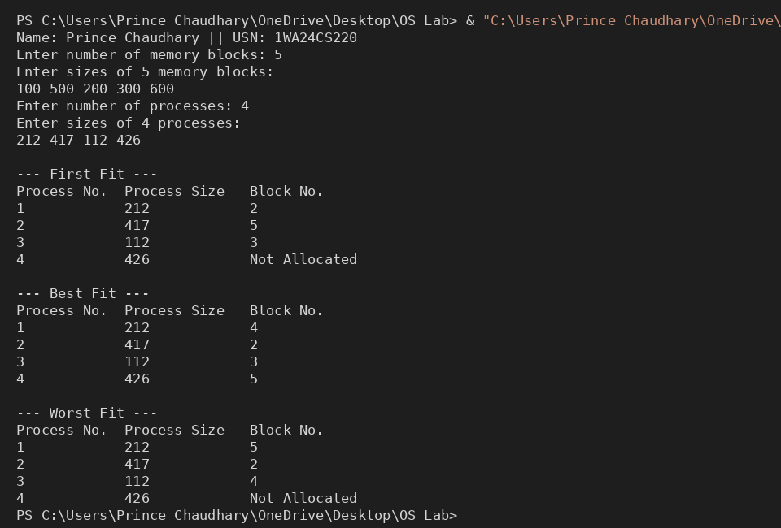

7. Write a C program to simulate page replacement algorithms.
a) FIFO
b) LRU
c) Optimal

#include <stdio.h>
#include <stdbool.h>
void print_frames(int frames[], int count) {
printf("[");
for (int i = 0; i < count; i++) {
printf("%d", frames[i]);
if (i < count - 1) {
printf(" ");
}
}
printf("]\n");
}
void fifo(int pages[], int n, int f) {
printf("\n--- FIFO Page Replacement ---\n");
int frames[f];
int count = 0;
int next = 0;
int faults = 0;
for (int i = 0; i < n; i++) {
int p = pages[i];
bool hit = false;
for (int j = 0; j < count; j++) {
if (frames[j] == p) {
hit = true;
break;
}
}
if (!hit) {
if (count < f) {
frames[count++] = p;
} else {
frames[next] = p;
next = (next + 1) % f;
}
faults++;
}
printf("Page %d -> ", p);
print_frames(frames, count);
}
printf("Total Page Faults (FIFO): %d\n", faults);
}
void lru(int pages[], int n, int f) {
printf("\n--- LRU Page Replacement ---\n");
int frames[f];
int count = 0;
int faults = 0;
for (int i = 0; i < n; i++) {
int p = pages[i];
int hit_index = -1;
for (int j = 0; j < count; j++) {
if (frames[j] == p) {
hit_index = j;
break;
}
}
if (hit_index != -1) {
int val = frames[hit_index];
for (int j = hit_index; j < count - 1; j++) {
frames[j] = frames[j + 1];
}
frames[count - 1] = val;
} else {
if (count < f) {
frames[count++] = p;
} else {
for (int j = 0; j < f - 1; j++) {
frames[j] = frames[j + 1];
}
frames[f - 1] = p;
}
faults++;
}
printf("Page %d -> ", p);
print_frames(frames, count);
}
printf("Total Page Faults (LRU): %d\n", faults);
}
void optimal(int pages[], int n, int f) {
printf("\n--- Optimal Page Replacement ---\n");
int frames[f];
int count = 0;
int faults = 0;
for (int i = 0; i < n; i++) {
int p = pages[i];
bool hit = false;
for (int j = 0; j < count; j++) {
if (frames[j] == p) {
hit = true;
break;
}
}
if (!hit) {
if (count < f) {
frames[count++] = p;
} else {
int farthest = -1;
int replace_idx = -1;
for (int j = 0; j < f; j++) {
int next_use = -1;
for (int k = i + 1; k < n; k++) {
if (frames[j] == pages[k]) {
next_use = k;
break;
}
}
if (next_use == -1) {
replace_idx = j;
break;
}
if (next_use > farthest) {
farthest = next_use;
replace_idx = j;
}
}
frames[replace_idx] = p;
}
faults++;
}
printf("Page %d -> ", p);
print_frames(frames, count);
}
printf("Total Page Faults (Optimal): %d\n", faults);
}
int main() {
int n, f;
printf("Enter number of pages: ");
scanf("%d", &n);
int pages[n];
printf("Enter page reference string:\n");
for (int i = 0; i < n; i++) {
scanf("%d", &pages[i]);
}
printf("Enter number of frames: ");
scanf("%d", &f);
fifo(pages, n, f);
lru(pages, n, f);
optimal(pages, n, f);
return 0;
}

Output:
