Program 4: Process Synchronization
Aim: Write a C program to simulate: a) Producer-Consumer problem using semaphores b) Dining-Philosopher's problem

a) Producer-Consumer Problem using Semaphores
#include <stdio.h>
#include <pthread.h>
#include <unistd.h>
#include <semaphore.h>
#define BUFFER_SIZE 5
int buffer[BUFFER_SIZE], in=0, out=0;
sem_t empty, full; pthread_mutex_t mutex;
void* producer(void* arg){
int item, i=0;
while(1){
item=i++;
sem_wait(&empty); pthread_mutex_lock(&mutex);
buffer[in]=item;
printf("Produced: %d at buffer[%d]\n",item,in);
in=(in+1)%BUFFER_SIZE;
pthread_mutex_unlock(&mutex); sem_post(&full); sleep(1);
}
}
void* consumer(void* arg){
int item;
while(1){
sem_wait(&full); pthread_mutex_lock(&mutex);
item=buffer[out];
printf("Consumed: %d from buffer[%d]\n",item,out);
out=(out+1)%BUFFER_SIZE;
pthread_mutex_unlock(&mutex); sem_post(&empty); sleep(2);
}
}
int main(){
pthread_t prod, cons;
sem_init(&empty,0,BUFFER_SIZE); sem_init(&full,0,0);
pthread_mutex_init(&mutex,NULL);
pthread_create(&prod,NULL,producer,NULL);
pthread_create(&cons,NULL,consumer,NULL);
pthread_join(prod,NULL); pthread_join(cons,NULL);
sem_destroy(&empty); sem_destroy(&full);
pthread_mutex_destroy(&mutex);
return 0;
}

Output:
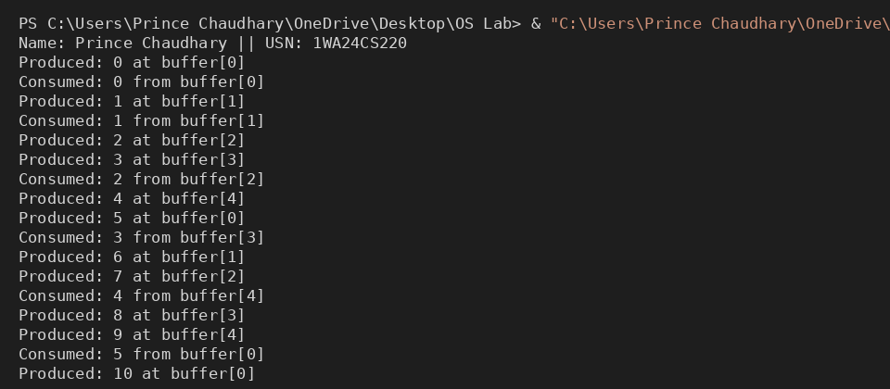

b) Dining-Philosopher's Problem
#include <stdio.h>
#include <pthread.h>
#include <unistd.h>
#define N 5
pthread_mutex_t forks[N]; pthread_t philosophers[N];
void* philosopher(void* num){
int id=*(int*)num, left=id, right=(id+1)%N;
while(1){
printf("Philosopher %d is thinking.\n",id);
if(id%2==0){
pthread_mutex_lock(&forks[left]);
printf("Philosopher %d picked up left fork %d.\n",id,left);
pthread_mutex_lock(&forks[right]);
printf("Philosopher %d picked up right fork %d.\n",id,right);
} else {
pthread_mutex_lock(&forks[right]);
printf("Philosopher %d picked up right fork %d.\n",id,right);
pthread_mutex_lock(&forks[left]);
printf("Philosopher %d picked up left fork %d.\n",id,left);
}
printf("Philosopher %d is eating.\n",id); sleep(2);
pthread_mutex_unlock(&forks[left]);
pthread_mutex_unlock(&forks[right]);
printf("Philosopher %d put down forks %d and %d.\n",id,left,right);
}
}
int main(){
int i, ids[N];
for(i=0;i<N;i++){ pthread_mutex_init(&forks[i],NULL); ids[i]=i; }
for(i=0;i<N;i++) pthread_create(&philosophers[i],NULL,philosopher,&ids[i]);
for(i=0;i<N;i++) pthread_join(philosophers[i],NULL);
for(i=0;i<N;i++) pthread_mutex_destroy(&forks[i]);
return 0;
}

Output:
