Program 5: Deadlock Avoidance and Detection
Aim: Write a C program to simulate: a) Banker's Algorithm for deadlock avoidance b) Deadlock Detection

a) Banker's Algorithm for Deadlock Avoidance
#include <stdio.h>
int main(){
int n, r;
printf("Enter number of processes: "); scanf("%d",&n);
printf("Enter number of resources: "); scanf("%d",&r);
int alloc[n][r],max[n][r],avail[r],need[n][r],safeSeq[n],finish[n];
printf("Enter Allocation Matrix:\n");
for(int i=0;i<n;i++) for(int j=0;j<r;j++) scanf("%d",&alloc[i][j]);
printf("Enter Maximum Demand Matrix:\n");
for(int i=0;i<n;i++) for(int j=0;j<r;j++){
scanf("%d",&max[i][j]);
need[i][j]=max[i][j]-alloc[i][j];
}
printf("Enter Available Resources:\n");
for(int i=0;i<r;i++) scanf("%d",&avail[i]);
for(int i=0;i<n;i++) finish[i]=0;
int count=0;
while(count<n){
int found=0;
for(int p=0;p<n;p++){
if(finish[p]==0){
int j;
for(j=0;j<r;j++) if(need[p][j]>avail[j]) break;
if(j==r){
for(int k=0;k<r;k++) avail[k]+=alloc[p][k];
safeSeq[count++]=p; finish[p]=1; found=1;
}
}
}
if(found==0){ printf("\nSystem is not in a safe state."); return 0; }
}
printf("\nSystem is in a safe state.\n");
printf("Safe sequence is: ");
for(int i=0;i<n;i++){ printf("P%d",safeSeq[i]); if(i!=n-1) printf(" -> "); }
printf("\n");
return 0;
}

Output:
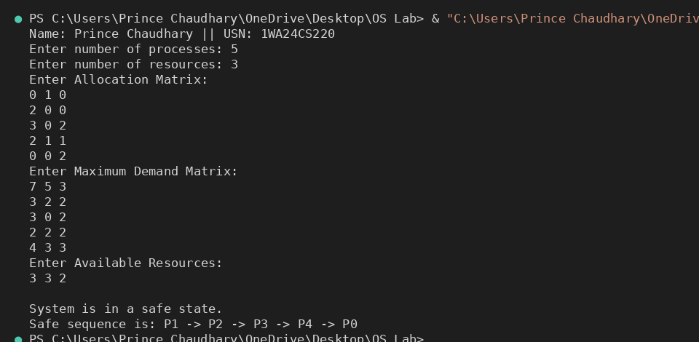

b) Deadlock Detection
#include <stdio.h>
int main(){
int n,r;
printf("Enter the number of processes: "); scanf("%d",&n);
printf("Enter the number of resources: "); scanf("%d",&r);
int alloc[n][r],request[n][r],avail[r],safeSeq[n],finish[n];
printf("Enter the allocation matrix:\n");
for(int i=0;i<n;i++){ printf("Process %d: ",i); for(int j=0;j<r;j++) scanf("%d",&alloc[i][j]); }
printf("Enter the request matrix:\n");
for(int i=0;i<n;i++){ printf("Process %d: ",i); for(int j=0;j<r;j++) scanf("%d",&request[i][j]); }
printf("Enter the available resources: "); for(int i=0;i<r;i++) scanf("%d",&avail[i]);
for(int i=0;i<n;i++) finish[i]=0;
int count=0;
while(count<n){
int found=0;
for(int p=0;p<n;p++){
if(finish[p]==0){
int j;
for(j=0;j<r;j++) if(request[p][j]>avail[j]) break;
if(j==r){
for(int k=0;k<r;k++) avail[k]+=alloc[p][k];
safeSeq[count++]=p; finish[p]=1; found=1;
}
}
}
if(found==0){ printf("\nSystem is not in a safe state.\n"); return 0; }
}
printf("System is in safe state.\n");
printf("Safe Sequence is: ");
for(int i=0;i<n;i++){ printf("P%d",safeSeq[i]); if(i!=n-1) printf(" "); }
printf("\n");
return 0;
}

Output:
