4/15/2018

Programming Language Research Project

algonquincollege

How-To get this project up and running for further development

BY: PRINCEDEEP SINGH

# **Project Description**

This project is simple GUI which is built using python language and Tkinter framework. This application will help user to read and view data in any csv file. Furthermore, user can select any csv file and can perform C.R.U.D operations on it. It also allows user to create a new file of any format.

# **Requirements**

There are certain tools and prerequisites which are needed in order to make this project up and running. Here is list of such requirements:

* Operating System: Windows 10 Home
* Programming Language Python Version: Python 3.6.5 or above. Please refer Installation section 1.0 for guide on downloading and installing python.
* Required Python Ide: Jet Brains PyCharm professional 2018.1 or above. Please refer Installation section 2.0 for guide on downloading and installing python.
* Database: MySQL database is used. Version of MySQL is mysql-installer-community-5.7.21.0.msi. Please refer Installation section 3.0 for guide on downloading and installing python.
* Required Modules or API’s: mysql-connector-python, CSV, threading, codecs, OS, Menu Bar, unittest. Any version will work for listed items as they update automatically with python updates. Please refer Installation section 4.0 for guide on downloading and installing python.

For mysql-connector-python installation refer installation section 4.1.

# **Installation**

Section 1.0 Downloading and installing python:

* Firstly, go to link provided to below to download python. This will show a screen like this:

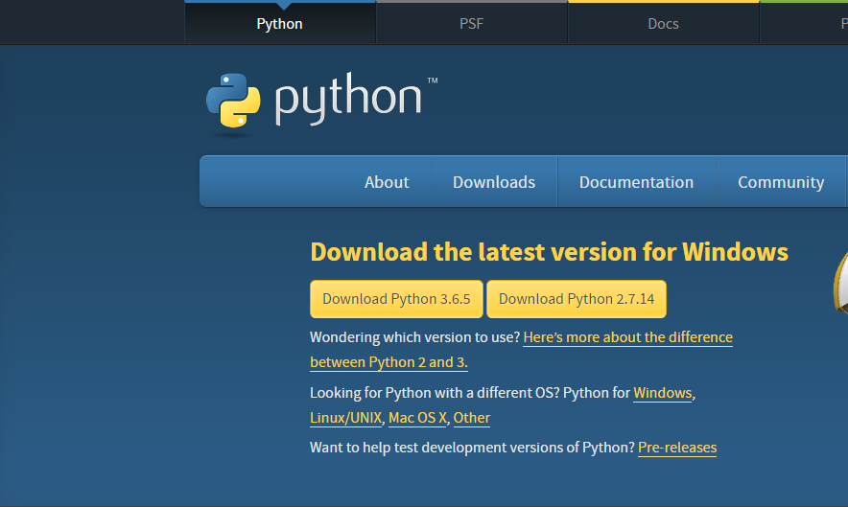

Figure 1: Python download page [1]

<https://www.python.org/downloads/>

* Choose highest possible version and click download button. Hopefully, this will start downloading python on your machine.
* Now you will have .exe file downloaded. Double click to start setup. After setup has started click install now.

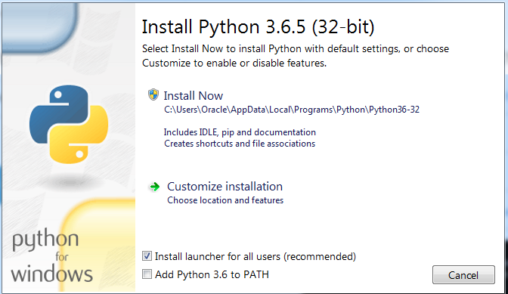

Figure 2: Python installation

* Once setup begin use default settings and click **next** or **ok** end. In any case if any assistance required please visit link below for more help:

<https://www.ics.uci.edu/~pattis/common/handouts/pythoneclipsejava/python.html>

Section 2.0 Downloading and installing Jet Brains PyCharm:

* Firstly, go to link provided to below to download python. This will show a screen like this:

[https://www.jetbrains.com/pycharm/download/#section=windows](https://www.jetbrains.com/pycharm/download/%23section=windows)

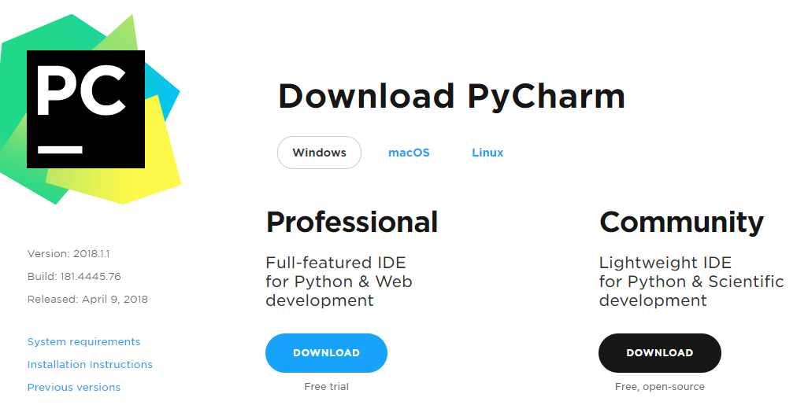

Figure 3: PyCham download screen

* Choose Professional version and click download button. Hopefully, this will start downloading PyCharm on your machine.
* Now you will have .exe file downloaded. Double click to start setup.
* Once setup begin use default settings and click **next** or **ok** end. In any case if any assistance required please visit link below for more help:

<https://www.youtube.com/watch?v=QzcaEELafkE>

Section 3.0 Downloading and installing MySQL:

* Follow the given link which provides complete guide on downloading and installing MySQL.

<http://www.mysqltutorial.org/install-mysql/>

Section 4.0 Downloading and installing modules or api’s in python:

* To use any api or module listed above in list you just require import statement for each item at the top of every python file. There is no need to download any module as they all are inbuilt in python language. Sample is shown below:

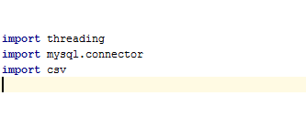

Figure 4: Importing modules

4.1 Downloading and installing mysql-connector-python installation:

* For this open Jet Brains PyCharm IDE. You will have screen like this:

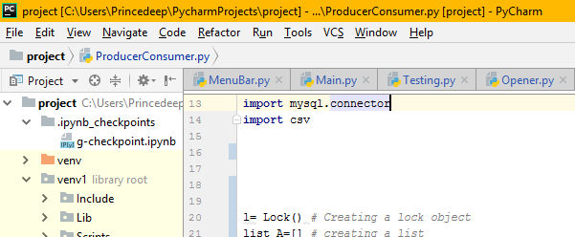

Figure 5: Ide main screen

* Click file menu -> Click Settings.
* Click Project in menu on left hand side as shown.

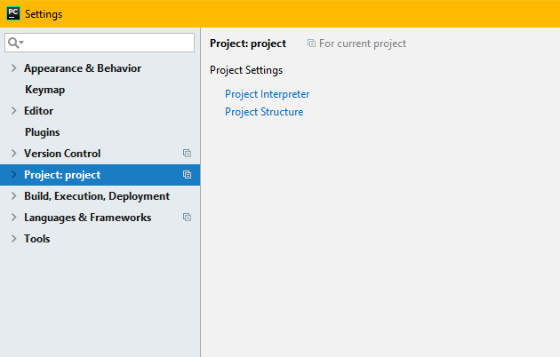

Figure 6: Settings menu

* Under Project select Project Interpreter and window will open on right hand side like this:

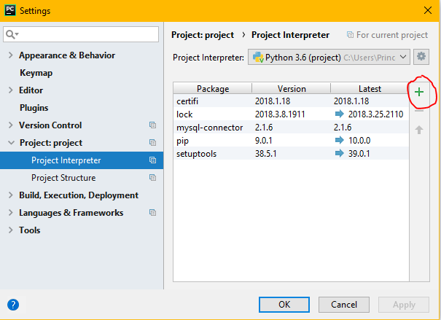

Figure 7: Project interpreter

* Now click on plus button as shown in above screen. You will have screen like this:

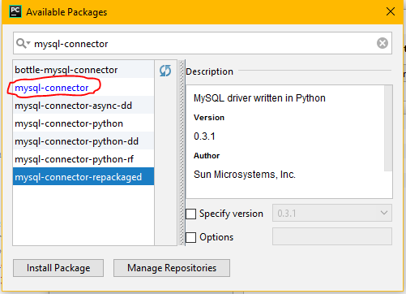

Figure 8: Available packages list

* Now type ***mysql-connector*** in search bar. Choose exact same option in list and click install package. After sometime installation will complete and ide will notify you. Now close this window and Click ok.
* Now to use mysql connector in any python file just type import statement like this:

Import ***mysql.connector .***

Now you are ready to use mysql connector.

# References

|  |  |
| --- | --- |
| [1] | [Online]. Available: https://www.python.org/downloads/. [Accessed 12 04 2018]. |