CEUC102: Programming with C++
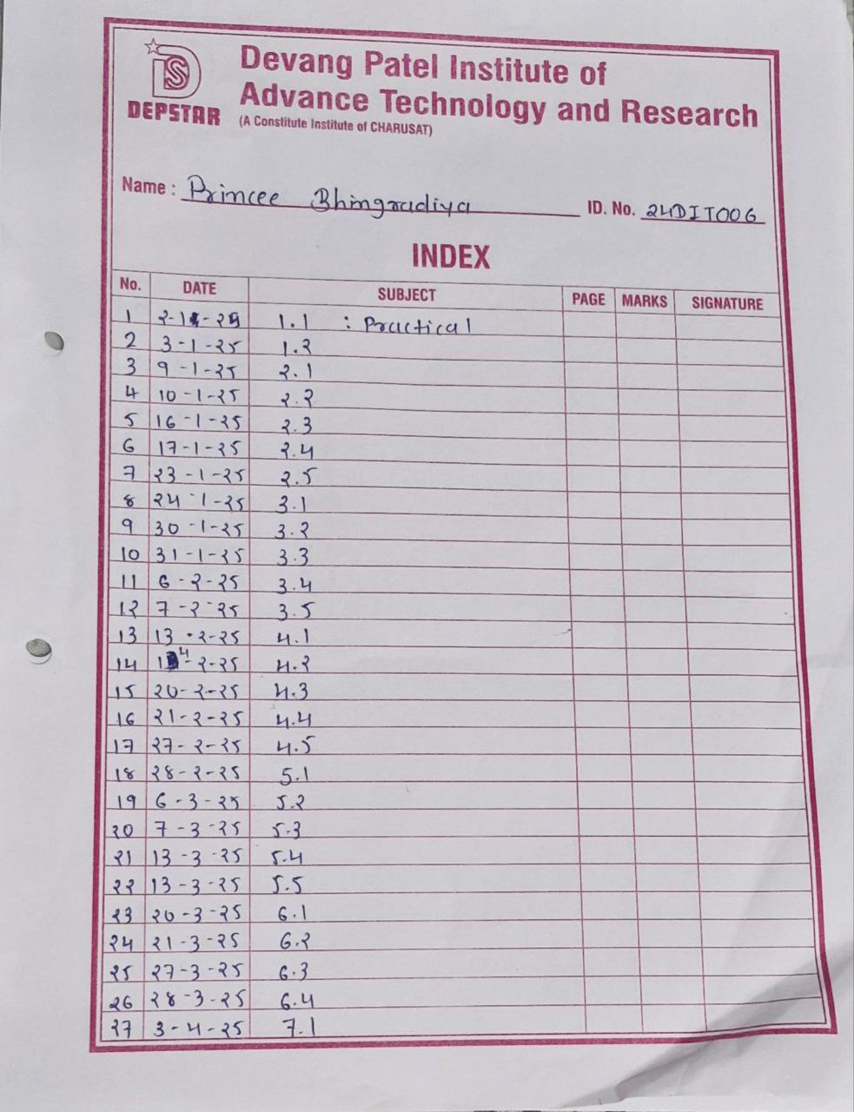

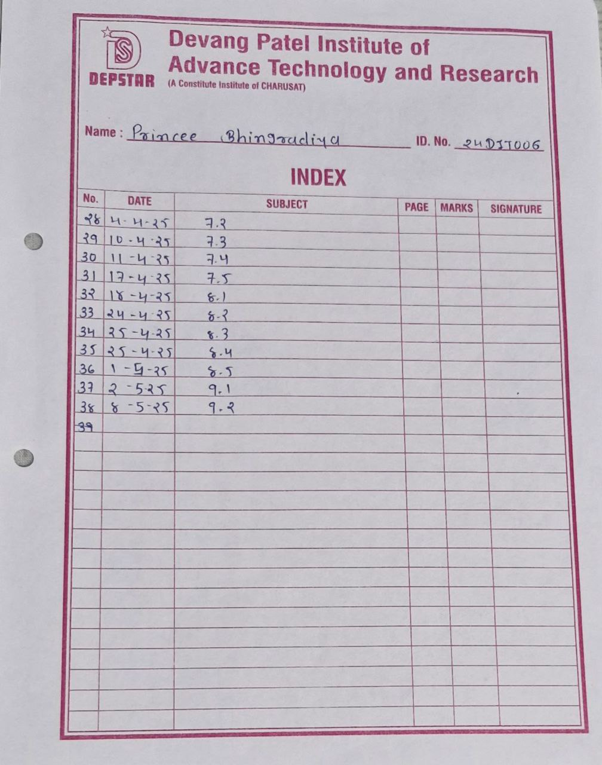

Practical :1.1 | A bank wants to create a simple system to manage customer bank accounts. The system should allow customers to perform basic banking operations such as depositing money, withdrawing money, and checking their account balance.  Each bank account will need to have an account holder's name, a unique account number, and a balance. Deposits should increase the account balance, while withdrawals should only be allowed if there are sufficient funds in the account. If an attempt is made to withdraw more money than is available, an error message should be displayed. Customers should also have the ability to view their account balance whenever required. The system must be designed using Object-Oriented Programming principles, focusing on creating a simple and efficient solution to manage the accounts effectively. The system should ensure that all account details are secure and accessible only through authorized methods.
Code: | // practical :: 1.1  // Program of simple class Bank Account to represent a bank account  #include <iostream>  using namespace std;  // Creating a Class named Bank Account  class BankAccount  {  // Declaring private data member +  private:  string Account_Holder_Name;  int Account_Number;  int Balance;  public:  // Declaring and defining public method and constructor  void SetData()  {  cout << endl  << "Enter Your Bank Detials::::::::::::";  cout << endl  << "Enter The Account Holder Name::";  cin >> Account_Holder_Name;  cout << endl  << "Enter The Account Number::";  cin >> Account_Number;  cout << endl  << "Enter The Account Balance::";  cin >> Balance;  }  // Method to add money to the account  void Deposite(int Money)  {  Balance = Balance + Money;  }  // Method to withdraw money from the account  void Withdraw(int Amount)  {  if (Amount > Balance) /// Checking for sufficient balance exist or not  {  cout << "Error! there is no sufficient money!!";  }  else  {  Balance = Balance - Amount;  }  }  // method to show the current balance  void Display_Balance()  {  cout << "Current Balance:" << Balance << endl;  }  };  int main()  {  BankAccount A1;  int Money, Amount;  A1.SetData();  cout << endl  << "Enter the Amount which is to be Deposited :";  cin >> Money;  A1.Deposite(Money);  A1.Display_Balance();  cout << endl  << "Enter the Amount you want to Withdraw : :";  cin >> Amount;  A1.Withdraw(Amount);  A1.Display_Balance();  cout << endl<< endl<< "24DIT006_PRINCEE BHINGRADIYA" << endl<<endl;  return 0;  }
Output: | 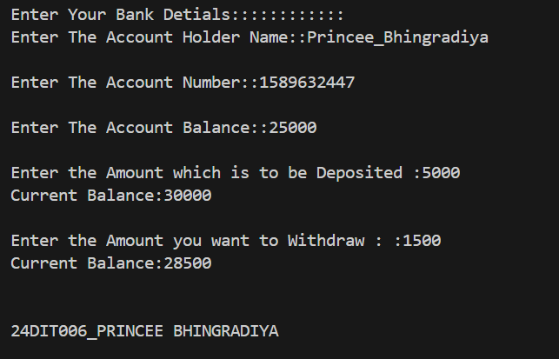
Practical:1.2 | A small retail store is facing challenges in managing its inventory effectively. The store sells a variety of products, each identified by a unique product ID, a name, the available quantity in stock, and the price per unit. To streamline their operations, the store needs a basic system to manage this inventory efficiently.  The system must provide the ability to add new products to the inventory, ensuring that each product has its ID, name, quantity, and price properly recorded. Additionally, the system should allow the store staff to update the quantity of any existing product, such as when new stock arrives or when items are sold. Another essential feature of the system is the calculation of the total value of all products in the inventory, which is determined by multiplying the quantity of each product by its price and summing these values for all products. The store management is exploring two approaches for this system: a procedural approach and an object-oriented approach. The goal is to evaluate these approaches by comparing their ease of implementation, code reusability, and overall complexity. The system's design and implementation should consider these requirements and provide an effective solution (either procedural approach or an object-oriented approach) to the store's inventory management problems.
Code: | // Practical:1.2  // A Program for an inventory managment system using object oriented approaches.  #include <iostream>  using namespace std;  // creating class named product  class Product  {  public:  // Declaring attributes for product in public  string ID;  string Name;  int Quantity;  double price;  // Declaring and defining methods  // Method for update quantity  void updateQuantity()  {  Quantity += 1;  }  // Method that calculates total price  double totalPriceOfProduct()  {  return (Quantity * price);  }  // Method for printing information of product  void getinfo()  {  cout << "Product Name:" << Name  << endl  << "Product id:" << ID  << endl  << "Quantity:" << Quantity  << endl  << "Price:" << price  << endl;  }  };  int main()  {  string tempID; // For finding the product for edit quantity  int i, choice, numOfproduct = 0;  Product product[30]; // Creating array of object  cout << "Enter Number of product:";  cin >> numOfproduct;  cout << endl  << "Enter Product Details::"  << endl;  // Taking user input for product information  for (int i = 0; i < numOfproduct; i++)  {  cout <<endl  << "For Product no."  << i + 1  << endl  << "Enter the Detials:"  << endl;  cout << "ID:";  cin >> product[i].ID;  cout << "Name:";  cin >> product[i].Name;  cout << "Quantity :";  cin >> product[i].Quantity;  cout << "Price : ";  cin >> product[i].price;  cout << "*-*-*-*-*-*-*-*-*-*-*-*-*-*-*-"  <<endl;  }  // Displaying product detials  for (i = 0; i < numOfproduct; i++)  {  product[i].getinfo();  cout << "*-*-*-*-*-*-*-*-*-*-*-*-*-*-*-*-*" << endl;  }  again:  // Displaying press keys for differnt tasks  cout << "press 1 : If you want add product" << endl;  cout << "press 2 : If you want edit quantity of any product" << endl;  cout << "press 0 : for select neither of them" << endl;  cin >> choice; // Taking user's choice  if (choice == 1) // if choice=1 then it will execute  {  cout << "For Product no. " << i + 1 << " Enter the details :" << endl;  cout << "ID : ";  cin >> product[i].ID;  cout << "Name : ";  cin >> product[i].Name;  cout << "Quantity :";  cin >> product[i].Quantity;  cout << "price : ";  cin >> product[i].price;  cout << "*-*-*-*-*-*-*-*-*-*-*-*-*-*-*-*-*" << endl;  product[i].getinfo();  cout << "*-*-*-*-*-*-*-*-*-*-*-*-*-*-*-*-*" << endl;  i++;  numOfproduct++;  goto again;  }  else if (choice == 2) // if choice=2 then it will execute  {  int edit = 0; // For edit the quantity  cout << "Enter ID of Product : ";  cin >> tempID;  for (i = 0; i < numOfproduct; i++)  {  if (product[i].ID == tempID)  {  cout << "*-*-*-*-*-*-*-*-*-*-*-*-*-*-*-*-*" << endl;  cout << "Enter no of Quantity:";  cin >> edit;  product[i].Quantity += edit;  cout << "*-*-*-*-*-*-*-*-*-*-*-*-*-*-*-*-*" << endl;  product[i].getinfo();  cout << "*-*-*-*-*-*-*-*-*-*-*-*-*-*-*-*-*" << endl;  break;  }  }  if (edit == 0)  {  cout << "*****There is no such product with ID***** " << tempID << endl;  }  goto again;  }  else if (choice == 0) // if choice=0 then it will execute  {  goto continueTheflow;  }  continueTheflow:  double totalPriceOfAllPrroducts = 0;  for (i = 0; i < numOfproduct; i++)  {  totalPriceOfAllPrroducts += product[i].totalPriceOfProduct();  }  cout << "*-*-*-*-*-*-*-*-*-*-*-*-*-*-*-*-*" << endl;  cout << "Total Price of all products is " << totalPriceOfAllPrroducts << endl;  cout << "*-*-*-*-*-*-*-*-*-*-*-*-*-*-*-*-*" << endl;  cout << endl  << endl  << "24DIT006 PRINCEE_BHINGRADIYA" << endl;  return 0;  }
Output: | 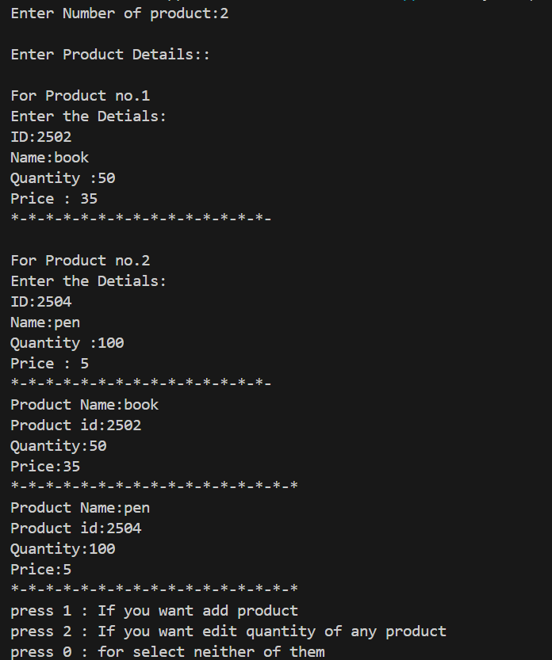  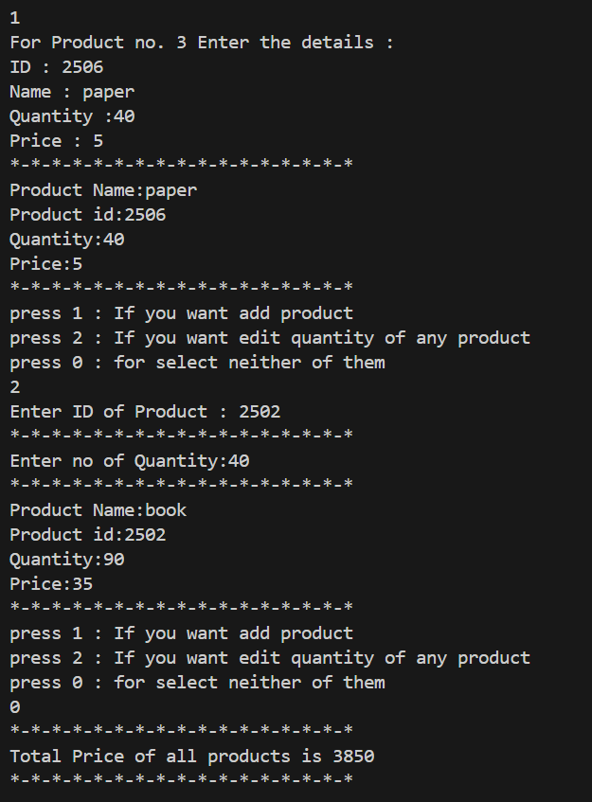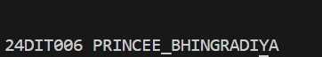
Practical:2.1 | A local construction company frequently deals with rectangular plots and structures of varying dimensions. To streamline their planning and estimation processes, the company requires a simple system to manage and analyse rectangular shapes efficiently. The system must be able to handle multiple rectangles, each with distinct dimensions. For each rectangle, the length and width need to be defined and stored securely. Additionally, the company needs the ability to calculate two key metrics for any given rectangle: The area, to estimate usable space or material coverage. The perimeter, to estimate boundary lengths or material requirements for edges. To make this system functional, there should be a way to define or update the dimensions of any rectangle as required. The system should be capable of creating and managing multiple rectangle records, performing calculations for each, and displaying the results  clearly for analysis and planning purposes.
Code: | #include <iostream>  using namespace std;  // Define a class named Rectangle  class Rectangle  {  private:  // Private data member to store length and width of Rectangle  int L;  int W;  public:  // Public member function to input dimension of the rectangle  void setDimensions()  {  cout << "Enter Rectangle L:";  cin >> L; // Take input for length  cout << "Enter Rectangle W:";  cin >> W; // Take input for width  }  // Public member function to calculate area of the rectangle  int Area()  {  int A = L * W;  return A;  }  // Public member function to calculate perimeter of the rectangle  int Perimeter()  {  int p = 2 * (L + W);  return p;  }  };  int main()  {  Rectangle h, v; // create an object h, v of class Rectangle  h.setDimensions(); // Call function to input length and width  int AA = h.Area(); // Output of area  cout << "Area :" << AA << endl;  int PP = h.Perimeter(); // Output of perimeter  cout << "Perimeter :" << PP << endl;  v.setDimensions(); // Call function to input length and width  int BB = v.Area(); // Output of area  cout << "Area :" << BB << endl;  int CC = v.Perimeter(); // Output of perimeter  cout << "Perimeter :" << CC << endl;  cout << endl<< endl<< "24DIT006_PRINCEE BHINGRADIYA" << endl<<endl;  return 0;  }
Output: | 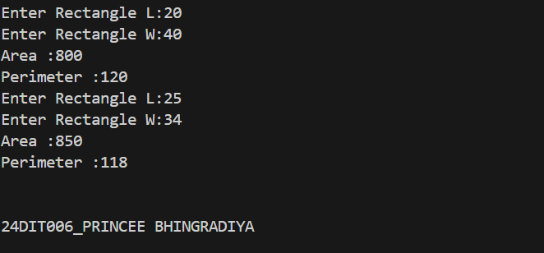
Practical:2.2 | A university managing academic data for its students. The administration seeks to digitize the records of student performance, including personal and academic details. The system must store each student's roll number, name, and marks in three subjects. Additionally, it should provide functionalities to calculate and display the average marks for performance analysis. The institution's IT team proposed a solution where student records could be initialized in two ways: either with default values for testing purposes or by accepting specific input details for each student. Once initialized, the system would allow for viewing comprehensive student details, including their  roll number, name, marks, and calculated average. This functionality was designed to help faculty and administrators track individual student performance efficiently.  To simulate real-world usage, the team decided to create multiple student records. They planned to populate the system with a mix of students initialized using both default and specific values. The system's ability to accurately calculate averages and display detailed student information was to be tested with this data.
Code: | #include <iostream>  using namespace std;  // Define a class named Student  class Student  {  private:  int rollNumber;  string nameOfStudent;  double marks[10] = {0};  public:  // Default constructer initializing rollnumber and name  Student()  {  rollNumber = 0;  nameOfStudent = "N/A";  }  // Parameterizedd constructer to initialize all data members  Student(int rollNum, string name, int numOfstudent, double marksOfstudent[])  {  rollNumber = rollNum;  nameOfStudent = name;  for (int i = 0; i < numOfstudent; i++)  {  marks[i] = marksOfstudent[i]; // Copy marks to class array  }  }  // Function to display student detials including marks and avarage  void displayDetials(int noOFsub)  {  cout << "Name :" << nameOfStudent  << endl;  cout << "Roll Number :" << rollNumber  << endl;  for (int i = 0; i < noOFsub; i++)  {  cout << "Marks of Subject " << i + 1 << ":" << marks[i] << endl;  }  cout << "Avrage marks is : " << calculateAverage(noOFsub) << endl;  }  // Function tp calculate and return the average marks  double calculateAverage(int numOfsub)  {  double avg = 0, sum = 0;  for (int i = 0; i < numOfsub; i++)  {  sum = sum + marks[i]; // Sum of marks  }  avg = sum / numOfsub; // Calculate average  return avg;  }  };  int main()  {  Student s1; // Create student object s1 using default constructor  cout << endl;  int rollNumber, numOfSub;  string name;  // Take user input for student detials  cout << "Enter Name Student :";  cin >> name;  cout << "Enter Roll Number :";  cin >> rollNumber;  cout << "Enter Number of Subject :";  cin >> numOfSub;  double marks[numOfSub]; // Array to hold marks  // Input marks for each sub  for (int i = 0; i < numOfSub; i++)  {  cout << "Enter marks of subject " << i + 1 << ":";  cin >> marks[i];  }  // Display default object detials (default values)  s1.displayDetials(numOfSub);  cout<<endl  <<endl;  //Create student object s2 using parameterized constructor  Student s2(rollNumber, name, numOfSub, marks);  //Display actual student detials with provided data  s2.displayDetials(numOfSub);  cout << endl<< endl<< "24DIT006_PRINCEE BHINGRADIYA" << endl<<endl;  }
Output: | 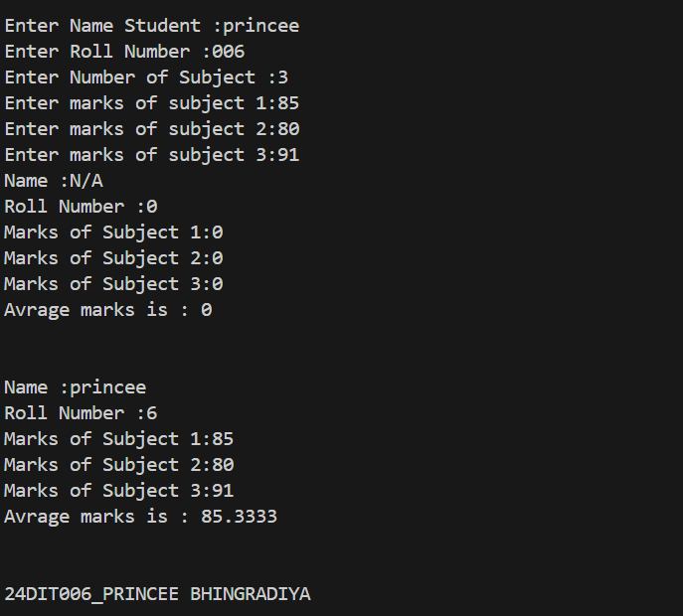
Practical:2.3 | In a growing city, a newly established bank sought to streamline its operations by implementing a digital system to manage customer accounts. The management envisioned a system where each account would store details about the account holder, their unique account number, and the current balance. To ensure flexibility and accuracy, they required functionalities for creating accounts with  varying initial balances, depositing money, withdrawing funds (with checks for sufficient balance), and generating detailed account summaries. The bank's IT team faced the challenge of developing a robust solution. They began by sketching out  the essential features of the system. The team highlighted that new accounts could be created in two ways: one with no initial balance, and another with specified account details and a starting amount. Additionally, they recognized the need for reliable mechanisms to handle deposits and withdrawals, ensuring proper validation to prevent overdrafts. Displaying account details in a clear format was also prioritized for customer communication. To ensure scalability, the team decided to simulate the system by creating multiple accounts using the proposed methods. They tested various scenarios, such as depositing and withdrawing different amounts, handling edge cases like insufficient funds, and verifying that the account summaries were accurate. This iterative approach helped them refine the system and ensure its readiness for  deployment.
Code: | #include<iostream>  using namespace std;  //Deafult BankAccount class  class BankAccount  {  public:  string nameOfAccHolder ;  string accountNum ;  double Balance ;  //Default constructor to initialize Balance to 0  BankAccount()  {  Balance = 0;  }  //Parameterized constructor to initialized object with given data  BankAccount(string name , string AccNum , double AccBalance)  {  nameOfAccHolder = name;  accountNum = AccNum;  Balance = AccBalance;  }  //Function to deposite money into account  void Deposite (double Amounnt)  {  Balance += Amounnt;  cout<<"Transaction is successfully done!!"<<endl;  }  //Function to Withdraw money from accounnt with Balance check  void Withdraw (double Amount)  {  if (Amount <= Balance)  {  Balance -= Amount;  cout<<"There are not sufficient amount in your bank account !!"<<endl;  }  else  {  cout<<"There are not sufficient amount in your bank account !! "<<endl;  }  }  //Function to display account detials  void SeeDetials()  {  cout<<"---------------------------------------"<<endl;  cout<<"Account Holder Name :"<<nameOfAccHolder<<endl;  cout<<"Account Number :"<<accountNum<<endl;  cout<<"Balance :"<<Balance<<endl;  cout<<"---------------------------------------"<<endl;  }  void CurrentBalance()  {  cout<<"Balance :"<<Balance<<endl;  }  };  int main()  {  string name; //Character array to store account holder name  double AccBalance; //Variable to holder balance  string accNo; //Variable to hold account number  double Amount;  //Create an object acc1 using default constructor  BankAccount acc1;  acc1.nameOfAccHolder = "Princee Bhingradiya"; // Set details manualy  acc1.accountNum = "259874631";  acc1.Balance = 25000;  acc1.SeeDetials(); // Show account details  cout<<"How much money you want deposite :";  cin>>Amount;  acc1.Deposite(Amount); //Deposite money  acc1.CurrentBalance();  cout<<"How much money you want Withdraw :";  cin>>Amount;  acc1.Withdraw(Amount);  acc1.CurrentBalance(); // Withdraw money  cout<<endl;  //Take user input for a second account  cout<<endl  <<"-------------Second Account Holder ------------ "  <<endl;  cout<<"Enter Account Holder's Name :";  cin>>name;  cout<<endl;  cout<<"Enter Account Number :";  cin>>accNo;  cout<<endl;  cout<<"Enter Balance :";  cin>>AccBalance;  cout<<endl;  //Create an object acc2 using parameterized constructor  BankAccount acc2(name , accNo , AccBalance);  acc2.SeeDetials(); // Show account details  cout<<"How much money you want deposite :";  cin>>Amount;  acc2.Deposite(Amount); //Deposite money  acc2.CurrentBalance();  cout<<"How much money you want Withdraw :";  cin>>Amount;  acc2.Withdraw(Amount); // Withdraw money  acc2.CurrentBalance();  cout<<endl;  cout<<" 24DIT006 Princee_Bhingradiya"<<endl;  return 0;  }
Output: | 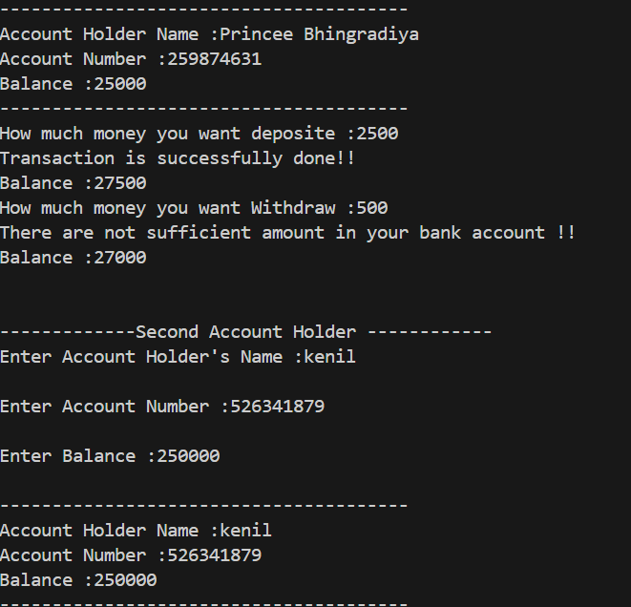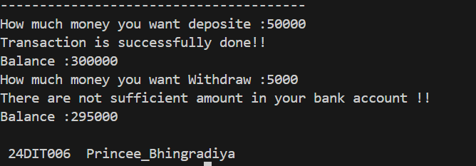
Practical:2.4 | A mid-sized retail store faced challenges in efficiently managing its inventory of items. The store's management sought to build a system that could keep track of individual items, including details like a unique item ID, item name, price, and the quantity available in stock. The need for a streamlined process arose due to frequent stock discrepancies, which led to issues with customer satisfaction and operational efficiency.  To address this, the store hired a team of developers to create a digital inventory management system. The envisioned solution would allow for the initialization of item details, either with default values or specific attributes like ID, name, price, and starting quantity. This system needed to handle operations like increasing stock levels when new shipments arrived and decreasing stock when items were sold, ensuring sufficient inventory was available for each transaction. Additionally, the system would  provide clear, detailed summaries of each item's status, aiding in decision-making and reporting. The developers faced real-world scenarios where they had to manage multiple inventory items simultaneously. They planned to design an array of inventory items and simulate common tasks such as adding stock, processing sales transactions, and displaying the current inventory details. Handling edge cases, such as attempting to sell more items than available in stock, became a critical part of the implementation to ensure reliability.
Code: | #include <iostream>  using namespace std;  // Class to represent an inventory item  class InventoryItem  {  public:  string itemID;  string itemName;  double price;  int Quantity;  // Default constructor initializing price and quantity  InventoryItem()  {  price = 0;  Quantity = 0;  }  // Parameterized constructor initializing all item detials  InventoryItem(string ID, string Name, double priceOfItem, int quantityOfItem)  {  itemID = ID;  itemName = Name;  price = priceOfItem;  Quantity = quantityOfItem;  }  // Function to add stock  void addStock(int qty)  {  Quantity += qty;  cout << "The Quantity is updated !!" << endl;  }  // Function to sell item (decrease stock)  void sellItem(int qty)  {  if (qty > Quantity)  {  cout << "There is no sufficient stock !!" << endl;  return;  }  Quantity -= qty;  cout << "The Quantity is updated !!" << endl;  }  // Function to display item detials  void displayItem()  {  cout << "-------------------------------"  << endl;  cout << "Item ID :" << itemID << endl;  cout << "Item Name :" << itemName << endl;  cout << "Price :" << price << endl;  cout << "Quantity :" << Quantity << endl;  cout << "-------------------------------"  << endl;  }  };  int main()  {  int num, qty;  string id, name;  double price;  // Input for total number of item  cout << "Enter number of item :";  cin >> num;  cout << endl;  InventoryItem item[num]; // Array of object to store multiple items  // Input detials for each item  for (int i = 0; i < num; i++)  {  cout << "Enter Detials of item " << i + 1 << "!" << endl;  cout << "Enter Item's ID : ";  cin >> id;  cout << "Enter Item's Name :";  cin >> name;  cout << "Enter Item's Price :";  cin >> price;  cout << "Enter Item's Quantity :";  cin >> qty;  item[i] = InventoryItem(id, name, price, qty); // Use Parameterized constructor  cout << "---------------------------------"<<endl;  }  // Display Details of all items  for (int i = 0; i < num; i++)  {  item[i].displayItem();  }  int choice, editqty, flag = 0;  string tempID;  // Menu deriven system for inventory managment  again:  cout << "Enter Below number for ti=o do corresponding work !!" << endl;  cout << " 1 To Add Quantity of Any Item" << endl;  cout << " 2 To Sell Any Item" << endl;  cout << " 3 To see Detials of any item" << endl;  cout << " 0 For Exit" << endl;  cout << "Enter Choice :";  cin >> choice;  // if we choose 1 this code excute  if (choice == 1)  {  cout << "Enter ID :";  cin >> tempID;  for (int i = 0; i < num; i++)  {  if (item[i].itemID == tempID)  {  cout << "Enter num of Quantity , that you want to add :";  cin >> editqty;  item[i].addStock(editqty);  flag = 1;  goto again;  }  }  if (flag == 0)  {  cout << "There is no such item id !!" << endl;  goto again;  }  }  // if we choose 2 this code excute  else if (choice == 2)  {  cout << "Enter ID :";  cin >> tempID;  for (int i = 0; i < num; i++)  {  if (item[i].itemID == tempID)  {  cout << "Enter num of Quantity , that you want yo sell :";  cin >> editqty;  item[i].sellItem(editqty);  flag = 1;  goto again;  }  if (flag == 0)  {  cout << "There is no such item id !!" << endl;  goto again;  }  }  }  // if we choose 3 this code excute  else if (choice == 3)  {  cout << "Enter ID :";  cin >> tempID;  for (int i = 0; i < num; i++)  {  if (item[i].itemID == tempID)  {  item[i].displayItem();  flag = 1;  goto again;  }  }  if (flag == 0)  {  cout << "There is no such item id !!";  goto again;  }  }  // if we want exit so we choose option 3  else if (choice == 0)  {  cout << "-----------THANK YOU------------------";  cout << endl  << " 24DIT006 PRINCEE_BHINGRADIYA" << endl;  }  return 0;  }
Output: | 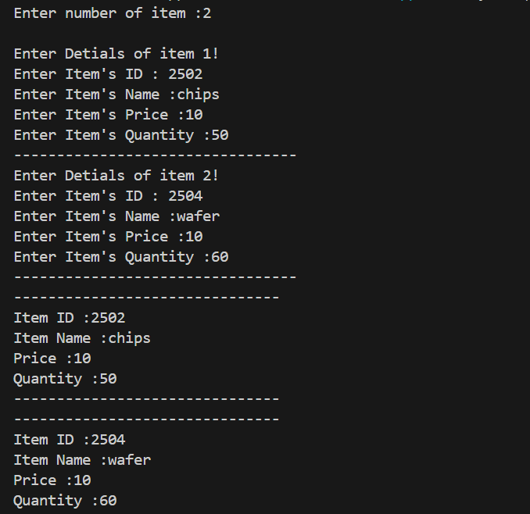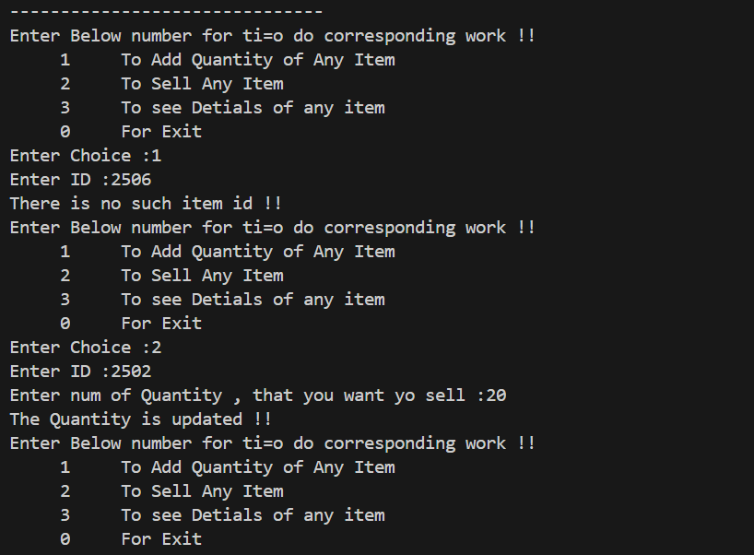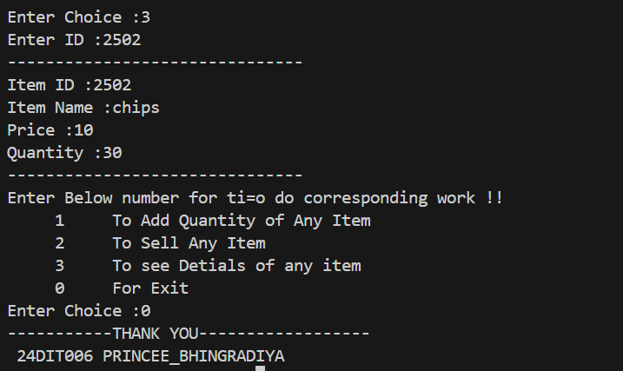
Practical:2.5 | A regional banking institution sought to improve its loan management process by developing a system that could efficiently handle loan details for applicants. The system was expected to streamline the calculation of monthly EMIs (Equated Monthly Instalments) and provide detailed loan summaries for customers. This initiative aimed to enhance customer experience by offering accurate and transparent information about their loans. To meet these requirements, the bank's technology team was tasked with designing a solution. They envisioned a system where each loan would be uniquely identified by a loan ID, and additional details such as the applicant's name, total loan amount, annual interest rate, and loan tenure in months would be stored. The team also emphasized the importance of accurately calculating the EMI using a standard formula based on the loan amount, interest rate, and tenure. The formula incorporated  compound interest principles to determine the fixed monthly payment for the loan term.  EMI=P ∗ R ∗ (1 + R)^T  -------------------------  ((1+R)^T) −1  As part of the implementation, the developers planned to initialize loans either with default values for  testing purposes or with actual customer data provided at the time of application. The system needed to include a feature to display comprehensive loan details, including the calculated EMI, in a customer- friendly format. This functionality was intended to aid both customers and bank staff in managing loan-related queries effectively.
Code: | #include<iostream>  #include<cmath>  using namespace std;  // Define the loan class  class Loan {  private:  int loanID;  string applicant_name;  float loan_amount;  float interestRate;  int loanTerm;  public:  // Default constructor initializing members with default values  Loan() : loanID(0), applicant_name("N/A"), loan_amount(0.0), interestRate(0.0), loanTerm(0) {}  // Parameterized constructor to initialize loanID and input other details  Loan(int id) {  loanID = id;  cout << "Enter Applicant's Name: ";  cin.ignore(); // Ignore leftover newline character  getline(cin, applicant_name);  cout << "Enter loan amount: ";  cin >> loan_amount;  cout << "Enter Interest Rate (Annual %): ";  cin >> interestRate;  cout << "Enter loan tenure (in months): ";  cin >> loanTerm;  }  // Function to calculate EMI using the corrected formula  float calculateEMI() {  float monthlyRate = interestRate / 100 / 12;  float a = loan_amount * monthlyRate * pow(1 + monthlyRate, loanTerm);  float b = pow(1 + monthlyRate, loanTerm) - 1;  return a / b;  }  // Function to display loan details and EMI  void displayLoanDetails() {  cout << "-------------------------------------" << endl;  cout << "Loan Details for Loan ID No. " << loanID << endl;  cout << "Loan ID: " << loanID << endl;  cout << "Applicant Name: " << applicant_name << endl;  cout << "Loan Amount: " << loan_amount << endl;  cout << "Interest Rate: " << interestRate << "%" << endl;  cout << "Loan Term: " << loanTerm << " months" << endl;  cout << "EMI per month: " << calculateEMI() << endl;  cout << "--------------------------------------" << endl;  }  };  int main() {  Loan l1; // Create loan object using default constructor  l1.displayLoanDetails(); // Display default loan details  Loan l2(20); // Create loan object with ID = 20 using parameterized constructor  l2.displayLoanDetails(); // Display entered loan details and EMI  cout << endl << "24DIT006 PRINCEE_BHINGRADIYA" << endl;  return 0;  }
Output: | 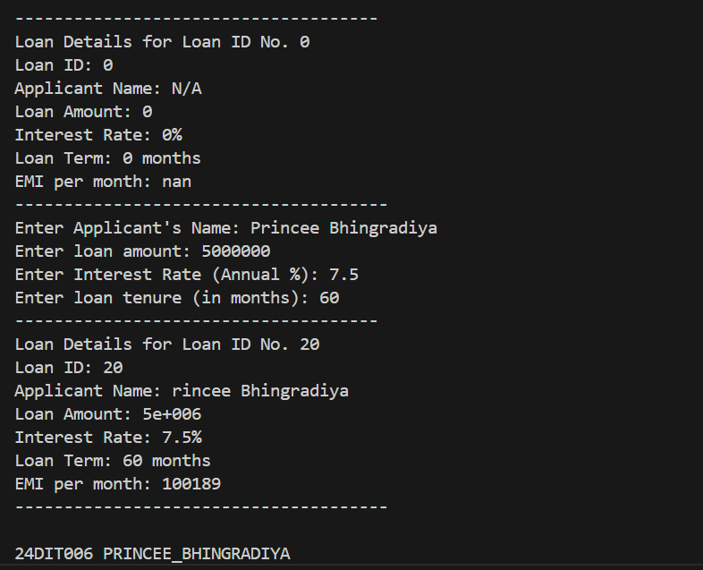
Practical:3.1 | A growing organization sought to enhance its payroll process to improve accuracy and efficiency in calculating employee salaries. The goal was to manage details such as the employee's name, basic salary, and bonus amount. While most employees would receive a default bonus, there was a need for flexibility to provide customized bonuses for exceptional performers or those in specialized roles. To ensure real-time computation of each employee's total salary, the system would dynamically  calculate the total salary by adding the basic salary and the bonus. An inline function was chosen for this task, allowing the system to compute the total salary instantly during processing. The system was designed to initialize employee records using a constructor, where the bonus could either be set to a default value or adjusted according to specific employee criteria. As the organization expanded, managing employee records efficiently became a key consideration. The solution involved storing employee details dynamically, ensuring the system could handle a growing number of records while maintaining scalability and flexibility. Each employee record would  include their personal details, basic salary, and bonus information, with the system displaying a breakdown of each employee’s details along with their total salary.
Code: | #include <iostream>  #include <vector>  using namespace std;  class Employee  {  private:  string employee_name;  int basic_salary;  int bonus;  public:  Employee(string name, int bsalary, int bonus = 500)  {  employee_name = name;  basic_salary = bsalary;  this->bonus = bonus; // Fixing scope issue  }  inline float salary()  {  return basic_salary + bonus; // Simplified logic  }  void display()  {  cout << "Employee name: " << employee_name << endl;  cout << "Basic salary: " << basic_salary << endl;  cout << "Bonus: " << bonus << endl;  cout << "Total salary: " << salary() << endl;  }  };  int main()  {  vector<Employee> a;  int n;  cout << "Enter the number of employees: ";  cin >> n;  cin.ignore(); // Prevent empty getline input  for (int i = 0; i < n; i++)  {  string employee_name;  cout << "Enter the Employee name: ";  getline(cin, employee_name); // Corrected input handling  int basic_salary;  cout << "Enter the Basic salary: ";  cin >> basic_salary;  int bonus;  cout << "Enter the Bonus: ";  cin >> bonus;  cin.ignore(); // Prevent input issues for next iteration  a.push_back(Employee(employee_name, basic_salary, bonus));  }  // Display all employees AFTER input collection is complete  cout << "\nEmployee Details:\n";  for (int i = 0; i < a.size(); i++)  {  a[i].display();  }  cout << endl<< endl<< "24DIT006_PRINCEE BHINGRADIYA" << endl<<endl;  return 0;  }
Output: | 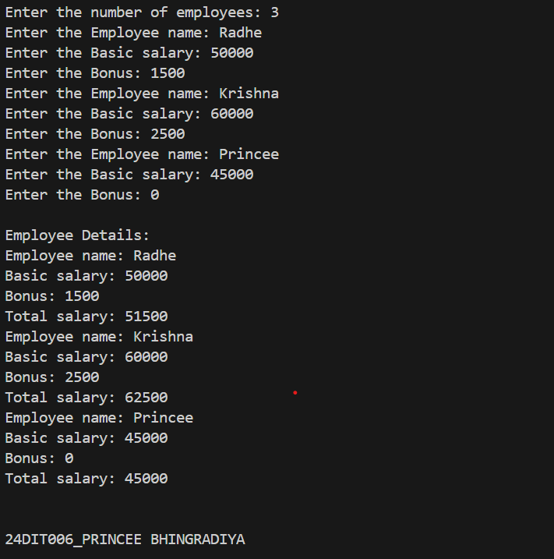
Practical:3.2 | A growing organization sought to enhance its payroll process to improve accuracy and efficiency in calculating employee salaries. The goal was to manage details such as the employee's name, basic salary, and bonus amount. While most employees would receive a default bonus, there was a need for flexibility to provide customized bonuses for exceptional performers or those in specialized roles.  To ensure real-time computation of each employee's total salary, the system would dynamically calculate the total salary by adding the basic salary and the bonus. An inline function was chosen for this task, allowing the system to compute the total salary instantly during processing. The system was designed to initialize employee records using a constructor, where the bonus could either be set to a default value or adjusted according to specific employee criteria. As the organization expanded, managing employee records efficiently became a key consideration. The solution involved storing employee details dynamically, ensuring the system could handle a growing number of records while maintaining scalability and flexibility. Each employee record would  include their personal details, basic salary, and bonus information, with the system displaying a breakdown of each employee’s details along with their total salary.
Code: | #include <iostream>  #include <vector>  using namespace std;  // Recursive function to calculate the sum of the array  int recursiveSum(const vector<int>& arr, int n) {  if (n == 0) {  return 0; // Base case: empty array  }  return arr[n - 1] + recursiveSum(arr, n - 1); // Recursive case  }  // Non-recursive function to calculate the sum of the array  int iterativeSum(const vector<int>& arr) {  int sum = 0;  for (int num : arr) {  sum += num;  }  return sum;  }  int main() {  int size;  cout << "Enter the size of the array: ";  cin >> size;  vector<int> arr(size);  cout << "Enter the elements of the array:" << endl;  for (int i = 0; i < size; i++) {  cin >> arr[i];  }  // Calculate the sum using recursive approach  int sumRecursive = recursiveSum(arr, size);  // Calculate the sum using non-recursive approach  int sumIterative = iterativeSum(arr);  // Display results  cout << "Sum using recursive approach: " << sumRecursive << endl;  cout << "Sum using non-recursive approach: " << sumIterative << endl;  cout << endl<< endl<< "24DIT006_PRINCEE BHINGRADIYA" << endl<<endl;  return 0;  }
Output: | 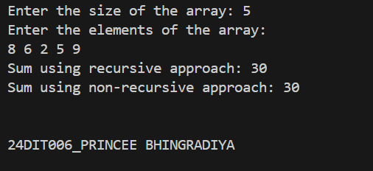
Practical:3.3 | A community bank sought to enhance its account management system with a digital solution to improve efficiency and provide better customer service. The system was required to manage the essential details of each account, including the account number, account holder’s name, and balance. Additionally, the bank wanted to provide a secure mechanism for transferring money between accounts, allowing customers to easily manage their funds. The bank also needed a way to track the total number of accounts created, which would be important for generating reports and understanding the growth of their customer base. This feature was aimed at helping the bank maintain an overview of their account portfolio and analyse trends over time. To ensure smooth and reliable operations, the system was designed to store account information in a  way that would allow easy access and updates. When new accounts were created, they would be added to the system dynamically. The management team planned for future scalability and performance improvements by considering more efficient storage and retrieval methods after the initial system was built, ensuring that the bank could easily accommodate more accounts and transactions as the customer base grew.
Code: | #include <iostream>  #include <vector>  #include <string>  using namespace std;  // Account class  class Account {  private:  int accountNumber;  string accountHolderName;  double balance;  public:  // Static variable to track total accounts  static int totalAccounts;  // Constructor  Account(int number, string name, double initialBalance)  : accountNumber(number), accountHolderName(name), balance(initialBalance) {  totalAccounts++;  }  // Destructor  ~Account() {}  // Get account details  void displayDetails() const {  cout << "Account Number: " << accountNumber << endl;  cout << "Account Holder: " << accountHolderName << endl;  cout << "Balance: " << balance << endl;  }  // Transfer money to another account  bool transfer(Account &toAccount, double amount) {  if (balance >= amount && amount > 0) {  balance -= amount;  toAccount.balance += amount;  return true;  }  return false;  }  // Get balance  double getBalance() const {  return balance;  }  // Static function to get total accounts  static int getTotalAccounts() {  return totalAccounts;  }  };  // Initialize static variable  int Account::totalAccounts = 0;  int main() {  // Vector to dynamically store accounts  vector<Account> accounts;  // Create accounts  accounts.push_back(Account(1001, "Radhe", 15000.00));  accounts.push_back(Account(1002, "Krishna", 13000.00));  accounts.push_back(Account(1003, "Princee", 7000.00));  // Display account details  cout << "Account Details:\n";  for (int i = 0; i< accounts.size();i++) {  accounts[i].displayDetails();  cout << "--------------------\n";  }  // Perform a money transfer  cout << "\nTransferring money...\n";  if (accounts[0].transfer(accounts[1], 3000.00)) {  cout << "Transfer successful.\n";  } else {  cout << "Transfer failed due to insufficient balance.\n";  }  // Display updated balances  cout << "\nUpdated Account Balances:\n";  for (int i =0 ; i <accounts.size();i++) {  accounts[i].displayDetails();  cout << "--------------------\n";  }  // Total accounts  cout << "\nTotal Accounts: " << Account::getTotalAccounts() << endl;  cout << endl<< endl<< "24DIT006_PRINCEE BHINGRADIYA" << endl<<endl;  return 0;  }
Output: | 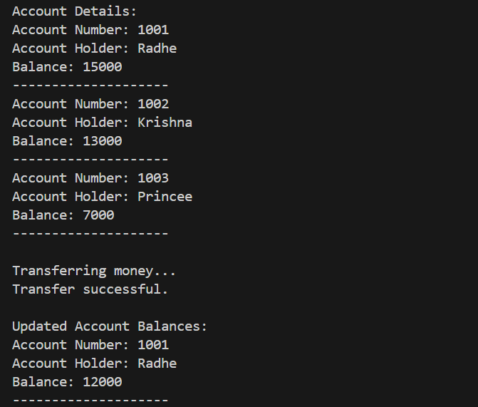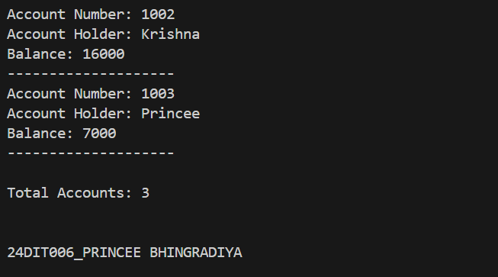
Practical:3.4 | A technology firm aimed to develop a flexible and reusable solution for managing collections of various data types, including integers, floating-point numbers, and characters. The system was intended to perform fundamental operations on these collections, such as finding the maximum value, reversing the collection, and displaying all elements. To achieve versatility and avoid redundancy in code, the solution was designed to use function templates, allowing the same logic to be applied seamlessly to different data types. The team recognized the importance of using dynamic arrays to store the collections, enabling efficient management of varying collection sizes. The design emphasized scalability and flexibility, ensuring that the system could handle different data types and their associated operations with minimal changes to the core logic. In practice, the system allowed for the creation of collections for various data types, such as integers, floating-point numbers, and characters. The operations on these collections included determining the maximum value, reversing the order of elements, and printing the collection contents.
Code: | #include <iostream>  using namespace std;  // Function template to find the maximum value in an array  template <typename T>  T findMax(T arr[], int size) {  T maxVal = arr[0];  for (int i = 1; i < size; i++) {  if (arr[i] > maxVal) {  maxVal = arr[i];  }  }  return maxVal;  }  // Function template to reverse the array  template <typename T>  void reverseArray(T arr[], int size) {  for (int i = 0; i < size / 2; i++) {  swap(arr[i], arr[size - i - 1]);  }  }  // Function template to display the array elements  template <typename T>  void displayArray(T arr[], int size) {  for (int i = 0; i < size; i++) {  cout << arr[i] << " ";  }  cout << endl;  }  int main() {  // Example with integers  int intArr[] = {3, 1, 4, 1, 5};  int intSize = sizeof(intArr) / sizeof(intArr[0]);  cout << "Integer array: ";  displayArray(intArr, intSize);  cout << "Max integer: " << findMax(intArr, intSize) << endl;  reverseArray(intArr, intSize);  cout << "Reversed integer array: ";  displayArray(intArr, intSize);  // Example with floating-point numbers  double floatArr[] = {2.5, 3.1, 0.7, 4.8};  int floatSize = sizeof(floatArr) / sizeof(floatArr[0]);  cout << "\nFloating-point array: ";  displayArray(floatArr, floatSize);  cout << "Max float: " << findMax(floatArr, floatSize) << endl;  reverseArray(floatArr, floatSize);  cout << "Reversed floating-point array: ";  displayArray(floatArr, floatSize);  // Example with characters  char charArr[] = {'a', 'z', 'e', 'r'};  int charSize = sizeof(charArr) / sizeof(charArr[0]);  cout << "\nCharacter array: ";  displayArray(charArr, charSize);  cout << "Max character: " << findMax(charArr, charSize) << endl;  reverseArray(charArr, charSize);  cout << "Reversed character array: ";  displayArray(charArr, charSize);  cout << endl<< endl<< "24DIT006_PRINCEE BHINGRADIYA" << endl<<endl;  return 0;  }
Output: | 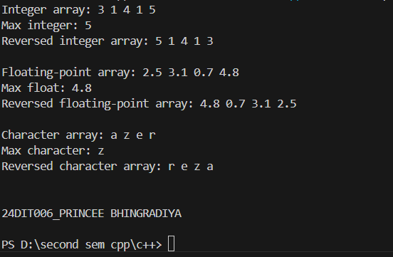
Practical:3.5 | A data analytics company was tasked with developing a unique digital signature system based on the concept of "super digits." The system required finding a single-digit representation of a given number through recursive digit summation. The algorithm was defined as follows: If the number has only one digit, it is its super digit. Otherwise, the super digit is the super digit of the sum of its digits, repeated recursively until a single digit is obtained. The challenge involved an additional complexity—constructing the number by concatenating a given string representation of an integer multiple times. For example, if the number n was represented as a string and concatenated k times, the super digit of the resulting number needed to be calculated. For instance: Given n = 9875 and k = 4, the number is represented as 9875987598759875. The sum of digits in this number is calculated recursively until a single digit remains: 9 + 8 + 7 + 5 + 9 + 8 + 7 + 5 + 9 + 8 + 7 + 5 + 9 + 8 + 7 + 5 = 116 1 + 1 + 6 = 8 The super digit is 8. The system was required to handle large numbers efficiently by leveraging mathematical insights rather than explicitly constructing large concatenated strings. This case study called for implementing a recursive solution to calculate the super digit, supported by a mathematical approach to optimize the handling of repeated sums.
Code: | #include<iostream>  #include<string>  using namespace std;  //Recursive function to calculate super digit  int SuperDigit(long long n)  {  if(n < 10)  {  return n;  }  long long sum = 0;  while( n > 0)  {  sum += n % 10;  n = n / 10;  }  return SuperDigit(sum);  }  int calculateSuperDigit( string n , int k)  {  long long initialSum = 0;  for(char ch : n)  {  initialSum += ch - '0';  }  return SuperDigit(initialSum * k);  }  int main()  {  string n;  int k;  n = "4523"; // 3 + 2 + 1 = 6  k = 2; // 1 time repeat  /*  n = "4523"; // 4+5+2+3+4+5+2+3 = 28 = 2+8 = 10 = 1+0 = 1  k = 2;  */  int result = calculateSuperDigit( n , k);  cout<<"Super Digit : "<<result <<endl;  cout << endl<< endl<< "24DIT006_PRINCEE BHINGRADIYA" << endl<<endl;  return 0;  }
Output: | 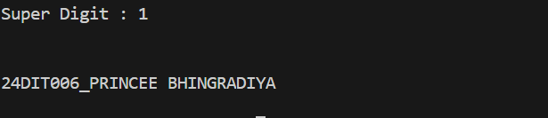
Practical:4.1 | A team of engineers was tasked with developing a program to calculate and manage the areas of multiple circles for a design project. To achieve this, they devised a solution using a structured, object oriented approach. At the foundation of their solution was a base class that represented a generic shape, responsible for storing and managing the radius of the circle. Building upon this, a specialized class for circles was created to extend functionality by introducing a method for calculating the area of a circle based on its radius. Using this framework, the team designed a system to handle multiple circles, ensuring that the process of storing, calculating, and displaying the areas was efficient and adaptable. They explored two different approaches for managing the collection of circles—one focusing on flexibility and dynamic handling, while the other used a more static structure. By implementing and comparing these methods, the engineers gained insights into the benefits of using efficient techniques for organizing and processing geometric data, enhancing their problem-solving capabilities.
Code: | #include <iostream>  #include <vector>  using namespace std;  // Base class representing a generic shape  class Shape  {  protected:  double radius;  public:  // Constructor to initialize radius  Shape(double r) : radius(r){}  // Access radius  double getRadius() const  {  return radius;  }  // Virtual function for calculating area  virtual double calculateArea() const  {  return 0.0;  }  };  // Derived class representing a circle  class Circle : public Shape  {  public:  // Constructor to initialize radius using base class constructo  Circle(double r) : Shape(r){}  // Overloading the calculateArea function to compute the area of a circle  double calculateArea() const  {  return 3.14159 * radius * radius;  }  };  // Function to display the areas of multiple circles  void displayAreas(const vector<Circle> &circle)  {  for (int i = 0; i < circle.size(); i++)  {  cout << "Circle " << i + 1 << " Radius : " << circle[i].getRadius()<< " Area ::" << circle[i].calculateArea() << endl;  }  }  int main()  {  // Creating a collection vector of circle dynamically  vector<Circle> circle;  // Adding circle with different radius ro the collection  circle.push_back(Circle(3.5));  circle.push_back(Circle(5.5));  // Displaying the areas of the circles  displayAreas(circle);  cout << endl<< endl<< "24DIT006_PRINCEE BHINGRADIYA" << endl<<endl;  return 0;  }
Output: | 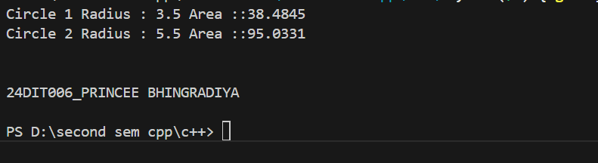
Practical:4.2 | A growing organization wanted to develop a system to manage its hierarchy and represent its structure in a programmatic way. To achieve this, a multilevel approach was designed, reflecting the natural progression of roles within the organization. At the foundation, a class was created to represent a person, capturing the basic details such as name and age. Building on this, an intermediate level was introduced to represent employees, adding a unique identifier for each. Finally, at the topmost level, a class for managers was created, which included additional details such as the department they oversee. The system needed to handle the initialization of all these attributes through constructors at each level, ensuring the proper propagation of information across the hierarchy. Additionally, the functionality to display details at every level was included to provide clear insights into the organization's structure. Two approaches were explored for managing multiple managers: one relied on an efficient method for retrieval and organization based on employee identifiers, while the other used a straightforward and static method for storage.
Code: | #include <iostream>  using namespace std;  // Base Class  class person  {  protected:  string name;  int age;  public:  // Constructor for print name and age  person(string n, int a)  {  name = n;  age = a;  }  void DisplayPerson()  {  cout << "Employee Name is :" << name << endl;  cout << "Employee age is :" << age << endl;  }  };  // Intermediate Class  class Employee : public person  {  protected:  string ID;  public:  Employee(string n, int a, string id) : person(n, a)  {  ID = id;  }  void DisplayID()  {  DisplayPerson();  cout << "Employee ID : " << ID << endl;  }  };  // Derived class  class Manager : public Employee  {  protected:  string Department;  public:  Manager(string n, int a, string id, string d) : Employee(n, a, id)  {  Department = d;  }  void DisplayDepartment()  {  DisplayID();  cout << "Employee Department :" << Department << endl;  }  };  int main()  {  Manager m1("princee_bhingradiya", 18, "24DIT006", "INFORMATION TECHNOLOGY");  m1.DisplayDepartment();  cout << endl  << endl  << "24DIT006_PRINCEE BHINGRADIYA" << endl  << endl;  return 0;  }
Output: | 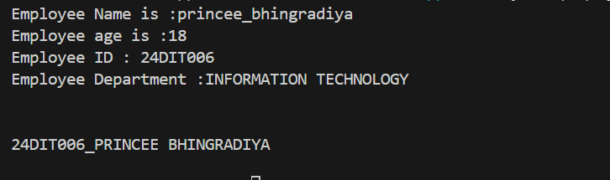
Practical:4.3 | A vehicle manufacturing company sought to create a robust system to organize and manage the details of various cars produced under its brand. To accomplish this, a hierarchical structure was conceptualized, reflecting the essential components of a vehicle. At the foundation, a class was designed to represent the type of fuel a vehicle uses. Another class was created to capture the brand name of the vehicle. These two foundational elements were then combined into a derived class specifically representing cars, integrating both fuel type and brand information. Constructors were used at each level to ensure proper initialization of attributes, allowing seamless integration of all details. Additionally, the ability to display complete information about a car, including its fuel type and brand, was incorporated into the system. To simulate a real-world scenario such as a service queue, multiple cars were organized and processed sequentially using a structured approach. This not only streamlined the handling of cars but also provided an opportunity to compare different methods of managing the collection and processing of vehicle data.
Code: | #include <iostream>  #include <queue>  #include <string>  using namespace std;  // Base class for fuel type  class Fuel {  protected:  string FuelType;  public:  Fuel(string type) : FuelType(type) {}  void DisplayFuel() {  cout << "Fuel Type: " << FuelType << endl;  }  };  // Base class for Brand  class Brand {  protected:  string BrandName;  public:  Brand(string name) : BrandName(name) {}  void DisplayBrand() {  cout << "Brand: " << BrandName << endl;  }  };  // Derived class combining fuel and brand  class Car : public Fuel, public Brand {  public:  Car(string type, string name) : Fuel(type), Brand(name) {}  void DisplayInfo() {  DisplayFuel();  DisplayBrand();  }  };  int main() {  // Create a queue to simulate service line  queue<Car> C;  // Create car objects and add them to the queue  Car car1("Petrol", "Toyota");  Car car2("Diesel", "KIA");  Car car3("Electric", "Tesla");  C.push(car1);  C.push(car2);  C.push(car3);  // Process each car in the queue  int Number = 1;  while (!C.empty()) {  cout << "Car " << Number << " Details::::::\n";  C.front().DisplayInfo();  C.pop();  Number++;  }  cout << endl<< endl<< "24DIT006_PRINCEE BHINGRADIYA" << endl<<endl;  return 0;  }
Output: | 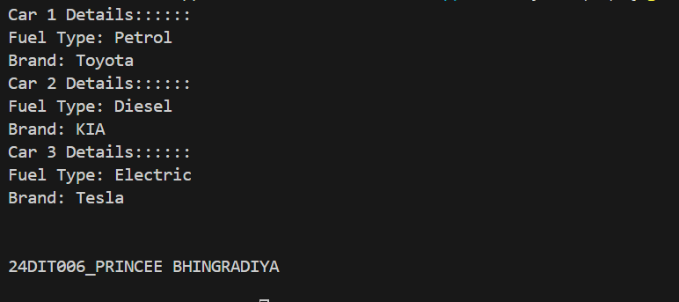
Practical:4.4 | In a bid to design an efficient and user-friendly banking system, a structure was proposed that mirrors the real-world operations of various account types. The foundation of the system is a base class representing a generic bank account, encapsulating essential details such as account number and balance. Building on this foundation, two specialized account types were created: a savings account, which includes an interest rate as an additional feature, and a current account, which allows an overdraft limit to accommodate specific customer needs. To ensure proper initialization and cleanup of account objects, constructors and destructors were implemented. Essential banking operations such as deposits and withdrawals were made available for both account types, allowing users to perform and manage their transactions effectively. The system also accounted for the need to track and manage transaction history, enabling operations such as undoing the last transaction. This was achieved by simulating a mechanism to store a sequence of transactions for each account type, providing insight into different ways of managing and organizing data.
Code: | #include <iostream>  #include <vector>  #include <string>  using namespace std;  // Base Account Class  class Account {  protected:  int accountNumber;  double balance;  vector<string> transactions;  public:  Account(int accNum, double initialBalance)  : accountNumber(accNum), balance(initialBalance) {}  virtual ~Account() {}  void deposit(double amount) {  balance += amount;  transactions.push_back("Deposit: " + to_string(amount));  }  virtual void withdraw(double amount) {  if (balance >= amount) {  balance -= amount;  transactions.push_back("Withdraw: " + to_string(amount));  } else {  cout << "Not enough balance!" << endl;  }  }  void printBalance() {  cout << "Account No: " << accountNumber << ", Balance: " << balance << endl;  }  void showHistory() {  cout << "Transactions for Account No: " << accountNumber << endl;  for (const auto& t : transactions) {  cout << t << endl;  }  }  };  // Savings Account  class Savings : public Account {  double interestRate;  public:  Savings(int accNum, double initialBalance, double rate)  : Account(accNum, initialBalance), interestRate(rate) {}  void applyInterest() {  double interest = balance * (interestRate / 100);  balance += interest;  transactions.push_back("Interest Applied: " + to_string(interest));  }  };  // Current Account  class Current : public Account {  double overdraftLimit;  public:  Current(int accNum, double initialBalance, double limit)  : Account(accNum, initialBalance), overdraftLimit(limit) {}  void withdraw(double amount) override {  if (balance + overdraftLimit >= amount) {  balance -= amount;  transactions.push_back("Withdraw: " + to_string(amount));  } else {  cout << "Overdraft limit exceeded!" << endl;  }  }  };  // Main Function  int main() {  Savings sAcc(101, 5000, 5); // Account No: 101, Initial Balance: 5000, Interest: 5%  sAcc.deposit(1000);  sAcc.withdraw(2000);  sAcc.applyInterest();  sAcc.printBalance();  sAcc.showHistory();  cout << endl;  Current cAcc(102, 3000, 1000); // Account No: 102, Initial Balance: 3000, Overdraft: 1000  cAcc.deposit(500);  cAcc.withdraw(3500);  cAcc.withdraw(5000); // Exceeds overdraft  cAcc.printBalance();  cAcc.showHistory();  cout << endl<< endl<< "24DIT006_PRINCEE BHINGRADIYA" << endl<<endl;  return 0;  }
Output: | 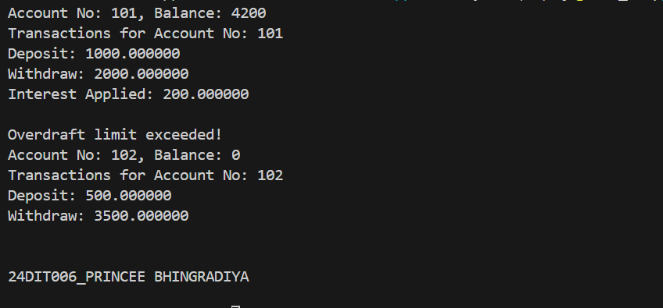
Practical:4.5 | In an educational setting, an advanced grading system was conceptualized to accommodate the diverse evaluation criteria for students at different academic levels. At the heart of the system is an abstract base class that defines the grading framework. This class includes a protected member to store marks and declares a pure virtual function for computing grades, ensuring that specific grading logic is implemented by derived classes. Two distinct derived classes were introduced to handle the unique grading needs of undergraduate and postgraduate students. Each class defines its own implementation of the grade computation method, reflecting the varying academic expectations for these groups. The system enables users to input student data, compute grades based on the respective criteria, and manage a collection of student records.
Code: | #include <iostream>  #include <vector>  using namespace std;  // Abstract base class  class Student  {  protected:  string name;  int marks;  public:  Student(string n, int m) : name(n), marks(m) {}  // Pure virtual function  virtual string computeGrade() = 0;  // Virtual function to display  virtual void display()  {  cout << "Name: " << name << "\nMarks: " << marks << "\nGrade: " << computeGrade() << "\n";  cout << "---------------------------\n";  }  virtual ~Student() {}  };  class Undergraduate : public Student  {  public:  Undergraduate(string n, int m) : Student(n, m) {}  string computeGrade() override  {  if (marks >= 70)  return "A";  else if (marks >= 60)  return "B";  else if (marks >= 50)  return "C";  else  return "F";  }  };  class Postgraduate : public Student  {  public:  Postgraduate(string n, int m) : Student(n, m) {}  string computeGrade() override  {  if (marks >= 80)  return "A";  else if (marks >= 70)  return "B";  else if (marks >= 60)  return "C";  else  return "F";  }  };  int main()  {  vector<Student *> students;  // Input data  students.push_back(new Undergraduate("Radhe", 75));  students.push_back(new Undergraduate("Yash", 48));  students.push_back(new Postgraduate("Krishna", 72));  students.push_back(new Postgraduate("Princee", 61));  // Display all student records  cout << "\n--- Student Records ---\n";  for (Student *s : students)  {  s->display();  }  for (Student *s : students)  {  delete s;  }  cout << endl  << endl  << "24DIT006_PRINCEE BHINGRADIYA" << endl  << endl;  return 0;  }
Output: | 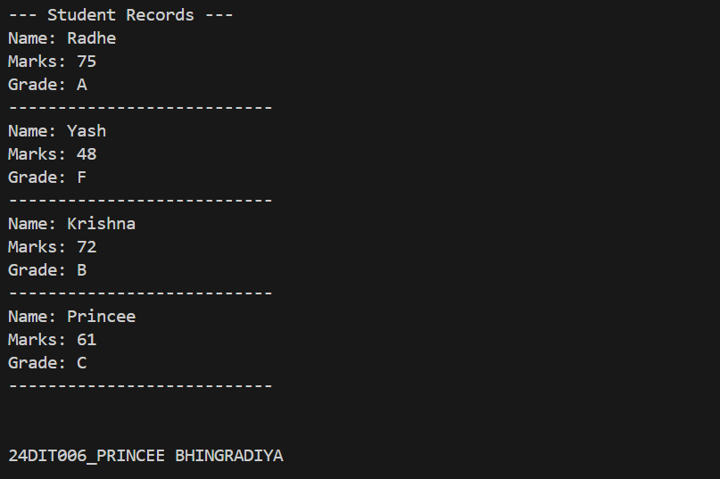
Practical:5.1 | A software development team aimed to design a versatile utility that could perform basic arithmetic operations while demonstrating the concept of function overloading. This effort resulted in a class-based calculator system capable of handling various combinations of input types, such as integers and floating-point numbers. The system includes multiple overloaded add functions, each tailored to accept distinct input types and perform addition operations accordingly. This approach ensures the calculator is adaptable and provides consistent functionality regardless of the input types. The case revolves around testing and validating the versatility of this calculator. Participants are expected to create instances of the calculator, invoke the appropriate overloaded functions for various input scenarios, and store the resulting values for further analysis. To organize and display these results, the system incorporates methods to sequentially process and present the outcomes.
Code: | #include<iostream>  using namespace std;  //template<T>  class Calculator  {  public:  // make add function for multiple time  //show Function overloding  int add(int a, int b)  {  int result = a + b ;  cout<<"Addition of "<<a<<" + "<<b<<" is ::: "<<result<<endl;  }  double add(double a, double b)  {  double result = a + b ;  cout<<"Addition of "<<a<<" + "<<b<<" is ::: "<<result<<endl;  }  double add(int a, double b)  {  double result = a + b ;  cout<<"Addition of "<<a<<" + "<<b<<" is ::: "<<result<<endl;  }  double add(double a, int b)  {  double result = a + b ;  cout<<"Addition of "<<a<<" + "<<b<<" is ::: "<<result<<endl;  }  };  int main()  {  Calculator calc;  //T a,b;  /*cout<<Enter value of a :;  cin>>a;  cout<<Enter value of b :;  cin>>b;  */  calc.add(5, 10); // int + int  calc.add(2.5, 4.3); // double + double  calc.add(3.14, 2); // double + int  calc.add(7, 3.5); // int + double  cout << endl  << endl  << "24DIT006_PRINCEE BHINGRADIYA" << endl  << endl;  return 0;  }
Output: | 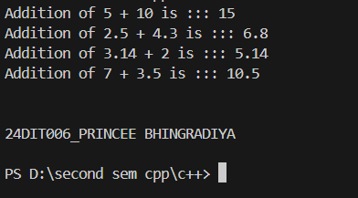
Practical:5.2 | A mathematical research group aimed to create a software model for handling and performing operations on complex numbers efficiently. To achieve this, they designed a Complex class that encapsulates the real and imaginary parts of a complex number. The class supports essential operator overloading to enhance usability, including the addition and subtraction of complex numbers and custom input and output functionality through the << and >> operators. These overloaded operators  ensure seamless arithmetic and user interaction with the system. The task involves implementing this system and exploring its capabilities by performing various  operations on complex numbers. Participants are expected to overload the specified operators and use them to add and subtract complex numbers, as well as to facilitate user-friendly input and output. Additionally, the solution encourages experimenting with managing collections of complex numbers to perform batch operations.
Code: | #include <iostream>  using namespace std;  class Complex {  public:  double real, imag;  Complex(double r, double i) {  real = r;  imag = i;  }  Complex add(Complex other) {  return Complex(real + other.real, imag + other.imag);  }  Complex subtract(Complex other) {  return Complex(real - other.real, imag - other.imag);  }  void display() {  cout << real << " + " << imag << "i" << endl;  }  };  int main() {  Complex c1(3, 4), c2(1, 2);  Complex sum = c1.add(c2);  Complex diff = c1.subtract(c2);  cout << "Sum: ";  sum.display();  cout << "Difference: ";  diff.display();  cout << endl  << endl  << "24DIT006_PRINCEE BHINGRADIYA" << endl  << endl;  return 0;  }
Output: | 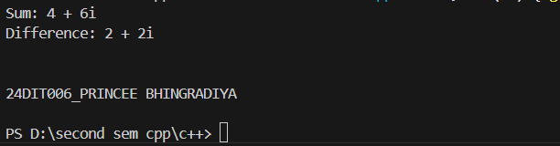
Practical:5.3 | A team of software developers was tasked with creating a graphical simulation where operations on 2D points play a crucial role. To facilitate this, they designed a class Point that encapsulates the coordinates x and y. The class provides flexibility through overloaded operators to manipulate points efficiently. The unary operator - is overloaded to negate the coordinates of a point, while the binary  operator + enables the addition of two points. Additionally, the equality operator == is overloaded to compare whether two points have identical coordinates.  The development process required performing various operations between multiple points. To manage these operations effectively, a mechanism was needed to track and potentially undo them. This challenge prompted two approaches: using a ready-made dynamic stack structure or building a custom stack implementation. By managing a sequence of operations in reverse, the stack-based design allowed for a systematic undo capability, crucial for simulations involving iterative adjustments.
Code: | #include <iostream>  #include <stack> // STL approach  using namespace std;  class Point {  public:  int x, y;  // Constructor  Point(int x = 0, int y = 0) : x(x), y(y) {}  // Overloading unary minus (-) operator  Point operator-() const {  return Point(-x, -y);  }  // Overloading binary plus (+) operator  Point operator+(const Point& p) const {  return Point(x + p.x, y + p.y);  }  // Overloading equality (==) operator  bool operator==(const Point& p) const {  return x == p.x && y == p.y;  }  // Display function  void display() const {  cout << "(" << x << ", " << y << ")" << std::endl;  }  };  // STL Approach: Using std::stack for undo functionality  class OperationStackSTL {  private:  stack<Point> history;  public:  void push(const Point& p) {  history.push(p);  }  Point undo() {  if (!history.empty()) {  Point lastOp = history.top();  history.pop();  return lastOp;  } else {  return Point(); // Default point if stack is empty  }  }  };  // Non-STL Approach: Using an array-based stack implementation  class OperationStackManual {  private:  Point history[100]; // Fixed size array  int top;  public:  OperationStackManual() : top(-1) {}  void push(const Point& p) {  if (top < 99) {  history[++top] = p;  }  }  Point undo() {  if (top >= 0) {  return history[top--];  } else {  return Point();  }  }  };  int main() {  Point p1(3, 4);  Point p2(1, 2);  OperationStackSTL operationsSTL;  Point p3 = p1 + p2;  operationsSTL.push(p3);  Point p4 = -p1;  operationsSTL.push(p4);  cout << "After Addition: "; p3.display();  cout << "After Negation: "; p4.display();  cout << "Undo Last Operation: "; operationsSTL.undo().display();  OperationStackManual operationsManual;  operationsManual.push(p3);  operationsManual.push(p4);  cout << "------------------------"<<endl;  cout << "Undo Last Operation: "; operationsManual.undo().display();  cout << endl  << endl  << "24DIT006_PRINCEE BHINGRADIYA" << endl  << endl;  return 0;  }
Output: | 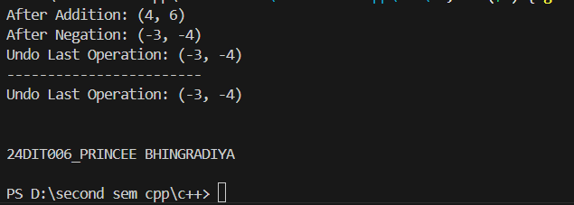
Practical:5.4 | A team of developers is tasked with building a temperature conversion system for a weather  application. To achieve this, the team creates two classes: Celsius and Fahrenheit. These classes  handle the conversion between temperature units, with the ability to convert from Celsius to  Fahrenheit and vice versa using type conversion. The team utilizes operator overloading to define the  conversion operators for both classes, enabling seamless conversions between the two units.  The system also requires the ability to compare two temperature objects to check if they are equal.  This is achieved by overloading the equality operator ==, which compares the values of the  temperatures in their respective units.  To ensure smooth processing of temperature conversions, the team needs to manage and store  multiple converted temperature objects. Two approaches are considered for handling this task. The  first approach involves using a dynamic data structure, a queue, to process the conversions in a first-  in-first-out (FIFO) manner. Alternatively, a basic array is used to store the converted objects in a static  manner.
Code: | #include <iostream>  #include <queue>  using namespace std;  class Fahrenheit; // Forward declaration  class Celsius {  double value;  public:  Celsius(double v) : value(v) {}  operator Fahrenheit(); // Conversion operator  bool operator==(const Celsius& p) const {  return value == p.value;  }  double getValue() const { return value; }  };  class Fahrenheit {  double value;  public:  Fahrenheit(double v) : value(v) {}  operator Celsius(); // Conversion operator  bool operator==(const Fahrenheit& p) const {  return value == p.value;  }  double getValue() const { return value; }  };  // Definition for conversion from Celsius to Fahrenheit  Celsius::operator Fahrenheit() {  return Fahrenheit((value * 9.0 / 5.0) + 32);  }  // Definition for conversion from Fahrenheit to Celsius  Fahrenheit::operator Celsius() {  return Celsius((value - 32) * 5.0 / 9.0);  }  int main() {  // Example objects  Celsius c1(30.0); // 25 degrees Celsius  Fahrenheit f1(86.0); // 77 degrees Fahrenheit  // Demonstrating conversions  Fahrenheit f2 = c1; // Celsius to Fahrenheit  Celsius c2 = f1; // Fahrenheit to Celsius  cout << "Celsius: " << c1.getValue() << " -> Fahrenheit: " << f2.getValue() << '\n';  cout << "Fahrenheit: " << f1.getValue() << " -> Celsius: " << c2.getValue() << '\n';  // Overloading == operator  if (c1 == c2) {  cout << "Celsius and Fahrenheit objects are equal after conversion.\n";  } else {  cout << "Celsius and Fahrenheit objects are not equal after conversion.\n";  }  queue<Fahrenheit> fahrenQueue;  queue<Celsius> celsiusQueue;  fahrenQueue.push(f2);  celsiusQueue.push(c2);  cout << " Celsius :" << celsiusQueue.front().getValue() << '\n';  cout << " Fahrenheit :" << fahrenQueue.front().getValue() << '\n';  cout << endl  << endl  << "24DIT006_PRINCEE BHINGRADIYA" << endl  << endl;  return 0;  }
Output: | 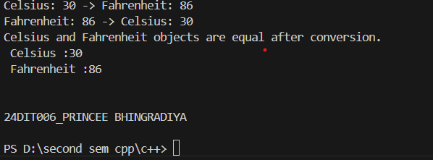
Practical:5.5 | A software development team is tasked with designing a system that can handle various geometric shapes and compute their areas in a flexible way. The challenge is to create a system that can easily extend to accommodate new types of shapes without altering the core functionality for each shape. To accomplish this, the system is designed with a base class called Shape, which includes a virtual function Area(). This function is meant to be overridden by each specific shape class to provide the correct formula for calculating the area. The derived classes, Rectangle and Circle, each implement the Area() function with their own formulas: the Rectangle calculates the area using its length and width, while the Circle uses its radius This structure allows the system to treat all shapes uniformly through a common interface, enabling easy extensibility. The goal is to use a single reference to the base class (Shape*) to calculate the area  of any shape, regardless of its type. This approach makes the system more adaptable, as new shapes can be added later without disrupting existing code. In managing a collection of shapes, there are two primary approaches: one method involves  dynamically managing a collection of shapes, allowing for easy addition and removal of shapes, while the other relies on a static method that requires manually managing the size of the collection. Both approaches aim to store and manage the shapes effectively, with one allowing automatic resizing as needed while the other requires more manual handling. Through this case study, the team will implement the base class Shape and the derived classes Rectangle and Circle, each with their own Area() function. The students will gain a deeper understanding of polymorphism, inheritance, and memory management while working with different methods to store and manage the collection of shapes.
Code: | #include <iostream>  #include <vector>  using namespace std;  // Base class  class Shape {  public:  virtual double Area() const = 0; // Pure virtual function  virtual ~Shape() {} // Virtual destructor  };  // Derived class for Rectangle  class Rectangle : public Shape {  private:  double length, width;  public:  Rectangle(double l, double w) : length(l), width(w) {}  double Area() const override {  return length * width;  }  };  // Derived class for Circle  class Circle : public Shape {  private:  double radius;  public:  Circle(double r) : radius(r) {}  double Area() const override {  return 3.14159 * radius * radius;  }  };  int main() {  // Dynamically managed collection  vector<Shape*> shapes;  int r,a,b;  cout<<"Enter Radius: ";  cin>>r;  cout<<"Enter Rectangle length and width: ";  cin>>a>>b;  shapes.push_back(new Circle(r));  shapes.push_back(new Rectangle(a, b));  for (const auto& shape : shapes) {  cout << "Area : " << shape->Area() << endl;  }  // Cleanup memory  for (auto shape : shapes) {  delete shape;  }  cout << endl  << endl  << "24DIT006_PRINCEE BHINGRADIYA" << endl  << endl;  return 0;  }
Output: | 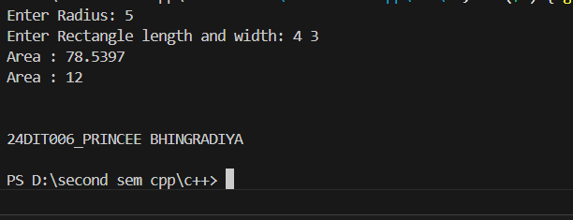
Practical:6.1 | In a rapidly growing software development firm, a team of engineers is tasked with building a lightweight, custom memory management system for handling dynamic datasets. The existing framework lacks flexibility in managing arrays, often leading to inefficient memory usage and performance bottlenecks. To address this, the engineers need to develop a solution that allows seamless insertion and deletion of elements while ensuring efficient memory utilization. The primary challenge is to design a structure that supports adding new data points dynamically at the end of the dataset and removing specific elements based on their position. Since the system operates in a resource-constrained environment, using standard template libraries is not an option,  and direct dynamic memory management must be implemented using pointers. The solution should ensure that memory is allocated and deallocated appropriately to prevent leaks and unnecessary overhead. The development team must carefully decide on the structure of their implementation, defining how data will be stored, accessed, and modified efficiently. They need to outline the appropriate class design, determine essential data members, and define necessary member functions to handle the operations effectively
Code: | #include <iostream>  using namespace std;  class DynamicArray  {  private:  int *data; // Pointer to dynamically allocated array  size_t size; // Current number of elements  size_t capacity; // Total allocated memory  void resize()  {  capacity *= 2; // Double the capacity  int *newData = new int[capacity];  // Copy existing elements  for (size_t i = 0; i < size; i++)  {  newData[i] = data[i];  }  delete[] data; // Free old memory  data = newData;  }  public:  DynamicArray(size_t cap = 2) : size(0), capacity(cap)  {  data = new int[capacity];  }  ~DynamicArray()  {  delete[] data; // Clean up memory  }  void insert(int value)  {  if (size == capacity)  {  resize();  }  data[size++] = value;  }  void remove(size_t index)  {  if (index >= size)  {  cerr << "Invalid index!\n";  return;  }  for (size_t i = index; i < size - 1; i++)  {  data[i] = data[i + 1];  }  size--;  }  void print()  {  if (size == 0)  {  cout << "Array is empty.\n";  return;  }  for (size_t i = 0; i < size; i++)  {  cout << data[i] << " ";  }  cout << endl;  }  };  int main()  {  DynamicArray arr;  arr.insert(10);  arr.insert(20);  arr.insert(30);  arr.insert(40);  arr.print(); // Output: 10 20 30 40  arr.remove(2);  arr.print(); // Output: 10 20 40  cout << endl<< endl<< "24DIT006_PRINCEE BHINGRADIYA" << endl<<endl;  return 0;  }
Output: | 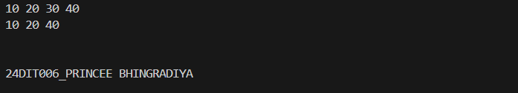
Practical:6.2 | In a digital mapping application, a team of developers is working on a feature that allows objects to be repositioned dynamically on a coordinate plane. The application requires precise control over the movement of individual points representing user-defined markers. To achieve this, the team needs to design a system that allows a point’s coordinates to be adjusted efficiently while maintaining a fluid  and chainable update mechanism. To ensure seamless movement, the developers must implement a structure that allows each point to shift by specified offsets in the x and y directions. Additionally, the solution should be designed in a way that supports method chaining, enabling multiple transformations to be applied in a single  statement. This requires careful handling of object references, utilizing this pointer to return the updated object. Furthermore, the implementation must be optimized for direct memory management, ensuring that objects are updated through pass-by-reference using pointers.
Code: | #include <iostream>  #include <vector>  using namespace std;  class Complex  {  private:  double real;  double imag;  public:  // Constructor  Complex(double r = 0, double i = 0) : real(r), imag(i) {}  // Overload + operator for addition  Complex operator+(const Complex &c)  {  return Complex(real + c.real, imag + c.imag);  }  // Overload - operator for subtraction  Complex operator-(const Complex &c)  {  return Complex(real - c.real, imag - c.imag);  }  // Overload << operator for output  friend ostream &operator<<(ostream &out, const Complex &c)  {  out << c.real << " + " << c.imag << "i";  return out;  }  };  // STL Approach using std::vector  void complex()  {  vector<Complex> complexNumbers;  Complex c1(2, 3);  Complex c2(4, -1);  Complex sum = c1 + c2;  Complex diff = c1 - c2;  complexNumbers.push_back(c1);  complexNumbers.push_back(c2);  complexNumbers.push_back(sum);  complexNumbers.push_back(diff);  for (const auto &c : complexNumbers)  {  cout << c << endl;  }  }  int main()  {  complex();  cout << endl<< endl<< "24DIT006_PRINCEE BHINGRADIYA" << endl<<endl;  return 0;  }
Output: | 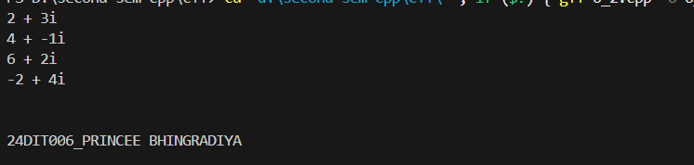
Pratical:6.3 | A financial analytics company is working on a system that processes large volumes of sorted numerical data from different sources. The challenge is to efficiently combine two independently sorted datasets into a single, fully sorted dataset while ensuring optimal memory management. Since the size of the datasets varies dynamically based on incoming data streams, the solution must be flexible and manage memory efficiently without relying on built-in container libraries. To achieve this, the development team needs to implement a mechanism that accepts two sorted arrays of different sizes and merges them into a new dynamically allocated array while maintaining the sorted order. The system should read input values specifying the sizes of both datasets, followed  by the elements of each array. After merging, the final sorted array should be displayed as output. Efficient memory handling is crucial in this implementation, requiring the use of new and delete operators for dynamic allocation and deallocation of memory.
Code: | #include<iostream>  using namespace std;  void mergeSortedArray(int *arr1, int n, int *arr2, int m, int *mergedArr)  {  int i = 0 , j = 0 , k = 0;  while (i < n && j< m)  {  if (arr1[i]<arr2[j])  {  mergedArr [k++] = arr1[i++];  }else  {  mergedArr[k++] = arr2[j++];  }  }  while (i < n)  {  mergedArr[k++] = arr1[i++];  }  while (j < m)  {  mergedArr[k++] = arr2[j++];  }  }  int main()  {  int n,m;  cout<<"Enter sizes of two arrays :";  cin>> n >> m;  int *arr1 = new int[n];  int *arr2 = new int[m];  int * mergedArr = new int [n+m];  cout << "Enter " << n << " sorted elements for first array: ";  for (int i = 0; i < n; i++)  {  cin >> arr1[i];  }  cout << "Enter " << m << " sorted elements for second array: ";  for (int i = 0; i < m; i++)  {  cin >> arr2[i];  }  mergeSortedArray(arr1, n, arr2, m, mergedArr);  cout << "Merged Sorted Array: ";  for (int i = 0; i < n + m; i++)  {  cout << mergedArr[i] << " ";  }  cout << endl;  delete[] arr1;  delete[] arr2;  delete[] mergedArr;  cout << endl<< endl<< "24DIT006_PRINCEE BHINGRADIYA" << endl<<endl;  return 0;  }
Output: | 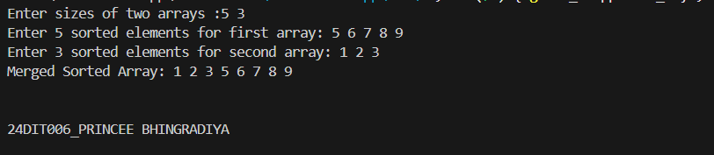
Practical:6.4 | A software development team is working on an advanced simulation system that involves hierarchical object management. The system includes a base class that defines general behavior and derived classes that introduce specialized functionality, including dynamic resource allocation. During testing, the team encounters unexpected memory leaks when deleting objects through base class pointers, raising concerns about proper resource management. To investigate the issue, the team examines how object destruction works in an inheritance hierarchy. They create a base class that serves as a foundation for derived classes, but they notice that when a Base* pointer is used to delete a Derived object, the destructor of the derived class is not invoked. This results in dynamically allocated resources remaining in memory, causing resource leakage.  To resolve this problem, the team explores the concept of virtual destructors. By marking the base class destructor as virtual, they ensure that the destructor of the derived class is correctly called when deleting an object through a base class pointer. This guarantees proper deallocation of dynamically allocated resources, preventing memory leaks. Since the project requires manual memory management, the team uses raw pointers and the new and delete operators to allocate and release resources.
Code: | #include <iostream>  using namespace std;  class Base  {  public:  virtual ~Base() { cout << "Base Destructor Called\n"; } // Virtual destructor  };  class Derived : public Base  {  private:  int *data;  public:  Derived() { data = new int(10); }  ~Derived()  {  delete data;  cout << "Derived Destructor Called\n";  }  };  int main()  {  Base *obj = new Derived(); // Upcasting  delete obj; // Both Base & Derived destructors are called, preventing memory leak!  cout << endl<< endl<< "24DIT006_PRINCEE BHINGRADIYA" << endl<<endl;  return 0;  }
Output: | 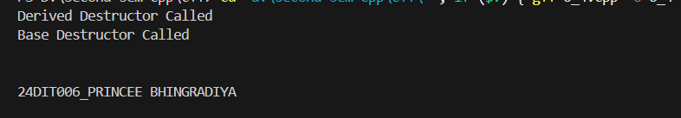
Practical:7.1 | A media research team is developing a tool to analyze word frequency in large textual datasets, such as news articles and research papers. The goal is to process a given paragraph, identify individual words, and count their occurrences while ensuring case-insensitive matching. Since the tool is intended for both constrained environments and high-performance systems, two different approaches are considered—one utilizing dynamic memory management and another relying on manually structured arrays.  The first challenge is reading an entire paragraph from the console as a single unformatted string. Once acquired, the text must be split into individual words, ensuring that uppercase and lowercase variations are treated as the same. To store and process words dynamically, the team designs a mechanism using raw pointers and dynamic memory allocation, allowing the program to handle variable input sizes effectively. In one approach, a dynamically allocated array is used to store words, with additional logic to countoccurrences efficiently. The array expands as needed, ensuring that new words can be accommodated. The frequency counting is implemented manually by searching for existing words in the array and updating counts accordingly.
Code: | /*#include <iostream>  #include <sstream>  #include <vector>  #include <unordered_map>  #include <algorithm>  using namespace std;  void countWordsSTL(const string& paragraph)  {  unordered_map<string, int> wordFreq;  stringstream ss(paragraph);  string word;  while (ss >> word)  {  transform(word.begin(), word.end(), word.begin(), ::tolower); // Convert to lowercase  wordFreq[word]++;  }  for (const auto& pair : wordFreq)  {  cout << pair.first << ": " << pair.second << "\n";  }  }  int main()  {  string paragraph;  cout << "Enter a paragraph: ";  getline(cin, paragraph); // Read entire input as a single string  countWordsSTL(paragraph);  return 0;  }  */  #include <iostream>  #include <cstring>  #include <cctype>  using namespace std;  #define MAX_WORDS 100  void toLowerCase(char *str)  {  for (int i = 0; str[i]; i++)  {  str[i] = tolower(str[i]);  }  }  void countWords(char *paragraph)  {  char *words[MAX_WORDS];  int wordCount[MAX_WORDS] = {0};  int totalWords = 0;  char *token = strtok(paragraph, " ");  while (token != nullptr)  {  toLowerCase(token);  bool found = false;  for (int i = 0; i < totalWords; i++)  {  if (strcmp(words[i], token) == 0)  {  wordCount[i]++;  found = true;  break;  }  }  if (!found)  {  words[totalWords] = token;  wordCount[totalWords] = 1;  totalWords++;  }  token = strtok(nullptr, " ");  }  for (int i = 0; i < totalWords; i++)  {  cout << words[i] << ": " << wordCount[i] << "\n";  }  }  int main()  {  char paragraph[500];  cout << "Enter a paragraph: ";  cin.getline(paragraph, 500); // Read entire input as a single string  countWords(paragraph);  cout << endl<< endl<< "24DIT006_PRINCEE BHINGRADIYA" << endl<<endl;  return 0;  }
Output: | 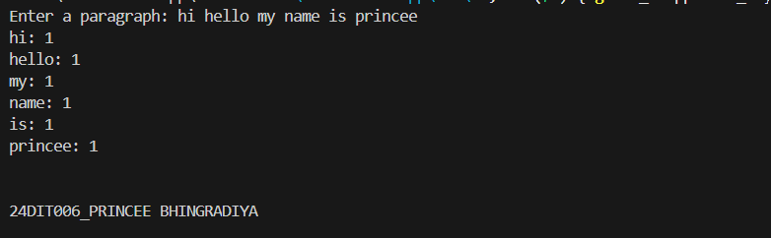
Practical:7.2 | A data analysis firm is developing a tool to process large text files and extract key statistics, such as the total number of characters, words, and lines. This tool is essential for tasks like document indexing, text summarization, and data validation. Given the varying sizes of input files, the system must handle large datasets efficiently while ensuring error detection when files are missing or inaccessible. To begin, the program needs to open a specified text file and process its contents line by line. If the  file cannot be found or opened due to permission issues, the system should notify the user with an appropriate error message and safely terminate execution. Once the file is successfully accessed, the program will analyze its contents to count the total number of lines, extract words while handling different delimiters, and compute the total number of characters, including spaces and punctuation. For handling this data, the team explores two approaches. One approach dynamically stores the lines in a manually managed array, processing the information without relying on built-in containers. This requires careful memory allocation and deallocation to avoid leaks. The alternative approach uses a dynamic structure to hold the lines in memory, allowing for efficient access and further analysis, such as searching or editing.
Code: | #include <iostream>  #include <fstream>  #include <vector>  #include <sstream>  using namespace std;  void processFileDynamic(const string &filename)  {  ifstream file(filename);  if (!file)  {  cerr << "Error: Unable to open file " << filename << "\n";  return;  }  vector<string> lines;  int lineCount = 0, wordCount = 0, charCount = 0;  string line;  while (getline(file, line))  {  lines.push_back(line);  charCount += line.length();  stringstream ss(line);  string word;  while (ss >> word)  {  wordCount++;  }  lineCount++;  }  file.close();  cout << "Lines: " << lineCount << "\n";  cout << "Words: " << wordCount << "\n";  cout << "Characters: " << charCount << "\n";  }  int main()  {  string filename = "sample.txt";  processFileDynamic(filename);  cout << endl<< endl<< "24DIT006_PRINCEE BHINGRADIYA" << endl<<endl;  return 0;  }
Output: | 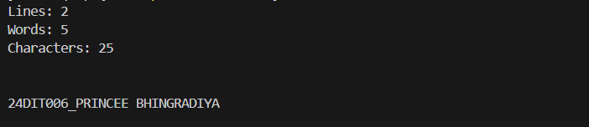
Practical:7.3 | A small retail business is looking for a simple yet effective inventory management system to keep track of its products. The system needs to support essential operations such as adding new items, viewing the complete inventory, and searching for specific products. Since the inventory data should persist across sessions, all operations must be performed using file storage. The business also requires an efficient way to retrieve item details without unnecessary file reads. To manage inventory, the system must allow employees to add new products by recording details such as the item name, quantity, and price. These records should be appended to a file, ensuring that previously stored data remains intact. When viewing inventory, the system should read the file  sequentially and display all stored items. Additionally, employees should be able to search for a product by name, retrieving its details without manually scanning the entire file. For implementation, two approaches are considered. One method processes file operations directly, reading and searching line by line to retrieve item information efficiently. This minimizes memory usage but requires re-reading the file for each search operation. An alternative approach loads inventory data into a dynamically managed array, enabling faster searches and future enhancements such as sorting and filtering without repeated file access.
Code: | #include <iostream>  #include <fstream>  #include <vector>  #include <sstream>  using namespace std;  struct Item  {  string name;  int quantity;  double price;  };  void addItemToFile(const Item &item, const string &filename)  {  ofstream file(filename, ios::app);  if (!file)  {  cerr << "Error: Unable to open file.\n";  return;  }  file << item.name << " " << item.quantity << " " << item.price << "\n";  file.close();  }  vector<Item> loadInventory(const string &filename)  {  vector<Item> inventory;  ifstream file(filename);  if (!file)  {  cerr << "Error: Unable to open file.\n";  return inventory;  }  Item item;  while (file >> item.name >> item.quantity >> item.price)  {  inventory.push_back(item);  }  file.close();  return inventory;  }  void searchItem(const vector<Item> &inventory, const string &itemName)  {  for (const auto &item : inventory)  {  if (item.name == itemName)  {  cout << "Item Found: " << item.name<<endl<< "Quantity: " << item.quantity <<endl<< "Price: $" << item.price << "\n";  return;  }  }  cout << "Item not found.\n";  }  int main()  {  string filename = "inventory.txt";  // Example: Adding items  addItemToFile({"Orange", 20, 2.0}, filename);  addItemToFile({"Grapes", 50, 3.5}, filename);  addItemToFile({"Apple", 25, 2.5}, filename);  // Loading inventory into memory  vector<Item> inventory = loadInventory(filename);  // Searching for an item  searchItem(inventory, "Apple");  cout << endl<< endl<< "24DIT006_PRINCEE BHINGRADIYA" << endl<<endl;  return 0;  }
Output: | 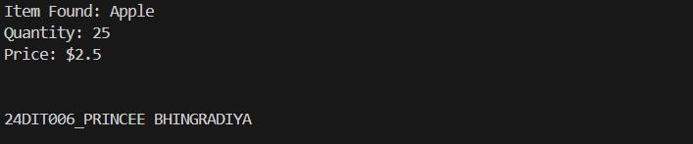
Practical:7.4 | An educational institution requires a system to generate well-structured student performance reports from raw data stored in a file. The system should read student records, including their name, marks, and grade, and present the information in a neatly formatted tabular format. Since the institution handles large datasets, the report generation must be efficient, ensuring clear alignment and readability while allowing for future enhancements such as sorting and filtering. To achieve this, the system must first handle file input operations, reading student data while ensuring error handling if the file is missing or inaccessible. The program should then format and display the  information in a structured manner, making use of a user-defined manipulator to align columns properly. This ensures that names, marks, and grades are clearly visible in the report, regardless of data length variations. For implementation, two approaches are explored. The first method processes the data directly from the file, formatting and displaying each entry without storing it in memory. This minimizes memory  usage but limits additional processing, such as sorting or filtering. The alternative approach dynamically stores student records using a manually managed data structure, allowing further modifications, such as sorting by marks or filtering based on grades, before presenting the final formatted report.
Code: | #include <iostream>  #include <fstream>  #include <vector>  #include <iomanip>  #include <sstream>  using namespace std;  struct Student {  string name;  int marks;  char grade;  };  ostream& tableFormat(ostream& os) {  os << left << setw(20);  return os;  }  void readFileWithSTL(const string& filename, vector<Student>& students) {  ifstream file(filename);  if (!file) {  cerr << "Error opening file!\n";  return;  }  string name;  int marks;  char grade;  while (file >> name >> marks >> grade) {  students.push_back({name, marks, grade});  }  }  void displayStudents(const vector<Student>& students) {  cout << tableFormat << "Name" << setw(10) << "Marks" << setw(10) << "Grade" << "\n";  cout << "------------------------------------------\n";  for (const auto& student : students) {  cout << tableFormat << student.name << setw(10) << student.marks << setw(10) << student.grade << "\n";  }  }  int main() {  vector<Student> students;  readFileWithSTL("sample.txt", students);  displayStudents(students);  cout << endl<< endl<< "24DIT006_PRINCEE BHINGRADIYA" << endl<<endl;  return 0;  }
Output: | 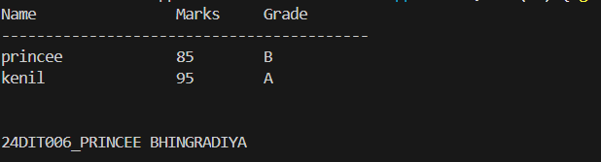
Practical:7.5 | A university administration is developing a system to display student marks in a structured and visually appealing format. The goal is to ensure clarity in academic reports by properly aligning names and scores while also demonstrating the use of currency formatting for tuition fees or other financial data. To achieve this, built-in stream manipulators such as endl, setw, setfill, and setprecision must be used  to create a neatly formatted output. The system first reads student names and their corresponding marks, ensuring that the data is aligned in tabular form. Proper spacing between columns enhances readability, preventing misalignment issues caused by varying name lengths or mark values. Additionally, numerical values must be  displayed with controlled decimal precision for consistency. Beyond academic scores, the university also wants to format financial figures, such as tuition fees, in  a standardized manner. To achieve this, the system includes a user-defined manipulator, currency(), which prepends a specified currency symbol (₹, $, etc.) before displaying monetary values. This custom formatting ensures that financial data is both readable and professionally presented.
Code: | #include <iostream>  #include <fstream>  #include <iomanip>  #include <vector>  #include <sstream>  using namespace std;  struct Student  {  string name;  int marks;  double tuitionFee;  };  ostream &currency(ostream &os)  {  return os << "₹"; // You can replace "₹" with "$" or any currency symbol as needed.  }  void readStudentData(const string &filename, vector<Student> &students)  {  ifstream file(filename);  if (!file)  {  cerr << "Error opening file!\n";  return;  }  string name;  int marks;  double tuitionFee;  while (file >> name >> marks >> tuitionFee)  {  students.push_back({name, marks, tuitionFee});  }  }  void displayStudentData(const vector<Student> &students)  {  cout << left << setw(20) << "Name"  << setw(10) << "Marks"  << setw(15) << "Tuition Fee" << "\n";  cout << setfill('-') << setw(45) << "" << setfill(' ') << "\n";  for (const auto &student : students)  {  cout << left << setw(20) << student.name  << setw(10) << student.marks  << currency << fixed << setprecision(2) << setw(15) << student.tuitionFee << "\n";  }  }  int main()  {  vector<Student> students;  readStudentData("students.txt", students);  displayStudentData(students);  cout << endl<< endl<< "24DIT006_PRINCEE BHINGRADIYA" << endl<<endl;  return 0;  }
Output: | 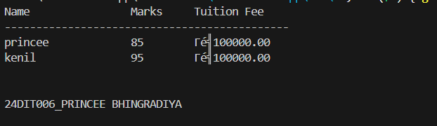
Practical:8.1 | A data analytics firm is developing a tool to process numerical sequences efficiently. One of the key requirements is to reverse a given sequence of integers while ensuring optimized performance using modern C++ techniques. The system should allow users to input a sequence of numbers, process the reversal using iterators, and display the transformed output.To accomplish this, two approaches are explored. The first method leverages the built-in std::reverse() function, which efficiently reverses elements within a dynamically managed sequence. The second approach involves manually implementing the reversal using iterators, providing deeper insight into  how iterators navigate and modify data structures. The system uses a dynamic storage mechanism to handle sequences of varying sizes efficiently. Iterators facilitate traversal and modification, ensuring that elements are manipulated without direct  indexing.
Code: | #include <iostream>  #include <vector>  #include <algorithm> // For reverse  #include <iterator> // For iterators  using namespace std;  // Function to reverse using std::reverse()  void reverseWithSTL(vector<int>& nums) {  reverse(nums.begin(), nums.end());  }  // Function to reverse manually using iterators  void reverseWithIterators(vector<int>& nums) {  auto start = nums.begin();  auto end = nums.end() - 1;  while (start < end) {  swap(*start, *end);  ++start;  --end;  }  }  void displaySequence(const vector<int>& nums) {  for (const int num : nums) {  cout << num << " ";  }  cout << endl;  }  int main() {  vector<int> numbers;  int n, value;  // User input  cout << "Enter the number of elements: ";  cin >> n;  cout << "Enter the sequence of numbers:\n";  for (int i = 0; i < n; ++i) {  cin >> value;  numbers.push_back(value);  }  cout << "\nOriginal Sequence: ";  displaySequence(numbers);  // Using reverse()  reverseWithSTL(numbers);  cout << "Reversed using reverse(): ";  displaySequence(numbers);  // Restore original order and reverse using iterators  reverseWithSTL(numbers); // Undo previous reversal  reverseWithIterators(numbers);  cout << "Reversed using iterators: ";  displaySequence(numbers);  cout << endl<< endl<< "24DIT006_PRINCEE BHINGRADIYA" << endl<<endl;  return 0;  }
Output: | 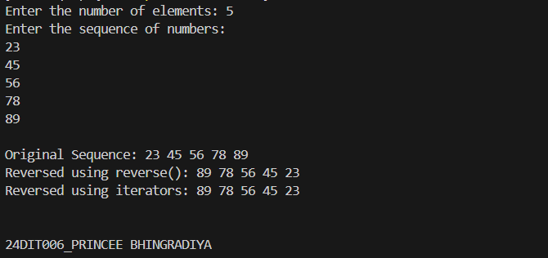
Practical:8.2 | A digital publishing company is developing a tool to analyze text content for word frequency distribution. This tool aims to help writers and editors understand the prominence of specific words in an article, enabling them to refine their content for clarity and impact. The system should process an input sentence, count occurrences of each unique word, and display the results in an organized manner.  To achieve this, the system utilizes an associative container that maps words to their corresponding frequencies. As the text is processed, each word is extracted and stored as a key, while its occurrence count is maintained as the associated value. By leveraging iterators, the system efficiently traverses the data structure, displaying each word along with its computed frequency. The use of a dynamic mapping approach ensures that words are stored in an ordered manner, allowing for fast retrieval and structured output.
Code: | #include <iostream>  #include <map>  #include <sstream>  #include <iterator>  using namespace std;  void analyzeWordFrequency(const string& text) {  map<string, int> wordCount;  istringstream stream(text);  string word;  // Extract words and update frequencies  while (stream >> word) {  ++wordCount[word];  }  // Display results  cout << "\nWord Frequency Distribution:\n";  for (const auto& entry : wordCount) {  cout << entry.first << " : " << entry.second << "\n";  }  }  int main() {  string inputText;  cout << "Enter text for analysis:\n";  getline(cin, inputText);  analyzeWordFrequency(inputText);  cout << endl<< endl<< "24DIT006_PRINCEE BHINGRADIYA" << endl<<endl;  return 0;  }
Output: | 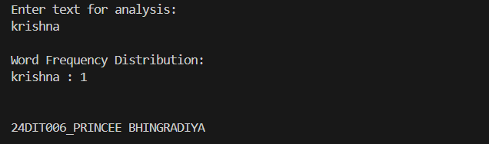
Practical:8.3 | A financial analytics firm is designing a data processing system to filter out duplicate transaction IDs from large datasets. The system must take an input list of integers, efficiently remove duplicates, and display the unique values in an ordered manner. Given the need for high performance in handling large datasets, the implementation must leverage efficient data structures that automatically eliminate redundancy.  To achieve this, the system employs an associative container that inherently ensures uniqueness while maintaining a sorted order. As integers are added, duplicate entries are automatically discarded, eliminating the need for explicit duplicate-checking logic. Once the unique values are identified, they are either displayed directly using iterators or converted back into a dynamically managed sequence for further processing.  By utilizing iterators, the system efficiently traverses the filtered dataset, ensuring that unique elements are accessed and displayed without additional computational overhead.
Code: | #include <iostream>  #include <set>  #include <vector>  #include <iterator>  using namespace std;  void processTransactions(const vector<int>& transactions) {  set<int> uniqueTransactions(transactions.begin(), transactions.end()); // Automatically filters duplicates  // Display unique transaction IDs  cout << "Unique Transaction IDs (Sorted):\n";  for (const int id : uniqueTransactions) {  cout << id << " ";  }  cout << endl;  }  int main() {  vector<int> transactionIDs;  int n, id;  // User input  cout << "Enter the number of transaction IDs: ";  cin >> n;  cout << "Enter transaction IDs:\n";  for (int i = 0; i < n; ++i) {  cin >> id;  transactionIDs.push_back(id);  }  processTransactions(transactionIDs);  cout << endl<< endl<< "24DIT006_PRINCEE BHINGRADIYA" << endl<<endl;  return 0;  }
Output: | 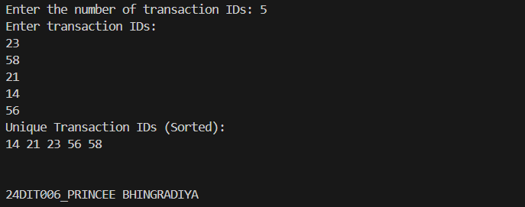
Practical:8.4 | An educational institution is developing a system to rank students based on their scores in an examination. The goal is to efficiently store student names along with their respective scores, sort the records in descending order based on scores, and display the ranked list. The system should be flexible enough to handle varying numbers of students dynamically. To achieve this, the system associates each student’s name with their score using a structured data representation. A dynamically resizable sequence is chosen to store student records, allowing efficient insertion and retrieval of entries. Each entry consists of a name-score pair, ensuring logical grouping of related information. Once the data is collected, a sorting operation is performed using a custom comparison function. By leveraging an efficient sorting algorithm, the system ensures that students with the highest scores appear at the top of the list. Iterators are then used to traverse and display the sorted data in a structured format, highlighting rank-based ordering.
Code: | #include <iostream>  #include <vector>  #include <algorithm>  #include <iomanip>  using namespace std;  struct Student {  string name;  int score;  };  // Custom comparison function for sorting students in descending order  bool compareStudents(const Student& a, const Student& b) {  return a.score > b.score; // Higher scores come first  }  void displayRankedStudents(const vector<Student>& students) {  cout << left << setw(5) << "Rank"  << setw(20) << "Name"  << setw(10) << "Score" << "\n";  cout << "--------------------------------------\n";  int rank = 1;  for (const auto& student : students) {  cout << left <<setw(5) << rank++  << setw(20) << student.name  << setw(10) << student.score << "\n";  }  }  int main() {  vector<Student> students;  int n;  cout << "Enter the number of students: ";  cin >> n;  // Input student data  for (int i = 0; i < n; ++i) {  Student s;  cout << "Enter name and score for student " << i + 1 << ": ";  cin >> s.name >> s.score;  students.push_back(s);  }  // Sorting students based on scores (descending order)  sort(students.begin(), students.end(), compareStudents);  cout << "\nRanked List of Students:\n";  displayRankedStudents(students);  cout << endl<< endl<< "24DIT006_PRINCEE BHINGRADIYA" << endl<<endl;  return 0;  }
Output: | 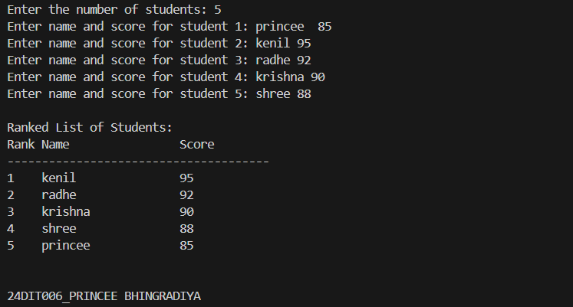
Practical:8.5 | A software development team requires a lightweight directory management system to efficiently organize project files. The system should allow users to create folders, add files to specific folders, and display the directory structure in an organized manner.  Each folder serves as a unique entry, mapping to a list of associated files, ensuring structured storage and easy retrieval. A hierarchical mapping approach is used, where folder names act as keys, and dynamically resizable sequences store the corresponding filenames. The system provides essential functionalities, including adding new folders, appending files to existing folders, and displaying the complete directory structure. To enhance accessibility, folder names are sorted alphabetically, allowing users to quickly locate specific folders and their contents. Iterators are used for efficient traversal and structured display of data. This approach ensures optimized performance, even for large datasets, while maintaining a logical and organized hierarchy
Code: | #include <iostream>  #include <map>  #include <vector>  #include <algorithm>  using namespace std;  class DirectoryManager  {  private:  map<string, vector<string>> directory; // Folder mapping  public:  // Function to create a new folder  void createFolder(const string &folderName)  {  if (directory.find(folderName) == directory.end())  {  directory[folderName] = {}; // Initialize empty file list  cout << "Folder '" << folderName << "' created successfully.\n";  }  else  {  cout << "Folder '" << folderName << "' already exists.\n";  }  }  // Function to add a file to a specified folder  void addFile(const string &folderName, const string &fileName)  {  if (directory.find(folderName) != directory.end())  {  directory[folderName].push_back(fileName);  cout << "File '" << fileName << "' added to folder '" << folderName << "'.\n";  }  else  {  cout << "Error: Folder '" << folderName << "' does not exist.\n";  }  }  // Function to display the directory structure  void displayDirectory() const  {  cout << "\nDirectory Structure:\n";  for (const auto &entry : directory)  {  cout << "[" << entry.first << "]\n";  for (const auto &file : entry.second)  {  cout << " - " << file << "\n";  }  }  }  };  int main()  {  DirectoryManager dm;  int choice;  string folderName, fileName;  while (true)  {  cout << "Directory Management System";  cout << "1. Create Folder";  cout << "2. Add File";  cout << "3. Display Directory";  cout << "4. Exit";  cout << "Enter choice: ";  cin >> choice;  switch (choice)  {  case 1:  cout << "Enter folder name: ";  cin >> folderName;  dm.createFolder(folderName);  break;  case 2:  cout << "Enter folder name: ";  cin >> folderName;  cout << "Enter file name: ";  cin >> fileName;  dm.addFile(folderName, fileName);  break;  case 3:  dm.displayDirectory();  break;  case 4:  cout << "Exiting program.";  return 0;  default:  cout << "Invalid choice. Please try again.";  }  }  cout << endl<< endl<< "24DIT006_PRINCEE BHINGRADIYA" << endl<< endl;  }
Output: | 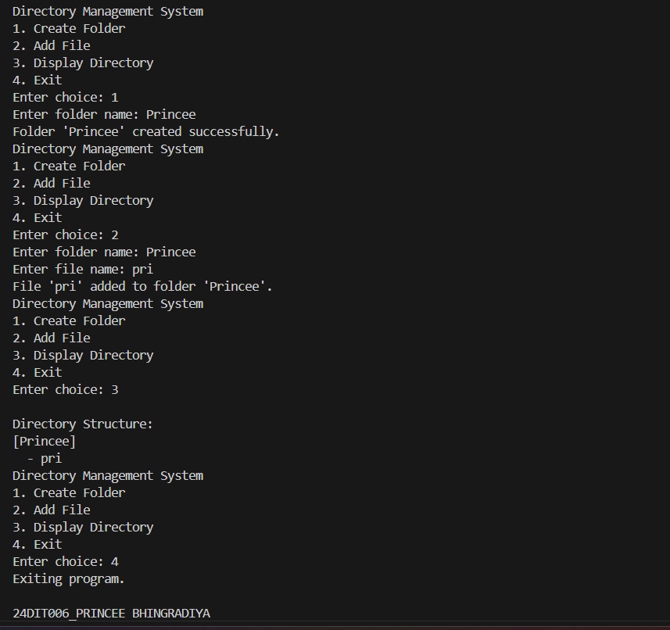
Practical:9.1 | Imagine you're developing a financial calculator for a bank's system that allows users to calculate the ratio of two monetary values they input. This tool must be reliable, as it's part of a crucial decision- making process for loan eligibility.  A bank customer is required to enter two values directly into the system:  1. The first value represents the total loan amount they wish to apply for.  2. The second value represents their annual income.  The system will compute and display the ratio of the loan amount to the income, which helps the bank assess the customer's loan-to-income ratio.  Major challenges that developer will face while developing the system would be, if the customer mistakenly enters non-numerical characters (e.g., "abc"), the system should handle the situation gracefully and prompt the user to correct their input. If the customer enters 0 as their annual income, the system must identify this issue and avoid performing a division that would lead to an invalid result.
Code: | #include <iostream>  #include <limits>  using namespace std;  void calculateLoanIncomeRatio() {  double loanAmount, annualIncome;  // Input loan amount  while (true) {  cout << "Enter the total loan amount: ";  cin >> loanAmount;  if (cin.fail() || loanAmount < 0) {  cin.clear(); // Clear error flag  cin.ignore(numeric_limits<streamsize>::max(), '\n'); // Discard invalid input  cout << "Invalid input! Please enter a valid positive number.\n";  } else {  break;  }  }  // Input annual income  while (true) {  cout << "Enter your annual income: ";  cin >> annualIncome;  if (cin.fail() || annualIncome <= 0) {  cin.clear(); // Clear error flag  cin.ignore(numeric_limits<streamsize>::max(), '\n'); // Discard invalid input  if (annualIncome == 0) {  cout << "Error: Annual income cannot be zero! Please enter a valid positive number.\n";  } else {  cout << "Invalid input! Please enter a valid positive number.\n";  }  } else {  break;  }  }  // Calculate and display the loan-to-income ratio  double ratio = loanAmount / annualIncome;  cout << "Loan-to-Income Ratio: " << ratio << endl;  }  int main() {  calculateLoanIncomeRatio();  cout << endl<< endl<< "24DIT006_PRINCEE BHINGRADIYA" << endl<<endl;  return 0;  }
Output: | 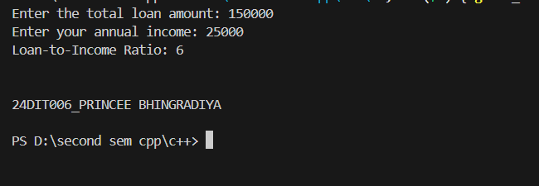
Practical:9.2 | Imagine you are tasked with developing a simple banking system for a local financial institution. The bank has observed an increase in customer complaints regarding unclear transaction records and unhandled errors during operations. They want a robust software module to manage bank accounts efficiently while maintaining a log of transactions.  As a software developer, your job is to create a banking system with the following features:  1. A way to represent individual bank accounts, including the ability to manage their balances.  2. Secure methods to deposit and withdraw funds.  3. An error-handling mechanism to address invalid operations, such as attempting to withdraw more than the account's current balance.  4. A feature that logs every function call when an error occurs to provide insights into the issue.  The bank also insists on maintaining a history of transactions using basic data structures without relying on advanced libraries or containers. Design and implement a banking system that fulfills the above requirements.
Code: | #include <iostream>  #include <vector>  using namespace std;  class BankAccount  {  private:  double balance;  vector<string> transactionHistory;  public:  BankAccount(double initialBalance) : balance(initialBalance)  {  transactionHistory.push_back("Account created with balance: " + to_string(balance));  }  void deposit(double amount)  {  if (amount > 0)  {  balance += amount;  transactionHistory.push_back("Deposited: " + to_string(amount));  cout << "Deposit successful. Balance: " << balance << endl;  }  else  {  transactionHistory.push_back("Deposit failed: Invalid amount.");  cout << "Error: Invalid deposit amount.\n";  }  }  void withdraw(double amount)  {  if (amount > 0 && amount <= balance)  {  balance -= amount;  transactionHistory.push_back("Withdrawn: " + to_string(amount));  cout << "Withdrawal successful. Balance: " << balance << endl;  }  else  {  transactionHistory.push_back("Withdrawal failed: Insufficient funds.");  cout << "Error: Insufficient funds.\n";  }  }  void displayTransactionLog() const  {  cout << "\nTransaction History:\n";  for (const auto &record : transactionHistory)  {  cout << record << endl;  }  }  };  int main()  {  BankAccount account(1000); // Initial balance  account.deposit(500);  account.withdraw(200);  account.withdraw(2000); // Should fail due to insufficient funds  account.displayTransactionLog();  cout << endl<< endl<< "24DIT006_PRINCEE BHINGRADIYA" << endl<<endl;  return 0;  }
Output: | 

