AI-Powered Event Management Platform
Workflow Documentation | Assignment 7: AI Event Management

1. Problem Analysis
Organizations conducting conferences, workshops, hackathons and training programs often manage registration, attendance, communication, certificates and feedback manually. This creates delays, duplicate work, data-entry errors and limited visibility into participant satisfaction.

Business Context
The proposed n8n solution automates the event lifecycle using Google Forms, Google Sheets, Gmail, Google Drive, Google Docs, QR Code API and OpenAI.

Stakeholders
- Participants
- Event organizers
- Event coordinators/volunteers
- Management/reporting team

Pain Points
- Manual registration and participant tracking
- Attendance verification is time-consuming
- Repeated event communication
- Manual certificate preparation
- Feedback analysis requires manual effort
- Post-event reports are slow to compile

Objectives
- Automate registration and attendance
- Improve participant communication
- Generate certificates automatically
- Collect and analyze feedback using AI
- Produce event performance reports

2. Workflow Architecture
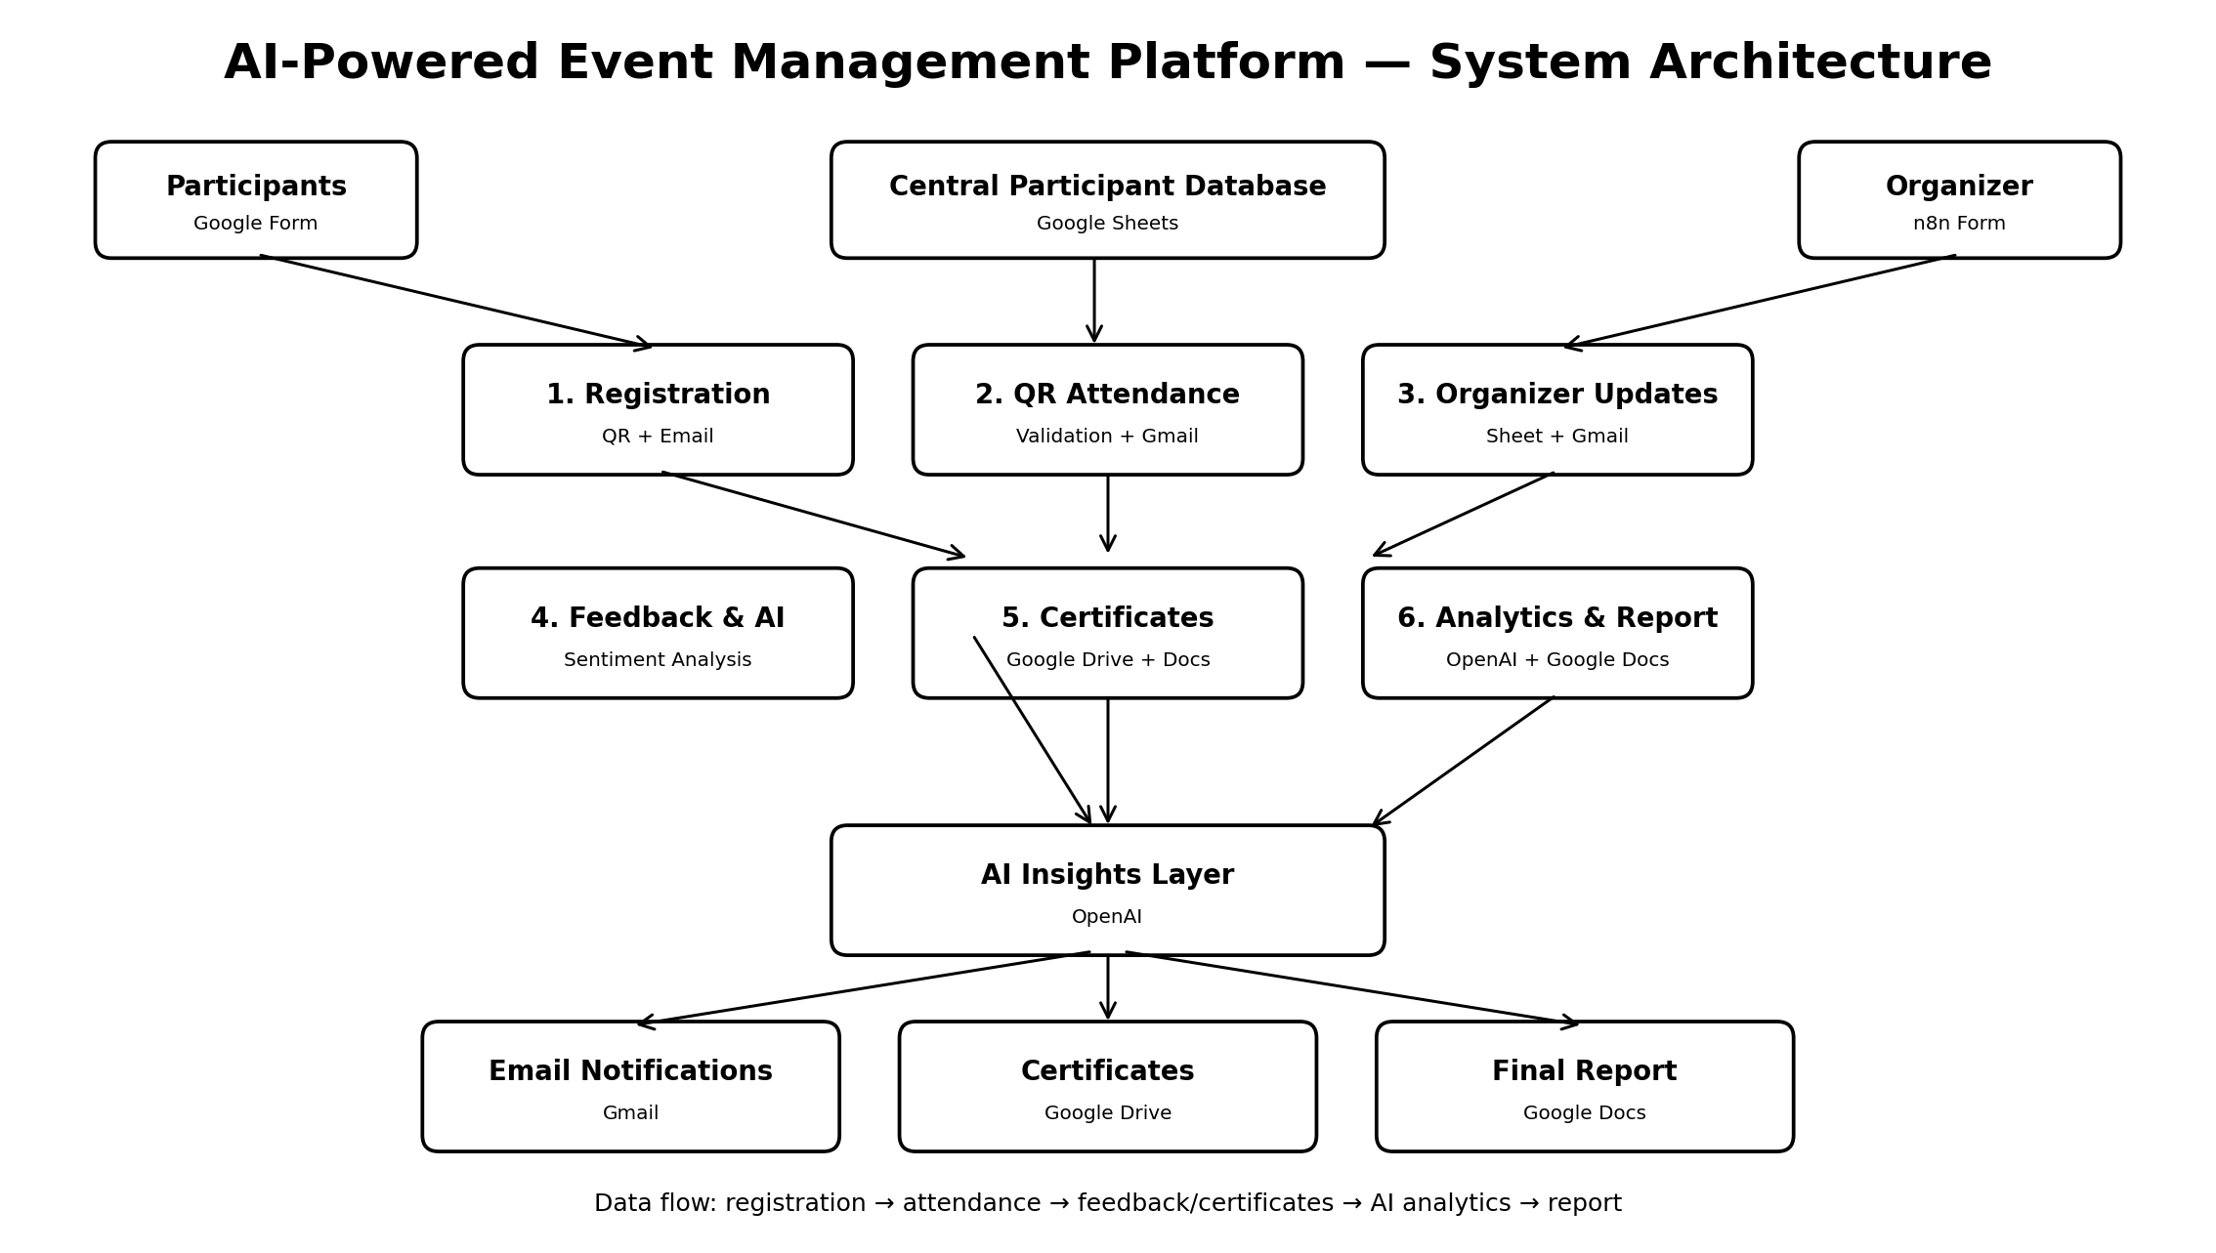
The six workflows are independent n8n automations coordinated through shared Google Sheets/Drive data and email communication.

3. Workflow Specifications
Workflow | Trigger | Main Flow | Purpose / Output | Integrations
1. Registration & Participant Management | n8n Form Trigger | Form → Edit Fields → JavaScript → Append Sheet → Generate QR → Gmail | Creates participant record, participant ID, QR code and confirmation email. | n8n, Google Sheets, QR API, Gmail
2. QR Code Attendance System | n8n Form Trigger | Form → Get Rows → IF → Mark Present → Gmail / Invalid branch | Validates participant ID, marks attendance and sends confirmation; invalid entries follow a separate branch. | n8n, Google Sheets, Gmail
3. Organizer Event Update | n8n Form Trigger | Form → Append Sheet → Gmail | Stores organizer announcements/updates and communicates them by email. | n8n, Google Sheets, Gmail
4. Feedback Collection & Event Analytics | Google Sheets Trigger | Sheets Trigger → OpenAI → Append Sheet | Analyzes participant feedback and classifies sentiment as Positive, Negative or Neutral. | n8n, Google Sheets, OpenAI
5. Certificate Generation | Manual Execute Trigger | Get Rows → IF → Copy File → Update Document → Update Sheet | Checks eligible participants, creates/updates a certificate from a template and records certificate status/link. | n8n, Google Sheets, Google Drive, Google Docs
6. Event Analytics & Report Generation | Manual Execute Trigger | Get Rows → OpenAI → Create Document → Update Document → Update Sheet | Aggregates event data, generates AI insights/recommendations and creates a final report. | n8n, Google Sheets, OpenAI, Google Docs

4. End-to-End Event Flow
1. Participant submits registration form.
2. Registration workflow stores participant data, creates an ID/QR code and sends confirmation.
3. Participant submits attendance information; the attendance workflow validates the record and marks Present.
4. Organizer can submit event updates independently; updates are logged and communicated.
5. Participant feedback is captured and analyzed by OpenAI for sentiment.
6. Eligible attendees receive automatically generated certificates.
7. The final analytics workflow aggregates event data and creates an AI-generated performance report.

5. Advanced Features Demonstrated
- AI-powered sentiment classification and event analysis
- Conditional IF branching for attendance validation and certificate eligibility
- Webhook/form-based event intake
- Scheduled/trigger-driven automation capability
- Google Sheets audit trail for participant, attendance and analytics data
- Error/invalid participant path in attendance workflow

6. Testing Checklist
☐ Test registration with a sample participant
☐ Confirm QR generation and email delivery
☐ Test valid attendance and verify Present status
☐ Test invalid participant path
☐ Submit positive and negative feedback and verify AI sentiment
☐ Generate a certificate for a Present participant
☐ Run final report workflow and verify Google Docs output

7. Submission Notes
Export each n8n workflow as JSON. Include screenshots of successful executions, Google Sheets results, QR/email confirmation, certificate output and final AI report in the GitHub repository and presentation.

