# PRIYA COACHING CENTER

# FOR CBSE, PSEB, ICSE

Would You like to be a topper ?

## A Master of your subjects ?

This is now easy..............

By becoming a student of Priya Coaching

* Result Oriented Faculty • Small Batches • Individual attention
  + Regular assignments • Periodic Tests to Give a Feel of Exam
    - Regular Parents Teacher Meeting

Student of 6th to 10th Class can join immediately.

# Mathematics

# Science

Student of 11th or 12th can also join us, Only limited seats available

# Biology

Address:-Ward no-4, Fatehpuri Mohalla , Main Bazar, Near Primary School, Kurali

FOR CBSE, PSEB,ICSE

# REGISTRATION OPEN FOR 2021-22

# Three year of teaching experience

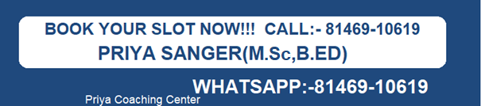

Ward no-4, Fatehpuri Mohalla, Main Bazar, Near Primary School, Kurali