Leveraging Graph Neural Networks to Uncover Illicit Financial Networks
Comprehensive Project Report — Anti-Money-Laundering on the Elliptic Bitcoin Dataset

1. Members of the Team
- Abhinav Mishra (solo project)

2. Overall Project Summary
Anti-money-laundering (AML) systems built on rule engines or tabular machine learning evaluate each transaction in isolation, ignoring the network of counterparties around it. This project reframes fraud detection on the Elliptic Bitcoin dataset as a graph representation learning problem: transactions are nodes, payment flows are edges, and Graph Neural Networks (GNNs) learn embeddings that mix a transaction’s own features with multi-hop network context through message passing.
We benchmark three GNN architectures (GCN, GraphSAGE, GAT) trained with Focal Loss against a strong XGBoost tabular baseline, under a strict temporal split that mimics production deployment. Two headline findings:
- Hand-engineered graph features are learnable. A GraphSAGE model given only the 94 transaction-local features outperforms the same model given all 166 features (test PR-AUC 0.681 vs 0.636) — the network learns neighbourhood structure directly from the graph.
- A hybrid GraphSAGE-embedding + XGBoost model gives the best operating point: illicit-class F1 0.773 at 95.3 % precision and a false-positive rate of 0.22 % — a ~6× FPR reduction versus the XGBoost baseline (1.39 %) at comparable recall.
All models degrade sharply after the dark-market shutdown at time step 43, quantifying how concept drift — not model capacity — is the binding constraint for production AML.

3. Details of the Dataset
Source: Elliptic Data Set (Kaggle), the benchmark for graph-based financial anomaly detection, introduced in Weber et al. (KDD 2019).
Property | Value
Nodes (Bitcoin transactions) | 203,769
Directed edges (payment flows) | 234,355
Node features | 166 (anonymised, standardised)
Time steps | 49 (≈ 2 weeks each); every edge is within one step → 49 disjoint snapshots
Labels | 4,545 illicit (2.2 %) · 42,019 licit (20.6 %) · 157,205 unknown (77.2 %)
Avg / max degree | 2.30 / 473, no isolated nodes

Feature structure: column 1 is the time step; columns 2–95 are 94 local features (LF) describing the transaction itself (fees, volumes, input/output counts); columns 96–167 are 72 aggregated features (AF) — hand-engineered one-hop neighbourhood statistics (max/min/std/correlation of neighbour features). Class 1 = illicit, class 2 = licit. Files: elliptic_txs_features.csv (690 MB), elliptic_txs_edgelist.csv, elliptic_txs_classes.csv.
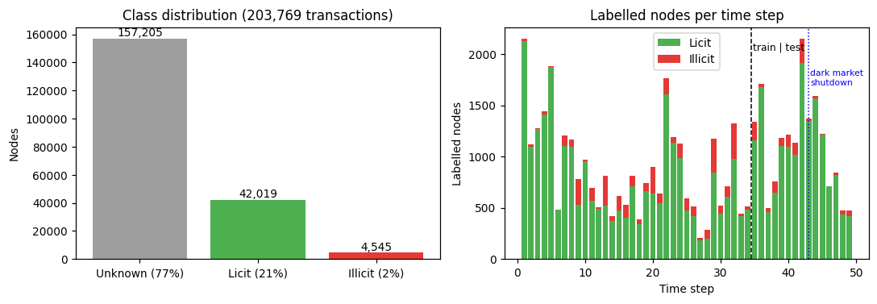
Figure 1 — Class distribution and labelled nodes per time step (train/test boundary and dark-market shutdown marked)

4. Details of Data Preprocessing
- Type-safe parsing — features read as float32; txId parsed as integer (float32 silently corrupts 9-digit ids, e.g. 230425980 → 230425984).
- Label encoding — 1→1 (illicit), 2→0 (licit), unknown→−1. Unknown nodes are excluded from losses/metrics but kept in the graph so they relay messages between labelled nodes (semi-supervised setting).
- Node re-indexing — txIds mapped to contiguous indices; the edge list becomes a (2, 234,355) int64 edge_index tensor (PyTorch Geometric format).
- Undirected message passing — reverse edges added, since suspicion propagates both up- and downstream of a payment (as in the original Elliptic paper).
- No re-scaling — features ship already standardised.
- Temporal split — train t = 1–29 (26,381 labelled nodes), validation t = 30–34 (3,513; early stopping + threshold tuning), test t = 35–49 (16,670). Random splits would leak future information.

5. Feature Extraction and Weighting Methods
- Feature sets: AF = all 166 features; LF = 94 local features only. The LF ablation tests whether the GNN can replace the 72 manual aggregates.
- Learned structural features: the trained GraphSAGE-LF model’s 64-d penultimate-layer embeddings are concatenated with the 166 raw features for the hybrid XGBoost model (230 dims total).
- Class weighting: GNNs use Focal Loss (α = 0.75 on illicit, γ = 2); XGBoost uses scale_pos_weight ≈ 8.2.
- Decision thresholds: tuned on the validation window only (max illicit F1) and frozen before testing — no test-set leakage.

6. Libraries Used
Library | Version | Role
torch | 1.13.1 | tensor ops, autograd, training
torch-geometric | 2.3.1 | GCN/SAGE/GAT layers, GNNExplainer, graph utilities
xgboost | 3.2.0 | tabular baseline + hybrid classifier
scikit-learn | 1.7.2 | metrics (PR-AUC, F1, confusion), PR curves
pandas / numpy | 2.3.3 / 1.26.4 | data wrangling
matplotlib / networkx | 3.10.9 / 3.4.2 | figures, subgraph visualisation
nbformat | 5.10.4 | notebook tooling

7. Architecture of the Models Employed
All GNNs: 2 layers (2-hop receptive field), hidden width 64, dropout 0.5, linear classification head, Adam (lr 5e-3, weight decay 5e-4), full-batch transductive training, early stopping on validation PR-AUC (patience 40).
- GCN — GCNConv(166→64) → ReLU → dropout → GCNConv(64→64) → ReLU → dropout → Linear(64→2). Symmetric-normalised mean aggregation.
- GraphSAGE — same skeleton with SAGEConv (mean aggregator): h′ = W₁h + W₂·mean(neighbours). The separate self-transform preserves local evidence; the architecture is inductive (embeds unseen nodes) and scales via NeighborLoader mini-batching.
- GAT — two GATConv layers, 4 attention heads each (64 channels total), ELU activations, attention dropout 0.3 — attention weights suspicious neighbours above benign ones.
- Focal Loss — FL = α_t (1−p_t)^γ · CE with α_illicit = 0.75, γ = 2 — focuses gradient on the rare, hard illicit class.
- XGBoost baseline — 400 trees (early-stopped on validation aucpr), depth 6, lr 0.1, hist method, scale_pos_weight ≈ 8.2.
- Hybrid — XGBoost with identical hyperparameters over [166 raw features ‖ 64 GraphSAGE-LF embeddings].
- Explainability — GNNExplainer (100 epochs) on the 2-hop subgraph of flagged transactions yields edge-importance masks and feature attributions.

8. Final Results
Test window t = 35–49 (16,670 labelled transactions, 6.5 % illicit). Thresholds tuned on validation only.
Model | PR-AUC | Macro F1 | Illicit F1 | Precision | Recall | FPR %
XGBoost (166 feats, baseline) | 0.789 | 0.871 | 0.758 | 0.785 | 0.733 | 1.39
GCN (AF) | 0.275 | 0.676 | 0.406 | 0.330 | 0.529 | 7.47
GAT (AF) | 0.382 | 0.723 | 0.490 | 0.413 | 0.600 | 5.92
GraphSAGE (AF) | 0.636 | 0.773 | 0.577 | 0.551 | 0.607 | 3.44
GraphSAGE (LF-94) | 0.681 | 0.827 | 0.675 | 0.735 | 0.623 | 1.56
Hybrid SAGE-emb + XGBoost | 0.764 | 0.880 | 0.773 | 0.953 | 0.650 | 0.22

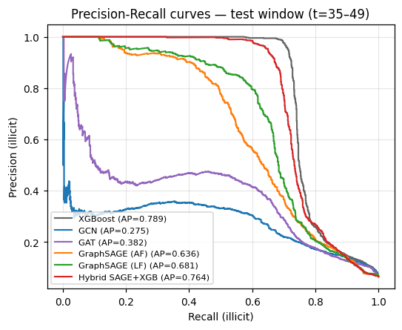
Figure 2 — Precision-Recall curves on the test window
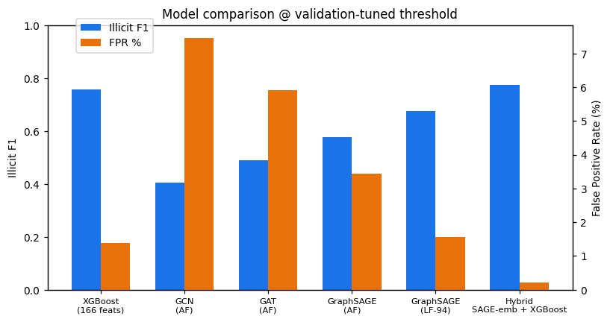
Figure 3 — Illicit F1 and FPR per model at validation-tuned thresholds
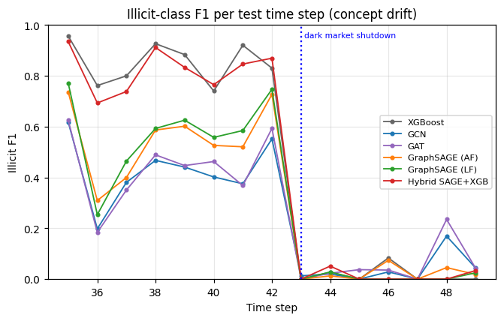
Figure 4 — Concept drift: per-time-step illicit F1 collapses after the dark-market shutdown (t = 43)
- Hybrid wins the operating point that matters: highest illicit and macro F1, 95 % alert precision, 6× lower FPR than the baseline — of every 100 alerts raised, ~95 are true hits vs ~79 for XGBoost.
- GraphSAGE ≫ GCN/GAT here: GCN’s normalisation dilutes self-features; GraphSAGE’s explicit self-transform preserves them.
- LF ablation: removing the 72 engineered features improves GraphSAGE (PR-AUC 0.636 → 0.681) — structure is learned, not engineered.
- Concept drift dominates: per-time-step F1 collapses for all models after t = 43.
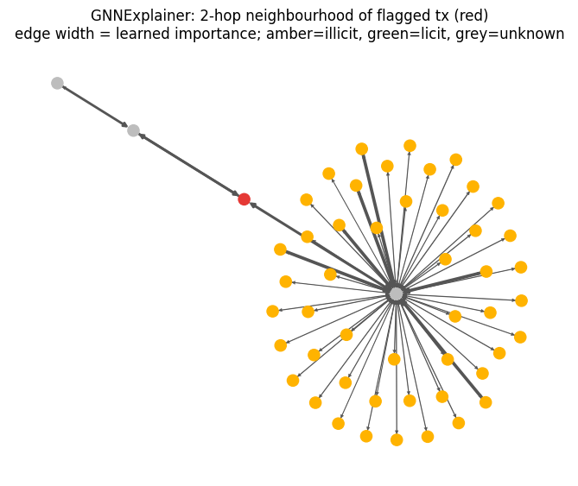
Figure 5 — GNNExplainer evidence subgraph for a flagged transaction (p = 0.91): red = flagged tx, amber = known illicit, green = licit, grey = unlabeled; edge width = importance

9. Conclusions, Improvements over Legacy Approaches, and Limitations

Conclusions
Graph structure carries real, learnable signal for AML: GNN embeddings encode neighbourhood context that (a) replaces manual feature engineering and (b) sharpens a tree-based classifier into a far more precise alerting system. Pure GNNs do not beat well-tuned XGBoost on curated features — the practical recipe is GNN for structure, trees for decision boundaries.

Improvements over legacy approaches
- Drops the I.I.D. assumption — decisions use who-transacts-with-whom context, catching ring structures invisible to row-wise models.
- Eliminates the feature-engineering bottleneck — the LF experiment shows multi-hop structure is learned automatically.
- False-positive reduction — FPR 1.39 % → 0.22 % at similar recall, i.e. ~84 % fewer false alerts to investigate.
- Inductive scoring (GraphSAGE) — new transactions embedded without retraining; neighbourhood sampling is the scaling path to million-node graphs.
- Auditability — GNNExplainer supplies the subgraph-plus-features evidence trail compliance requires.

Limitations
- Concept drift: static models fail on post-shutdown patterns; production needs continual retraining or temporal GNNs (EvolveGCN, TGN).
- Anonymised features cap semantic interpretability of attributions.
- 77 % unlabeled nodes are used only passively; self-supervised pre-training or label propagation could exploit them further.
- Full-batch training sufficed here but is not the scaling path; the GraphSAGE mini-batch pipeline is.
- Threshold choice is deployment-specific and should be re-tuned on each institution’s validation stream.

10. Sources
- M. Weber et al., Anti-Money Laundering in Bitcoin: Experimenting with Graph Convolutional Networks for Financial Forensics, KDD Workshop 2019, arXiv:1908.02591.
- T. Kipf & M. Welling, Semi-Supervised Classification with Graph Convolutional Networks, ICLR 2017, arXiv:1609.02907.
- W. Hamilton, R. Ying, J. Leskovec, Inductive Representation Learning on Large Graphs, NeurIPS 2017, arXiv:1706.02216.
- P. Veličković et al., Graph Attention Networks, ICLR 2018, arXiv:1710.10903.
- T.-Y. Lin et al., Focal Loss for Dense Object Detection, ICCV 2017, arXiv:1708.02002.
- R. Ying et al., GNNExplainer: Generating Explanations for Graph Neural Networks, NeurIPS 2019, arXiv:1903.03894.
- Elliptic Data Set, Kaggle: kaggle.com/datasets/ellipticco/elliptic-data-set
- PyTorch Geometric documentation: pytorch-geometric.readthedocs.io

