LISNERS

Overview
Lisners is a technology-driven mental health and wellness app developed by Brightlanes Technologies Private Limited, based in Delhi, India, and founded in 2020. It aims to connect users with mental health professionals through a mobile platform, focusing on accessibility, confidentiality, and reducing stigma, particularly in underserved regions like Tier-2 and Tier-3 cities in India. The app integrates psychology with technology to provide comprehensive mental health solutions.
How Lisners Works
- Lisners operates as an online platform that facilitates 24/7 mental health consultations via GDPR-compliant audio and video calls.
- Ensuring user anonymity by not requiring phone number sharing.
- Users can access the app on Android (and likely iOS) through app stores, sign up, and create a profile with health details to receive personalized support.
- The platform matches users with suitable professionals based on their needs, using a person-centered approach that emphasizes empathetic guidance and practical solutions.
Services Provided
Lisners offers a range of personalized mental health and wellness services, including:
- Online Therapist Consultations: Access to licensed psychologists, psychiatrists, counselors, social workers, and life coaches via audio/video calls.
- Specialized Counseling:
  - Mental Health for Men and Boys: Addressing cultural barriers to emotional expression.
  - Marriage and Relationship Issues: Guidance for couples and individuals.
  - Career Counseling: Support for career decisions and stress management.
  - Child and Adolescent Mental Health: Tailored support for younger users.
- Holistic Support: Incorporates lifestyle factors like sleep, exercise, and nutrition into mental health care.
- Peer Network: An in-app community for users to connect anonymously, share experiences, and support each other.
- Additional Services: Legal advice for mental health-related issues and tools like mood trackers and journaling.
The app emphasizes a psychosocial model, focusing on emotional, psychological, and social well-being, with services available in multiple languages to cater to diverse users.lisners.comthousand.mocerohealth.in
Business Model
Lisners operates on a Direct-to-Consumer (D2C) subscription-based model with a freemium approach:
- Free Tier: Offers limited access, such as free initial consultations or basic features, to attract users and reduce barriers to entry.
- Premium Subscriptions: Users pay for access to full services, including consultations with professionals and premium features like priority booking or exclusive content. Subscription plans are tiered (e.g., Basic and Premium) to cater to different needs and budgets, with reported pricing starting at around ₹500/month for basic plans and ₹1000/month for premium plans (based on similar apps’ pricing structures). Rocketdigital
- Revenue Generation: Income is derived from subscription fees, with potential additional revenue from partnerships with colleges or organizations. The model focuses on affordability to appeal to students and users in Tier-2 and Tier-3 cities.
- Challenges: As noted in industry analyses, D2C models can face high marketing costs and user expectations for insurance coverage, which may push Lisners toward exploring B2B partnerships (e.g., with colleges or employers) in the future. rocketdigital Lisners’ business model prioritizes user privacy, accessibility, and quality care, with compensation to professionals tied to care quality rather than time spent, aligning with effective mental health care practices.
1. Identifying the Target Market

Demographics and Characteristics
- Age Group: 18-24 years, primarily college students.
- Location: Tier-2 cities (e.g., Coimbatore, Indore, Jaipur) and Tier-3 cities (e.g., Bhagalpur, Guntur, Udaipur).
- Psychographics:
  - Tech-savvy, with high smartphone penetration (India’s mental health apps market is projected to grow at a CAGR of 18.2% from 2023 to 2030 due to increasing smartphone use).
  - Facing mental health challenges such as academic pressure, social isolation, career uncertainty, and relationship issues.
  - Hesitant to seek help due to stigma or lack of access to mental health professionals in smaller cities.
- Market Needs:
  - Research indicates that 20-30% of Indian students experience anxiety, depression, or other mental health issues, with a severe shortage of professionals (0.75 psychiatrists per 100,000 people).
  - Tier-2 and Tier-3 cities have limited mental health infrastructure, making digital solutions like Lisners critical.

Why This Audience?
College students in smaller cities represent a high-potential market due to their mental health needs and growing digital access. Lisners’ focus on accessibility and anonymity aligns with their preferences, addressing the treatment gap highlighted by the National Mental Health Survey (2015-16), which found that 150 million Indians need mental health interventions, but fewer than 30 million receive care.

Defining the Secondary Target Audience
The secondary target audience includes young adults aged 25-35 in Tier-2 and Tier-3 cities, as well as individuals in smaller towns or rural areas with internet access. This group is inferred based on the app’s broader service offerings and potential reach:
- Young Adults (25-35): This group includes recent graduates and early-career professionals who may face work-related stress, relationship challenges, and financial pressures. Lisners’ services, such as career counseling and marriage/relationship guidance, are relevant, especially in regions with limited mental health resources.
- Individuals in Smaller Towns or Rural Areas: Given Lisners’ mission to serve un-served and under-served regions, individuals in areas with even less access to mental health services could benefit from the app’s digital platform, provided they have internet access. This aligns with the app’s focus on accessibility via smartphones.
- Additional Demographics: The app also mentions services for men and boys, adolescents, and the ageing population, suggesting potential secondary audiences. However, for marketing purposes, the focus on young adults and rural users is more aligned with the app’s strategic outreach.

Competitive Analysis Framework
The analysis compares Lisners with competitors across key dimensions relevant to the target audience of college students in Tier-2 and Tier-3 cities.
Criteria | Lisners | Wysa | YourDOST | Lissun | Evolve | MANAS
Target Audience Focus | College students in Tier-2/Tier-3 cities, emphasizing anonymity. | Broad audience, including younger people. | Students, professionals, broad audience; strong college focus. | Individuals, corporates, healthcare institutions; less Tier-3 focus. | Broad audience, including LGBTQIA+; less Tier-3 focus. | All age groups, rural/urban; less student-specific.
Service Range | Therapy, career/relationship counseling, peer community, legal advice. | AI chatbot, CBT, DBT, meditation, mindfulness exercises. | Therapy, coaching, self-help, corporate wellness. | Therapy, self-help, corporate wellness. | Meditation, sleep tools, emotional regulation. | Life skills, mindfulness, therapy referrals.
Anonymity & Privacy | GDPR-compliant calls, anonymous peer forums. | Anonymous AI chat, secure human sessions. | Anonymous chat, strong privacy focus. | Anonymous options, privacy-focused. | Limited anonymity features. | Basic privacy, less emphasis on anonymity.
Pricing | Freemium, ₹500-₹1,000/month (estimated). | Freemium, $99.99/month or $99.99/year (varies by country). | Freemium, ₹400-₹600/45 mins for individuals, company subscriptions. | Not specified, likely subscription or session-based. | Freemium, free for LGBTQIA+ content, premium features. | Free, government-funded.
Market Reach | Early-stage, Tier-2/Tier-3 focus, 100+ downloads. | Global, 5M+ downloads, strong India presence. | Established, 200+ college partnerships, urban reach. | Growing, focus on corporates and individuals. | Over 200,000 users worldwide, urban/semi-urban. | Nationwide, government initiative, limited marketing.
Technology | Mood trackers, journaling, secure calls, peer community. | AI chatbot, CBT tools, advanced analytics. | Mood tracking, chat, self-help tools. | User-friendly interface, self-help tools, AI integration planned. | Meditation, sleep trackers, contextual content. | Evidence-based tools, basic interface, bilingual support.
Funding & Stability | No public funding data, DPIIT/MSME recognition. | $20M (2022), highly funded. | $1.2M (2020), stable. | $5M total, recent $2.5M in 2024, growing. | Limited data, viable post-COVID. | Government-funded, stable.
College Engagement | Emerging college partnerships, student ambassadors proposed. | Partnerships with educational institutions. | Strong college tie-ups, workshops in 200+ institutions. | Moderate college focus, corporate-heavy. | Limited college-specific engagement. | Public health focus, less college-specific.

User Persona Development
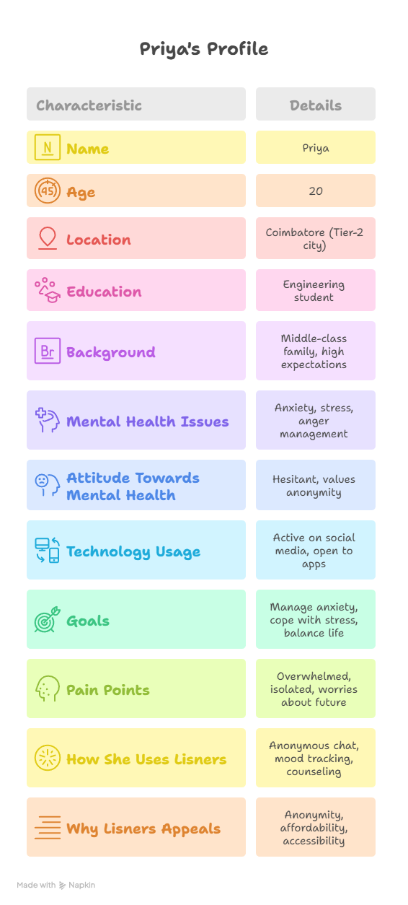
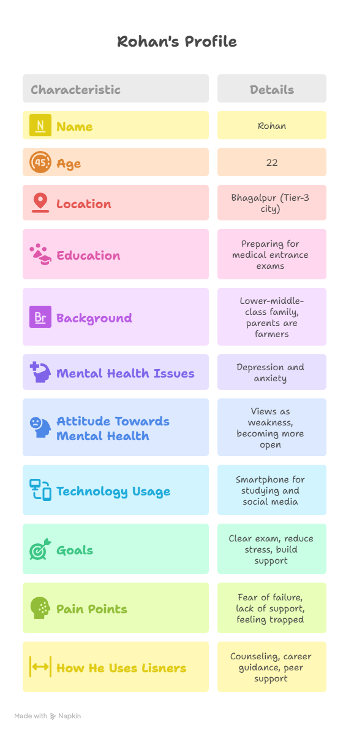
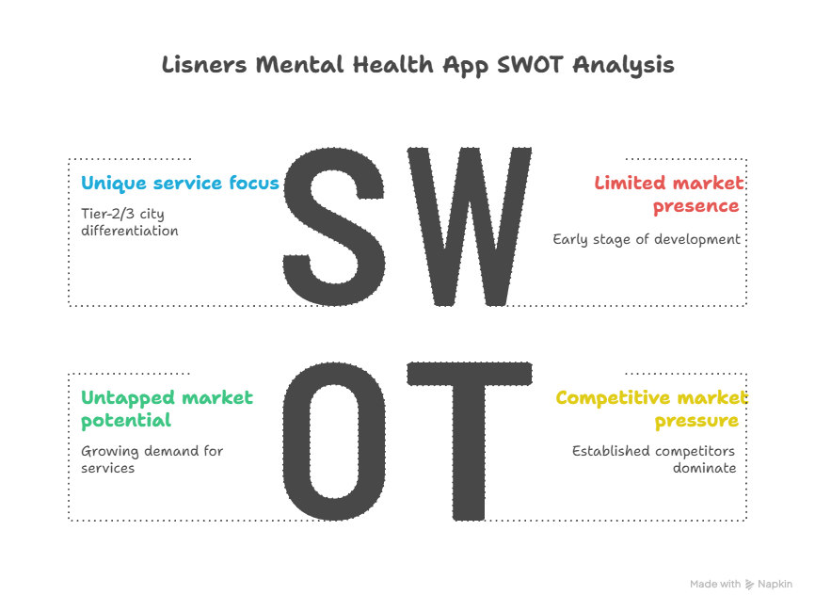

Positioning Plan for Lisner

Positioning Statement
“Lisners is India’s most accessible and confidential mental health support system, designed for college students in Tier-2 and Tier-3 cities, where professional help is often out of reach.”

Key Messaging
- Accessibility: Available 24/7 via smartphones, Lisners brings professional mental health support to students in underserved areas.
- Confidentiality: GDPR-compliant audio/video calls and anonymous chat features reduce stigma and encourage help-seeking.
- Affordability: Offers cost-effective plans tailored for students, with free initial consultations to lower barriers.
- Tailored Services: Addresses student-specific issues like career counseling, relationship guidance, and stress management.
- Technology-Driven: Combines cutting-edge technology with psychology, offering tools like mood trackers and journaling.

Differentiation
Lisners stands out from competitors like YourDOST, Lissun, and Amaha by:
- Focusing on Tier-2 and Tier-3 cities, where mental health services are scarce.
- Offering a holistic approach with services beyond therapy, including career and relationship counseling.
- Emphasizing anonymity and privacy, critical for reducing stigma among young adults.

De-stigmatization and Regional Storytelling Ideas

De-stigmatization Campaigns
- Campaign Theme: “It’s okay to not be okay—your mental health matters.”
  - Use relatable content like memes, short videos, and infographics to normalize mental health conversations.
  - Example: A video showing a student overcoming exam stress with Lisners’ help, shared on Instagram Reels.
- Influencer Partnerships: Collaborate with student influencers or local celebrities in Tier-2 and Tier-3 cities to share personal mental health stories.
- Educational Content: Create blog posts and social media threads explaining common mental health issues and the benefits of seeking help.

Regional Storytelling
- Localized Content: Develop marketing materials in regional languages (e.g., Hindi, Tamil, Telugu, Marathi) to resonate with students in smaller cities.
- Testimonials: Feature real stories from users in Tier-2 and Tier-3 cities. Examples:
  - A student from Coimbatore sharing how Lisners helped manage academic stress.
  - A user from Bhagalpur discussing improved confidence through career counseling.
- Cultural Relevance: Incorporate local idioms, cultural references, and relatable scenarios (e.g., stress from competitive exams like JEE or NEET) to make the app feel familiar.
- Video Series: Produce a “Lisners Stories” video series showcasing diverse student experiences, distributed on YouTube and social media.

Community Engagement Approach

College Partnerships
- Partner with colleges in Tier-2 and Tier-3 cities to host mental health awareness workshops, seminars, and webinars.
- Offer free Lisners sessions during these events to introduce the app and build trust.
- Example: A webinar on “Managing Stress During Exams” hosted by a Lisners psychologist.

Online Communities
- Build an in-app community feature where users can connect anonymously, share experiences, and support each other.
- Moderate forums to ensure a safe and supportive environment.
- Example: A “Student Stress Support” group where users discuss academic challenges.

Virtual Events
- Host regular webinars with mental health experts, career counselors, or relationship therapists.
- Promote events through college networks and social media to drive engagement.
- Example: A monthly “Mental Health Matters” webinar series open to all users.

5. Marketing Funnel and User Acquisition Plan

Awareness
- Social Media: Use platforms popular among students (Instagram, Facebook, WhatsApp) for targeted ads and organic content.
  - Content types: Short videos, memes, infographics, and testimonials.
  - Example: An Instagram Reel showing a day in the life of a student using Lisners to manage stress.
- Influencer Marketing: Partner with micro-influencers (5,000-50,000 followers) in Tier-2 and Tier-3 cities to reach local audiences.
- College Networks: Leverage college social media pages, WhatsApp groups, and campus events to spread awareness.

Interest
- Offer a 7-day free trial or one free consultation to encourage sign-ups.
- Implement a referral program where users get discounts or rewards for inviting friends.
- Example: “Refer a friend and get 1 month free on Lisners Premium.”

Engagement
- Send regular push notifications with mental health tips, success stories, or event reminders.
- Provide interactive content like quizzes (e.g., “What’s your stress level?”) to keep users active.
- Use the in-app community feature to foster ongoing engagement.

Conversion
- Offer tiered pricing plans (e.g., Basic: ₹500/month, Premium: ₹1000/month) with added features like priority booking or exclusive webinars.
- Provide discounts for longer subscriptions (e.g., 20% off for annual plans).

Retention
- Build loyalty through continuous value:
  - Exclusive content for paid subscribers (e.g., guided meditation sessions).
  - Regular app updates with new features like enhanced mood trackers.
  - Community events to maintain user connection.

6. Budget for the Strategy

Total Budget
₹10-15 lakhs (approximately $12,000-$18,000 USD) for the initial launch phase (3-6 months).

Budget Allocation
Category | Percentage | Amount (₹) | Description
Social Media Advertising | 40% | 4-6 lakhs | Targeted ads on Instagram, Facebook, and WhatsApp.
Influencer Partnerships | 20% | 2-3 lakhs | Collaborations with student influencers and local celebrities.
Content Creation | 15% | 1.5-2.25 lakhs | Videos, graphics, and written materials for campaigns and storytelling.
Event Hosting | 10% | 1-1.5 lakhs | Virtual webinars and college workshops.
App Maintenance & Development | 10% | 1-1.5 lakhs | Ensuring a user-friendly and functional app experience.
College Partnerships | 5% | 0.5-0.75 lakhs | Sponsorships or event support for colleges.

Measurable Benchmarks to Track
Metric | Description | Target
App Downloads | Number of new downloads per week/month. | 5,000 downloads in 3 months.
User Engagement | Daily active users, session duration, most-used features (e.g., consultations). | 50% of users active weekly.
Conversion Rates | Percentage of free trial users converting to paid subscribers. | 20% conversion rate.
Retention Rates | Percentage of users active after 1, 3, and 6 months. | 60% retention after 3 months.
Customer Satisfaction | Net Promoter Score (NPS) and user feedback via surveys. | NPS of 50 or higher.
Mental Health Outcomes | Anonymous surveys on perceived mental health improvements. | 70% report positive impact.
Social Media Metrics | Follower growth, engagement rates, click-through rates from ads. | 10,000 followers in 3 months.
Partnership Impact | Number of colleges partnered with, event attendance. | 10 college partnerships.

