* Difference between c and C++ :- C++ was developed as an extension of [C](https://www.w3schools.com/c/index.php), and both languages have almost the same syntax. and C++ support classes and objects, while C does not.

* If else :- if-else statement is a conditional expression that work different statements based on whether a condition is true or false.

* Use if to specify a block of code to be executed, if a specified condition is true
* Use else to specify a block of code to be executed, if the same condition is false
* Use else if to specify a new condition to test, if the first condition is false.

Example :  
 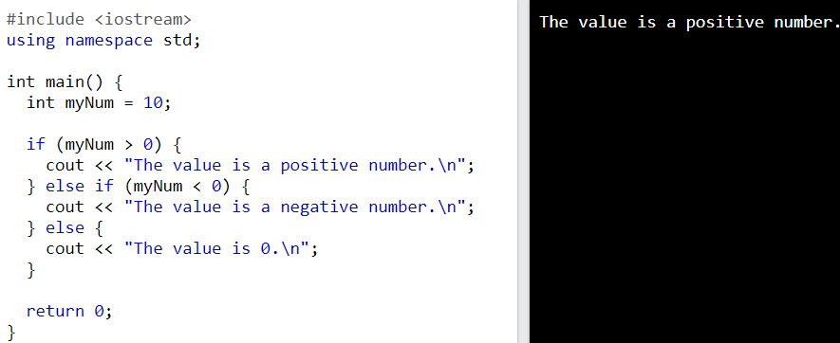

*While loop :- while loop is a control flow statement that allows code to be executed repeatedly based on a given condition. It repeats a block of code as long as the condition evaluates to true.

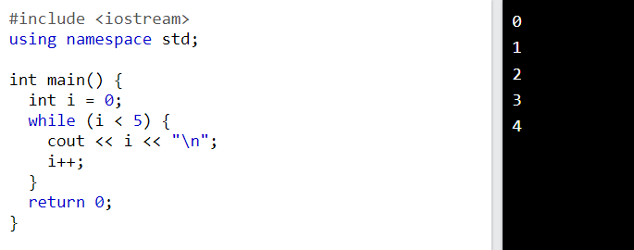

*Do while-loop :- This loop will execute the code block once, before checking if the condition is true, then it will repeat the loop as long as the condition is true.

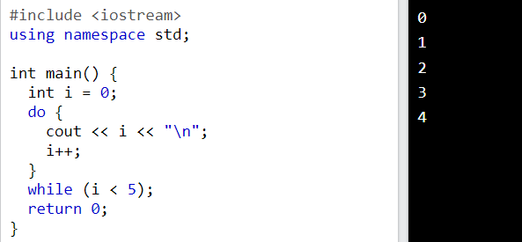

*For-loop :- a **for loop** is used to repeatedly execute a block of code for a specified number of iterations.

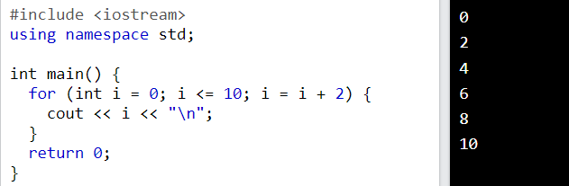

*Function :- a function is a block of code that performs a specific task. functions are used to perform certain actions, and they are important for reusing code, Define the code once, and use it many times.

Example:

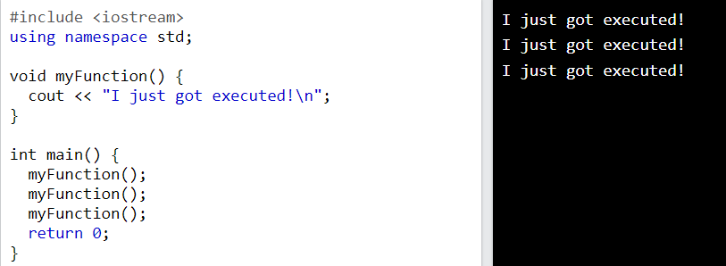

* What is Data Structure: - data structure is a way to store arrange data in main memory for efficient usage.
* Why create(need) data structures: - they help make code more efficient and easier to understand, and they help solve complex problems.
* Algorithm: - algorithm is a sequence of set of instruction (steps) to solve a given problem. In step by step.
* Database: - database is collection of data in a format that can be easily accessed(digital).

* Primitive data structure: - the most basic data structures that are built into a programming language and are used to store simple values of data, Like integer, character, float.
* Non-primitive data structures: - more complex data structures that can store collections of values in two type first one is linear data structures and second is non-linear data structures.

1. Linear data structure: - A linear data structure is a type of data structure that stores the data linearly or sequentially in various formats, such as arrays, stacks, queues, link-list.

2. Non-linear data structure: - It is a form of data structure where the data elements don't stay arranged linearly or sequentially various formats, such as trees, graphs,

…. (Static memory: - memory allocated during compile time is called static memory.

Dynamic memory: - the process of allocating memory at the time of execution is called dynamic memory allocation.)

* Heap memory: - heap memory is used to dynamic memory white the help of a pointer.
* The major difference between Stack memory and heap memory is that the stack is used to store the order of method execution and local variables while the heap memory stores the objects, and it uses dynamic memory allocation and deallocation.
* Time complexity: -it is the total time taken by an algorithm takes to run based on the input size is known as time complexity.
* Why is it important to know time complexity: -time complexity is required to determine the programmes efficiency, the last the time complexity, the faster the execution.
* Best case: - best case is the case in which the time taken to perform a task is less and efficient.
* Worst case: - worst case is the case in which the time taken to perform a task is more as compare to it time complexity.
* Average case: -average case is the case in which the time taken to perform a task with a normal time as it required.
* Space complexity: - space complexity it is the amount of space taken by an algorithm as a function of length of input/output.
* Array: - array it is a collection of data. array is a data structure used to store multiple elements, it store same type of data type, it store at contiguous location.

Bubble Sort, selection sort, insertion sort, quick sort, marge sort,

Linear search, Binary search

* Linked list:- linked list is the linear data structure where data are not stored sequentially inside the computer memory but they are link with each other by the help of address.

There are three types of linked list.

1. Single linked list
2. Doubly linked list
3. Circular linked list
4. Circular doubly linked list

1.. Given an array of **positive** integers. Your task is to rearrange the array elements alternatively i.e. first element should be the max value, the second should be the min value, the third should be the second max, the fourth should be the second min, and so on.  
**Note:**Modify the original array itself. Do it without using any extra space. You do not have to return anything.

**Examples:**

**Input:** arr[] = [1, 2, 3, 4, 5, 6]

**Output:** [6, 1, 5, 2, 4, 3]

**Explanation:** Max element = 6, min = 1, second max = 5, second min = 2, and so on... The modified array is: [6, 1, 5, 2, 4, 3]

**Input:** arr[]= [10, 20, 30, 40, 50, 60, 70, 80, 90, 100, 110]

**Output:** [110, 10, 100, 20, 90, 30, 80, 40, 70, 50, 60]

**Explanation:** Max element = 110, min = 10, second max = 100, second min = 20, and so on... Modified array is : [110, 10, 100, 20, 90, 30, 80, 40, 70, 50, 60]

**Input:** arr[]= [1]

**Output:** [1]

**Constraints:**  
1 <= arr.size <= 106  
1 <= arr[i] <= 106

2.. Given anarray **arr[]**of **n** integers where arr[i] represents the **number of chocolates** in **ith** **packet**. Each packet can have a **variable number** of chocolates. There are**m students**, the task is to **distribute** chocolate packets such that:

* Each student gets **exactly** **one** packet.

1. The difference between the **maximum** and **minimum** number of chocolates in the packets given to the students is **minimized**.

**Examples:**

***Input:*** *arr[] = {7, 3, 2, 4, 9, 12, 56}, m = 3****Output:*** *2****Explanation:*** *If we distribute chocolate packets {3, 2, 4}, we will get the minimum difference, that is* ***2****.*

***Input:*** *arr[] = {7, 3, 2, 4, 9, 12, 56}, m = 5****Output:*** *7****Explanation****: If we distribute chocolate packets {3, 2, 4, 9, 7}, we will get the minimum difference, that is 9 – 2 =* ***7****.*

3.. Given the head of a linked list, the task is to find the **middle**. For example, the middle of **1-> 2->3->4->5**is **3**. If there are two middle nodes (even count), return the **second middle**. For example, middle of **1->2->3->4->5->6** is **4**.

**Examples:**

**Input:** Linked list: 1->2->3->4->5

**Output:** 3  
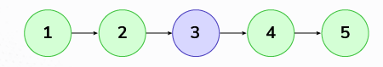  
**Explanation:** The given linked list is 1->2->3->4->5 and its middle is 3.

**Input:** Linked list: 2->4->6->7->5->1

**Output:** 7   
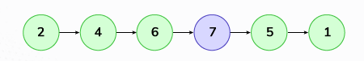  
**Explanation:** The given linked list is 2->4->6->7->5->1 and its middle is 7.

**Expected Time Complexity:**O(n)  
**Expected Auxiliary Space:**O(1)

**Constraints:**  
1 <= no. of nodes <= 105

Print factorial program<<<

The third largest number from an array

If num > 41 then print foo if num>43 then print baar if num > 41 and num >43 print foobaar

Find duplicate items in the string

Find distinct character count from string example

Find whether the given array is palindrome or not

Find duplicate items from the given array

To find the third largest element in an array of distinct integers

4.. Given two strings s1 and s2 consisting of lowercase characters, the task is to check whether the two given strings are anagrams of each other or not. An anagram of a string is another string that contains the same characters, only the order of characters can be different.

5.. Given a string str, the task is to reverse the order of the words in the given string. Note that str may contain leading or trailing dots(.) or multiple trailing dots(.) between two words. The returned string should only have a single dot(.) separating the words.

6.. Given a string s having lowercase characters, find the length of the longest substring without repeating characters.

7.. Given an array arr[] of n integers and a target value, the task is to find whether there is a pair of elements in the array whose sum is equal to target. This problem is a variation of [2Sum problem](https://www.geeksforgeeks.org/2sum/).

8.. Given an array arr[] of n elements that contains elements from 0 to n-1, with any of these numbers appearing any number of times. The task is to find the repeating numbers.

9.. Given an array arr[], the task is to find the subarray that has the maximum sum and return its sum.

10.. Given a sorted array of distinct elements arr[] of size n that is rotated at some unknown point, the task is to find the minimum element in it.

11.. Given a matrix of size n X m, find the transpose of the matrix. [Transpose of a matrix](https://www.geeksforgeeks.org/transpose-of-a-matrix/) is obtained by changing rows to columns and columns to rows. In other words, transpose of mat[n][m] is obtained by changing mat[i][j] to mat[j][i].

12.. Given a string, the task is to find the maximum consecutive repeating character in a string.

13.. Given two sorted arrays a[] and b[] of size n and m respectively, the task is to merge them in sorted order without using any extra space. Modify a[] so that it contains the first n elements and modify b[] so that it contains the last m elements.

14.. Given an array of integers arr[], the task is to move all the zeros to the end of the array while maintaining the relative order of all non-zero elements.

15.. Given a sorted array arr[] of size n, the goal is to rearrange the array so that all distinct elements appear at the beginning in sorted order. Additionally, return the length of this distinct sorted subarray.

 16.. Program to Check for Palindrome String

* INPORTENT QUESTIONS.

1. Print Factorial of the number. ✔️✔️ // 4=4x3x2x1
2. Print Fibonacci Series. ✔️ ✔️ // 0 1 1 2 3 5 8 13
3. print sum of even number from a to b. ✔️✔️ 1>. print add all even number or multiply odd number a to b. ✔️✔️ 2>. Print power of n number or n number of power user define. ✔️✔️
4. Add any digit numbers to convert a single digit number foam. ✔️✔️
5. Search any number is leap year or not. ✔️✔️
6. Print Reverse integer numbers. ✔️✔️
7. Check any number is Power of two. ✔️✔️
8. Check a number Palindrome or not. ✔️✔️ //12321
9. Any small character to convert an upper case. ✔️✔️
10. Check number is Armstrong or not. ✔️✔️ 153=1*+5*+3*
11. Find the factorial of any number and count the total number of zero. ✔️✅
12. Find the total moves for bishop. ✔️✔️
13. Linear search. ✔️✔️
14. Reverse array. ✔️✔️
15. Second max and third max. ✔️✔️
16. Missing number in array. ✔️✔️
17. Cyclically rotate an array by one. ✔️✔️
18. Count Even Digits or Odd Digits in number. ✔️✔️ // 2473
19. Find the largest of 3 numbers. ✔️✔️
20. Check Number is prime or not. ✔️✔️
21. Swapping of two numbers without 3rd variable. ✔️✔️
22. Insertion short. ✔️✔️
23. Selection short. ✔️✔️
24. Bubble short. ✔️✔️
25. Binary search. ✔️✔️
26. Marge short. ✔️
27. Queck short. ✔️
28. Maximum and Minimum Element in an Array. ✔️✔️
29. Maximum-subarray. ✔️
30. Contain Duplicate. ✔️
31. Search in rotated sorted array. ✔️
32. Print all the Palindrome no from 1 to N. ✔️✔️
33. Print all the Armstrong no from 1 to N. ✔️✔️
34. Next Permutation.
35. Chocolate distribution problem.
36. ASCII value se related Questions.
37. Check Number, String is palindrome or not.