Creating Repository in GitHub:

Step 1 Click new nearby repository

Step 2 Give the repository name

Step 3 select the "Add README"

Step 4 Click Create Repository Adding Content to README file

Step 1 Open the repository create

Step 2 Open README.md in edit mode and add the content Step 3 Click commit changes

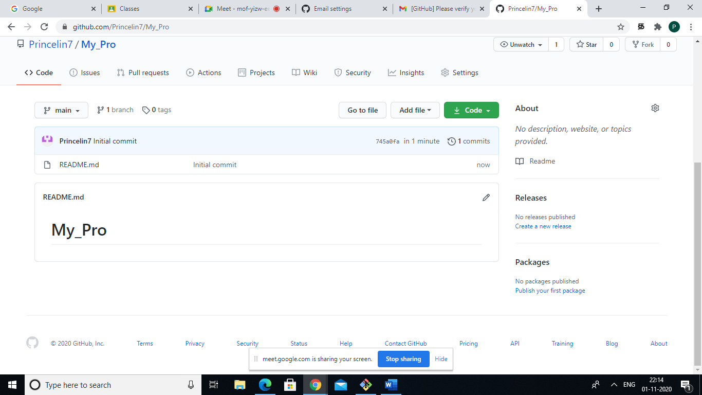

Cloning Repository: