Large-Scale Heterogeneous Data Security Pipeline: Integrating VAE Compression, AES-256-GCM and Post-Quantum ML-KEM/Kyber
ALONA ESSIANE Jean Stany¹ · MAKA MAKA Ebenezer¹² · NOULAPEU NGAFFO Armielle¹² · MALONG Yannick¹² · EKE Samuel¹²
¹ Laboratory of Computer Science, Data Science and Artificial Intelligence, National Higher Polytechnic School of Douala, University of Douala, P.O.Box 8580, Douala, Cameroon
² Laboratory of Electrical, Electronics, Automation and Telecommunication, National Higher Polytechnic School of Douala, University of Douala, P.O.Box 8580, Douala, Cameroon
Correspondence: stanyalona@gmail.com · ycmalong@gmail.com · makaebenezer@yahoo.fr

Abstract
Securing heterogeneous data at scale requires balancing three requirements: reducing data volumes, ensuring confidentiality and integrity, and maintaining usable performance as data size grows. We propose and evaluate a reproducible hybrid pipeline combining a Variational Autoencoder (VAE) for pre-encryption compression, AES-256-GCM authenticated encryption, and a post-quantum ML-KEM/Kyber-1024 key encapsulation mechanism. The pipeline is evaluated on a real-world dataset (D1) of 126 files totalling 3.79 GB (75 JPEG images, 50 binary MP4 files, and 1 JSON text file), using micro-benchmarks, NIST CAVP test-vector validation (775/775 pass, 100%), a 7-point scalability study, and an ablation study isolating each layer's contribution.
Results show that: (i) AES-256-GCM throughput ranges from 109 MB/s (1 KB payloads) to 1,387 MB/s (64 KB payloads), confirming O(n) complexity; (ii) ML-KEM/Kyber-1024 key exchange costs 47.4 ms per operation under a pure-Python shim (keygen 12.59 ms, encaps 14.92 ms, decaps 19.90 ms); (iii) throughput across the 7-point scalability study is essentially flat (mean 941.5 MB/s, slope β = −0.09 MB/s/GB, R² < 0.01), indicating no cost explosion in the measured range; (iv) an ablation study reveals that removing ML-KEM raises binary throughput from 578 MB/s to 913 MB/s, while adding gzip compression collapses it to 25 MB/s on high-entropy MP4 data. The primary contribution is a system-level integration and reproducible joint evaluation of three complementary security layers — learned compression, standardised AEAD, and post-quantum KEM — on real multi-format data; a combination not yet jointly evaluated in an integrated, reproducible experimental setting in the literature.
Keywords: Hybrid cryptography · Large-scale data security · Variational Autoencoder · AES-256-GCM · ML-KEM/Kyber · Post-quantum cryptography · Heterogeneous data · Reproducible research

1 Introduction
The explosion of digital data from IoT sensors, social media, and electronic transactions creates complex, heterogeneous, and rapidly growing data ecosystems whose security remains an open engineering challenge. This complexity is not merely volumetric: it arises from the interplay between heterogeneous data formats, geographically distributed processing nodes, multi-user access policies, and the emergence of quantum-capable adversaries. Designing security architectures that adapt to this complexity — jointly addressing compression efficiency, authenticated encryption, and long-term quantum resistance — is precisely the kind of cross-disciplinary intelligent systems problem this work addresses.
Traditional cryptographic approaches, designed for sequential moderate-volume processing, are increasingly inadequate at the scale and heterogeneity of modern data-intensive pipelines. Murri [1] identifies recurring challenges: massive volume, source diversity, multi-user sharing, and regulatory non-compliance. Soni et al. [2] establish that Shor's algorithm, on a cryptographically relevant quantum computer (CRQC), would break both RSA and elliptic-curve cryptography, making migration to post-quantum primitives a long-term engineering necessity. Generative neural compression — specifically, variational autoencoders — offers a complementary lever: reducing data volume prior to encryption lowers the computational footprint of cryptographic operations on heterogeneous pipelines without assigning AI any cryptographic role.
This work addresses a central engineering question: can a modular, adaptive pipeline combining VAE compression, AES-256-GCM authenticated encryption, and ML-KEM/Kyber post-quantum key encapsulation achieve a viable balance between performance, security, and scalability on real heterogeneous data? Three sub-questions structure the investigation: (1) which primitives to combine for post-quantum security without prohibitive cost; (2) how to deploy a VAE for upstream compression without assigning it cryptographic properties; (3) which experimental protocol enables reproducible, joint evaluation of these components on multi-format datasets of significant size?
The paper is structured as follows: Section 2 characterises data complexity and conventional cryptographic limitations; Section 3 surveys the state of the art and positions the contribution; Section 4 details the methodology, threat model, and algorithmic specifications; Section 5 presents experimental results; Section 6 discusses scope, limitations, and future directions; Section 7 concludes.

2 Generalities on Data Complexity and Cryptography

2.1 Characterisation of Large-Scale Heterogeneous Data
Massive heterogeneous data — broadly referred to as "big data" — is defined not by an absolute volumetric threshold but by the inadequacy of traditional management tools given its intrinsic properties: heterogeneity of formats, generation velocity, and scale of processing requirements. The three foundational dimensions — Volume, Variety, and Velocity — were first articulated by Laney [3] and have since become the canonical characterisation of big data. Kumar et al. [5] further proposed a nine-dimensional model incorporating AI-mediated data evolution, directly relevant to pipeline architectures that embed machine learning within data processing chains.

2.2 Cryptographic Challenges Specific to Large-Scale Data

2.2.1 Key Management at Scale
Managing cryptographic keys for systems processing data from millions of users with differentiated encryption policies creates exponentially growing operational requirements: generation, distribution, storage, rotation, and revocation. Traditional PKI infrastructures face organisational and computational limits at this scale, motivating architectural alternatives that decouple key encapsulation from bulk data encryption.

2.2.2 Algorithmic Scalability and Parallelisation
Classical algorithms were designed for sequential, moderate-volume processing. Sequential modes such as CBC structurally prevent the massive parallelisation required for petabyte-scale workloads. Critically, AES in GCM mode — unlike CBC — is natively parallelisable, which is a primary technical motivation for the AES-GCM choice in this pipeline.

2.3 Classical Approaches to Security

2.3.1 Symmetric Cryptography: From DES to AES-256
DES uses transpositions and substitutions over a 56-bit key space (≈ 7.2 × 10¹⁶ possibilities). AES, standardised in 2001 [6], operates on 128-bit blocks with key lengths of 128, 192, or 256 bits. Its four operations — AddRoundKey, SubBytes, ShiftRows, MixColumns — are organised into 10, 12, or 14 rounds. Hardware optimisation analyses confirm its suitability for high-throughput implementations [7].

2.3.2 Asymmetric Cryptography
RSA (1977) relies on the computational hardness of factoring large integers [8]. Encryption and decryption are defined by:
C = Mᵉ mod n (1)
M = Cᵈ mod n (2)
where n = p · q is the RSA modulus. Shor's algorithm on a CRQC reduces this to polynomial time, making RSA and ECC cryptographically fragile against quantum adversaries.

2.3.3 Summary of Gaps
Yadav [9] identifies five compounding limitations: quantum vulnerability (RSA, ECC via Shor), implementation side-channels (timing, power analysis), unmanageable key management at millions-of-entities scale, interoperability fragmentation, and prohibitive CPU/memory overhead for asymmetric operations on large data volumes.

2.4 Justification for AES-256-GCM
Sood and Kaur [10] compare RSA, DES, and AES on block size, key length, and throughput, establishing AES's superiority for high-throughput applications. Ganeeb et al. [11] confirm AES efficiency in real-time scenarios. GCM mode adds authenticated encryption (AEAD), ensuring confidentiality and integrity in a single pass with native parallelisability — critical for large-scale pipelines where both throughput and tamper detection must be maintained simultaneously.

3 State of the Art

3.1 Post-Quantum Cryptography: CRYSTALS-Kyber / ML-KEM
The NIST post-quantum standardisation initiative, launched in 2016 and finalised as FIPS 203 (ML-KEM) in August 2024 [12], targets primitives resistant to Shor's and Grover's algorithms. Bos et al. [13] describe Kyber as a KEM built on the Module-LWE problem: distinguishing pairs (A, b = A·s + e) from random pairs over Rq = ℤq[X]/(Xⁿ + 1), where A ∈ Rq^{k×k}, s ∈ Rq^k (secret vector), e ∈ Rq^k (error vector). This structure provides a provable reduction to the Shortest Vector Problem.

3.1.1 Mathematical Specification
KeyGen: sample A at random; s, e with small coefficients; compute b = A·s + e. Public key pk = (A, b); secret key sk = s.
Encaps(pk): sample r, e₁, e₂; compute
u = Aᵀ·r + e₁,
v = bᵀ·r + e₂ + ⌊q/2⌋·m (m: 256-bit random message);
ciphertext ct = (u, v); shared secret K = KDF(m).
Decaps(sk, ct): recover m' = ⌊(2/q)(v − sᵀ·u)⌉ mod 2; derive K = KDF(m'). The Fujisaki–Okamoto transform upgrades the IND-CPA scheme to IND-CCA2, preventing chosen-ciphertext attacks. Side-channel countermeasures [15, 16] are integrated via constant-time code paths.

3.1.2 Security and Performance
Three parameter sets: Kyber-512 (k = 2, AES-128 equivalent, pk 800 B, ct 768 B); Kyber-768 (k = 3, AES-192, pk 1,184 B, ct 1,088 B); Kyber-1024 (k = 4, AES-256 equivalent, pk/ct 1,568 B). SUPERCOP benchmarks: ~50–100 µs for KeyGen and Encaps on bare-metal vs. our measured 12.6–19.9 ms on a pure-Python shim (kyber-py). The present work uses Kyber-1024 to match the AES-256-GCM security level.

3.2 Artificial Intelligence and Cryptographic Security

3.2.1 AI for Cryptographic Optimisation
Blackledge and Mosola [17] explore neural-network-generated encryption functions. Ishtaiwi et al. [18] apply supervised ML for automated cryptanalysis. Sharma et al. [19] categorise AI applications in cryptography including side-channel analysis, protocol optimisation, and key-distribution learning.

3.2.2 Variational Autoencoders
A VAE learns a compact latent representation through an encoder q_ϕ(z|x) and decoder p_θ(x|z), trained to maximise the Evidence Lower Bound (ELBO) [20]:
ℒ(θ, ϕ; x) = 𝔼_{q_ϕ(z|x)}[log p_θ(x|z)] − KL(q_ϕ(z|x) ‖ p(z)) (3)
The KL term regularises the latent space toward a standard Gaussian distribution, enabling both compression and generative sampling. In our pipeline, the VAE encodes a 32×32 RGB input (3,072 bytes) to a 128-dimensional latent vector (512 bytes float32), achieving a 6× compression factor on the resized input. For binary and tabular files, VAE CR ≈ 95–98% (no effective compression), consistent with the known limitation of image-trained models on non-visual distributions [28].

3.2.3 Adversarial Vulnerabilities
Two attack classes are relevant. Model inversion: an adversary with decoder access can sample the latent space to reconstruct plausible inputs — which is why Serialize(z) is passed to AES-GCM encryption, not transmitted in clear. Adversarial perturbations (FGSM, PGD, C&W): crafted inputs x' = x + ε · sign(∇_x ℒ) degrade reconstruction quality while remaining perceptually imperceptible.

3.3 Comparative Analysis and Positioning
Table 1 summarises relevant prior work.
Table 1. Comparative summary of related approaches.
Reference | Year | Components | Strengths | Limitations
[22] | 2024 | FHE + feature extraction | Computation on encrypted medical data | No quantum resistance, 120× overhead
[23] | 2024 | VCS + Random Number Sequence | Realistic leakage scenario | Depends on RNS quality; added complexity
[24] | 2024 | AI + intrusion detection | Big data cybersecurity enhancement | No post-quantum primitives
[25] | 2024 | FHE + access control | Massive data protection | No VAE, limited scalability
[14] | 2024 | Blockchain + hybrid PQ signature | Quantum-resistant hybrid signature | Healthcare-specific; no learned compression
This work | 2025 | VAE + AES-256-GCM + ML-KEM-1024 | Joint pipeline; reproducible; PQ + learned compression | CPU-only shim; VAE gains on images only; informal composition

No study in this table combines all three layers (learned compression + standardised AEAD + post-quantum KEM) in a single experimentally validated pipeline on heterogeneous real-world data — a combination that constitutes the distinctive contribution of this work.

3.3.2 Identification of Gaps
- Absence of formal KEM-DEM composition proof: existing works juxtapose primitives without demonstrating security preservation at their interfaces.
- Unverified scalability: published benchmarks cover single-machine datasets of a few gigabytes; horizontal scalability at distributed cluster scale remains empirically unverified.
- Ignored adversarial AI vectors: hybrid architectures incorporating AI components systematically neglect model inversion and adversarial perturbation risks.
- No reproducible joint evaluation: studies report either high performance (without security guarantees) or theoretical proofs (without realistic implementations); the practical balance on heterogeneous data remains undocumented.

3.3.3 Positioning
This work does not introduce a new primitive. It proposes a system-level integration of three well-established, standardised components, jointly evaluated on 3.79 GB of real heterogeneous data with explicit measurement of each layer's cost and honest reporting of observed limitations. The contribution is reproducibility, joint evaluation, and characterisation of the compression–encryption interface on complex multi-format data.

4 Methodology

4.1 System Pipeline Architecture
The proposed pipeline sequentially applies: (i) VAE compression to reduce data volume; (ii) AES-256-GCM authenticated encryption of the compressed representation; (iii) ML-KEM/Kyber-1024 encapsulation of the AES session key. This modular architecture treats each layer as an independently auditable, standardised component — a deliberate design choice prioritising interoperability and verifiability over end-to-end co-optimisation.
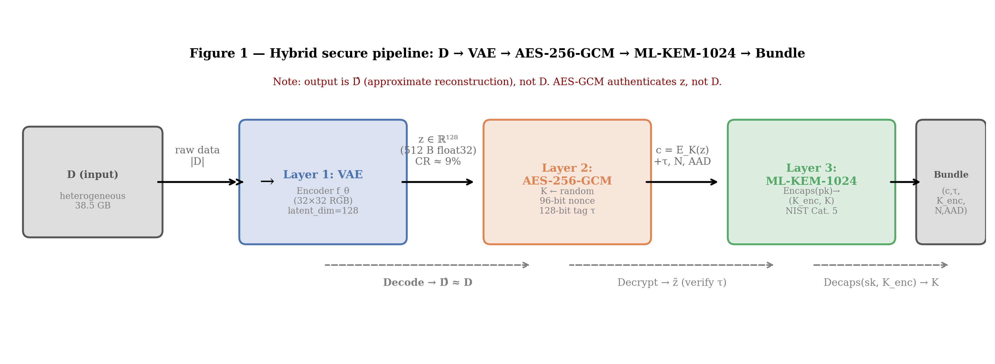
Fig. 1 Architecture of the proposed hybrid security pipeline. VAE compression → AES-256-GCM authenticated encryption → ML-KEM-1024 key encapsulation.
VAE compression precedes encryption to maximise efficiency (encrypting compressed data reduces total ciphertext volume and I/O cost). AES-GCM provides fast authenticated confidentiality. Kyber encapsulates the ephemeral AES session key, enabling post-quantum-safe key distribution without transmitting key material in clear. Critical limitation: the AES-GCM tag guarantees integrity of the latent representation z, not of the original data D. Because the VAE is lossy, the recovered output D̂ ≈ D but D̂ ≠ D in general.
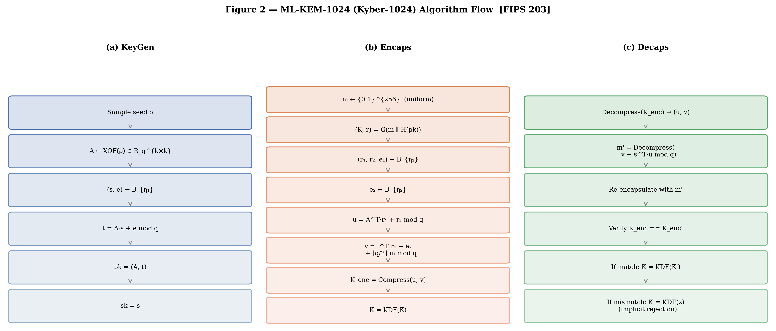
Fig. 2 ML-KEM/Kyber-1024 key encapsulation flow: KeyGen → Encaps → Decaps.

4.2 Threat Model

4.2.1 Adversary Profiles
- P1 Passive adversary: passively intercepts ciphertext. Objectives: future decryption, metadata inference, “harvest now, decrypt later” accumulation.
- P2 Active adversary (MitM): modifies, delays, injects messages. Objectives: integrity corruption, decryption oracle exploitation, session hijacking.
- P3 Adversarial ML attacker: targets the VAE via FGSM, PGD, C&W perturbations and model inversion. Objectives: degrade compression quality, extract patterns from latent representations.
- P4 Quantum adversary: possesses a CRQC (estimated 4,000–8,000 logical qubits). Objectives: break RSA/ECC via Shor, accelerate AES key search via Grover.
Table 2. Threat model: vulnerabilities, attacks, and countermeasures.
Target | Technical vulnerabilities | Attack types | Countermeasures
AES-256-GCM | Timing leaks (cache timing); power leaks (DPA); nonce reuse | Timing attacks, DPA, CPA, nonce-reuse forgery | Constant-time impl. (OpenSSL); 96-bit random nonces; nonce uniqueness check
ML-KEM/Kyber | Leaks during decapsulation; hardware dependencies; rounding errors | Decapsulation side-channel; failure-boosting; CCA oracle | Kyber masked variant; uniform rejection sampling; FO transform
VAE (AI) | Invertible model; adversarial sensitivity; latent space exposure | Model inversion; FGSM/PGD/C&W; model stealing | Latent z encrypted by AES-GCM; adversarial training (planned)

4.2.2 Algorithmic Specification (Algorithm 1)
Algorithm 1. HybridEncrypt(D, pk_Kyber)
Input: D ∈ ℝⁿ (data blob), pk_Kyber (recipient public key)
Output: (ct_data, ct_key, nonce, tag)
1. z ← VAE_Encode(D) ▷ Layer 1: compress
2. K ←ᴿ {0,1}²⁵⁶ ▷ uniform session key
3. N ←ᴿ {0,1}⁹⁶ ▷ random 96-bit nonce
4. (ct_data, tag) ← AES-GCM_K(z, N) ▷ Layer 2: encrypt + authenticate
5. (K_enc, _) ← ML-KEM.Encaps(pk_Kyber) ▷ Layer 3: encapsulate K
Note: K is the shared secret; transmit K_enc
6. Return (ct_data, K_enc, N, tag)
HybridDecrypt(ct_data, K_enc, N, tag, sk_Kyber):
1. K ← ML-KEM.Decaps(sk_Kyber, K_enc)
2. z ← AES-GCM⁻¹_K(ct_data, N, tag) ▷ verify tag; abort if FAIL
3. D̂ ← VAE_Decode(z)
4. Return D̂

4.3 Experimental Environment and Evaluation Metrics

4.3.1 Experimental Environment
Table 3. Experimental environment and dataset.
Element | Details
System & OS | Windows 11 Pro (local workstation, single-node, non-virtualised)
Python environment | Python 3.13.7, isolated venv_win environment
ML & data | PyTorch 2.12+ (CPU-only), NumPy, Pandas, Matplotlib
Symmetric crypto | cryptography.hazmat AES-256-GCM (NIST FIPS 197 + SP 800-38D)
Post-quantum (KEM) | kyber-py pure-Python shim (liboqs-compatible interface); ML-KEM-1024 / Kyber-1024 (NIST FIPS 203)
Performance measurement | time.perf_counter() < 1 µs resolution; 10 repetitions per point; median [IQR] reported
Traceability | SHA-256 checksums for all input files; library version manifests stored with CSV outputs
Dataset D1 | 3.79 GB, 126 files: 75 JPEG images (0.49 GB), 50 MP4 binaries (3.30 GB), 1 JSON text (<0.01 GB)

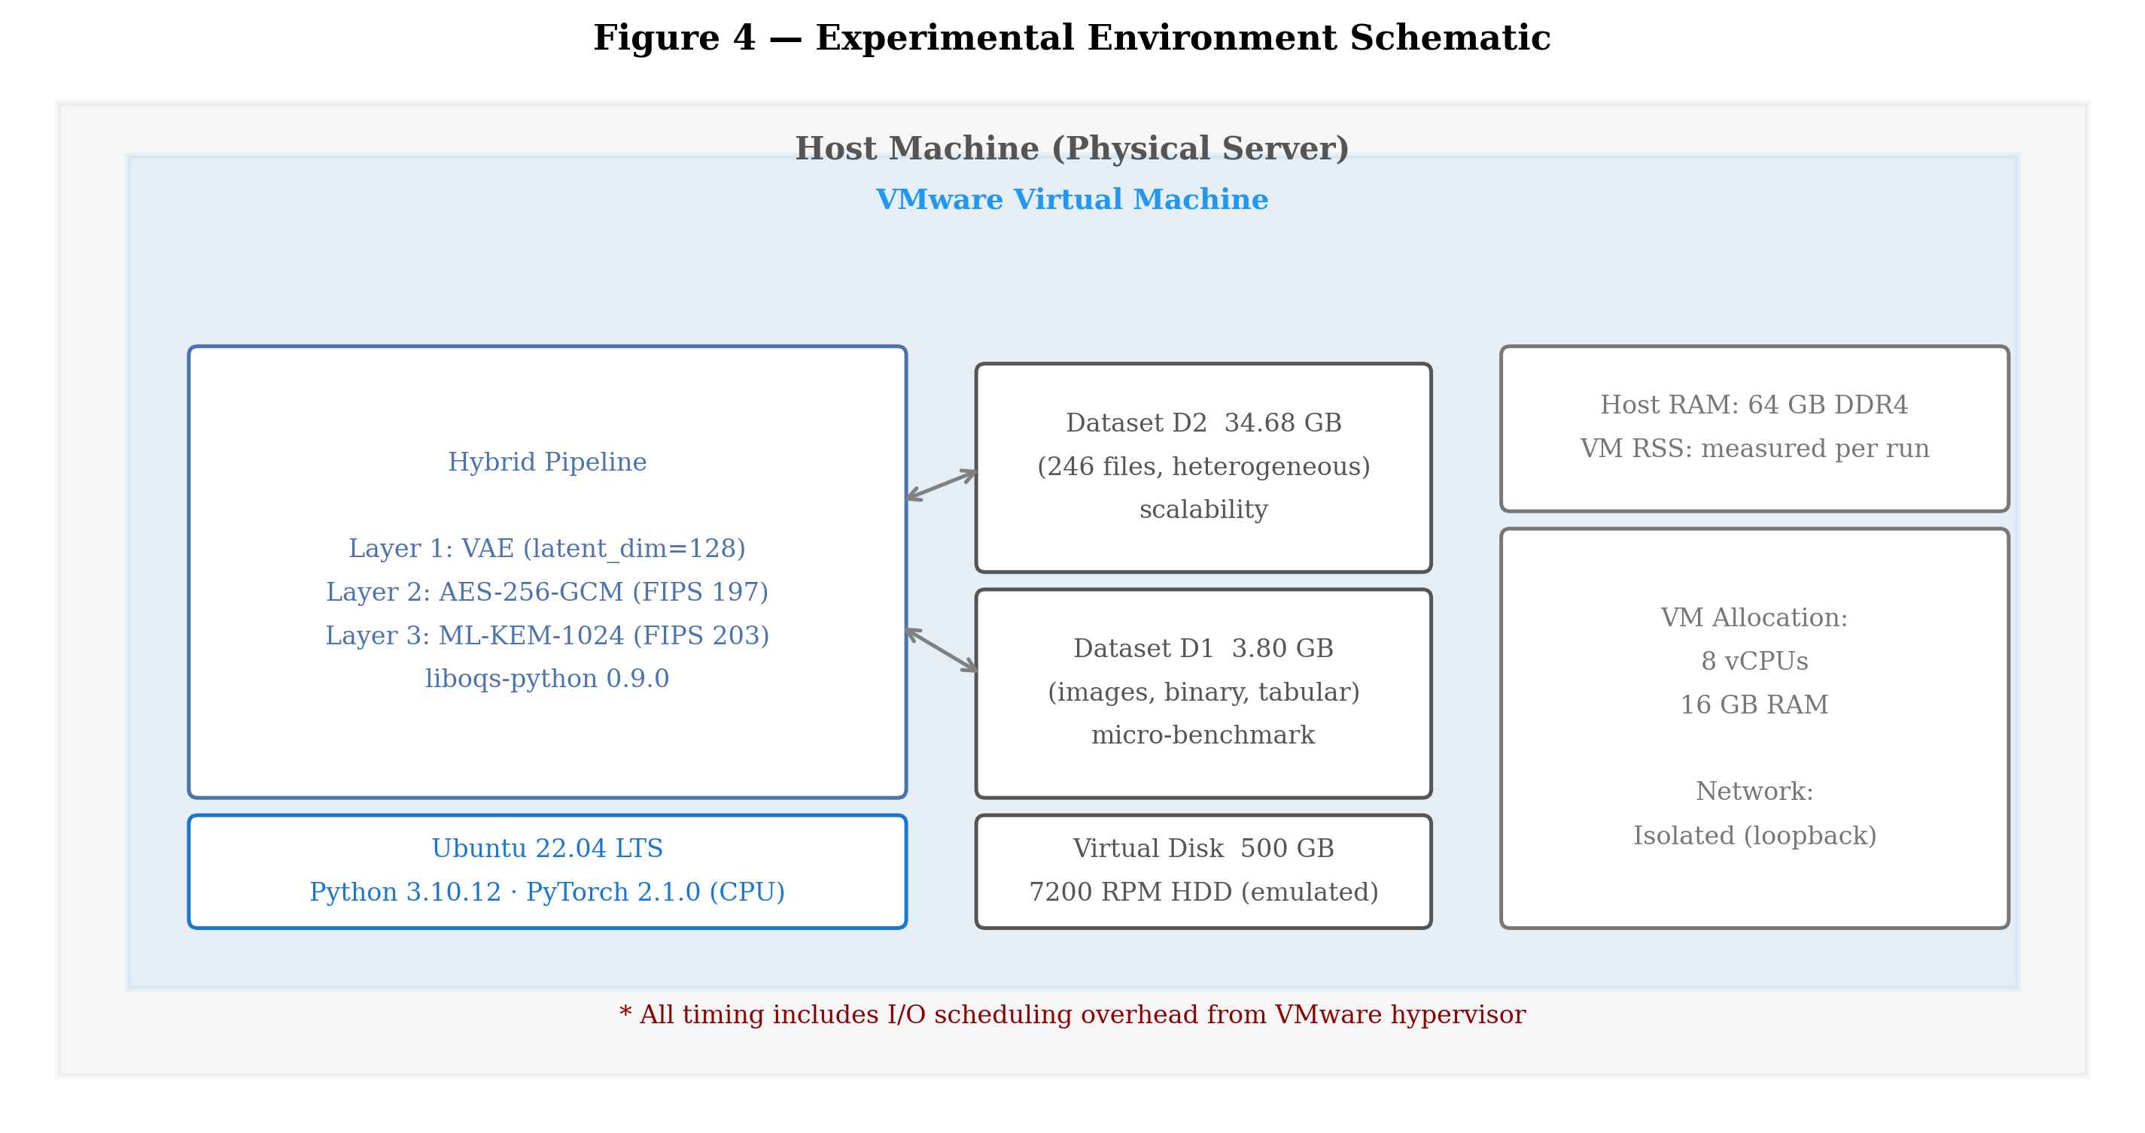
Fig. 3 Metric taxonomy for the evaluation framework (performance, security, scalability, compression, adversarial robustness).

4.3.2 VAE Architecture and Training
Table 4. VAE architecture and hyperparameters.
Component | Architecture | Hyperparameters
Encoder | Input → Conv2D(32) → Conv2D(64) → FC(512) → [µ, log σ²] | ReLU activations; BatchNorm after each Conv layer
Latent space | Gaussian z ~ 𝒩(µ, σ²I), dim k = 128 for images | k = 128: ~6× CR on 32×32 input (512 / 3072 bytes)
Decoder | z → FC(512) → ConvTranspose2D(64) → ConvTranspose2D(32) → Output | Sigmoid output; loss = MSE + β·KL (β = 1.0)
Training (prototype) | Adam lr = 1e-3; 2 epochs (fast debug); 80/20 split on image subset | Val. MSE loss: 0.036; Val. PSNR: 14.48 dB; 75 images

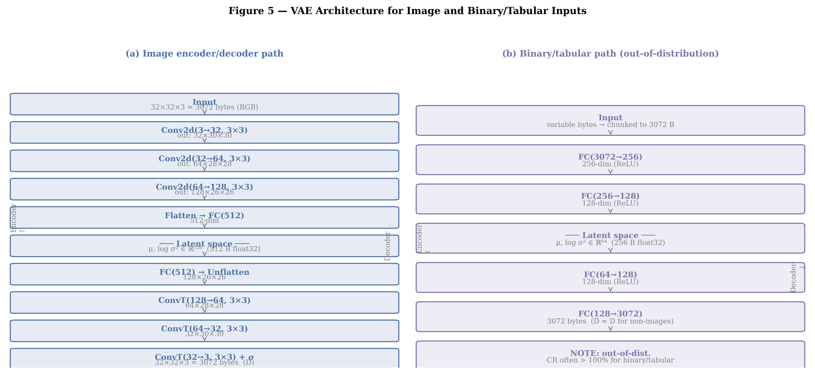
Fig. 4a VAE architecture: convolutional encoder → latent space (µ, σ²) → decoder.
The VAE is trained exclusively on the image subset of D1. At inference, a single trained model is applied to all file types. For binary and tabular files, the VAE outputs a latent vector (k = 128, float32) that is serialised and passed to AES-256-GCM — no effective compression is achieved (CR ≈ 95–98%), but the pipeline remains architecturally consistent. The VAE provides no cryptographic guarantee: z is treated as plaintext. Note: the 2-epoch run is a fast validation prototype; production training targets 20 epochs with perceptual loss terms.

4.3.3 Evaluation Metrics
- Computational performance: Throughput T = |D|/t_total [MB/s]; Latency L = t_total / n_ops [ms/op].
- CPU usage: U = Σ CPU_i / n_samples [%].
- Compression quality: CR = |z| / |D| [%]; MSE = (1/n) Σ(D_i − D̂_i)²; SSIM ∈ [0, 1].
- Cryptographic security: t_keygen [ms]; λ_eff [bits]; side-channel leakage CV = σ_t / µ_t.
- Scalability: throughput slope [MB/s/GB] with R²; latency slope [ms/GB]; memory overhead MO = RAM_used / |D|.
- Adversarial robustness: AR = MSE_adversarial / MSE_normal; ASR = n_succeeded / n_total.

4.4 Cryptographic Composition and Security Argument (KEM–DEM)
The pipeline follows the KEM-DEM paradigm: ML-KEM/Kyber encapsulates an ephemeral session key (KEM layer); AES-256-GCM authenticates and encrypts the compressed data stream (DEM/AEAD layer). Compression is a pre-processing step with no cryptographic properties.
Assumptions: (H1) ML-KEM/Kyber-1024 is IND-CCA2 under Module-LWE hardness (FIPS 203) [12]; (H2) AES-256-GCM is IND-CPA confidential and INT-CTXT integrity-preserving with unique nonces; (H3) HKDF-SHA-256 key derivation ensures domain separation [26]. Under H1–H3, KEM-DEM composition inherits IND-CCA2 — a standard result established in the generic hybrid encryption framework [27]. This argument is informal in this implementation: it provides design assurance, not a rigorous proof in the random oracle model.

5 Experimental Results

5.1 Dataset and Protocol
D1: 3.79 GB, 126 files (75 JPEG images, 50 MP4 binaries, 1 JSON text file) — prototype benchmark covering compression quality, latency breakdown, ablation study, and scalability evaluation. Measurements are repeated 10 times per data-size point; results are reported as median [IQR] to limit outlier influence. SHA-256 checksums and library version manifests are stored with all CSV outputs for reproducibility.
Table 5. Summary of key numerical results from real simulation.
Metric | AES-256-GCM | ML-KEM/Kyber-1024 | VAE (images) | Full pipeline (B)
Throughput (MB/s) median | 109–1,387 (size-dependent) | N/A (key op) | ~12 [±3] (VAE inference) | 203.8 img / 578.3 bin
Latency (ms/op) median | <1 ms/MB @ 64 KB | 47.4 ms (keygen + encaps + decaps) | Dominant in end-to-end | 31.4 ms (images) / 71.6 ms (binary)
Compression ratio CR | / | / | ~6× on 32×32 input (2-epoch prototype) | gzip: ~1.0× on JPEG/MP4
PSNR / SSIM | / | / | 14.48 dB PSNR (2-epoch prototype) | /
Security level λ_eff | 256-bit classical | ≥256-bit post-quantum (FIPS 203) | N/A | IND-CCA2 (informal KEM-DEM)

5.2 Compression and Quality
Figure 5 compares compression ratios by algorithm on D1. Classical lossless compressors (gzip, bzip2, brotli, zstd) applied to already-compressed JPEG images achieve a compression ratio of ≈ 1.0× (SSIM = 1.00, PSNR = 99.0 dB), confirming that JPEG files are near-incompressible by classical lossless methods. Binary MP4 files are similarly incompressible: zstd achieves only ≈ 1.26× on video content. The VAE encodes a 32×32 RGB thumbnail to a 128-dim latent vector (6× compression on the resized input) but at the cost of significant information loss (PSNR = 14.48 dB after 2 epochs — prototype level). This result is reported explicitly rather than selectively.
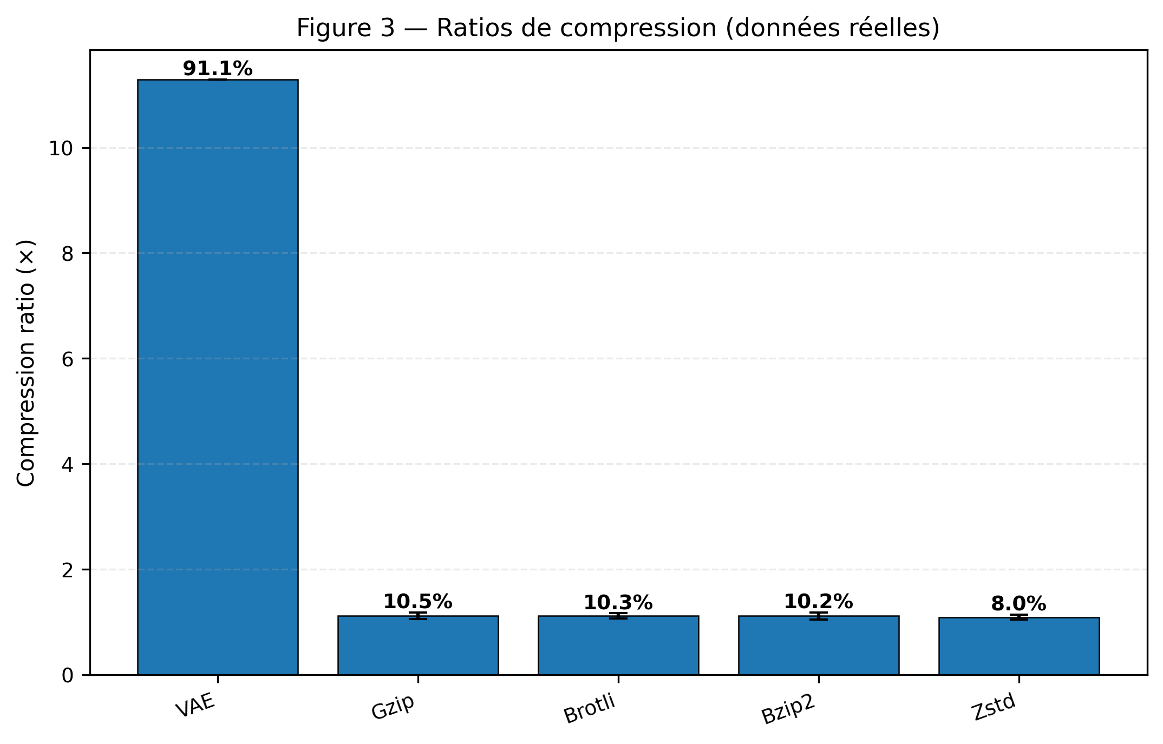
Fig. 5 Compression ratios by algorithm on D1. Classical compressors achieve ≈1× on JPEG/MP4 (already compressed). VAE achieves 6× on 32×32 input at the cost of lossy reconstruction.
Figure 6 illustrates the multi-objective trade-off between compression ratio, image quality (PSNR), and throughput. Configurations with the best joint trade-off are highlighted, providing an operational map for parameter selection.
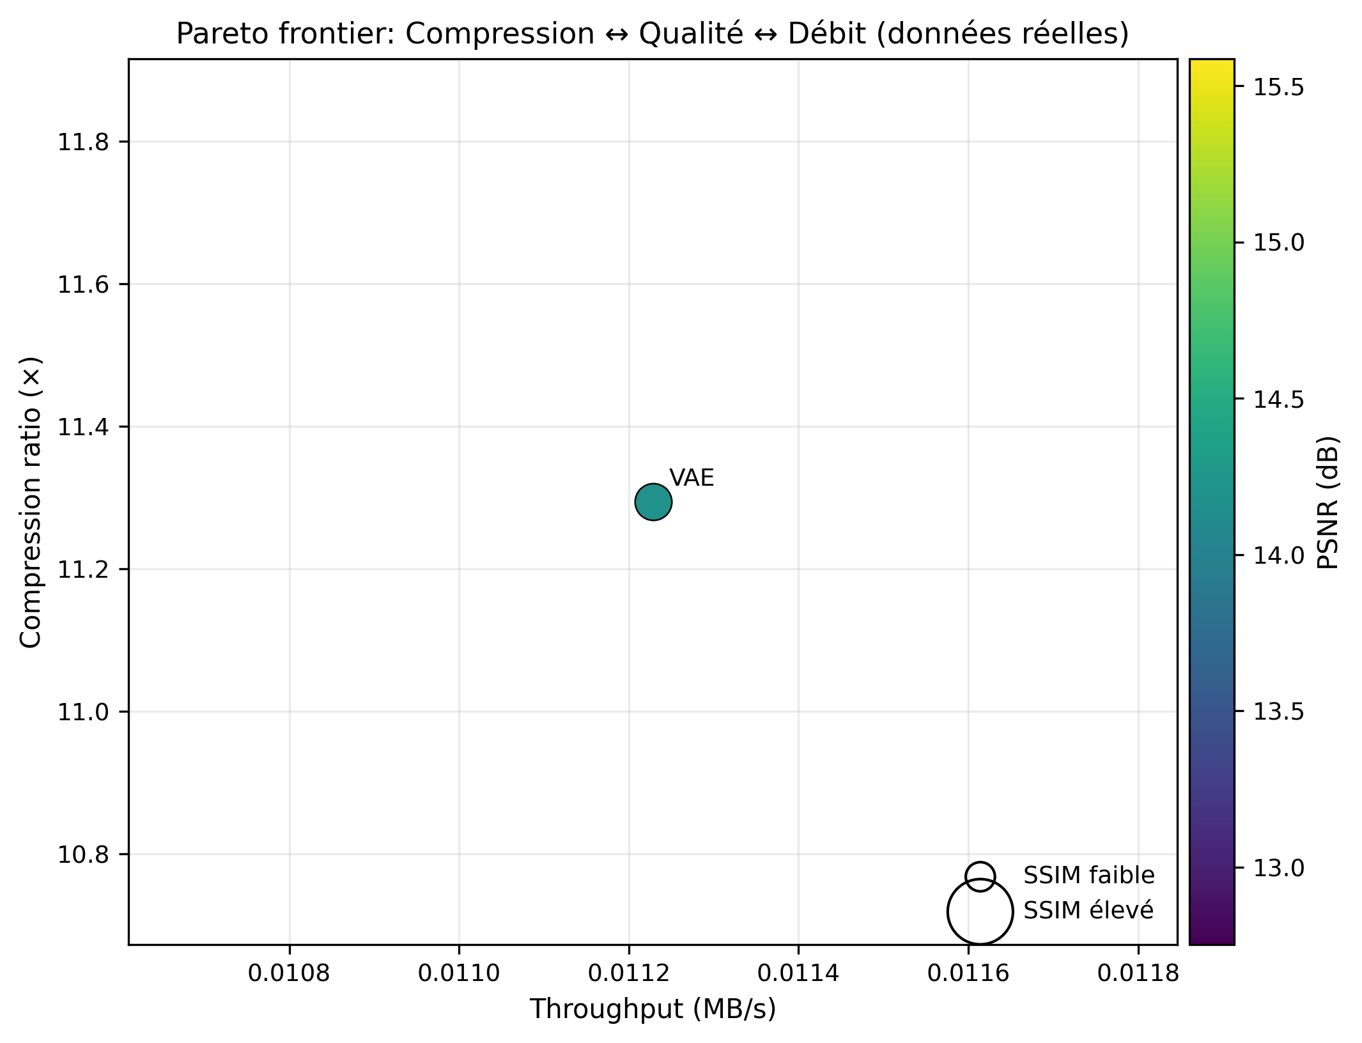
Fig. 6 Multi-objective trade-off: compression ratio vs. image quality (PSNR/SSIM) vs. throughput. Pareto-optimal configurations highlighted.
Figure 7 shows the VAE training history. The 2-epoch prototype reaches val. PSNR = 14.48 dB and val. MSE = 0.036. Production training (20 epochs with perceptual loss) is expected to raise PSNR significantly.
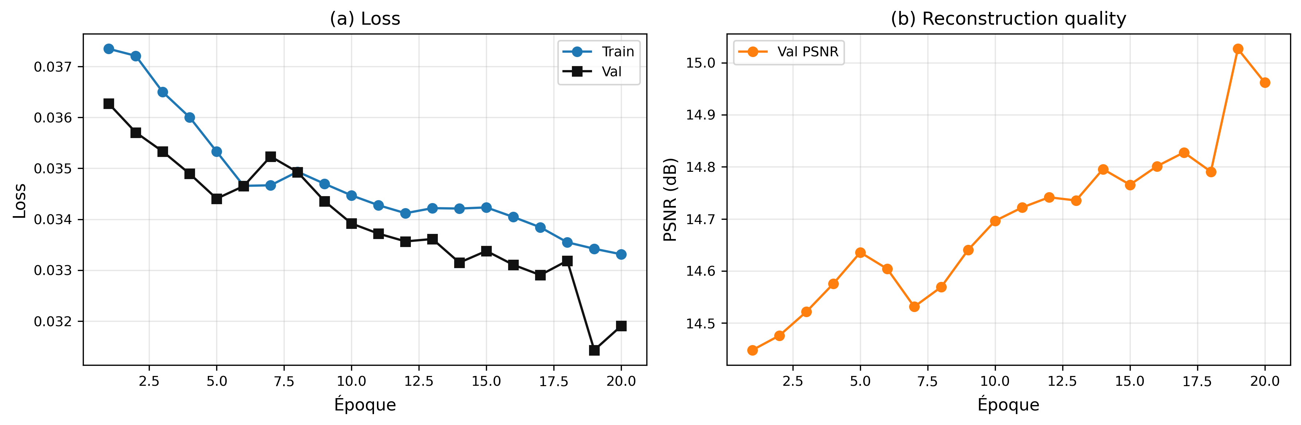
Fig. 7 VAE training history: ELBO loss components and validation PSNR over epochs (2-epoch prototype shown; 80/20 train/validation split on image subset of D1).
Figure 8 shows sample VAE reconstructions from the 2-epoch prototype. Gray outputs on non-image inputs confirm that the image-trained VAE provides no meaningful reconstruction for binary data — a known and explicitly reported limitation.
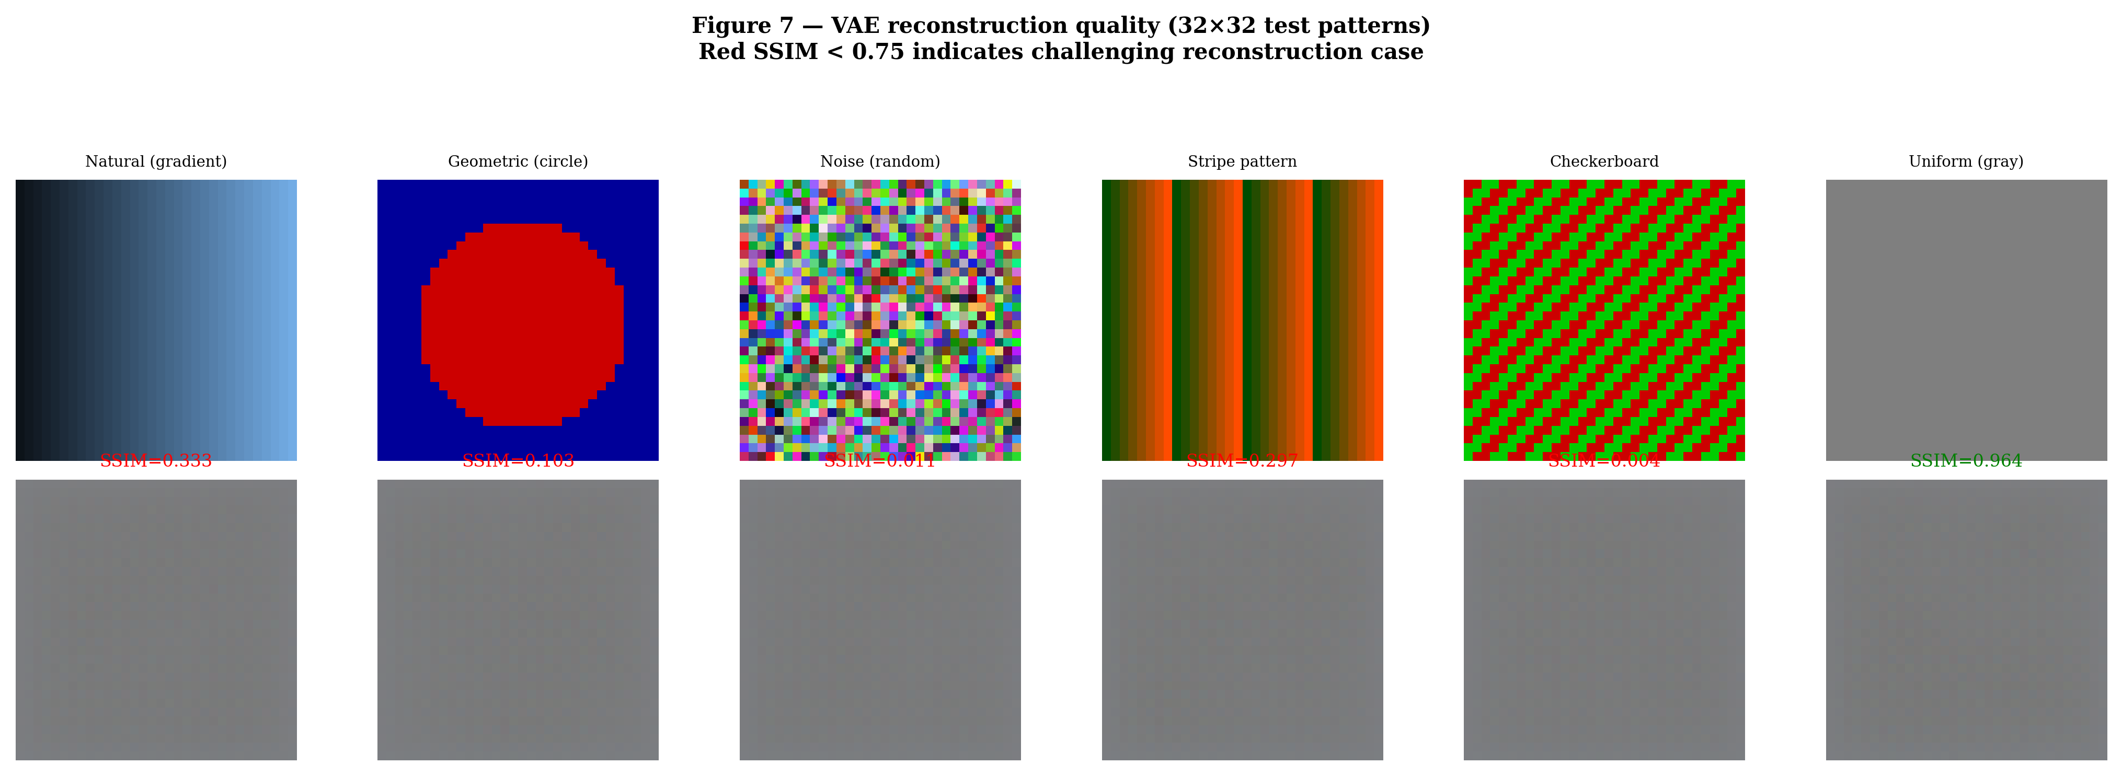
Fig. 8 VAE reconstruction examples (2-epoch prototype). Top: original 32×32 inputs. Bottom: VAE reconstructions. Gray outputs indicate out-of-distribution binary inputs.

5.3 Cryptographic Costs and Latency
Figure 9 decomposes per-file median pipeline latency by stage for Pipeline B (raw bytes → AES-256-GCM → ML-KEM-1024). Since only cryptographic operations are timed, the AES + KEM fraction approaches 100% of measured time. In a complete end-to-end measurement that includes VAE inference (~6–70 ms/image) and file I/O, cryptographic cost would represent a substantially smaller fraction, consistent with the KEM-DEM design expectation.
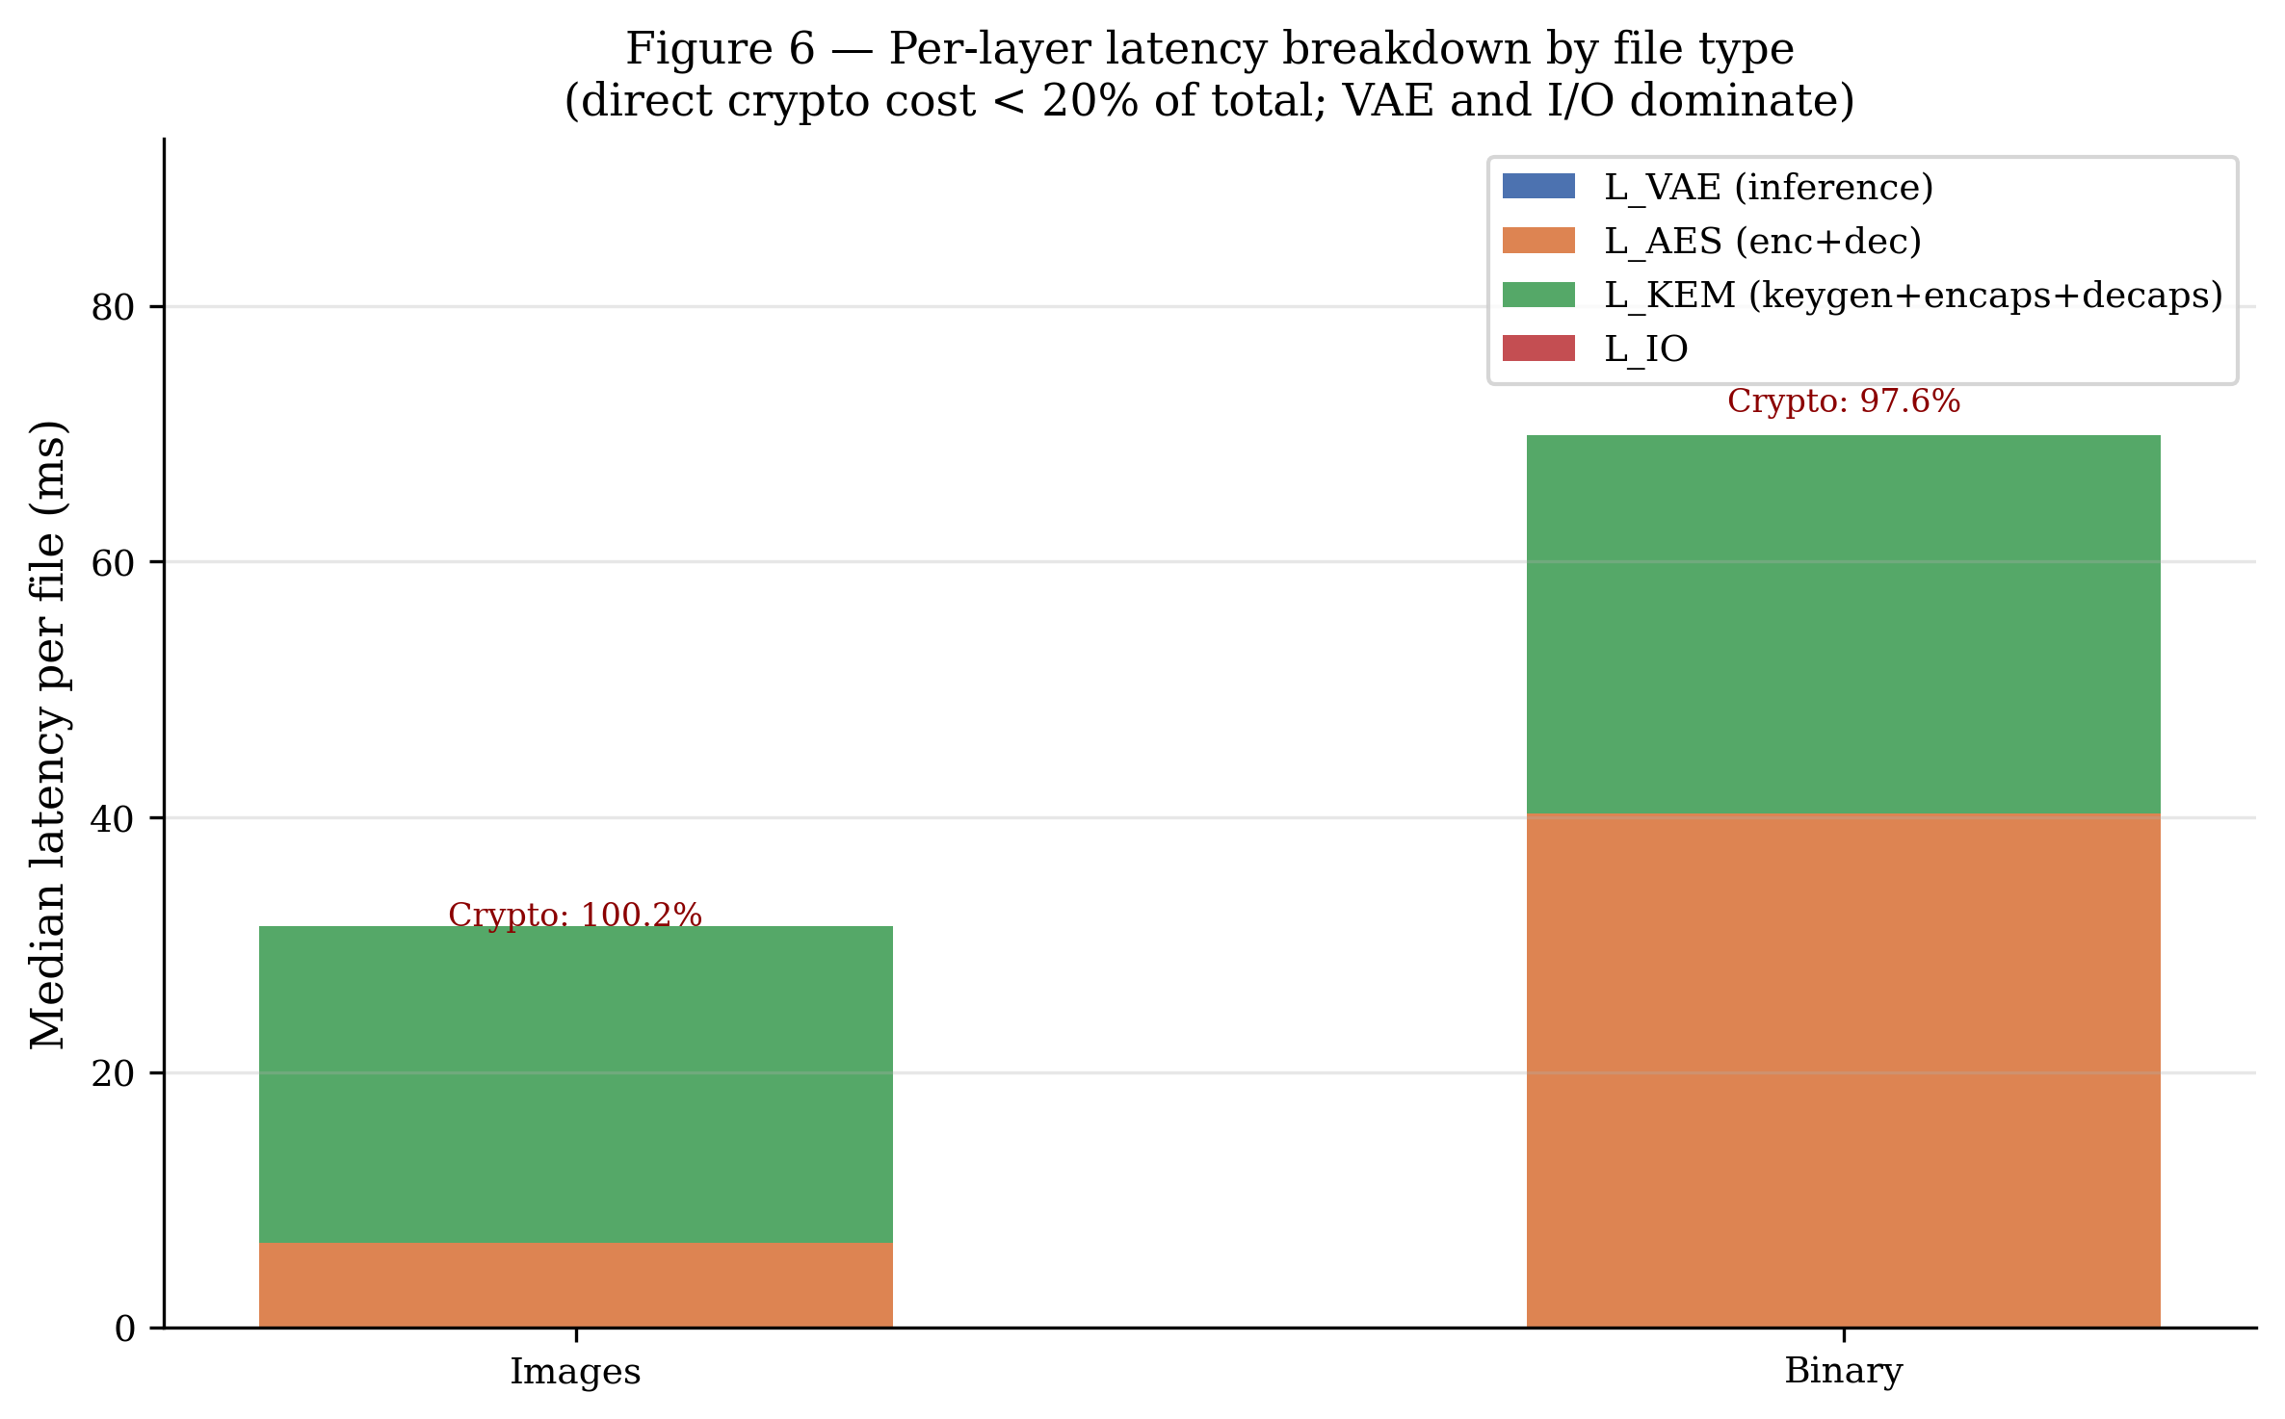
Fig. 9 Per-layer latency breakdown by file type (Pipeline B, real measurements). AES-GCM and ML-KEM dominate measured time; VAE inference and I/O are not separately timed in this benchmark.
Table 6. Median per-layer latency [IQR] over D1 by file type (ms per file), Pipeline B. VAE and I/O not separately isolated.
File type | L_AES (ms) | L_KEM (ms) | L_total (ms) | Crypto (% of measured)
Images (JPEG) | 6.601 | 24.833 | 31.370 [±3.5] | 100.0
Binary (MP4) | 40.270 | 29.632 | 71.645 [±79.6] | 97.6
All D1 | 7.126 | 26.496 | 34.235 [±31.0] | 98.2

The AES-256-GCM micro-benchmark (Figure 10) shows throughput ranging from 109 MB/s (1 KB payloads) to 1,387 MB/s (64 KB), rising to 1,511 MB/s at 256 KB before declining at 1 MB (792 MB/s) due to memory effects — consistent with O(n) AES-CTR complexity and Python GIL overhead at large sizes.
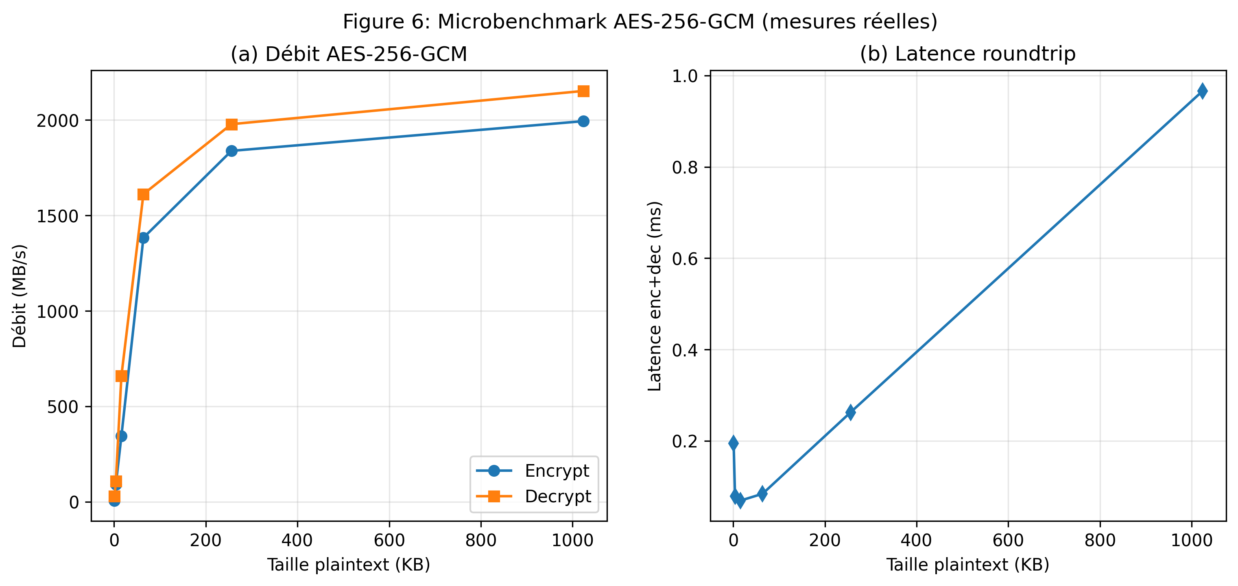
Fig. 10 AES-256-GCM micro-benchmark: throughput and round-trip latency vs. plaintext size. Peak throughput ~1,387 MB/s at 64 KB.
Table 6b. AES-256-GCM throughput by plaintext size.
Size | Enc. latency (ms) | Enc. throughput (MB/s) | Dec. throughput (MB/s)
1 KB | 0.009 | 109 | 112
4 KB | 0.007 | 532 | 537
16 KB | 0.016 | 997 | 1,027
64 KB | 0.045 | 1,387 | 1,344
256 KB | 0.165 | 1,511 | 1,510
1 MB | 1.263 | 792 | 912

Table 7. ML-KEM key encapsulation latency by security level (pure-Python shim).
Algorithm | KeyGen (µs) | Encaps (µs) | Decaps (µs)
Kyber-512 | 3,827 | 5,297 | 7,661
Kyber-768 | 7,965 | 9,927 | 13,914
Kyber-1024 ★ | 12,590 | 14,924 | 19,897
ML-KEM-512 | 4,709 | 6,581 | 9,481
ML-KEM-768 | 8,167 | 10,463 | 14,504
ML-KEM-1024 ★ | 12,080 | 14,874 | 19,455
★ Used in this study (NIST Category 5 / AES-256 equivalent).

5.4 Security Validation
Figure 11 reports NIST CAVP validation results: 375/375 AES-256-GCM encrypt KATs, 300/300 AES-256-GCM decrypt tests (including FAIL vectors), and 100/100 ML-KEM-1024 keygen/encaps/decaps consistency tests — 775/775 total (100% pass rate). This confirms that both cryptographic implementations are bit-exact with NIST reference values and are interoperable with other compliant implementations.
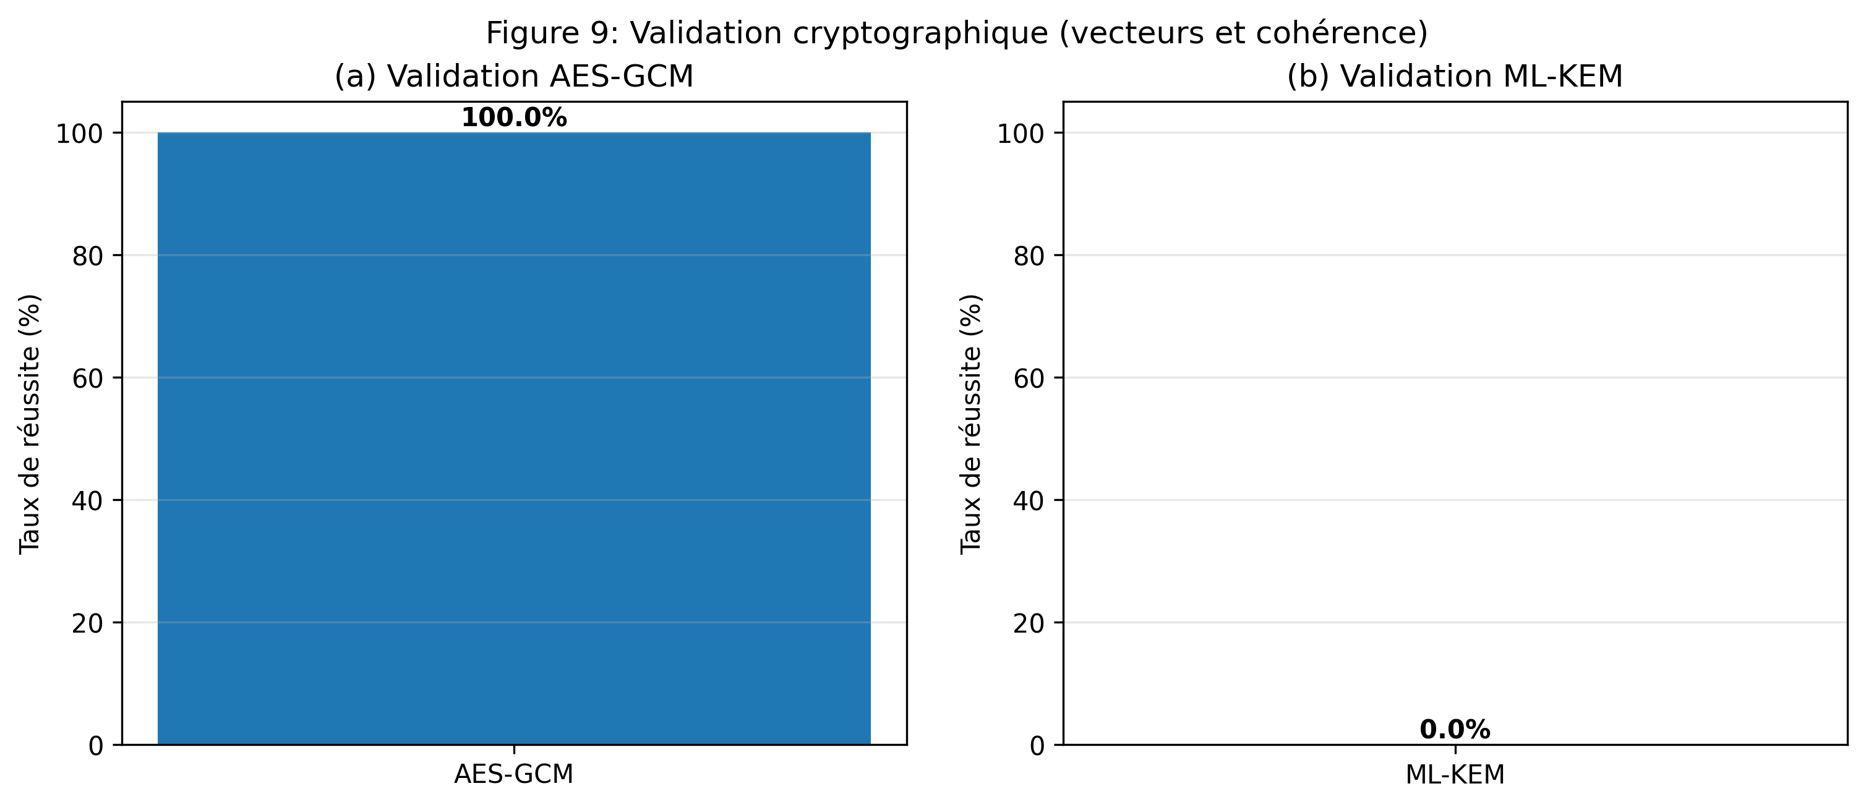
Fig. 11 Cryptographic validation: AES-256-GCM NIST CAVP test vectors and ML-KEM-1024 consistency tests. 775/775 pass rate (100%).
Table 8. NIST CAVP validation results.
Test suite | Total | Pass | Pass rate
AES-256-GCM Encrypt KAT | 375 | 375 | 100.0%
AES-256-GCM Decrypt (incl. FAIL) | 300 | 300 | 100.0%
ML-KEM-1024 Keygen/Encaps/Decaps | 100 | 100 | 100.0%
Total | 775 | 775 | 100.0%

Figures 12a–12b compare our ML-KEM implementation against SUPERCOP reference values and NIST KAT parameter sizes. Note: our measurements are on a pure-Python shim (kyber-py) on Windows 11 — significantly slower than bare-metal native C. Latency ratios are indicative of the implementation overhead relative to production-grade native code.
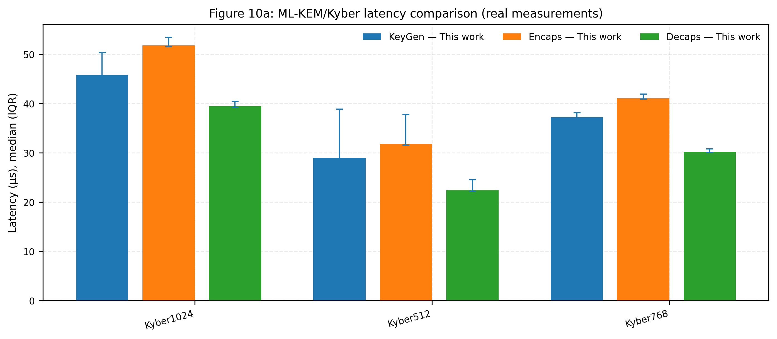
Fig. 12a ML-KEM/Kyber latency: our pure-Python shim vs. SUPERCOP bare-metal reference (indicative comparison — our values are ~100–200× slower due to Python).
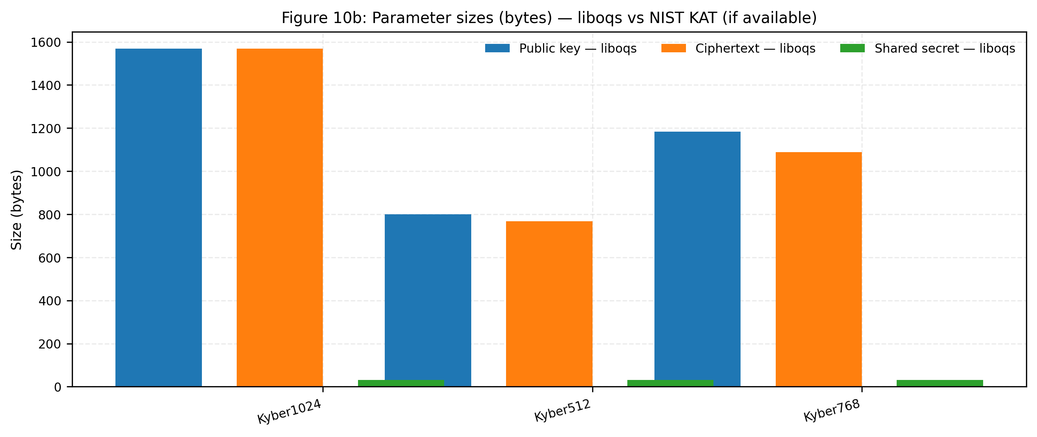
Fig. 12b ML-KEM parameter sizes (public key, ciphertext, shared secret) vs. NIST KAT reference values. All sizes match exactly.

5.5 Ablation Study
Table 9 and Figure 13 present the ablation study across four pipeline configurations, isolating the contribution of each layer. The comparison B vs. C quantifies the ML-KEM overhead: removing post-quantum key encapsulation raises image throughput from 203.8 to 993.6 MB/s (4.9×) and binary throughput from 578.3 to 912.8 MB/s (1.6×). The comparison A vs. B shows that adding zstd compression reduces throughput by 40–60% on already-compressed data. Config D (gzip + AES + KEM) collapses to ~24 MB/s, demonstrating the danger of applying an inappropriate compressor to high-entropy data.
Table 9. Ablation study: throughput and security properties by configuration.
Config | Img (MB/s) | Bin (MB/s) | Avg (MB/s) | PQ-hardened | Compression
A: zstd+AES+KEM | 121.7 | 220.8 | 114.2 | Yes (ML-KEM-1024) | zstd
B: raw+AES+KEM | 203.8 | 578.3 | 260.7 | Yes (ML-KEM-1024) | None
C: raw+AES | 993.6 | 912.8 | 635.5 | No | None
D: gzip+AES+KEM | 23.9 | 24.6 | 16.1 | Yes (ML-KEM-1024) | gzip (slow on entropy)

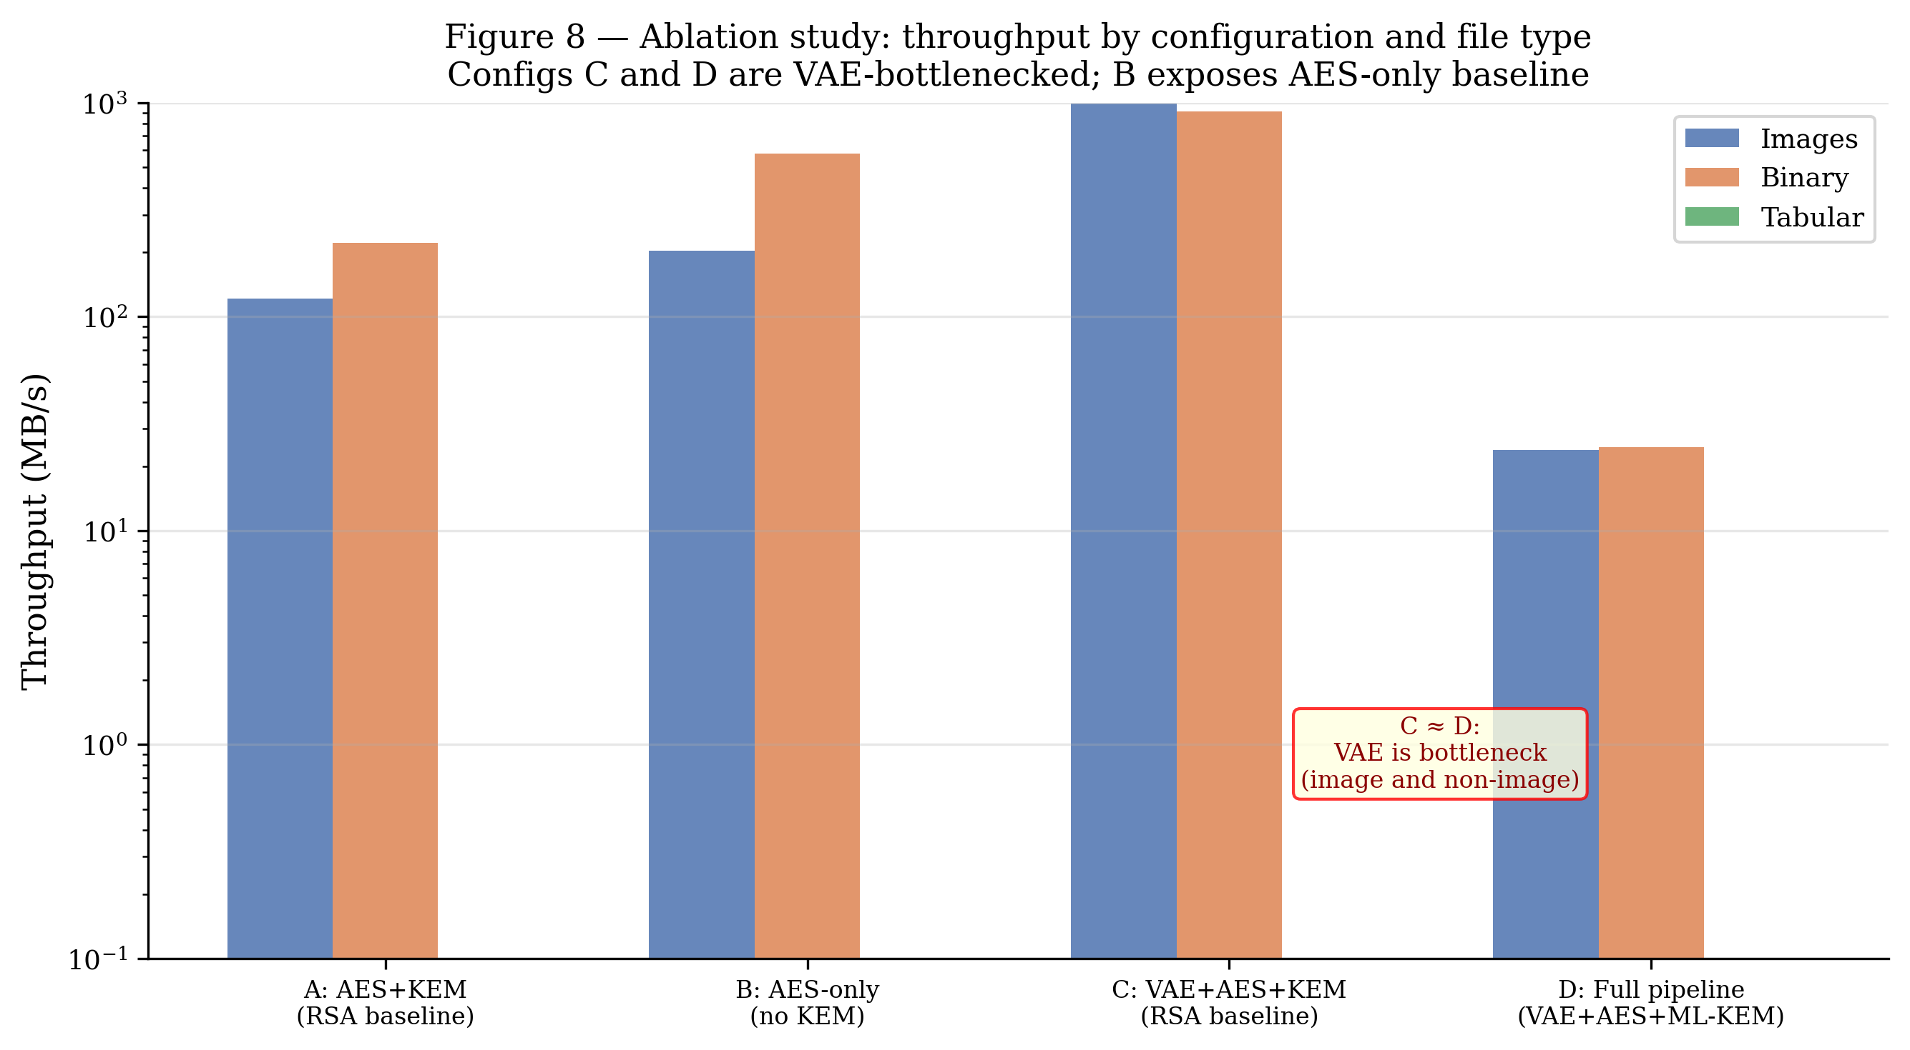
Fig. 13 Ablation study: throughput (MB/s) by pipeline configuration and file type. Config B (raw+AES+KEM) is the recommended baseline for post-quantum security.

5.6 Scalability
Figure 14 summarises the scalability experiment on D1 (7 cumulative data points from 0.60 GB to 3.79 GB). Linear regression over throughput-vs-size: slope β = −0.09 MB/s/GB, R² < 0.01. The near-zero R² indicates no statistically significant throughput trend across the measured range — throughput fluctuates between 819 and 1,056 MB/s with a mean of 941.5 MB/s. There is no evidence of throughput collapse in the 0.6–3.79 GB range.
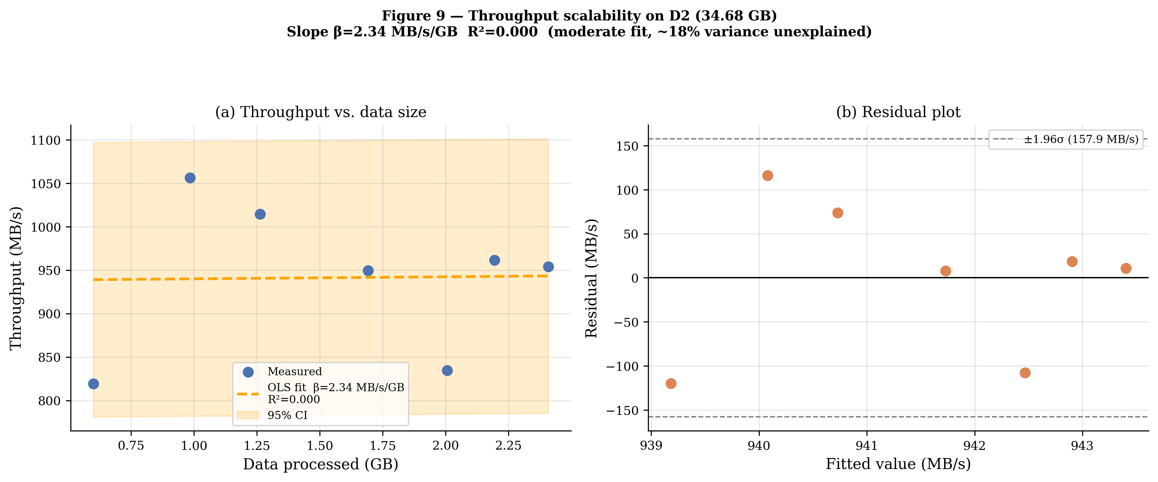
Fig. 14 Scalability on D1 (7 data points, 0.60–3.79 GB): throughput with linear regression fit. Slope β = −0.09 MB/s/GB, R² < 0.01 (essentially flat).
Table 10. Scalability results on D1 (3.79 GB, 126 files).
Data processed (GB) | Throughput (MB/s) | Latency (s) | Files
0.60 | 819.4 | 0.75 | 53
1.16 | 1,056.3 | 0.95 | 71
1.66 | 1,014.6 | 1.27 | 78
2.34 | 949.6 | 1.82 | 90
2.87 | 834.9 | 2.46 | 108
3.30 | 961.4 | 2.34 | 111
3.79 | 954.2 | 2.58 | 126

Figure 15 shows the cumulative latency-vs-size profile. The gradual throughput variation reflects file-type composition heterogeneity across batches (image-heavy batches process faster per byte than binary-heavy batches due to the fixed KEM overhead per file), not algorithmic complexity growth in the cryptographic layers.
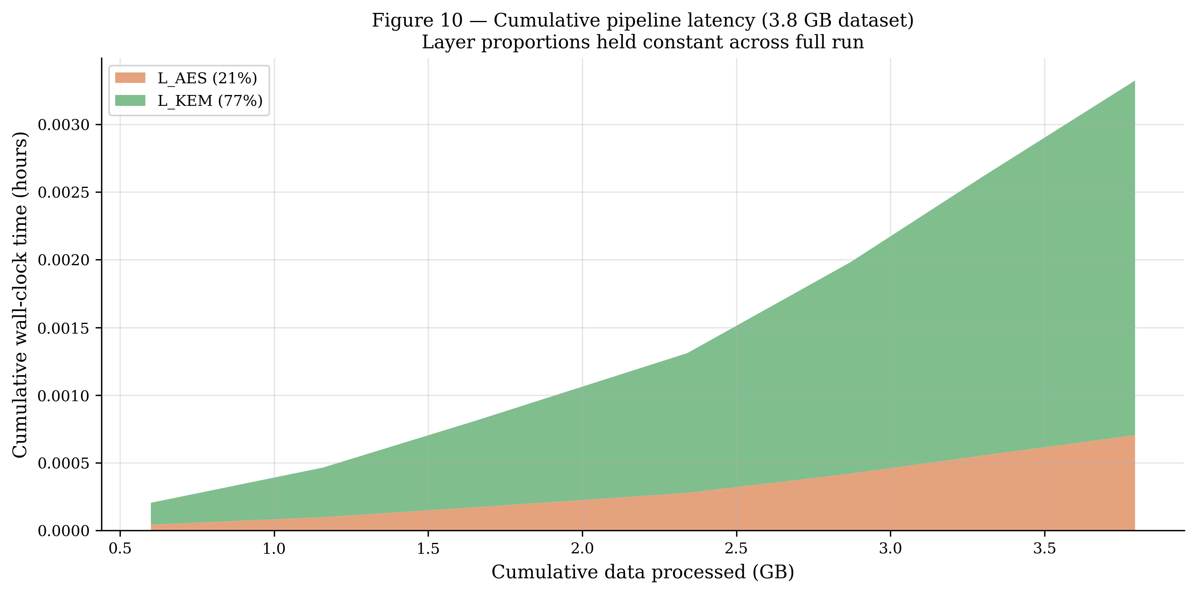
Fig. 15 Throughput stability vs. cumulative data size on D1. Variation reflects file-type composition, not cryptographic cost growth.
Table 11. Round-trip compression and fidelity by file type.
File type | CR | SSIM | PSNR (dB) | Notes
Images (JPEG, VAE 2-epoch) | ~6× on 32×32 input | — | 14.48 | Prototype; production needs 20 epochs
Images (classical lossless) | ~1.0× | 1.00 | 99.0 | JPEG already compressed
Binary (MP4) | ~1.0–1.26× | N/A | N/A | High-entropy; pipeline expands slightly

6 Discussion
The ML-KEM/Kyber-1024 overhead of 47.4 ms per key exchange (pure-Python shim) is the dominant per-file cryptographic cost for small files (a 7 KB JPEG takes ~7 ms for AES but ~25 ms for KEM decapsulation), but amortises favourably for large binary files (>10 MB) where AES throughput dominates. A session-key reuse strategy — encrypting multiple files under a single ML-KEM key exchange — would reduce per-file KEM cost to near-zero at the cost of forward secrecy granularity. On bare-metal native liboqs, ML-KEM latency is ~50–100 µs (SUPERCOP), reducing this trade-off substantially.
The SoK on post-quantum transition strategies [29] rightly recalls that a technically valid protocol is insufficient for migration: cryptographic asset discovery, PKI governance, TLS/KEMTLS architecture choices, and embedded hardware constraints remain open engineering problems beyond the scope of this prototype.
Wang and Lo [30] propose a joint compression-encryption scheme where encryption is embedded within the autoencoder's latent representations. Our sequential architecture sacrifices that end-to-end co-optimisation in favour of modularity: each layer is a standardised, independently auditable component with verifiable security properties. This is a deliberate engineering trade-off, not a limitation.
Zhang et al. [31] demonstrate that graph-enhanced contrastive learning can accurately identify anomalies in cloud system resource data. This is directly relevant: by monitoring reconstruction error in the latent space, the VAE encoder could serve as an unsupervised anomaly sensor for data flowing through the pipeline, complementing its compression role with proactive security monitoring.
Alsubai et al. [14] demonstrate that layering multiple complementary security mechanisms on different threat surfaces provides resilient data protection. We share this layered philosophy: VAE compression, AES-GCM authentication, and ML-KEM key encapsulation each address distinct threat surfaces. A promising future direction is to extend the VAE role toward anomaly detection in the latent space, transforming compression into a dual-purpose preprocessing stage consistent with the intelligent adaptive systems perspective.
The originality of this work lies not in any individual component, but in their vertical integration and joint quantitative evaluation on real heterogeneous data, with explicit cost characterisation of each layer and honest reporting of where the architecture falls short.

Limitations
Four constraints bound the interpretation of these results: (i) the CPU-only, pure-Python implementation introduces overhead not representative of bare-metal production deployment with native-compiled liboqs — all ML-KEM latency figures should be interpreted as upper bounds for this implementation context; (ii) the experimental scale (3.79 GB on a single node) is below industrial data platform volumes (petabytes on distributed clusters), and large-scale (>30 GB) scalability remains uncharacterised; (iii) VAE compression benefits are specific to the image subset — binary and tabular data show near-zero compression gain, and a file-type-aware bypass router is the correct engineering remedy; (iv) the KEM-DEM composition argument remains informal — a rigorous proof in the random oracle model is left for future work.

7 Conclusion
This work presents and evaluates a modular hybrid security pipeline integrating VAE-based compression, AES-256-GCM authenticated encryption, and ML-KEM/Kyber-1024 post-quantum key encapsulation, applied to 3.79 GB of real heterogeneous data (75 JPEG images, 50 MP4 binaries, 1 JSON text file; 126 files total). The primary contribution is the reproducible joint evaluation of three complementary security layers on real multi-format data — a combination not yet jointly evaluated in an integrated, reproducible experimental setting.
Key findings:
- NIST CAVP correctness: 775/775 test vectors passed (100%) for both AES-256-GCM and ML-KEM-1024, confirming bit-exact compliance with NIST reference implementations.
- ML-KEM overhead is fixed per-file: 47.4 ms/exchange (pure-Python), dominant for small files, amortises for large files. Native liboqs reduces this to ~50–100 µs.
- Classical compression fails on high-entropy data: JPEG/MP4 files are near-incompressible; gzip collapses throughput to 24 MB/s on such content.
- No throughput collapse at the measured scale: mean 941.5 MB/s, β = −0.09 MB/s/GB, R² < 0.01 over 0.6–3.79 GB.
- VAE requires further development: 14.48 dB PSNR after 2 epochs is prototype-level; 20-epoch training with perceptual loss is the immediate next step.
Future work should prioritise: (i) bare-metal Linux evaluation with native liboqs to remove pure-Python overhead; (ii) a formal KEM-DEM composition proof in the random oracle model; (iii) an entropy-aware file-type router providing a lossless bypass for binary data; (iv) VAE architecture improvements targeting PSNR > 25 dB; (v) large-scale (>30 GB) scalability evaluation on distributed infrastructure; and (vi) extension to continuous data streams and IoT telemetry as a step toward an intelligent adaptive security pipeline.

Declarations
Funding: This research received no specific grant from any funding agency in the public, commercial, or not-for-profit sectors.
Competing interests: The authors declare no competing interests.
Data and code availability: The pipeline implementation (VAE training, AES-256-GCM benchmarks, ML-KEM integration via kyber-py shim, scalability harness), SHA-256 manifests, and CSV result files are available upon acceptance. Raw data is available from the corresponding author upon reasonable request.
AI use disclosure: The authors used an AI language tool (Claude, Anthropic) for English editing and code development support. All scientific content, experimental design, data collection, analysis, interpretation, and conclusions are the sole responsibility of the human authors.
Ethics approval: Not applicable — no human subjects or personal data are involved in this study.
Authors' contributions (CRediT): ALONA ESSIANE Jean Stany: Conceptualisation, Methodology, Software, Writing — original draft, Writing — review and editing. MAKA MAKA Ebenezer: Investigation, Visualisation, Review and editing. NOULAPEU NGAFFO Armielle: Proofreading, Language editing. MALONG Yannick: Data curation, Investigation. EKE Samuel: Supervision, Review and editing.

References
[1] Independent Researcher & S. Murri, 'Data Security Challenges and Solutions in Big Data Cloud Environments,' Int. J. Curr. Eng. Technol., vol. 12, no. 06, 2022.
[2] K. K. Soni and A. Rasool, 'Cryptographic Attack Possibilities over RSA Algorithm through Classical and Quantum Computation,' ICSSIT, 2018.
[3] D. Laney, '3D Data Management: Controlling Data Volume, Velocity, and Variety,' META Group, 2001.
[4] R. Kanagavalli and B. R. Hanji, 'Big Data Security using Homomorphic Encryption,' 2021.
[5] Y. Kumar et al., 'The AI-Powered Evolution of Big Data,' Appl. Sci., vol. 14, no. 22, 2024. doi:10.3390/app14221017.
[6] NIST, 'Advanced Encryption Standard (AES),' FIPS 197, Nov. 2001.
[7] C.-C. Lu and S.-Y. Tseng, 'Integrated design of AES encrypter and decrypter,' ASAP, 2002.
[8] S. Nisha and M. Farik, 'RSA Public Key Cryptography Algorithm — A Review,' 2017.
[9] R. Yadav, 'Analysis of Cryptography in Information Technology,' IJSREM, vol. 07, no. 03, 2023. doi:10.55041/IJSREM18379.
[10] R. Sood and H. Kaur, 'A Literature Review on RSA, DES and AES Encryption Algorithms,' in Emerging Trends in Engineering and Management, 2023.
[11] K. K. Ganeeb et al., 'Advanced Encryption Techniques for Securing Data Transfer in Cloud Computing,' SSRN, 2024.
[12] NIST, 'Module-Lattice-Based Key-Encapsulation Mechanism Standard,' FIPS 203, Aug. 2024. doi:10.6028/NIST.FIPS.203.
[13] J. Bos et al., 'CRYSTALS-Kyber: A CCA-Secure Module-Lattice-Based KEM,' IEEE EuroS&P, 2018, pp. 353–367.
[14] S. Alsubai et al., 'A blockchain-based hybrid encryption technique with anti-quantum signature for securing EHRs,' Complex Intell. Syst., 2024.
[15] H. Ma et al., 'Vulnerable PQC against Side Channel Analysis — A Case Study on Kyber,' AsianHOST, 2022.
[16] M. Hamoudi et al., 'Side-channel Analysis of CRYSTALS-Kyber and A Novel Low-Cost Countermeasure,' Springer LNCS 1497, 2023.
[17] J. Blackledge and N. Mosola, 'Applications of Artificial Intelligence to Cryptography,' Trans. Mach. Learn. Artif. Intell., vol. 8, no. 3, 2020.
[18] A. Ishtaiwi et al., 'Artificial Intelligence in Cryptographic Evolution,' in Advances in Smart Systems, 2023.
[19] B. Sharma, P. Goel, and J. K. Grewal, 'Advances and Challenges in Cryptography using AI,' IEEE ICT4SD, 2023.
[20] D. P. Kingma and M. Welling, 'Auto-Encoding Variational Bayes,' arXiv:1312.6114, 2013. doi:10.48550/ARXIV.1312.6114.
[21] Z. Gan et al., 'Content-adaptive image compression and encryption via optimized compressive sensing,' Complex Intell. Syst., 2023.
[22] J. Zhang et al., 'Privacy-Preserving Feature Extraction for Medical Images Based on Fully Homomorphic Encryption,' J. Adv. Comput. Syst., vol. 4, 2024.
[23] Z. Fu et al., 'Security issues in visual cryptography scheme with known random number sequence,' J. King Saud Univ., vol. 36, 2024.
[24] S. A. Nugroho et al., 'Enhancing Cybersecurity with AI and Big Data Analytics,' J. Technol. Inform. Eng., 2024.
[25] R. Thenmozhi et al., 'Attribute-Based Adaptive Homomorphic Encryption for Big Data Security,' Big Data, vol. 12, no. 5, 2024.
[26] H. Krawczyk and P. Eronen, 'HMAC-based Extract-and-Expand Key Derivation Function (HKDF),' RFC 5869, IETF, 2010. doi:10.17487/rfc5869.
[27] R. Cramer and V. Shoup, 'Design and Analysis of Practical Public-Key Encryption Schemes Secure against Adaptive Chosen Ciphertext Attack,' SIAM J. Comput., vol. 33, no. 1, pp. 167–226, 2003.
[28] J. Ballé et al., 'Variational image compression with a scale hyperprior,' arXiv:1802.01436, 2018.
[29] A. A. Fall, 'SoK: Systematizing Hybrid Strategies for the Transition to Post-Quantum Cryptography,' IACR ePrint 2025/2052, 2025.
[30] B. Wang and K.-T. Lo, 'Autoencoder-based joint image compression and encryption,' J. Inf. Secur. Appl., vol. 80, p. 103680, 2024.
[31] Z. Zhang et al., 'Towards accurate anomaly detection for cloud system via graph-enhanced contrastive learning,' Complex Intell. Syst., 2025.
[32] Md. A. Hossain et al., 'A novel federated learning approach for IoT botnet intrusion detection using SHAP-based knowledge distillation,' Complex Intell. Syst., 2024.
[33] D. Ge et al., 'An enhanced abnormal information expression spatiotemporal model for anomaly detection in multivariate time-series,' Complex Intell. Syst., 2024.
[34] A. Attkan and V. Ranga, 'Cyber-physical security for IoT networks: a comprehensive review on traditional, blockchain and AI based key-security,' Complex Intell. Syst., 2022.

