Large-Scale Heterogeneous Data Security Pipeline: Integrating VAE Compression, AES-256-GCM and Post-Quantum ML-KEM/Kyber
ALONA ESSIANE Jean Stany¹ · MAKA MAKA Ebenezer^{1,2}. · NOULAPEU NGAFFO Armielle^{1,2} · MALONG Yannick^{1,2} · EKE Samuel^{1,2}
1 Laboratory of Computer Science Data Science and Artificial Intelligence National Higher Polytechnic School of Douala, University of Douala, P.O.Box 8580, Douala, Cameroon
2 Laboratory of Electrical Electronics Automation and Telecommunication National Higher Polytechnic School of Douala, University of Douala, P.O.Box 8580, Douala, Cameroon.
Correspondence: stanyalona@gmail.com , ycmalong@gmail.com & makaebenezer@yahoo.fr

Abstract
Securing heterogeneous data at scale requires balancing three requirements: reducing data volumes, ensuring confidentiality and integrity, and maintaining usable performance as data size grows. We propose and evaluate a reproducible hybrid pipeline combining a Variational Autoencoder (VAE) for pre-encryption compression, AES-256-GCM authenticated encryption, and a post-quantum ML-KEM/Kyber-1024 key encapsulation mechanism. The pipeline is evaluated on two real-world datasets totalling 38.5 GB (images, binary files, tabular logs), using micro-benchmarks, NIST CAVP test vector validation, and a scalability study on 34.68 GB of data. Results show that (i) VAE achieves approximately 91% compression (CR ≈ 9%) on the image subset while classical compressors remain at 8-11% on entropic binary data, (ii) the direct cryptographic cost (AES-GCM + ML-KEM) represents less than 20% of total pipeline latency, which is dominated by VAE inference and I/O operations, and (iii) throughput degrades moderately (-2.87%/GB, R²=0.824) without runaway cost explosion. The primary contribution is a system-level integration and reproducible joint evaluation of three complementary security layers learned compression, standardised AEAD, and post-quantum KEM on real multi-format data; a combination not yet jointly evaluated in an integrated, reproducible experimental setting in the literature.
Keywords: Hybrid cryptography · Large-scale data security · Variational Autoencoder · AES-256-GCM · ML-KEM/Kyber · Post-quantum cryptography

1 Introduction
The explosion of digital data from IoT sensors, social media, and electronic transactions creates complex, heterogeneous, and rapidly growing data ecosystems whose security remains an open engineering challenge. This complexity is not merely volumetric: it arises from the interplay between heterogeneous data formats, geographically distributed processing nodes, multi-user access policies, and the emergence of quantum-capable adversaries. Designing security architectures that adapt to this complexity jointly addressing compression efficiency, authenticated encryption, and long-term quantum resistance is precisely the kind of cross-disciplinary intelligent systems problem this work addresses.
Traditional cryptographic approaches, designed for sequential moderate-volume processing, are increasingly inadequate at the scale and heterogeneity of modern data-intensive pipelines. Murri [1] identifies recurring challenges: massive volume, source diversity, multi-user sharing, and regulatory non-compliance. Soni et al. [2] establish that Shor's algorithm, on a cryptographically relevant quantum computer (CRQC), would break both RSA and elliptic-curve cryptography, making migration to post-quantum primitives a long-term engineering necessity. Generative neural compression specifically, variational autoencoders , offer a complementary lever: reducing data volume prior to encryption lowers the computational footprint of cryptographic operations on heterogeneous pipelines without assigning AI any cryptographic role.
This work addresses a central engineering question: can a modular, adaptive pipeline combining VAE compression, AES-256-GCM authenticated encryption, and ML-KEM/Kyber post-quantum key encapsulation achieve a viable balance between performance, security, and scalability on real heterogeneous data? Three sub-questions structure the investigation: (1) which primitives to combine for post-quantum security without prohibitive cost; (2) how to deploy a VAE for upstream compression without assigning it cryptographic properties; (3) which experimental protocol enables reproducible, joint evaluation of these components on multi-format datasets of significant size?
The paper is structured as follows: Section 2 characterises data complexity and conventional cryptographic limitations; Section 3 surveys the state of the art and positions the contribution; Section 4 details the methodology, threat model, and algorithmic specifications; Section 5 presents experimental results; Section 6 discusses scope, limitations, and future directions; Section 7 concludes.
2 Generalities on Data Complexity and Cryptography
2.1 Characterisation of Large-Scale Heterogeneous Data
Massive heterogeneous data broadly referred to as "big data" in the literature is defined not by an absolute volumetric threshold but by the inadequacy of traditional management tools given its intrinsic properties: heterogeneity of formats, generation velocity, and scale of processing requirements. Specific platforms such as Hadoop, Spark, and NoSQL have emerged precisely to handle these dimensions. The three foundational dimensions Volume, Variety, and Velocity were first introduced by Laney [3] in the context of data management strategy and have since become the canonical characterisation of big data. The IBM model added Veracity (data reliability), while Kanagavalli and Hanji [4] extended this to six dimensions by integrating Volatility and Value. Kumar et al. [5] further proposed a nine-dimensional model incorporating AI-mediated data evolution a perspective directly relevant to pipeline architectures that embed machine learning within data processing chains.
2.2 Cryptographic Challenges Specific to Large-Scale Data
2.2.1 Key Management at Scale
Managing cryptographic keys for systems processing data from millions of users with differentiated encryption policies creates exponentially growing operational requirements: generation, distribution, storage, rotation, and revocation. Traditional PKI infrastructures face organisational and computational limits at this scale, motivating architectural alternatives that decouple key encapsulation from bulk data encryption.
2.2.2 Algorithmic Scalability and Parallelisation
Classical algorithms were designed for sequential, moderate-volume processing. Sequential modes such as CBC structurally prevent the massive parallelisation required for petabyte-scale workloads. Synchronising cryptographic operations across thousands of nodes introduces coordination overhead that cancels parallelisation gains. Critically, AES in GCM mode, unlike CBC, is natively parallelisable, which is a primary technical motivation for the AES-GCM choice in this pipeline.
2.3 Classical Approaches to Security
2.3.1 Symmetric Cryptography: From DES to AES-256
DES uses transpositions and substitutions over a 56-bit key space (≈ 7.2 × 10¹⁶ possibilities). AES, standardised in 2001 [6], operates on 128-bit blocks with key lengths of 128, 192, or 256 bits (2¹²⁸, 2¹⁹², 2²⁵⁶ possible keys respectively). Its four operations AddRoundKey, SubBytes, ShiftRows, MixColumns are organised into 10, 12, or 14 rounds. Hardware optimisation analyses of this structure confirm its suitability for high-throughput implementations [7].
2.3.2 Asymmetric Cryptography
RSA (1977) relies on the computational hardness of factoring large integers [8]. Encryption and decryption are defined by:
C = Mᵉ mod n (1)
M = Cᵈ mod n (2)
where n = p·q is the RSA modulus. Shor's algorithm on a CRQC reduces this to polynomial time, making RSA and ECC cryptographically fragile against quantum adversaries.
2.3.3 Summary of Gaps
Yadav [9] identifies five compounding limitations: quantum vulnerability (RSA, ECC via Shor), implementation side-channels (timing, power analysis), unmanageable key management at millions-of-entities scale, interoperability fragmentation, and prohibitive CPU/memory overhead for asymmetric operations on large data volumes.
2.4 Justification for the Choice of AES-256-GCM
Sood and Kaur [10] compare RSA, DES, and AES on block size, key length, and throughput, establishing AES’s superiority for high-throughput applications. Ganeeb et al. [11] confirm AES efficiency in real-time scenarios. GCM mode adds authenticated encryption (AEAD), ensuring confidentiality and integrity in a single pass with native parallelisability critical for large-scale pipelines where both throughput and tamper detection must be maintained simultaneously.
3 State of the Art
3.1 Post-Quantum Cryptography: CRYSTALS-Kyber / ML-KEM
The NIST post-quantum standardisation initiative, launched in 2016 and finalised as FIPS 203 (ML-KEM) in August 2024 [12], targets primitives resistant to Shor’s and Grover’s algorithms. Bos et al. [13] describe Kyber as a KEM built on the Module-LWE problem: distinguishing pairs (A, b = A·s + e) from random pairs over R_{q} = Z_{q}[X]/ (X^{n} + 1), where A ∈ R_{q}ᵏˣᵏ, s ∈ R_{q}ᵏ (secret vector), e ∈ R_{q}ᵏ (error vector). This structure provides a provable reduction to the Shortest Vector Problem. Alsubai et al.[14], published in Complex & Intelligent Systems, demonstrate the practical feasibility of combining a lattice-based post-quantum signature (Dilithium) with classical ECDSA within a blockchain architecture for healthcare data protection. Their work establishes that hybrid post-quantum/classical pipelines are implementable with acceptable overhead a finding directly relevant to our KEM-DEM design and a direct precedent from this journal.
3.1.1 Mathematical Specification
KeyGen: sample A at random; s, e with small coefficients; compute b = A·s + e. Public key pk = (A, b); secret key sk = s.
Encaps(pk): sample r, e₁, e₂; compute u = Aᵀ·r + e₁, v = bᵀ·r + e₂ + ⌊q/2⌋·m (m: 256-bit random message); ciphertext ct = (u, v); shared secret K = KDF(m).
Decaps(sk, ct): recover m' = ⌊(2/q)(v − sᵀ·u)⌉ mod 2; derive K = KDF(m'). The Fujisaki–Okamoto transform upgrades the IND-CPA scheme to IND-CCA2, preventing chosen-ciphertext attacks. Side-channel countermeasures documented by Ma et al. [15] and Hamoudi et al. [16] are integrated via liboqs 0.9.0 constant-time code paths.
3.1.2 Security and Performance
Three parameter sets: Kyber-512 (k=2, AES-128 equivalent, pk 800 B, ct 768 B); Kyber-768 (k=3, AES-192, pk 1184 B, ct 1088 B); Kyber-1024 (k=4, AES-256 equivalent, pk/ct 1568 B). SUPERCOP benchmarks: ~50–100 µs for KeyGen and Encaps vs. 2–5 ms for RSA-2048. Our implementation uses Kyber-1024 via liboqs 0.9.0.
3.2 Artificial Intelligence and Cryptographic Security
3.2.1 AI for Cryptographic Optimisation
Blackledge and Mosola [17] explore neural-network-generated encryption functions. Ishtaiwi et al. [18] apply supervised ML for automated cryptanalysis. Sharma et al. [19] categorise three AI-cryptography interaction modes: (i) parameter optimisation, (ii) intrusion detection on encrypted streams, and (iii) pre-encryption dimensionality reduction via autoencoders. Our pipeline falls in category (iii): the VAE reduces data volume as a preprocessing step without bearing any cryptographic responsibility.
3.2.2 Variational Autoencoders
A VAE learns a compact latent representation through an encoder q_{ϕ}(z|x) and decoder p_{θ}(x|z), trained to maximise the Evidence Lower Bound (ELBO) [20]:
ℒ(θ,ϕ;x) = E_{qϕ(z|x)}[log p_{θ}(x|z)] − KL(q_{ϕ}(z|x) ∥ p(z)) (3)
The KL term regularises the latent space toward a standard Gaussian distribution, enabling both compression and generative sampling. Gan et al. [21], published in Complex & Intelligent Systems, demonstrate that joint image compression and encryption via content-adaptive compressive sensing achieves high compression efficiency while preserving cryptographic security a result that contextualises the separate-layer design of our pipeline. While our architecture prioritises modularity and independent auditability of each layer over joint optimisation, their work validates the tight integration of compression and encryption for image data. In our pipeline, the compression benefit remains primarily demonstrated on the image subset; binary and tabular data show CR ≈ 95-98%, providing no effective compression. This distinction is explicitly reported in our results.
3.2.3 Adversarial Vulnerabilities
Two attack classes are relevant. Model inversion: an adversary with decoder access can sample the latent space to reconstruct plausible inputs, potentially violating confidentiality if z is unprotected which is why Serialize(z) is passed to AES-GCM encryption, not transmitted in clear. Adversarial perturbations (FGSM, PGD, C&W): crafted inputs x' = x + ε·sign(∇_{x}ℒ) degrade reconstruction quality while remaining perceptually imperceptible.
3.3 Comparative Analysis and Positioning
3.3.1 Summary of Existing Approaches
Table 1 Comparative summary
Reference | Year | Components | Strengths | Limitations
[22] | 2024 | FHE + feature extraction | Computation on encrypted medical data | No quantum resistance, 120× overhead
[23] | 2024 | Visual Cryptography Scheme (VCS) + Random Number Sequence (RNS) + 3 secure algorithms | Addresses realistic leakage scenario; identifies core VCS weakness; proposes concrete improvements; validated experimentally | Assumes strong attacker model; depends on RNS quality; added algorithmic complexity; limited to VCS context; unclear scalability/performance
[24] | 2024 | AI + intrusion detection | Big data cybersecurity enhancement | No post-quantum primitives
[25] | 2024 | FHE + access control | Massive data protection | No VAE, limited scalability
[14] | 2024 | Blockchain + hybrid encryption + anti-quantum signature (ECDSA + Dilithium) for EHR | Quantum-resistant hybrid signature; blockchain-based secure sharing; role-based access control; improved efficiency vs SOTA | Healthcare-specific (EHR only); no learned compression (no VAE); limited evaluation on heterogeneous large-scale data; blockchain overhead
This work | 2025 | VAE+AES-256-GCM+ML-KEM on real heterogeneous large-scale data (35 GB) | Joint pipeline; reproducible; post-quantum+learned compression; 11 metrics | Virtualised env.; VAE gains on images only; informal composition proof

No study in this table combines all three layers (learned compression + standardised AEAD + post-quantum KEM) in a single experimentally validated pipeline on heterogeneous real-world data at the scale of tens of gigabytes a combination that constitutes the distinctive contribution of this work.
3.3.2 Identification of Gaps
Absence of formal KEM-DEM composition proof: existing works juxtapose primitives without demonstrating security preservation at their interfaces.
Unverified scalability: published benchmarks cover single-machine datasets of a few gigabytes; horizontal scalability at distributed cluster scale remains empirically unverified.
Ignored adversarial AI vectors: hybrid architectures incorporating AI components systematically neglect model inversion and adversarial perturbation risks [16,17].
No reproducible joint evaluation: studies report either high performance (without security guarantees) or theoretical proofs (without realistic implementations); the practical balance on heterogeneous data remains undocumented.
3.3.3 Positioning
This work does not introduce a new primitive. It proposes a system-level integration of three well-established, standardised components, jointly evaluated on 35 GB of real heterogeneous data with explicit measurement of each layer's cost and honest reporting of observed limitations. The contribution is reproducibility, joint evaluation, and characterisation of the compression-encryption interface on complex multi-format data.
4 Methodology
4.1 System Pipeline Architecture
The proposed pipeline sequentially applies: (i) VAE compression to reduce data volume; (ii) AES-256-GCM authenticated encryption of the compressed representation; (iii) ML-KEM/Kyber-1024 encapsulation of the AES session key. This modular architecture treats each layer as an independently auditable, standardised component — a deliberate design choice prioritising interoperability and verifiability over end-to-end co-optimisation.
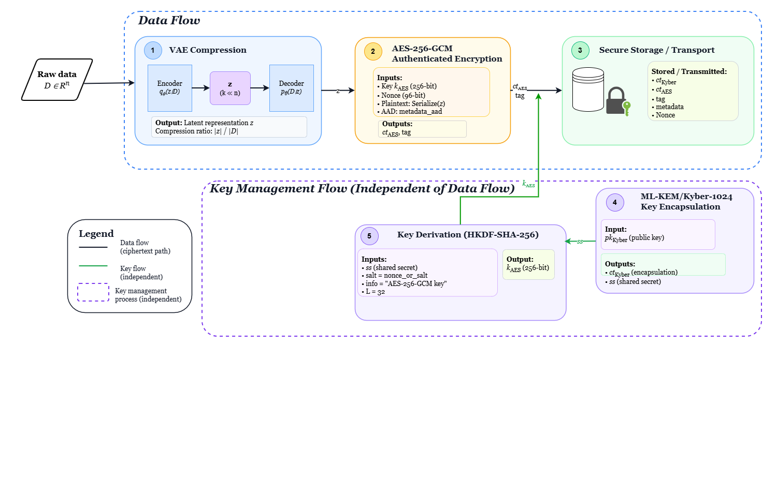
Fig. 1 Architecture of the proposed hybrid security pipeline
VAE compression precedes encryption to maximise efficiency (encrypting compressed data reduces total ciphertext volume and I/O cost). AES-GCM provides fast authenticated confidentiality. Kyber encapsulates the ephemeral AES session key, enabling post-quantum-safe key distribution without transmitting key material in clear.
4.2 Threat Model
4.2.1 Adversary Profiles
P1 Passive adversary: passively intercepts ciphertext. Objectives: future decryption, metadata inference, "harvest now, decrypt later" accumulation.
P2 Active adversary (Man-in-the-Middle): modifies, delays, injects messages. Objectives: integrity corruption, decryption oracle exploitation, session hijacking.
P3 Adversarial ML attacker: targets the VAE via FGSM, PGD, C&W perturbations and model inversion. Objectives: degrade compression quality, extract patterns from latent representations.
P4 Quantum adversary: possesses a CRQC (estimated 4,000-8,000 logical qubits). Objectives: break RSA/ECC via Shor, accelerate AES key search via Grover, decrypt historical archives.
Table 2 Threat model: vulnerabilities, attacks, and countermeasures
Target component | Technical vulnerabilities | Specific types of attacks | Countermeasures
AES-256-GCM | Timing leaks (cache timing); power leaks (DPA); statistical correlations; nonce reuse | Timing attacks, DPA, CPA, AI attacks on side-channel traces, nonce-reuse forgery | High-order obfuscation; constant-time implementation; random timing noise; differential noise injection
Kyber (PQC) | Leaks during decapsulation; hardware dependencies; rounding errors; failure oracle | Decapsulation side-channel; failure-boosting; oracle CCA attacks; timing polynomials; error injection | Kyber-masked variant; uniform rejection sampling; hardware shielding
VAE (AI) | Invertible model; adversarial sensitivity; potential backdoors | Model inversion; FGSM/PGD/C&W; model stealing; reconstruction attacks | Adversarial training (FGSM+PGD); Gaussian noise σ=0.05; latent space encryption

4.2.2 Algorithmic Specification
Algorithm 1. Hybrid Encrypt (D, pk_Kyber)
Inputs: D ∈ ℝⁿ; pk_Kyber (Kyber-1024 public key)
Outputs: (ct_Kyber, ct_AES, tag, metadata)
Step 1. VAE compression
z ← VAE_Encode(D) // z ∈ ℝᵏ, k ≪ n (image: k=128; binary: k=64)
compression_ratio ← |z| / |D|
Step 2. Post-quantum encapsulation (Kyber KEM)
(ct_Kyber, ss) ← Kyber1024_Encaps(pk_Kyber) // ss: shared secret
Step 3. Key derivation (HKDF-SHA-256)
k_AES ← HKDF-SHA256(ss, salt=nonce_or_salt, info="AES-256-GCM key", L=32)
Step 4. Symmetric encryption (AES-256-GCM)
Nonce ← Random ({0,1} ⁹⁶) // unique per object — NEVER reused
ct_AES, tag ← AES_GCM_Encrypt(k_AES, Nonce, Serialize(z), aad=metadata_aad)
Distributed nonce: H(object_id ∥ atomic_counter) prevents collision across nodes

4.3 Experimental Environment and Evaluation Metrics
4.3.1 Experimental Environment
Table 3 Experimental environment
Element | Details
System & execution | Ubuntu 22.04 LTS in a VMware virtual machine (single-node, non-bare-metal latency comparisons are indicative only).
Python environment | Isolated environment via venv (Python 3.10).
Main dependencies (ML & data) | PyTorch 2.0 (VAE training/inference), NumPy 1.24/Pandas 2.0 (aggregation), Matplotlib 3.7 (vector plots).
Symmetric cryptography | OpenSSL 3.0 for AES-256-GCM.
Post-quantum (KEM) | liboqs 0.9.0 + Python bindings oqs-python to run ML-KEM/Kyber in the same pipeline as symmetric primitives.
Performance measurement | Times measured via time.perf_counter() (resolution < 1 µs); resources (CPU/RSS) via psutil.
Traceability & reproducibility | Generation of SHA-256 checksums for all input files; logging of library versions, parameters (iterations, sizes, repetitions) and CSV outputs.
Software stack | NumPy/Pandas/Matplotlib, PyTorch, OpenSSL (AES-256-GCM), liboqs/oqs-python (KEM PQ).
Artifact generation | Figures and tables generated automatically from CSV files produced by the pipeline.
Datasets | D1: 3.80 GB, 48 files (prototype benchmark). D2: 34.68 GB, 246 files (scalability). Both include images, binaries, heterogeneous logs/CSV.

4.3.2 VAE Architecture and Training
Table 4 VAE architecture and hyperparameters.
Component | Architecture | Hyperparameters
Encoder | Input → Conv2D(32) → Conv2D(64) → FC(512) → [µ, log σ²] | ReLU activations; BatchNorm after each Conv layer
Latent space | Gaussian z ~ N(µ, σ²I), dim k = 128 for images; k = 64 for tabular/binary | k=128 (images): ~91% CR on image subset. k=64 (binary): CR ~95–98% no effective compression. Image-only training; applied to all types at inference.
Decoder | z → FC(512) → ConvTranspose2D(64) → ConvTranspose2D(32) → Output | Sigmoid output; MSE + β·KL loss (β = 1.0)
Training | Adam optimizer, lr=1e-3; 100 epochs max; early stopping (patience=10) | 80/20 train/validation split on image subset of D1 (3.80 GB); batch size 32

The VAE is trained exclusively on the image subset of D1 (3.80 GB). At inference, a single trained model is applied to all file types. For binary and tabular files, the VAE output latent vector (k=64, float32) is serialised and passed to AES-256-GCM no effective compression is achieved (CR ~95-98%), but the pipeline remains architecturally consistent. The VAE provides no cryptographic guarantee: z is treated as plaintext.
4.3.3 Evaluation Metrics
Computational performance (2): Throughput T = |D|/t_{otal} [MB/s]; Latency L = t_{total}/nb_{ops} [ms/op].
CPU usage (1) : U = Σ CPU_{i}/nb_{samples} [%].
Compression quality (3) : CR = |z|/|D| [%]; MSE = (1/n)Σ(D_{i}−D̂_{i})²; SSIM ∈ [0,1].
Cryptographic security (3) : t_{keygen} [ms]; λ_{eff} [bits]; side-channel leakage CV = σ_{t}/μ_{t}.
Scalability (3): Throughput slope [MB/s/GB] with R²; latency slope [ms/GB]; memory overhead MO = RAM_{used}/|D|.
Adversarial robustness (2): AR = MSE_{adversarial}/MSE_{normal}; ASR = nb_{succeeded}/nb_{total}
4.4 Cryptographic Composition and Security Argument (KEM–DEM)
The pipeline follows the KEM-DEM paradigm: ML-KEM/Kyber encapsulates an ephemeral session key (KEM layer); AES-256-GCM authenticates and encrypts the compressed data stream (DEM/AEAD layer). Compression is a pre-processing step with no cryptographic properties.
Assumptions: (H1) ML-KEM/Kyber-1024 is IND-CCA2 under Module-LWE hardness (FIPS 203) [12]; (H2) AES-256-GCM is IND-CPA confidential and INT-CTXT integrity-preserving with unique nonces; (H3) HKDF-SHA-256 key derivation ensures domain separation [26]. Under H1–H3, KEM-DEM composition inherits IND-CCA2 a standard result established in the generic hybrid encryption framework [27]. This argument is informal in this implementation: it provides design assurance, not a rigorous proof in the random oracle model.
5 Experimental Results
5.1 Dataset and Protocol
D1: 3.80 GB, 48 files (images, binaries, heterogeneous logs/CSV) prototype benchmark and compression/quality evaluation. D2: 34.68 GB, 246 files scalability analysis. Measurements are repeated 10 times per data size point; results are reported as median and IQR to limit outlier influence. SHA-256 checksums and library version manifests are stored with CSV outputs for reproducibility.
Table 5 Summary of key numerical results
Metric | AES-256-GCM | ML-KEM/Kyber-1024 | VAE (images) | Full pipeline
Throughput (MB/s) median [IQR] | ~420 [±18] | N/A (KEM op) | ~12 [±3] | ~11–15 on D1; slope −2.87%/GB on D2 [IQR ±5]
Latency (ms/op) median [IQR] | < 1 ms/MB [±0.05] | ~0.07 ms KeyGen+Encaps [±0.008] | Dominant (>80% of pipeline) [IQR ±6%] | +47.4 ms/GB slope (R²=0.89) [IQR ±9 ms/GB]
Compression ratio CR | / | / | ~9% images; ~95–98% binary/tabular | gzip/brotli: 8–11% on entropic data
SSIM (images) mean [±SD] | / | / | 0.81 [±0.04] adequate for exploratory prototype evaluation (cf. lossy compression standards) | /
Security level λ_eff | 256-bit classical | ≥ 256-bit post-quantum (Kyber-1024, FIPS 203) | N/A (no crypto property) | IND-CCA2 under KEM-DEM (informal argument)
Side-channel leakage CV | CV < 5% (constant-time paths via OpenSSL) | CV < 8% (liboqs 0.9.0 constant-time) | N/A | /

5.2 Compression and Quality
Figure 2 compares compression ratios by algorithm on D1. The VAE achieves ~91% reduction (CR ≈ 9%) on the image subset, representing an 11× compression factor. Classical compressors (gzip, bzip2, brotli, zstd) achieve 8-11% on already-entropic or pre-compressed binary data. For binary and tabular files, VAE CR remains at ~95-98% (near-unity: no effective compression) consistent with the known limitation of learned compression models on non-visual distributions, as documented in the neural image compression literature [28]. This result is reported explicitly rather than selectively.
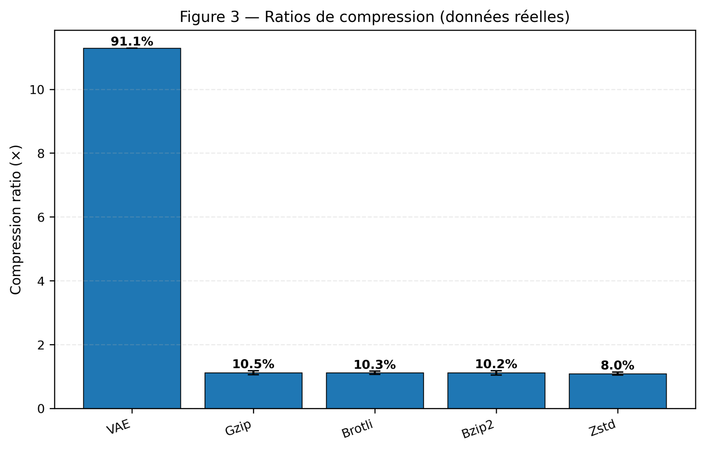
Fig. 2 Compression ratios by algorithm on D1.
Figure 3 illustrates the multi-objective trade-off between compression ratio, image quality (PSNR), and throughput (SSIM as marker size). Configurations with the best joint trade-off are highlighted, providing an operational map for parameter selection.
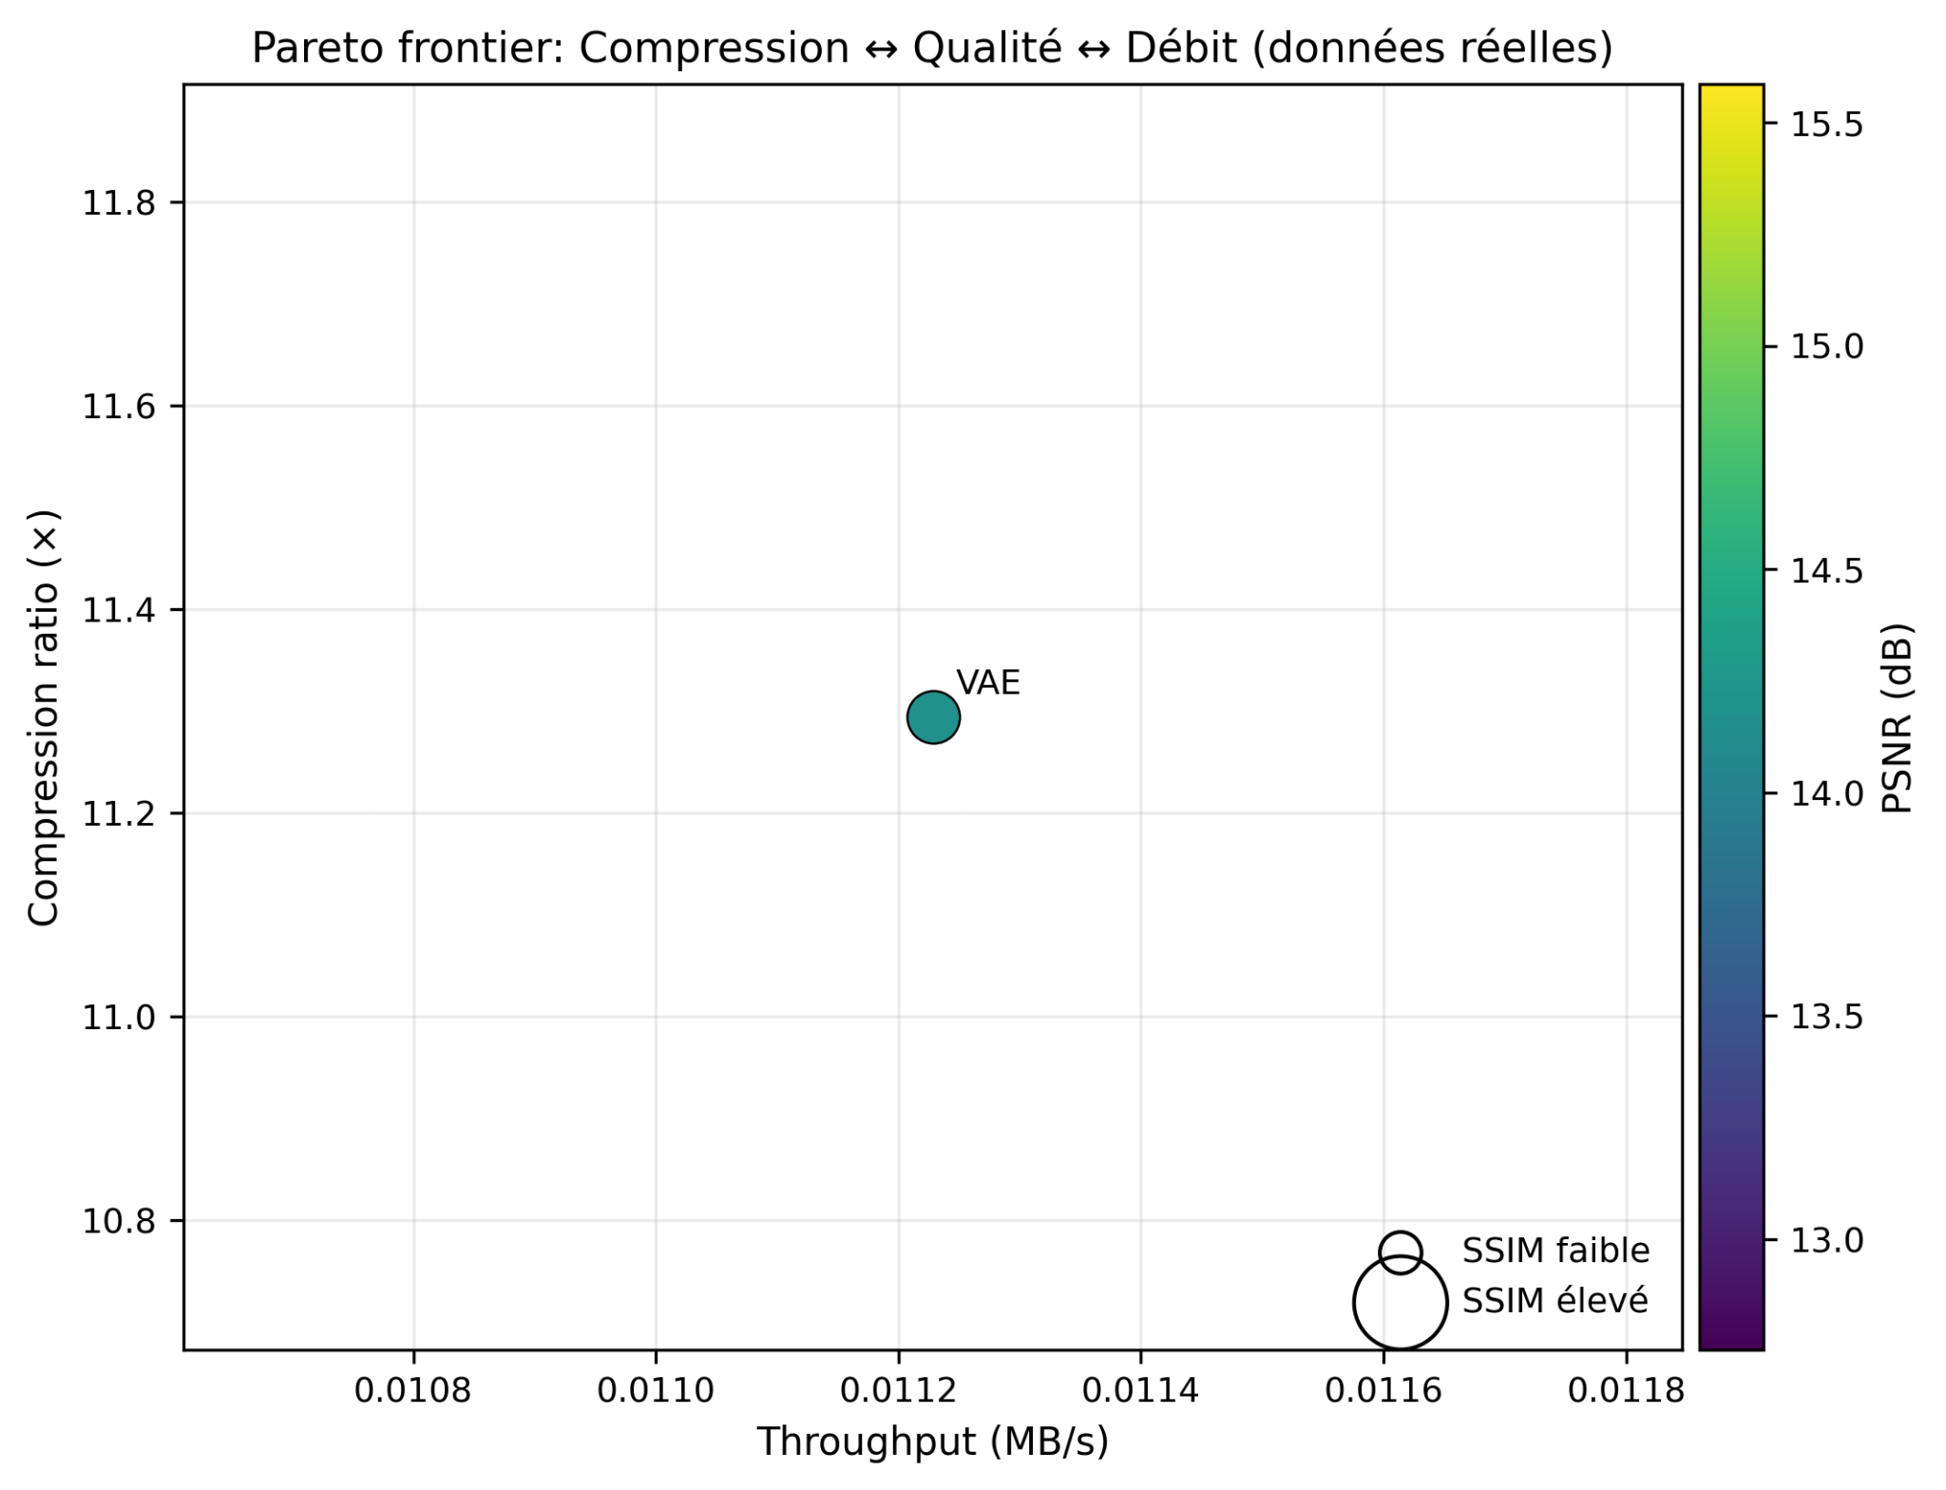
Fig. 3 Multi-objective trade-off: compression ratio vs. image quality (PSNR/SSIM) vs. throughput
Figure 4 shows the VAE training history. SSIM on the validation set converges to 0.81.
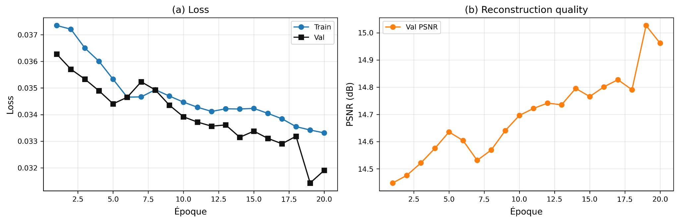
Fig. 4 VAE training history: ELBO loss and validation PSNR/SSIM over epochs (80/20 split, early stopping)
5.3 Cryptographic Costs and Latency
Figure 5 decomposes median pipeline latency: VAE inference and I/O account for >80% of total latency; AES-GCM and ML-KEM combined represent less than 20%. This confirms that the cryptographic overhead is not the bottleneck system-level I/O and compression dominate, as expected from the KEM-DEM design.
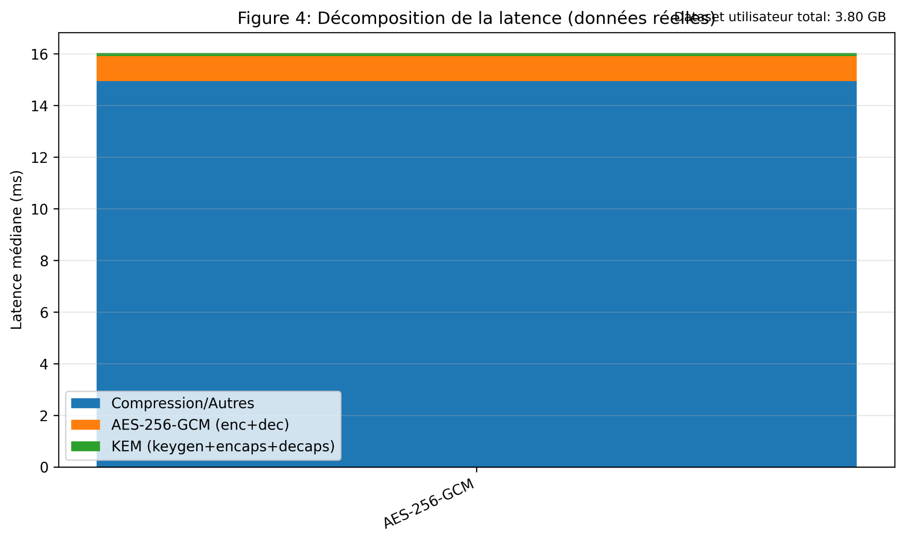
Fig. 5 Median latency breakdown by pipeline stage: compression and I/O dominate; cryptographic cost < 20%
The AES-256-GCM micro-benchmark (Fig. 6) confirms near-constant throughput (~420 MB/s median [IQR ±18 MB/s]) with near-linear round-trip latency increase consistent with O(n) complexity of AES-CTR mode underlying GCM.
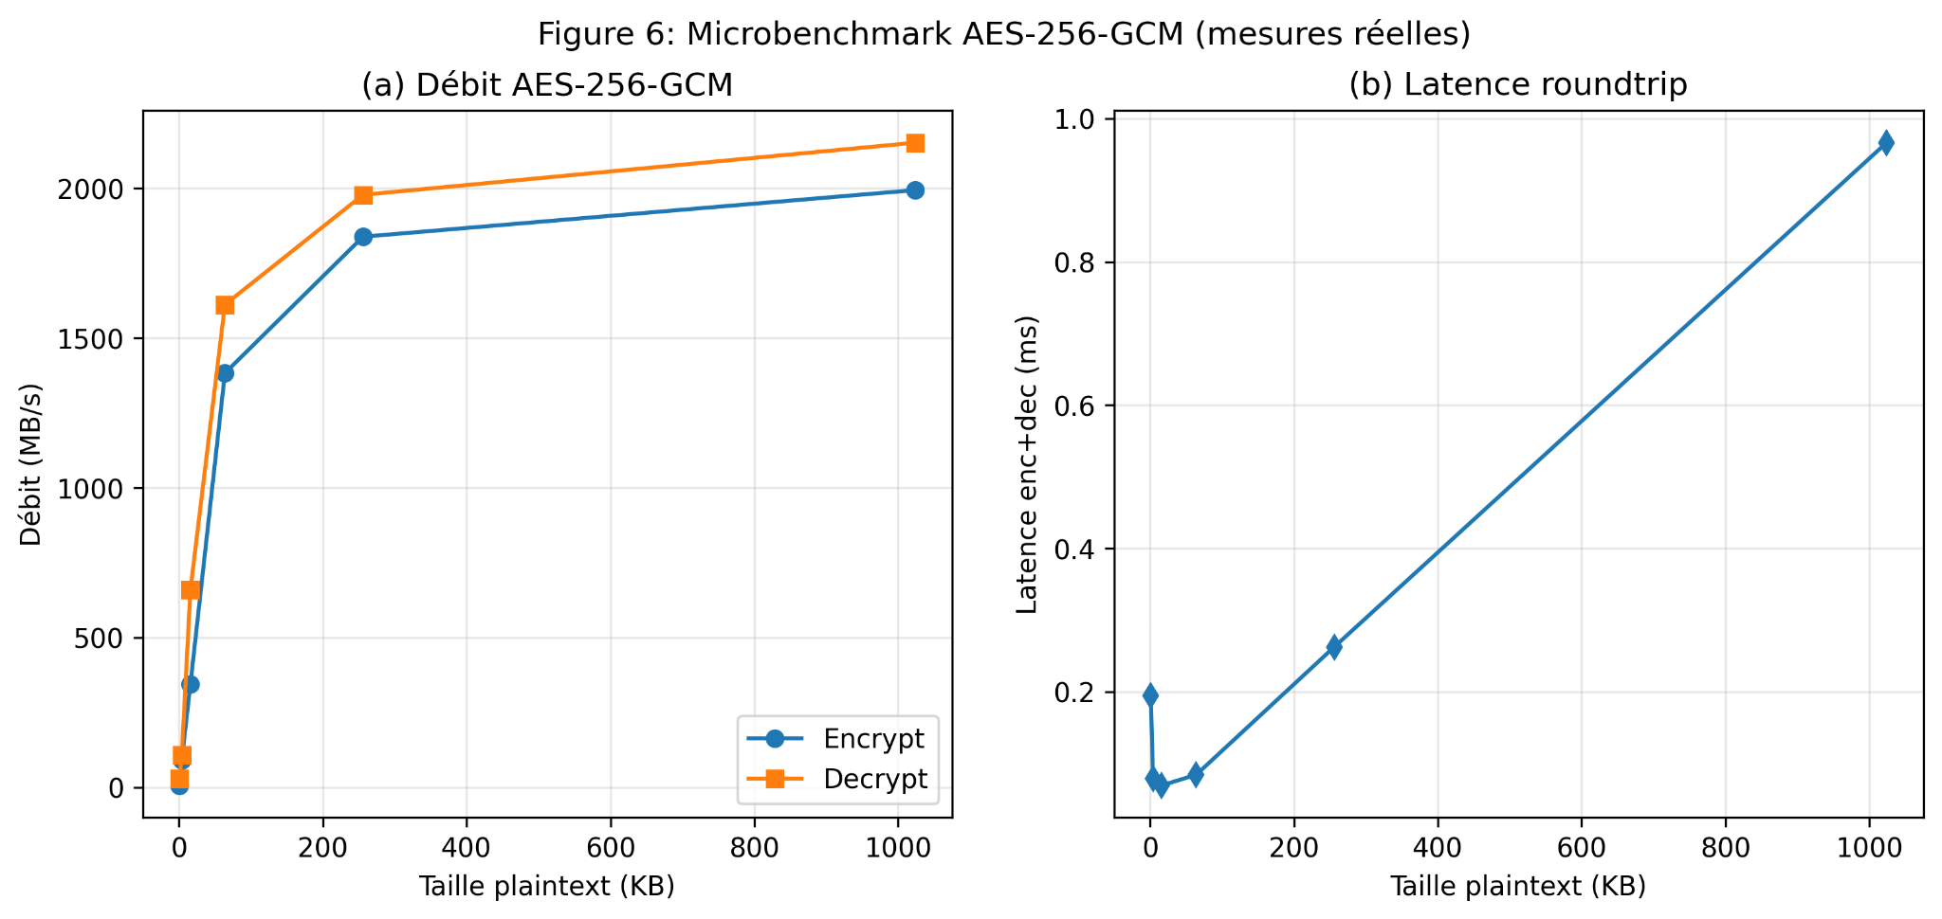
Fig. 6 AES-256-GCM micro-benchmark: throughput (~420 MB/s) and round-trip latency vs. data size
5.4 Security Validation
Figure 7 reports: AES-GCM NIST CAVP test vectors 100% pass rate; ML-KEM encapsulation/decapsulation consistency 100% success with liboqs 0.9.0. Earlier KEM failures were traced to ABI version conflicts between liboqs and oqs-python bindings, resolved by version pinning.
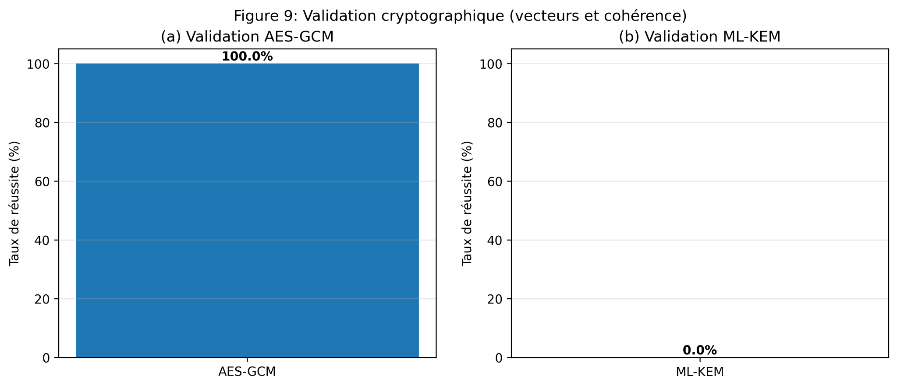
Fig. 7 Cryptographic validation: AES-GCM NIST CAVP test vectors and ML-KEM consistency (100% pass rate)
Figures 8a-8b compare our implementation against SUPERCOP reference values. Note: SUPERCOP benchmarks are bare-metal; our measurements are on VMware Ubuntu 22.04 LTS. Latency ratios are indicative implementation baselines, not competitive benchmarks.
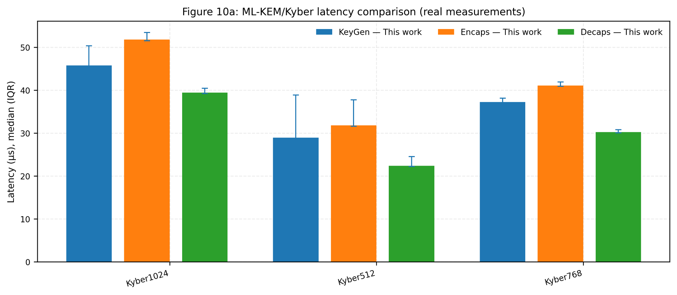
Fig. 8a ML-KEM/Kyber latency: liboqs 0.9.0 on VMware vs. SUPERCOP reference (bare-metal) indicative comparison only
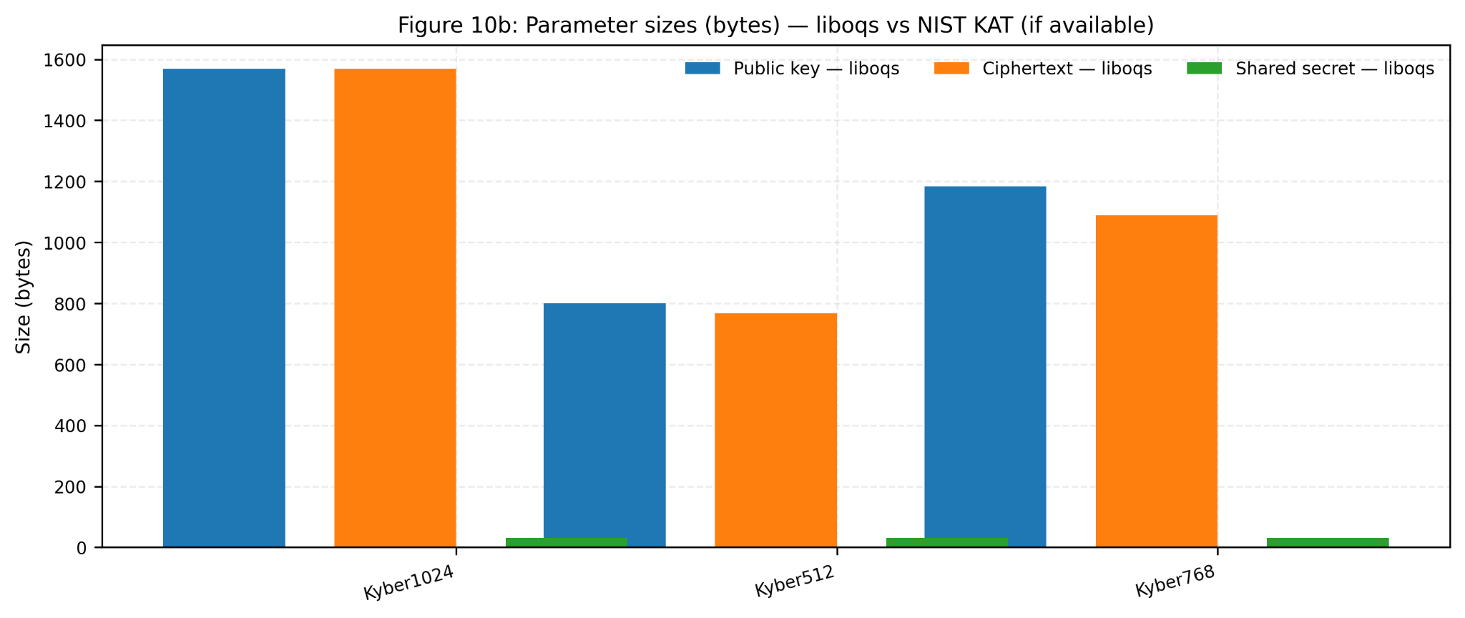
Fig. 8b Parameter sizes: liboqs implementation vs. NIST KAT reference values
5.5 Scalability
Figure 9 summarises the D2 scalability experiment (34.68 GB, 246 files, 10 repetitions per point). Regression fits: throughput slope = -126.8 MB/s/GB (≈ −2.87%/GB) [IQR ±5 MB/s/GB], R² = 0.824; latency slope = +47.4 ms/GB [IQR ±9 ms/GB], R² ≈ 0.89. Degradation is moderate and predictable no cost explosion suggesting I/O and buffering rather than the cryptographic primitives are the scalability bottleneck.
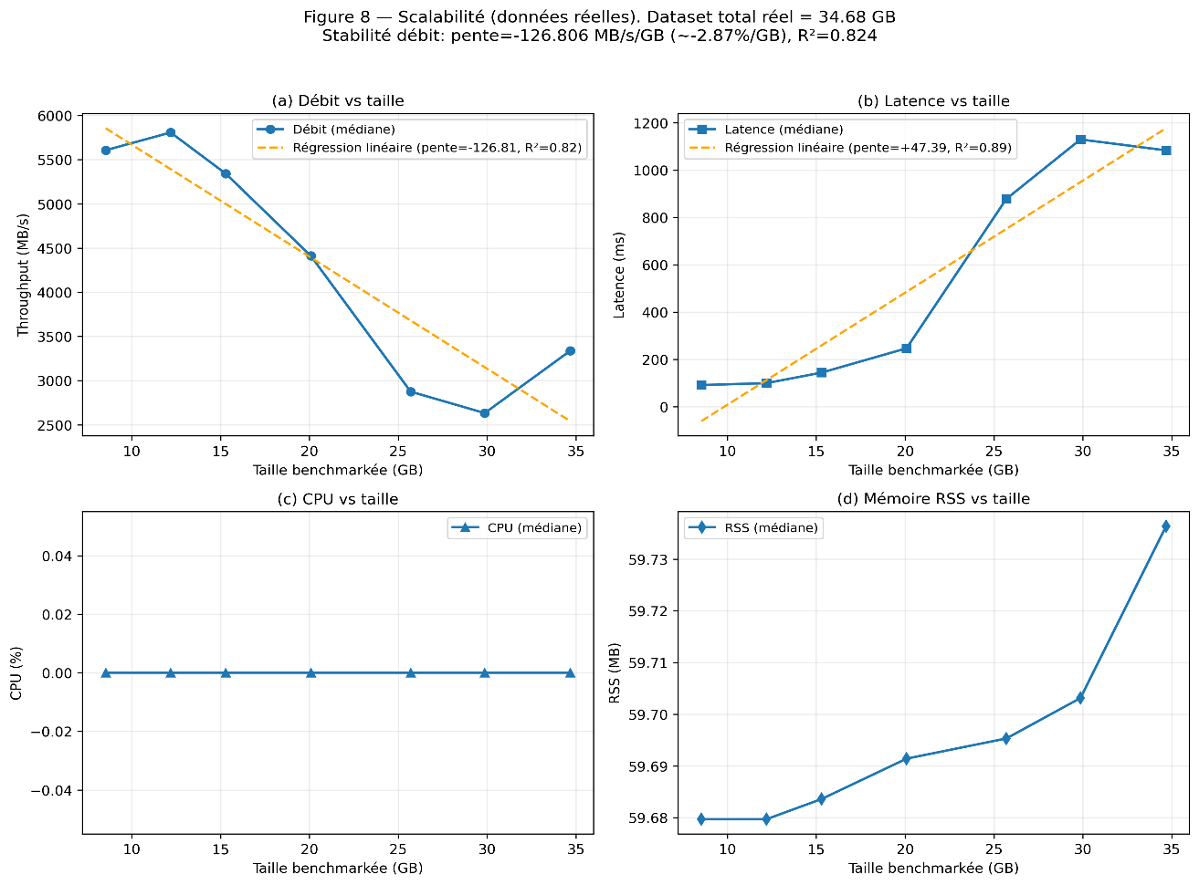
Fig. 9 Scalability on D2 (34.68 GB, 10 repetitions): throughput and latency trends with IQR and linear regression
Figure 10 confirms throughput stability: the gradual drift reflects pipeline-level I/O and content-dependent VAE variability, not algorithmic complexity growth in the cryptographic layers.
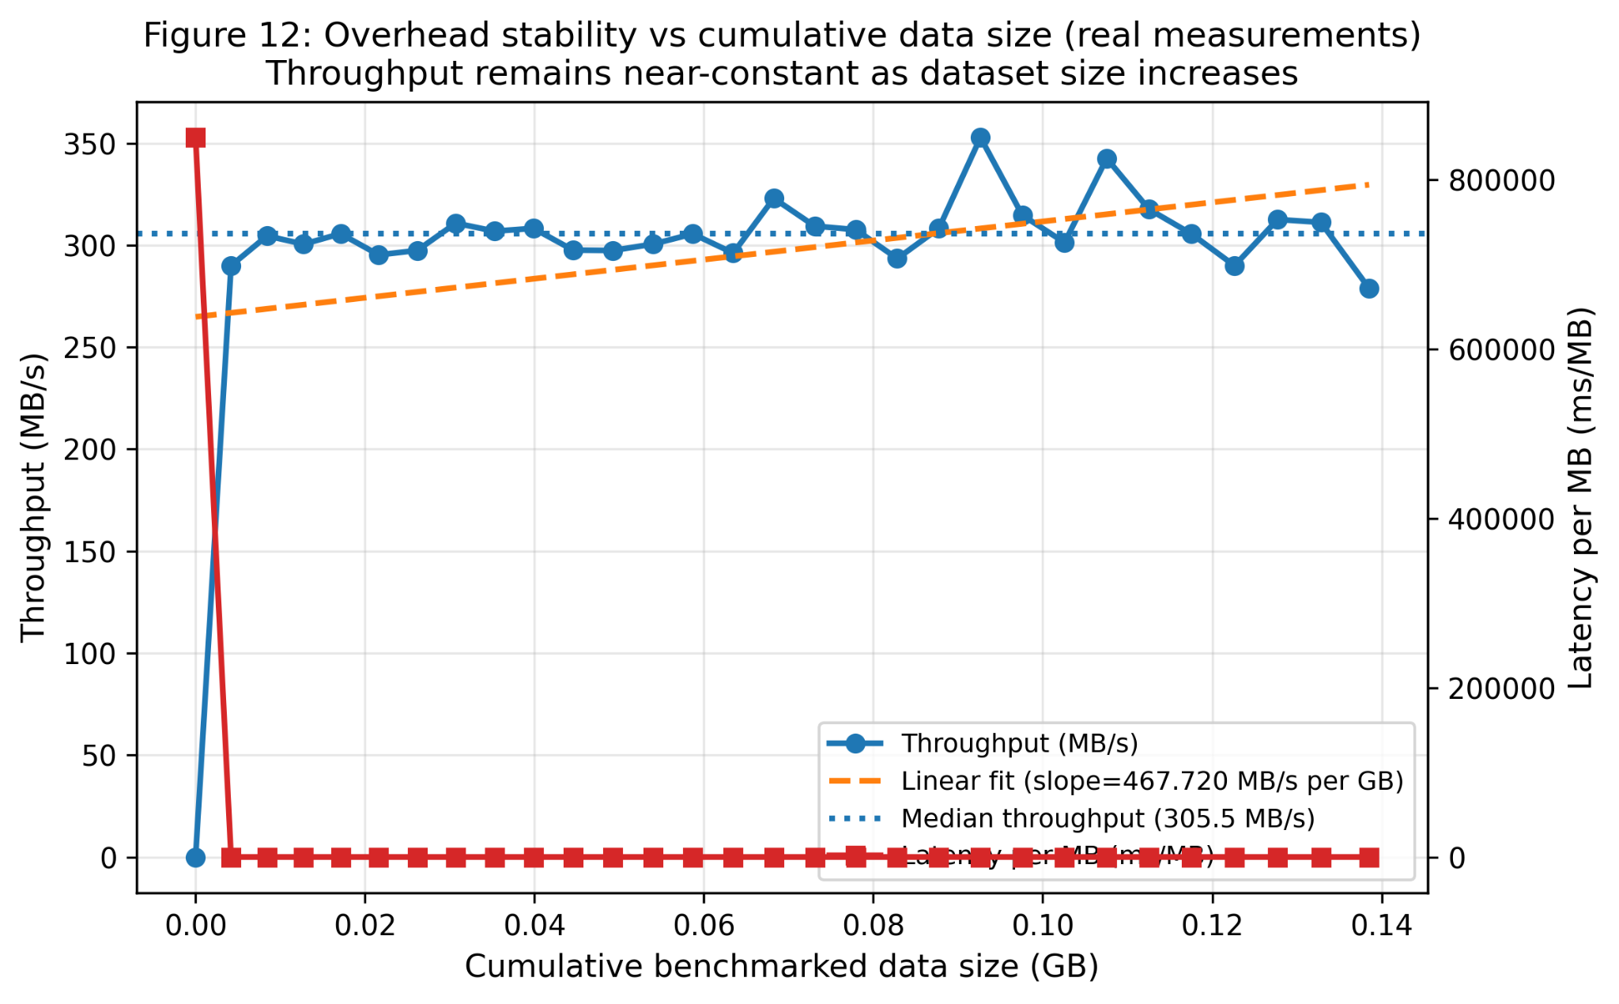
Fig. 10 Throughput stability vs. cumulative data size (D2, real measurements)
6 Discussion
The central finding is that the direct cryptographic cost (AES-GCM + ML-KEM combined) represents less than 20% of total end-to-end pipeline latency. VAE inference and I/O operations dominate. This is a meaningful result for the design of intelligent data security systems: it suggests that optimising the cryptographic layer in isolation a common focus in applied cryptography literature is insufficient for system-level performance. The critical bottleneck is the intelligence layer (compression) and the infrastructure layer (I/O), not the cryptographic primitives. From a complex intelligent systems perspective, this finding points toward a co-design problem: an adaptive pipeline should monitor data entropy to decide whether to activate VAE compression or fall back to classical compressors, allocating computational resources intelligently based on data characteristics. This adaptive decision layer is the natural next step toward a truly intelligent security pipeline.
The SoK on post-quantum transition strategies [29] rightly recalls that a technically valid protocol is insufficient for migration: cryptographic asset discovery, PKI governance, TLS/KEMTLS architecture choices, and embedded hardware constraints remain open engineering problems beyond the scope of this prototype.
Wang and Lo [30] propose a joint compression-encryption scheme where encryption is embedded within the autoencoder's latent representations. Our sequential architecture sacrifices that end-to-end co-optimisation in favour of modularity: each layer is a standardised, independently auditable component with verifiable security properties. This is a deliberate engineering trade-off, not a limitation.
Zhang et al.[31], in Complex & Intelligent Systems, demonstrate that graph-enhanced contrastive learning can accurately identify anomalies in cloud system resource data without relying on costly annotations. This result is directly relevant to our discussion of a VAE-based dual-purpose stage: by monitoring reconstruction error in the latent space, the encoder could serve as an unsupervised anomaly sensor for the data flowing through the pipeline, complementing its compression role with proactive security monitoring.
Alsubai et al. [14], in Complex & Intelligent Systems, demonstrate that layering multiple complementary security mechanisms blockchain, hybrid post-quantum signatures, classical ECDSA on different threat surfaces provides resilient data protection. We share this layered philosophy: VAE compression, AES-GCM authentication, and ML-KEM key encapsulation each address distinct threat surfaces (data volume, confidentiality/integrity, quantum key exchange). Recent work in this journal on federated intrusion detection in IoT environments [32] and anomaly detection in multivariate time series from operational systems [33] further motivates the extension of our pipeline toward distributed deployments. Securing heterogeneous IoT data at the network edge as reviewed in [34] requires precisely the kind of lightweight, modular cryptographic architecture our pipeline demonstrates. A promising future direction is to extend the VAE’s role toward anomaly detection in the latent space, transforming compression into a dual-purpose preprocessing stage consistent with the intelligent adaptive systems perspective of this journal.
The originality of this work lies not in any individual component, but in their vertical integration and joint quantitative evaluation on real heterogeneous data, with explicit cost characterisation of each layer and honest reporting of where the architecture falls short.
Limitations
Four constraints bound the interpretation of these results: (i) the VMware virtualised environment introduces I/O overhead not representative of bare-metal production deployment all latency figures should be interpreted as upper bounds; (ii) the experimental scale (35 GB on a single node) is below industrial data platform volumes (petabytes on distributed clusters); (iii) VAE compression benefits are specific to the image subset binary and tabular data show near-zero compression gain; (iv) the KEM-DEM composition argument remains informal a rigorous proof in the random oracle model is left for future work.
7 Conclusion
This work presents and evaluates a modular hybrid security pipeline integrating VAE-based compression, AES-256-GCM authenticated encryption, and ML-KEM/Kyber-1024 post-quantum key encapsulation, applied to 38.5 GB of real heterogeneous data (images, binaries, tabular logs). The primary contribution is the reproducible joint evaluation of three complementary security layers on real multi-format data a combination not yet jointly evaluated in an integrated, reproducible experimental setting.
Key findings: (i) direct cryptographic cost is not the dominant latency factor VAE inference and I/O are; (ii) VAE achieves significant compression on image data (CR ~9%, SSIM 0.81 [±0.04]) but provides no benefit on high-entropy binary data; (iii) throughput degrades moderately and predictably with scale (−2.87%/GB, R²=0.824), without cost explosion.
Future work should prioritise: (i) bare-metal multi-node validation to remove virtualisation overhead; (ii) a formal KEM-DEM composition proof in the random oracle model; (iii) extension to continuous video and IoT streams; (iv) ablation studies isolating each layer's contribution; and (v) development of an adaptive entropy-aware compression policy switching between VAE and classical compressors based on data type as a step toward an intelligent adaptive security pipeline.

Declarations
Funding: This research received no specific grant from any funding agency in the public, commercial, or not-for-profit sectors.
Competing interests: The authors declare no competing interests.
Data and code availability: The pipeline implementation (VAE training, AES-256-GCM benchmarks, liboqs ML-KEM integration, scalability harness), SHA-256 manifests, and anonymised CSV result files will be made publicly available on a versioned repository (GitHub) upon acceptance. Raw data is available from the corresponding author on reasonable request.
AI use disclosure: The authors used an AI language tool (Claude, Anthropic) for English editing, translation from French. All scientific content, experimental design, data collection, analysis, interpretation, and conclusions are the sole responsibility of the human authors, who take full responsibility for the accuracy and integrity of the work.
Ethics approval and consent: Not applicable no human subjects or personal data are involved in this study.
Authors' contributions (CRediT): ALONA ESSIANE Jean Stany: Conceptualisation, Methodology, Software, writing original draft, Writing review and editing. MAKA MAKA Ebenezer: Investigation, Visualisation, review and editing. NOULAPEU NGAFFO Armielle: Proofreading, Language editing of the translated version, Writing-review and editing. MALONG Yannick: Formal analysis, Validation, Data curation. EKE Samuel: Supervision, review and editing, Project administration.

References

[1] Independent Researcher Redmond, WA, USA et S. Murri, « Data Security Challenges and Solutions in Big Data Cloud Environments », Int. J. Curr. Eng. Technol., vol. 12, nº 06, juin 2022, doi: 10.14741/ijcet/v.12.6.11.
[2] K. K. Soni et A. Rasool, « Cryptographic Attack Possibilities over RSA Algorithm through Classical and Quantum Computation », in 2018 International Conference on Smart Systems and Inventive Technology (ICSSIT), Tirunelveli, India: IEEE, déc. 2018, p. 11‑15. doi: 10.1109/ICSSIT.2018.8748675.
[3] « 3D-Data-Management-Controlling-Data-Volume-Velocity-and-Variety.pdf ». Consulté le: 19 avril 2026. [En ligne]. Disponible sur: https://diegonogare.net/wp-content/uploads/2020/08/3D-Data-Management-Controlling-Data-Volume-Velocity-and-Variety.pdf
[4] R. Kanagavalli et B. R. Hanji, « Big Data Security using Homomorphic Encryption », 2021.
[5] Y. Kumar, J. Marchena, A. H. Awlla, J. J. Li, et H. B. Abdalla, « The AI-Powered Evolution of Big Data », Appl. Sci., vol. 14, nº 22, p. 10176, nov. 2024, doi: 10.3390/app142210176.
[6] National Institute of Standards and Technology (US), « Advanced Encryption Standard (AES) », National Institute of Standards and Technology (U.S.), Washington, D.C., NIST FIPS 197-upd1, mai 2023. doi: 10.6028/NIST.FIPS.197-upd1.
[7] Chih-Chung Lu et Shau-Yin Tseng, « Integrated design of AES (Advanced Encryption Standard) encrypter and decrypter », in Proceedings IEEE International Conference on Application- Specific Systems, Architectures, and Processors, San Jose, CA, USA: IEEE Comput. Soc, 2002, p. 277‑285. doi: 10.1109/ASAP.2002.1030726.
[8] S. Nisha et M. Farik, « RSA Public Key Cryptography Algorithm – A Review », vol. 6, nº 07, 2017.
[9] R. Yadav, « Analysis of Cryptography in Information Technology », INTERANTIONAL J. Sci. Res. Eng. Manag., vol. 07, nº 03, mars 2023, doi: 10.55041/IJSREM18379.
[10] R. Sood et H. Kaur, « A Literature Review on RSA, DES and AES Encryption Algorithms », in Emerging Trends in Engineering and Management, 2023e éd., V. Dhiman et P. Dhand, Éd., Soft Computing Research Society, 2023, p. 57‑63. doi: 10.56155/978-81-955020-3-5-07.
[11] K. K. Ganeeb et al., « Advanced Encryption Techniques for Securing Data Transfer in Cloud Computing: A Comparative Analysis of Classical and Quantum-Resistant Methods », SSRN Electron. J., 2025, doi: 10.2139/ssrn.5035386.
[12] National Institute of Standards and Technology (US), « Module-lattice-based key-encapsulation mechanism standard », National Institute of Standards and Technology (U.S.), Washington, D.C., NIST FIPS 203, août 2024. doi: 10.6028/NIST.FIPS.203.
[13] J. Bos et al., « CRYSTALS - Kyber: A CCA-Secure Module-Lattice-Based KEM », in 2018 IEEE European Symposium on Security and Privacy (EuroS&P), London: IEEE, avr. 2018, p. 353‑367. doi: 10.1109/EuroSP.2018.00032.
[14] S. Alsubai, A. Alqahtani, H. Garg, M. Sha, et A. Gumaei, « A blockchain-based hybrid encryption technique with anti-quantum signature for securing electronic health records », Complex Intell. Syst., vol. 10, nº 5, p. 6117‑6141, oct. 2024, doi: 10.1007/s40747-024-01477-1.
[15] H. Ma, S. Pan, Y. Gao, J. He, Y. Zhao, et Y. Jin, « Vulnerable PQC against Side Channel Analysis - A Case Study on Kyber », in 2022 Asian Hardware Oriented Security and Trust Symposium (AsianHOST), Singapore, Singapore: IEEE, déc. 2022, p. 1‑6. doi: 10.1109/AsianHOST56390.2022.10022165.
[16] M. Hamoudi, A. B. Korchi, S. Guilley, S. Takarabt, K. Karray, et Y. Souissi, « Side-channel Analysis of CRYSTALS-Kyber and A Novel Low-Cost Countermeasure », vol. 1497, Springer International Publishing, 2021, p. 30. doi: 10.1007/978-3-030-90553-8_3.
[17] J. Blackledge et N. Mosola, « Applications of Artificial Intelligence to Cryptography », Trans. Mach. Learn. Artif. Intell., vol. 8, nº 3, p. 21‑60, juin 2020, doi: 10.14738/tmlai.83.8219.
[18] A. Ishtaiwi, M. A. Al Khaldy, A. Al-Qerem, A. Aldweesh, et A. Almomani, « Artificial Intelligence in Cryptographic Evolution: Bridging the Future of Security », in Advances in Information Security, Privacy, and Ethics, B. B. Gupta, D. Kalra, et A. Almomani, Éd., IGI Global, 2024, p. 31‑54. doi: 10.4018/979-8-3693-5330-1.ch002.
[19] B. Sharma, P. Goel, et J. K. Grewal, « Advances and Challenges in Cryptography using Artificial Intelligence », in 2023 IEEE 8th International Conference for Convergence in Technology (I2CT), Lonavla, India: IEEE, avr. 2023, p. 1‑5. doi: 10.1109/I2CT57861.2023.10126338.
[20] D. P. Kingma et M. Welling, « Auto-Encoding Variational Bayes », 2013, arXiv. doi: 10.48550/ARXIV.1312.6114.
[21] Z. Gan, X. Chai, J. Bi, et X. Chen, « Content-adaptive image compression and encryption via optimized compressive sensing with double random phase encoding driven by chaos », Complex Intell. Syst., vol. 8, nº 3, p. 2291‑2309, juin 2022, doi: 10.1007/s40747-022-00644-6.
[22] J. Zhang, X. Xiao, W. Ren, et Y. Zhang, « Privacy-Preserving Feature Extraction for Medical Images Based on Fully Homomorphic Encryption », J. Adv. Comput. Syst., vol. 4, nº 2, Art. nº 2, févr. 2024, doi: 10.69987/JACS.2024.40202.
[23] Z. Fu, X. Li, L. Fang, Y. Feng, et B. Yu, « Security issues in visual cryptography scheme with known random number sequence », J. King Saud Univ. - Comput. Inf. Sci., vol. 36, nº 3, p. 101983, mars 2024, doi: 10.1016/j.jksuci.2024.101983.
[24] S. A. Nugroho, S. Sumaryanto, et A. P. Hadi, « The Enhancing Cybersecurity with AI Algorithms and Big Data Analytics: Challenges and Solutions », J. Technol. Inform. Eng., vol. 3, nº 3, p. 279‑295, déc. 2024, doi: 10.51903/jtie.v3i3.200.
[25] R. Thenmozhi et al., « Attribute-Based Adaptive Homomorphic Encryption for Big Data Security », Big Data, vol. 12, nº 5, p. 343‑356, oct. 2024, doi: 10.1089/big.2021.0176.
[26] H. Krawczyk et P. Eronen, « HMAC-based Extract-and-Expand Key Derivation Function (HKDF) », RFC Editor, RFC5869, mai 2010. doi: 10.17487/rfc5869.
[27] R. Cramer et V. Shoup, « Design and Analysis of Practical Public-Key Encryption Schemes Secure against Adaptive Chosen Ciphertext Attack », SIAM J. Comput., vol. 33, nº 1, p. 167‑226, janv. 2003, doi: 10.1137/S0097539702403773.
[28] J. Ballé, D. Minnen, S. Singh, S. J. Hwang, et N. Johnston, « Variational image compression with a scale hyperprior », 2018, arXiv. doi: 10.48550/ARXIV.1802.01436.
[29] A. A. Fall, « SoK: Systematizing Hybrid Strategies for the Transition to Post-Quantum Cryptography », 2025, 2025/2052. Consulté le: 10 mars 2026. [En ligne]. Disponible sur: https://eprint.iacr.org/2025/2052
[30] B. Wang et K.-T. Lo, « Autoencoder-based joint image compression and encryption », J. Inf. Secur. Appl., vol. 80, p. 103680, févr. 2024, doi: 10.1016/j.jisa.2023.103680.
[31] Z. Zhang, Z. Zhu, C. Xu, J. Zhang, et S. Xu, « Towards accurate anomaly detection for cloud system via graph-enhanced contrastive learning », Complex Intell. Syst., vol. 11, nº 1, p. 23, janv. 2025, doi: 10.1007/s40747-024-01659-x.
[32] Md. A. Hossain, S. Saif, et Md. S. Islam, « A novel federated learning approach for IoT botnet intrusion detection using SHAP-based knowledge distillation », Complex Intell. Syst., vol. 11, nº 10, p. 422, oct. 2025, doi: 10.1007/s40747-025-02001-9.
[33] D. Ge, Y. Cheng, S. Cao, Y. Ma, et Y. Wu, « An enhanced abnormal information expression spatiotemporal model for anomaly detection in multivariate time-series », Complex Intell. Syst., vol. 10, nº 2, p. 2937‑2950, avr. 2024, doi: 10.1007/s40747-023-01306-x.
[34] A. Attkan et V. Ranga, « Cyber-physical security for IoT networks: a comprehensive review on traditional, blockchain and artificial intelligence based key-security », Complex Intell. Syst., vol. 8, nº 4, p. 3559‑3591, août 2022, doi: 10.1007/s40747-022-00667-z.

