**This document contains the result of the data standardization approaches**:

1. **Normalisation approach(AEEEM DATASET)**

* Firstly the model is trained on the specific project data and then for the testing data the other projects are used. The classifier used is **J48**

1. **EQ**
2. **Training the EQ project:**

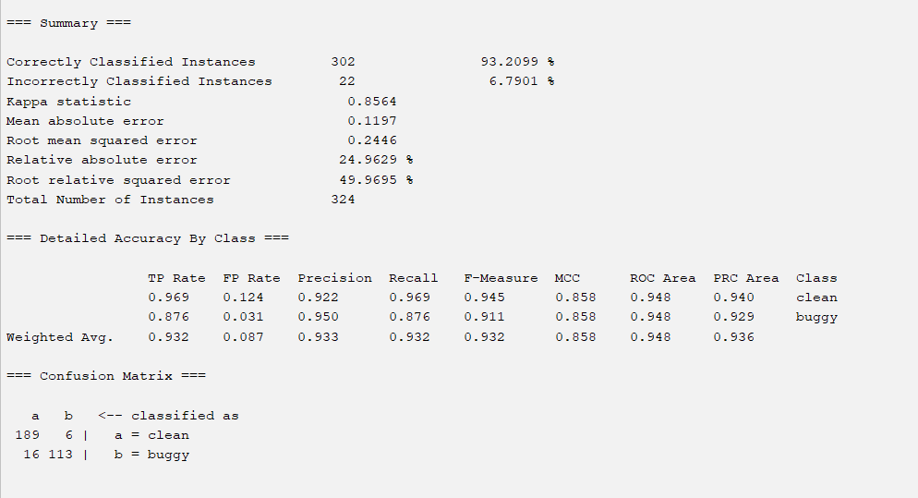

1. **EQ->JDT**

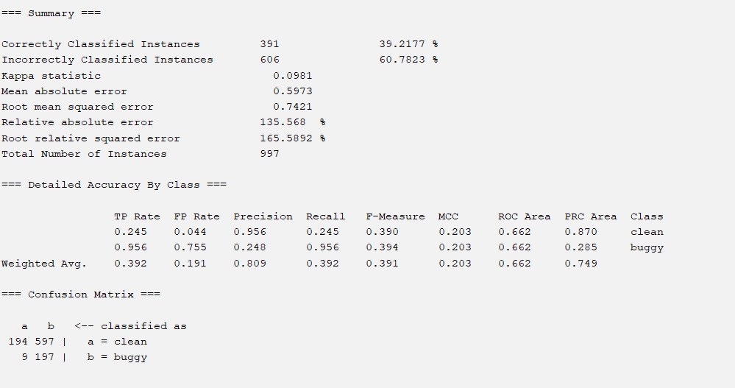

1. **EQ->LUCENE**

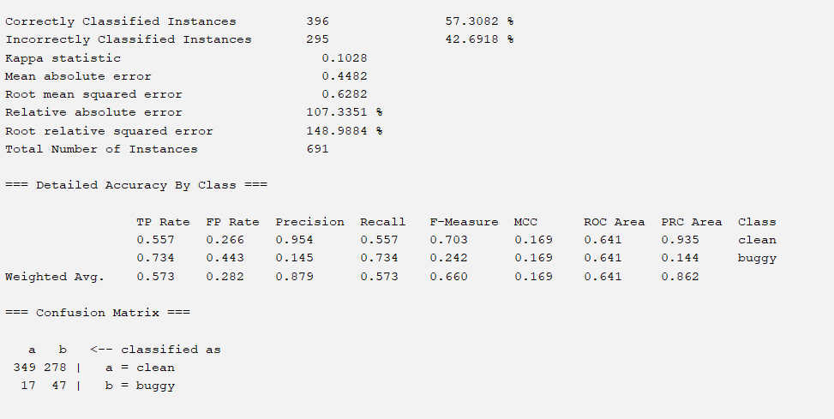

1. **EQ->MYLENE**

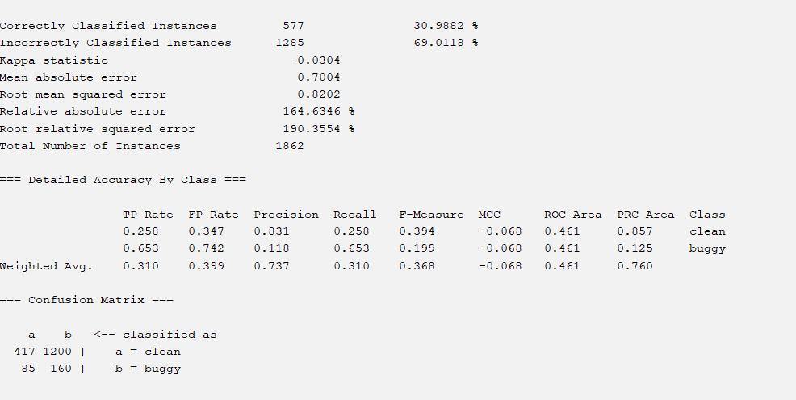

1. EQ->PDE

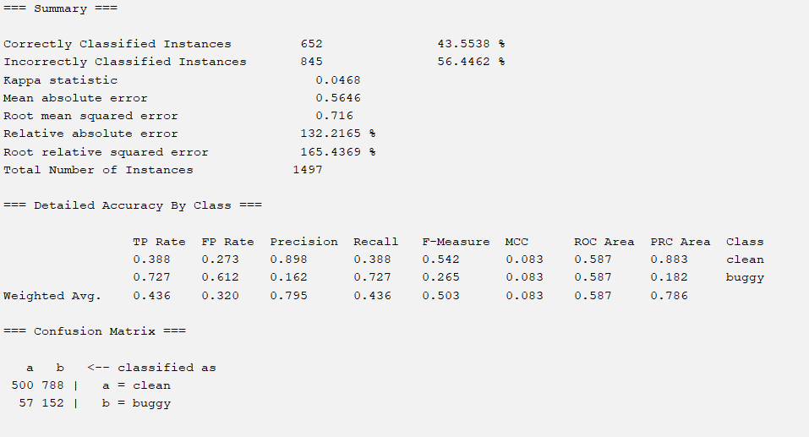

1. **JDT**
2. Training the JDT

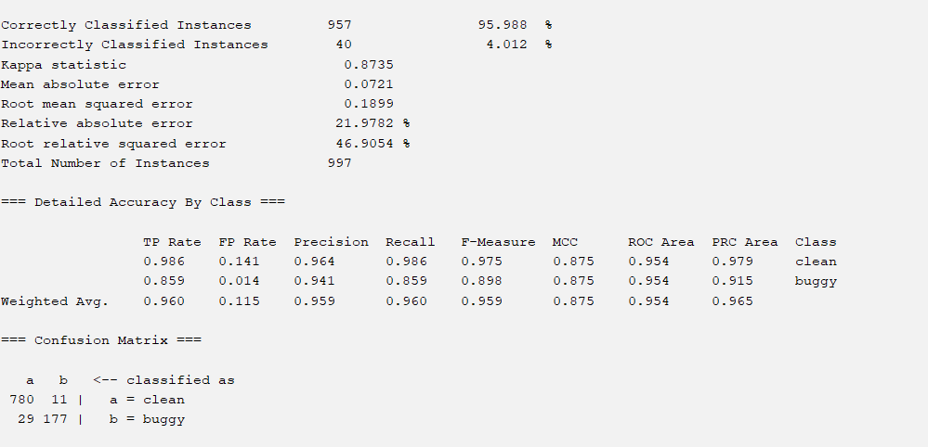

1. JDT->EQ

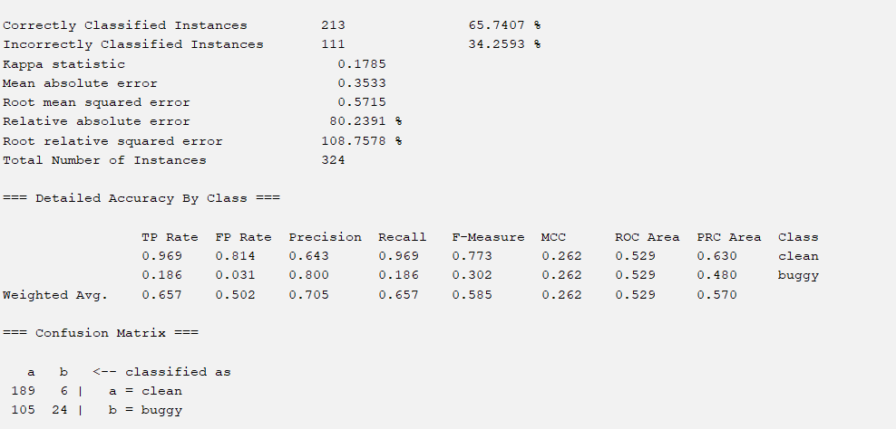

1. JDT->LUCENE

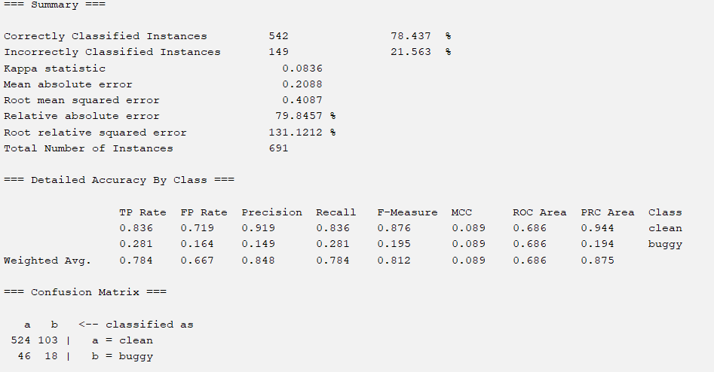

1. JDT->MYLENE

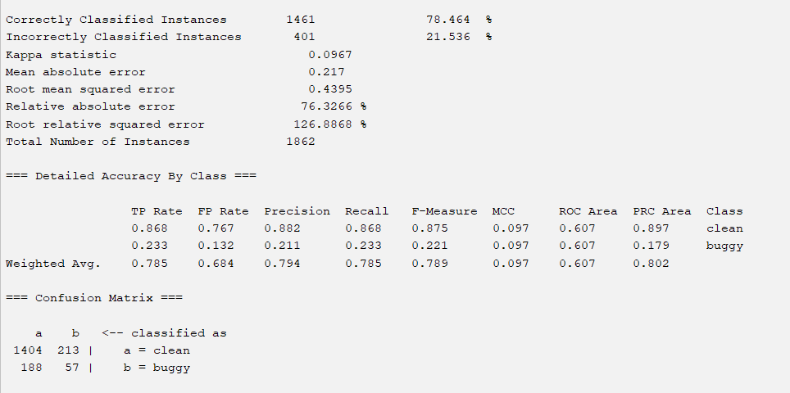

1. JDT->PDE

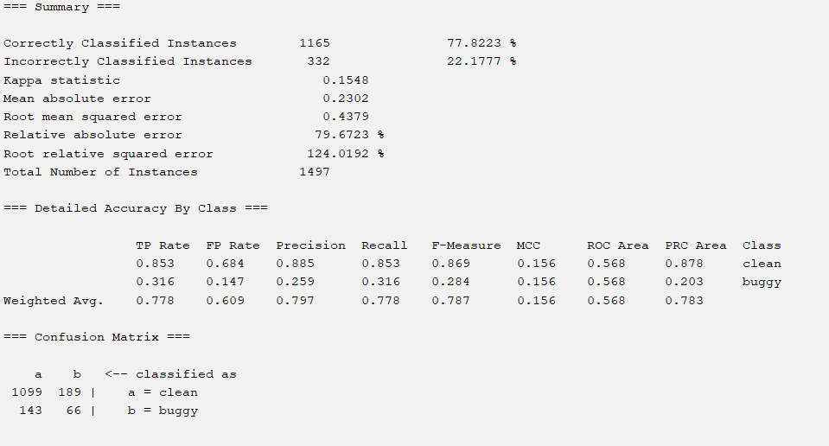

1. **LUCENE**

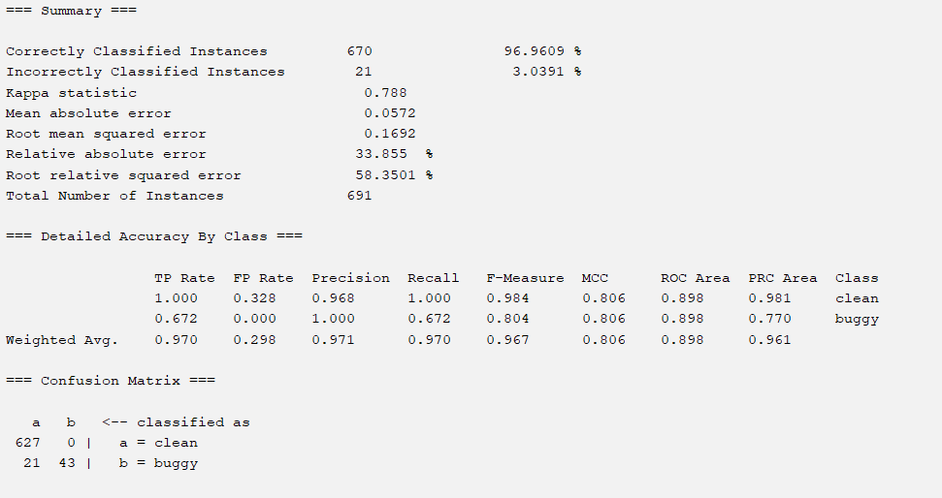

b. LUCENE->EQ

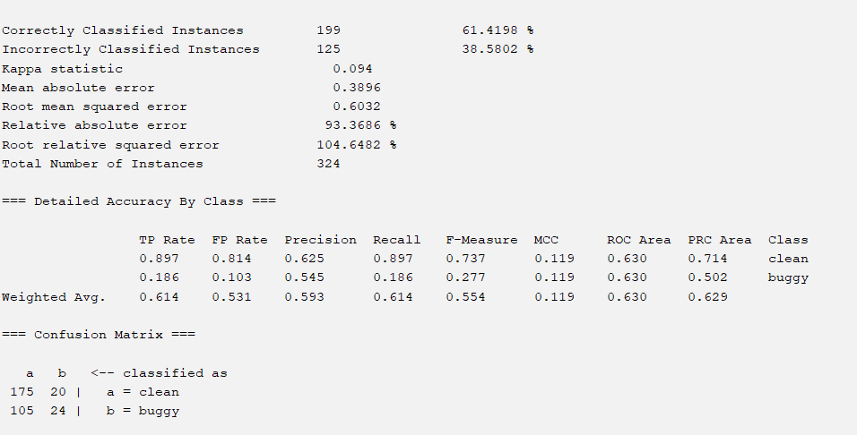

c. LUCENE->JDT

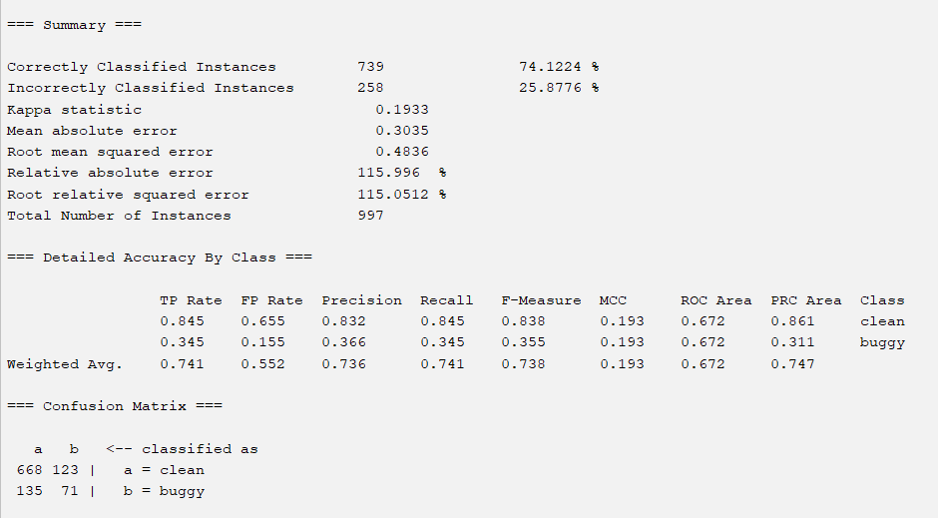

d. lucene->mylene

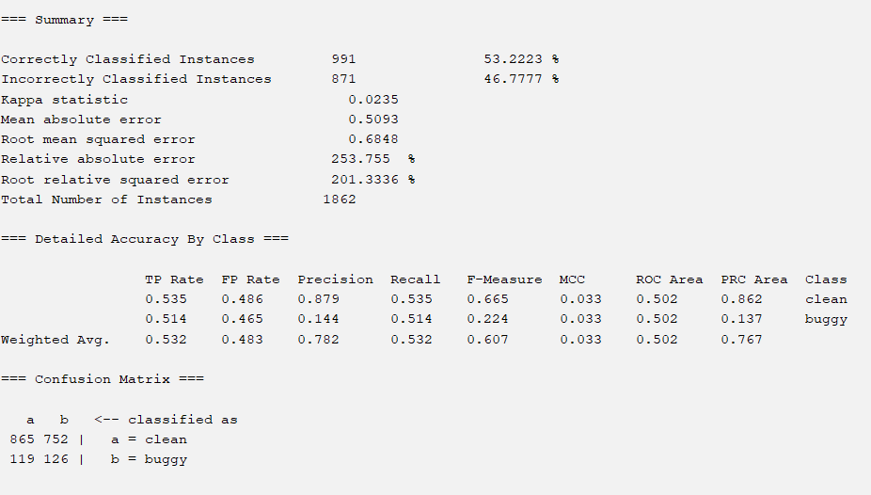

E lucene->pde

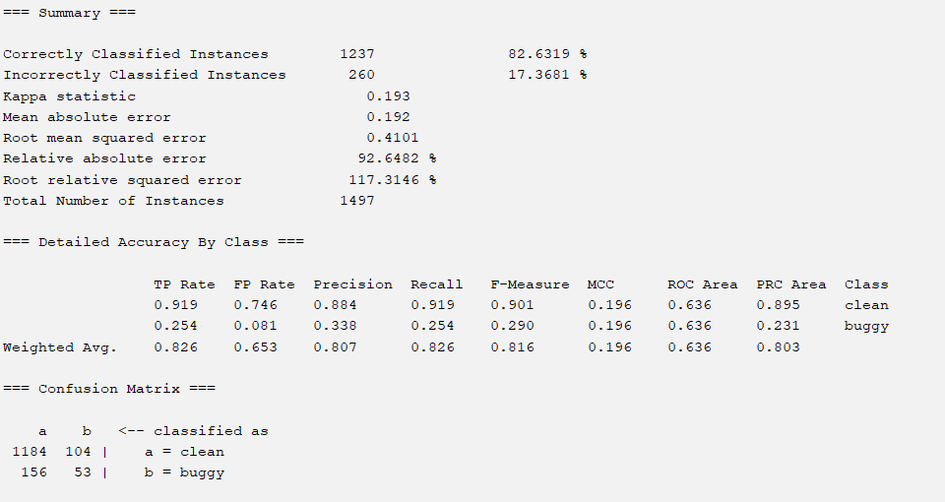

**MYLYN:**

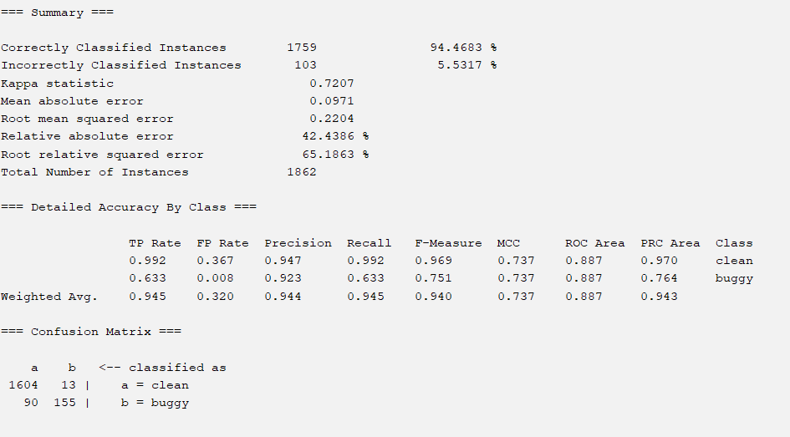

**MYLYN->EQ**

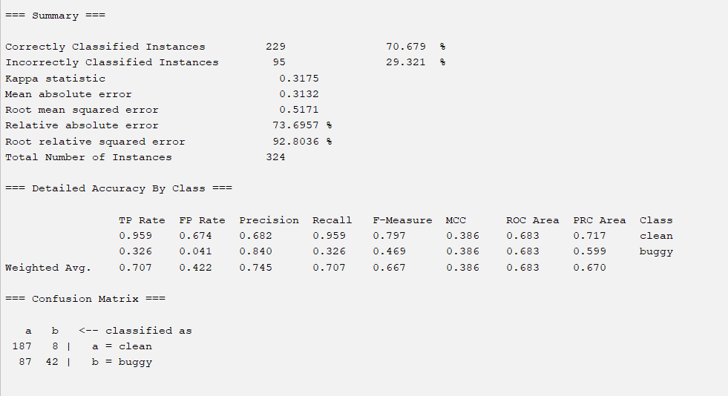

1. **MYLYN->JDT**

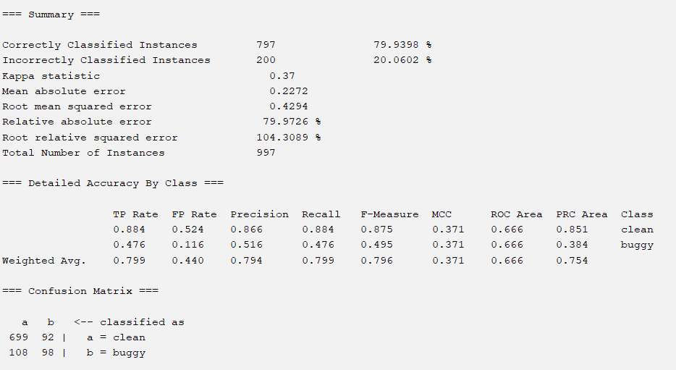

**MYLYN->LUCENE**

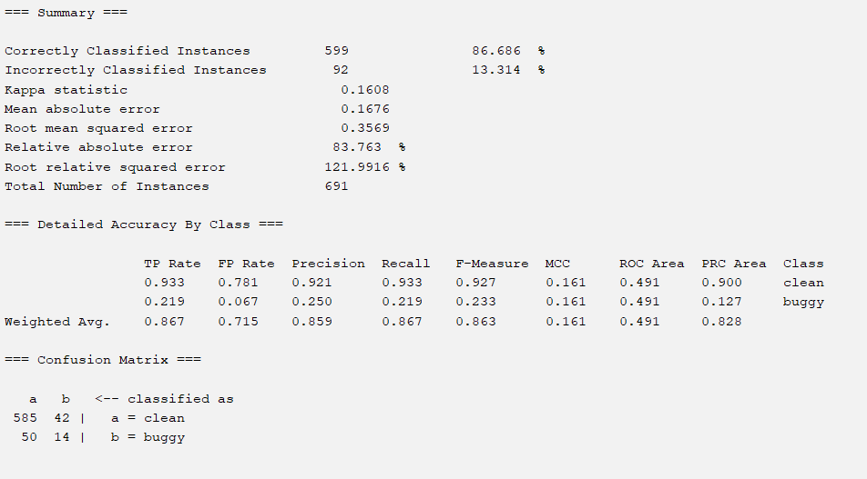

**MYLYN->PDE**

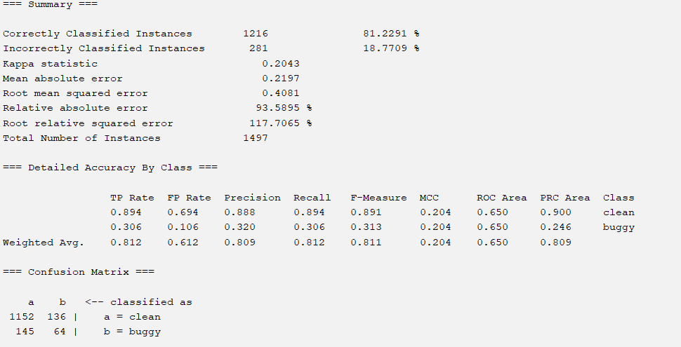

**PDE:**



**PDE->EQ**



**PDE->JDT**



**PDE->LUCENE**

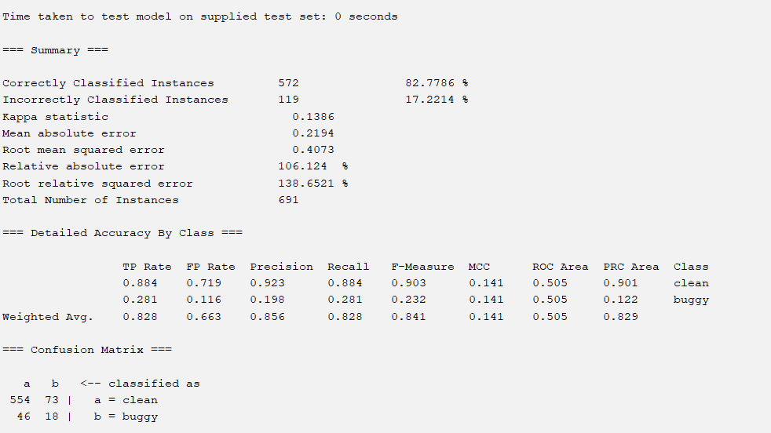

**PDE->MYLYN**

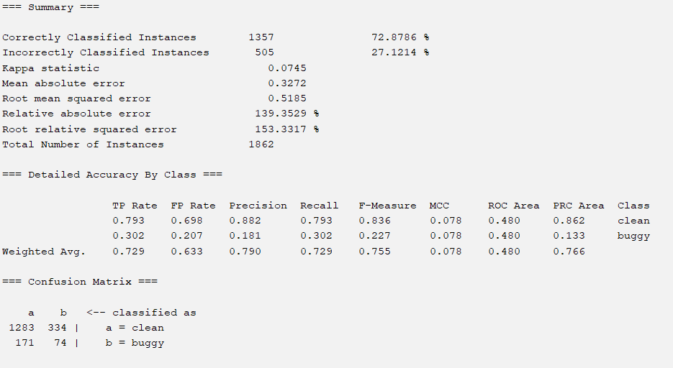

**🡨------------------END OF AEEEM DATASET RESULTS---------------🡪**

**The results for the PROMISE DATASET is below:  
