Chapter Three

METHODOLOGY AND SYSTEM DESIGN

3.1 METHODOLOGY ADOPTED

A methodology is a systematic procedure used in the analysis, design, and implementation of an information system. Several methodologies are used in software development, but for this study, three major methodologies are considered.

3.1.1 Structured System Analysis and Design Methodology (SSADM)
Structured System Analysis and Design Methodology (SSADM) is a traditional method used in system development. It focuses on breaking a system into smaller processes and analyzing how data flows between them. SSADM uses tools such as:
Data Flow Diagrams (DFD)
Entity Relationship Diagrams (ERD)
Data Dictionary
According to Avison Dennis and Fitzgerald (2006), SSADM provides a logical way of analyzing system requirements before implementation. Its major advantage is that it ensures proper documentation, but it can be time-consuming for large systems.

3.1.2 Object-Oriented Analysis and Design Methodology (OOADM)
Object-Oriented Analysis and Design Methodology (OOADM) focuses on identifying objects in a system and defining how they interact. In this methodology, each object represents a real-world component of the system.
Common tools used in OOADM include:
Use Case Diagram
Class Diagram
Sequence Diagram
Activity Diagram
According to Grady Booch (2007), object-oriented methodology improves system flexibility and makes software easier to maintain. It is suitable for systems that require modular design and future expansion.

3.1.3 Prototype Model

The Prototype Model involves developing an early version of the system (prototype) to help users understand and refine requirements.

Advantages:
- Helps clarify system requirements
- Reduces design errors
- Improves user satisfaction

Disadvantages:

•Time-consuming
•Can increase development cost
•Users may confuse prototype with final system

Methodology Adopted (Waterfall Model)

For the development of the Computer Repair Management System for Technoid Technologies, the Waterfall Model was adopted.

Reasons for Choosing Waterfall Model:

•System requirements are clearly defined
•Suitable for structured academic work
•Easy to implement and document
•Each phase is completed step-by-step

Application of Waterfall Model to the System

1. Requirement Analysis
Information was gathered about customer records, repair tracking, technician assignment, and billing.
2. System Design
The system architecture, database, and interface were designed.
3. Implementation
Coding of modules such as:
°Customer registration
°Repair management
°Technician assignment
°Payment system
4. Testing
The system was tested to identify and fix errors.
5. Deployment
The system was installed for use in Technoid Technologies.
6. Maintenance
Future updates and improvements were planned.

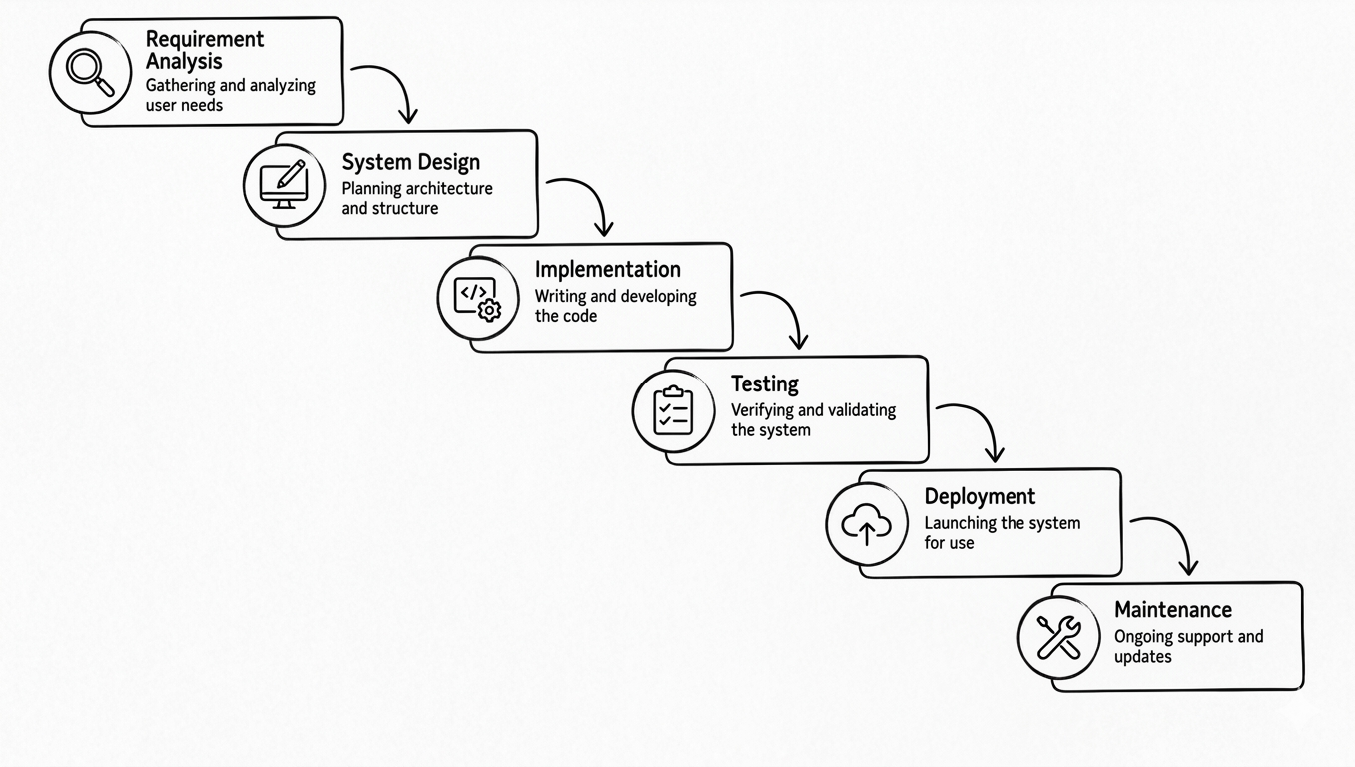

Fig 3.1: Waterfall Model Diagram

3.1.4 Selection of methodology
For this study, the Object-Oriented Analysis and Design Methodology (OOADM) was adopted because it provides a suitable framework for the development of a Computer Repair Management System.
The reasons for choosing OOADM include:

- It supports modular system design
- It improves maintainability
- It allows easy system expansion
- It represents real-life system components clearly
- It supports diagrammatic representation of the system

Therefore, OOADM is considered the most appropriate methodology for the design and implementation of the proposed system.

3.2 SYSTEM ANALYSIS
System analysis involves examining the existing system in order to understand how it operates and identify areas that require improvement.
In this study, the system analysis focuses on the operations of computer repair centers, including:
1. Customer registration
2. Device intake
3. Fault reporting
4. Repair processing
5. Payment handling
The aim is to evaluate how these activities are currently managed and to identify inefficiencies that the proposed system will address.

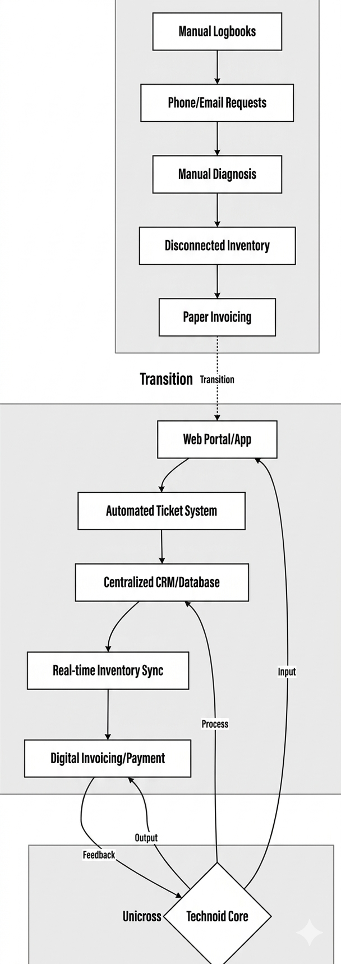

Fig 3.2: System Analysis Flow

3.3 ANALYSIS OF THE EXISTING SYSTEM
The existing system is a partially computerized system used in computer repair centers to manage repair activities. It allows basic recording of customer details and repair jobs but lacks full integration of operations.

In the current system:
1. Customer information is stored separately from repair records
2. Repair tracking is not fully automated
3. Communication between technicians and management is limited
4. Report generation is either manual or incomplete
Although the system improves basic record keeping, it does not provide a comprehensive solution for managing repair operations efficiently.

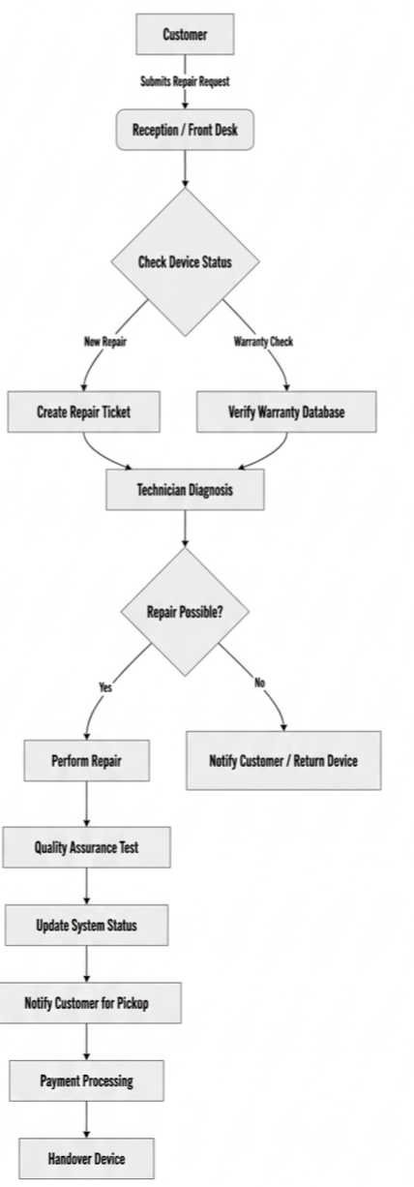

Fig 3.3: Existing System Flowchart

3.4 WEAKNESS OF THE EXISTING SYSTEM
The existing system has several limitations, which include:

• Lack of integration: Different operations are not connected within a single system
• Limited tracking: Difficulty in monitoring repair progress in real-time
• Poor reporting: Inability to generate detailed and accurate reports
• Data redundancy: Repetition of data across different records
• Low efficiency: Slower processing of repair jobs
• Limited accessibility: System cannot be accessed remotely
These weaknesses justify the need for an improved system.

3.5 ANALYSIS OF PROPOSED SYSTEM
The proposed Computer Repair Management System is a computerized solution designed to automate all repair-related operations at Technoid Technologies.

Key Features of the Proposed System:
• Customer registration and record management
• Repair job logging and tracking
• Technician assignment and monitoring
• Status updates (Pending, In Progress, Completed)
• Automated report generation
• Secure database storage

System Components:
•User Interface: For admin and technicians
•Database: Stores customer and repair data
•Processing Unit: Handles system logic and operations

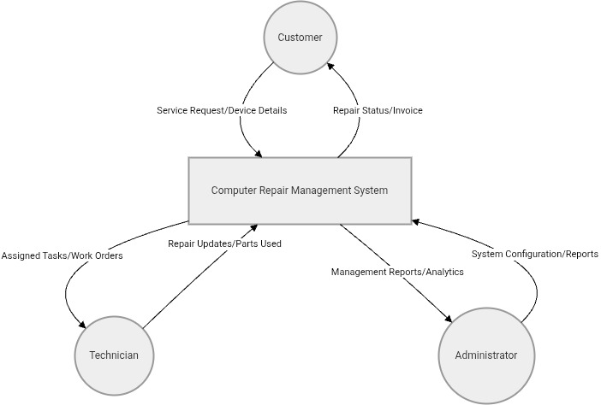

Fig 3.5 Proposed System Data Flow Diagram (DFD-Level 0)

3.6 ADVANTAGES OF THE PROPOSED SYSTEM
The proposed system offers several benefits over the existing system:

• Improved Efficiency: Faster processing of repair jobs
• Data Security: Safe storage of records in a database
• Easy Retrieval: Quick access to customer and repair information
• Reduced Errors: Minimizes human mistakes
• Better Tracking: Real-time monitoring of repair status
• Enhanced Reporting: Automatic generation of reports
•Customer Satisfaction: Improved service delivery

3.7 HIGH-LEVEL MODEL OF THE PROPOSED SYSTEM
The high-level model describes how different components of the system interact.
Components:
1. User (Admin/Technician)
2. System Interface
3. Application Logic
4. Database
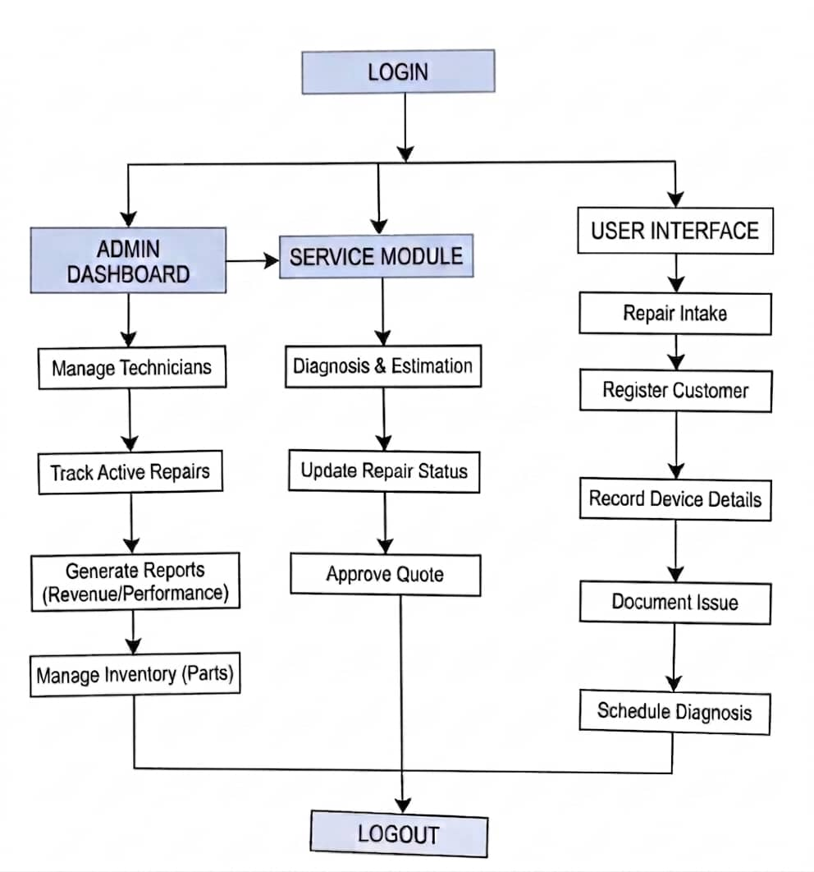
Fig 3.7 of the high level model of the proposed system

