**CHAPTER THREE**

**METHODOLOGY AND SYSTEM ANALYSIS**

**3.0 System Methodology**

System Methodology refers to a structured approach used to guide the process of planning, designing, implementing, and maintaining an information system. For the Waste Information Management System (WIMS) at UNICROSS, adopting a systematic methodology is crucial to ensuring that every phase from data collection to waste reporting—is addressed in a coherent manner. Common software methodologies include:

1. Waterfall Methodology
2. Agile Methodology
3. Iterative Development Methodology
4. Prototyping Methodology

**3.1 Methodology Adopted**

For the development and implementation of the WIMS at UNICROSS, the Agile Methodology is adopted. Agile’s iterative and user-centric approach is ideal for addressing the dynamic challenges of waste management on a busy university campus. This methodology allows for continuous stakeholder feedback particularly from waste management staff, facility managers, and university administrators ensuring that the system evolves to meet real-world operational needs. Figure 3.1 show the development life cycle for the Agile methodology.

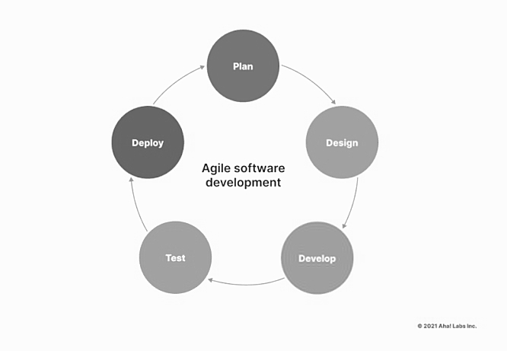

fig. 3.1: The Agile Development Methodology

The Agile approach is implemented through the following phases:

**Planning:**

Define project objectives and scope, and break down tasks into manageable sprints. This phase involves setting clear goals for automating waste tracking, collection scheduling, and reporting.

**Design:**

Iteratively develop system modules and user interfaces. Feedback from stakeholders is incorporated continuously to ensure the system remains aligned with operational needs.

**Development:**

Code and implement functionalities including data input forms, automated scheduling, notifications, and dashboard reporting.

**Testing:**

Conduct unit testing for individual components and integration testing to ensure seamless interactions between modules. Testing is continuous throughout each sprint to detect and resolve issues early.

**Deployment:**

Release working software increments to stakeholders at the end of each sprint, facilitating real-time feedback and further refinements.

**Requirement Gathering:**

1. Engage with waste management personnel, facility managers, and administrative staff to understand current practices and gather system requirements.
2. Use questionnaires and interviews to collect both quantitative and qualitative data regarding desired features such as real-time waste tracking, scheduling alerts, and comprehensive reporting.
3. Analyze existing waste management processes to identify inefficiencies that the system should address.

**System Modeling:**

1. Develop a conceptual model outlining system interfaces, modules, and interactions.
2. Use Case Diagrams to depict interactions between system users (e.g., waste collectors, administrators) and functionalities.
3. Create Sequence Diagrams to illustrate the flow of waste-related data—from generation, through collection, to disposal.

System Validation:

1. Perform unit tests on individual components to verify functionality.
2. Conduct integration testing to ensure modules communicate seamlessly.
3. Validate the system against user requirements through acceptance testing, incorporating feedback to address any discrepancies.

**Documentation:**

Develop and continuously update detailed documentation covering system specifications, design decisions, and user requirements. Maintain records of all modifications and enhancements throughout the development lifecycle.

**3.2 System Analysis**

System analysis is a critical phase in system development that involves evaluating the existing waste management processes at UNICROSS, identifying inefficiencies, and defining the requirements for the proposed Waste Information Management System (WIMS). The WIMS is designed to optimize waste handling activities by automating scheduling, tracking, reporting, and communication across departments, thereby improving operational efficiency and environmental sustainability.

The system will consist of three major components:

1. User Interface Layer (Front-End): This layer provides an interactive platform for waste management staff, facility managers, and administrators to access and manage waste data. It features dashboards for real-time waste tracking, collection schedules, notification management, and comprehensive reporting tools.
2. Application Logic Layer (Back-End): This layer handles the system’s core functionalities such as data processing, automated scheduling, notification dispatch, and analytics. It will be developed using robust server-side technologies (e.g., PHP, Python, or Node.js) to ensure efficient handling of requests. Role-based access control will be implemented to distinguish user permissions among waste collectors, supervisors, and administrators.
3. Database Management Layer: This layer stores and manages all data including waste generation records, collection logs, scheduling information, and user credentials. A relational database management system (e.g., MySQL, PostgreSQL) will be utilized to ensure secure data storage and integrity, with normalization applied to reduce redundancy.

**System Components and Processes**

1. User Authentication & Role-Based Access Control: Users will securely log in using authentication credentials. Roles will define system access levels, allowing waste collectors to update collection statuses, while administrators manage schedules and generate reports.
2. Automated Scheduling & Notification System: The system will automate waste collection scheduling based on input data and notify relevant personnel via email or SMS alerts to improve coordination and timeliness.
3. Real-Time Waste Tracking Dashboard: Users can monitor waste levels and collection status in real time, enabling prompt responses to issues like overflow or missed pickups.
4. Reporting and Analytics Module: This module will provide detailed reports on waste management performance, trend analysis, and resource utilization to support decision-making and planning.
5. Communication and Collaboration Tools: Integrated messaging features will facilitate efficient communication among staff to resolve operational challenges swiftly.

**System Workflow**

* User Registration/Login → Secure access to system functionalities.
* Dashboard Navigation → Real-time monitoring and access to system modules.
* Scheduling & Notifications → Automated assignment and alerts for waste collection.
* Data Input → Waste collectors update collection status and volumes.
* Reporting → Generate analytics and operational reports for administrators.
* Communication → Staff coordination through built-in messaging tools.

**Justification for the System Framework**

1. Increased Efficiency: Automation reduces manual data entry and scheduling errors, speeding up waste management operations.
2. Improved Data Accessibility: Centralized data storage supports real-time tracking and historical analysis.
3. Enhanced Communication: Built-in communication tools promote timely collaboration between departments.
4. Scalability: The system is designed to evolve, supporting future expansions such as mobile app integration and advanced analytics.

Fig. 3.2 below shows the diagrammatic framework of the system. The diagram illustrates the key modules and user interactions, including real-time tracking, scheduling, reporting, and communication within WIMS.

User Registration/Login

Scheduling & Notifications

Data Input

Reporting

Notifacation/ FAQ

**Fig. 3.2 Diagrammatic framework of the system**

3.3 Analysis of the Existing System

Waste management at UNICROSS (University of Cross River State) currently relies heavily on manual and fragmented processes, which hamper efficiency and overall effectiveness in handling campus waste. The existing system involves physical record-keeping and in-person coordination among waste collectors, supervisors, and administrative staff, resulting in delays, communication gaps, and limited data tracking.

The present waste management process follows these major steps:

* Waste Collection Scheduling: Supervisors manually plan and assign waste collection tasks to collectors, often relying on verbal instructions or physical schedules.
* Waste Collection Reporting: Waste collectors record collection activities and waste volumes using paper logs or informal methods during rounds.
* Data Compilation and Analysis: Administrative staff collate data from paper records to generate reports, often encountering errors or delays due to the manual nature of the process.
* Communication: Information and alerts regarding waste management tasks or issues are shared via informal channels such as phone calls or face-to-face interactions.

The current system faces several critical limitations that affect operational efficiency and service quality:

1. Inefficient Scheduling and Coordination: Manual scheduling often leads to conflicts, missed collections, and unoptimized routes, reducing overall efficiency.
2. Limited Real-Time Monitoring: The absence of digital tracking makes it difficult to monitor waste collection progress or respond promptly to arising issues.
3. Data Inaccuracy and Delays: Reliance on paper logs results in frequent data loss, errors, and delayed reporting, affecting decision-making and resource allocation.
4. Poor Accessibility to Waste Management Information: Lack of a centralized platform restricts access to relevant data for staff, limiting transparency and accountability.
5. High Administrative Burden: Staff spend excessive time on repetitive paperwork and communication tasks, diverting effort from proactive waste management activities.

Fig. 3.3 below presents the Data Flow Diagram (DFD) of the existing waste management system, illustrating how information and tasks move through manual channels, highlighting bottlenecks and areas prone to inefficiency.

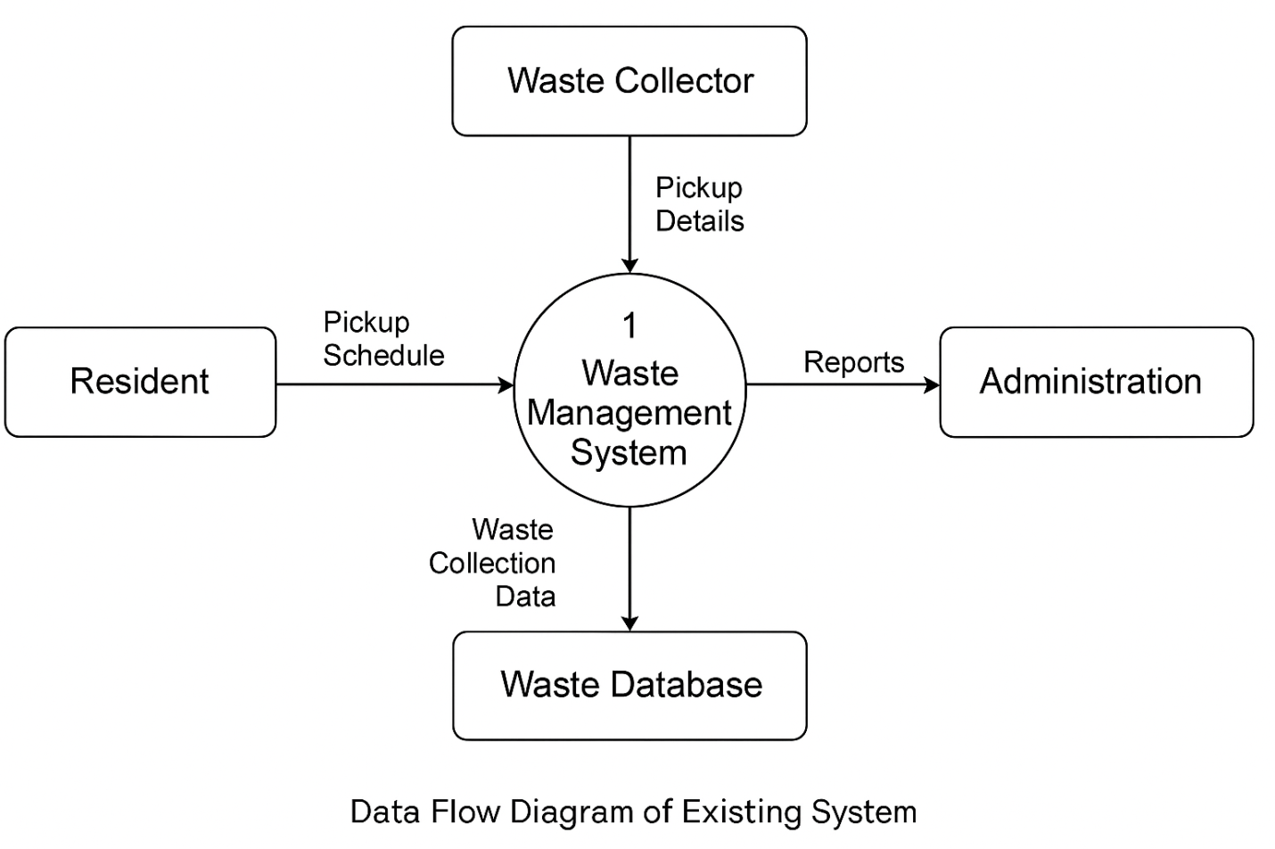

**3.4 Weaknesses of the Existing System**

The analysis of the current waste management practices has revealed several critical weaknesses:

1. Automation Deficiency: The absence of automated processes for data collection and scheduling leads to significant delays and errors.
2. Integration Gap: Departments operate independently with minimal data sharing, resulting in fragmented waste management processes.
3. Real-Time Information Access Challenges: The lack of real-time monitoring impedes the ability to quickly address issues such as overflowing waste bins or delayed collections.
4. Inadequate Data Management: Manual record-keeping increases the risk of data loss, inaccuracies, and difficulties in maintaining a centralized data repository.
5. Communication Limitations: Traditional communication channels hinder timely coordination among staff, affecting the overall efficiency of waste management.
6. Limited Reporting and Analytics: Without robust analytical tools, it is challenging to monitor performance, identify trends, or make data-driven decisions.
7. These weaknesses underscore the necessity for a comprehensive, automated system that can integrate all aspects of waste management at UNICROSS.

3.5 Analysis of the Proposed System

The proposed Waste Information Management System (WIMS) for the University of Cross River State (UNICROSS) is designed to overcome the limitations of the existing manual waste management processes by automating key waste tracking, scheduling, and communication functions. This system aims to streamline campus waste management operations, improve efficiency for facility staff, and enhance waste disposal practices across the university.

Key features of the proposed system include:

1. Automated Waste Collection Scheduling: Campus staff can schedule waste collection activities online, optimizing routes and timings to reduce delays and overlaps in waste pickup.
2. Real-time Waste Tracking and Reporting: The system will allow facility managers to monitor waste levels and collection status in real-time, facilitating timely interventions and accurate reporting.
3. Centralized Waste Information Repository: A platform for storing and accessing waste-related data, including collection logs, disposal methods, and recycling statistics, to support decision-making and compliance reporting.
4. User Authentication and Role-Based Access Control: Access will be restricted to authorized personnel such as waste handlers, facility managers, and administrators. Secure login mechanisms will protect sensitive data and ensure system integrity.
5. Notification and Alert System: Automated alerts will notify relevant staff about scheduled waste pickups, delays, or any issues detected in the waste management process, promoting proactive response.

Fig. 3.4 below shows the data flow diagram of the proposed system.

Resident

Waste Collector

Administrator

Waste Database

Manage Schedules

Pickup Details

Pickup Request

Administrator

**Fig.3.4 Data Flow Diagram of the Proposed System**

3.6 Advantages of the Proposed System

The proposed Waste Information Management System offers several advantages over the current manual processes:

1. Increased Efficiency: Automation reduces the manual workload and speeds up data processing, leading to faster waste collection and disposal operations.
2. Improved Data Management: A centralized DBMS ensures data accuracy, integrity, and easy accessibility, supporting informed decision-making.
3. Enhanced Communication: Integrated communication features facilitate better coordination among waste management staff and university administrators.
4. Real-Time Monitoring: Continuous tracking of waste data allows for immediate identification and resolution of issues, thus enhancing responsiveness.
5. Robust Reporting and Analytics: Comprehensive analytical tools support trend analysis, performance monitoring, and strategic planning.
6. Environmental and Health Benefits: Improved waste management leads to a cleaner campus environment, reducing health hazards and supporting the university’s sustainability goals (United Nations, 2015).

These advantages are expected to result in not only operational improvements but also long-term benefits in terms of sustainability and resource management.

3.7 High Level Model of the Proposed System

Fig. 3.5 below outlines the key components of the Waste Information Management System, including user access roles (waste handlers, facility managers, and administrators), waste collection scheduling, waste data repository, real-time tracking modules, and a centralized database for storing waste management records. This system enhances operational efficiency by automating waste collection workflows, centralizing waste data, and streamlining communication among campus waste management stakeholders.

Logout

WIMS UNICROSS

User

System Admin

Request Service

View Request

Add User

Manage User Data

Receive Notification

Login Module

Manage Service Request

**Fig. 3.5 High level model of the proposed system**