**High Level Document**

1. **Class Diagram**

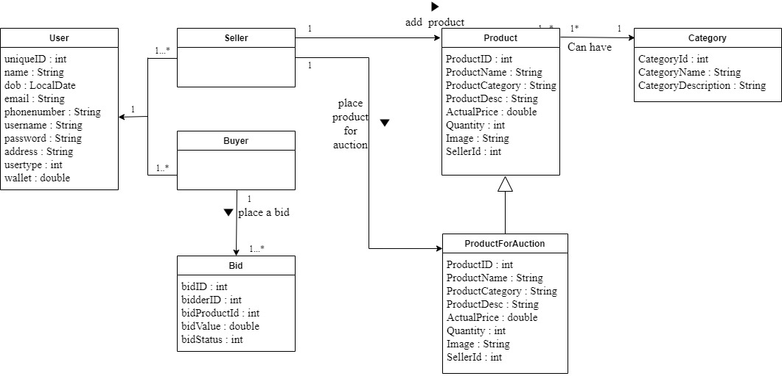

1. **EER Diagram**

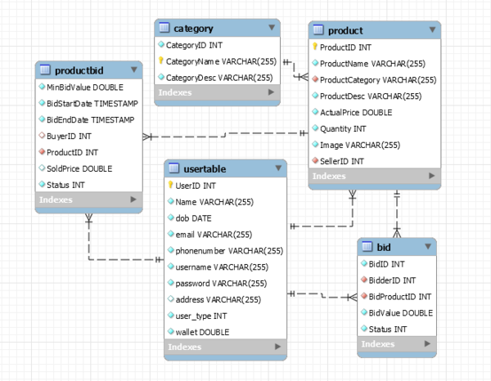

1. **Data Flow Diagram 1 and 2**
2. **Use case diagram**

