 

Department of Computer Science & Information Technology

III Year,V Semester(Batch 2022-2026)

Lab Record Submission of

Linux (Lab)

Subject Code – CSIT-505

Submitted to: Submitted by:

Prof. Nidhi Nigam Prince Sahu

0827CI221106

**Linux Lab file -2**

**Commands**

* **Cal**

The command cal in Linux is used to display a simple calendar in the terminal. By default, it shows the current month, but you can use it with various options to display a different year or a specific month.

Syntax:

cal [month] [year]

Command:

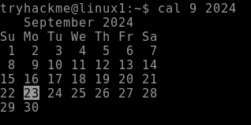

* **echo command**

Syntax- echo(statement)

Description: This is a built-in command in many shell environments, including Bash. Its primary function is to display a line of text or variable value to the standard output (usually the terminal).

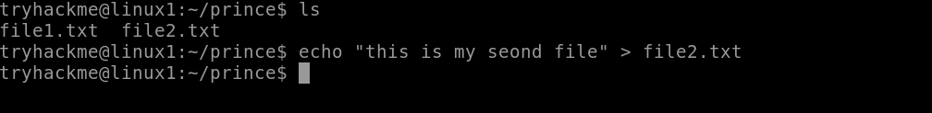 a

* **whatis command**

Syntax- whatis(command name)

Description- : This is the command itself, which queries the manual database for descriptions of commands.

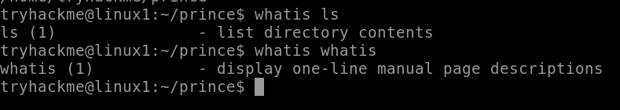

* **date command**

Syntax- date(command name)

Description- : This is the command itself, which retrieves and displays the current date and time.

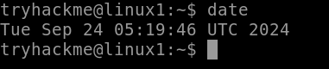

* **pwd command**

Syntax- pwd

Description- : This is the command itself, which outputs the full path of the current workingdirectory. 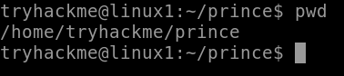

* **mkdir command**

Syntax- mkdir (directory name)

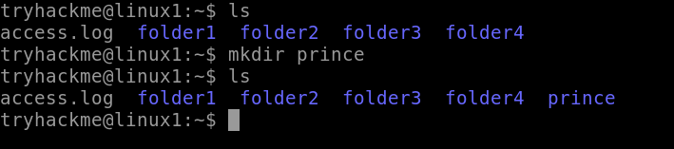 Description- : This is the command itself, which is used to create one or more directories.

* **cd command**

Syntax- cd (directory name)

Description- : This is the command itself, which is used to change the current working directory.

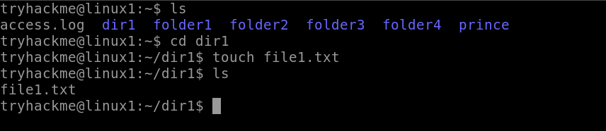

* **rmdir command**

Syntax- rmdir (directory name)

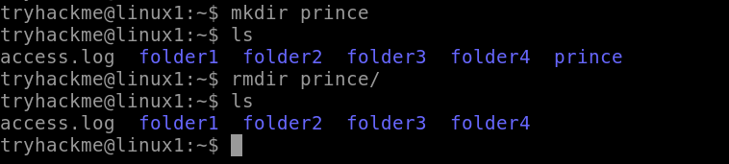 Description- :  This is the command itself, which is used to remove empty directories.

* **ls command**

Syntax- ls

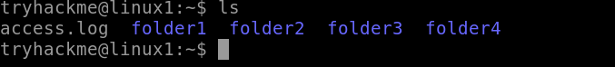 Description- This is the command itself, which stands for "list." By default, it lists the files and directories in the current working directory.

* **grep command**

Syntax- grep(file name)

Description- This is the command itself, which searches for patterns in text.

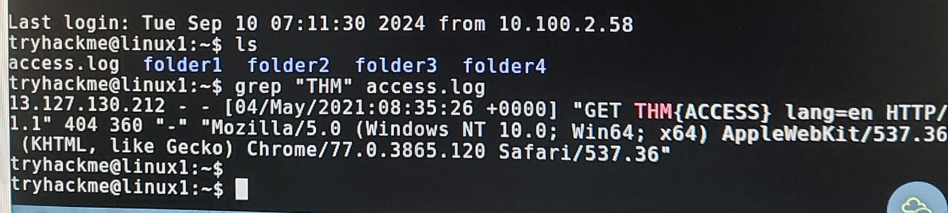

* **find command**

Syntax- find(file name)

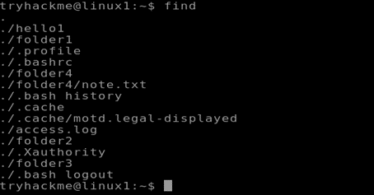 Description- The find command is a powerful utility in Unix/Linux systems used to search for files and directories within a specified directory hierarchy

* **touch command**

Syntax- touch(file name)

Description- The touch command in Linux is used to create empty files or update the timestamps of existing files

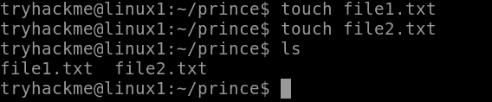

* **whatis**
* **Whoami**

The whoami command prints the effective username of the user who is currently executing the command.

Syntax:

whoami

Command:

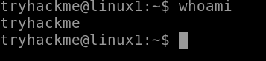

* **ls -l command**

Syntax- ls -l

Description- The ls -l command in Linux is used to list files and directories in a detailed (long) format.

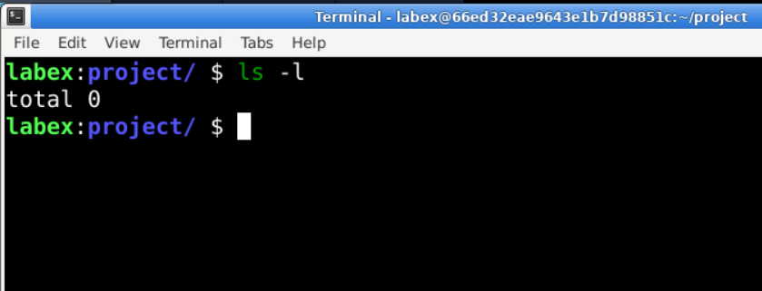

* **cp command**

Syntax- cp [options] source destination

Description- The cp command is a utility in Unix-like operating systems used to copy files and directories.

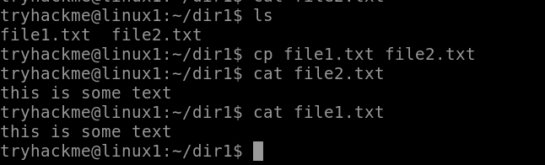

* **Sudo**

The sudo command grants elevated privileges to run commands that require root or administrative permissions. It's typically used to perform system administration tasks.

Syntax:

sudo [options] command

Command:

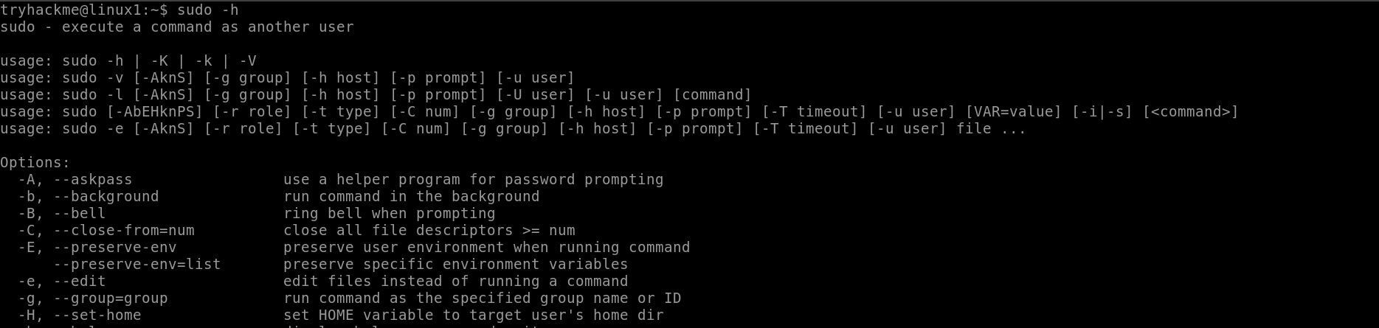

* **ls -a command**

Syntax – ls -a

Description - The ls -a command in Linux is used to list all files and directories in the current directory, including hidden files.

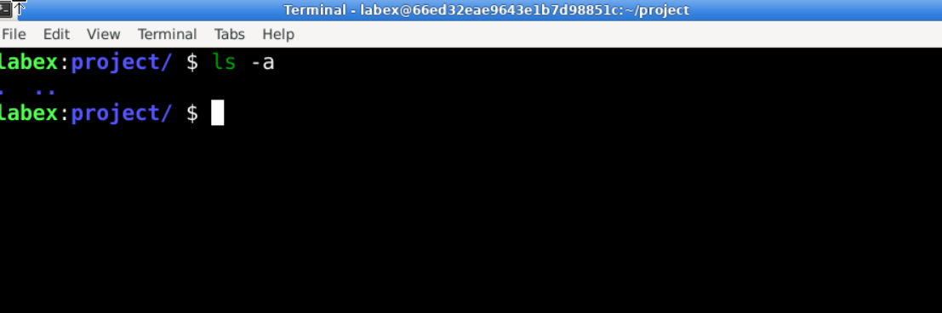

* **mv command**

Syntax- mv (file name)

Description- The mv command in Linux is used to move or rename files and directories

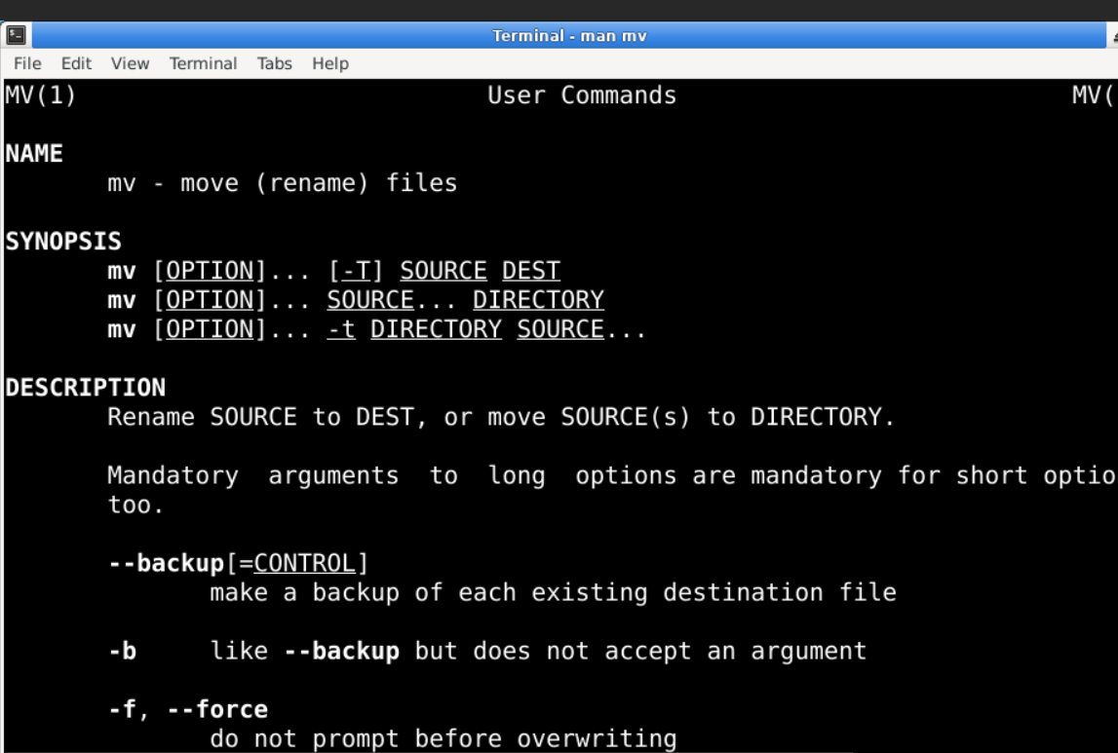

* **less command**

Syntax- less (file name)

Description- The less command is a commonly used command-line utility in Unix-like operating systems for viewing the contents of files one screen at a time

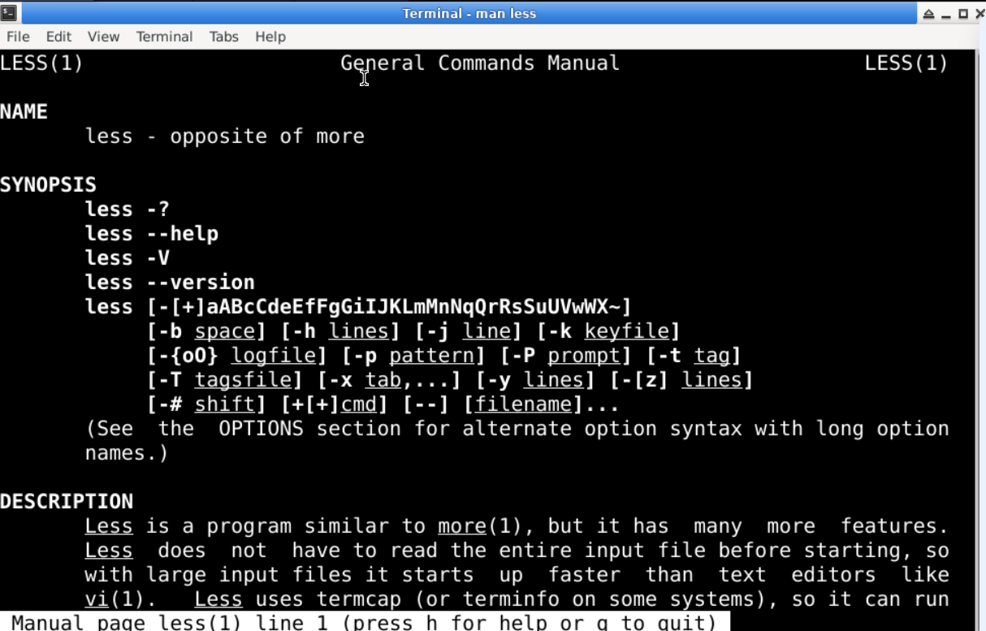

* **ps command**

syntax- ps

description- The ps command is used in Unix-like operating systems to display information about the currently running processes.

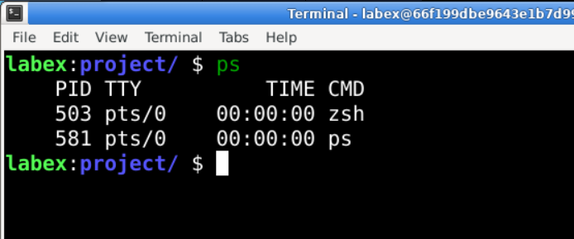

* **kill command**

syntax- kill [optin] <pid>

description- The kill command is used in Unix-like operating systems to terminate processes

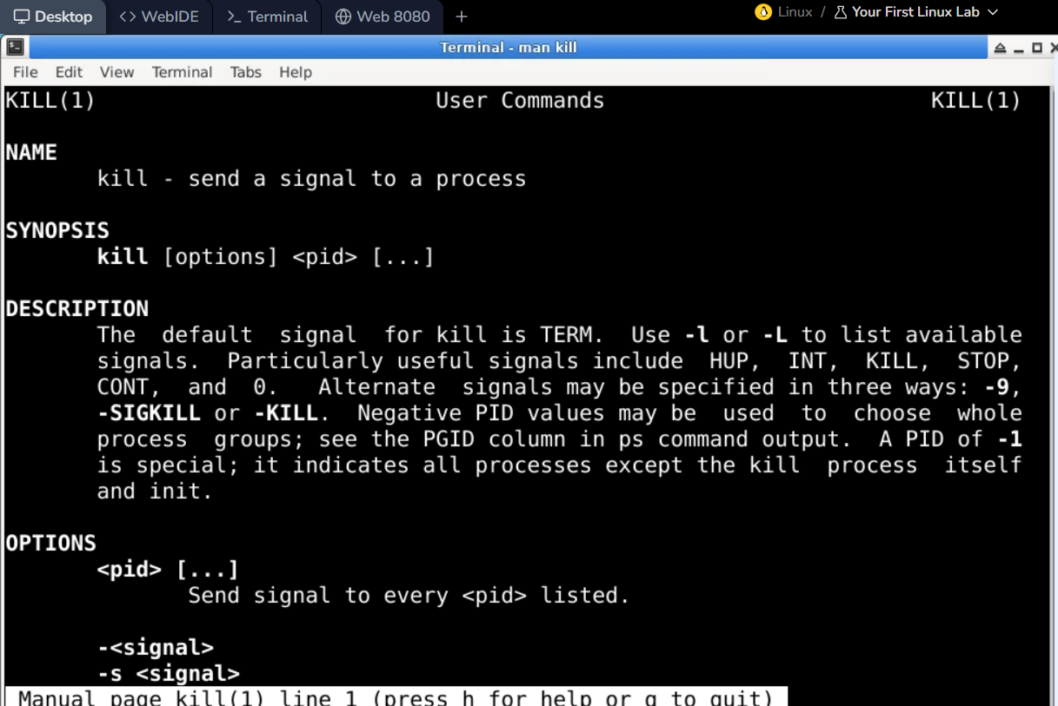

* **ip**

syntax-ip

description- The ip command is a powerful utility in Linux and Unix-like operating systems used for managing network interfaces,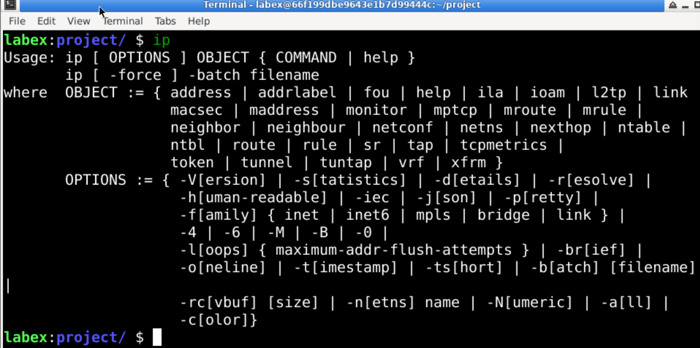

* **ifconfig command**

syntax= ifconfig

description- The ifconfig command is a network utility in Unix-like operating systems used to configure and display network interface parameters.

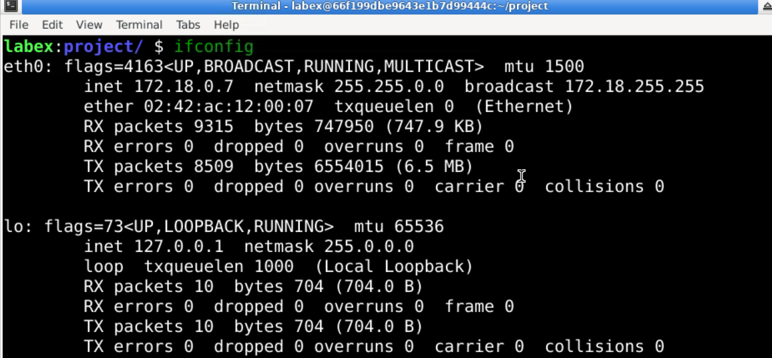

* **head command**

syntax- head (file name)

decription= The head command is a utility in Unix-like operating systems used to display the beginning of a file or standard input.

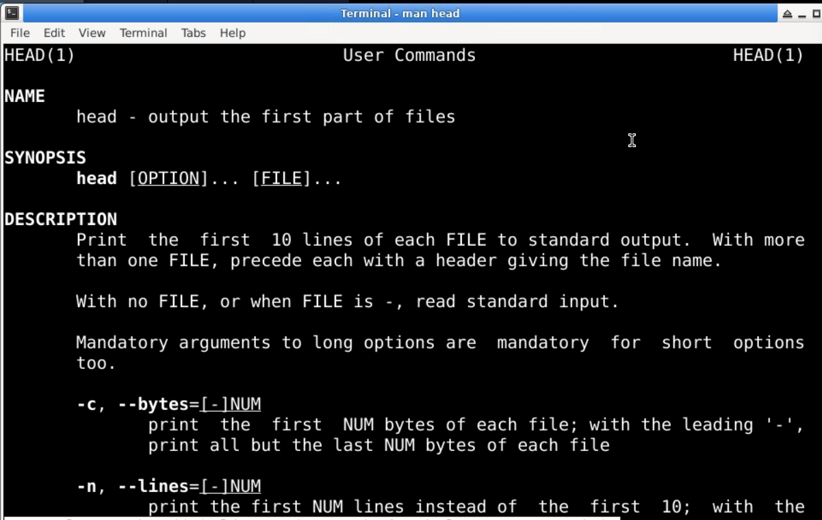

* tail command

syntax- tail (filename)

description- The tail command is a utility in Unix-like operating systems used to display the end of a file or standard input

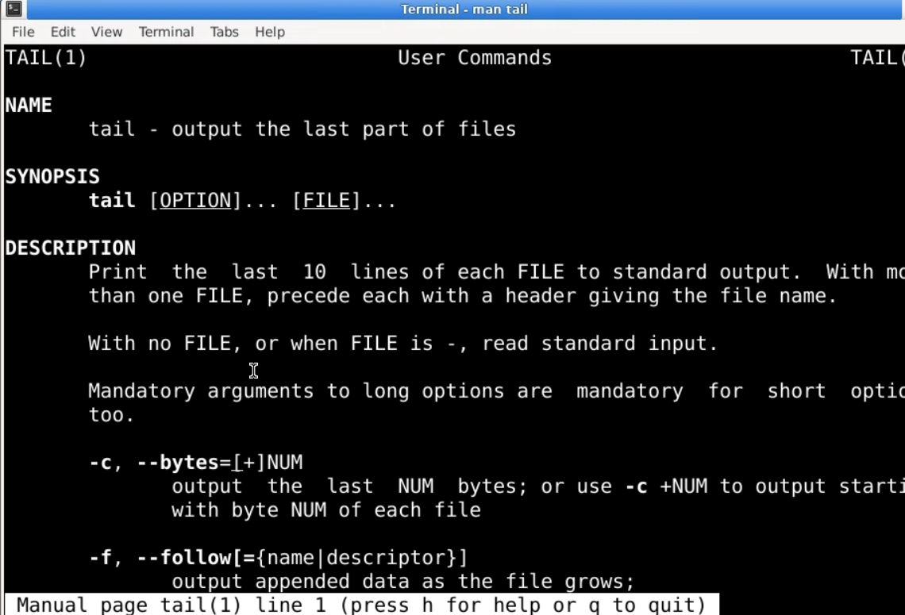

* netset

The netstat command provides information about active network connections and network interface statistics, helping users monitor and troubleshoot network issues.

Syntax:

netstat [options]

Example:

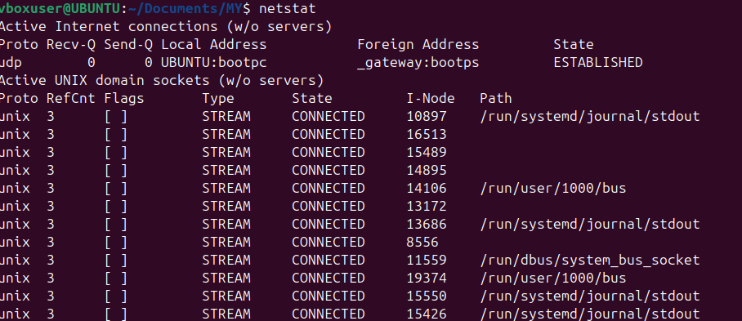

* gid

In Linux, GID stands for Group Identifier. It is a numeric value used to identify a specific group on the system. Each user in Linux can belong to one or more groups, and each group is assigned a unique GID.

Syntax:

id username

Example:



* **chmod**

The chmod command allows users to specify who can read, write, or execute a file. Permissions can be set for three categories: the file owner, the group, and others.

Syntax:

chmod [options] mode file

Example:



* **man**

The man command is a built-in command that allows users to access the manual documentation for commands, functions, system calls, and other components in Linux.

Syntax:

man [options] command

Example:



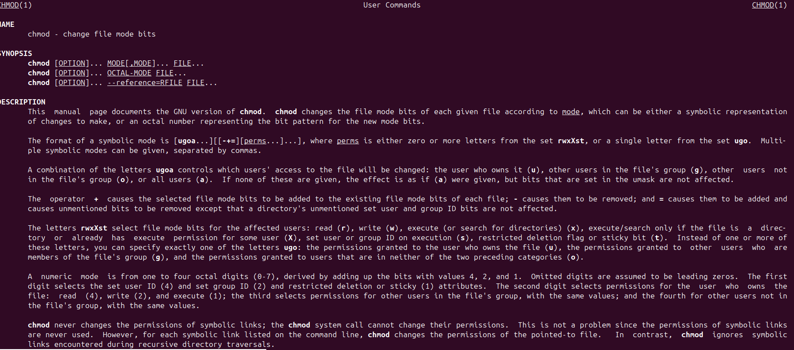

* **rm**

The rm command allows users to delete files and directories from the filesystem. It is a powerful command that permanently removes files without placing them in a recycle bin or trash.

Syntax:

rm [options] file

Example:

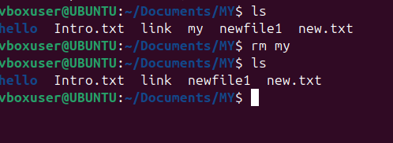

* **locate**

The locate command searches for files and directories in a database that contains the paths of all files on the system. This database is typically updated daily by a background service (updatedb), allowing for fast searches.

Syntax:

locate [options] pattern

Example:

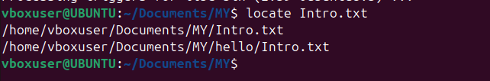

* df - df command checks your Linux system’s disk usage, displaying the used space in percentage and kilobyte (KB).

Syntax:

df [options] [file system]

Command:

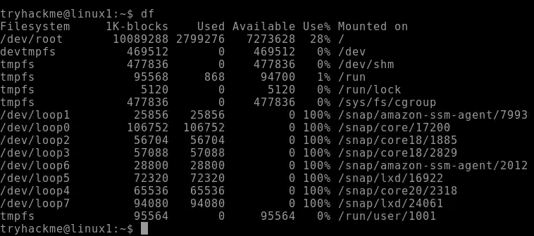

* **history** :

Run the history command to check previously run utilities.

Syntax: history [options]

Command:

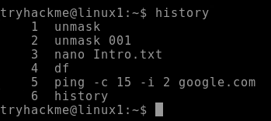

* **ping:**

ping command sends packets to a target server and fetches the responses. It is helpful for network diagnostics.

Syntax:

ping [option] [hostname_or_IP_address]

Command:

