MASTER OF COMPUTER APPLICATIONS (MCA)

FINAL SEMESTER PROJECT REPORT
ON
"SMART ELECTRICITY BILLING SYSTEM"

Submitted by:
Name: ________________________________
Roll No: ______________________________
Registration No: ______________________

Under the Guidance of:
Guide Name: ___________________________

Department of Computer Applications
College Name: _________________________
University: ___________________________

Academic Year: 2025-2026 Date: 25-05-2026

CERTIFICATE
This is to certify that the project report entitled "Smart Electricity Billing System" is a bona fide work carried out by the above student in partial fulfillment of the requirements for the award of the degree of Master of Computer Applications (MCA). This work has been completed under my guidance and supervision.
Guide Signature: _____________________
Head of Department: __________________
External Examiner: ___________________

ACKNOWLEDGEMENT
I would like to express my sincere gratitude to my project guide, faculty members, and the department for their continuous support and valuable guidance during the development of this project. I also thank my friends and family for their encouragement and motivation throughout this work.

ABSTRACT
The Smart Electricity Billing System is a web-based application developed using Django and SQLite for managing consumer data, generating electricity bills, tracking payment status, and providing analytical insights through interactive dashboards. The system automates unit and amount calculation using slab-based tariff logic, supports PDF bill generation, and provides separate portals for admin and consumers. The interface is modern, responsive, and designed using Tailwind CSS, making the project suitable for real-time demonstration and academic submission.
PROJECT CONTENTS
- 1. Introduction
- 2. Problem Statement
- 3. Objectives
- 4. Scope of the Project
- 5. Technology Stack
- 6. System Modules
- 7. Database Design
- 8. Implementation Highlights
- 9. Testing and Validation
- 10. Screenshots
- 11. Conclusion
- 12. Future Enhancements
- 13. References

1. Introduction
Electricity boards and utility providers handle large volumes of consumer records, monthly meter readings, and bill generation tasks. Manual methods are slow and error-prone. This project digitizes billing operations through a centralized web application.
2. Problem Statement
Traditional billing workflows often result in delays, incorrect calculations, and difficulty in tracking payment status. A secure and simple system is needed to automate billing and improve transparency.
3. Objectives
The project aims to provide admin login, consumer management, automated bill generation, bill history tracking, PDF bill download, dashboard analytics, and a consumer portal to view own bills and status.
4. Scope of the Project
This system is designed for academic demonstration and small-to-medium electricity billing operations. It supports billing lifecycle activities from consumer registration to status monitoring and report download.
5. Technology Stack
Backend: Python, Django
Database: SQLite
Frontend: Django Templates, Tailwind CSS, Alpine.js, Lucide Icons, Chart.js
Reporting: ReportLab for PDF generation.
6. System Modules
- Authentication Module (Admin and Consumer Login)
- Admin Dashboard Module
- Consumer Management Module
- Bill Generation Module
- Bill History and Status Module
- PDF Bill Download Module
- Consumer Portal Module
- Django Admin Management Module
7. Database Design
Model | Important Fields | Purpose
Consumer | name, consumer_number, meter_number, address, mobile_number, connection_type | Stores consumer master data
Bill | consumer, previous_reading, current_reading, units_used, total_amount, due_date, status | Stores billing records and amount details
Payment | bill, payment_date, amount_paid, reference_number | Stores payment confirmation information
8. Implementation Highlights
- Automatic slab-based tariff calculation (0-100: Rs.3, 101-300: Rs.5, above 300: Rs.7).
- Fixed charge and tax applied during bill save operation.
- Interactive analytics charts for usage and bill status.
- Role-based access separation for admin and consumer portals.
- Printable and downloadable PDF electricity bills.
9. Testing and Validation
Functional testing was performed for login/logout, consumer CRUD operations, bill generation, status filtering, consumer portal access control, and PDF generation. The project runs successfully on local server with SQLite database.

10. Screenshots
Figure 1: Admin Login Page
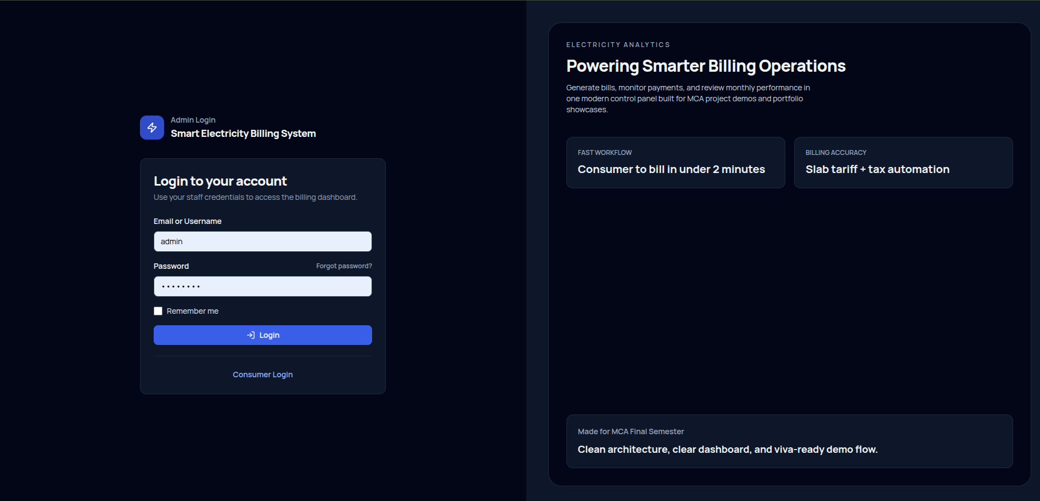
Admin Login Page

Figure 2: Admin Dashboard Analytics
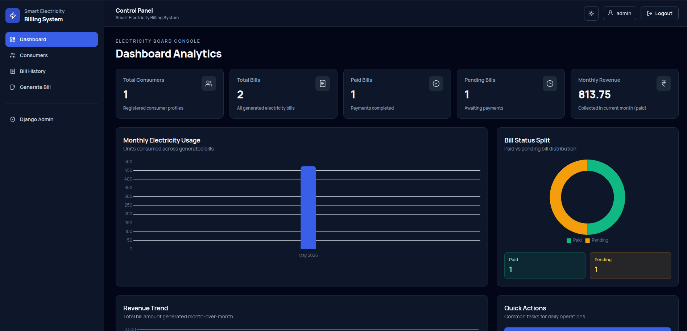
Admin Dashboard Analytics

Figure 3: Consumer Management Page
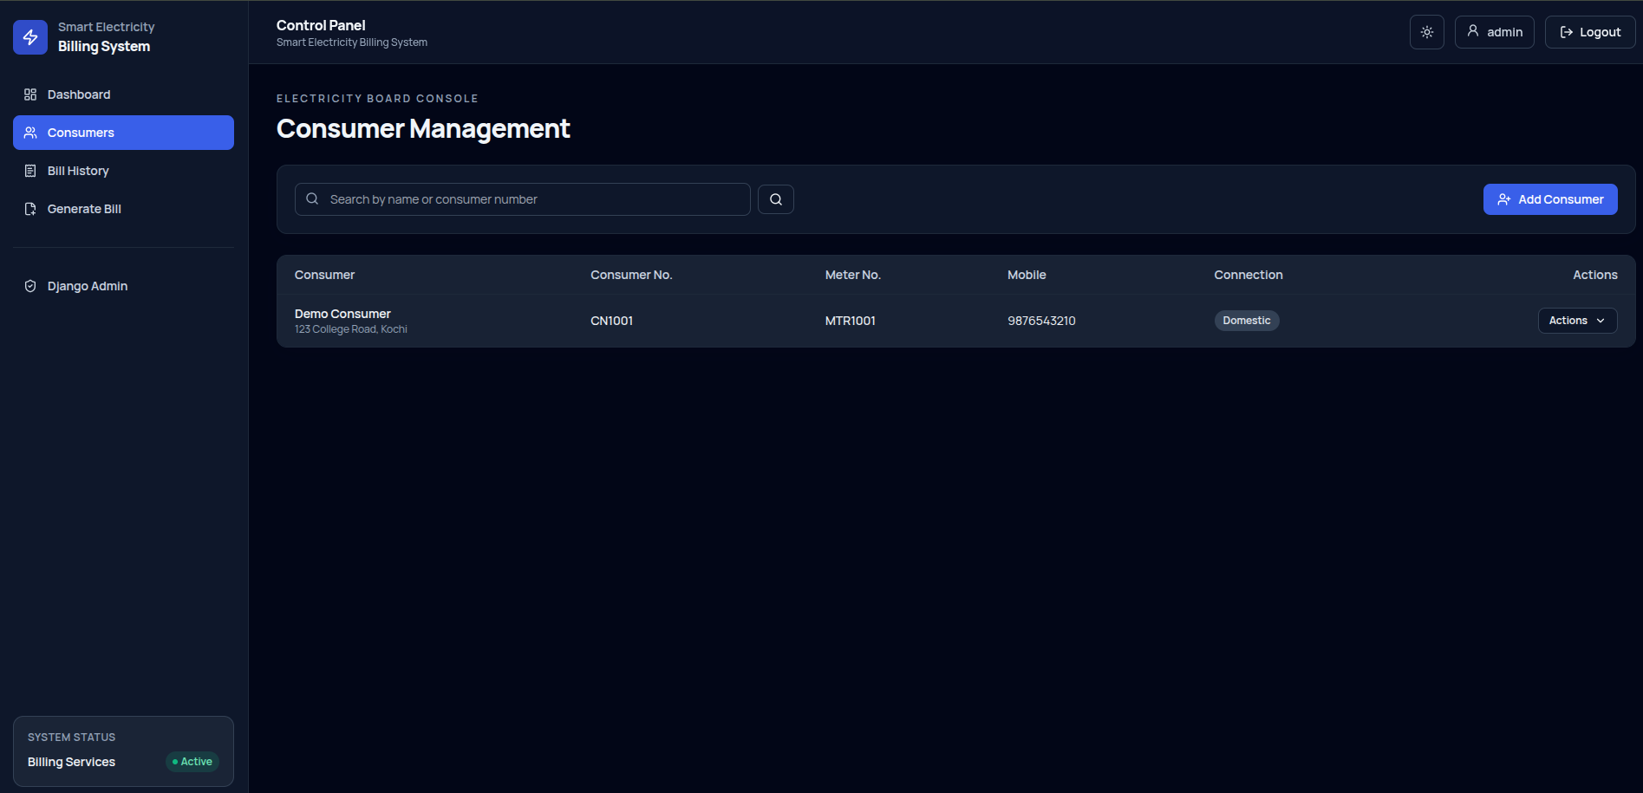
Consumer Management Page

Figure 4: Bill History Page
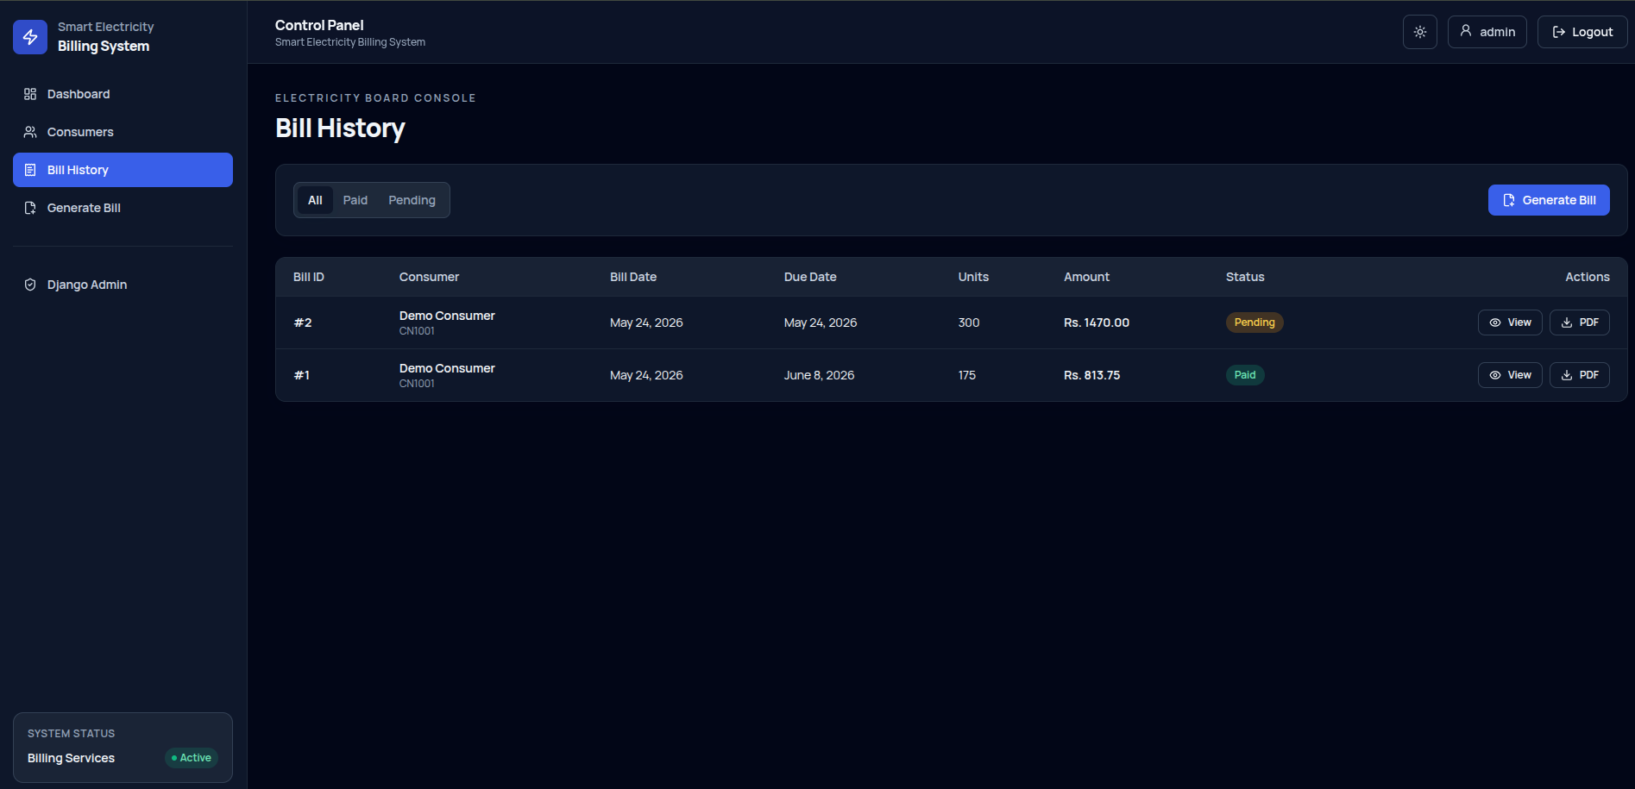
Bill History Page

Figure 5: Bill Generation Page
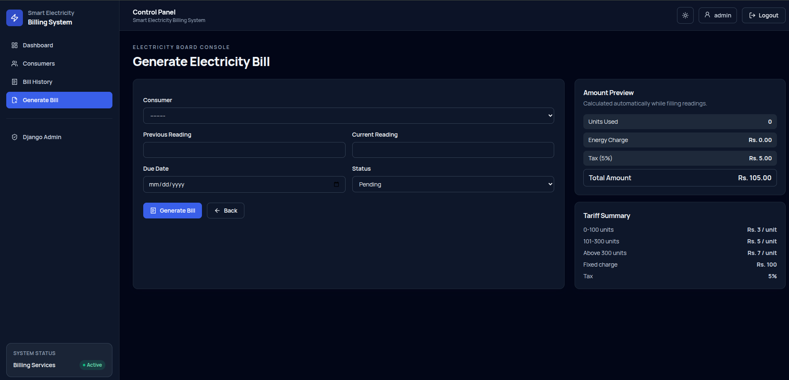
Bill Generation Page

Figure 6: Django Admin Panel
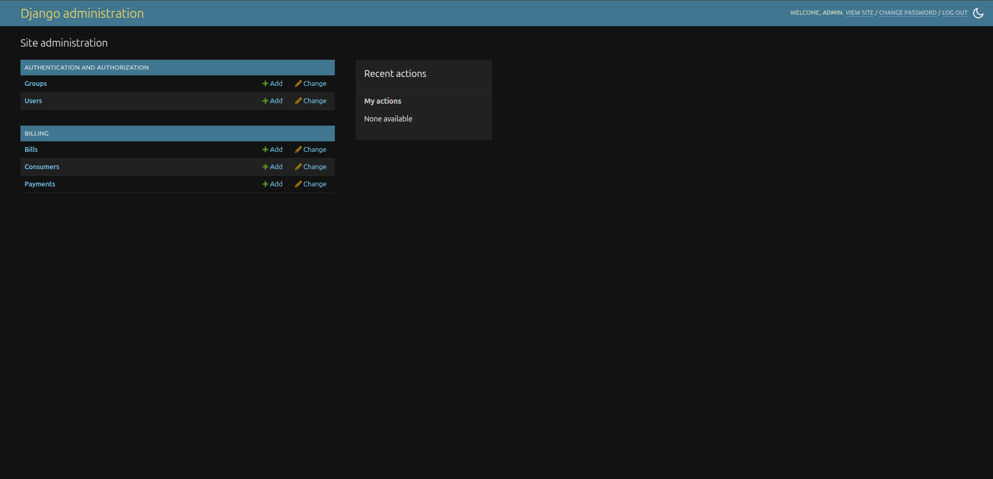
Django Admin Panel

Figure 7: Consumer Login Page
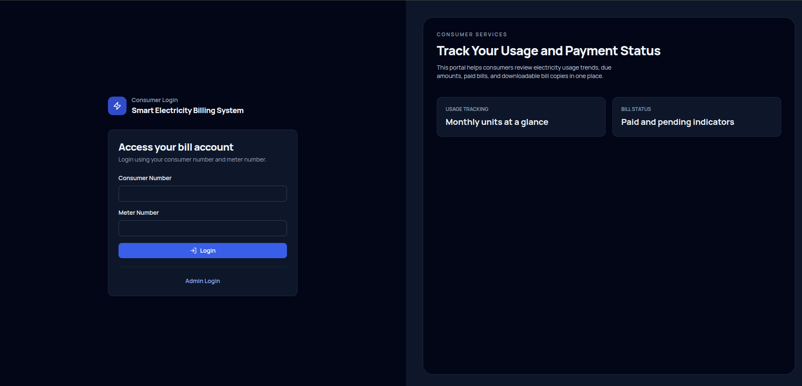
Consumer Login Page
11. Conclusion
The Smart Electricity Billing System successfully automates end-to-end electricity billing activities and demonstrates a practical, scalable, and user-friendly approach to utility billing management.
12. Future Enhancements
- Online payment gateway integration.
- SMS and email bill alerts.
- Advanced analytics and forecasting module.
- Multi-office or multi-region role hierarchy.
- Cloud deployment for production usage.
13. References
Django Official Documentation: https://docs.djangoproject.com/
Chart.js Documentation: https://www.chartjs.org/docs/
Tailwind CSS Documentation: https://tailwindcss.com/docs
ReportLab Documentation: https://www.reportlab.com/documentation/

