**Gulay-Bato: A Mobile Fruit and Vegetable Classification for the Dietary Restrictions of Zamboangueño Hemodialysis Patients utilizing a Convolutional Neural Network**

**A Thesis by**

**Gozum, Vicenta Princess C.**

**Musa, Sainur B.**

**Hamsiri, Al-Jadeed S.**

**BSCS ST / BSCS**

**Submitted to the BS Computer Science Program**

Western Mindanao State University

**In Partial Fulfillment**

**of the Requirements for the Degree**

**BS Computer Science / BS Computer Science –Software Technology**

**December 16, 2019**

APPROVAL SHEET

This thesis proposal entitled **Gulay-Bato: A Mobile Fruits and Vegetable Classification for the Dietary Restriction of Zamboangueño Hemodialysis Patients**, prepared and submitted by **Vicenta Princess C. Gozum, Sainur B. Musa, Jadeed S. Hamsiri**, in partial fulfillment of the requirements for the degree **BACHELOR OF SCIENCE IN COMPUTER SCIENCE** is hereby accepted.

|  |  |
| --- | --- |
| **Ms. Angeline Chrisette C. Olegario** | |
| Research Paper Adviser | |
| **Mr. Jason Catadman** | |
| Chair, Defense Panel | |
| **Ms. Pauleen Gregana** | **Ms. Angeline Chrisetter C. Olegario** |
| Panel Member | Panel Member |

Accepted and approved for implementation in Thesis 2.

**Roderick P. Go**

Director, Institute of Computer Studies

ACKNOWLEDGMENTS

We would like to express our deepest and sincere gratitude to our adviser Ms. Angeline Chrisette C. Olegario for the unending support to our Thesis research. To the patience she gave to us, Knowledge she shared, to the motivation, trust, and enthusiasm throughout our research. Her guidance helped us to boost our confidence and believe that we can finish our research through hard work and passion for what we do. We could not have imagined without her guidance we would not be able to do this kind of Thesis Research. We also would like to thank Mr. Jaydee Ballaho who was also the one that shared his ideas about Machine learning.

We would like to thank the panelist who also gave us ideas about their perspective that have also helped us to fulfill this kind of research especially to Dr. Cielito C. Olegario who suggest us to make a pre-test and post-test to her classmates in Hemodialysis and clarify us about the stages of the kidney failure.

We would also like to thank our classmates that also help us to motivate ourselves and keep us updated with anything that involves our thesis subject.

Last but not the least, to our families who continuously support us throughout our studies, financially, emotionally, and spiritually who are also one of our inspirations to fulfill our dreams.

Table of Contents

1 INTRODUCTION 8

1.1 Background of the Study 8

1.2 Objectives of the Study 9

1.3 Significance of the Study 11

1.4 Scope and Delimitations 12

2 THEORETICAL FRAMEWORK 14

2.1 Review of Related Literature 14

3 OPERATIONAL FRAMEWORK 21

3.1 Materials 21

3.1.1 Software 21

3.1.2 Hardware 21

3.1.3 Data 21

3.2 Methods 22

3.2.1 Experimental design 22

3.2.2 Procedures for the different phases 25

3.2.3 Evaluation or Testing 26

4 RESULT OF PRE-TEST AND POST-TEST 27

5 DISCUSSION 29

6 CONCLUSION 35

7 RECOMMENDATIONS 36

LIST OF TABLES

Table 1 List of Vegetables and Fruits feed in Model 13

Table 2 Prior art Feature similarity and differences from our Application 19

Table 3 Pre-test and Post-test result chart 27

LIST OF FIGURES

Figure 1 :1x1 Convolutional Filters called Pointwise Convolution in the context of Depth wise Separable Convolution 19

Figure 2 : The Agile Methodology Cycle 24

Figure 3 Number 1 question and answers 32

Figure 4 Number 2 question and answers 33

Figure 5 Number 3 question and answers 33

Figure 6 Number 4 Question and answers 34

Figure 7 Number 5 question and answers 34

Figure 8 Number 6 question and their answers 35

Figure 9 Number 7 question and their answers 35

Figure 10: The Login Interface 43

Figure 11 : The Forgot Password Interface 43

Figure 12: The Sign-Up page 44

Figure 13: The terms and conditions of our application 44

Figure 14 : The tutorial interface of our application 45

Figure 15 : The Dashboard of our application 46

Figure 16 : The camera interface 46

Figure 17 : The History Interface 47

Figure 18 : The Feedbacks interface 48

Figure 19 : About Us Interface 49

Figure 20: The User Profile Interface 49

ABSTRACT

Hemodialysis has given hope for millions of people throughout the world for patients who have End-Stage Renal Disease (ESRD) with limited or the kidney does not function anymore. However, there is also an impact on people who undergo dialysis aside from mental health also in psychological health due to the stress, worries, and other restrictions that have affected their normal life especially in what they eat specifically the fruits and vegetables that can or cannot be consumed. Nowadays, assistive technologies have been improved, machine learning and artificial intelligence are being used in other fields, with applications that are binding to our gadgets which we can easily access anywhere and CNN Neural Network (CNN) is also being used such as in face recognition and other pattern recognition. Through an application that can help in classifying the fruit and vegetable dietary restriction for the hemodialysis patients with the use of CNN and a model which is MobileNet that can accurately give results to lessen their lifestyle burdens. At first, we intend to use ResNet model and only vegetable dietary restriction of the hemodialysis patients will be the base of our datasets but due to Covid-19 crisis and lack of internet connection, we have a hard time in using Resnet model due to it consumes us a lot of time in training, so we decided to find an alternative way and able to use MobileNet model so that we can continue with the next phase of the project and also the datasets we use are can be found in local places instead of only in Zamboanga City and added also fruits to make a large number of datasets. We also added a feature that displays the nutritional value of each fruit and vegetable to expand the information or knowledge of the user and the history of captured fruits and vegetables.

Keywords: Hemodialysis, Convolutional Neural Network, MobileNet Model, Fruits and Vegetables Dietary Restriction

# INTRODUCTION

## Background of the Study

Every individual has their way of maintaining their well-being. One of those factors is what we eat, what type of food groups are good for our body whether or not we have illnesses, we want to be healthy. So how much more for people who have illness especially for Hemodialysis Patients, who cannot filter toxins in their bloodstream because of their kidney failure. How will they be able to know what they can and cannot eat? Will all the fruits and vegetables be good for their health? With these questions we have, we want to help them to lessen their stress with the use of technologies that can recognize their fruits and vegetable dietary restrictions.[1]

Convolutional Neural Network is a specified kind of Artificial Neural Network (ANNs) that uses convolution in general matrix multiplication in at least one of their layers. They broadly used to recognize objects in images and analyze patterns in time series data as well as in sensor data classification.[2] The success of the convolutional neural network in image recognition is one of the core reasons why deep learning was known to the world. The success of a deep convolutional neural architecture called AlexNet Model in the 2012 ImageNet Large Scale Vision Recognition Competition (ILSVRC).[3] While many detection technologies are provided for internet devices and with the enhanced power of mobile devices that can be used anytime, anywhere regardless of internet connection.[4] Wherein, MobileNet is one of the efficient models to use in an image processing system because of its capabilities in building low-latency or light convolutional neural networks perfect for smartphones that are being used today.[5]

With the use of technology to classify images and to help people lessen their stress, some applications classify food and vegetables such as the “Classification of Vegetables using TensorFlow” and “Food Recognition Smartphone Application” wherein most of their work in image classification is composed of three main steps which include: background subtraction; feature extraction; training and classification which uses Inception model and TensorFlow.[6][7]

With the present applications, it can be developed through classifying fruits and vegetables dietary restriction for the hemodialysis patients using the MobileNet model to have a more accurate result which can be a big help to lessen their stress. Before, we plan to use the ResNet model and the datasets to be used was vegetable that is only can be found around Zamboanga City but due to lack of datasets to feed we decided to add the fruits in our project and using MobileNet Model for the Image Classification as well as we also added features that may also help the hemodialysis patients to improve their knowledge through showing them the nutritional value or benefits of a certain fruit or vegetable as well as the history of captured fruits and vegetables.

## Objectives of the Study

The first objective we have was to provide a solution to the problem through the use of Mobile Applications in the Android Operating System and classify only the vegetable dietary restriction that can only be found around Zamboanga City using the ResNet Model. But as we go on with our developing phase, we have a hard time in the ResNet model and decided to use other models which are the MobileNet Model, we also added fruits to our datasets to have a large number of datasets and features such as the history of captured fruits and vegetable as well as its nutritional value or benefits.

The specific objectives are the following:

a. To provide a feature that can distinguish and cross-check in the database which is the firebase of what fruits and vegetables that can and cannot be consumed by the Hemodialysis Patients of Zamboanga City;

b. The datasets shall come from fruit and vegetable images provided online and where being generated by the researchers;

c. Develop a mobile-based application specifically for Android OS with a minimum version of android which is 5.0 or lollipop;

d. To improve the knowledge of Hemodialysis Patients about their Fruits and Vegetable Dietary Restrictions and to provide an analysis of this improvement through the Pretest and Posttest to be administered;

e. To cross-check to the database of what fruit and vegetable can and cannot be consumed by the Hemodialysis Patients in Zamboanga City and improve their knowledge about the nutritional value of that certain fruits or vegetables.

f. The user may or may not save the captured fruits or vegetable for him or her and be able to remember what he or she ate which can help the user when it comes to consultation with his or her dietician.

g. The application can be use offline but only for classifying fruits and vegetables, and browsing the history

## Significance of the Study

Most in the present applications in classifying foods they used Inception Model and the features of this applications are only to classify that certain vegetable or food but the applications did not check if this fruit or vegetable can or cannot be consumed by the user and show them the nutritional value of that certain food although their application can be a big help for people with disability but for people who undergo hemodialysis this application may not be usable for them because their main concerns are their diet. Regarding the restrictions of end-stage renal disease who undergo hemodialysis, fluid, and food restriction is a major source of stress for these patients. Hemodialysis Patients’ psychological condition is affected by the social and family support they receive. People should have to be well-known that depression is the most common psychological problem of hemodialysis, which has a negative impact on the quality of patients’ life, their social, economic, and psychological well-being. Moreover, many hemodialysis patients have anemia which is the most common complication when undergoing hemodialysis.[9]

The contribution of this research is to give a more accurate result with the use of the MobileNet Model due to that it uses a depthwise separable convolution which makes the model lighter which is perfect for mobile devices while not decreasing accuracy significantly.[10] And help hemodialysis patients to improve their knowledge about the nutritional value of fruits and vegetables dietary restriction.

## Scope and Delimitations

a. This application is intended for Hemodialysis Patients in Zamboanga City;

b. The application will cross-check the database if that certain fruit or vegetable can or cannot be consumed by hemodialysis patients;

c. The researchers use firebase because it has ML Kit or Machine Learning Kit that can solve real-world problems;

d. The application can only classify fruits and vegetables one at a time;

e. The application cannot classify if the fruits or vegetables are already cooked;

f. The application cannot classify the freshness of the fruits and vegetable;

g. The application aims to show the hemodialysis patients the nutritional value of the fruits and vegetables;

h. The application will not be able to classify the fruit or vegetable if it is mixed with other components (e.g. viands, salads)

i. The researchers intend to use the MobileNet model for classifying an image.

j. The users can view the history of their captured vegetables and fruits

k. The application can only classify when the fruit or vegetable are focus and in the right angle (inside the circle of the application)

l. The application can only use the back camera of the mobile cellphones

m. This is the list of fruits and vegetables that the researchers used to feed to the MobileNet Model:

**Table 1 List of Vegetables and Fruits feed in Model**

|  |  |
| --- | --- |
| List of Vegetables | List of Fruits |
| Bitter Gourd or Ampalaya | Avocado |
| Asparagus | Banana |
| Bell Pepper | Calamansi |
| Broccoli | Cucumber |
| Cabbage | Durian |
| Carrots | Kiwi |
| Cauliflower | Lemon |
| Celery | Mango |
| Chili Pepper | Orange |
| Coconut | Papaya |
| Eggplant | Pineapple |
| Garlic | Rambutan |
| Ginger | Tomato |
| Green Beans | Watermelon |
| Lettuce | Zucchini or Pipino |
| Moringa or Malunggay |  |
| Mushroom |  |
| Okra |  |
| Onion |  |
| Potato |  |
| Pumpkin |  |
| Radish |  |
| Spring Onions |  |

# THEORETICAL FRAMEWORK

## Review of Related Literature

Healthy Kidneys clean your body by removing excess fluid, minerals, and wastes. They also create hormones to retain your bones strong and your blood healthy. When your kidneys fail, unsafe wastes build up in your body, your blood pressure may rise, and your body may keep excess fluid and not make adequate red blood cells.[11] When your kidneys fail to work you need a treatment that you have to undergo dialysis. Dialysis is a treatment that does some of the things done by the healthy kidneys which are to eradicate toxins from the blood. It is required when your kidneys can no longer take care of your body’s needs.[12] There are two types of dialysis, first is the Hemodialysis is ongoing dialysis(3 to 5 times a week) that cleans the blood by cycling your blood through a machine that gets rid of waste and toxins, and then it returns the blood to your body.[13] Another treatment is the Peritoneal Dialysis in this dialysis your blood is cleaned inside your body. The doctor will do surgery to place a plastic tube called a catheter into your abdomen or belly to make an entrance. Throughout the treatment, your abdominal area (called the peritoneal cavity) is gradually filled with dialysate through the catheter. The blood stops in the arteries and veins that line in your peritoneal cavity. Added fluid and waste products are drained out of your blood and into the dialysate.[12] Eating precisely can help make less waste build up in your blood, which makes you feel better and keeps you well. One of the most important dietary issues to monitor when on dialysis are protein, sodium, phosphorus, potassium, and fluid. Protein is for building up and repairing muscles it also helps to fight off infections and because during the dialysis process some protein is lost. Eating too much sodium or salt can make us thirsty, the more fluid you drink, the more your heart works to pump the fluid through your body which can cause heart failure to hemodialysis patients. Phosphorus and Calcium can settle in your soft tissues, which can cause damage to your heart and blood vessels. Most people in dialysis need to limit their fluid intake in a day, if you drink too much you may feel short of breath and your heart will have to work harder and then your blood pressure may be high, you may gain weight or get edema or swelling.

On the other hand, with the rapid development of technology nowadays, the concept of Artificial Intelligence (AI) in the area of science is close to fiction before, however, this idea has become a reality that has become a part of our daily lives today. Artificial Intelligence allows machines to process complex data and provide accurate information. AI has been the most advanced technology and has improved the lives of people wherein it was also developed robots to assists in human risky situations.[14] In the area of computer science, it emphasizes the creation of intelligent machines that work and react like humans.[15] In short, Artificial Intelligence refers to an artificial creation of human-like intelligence that can learn, reason, plan, perceive, or process natural language.

Machine Learning is particularly in the development of new algorithms and models which are used to solve a problem. Algorithms are developed by programmers to instruct the computers. Computer algorithms organize massive amounts of data into information and services. The basic process of machine learning is to give training data to a learning algorithm. The learning algorithm generates a new set of rules, based on inferences from the data. This is in the essence of generating a new algorithm or referred to as the machine learning model. How do machines learn? Typically, there are three categorized types which are the supervised learning, the learning algorithm is given labeled data and desired output. The second type is the unsupervised learning, the data is given to the learning algorithm is unlabeled and the algorithm is asked to identify patterns in the input data. The last type is reinforcement learning, the algorithm interacts with a dynamic environment that provides feedback in terms of rewards and punishments.[16]

Since machine learning develops new algorithms and models to solve a problem, so what is this model? Neural networks are a class of models within the wide-ranging machine learning. They are motivated by biological neural networks and of what we so-called deep neural networks that have proven to work well. We need to study first the neural network for us to be able to solve practical problems by using novel learning algorithms inspired by the brain.[17]

Convolutional Neural Network (CNN) is an artificial neural network with multiple hidden layers of units between input and output layers.[18] CNN is used to identify images by converting the original image through layers. CNN was stimulated by the virtual cortex. Every time we see something, a sequence of layers of neurons gets activated, and each layer will detect a set of features such as lines, edges. The high level of layers will distinguish more complex features to identify what we saw.[19]

MobileNet is a CNN architecture model for Image Classification and Mobile Vision. MobileNet is special due to that it has less computation power to run or apply transfer learning.[20] This makes it a perfect fit for Mobile devices, embedded systems, and computers without GPU or low computational efficiency with conceding significantly with the accuracy of the outcomes. The central layer of MobileNet is depthwise separable filters, named as Depthwise Separable Convolution. The network structure has added factors to increase performance. Depthwise separable convolutions which are a procedure of factorized convolutions which factorize a standard convolution into a depthwise convolution and a 1×11×1 convolution called a pointwise convolution. In MobileNet, the depthwise convolution applies a single filter to each input channel. The pointwise convolution then applies a 1×11×1 convolution to combine the outputs the depthwise convolution.[21]

**Figure SEQ Figure \* ARABIC 1: 1x1 Convolutional Filters called Pointwise Convolution in the context of Depth wise Separable Convolution**

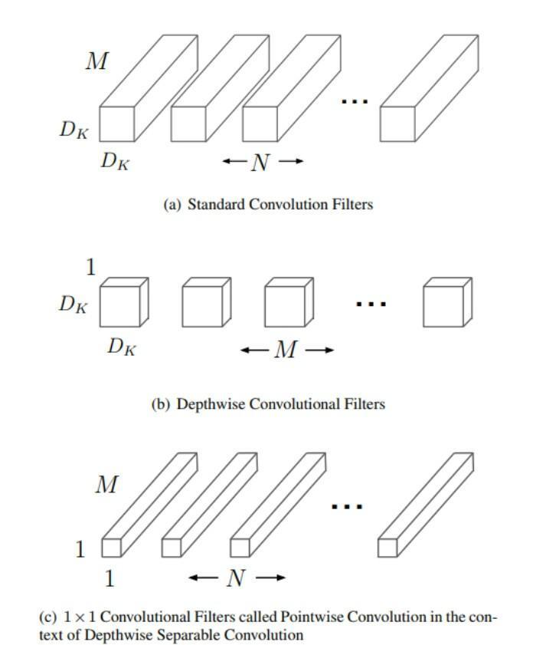

**Figure 1 :1x1 Convolutional Filters called Pointwise Convolution in the context of Depth wise Separable Convolution**

Researchers perceived that it makes sense to support that *“*the deeper the better” when it comes to convolutional neural networks. Since the models should be more capable (their flexibility to adapt to any space increase since they have a larger parameter space to explore). However, it has been observed that after some depth, the presentation degrades.

Figure 1 shows the convolutional filters using MobileNet Model. Figure A is the standard convolution filter. This convolutional figure is used in both combining and filtering inputs to be able to make output in a single step then, Figure B is the depthwise separable convolution filter. This convolution uses filter users a single filter in each convolution in performing on each single or color channel. The depthwise separable convolution is divided into two parts, and that is the reason why it is separated. The first part is used for filtering inputs and the other parts are used for combining inputs. Lastly, the C figure is the pointwise convolution filter. This convolution filter uses a 1x1 convolution to merge the outputs in depth wise convolution.[22]

**Table 2 Prior art Feature similarity and differences from our Application**

|  |  |  |  |  |  |  |  |
| --- | --- | --- | --- | --- | --- | --- | --- |
| Name of the Application | TensorFlow | Inception Model | MobileNet Model | Cross-check Fruits and dietary restriction | Classify Images | Shows the Nutritional Value | History of Captured Fruits and Vegetables |
| Classification of Vegetables using TensorFlow |  |  |  |  |  |  |  |
| Food Recognition Smartphone Applications |  |  |  |  |  |  |  |
| Gulay-Bato: A Mobile Fruits and Vegetable Classification for the Dietary Restrictions of Hemodialysis Patients Utilizing a Convolutional Neural Network |  |  |  |  |  |  |  |

Some applications have used Inception Model in Classifying foods or vegetables such as the “Classification of Vegetables using TensorFlow” and “Food Recognition Smartphone Applications which is you can see in Table 1 and Table 2 that it was already stated there the uses of certain features. [6][7]

We intend to do in this research is to use MobileNet model due to that it can still classify fruits and vegetables only according to the fruits and vegetable dietary restriction of the Hemodialysis Patients offline which can be used anytime and anywhere that will give the user a less disturbance in classifying and then to cross-validate it to our database which is the firebase if that certain vegetable can or cannot be consumed by them. We also added the nutritional value of each fruit and vegetable for them to gain more knowledge of what they need to consume and not. The user also can view the captured fruits and vegetables which we added a history feature in our system.

# OPERATIONAL FRAMEWORK

## Materials

### Software

We use Android Studio for the Prototype or design of our Application and PyCharm to make a model for the image classification and use Firebase as our database

### Hardware

We use Android Mobile Phones with a minimum requirement of lollipop version or version 5.0 to test the result of the applications if it gives the accurate result and displays its nutritional value.

### Data

The datasets used in feeding the model were provided by online images and were being generated by the researchers. We also used journals, articles based on which of the fruits and vegetables can or cannot be consumed by the patients, and also the nutritional value of certain fruits and vegetables. We also conduct a pre-test and post-test to the Hemodialysis Patients to know more about our target user.

## Methods

*Figure SEQ Figure \* ARABIC 2: The Agile Methodology Cycle*

### Experimental design

**Figure 2 : The Agile Methodology Cycle**

**Figure SEQ Figure \* ARABIC 1 : The Agile Methodology Cycle**

**Figure SEQ Figure \* ARABIC 2: The Agile Methodology Cycle**

In this project, the researcher intends to use the Agile Methodology. Agile Methodology utilizes iterative development and prototyping and is broadly used in a variety of projects which can satisfy the changes of requirements and Short Iterations are used for well-organized product delivery.[22]

In figure 3, the first step is the Concept which we discuss the concept of our research and select then prioritize what we want to make for our research together with our adviser. The next step is the Requirements Gathering, In this phase, we gathered data and information needed to our research such as the journals and articles that have helped us to learn more and understand about what we really want to achieve in our Project, we also watched tutorials from the internet and development sites related with our topic about developing and how MobileNet Model Works. The next phase is the Development/Construction, so, at first, we intend to use ResNet Model due to its low error rate in Image Classification but as we continue with our development and tried to use the ResNet model it turns out that it consumes us a lot of time in training and does not classify correctly so we find an alternative way so that we can move on with our next phase. We decided to use the MobileNet Model due to that it works well with latency, size, accuracy, in terms of output performanceand is able to correctly identify the fruits and vegetables as well as it does not consume our time when training the model for about an hour. And due to the Covid-19 Crisis that we are facing we cannot collect a lot of datasets that can be found around Zamboanga City so we decided that our datasets can be found around local places and added fruits so that we can have a large number of datasets. The next phase of our methodology is the development or construction, this is where we develop our prototype or design in Android Studio and use the Pycharm editor for the Image Classification. We use Firebase for our database which serves as the storage of all the information such as the nutritional value or benefits of the fruits and vegetable dietary restriction, the list of fruits and vegetables that can or cannot be consumed by the hemodialysis patients and also the user’s information. For our MobileNet Model we use a Pycharm editor to create a model and Tensorflow to test the accuracy of our Model.

The next step will be the testing phase this is where we will use the Tensorflow to train the models and to know if the result is accurate if there is a bug or not accurate we will go back to the development phase and test again until the result will give a high accuracy rate and also a large amount of dataset and test if it cross-check with the database. After testing the next step is the Production in this phase we will support and operate the application that we have made and then the Deploy which we will remove from the production.

### Procedures for the different phases

1. Concept

* The team together with the adviser of this project will discuss and share their ideas and come up with a better project that can be useful for people. In our case, we chose Image Processing for Hemodialysis Patients in regards to their Vegetable Dietary Restriction.

1. Requirements Gathering

* The team shall discuss the preliminary environment and requirements needed in the project such as:

1. Datasets

* The datasets shall come from fruit and vegetable images provided online and where being generated by the researcher.

1. Models
   * + The team has decided to use the MobileNet Model due it is embedded for mobile devices and can run quickly with high accuracy.
2. Database

* The researchers decided to use Firebase because it has ML Kit or Machine Learning Kit that can solve real-world problems.

1. Journals and Articles

* It helps us to learn and broaden our knowledge towards our studies such as the fruits and vegetable dietary restriction of hemodialysis patients which we get from many articles and journals as well as understanding the MobileNet model.

1. Android Studio

* We used Android Studio to make our prototype or design for the application

1. TensorFlow

* We use to train the MobileNet Model

### Evaluation or Testing

The evaluation is varied by questions and were conducted upon the mobile application is finished. It is intended for people who undergo hemodialysis; The questions made are reflected in the mobile application. It is for the researchers to be informed how knowledgeable the hemodialysis patients are on their fruits and vegetable dietary restriction with the help of pre-test. After the application had been fully developed, a post-test then was conducted by the researchers and they were given the same questions as the pre-test as seen in appendix A, to know if they had gained knowledge and that our objective had been made.

The researchers acquired the key answers from the articles and other sites which are about the fruits and vegetable dietary restriction and its nutritional value or benefits for hemodialysis Patients.

### RESULT OF PRE-TEST AND POST-TEST

**Table 3 Pre-test and Post-test result chart**

|  |  |  |  |  |  |  |  |  |  |  |  |  |
| --- | --- | --- | --- | --- | --- | --- | --- | --- | --- | --- | --- | --- |
| No. of Respondents | No. of Questions | Q1 | Q2 | Q3 | Q4 | Q5 | Q6 | Q7 | Total Remarks | | | |
| Patient 1 | Ciel |  |  |  |  |  |  |  | YES | NO | | Total Score in Q6 and Q7 |
| **3** | **2** | | **9/ 12** |
|  | PRE-TEST | NO | YES | NO | YES | YES | 5 | 4 |
|  | POST- TEST |  |  |  |  |  |  |  |  |  | |  |
| Patient 2 | Mairan Lakibul |  |  |  |  |  |  |  |  | | | |
|  | PRE-TEST | NO | YES | NO | NO | YES | 5 | 4 | **2** | | **3** | **9/12** |
|  | POST-TEST | YES | YES | NO | NO | YES | 5 | 4 | **3** | | **2** | **9/12** |
| Patient 3 | None |  |  |  |  |  |  |  |  | | | |
|  | PRE-TEST | NO | NO | YES | YES | YES | 1 | 6 | **3** | | **2** | **7/12** |
|  | POST-TEST |  |  |  |  |  |  |  |  | |  |  |
| Patient 4 | Rowena |  |  |  |  |  |  |  |  | | | |
|  | PRE-TEST | NO | YES | NO | YES | YES | 1 | 3 | **3** | | **3** | **4/12** |
|  | POST-TEST | YES | YES | NO | YES | YES | 4 | 4 | **4** | | **1** | **8/12** |
| Patient 5 | Mohammad Wajir Igasan |  |  |  |  |  |  |  |  | | | |
|  | PRE-TEST | NO | YES | YES | NO | YES | 3 | 3 | **3** | | **2** | **6/12** |
|  | POST-TEST |  |  |  |  |  |  |  |  | |  |  |

### DISCUSSION

Discussion about how knowledgeable the hemodialysis patients are in terms in their fruits and vegetable dietary restriction. Wherein, users had some previous knowledge about their fruits and vegetables dietary restriction before the pre-test. The hemodialysis patients were asked “if they have used an application that helps them to classify their fruits and vegetables dietary restriction?” where all of them answered No. When we asked them about “If they were asked by their dietician what fruits or vegetables they have consumed, can you remember all of them?” the majority answered Yes but one of the respondents answered No. We also let them classify “Which in the list of fruits they cannot consume based on their fruits dietary restriction?” only 2 of the respondents were able to distinguish all the right answers. We also let them classify “Which in the list of vegetables they can consume based on their vegetable dietary restriction?” None of them got all the right answers. The mobile application was designed to not only improve their knowledge but help them to lessen their stress or worries in consuming fruits and vegetables. The practical test with the application revealed gradual changes to the hemodialysis patients in terms of their knowledge in the nutritional value or benefits to their health. After post-test, the application is somehow effective to some respondents but with more time using the application and continuous feedback, the application will be more effective than what the results show right now

Name (Optional)

Ciel

Mairan Lakibul

No Name

Rowena

Mohammad Wajir Igasan

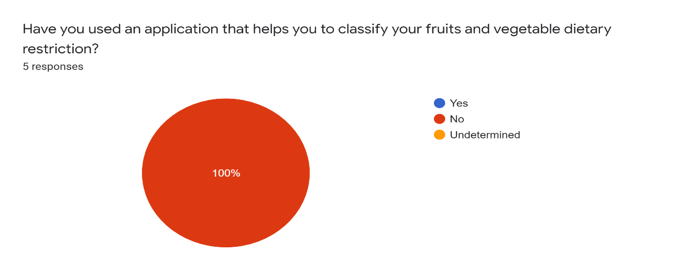

**Figure 3 Number 1 question and answers**

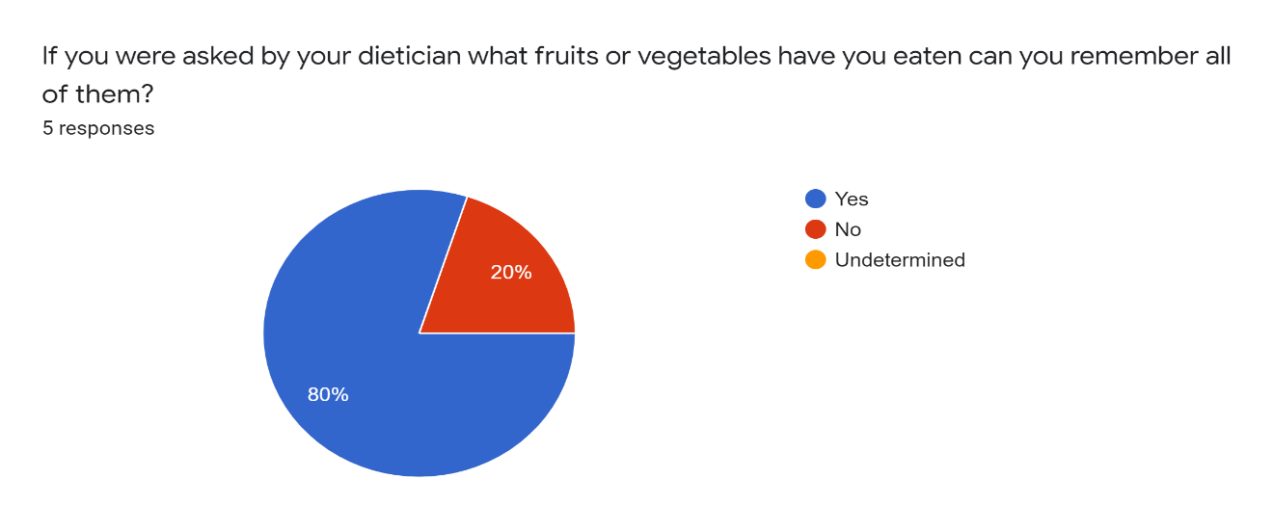

**Figure 4 Number 2 question and answers**

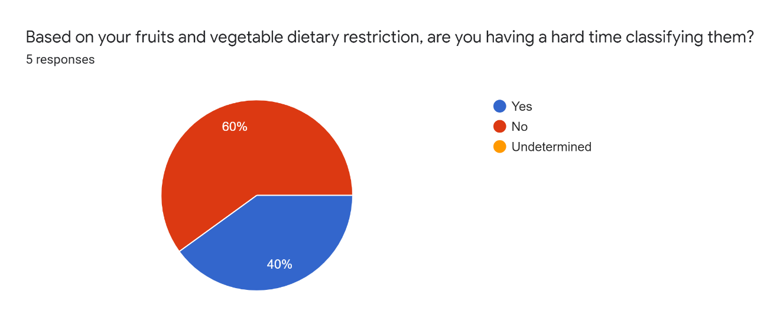

**Figure 5 Number 3 question and answers**

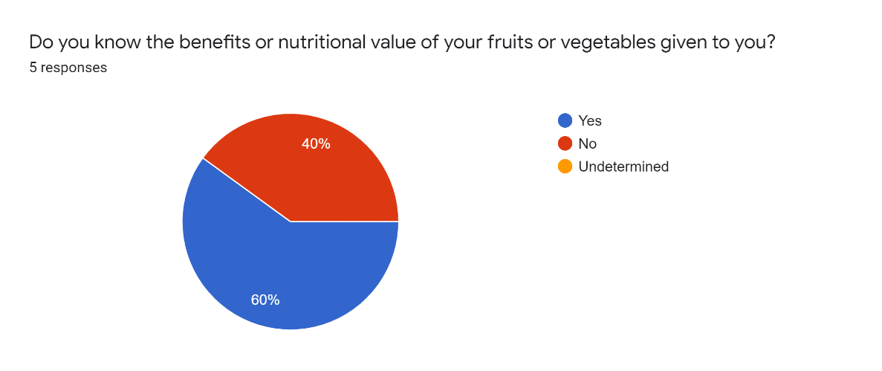

**Figure 6 Number 4 Question and answers**

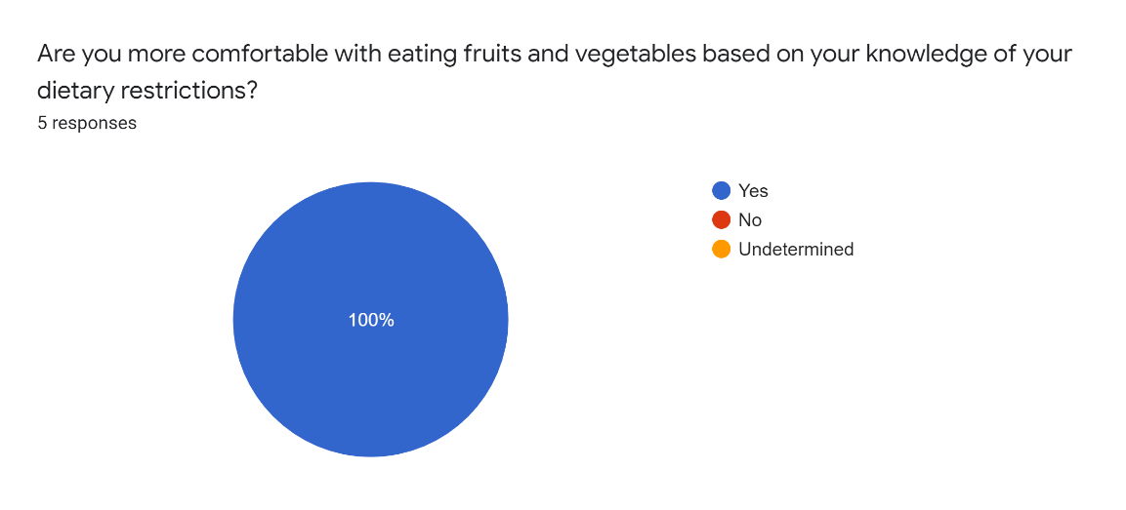

**Figure 7 Number 5 question and answers**

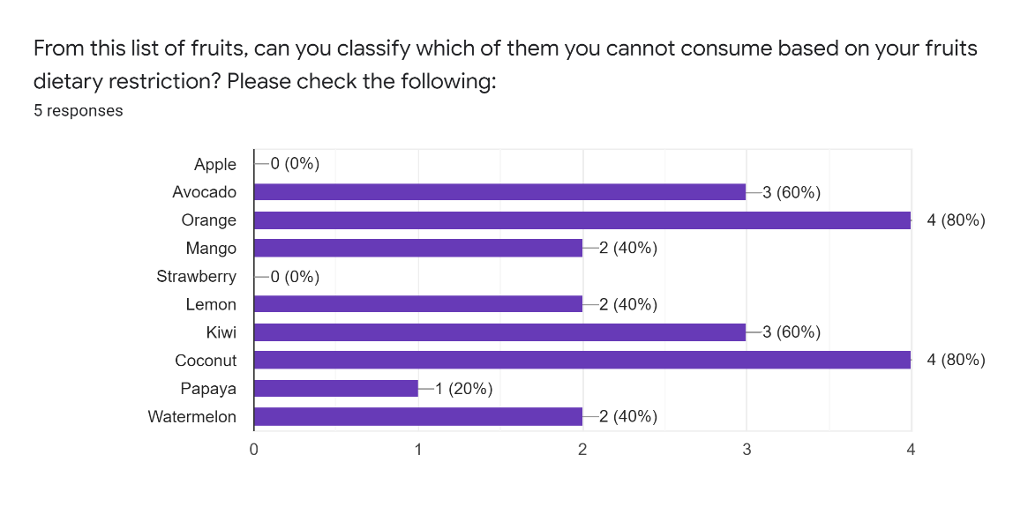

**Figure 8 Number 6 question and their answers**

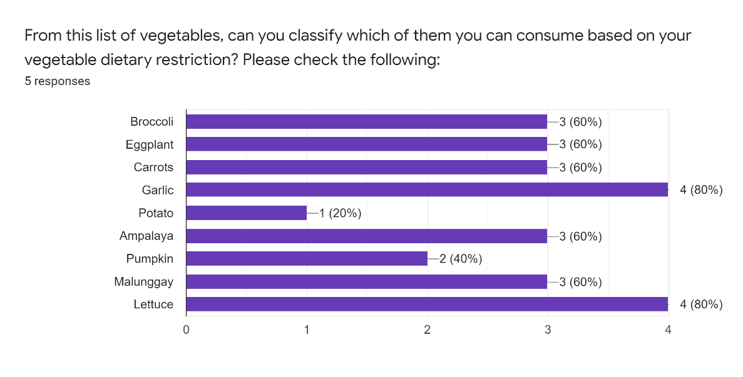

**Figure 9 Number 7 question and their answers**

**TECHNICAL OBSERVATION**

* Based on the survey, all of the five respondents haven’t used an application that can help with their dietary restrictions, given their age which are 30 – 50 years old, the researchers can assume that most of the respondents are already busy with their respective works.
* Most of the respondents are having a hard time classifying their dietary restrictions.
* Some of the respondents are not aware of the nutritional value of the vegetable and fruits that were given to them.
* Most of the respondents are comfortable eating fruits and vegetables based on their knowledge.

### CONCLUSION

The researchers developed and provided an application that will help the hemodialysis patients to classify their fruits and vegetable dietary restrictions. The researchers conducted a survey to find out the common – grounds of a hemodialysis patient in terms of them dealing with their fruits and vegetable dietary restrictions. Interestingly enough, the results differ with each individual but some share the common concerns. With that said, the researchers now have an idea of where to focus on and what part of the system needs to be optimized. Therefore, we conclude that the application can help hemodialysis patients to broaden their knowledge about their fruits and vegetable dietary restrictions. Also, the user can use the application anytime or anywhere because it can still classify their dietary restriction offline, we also added some features aside from classifying they can also browse their captured fruits or vegetables which can help them to remember what they have consumed in case their dietician ask about it.

### 7 RECOMMENDATIONS

Based on the findings, the following recommendation is formulated:

* In conducting Surveys, it is recommended to have an in-person survey for better results.
* With the further optimization and improvement, the researchers can also ask help from professionals such as doctors to recommend or introduce the application to their patients
* The larger the dataset the more accurate the result.

**REFERENCES**

[1] A. Cases, S. Cigarrán-Guldrís, S. Mas, and E. Gonzalez-Parra, “Vegetable-based diets for chronic kidney disease? It is time to reconsider,” *Nutrients*, vol. 11, no. 6, pp. 1–26, 2019.

[2] I. Namatēvs, “Deep Convolutional Neural Networks : Structure , Feature Extraction and Training,” vol. 20, no. December, pp. 40–47, 2017.

[3] “Intro in Convolutional Neural Network.” .

[4] R. Zhang, F. Zhu, J. Liu, and G. Liu, “Depth-wise separable convolutions and multi-level pooling for an efficient spatial CNN-based steganalysis,” *IEEE Trans. Inf. Forensics Secur.*, vol. PP, no. September, p. 1, 2019.

[5] “Comparing MobileNet Models”

[6] O. Patil, “Classification of Vegetables using TensorFlow,” *Int. J. Res. Appl. Sci. Eng. Technol.*, vol. 6, no. 4, pp. 2926–2934, 2018.

[7] K. Dy, J. Ligan, and M. Cabatuan, “Feasibility of food recognition and calorie estimation of fast food and healthy meals available in the Philippines,” *J. Telecommun. Electron. Comput. Eng.*, vol. 10, no. 1–8, pp. 9–16, 2018.

[8] A. G. Howard and W. Wang, “Applications,” 2012.

[9] S. Gerogianni *et al.*, “‘Concerns of patients on dialysis: A research study,’” *Heal. Sci. J.*, vol. 8, no. 4, pp. 423–437, 2014.

[10] G. Brain, A. N. Gomez, and G. Brain, “Depthwise Separable Convolutions for Neural Machine Translation.”

[11] T. Methods and K. Failure, “Treatment Methods for Kidney Failure HEMODIALYSIS.”

[12] “Kidney org.” .

[13] “Types of dialysis.” .

[14] I. Poola and C. Systems, “How Artificial Intelligence in Impacting Real Life Every day How Artificial Intelligence in Impacting Real Life Every day,” no. November, 2017.

[15] “Artificial Intellligence.” .

[16] “Artificial Intelligence and Machine Learning.” .

[17] “Machine Learning and Neural Networks.” .

[18] B. Benuwa, Y. Zhan, and B. Ghansah, “A Review of Deep Machine Learning,” no. June, 2016.

[19] “Convolutional Neural Network”

[20] A. Brzeski, K. Grinholc, and K. Nowodworski, *Residual MobileNets*, no. September. Springer International Publishing, 2019.

[21] “Classification using MobileNet”

[22] G. Kumar and P. K. Bhatia, “Impact of Agile Methodology on Software Development Process,” no. May, 2014.

[23] “Mindanao growers organize quality veggies, fruits.”

APPENDICES

**Appendix A: The System Overview**

The Gulay-Bato is a mobile application for the dietary restrictions of Hemodialysis Patients in Zamboanga City utilizing a Convolutional Neural Network with the use of MobileNet. Upon classifying the Image, the application will cross check it to the database which is the Firebase and will tell the Hemodialysis Patients if that certain vegetable and fruit can or cannot be consumed.

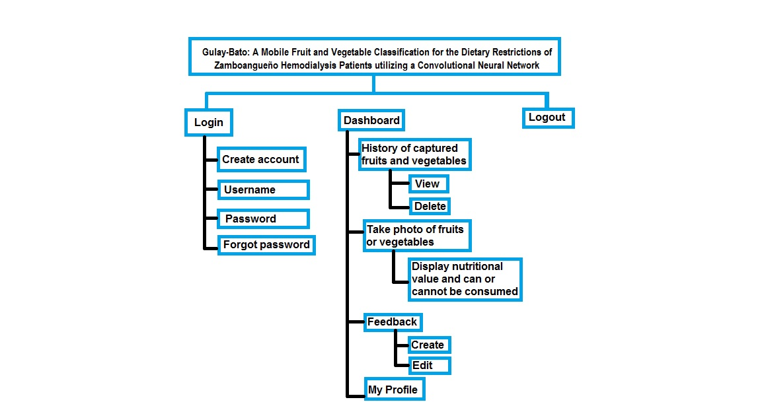**Appendix B: Hierarchical Chart of functions**

**Appendix C: The User Interface of Mobile Application**

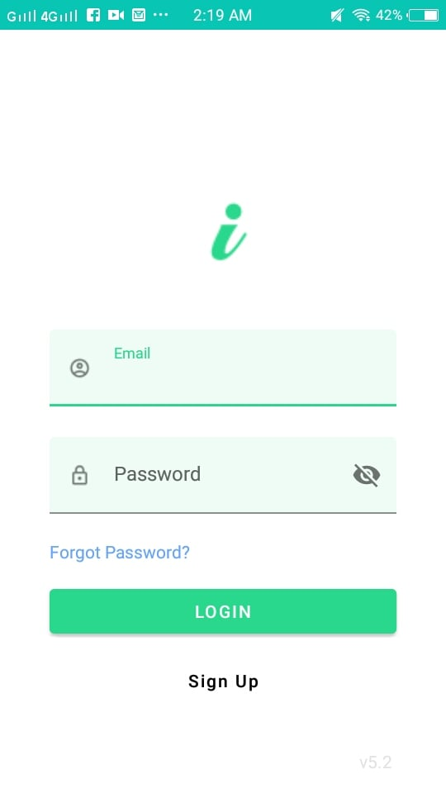

Figure : The Login Interface

This is our Login Page where you have to fill your Email and Password

**Figure SEQ Figure \* ARABIC 4: Sign Up Page**

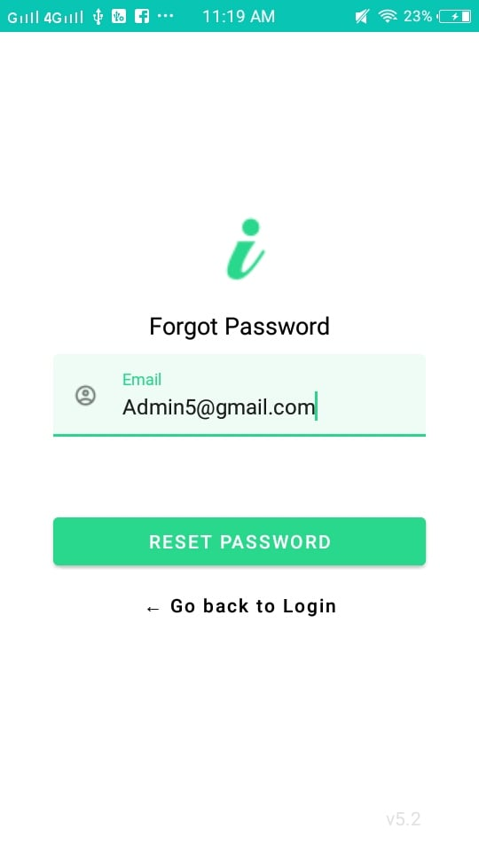

Figure : The Forgot Password Interface

This is the User interface of the forgot password wherein the

Field needed here is the Email of the user. You will receive an

Email that lets you reset your password.

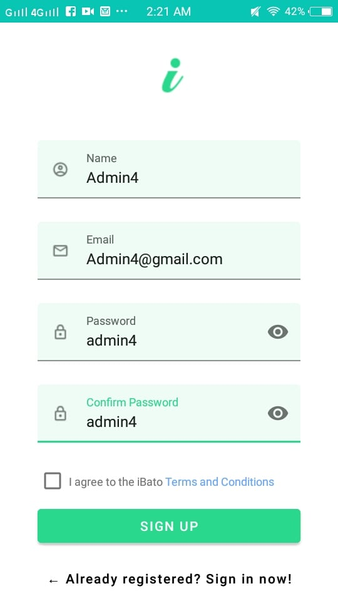.

Figure : The Sign-Up page

This is our Sign-Up Page wherein you have to fill the necessary fields.

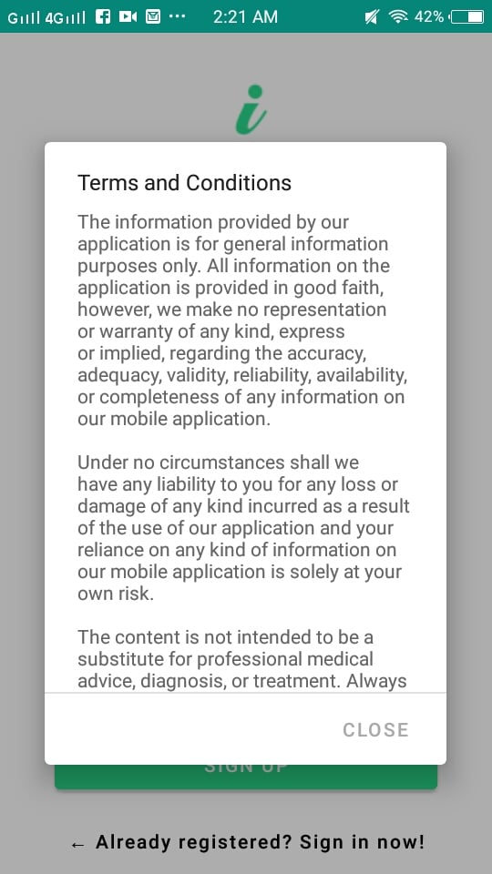

This is our terms and conditions which it states that we are

Not reliable of whatever may happen to the user and

Always seek professionals

Figure : The terms and conditions of our application

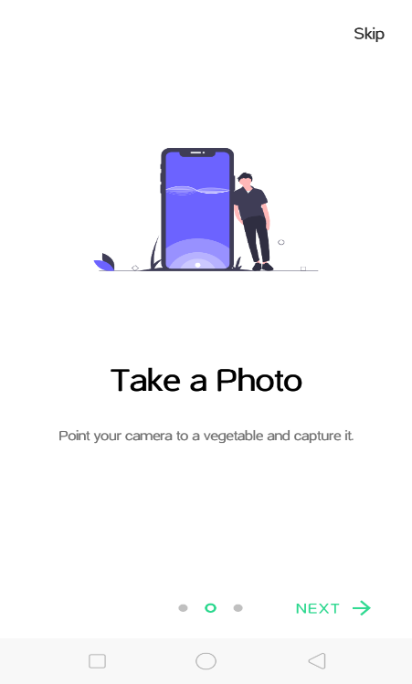

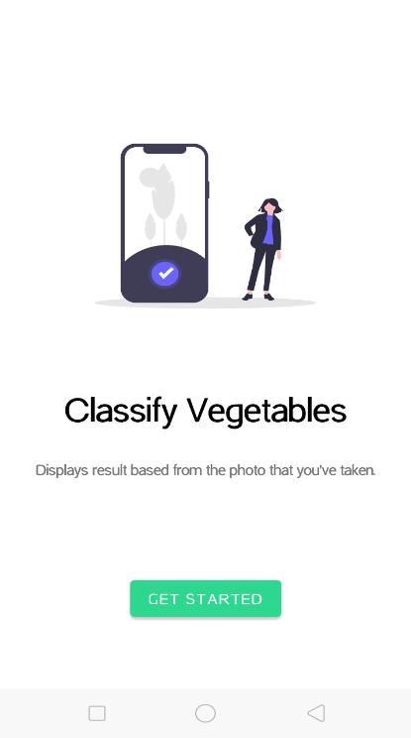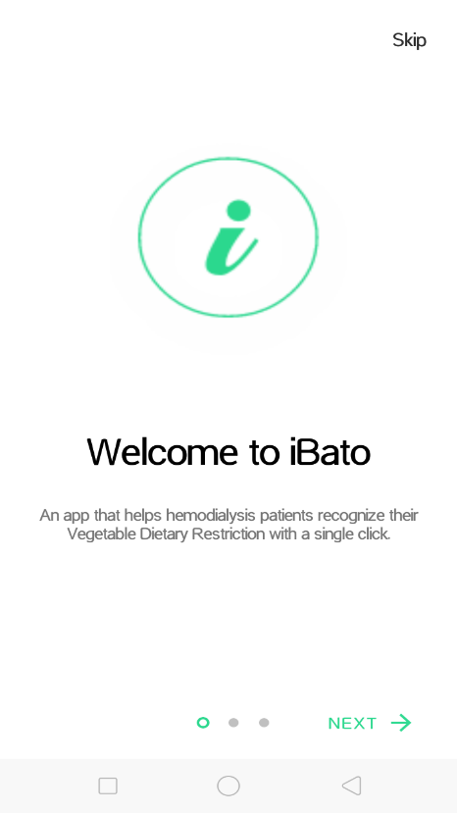

Figure : The tutorial interface of our application

If you are a new user of our application there will be a tutorial on how to use it which the user can skip if he/she want.

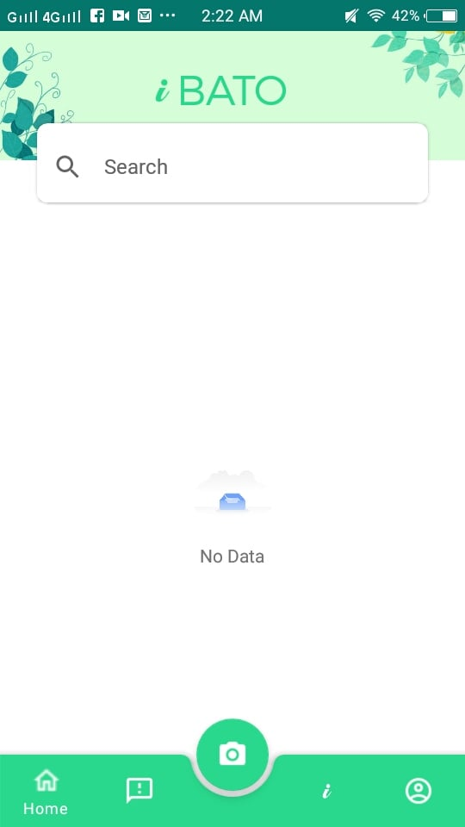

This is our Dashboard which contains History, Feedbacks, About the Application, Profile and a camera icon for capturing fruits or vegetable.

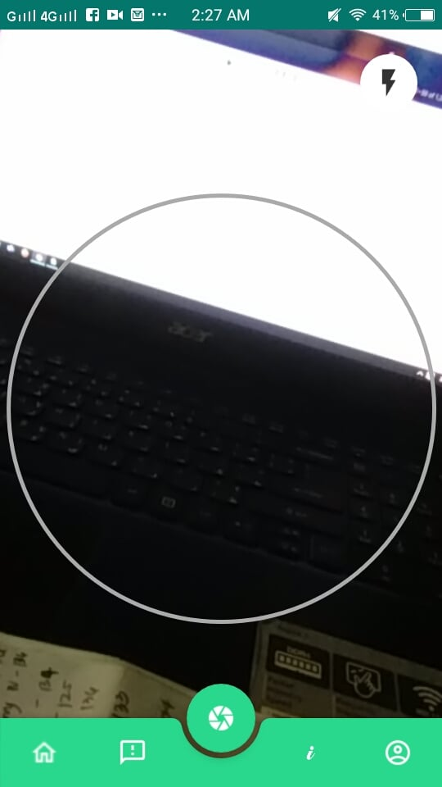

Figure : The Dashboard of our application

This is the User interface when you want to capture a fruit or vegetables as you can see there is a circle this is for to capture the right angle of the fruits or vegetable to be able to classify accurately.

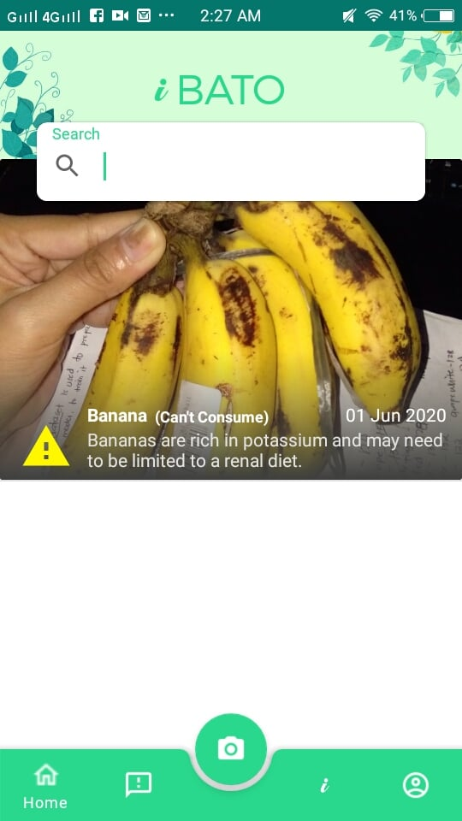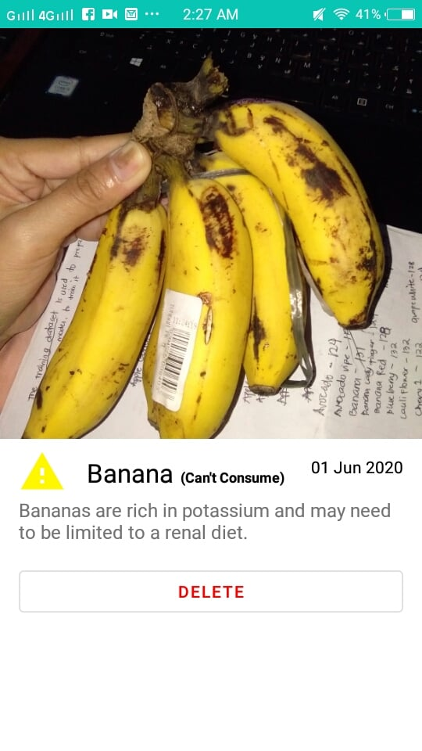

Figure : The camera interface

Figure : The History Interface

This is the interface of history which you can search and delete the captured images.

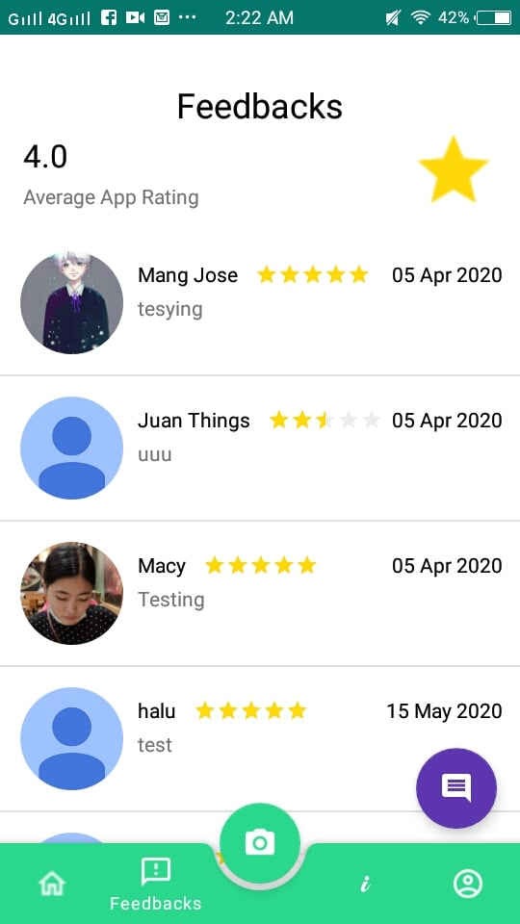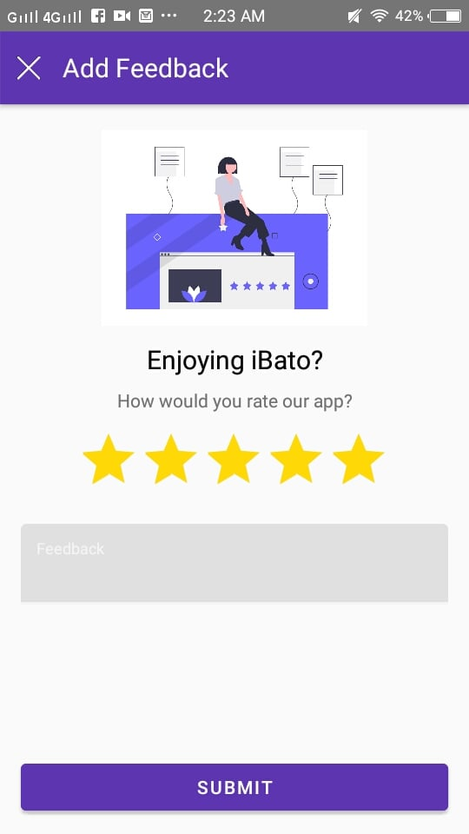

Figure : The Feedbacks interface

This is the user interface of our feedbacks wherein you can create and see the feedbacks or other user.

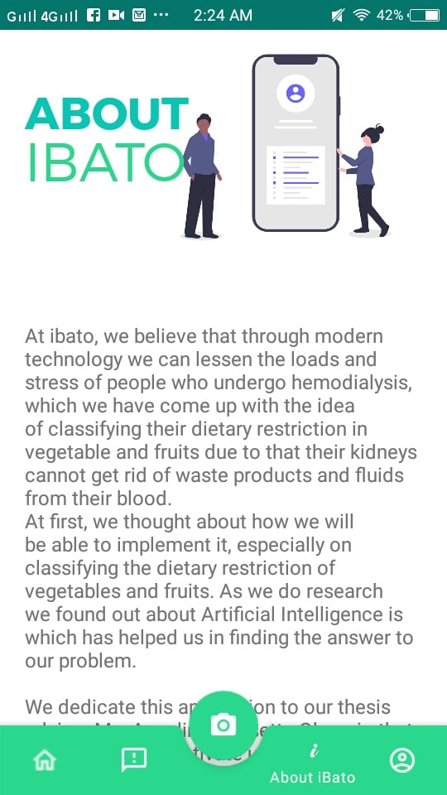

Figure : About Us Interface

This is the user interface of About Us, it states about why we wanted to help the hemodialysis patients and to whom we dedicate this application.

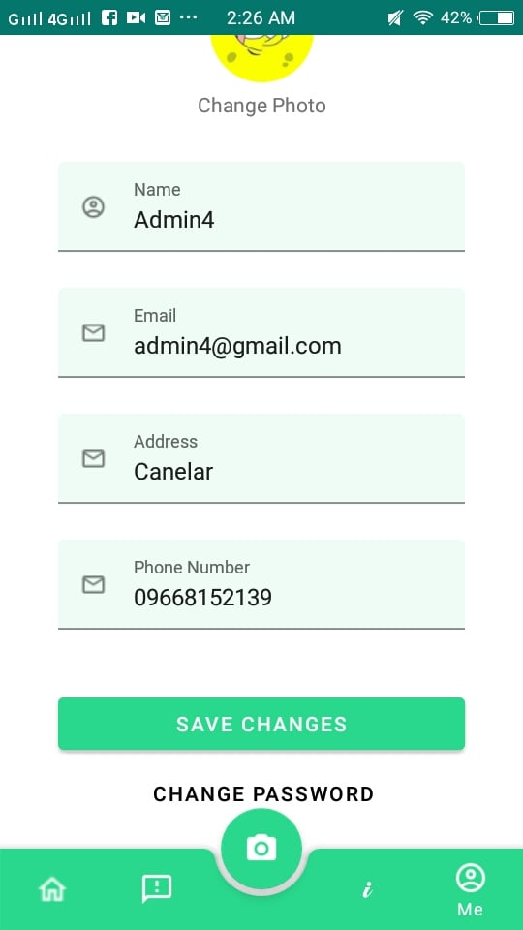

Figure : The User Profile Interface

This is our Profile User interface which the user can change password, change photo and fill up the other fields

**Appendix D: Pretest and Posttest Questionnaire**

1. Have you used an application that helps you to classify your fruits and vegetable dietary restriction?

[ ] Yes [ ] No [ ] Undetermined

1. If you were asked by your dietician what fruits or vegetables have you eaten can you remember all of them?

[ ] Yes [ ] No [ ] Undetermined

1. Based on your fruits and vegetable dietary restriction, are you having a hard time classifying them?

[ ] Yes [ ] No [ ] Undetermined

1. Do you know the benefits or nutritional value of your fruits or vegetables given to you?

[ ] Yes [ ] No [ ] Undetermined

1. Are you more comfortable with eating fruits and vegetables based on your knowledge of your dietary restrictions?

[ ] Yes [ ] No [ ] Undetermined

1. From this list of fruits, can you classify which of them you cannot consume based on your fruits dietary restriction? Please check the following:

[ ] Apple [ ] Avocado [ ] Orange [ ] Mango

[ ] Strawberry [ ] Lemon [ ] Kiwi [ ] Coconut

[ ] Papaya [ ] Watermelon

1. From this list of vegetables, can you classify which of them you can consume based on your vegetable dietary restriction? Please check the following:

[ ] Broccoli [ ] Eggplant [ ] Carrots [ ] Garlic

[ ] Potato [ ] Ampalaya [ ] Pumpkin [ ] Malunggay

[ ] Lettuce