Title

Software Design Document (SDD)
[Team Member Names]
Contents
Software Design Document (SDD) 1
1. Introduction 1
1.1 Purpose 1
1.2 Scope 2
2. System Architecture 2
2.1 Overview 2
2.2 Architectural Diagram 2
3. Module Design 2
3.1 Module Descriptions 2
3.2 Interaction Between Modules 2
4. Data Design 2
4.1 Data Structures 2
5. Interface Design 3
5.1 User Interface 3
5.2 UI Layouts and Design 3
6. Performance and Scalability Considerations 3
6.1 Performance 3
7. Appendices 3
7.1 Additional Diagrams and Designs 3

1. Introduction

1.1 Purpose
The purpose of this document is to define the detailed design for a digital implementation of the Uno card game. This SDD serves as a blueprint for developers, outlining the system architecture, module responsibilities, data structures, and interface design necessary to build a functional and user-friendly application. It ensures alignment with the Software Requirements Specification (SRS) and guides the implementation phase.

1.2 Scope
The system will implement a fully functional Uno game with the following features:
- Single-player mode with AI opponents
- Local multiplayer support
- Turn-based gameplay with strict rule enforcement
- Card rendering and animations
- Score tracking system
- Game restart and exit functionality
Out of Scope (optional for future expansion):
- Advanced AI (machine learning-based)
- Online multiplayer (initial version may exclude networking)

2. System Architecture

2.1 Overview
The system follows a Model-View-Controller (MVC) architecture using Java and JavaFX:
- Model (Game Logic Layer): Handles game rules, state, and data
- View (UI Layer): Displays the game visually using JavaFX
- Controller (Control Layer): Processes user input and updates the Model/View
This separation ensures modularity, maintainability, and scalability.

2.2 Architectural Diagram
Create a diagram showing the relationships between the system's components. This could include flowcharts, UML diagrams, or high-level block diagrams.
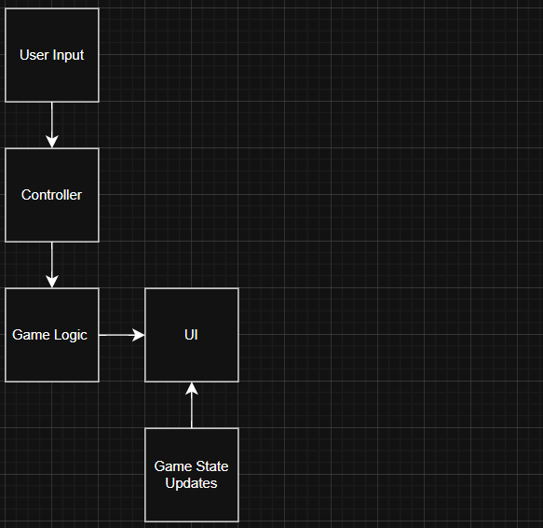

3. Module Design

3.1 Module Descriptions
Describe
1. Game Logic Module (Model)
Responsibilities:
- Enforces Uno rules (FR5–FR10)
- Manages game state (deck, discard pile, players)
- Validates moves
- Applies card effects (Skip, Reverse, Draw Two, Wild, etc.)
- Determines winner and scoring

2. Player Module
Responsibilities:
- Stores player data (hand, score, name, isAI)
- Handles player actions (play card, draw card, call Uno)

3. AI Module
Responsibilities:
- Simulates AI player decisions
- Chooses valid cards based on simple rule-based logic
- Decides when to draw or play

4. Deck Module
Responsibilities:
- Initializes and shuffles deck
- Deals cards
- Handles draw pile and discard pile

5. Controller Module
Responsibilities:
- Acts as mediator between UI and Game Logic
- Processes user input (mouse clicks, selections)
- Updates game state and triggers UI refresh

6. UI Module (JavaFX View)
Responsibilities:
- Displays cards, players, and game state
- Provides buttons and interaction elements
- Animates gameplay (card movement, turn changes)

3.2 Interaction Between Modules
- The UI Module captures user actions (e.g., selecting a card).
- The Controller Module receives input and sends commands to the Game Logic Module.
- The Game Logic Module validates the move and updates the game state.
- If AI is involved, the AI Module determines the next move.
- Updated game state is sent back to the UI Module for rendering.
Flow Example:
- Player clicks a card
- Controller sends action → Game Logic
- Game Logic validates move
- Game state updates
- UI refreshes display

4. Data Design

4.1 Data Structures

Card Object: 2 enums: one for color, one for values
Deck Object: List<Card> drawPile: starts with all the cards, List<Card> discardPile
Player Object: String for name, List<Card> hand, int score, Boolean isAI
GameState Object: List<Player> players, Deck deck, int currentPlayerIndex, Card topCard, boolean direction (clockwise/counterclockwise)

5. Interface Design

5.1 User Interface
The UI will include:
- Player Hand Panel: Displays cards available to the player
- Discard Pile Area: Shows the top card in play
- Draw Pile Button/Area: Allows drawing a card
- Player Info Panel: Displays scores and turn order
- Action Buttons:
  - Play Card
  - Call Uno
  - Restart Game
  - Exit Game
  - Rules

5.2 UI Layouts and Design
Provide visual mockups or screenshots of the user interface. Include a description of the layout and interactions.
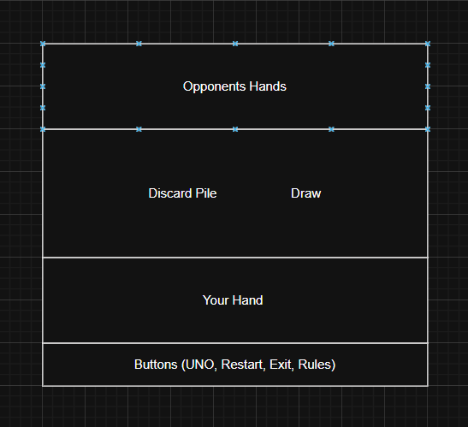

Opponents hands ( top of the screen) Shows you opponents name, how many cards they have
Main Play area (middle of the screen) Holds the discard and draw piles
Your hand (bottom of the screen) Shows the player their cards and allows them to click a card to play it
Buttons (very bottom of the screen, under the your hand section) Has the buttons to call UNO, to restart, to exit, and to pull up a rules page

6. Performance and Scalability Considerations

6.1 Performance
All user interactions will respond within 1 second (NFR1)
Efficient data structures (ArrayLists) for card handling
Minimal UI redraws to improve rendering performance
AI decisions computed quickly using simple logic

7. Appendices

7.1 Additional Diagrams and Designs
UML Diagram
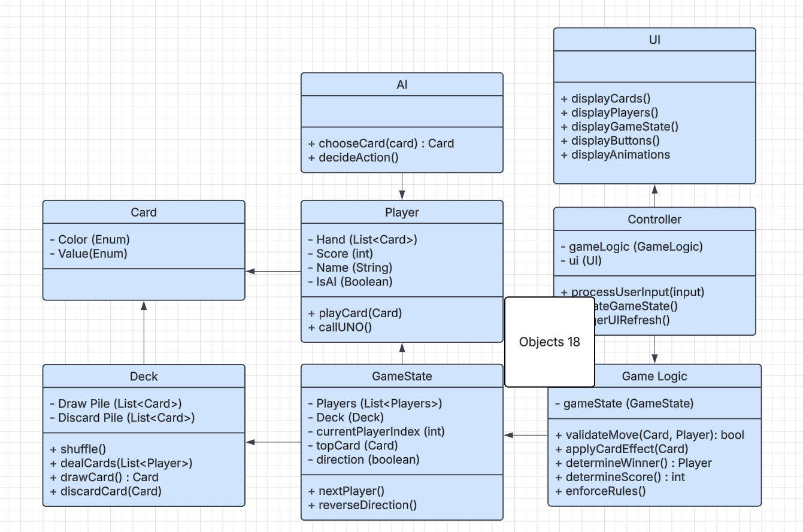

A flowchart illustrating the turn sequence
