|  |  |  |  |  |  |
| --- | --- | --- | --- | --- | --- |
| |  |  |  | | --- | --- | --- | | **C:\Users\sonnx0907\Desktop\Untitled.png** | **MINISTRY OF EDUCATION AND RAINING** | | | **FPT UNIVERSITY** | | |
| Capstone Project Document |
| Hospital Finder |
| |  |  |  |  |  |  |  |  |  |  |  | | --- | --- | --- | --- | --- | --- | --- | --- | --- | --- | --- | | |  |  | | --- | --- | | **Group 11** | | | **Group Members** | Lê Phước Việt – Team Leader – SE60706  Nguyễn Xuân Sơn – Team Member – SE60727 | | **Supervisor** | Nguyễn Đức Khoan | | **Ext Supervisor** | N/A | | **Capstone Project code** | HospitalF | | |

- Ho Chi Minh City, May / 2014 –

**CAPSTONE PROJECT REGISTER**

Class: Duration time: from 12/05/201 To 03/09/2014

(*) Profession: <Software Engineer> Specialty: <ES> <IS>

x

(*) Kinds of person make registers: Lecturer Students

X

1. Register information for supervisor (if have)

|  |  |  |  |  |
| --- | --- | --- | --- | --- |
|  | **Full name** | **Phone** | **E-Mail** | **Title** |
| Supervisor 1 | Nguyễn Đức Khoan |  | khoannd@fpt.edu.vn | Mr. |

2. Register information for students (if have)

|  |  |  |  |  |  |
| --- | --- | --- | --- | --- | --- |
|  | **Full name** | **Student code** | **Phone** | **E-mail** | **Role in Group** |
| Student 1 | Lê Phước Việt | SE60706 | 0949051851 | vietlpse60706@fpt.edu.vn | Team leader |
| Student 2 | Nguyễn Xuân Sơn | SE60727 | 01214184300 | sonnxse60727@fpt.edu.vn | Team member |
| Student 3 | Dương Thị Hoàng Anh | 60434 | 0908616730 | anhdth60434@fpt.edu.vn | Team member |

3. Register content of Capstone Project

(*) 3.1. Capstone Project name:

English: Hospital Finder.

Vietnamese: Tìm kiếm bệnh viện

Abbreviation:

- HospitalF

- Building the web application which compatible with both computer and mobile devices supports user to find the appropriate hospitals for their conditions. The system can find the appropriate hospitals and shows the result list and on map. In this map, user can interact with the system to see hospital image, name, address, short description, and the rating. The system can show full description, more images and users’ reviews. User also can write a review, rating and share information of the hospital if they have a social account.

(*) 3.2. Main proposal content (including result and product)

1. Theory and practice (document):

* Student should apply the software development process and the UML
* Software artifacts include User Requirement, Software Requirement Specification, Architecture Design, Detail Design, System Implementation and Testing Document, Installation Guide, sources code, and deployable software packages
* 3 tiers should be applied
* Server side technique:
  + Database design, OOA, OOD, OOP, MVC, Java, PHP or .Net technology, …
* Client side technique
  + HTML5, CSS, JavaScript, JQuery, Ajax, Android, …
* Communication technique
  + Exchange information and transfer data in effective in networks
* Research
  + Google Map API, Social Network Integration, …

1. Program:

* Main functions
  + Admin
    - Manage the systems, manage account, configure systems …
  + Staff
    - Update and create the new users, update hospital information ...
    - Make the statistic
  + Users
    - Make query/request, login using social account, rating, write the reviews

1. Other products:

N/A

4. Other comment (propose all relative thing if have)

N/A

|  |  |
| --- | --- |
| **Supervisor**  *(Sign and full name)* | HCM city, date 12/05/2014  **On behalf of Registers**  *(Sign and full name)* |

|  |
| --- |
|  |

**Table of Contents**

**Table of Acronyms and Abbreviations** 14

**A.** **Introduction** 15

**1.** **Project information** 15

**2.** **Introduction** 15

**3.** **Current Problem** 15

**4.** **Proposed solution** 15

**5.** **Functional Requirement** 16

**5.1.** **Search Hospital** 16

**5.2.** **Hospital Management** 16

**5.3.** **User Management** 16

**5.4.** **Meta data management** 16

**5.5.** **Statistics** 16

**5.6.** **Mobile Devices** 16

**6.** **Role and responsibility** 16

**B.** **Project Management Plan (PMP)** 17

**1.** **Problem Definition** 17

**1.1.** **Name of this Capstone Project** 17

**1.2.** **Problem Abstract** 17

**1.3.** **Project Overview** 17

**1.3.1.** **The Current System** 17

**1.3.2.** **The Proposed System** 17

**1.3.2.1.** **Computers** 17

**1.3.2.2.** **Mobile Devices** 18

**1.3.3.** **Boundaries of the System** 18

**1.3.4.** **Development Environment** 19

**1.3.4.1.** **Hardware requirements** 19

**1.3.4.2.** **Software requirements** 19

**2.** **Project Organization** 19

**2.1.** **System Process Model** 19

**2.2.** **Roles and Responsibilities** 20

**2.3.** **Tools and Techniques** 21

**2.3.1.** **Back-end** 21

**2.3.2.** **Front-end** 21

**3.** **Project Management Plan** 22

**3.1.** **Overview** 22

**3.2.** **Detail** 23

**3.2.1.** **Iteration 1** 23

**3.2.2.** **Iteration 2** 23

**3.2.3.** **Iteration 3** 23

**3.2.4.** **Iteration 4** 24

**4.** **Convention Rules** 24

**C.** **System Requirements Specification (SRS)** 24

**1.** **User Requirement Specification** 24

**1.1.** **Guest requirement** 25

**1.2.** **Normal User requirement** 25

**1.3.** **Hospital User requirement** 25

**1.4.** **Administrator requirement** 25

**2.** **System Requirements Specification** 26

**2.1.** **External Interface Requirements** 26

**2.1.1** **User Interfaces** 26

**2.1.2** **Software Interfaces** 26

**2.1.3** **Communication Protocol** 26

**2.2.** **Function Requirements** 26

**2.2.1.** **System Overview** 26

**2.2.2.** **Use case List** 27

**2.2.2.1.** **<GU> Overview Use Case** 27

**2.2.2.2.** **<GU> Login** 28

**2.2.2.3.** **<GU> Search Hospital** 31

**2.2.2.4.** **<GU> View Hospital Information** 34

**2.2.2.5.** **<GU> Search Doctor** 36

**2.2.2.6.** **<GU> Feedback** 38

**2.2.2.7.** **<NU> Overview Use Case** 40

**2.2.2.8.** **<NU> Search Hospital** 41

**2.2.2.9.** **<NU> View Hospital Information** 41

**2.2.2.10.** **<NU> Search Doctor** 41

**2.2.2.11.** **<NU> Feedback** 41

**2.2.2.12.** **<NU> Comment** 41

**2.2.2.13.** **<NU> Reply Comment** 43

**2.2.2.14.** **<NU> Rating Hospital** 44

**2.2.2.15.** **<US> Logout** 45

**2.2.2.16.** **<HU> Overview Use Case** 46

**2.2.2.17.** **<HU> Add New Doctor** 47

**2.2.2.18.** **<HU> Search List of Doctors** 47

**2.2.2.19.** **<HU> Update Doctor Information** 47

**2.2.2.20.** **<HU> Upload Photo** 47

**2.2.2.21.** **<HU> Update Hospital Information** 48

**2.2.2.22.** **<HU> View Hospital’s Statistics** 52

**2.2.2.23.** **<HU> Change Password** 54

**2.2.2.24.** **<AD> Overview Use Case** 56

**2.2.2.25.** **<AD> Create Hospital User’s Account** 56

**2.2.2.26.** **<AD> View List of Feedbacks** 59

**2.2.2.27.** **<AD> View List of Users** 59

**2.2.2.28.** **<AD> Activate User** 59

**2.2.2.29.** **<AD> De-active User** 59

**2.2.2.30.** **<AD> View System Statistics** 59

**2.2.2.31.** **<AD> Import Hospital Using Excel** 60

**2.2.2.32.** **<AD> Add Hospital** 62

**2.2.2.33.** **<AD> Upload Photo** 67

**2.2.2.34.** **<AD> Display List of Hospitals** 67

**2.2.2.35.** **<AD> Update Hospital Information** 68

**2.3.** **Non-Functional Requirements** 73

**2.3.1.** **Reliability** 73

**2.3.2.** **Availability** 73

**2.3.3.** **Security** 73

**2.3.4.** **Maintainability** 73

**2.3.5.** **Portability** 73

**2.3.6.** **Performance** 73

**3.** **Entity Relationship Diagram** 74

**D.** **System Design Description (SDD)** 75

**1.** **Design Overview** 75

**2.** **System Architecture Design** 75

**3.** **Component Diagram** 76

**4.** **Detailed Description of Components** 76

**4.1.** **Class Diagram** 77

**4.2.** **Class Diagram Explanation** 78

**4.2.1.** **User** 78

**4.2.2.** **Hospital** 78

**4.2.3.** **HospitalType** 80

**4.2.4.** **Doctor** 80

**4.2.5.** **DoctorSpeciality** 80

**4.2.6.** **DoctorHospital** 81

**4.2.7.** **Role** 81

**4.2.8.** **Rating** 81

**4.2.9.** **Feedback** 82

**4.2.10.** **FeedbackType** 82

**4.2.11.** **Facility** 82

**4.2.12.** **FacilityType** 83

**4.2.13.** **HospitalFacility** 83

**4.2.14.** **Service** 83

**4.2.15.** **ServiceType** 84

**4.2.16.** **HospitalService** 84

**4.2.17.** **Photo** 84

**4.2.18.** **Ward** 85

**4.2.19.** **District** 85

**4.2.20.** **City** 86

**4.2.21.** **Speciality** 86

**4.2.22.** **HospitalSpeciality** 86

**4.2.23.** **Disease** 87

**4.2.24.** **SpecialityDisease** 87

**4.2.25.** **Tag** 87

**4.2.26.** **TagHospital** 87

**4.2.27.** **SearchQuery** 88

**5.** **Sequence Diagram** 88

**5.1.** **Search Hospital** 88

**5.2.** **Import Hospital Using Excel** 88

**5.3.** **Create Hospital** 89

**5.4.** **View Hospital Detail** 89

**5.5.** **Display list of hospitals** 90

**5.6.** **Update Hospital Information** 90

**5.7.** **Comment** 91

**5.8.** **View Statistics** 91

**6.** **User Interface Design** 91

**6.1.** **Login** 91

**6.2.** **Logout** 91

**6.3.** **Change Password** 91

**6.4.** **Reclaim Forgotten Password** 91

**6.5.** **Search Hospital <GU> <US>** 92

**6.6.** **Import Hospital Using Excel** 92

**6.7.** **Create Hospital** 92

**6.8.** **Create Hospital User’s Account** 92

**6.9.** **View Hospital Information** 92

**6.10.** **Search Doctor <GU> <US>** 92

**6.11.** **Feedback** 92

**6.12.** **Comment** 92

**6.13.** **Reply Comment** 92

**6.14.** **Rating Hosptial** 92

**6.15.** **Add New Doctor** 92

**6.16.** **Search List of Doctor <HU>** 92

**6.17.** **Search List of Hospital <AD>** 92

**6.18.** **Update Doctor Information** 92

**6.19.** **Upload Photo** 92

**6.20.** **Update Hospital Information** 92

**6.21.** **View List of Feedbacks** 92

**6.22.** **View List of Users** 92

**6.23.** **Activate Users** 92

**6.24.** **Deactivate Users** 92

**6.25.** **View Hospital Statistics** 92

**6.26.** **View System Statistics** 92

**7.** **Database Design** 92

**7.1.** **Logical Database Design** 92

**7.2.** **User** 92

**7.3.** **Hospital** 93

**7.4.** **HospitalType** 93

**7.5.** **Doctor** 93

**7.6.** **Doctor_Speciality** 93

**7.7.** **Doctor_Hospital** 93

**7.8.** **Role** 93

**7.9.** **Rating** 93

**7.10.** **Feedback** 93

**7.11.** **FeedbackType** 93

**7.12.** **Facility** 93

**7.13.** **Hospital_Facility** 93

**7.14.** **Service** 93

**7.15.** **Hospital_Service** 93

**7.16.** **Photo** 93

**7.17.** **Ward** 93

**7.18.** **District** 93

**7.19.** **City** 93

**7.20.** **Speciality** 93

**7.21.** **Hospital_Speciality** 93

**7.22.** **Disease** 93

**7.23.** **Speciality_Disease** 93

**7.24.** **WordDictionary** 93

**7.25.** **Word_Hospital** 93

**7.26.** **SentenceDictionary** 93

**7.27.** **Sentence_Word** 93

**8.** **Algorithms** 94

**8.1.** **Geographic Information Retrieval** 94

**8.1.1.** **Definition** 94

**8.1.2.** **Examples** 94

**8.2.** **Boyer Moore Matching Algorithm** 94

**8.2.1.** **Definition** 94

**8.2.2.** **Examples** 94

**8.3.** **Haversine Formula** 94

**8.3.1.** **Definition** 94

**8.3.2.** **Example** 94

**E.** **System Implementation and Test (SIT)** 94

**1.** **Introduction** 94

**2.** **Database relationship Diagrams** 94

**3.** **Screen shots / Performance measures** 94

**4.** **Test Plan** 94

**4.1.** **Features to be tested** 94

**4.2.** **Features not to be tested** 94

**4.3.** **Testing Tools and Environment** 94

**5.** **Test Cases** 94

**5.1.** **Login** 94

**5.2.** **Search Hospital** 94

**5.3.** **Import Hospital Using Excel** 94

**5.4.** **Create Hospital** 94

**5.5.** **Create Hospital User’s Account** 94

**5.6.** **View Hospital Information** 94

**5.7.** **Search Doctor <GU> <US>** 95

**5.8.** **Feedback** 95

**5.9.** **Rating Hospital** 95

**5.10.** **Add New Doctor** 95

**5.11.** **Search List of Doctor <HU>** 95

**5.12.** **Search List of Hospital <AD>** 95

**5.13.** **Update Doctor Information** 95

**5.14.** **Upload Photo** 95

**5.15.** **Update Hospital Information** 95

**5.16.** **View Hospital Statistics** 95

**6.** **Checklists** 95

**F.** **System User’s Manual** 95

**1.** **Installation Guide** 95

**2.** **User’s Guide** 95

# **Table of Acronyms and Abbreviations**

|  |  |  |
| --- | --- | --- |
| **No.** | **Acronyms / Abbreviations** | **Definition** |
| 1 | HospitalF | Hospital Finder |
| 2 | Admin / AD | Administrator |
| 3 | HU | Hospital User |
| 4 | NU | Normal User |
| 5 | GU | Guest |
| 6 | ERD | Entity relationship diagram |
| 7 | PMP | Project management plan |
| 8 | SRS | System requirements specification |
| 9 | SDD | Software design description |
| 10 | SIT | System implementation and test |
| 11 | UML | Unified model language |
| 12 | GIR | Geographic information retrieval |

1. **Introduction**
2. **Project information**

* Project name: Hospital Finder
* Project code: HospitalF
* Product type: Responsive design website
* Start date: May 12, 2014
* End date: September 03, 2014

1. **Introduction**

* The needs of health services for people is raising every day. A list of hospitals or clinics center in a specific region is not so difficult to find, but finding suitable health services for a specific illness or disease is a headache problem. A nearer and faster curing service, a better chance for a patient to improve his/her condition. The more health services people required, the more specific information people want to know about their chosen centers. Understanding that needs, we offer a brand new website system for hospital service in Vietnam, named Hospital Finder.

1. **Current Problem**

* A system for finding appropriate health services base on patients’ conditions is not yet published.
* Vietnam doesn’t have an official published list of hospitals and clinics that offer health services in the country, and many non-official websites provide different versions of the list so the information is not consistent.
* A better list is supported by Google Map by using “Hospital” or “Health” keywords, but some locations and names are not relevant to health services because of attached advertising tag keywords.

1. **Proposed solution**

* Hospital Finder is a website application that’s built for finding appropriate hospitals with users’ conditions.
* The result will be displayed on a visual map, users can interact with it to show full description, images and another users’ reviews about any health centers. Users can also write comments, create rating or feedback to administrators if they see the provided information is not suitable or incorrect.
* The system is compatible with both computers and mobile devices.

1. **Functional Requirement**
2. **Search Hospital**

* Users can search for hospitals or clinics by using those features below:
* Patients’ conditions.
* Centers in a specific area in Vietnam.
* Centers around current location or at a specific location address.
* Centers that located at a specific distance reference to the current location of user.
* Search results and the shortest way to a specific center will be displayed on an interactive visual map.

1. **Hospital Management**

_ Administrators can import hospitals to the system using a pre-defined Excel template or create them manually.

_ Hospital members can manage, add or update the information of their hospitals.

1. **User Management**

_ Administrators have the right to create new hospital members. Keep track of current using members and have the right to active or de-active their accounts.

1. **Meta data management**

* Administrators have the right to manage data of specialities, diseases, supporting services or facilities of the system.
* Those data will be used as basement data for the whole system.

1. **Statistics**

_ System supports generating statistics about those features below:

* Search query that provides the highest counting result.
* Pecentage of each type of hospital in the system.
* Percentage of hospital that being managed by hospital user accounts.

1. **Mobile Devices**

_ Hospital Finder system is compatible with both computers and mobile devices.

1. **Role and responsibility**

|  |  |  |  |  |
| --- | --- | --- | --- | --- |
| **No.** | **Full Name** | **Roles** | **Position** | **Contact Detail** |
| 1 | Nguyễn Đức Khoan | Project Manager | Instructor | khoannd@fpt.edu.vn |
| 2 | Lê Phước Việt | Designer, developer, tester | Leader | vietlpse60706@fpt.edu.vn |
| 3 | Nguyễn Xuân Sơn | Designer, developer, tester | Member | sonnxse60727@fpt.edu.vn |
| 4 | Dương Thị Hoàng Anh | Designer, developer, tester | Member | anhdth60434@fpt.edu.vn |

1. **Project Management Plan (PMP)**
2. **Problem Definition**
3. **Name of this Capstone Project**

* Hospital Finder

1. **Problem Abstract**

* The needs of health services for people is raising every day. A list of hospitals or clinics center in a specific region is not so difficult to find, but finding suitable health services for a specific illness or disease is a headache problem. A nearer and faster curing service, a better chance for a patient to improve his/her condition. The more health services people required, the more specific information people want to know about their chosen centers. Understanding that needs, we offer a brand new website system for hospital service in Vietnam, named Hospital Finder.

1. **Project Overview**
2. **The Current System**

* A system for finding appropriate health services base on patients’ conditions is not yet published.
* Vietnam doesn’t have an official published list of hospitals and clinics that offer health services in the country, and many non-official websites provide different versions of the list so the information is not consistent.
* A better list is supported by Google Map by using “Hospital” or “Health” keywords, but some locations and names are not relevant to health services because of attached advertising tag keywords.

1. **The Proposed System**
   * 1. **Computers**

**Guest:**

* Search hospitals and clinics base on:
  + - Patients’ conditions.
    - Centers in a specific area in Vietnam.
    - Centers around current location or at a specific location address.
    - Centers that locate at a specific distance reference to current location.
* They can also view information of a specific hospital or clinic.
* Feedback about information of the system.

**Normal Users:**

* Have all priorities that supported for guests except Login.
* Create ratings and comments on a specific hospital or clinic.

**Hospital users:**

* Manage information about their hospitals or clinics.
* View users’ feedback about their hospitals or clinics.
* Manage doctor of their hospitals or clinics.
* View statistics.

**Administrators:**

* Create hospital users’ accounts.
* Manage normal and hospital users.
* View users’ feedback about the system.
* Manage and import list of hospitals or clinics.
* View statistics.
  + 1. **Mobile Devices**
* Only support functions for guests.

1. **Boundaries of the System**

* Hospital Finder can be used on both computers and mobile devices.
* Services for Administrators and Hospital users are not supported on mobile version.
* English and another foreign languages are not supported for searching.
* The list of hospitals and clinics in a specific area is not automatically updated.
* Auto detect tag keywords and search hospital base on alias name are not support in this version.
* The system is only an intermediate service between users and hospitals. It is not provide any service or method to manage business of a hospital or clinic online.

1. **Development Environment**
   * 1. **Hardware requirements**

For servers:

|  |  |  |
| --- | --- | --- |
| **Infrastructure** | **Minimum Requirements** | **Recommended** |
| Operating system | Window XP, 7 or 8 | Window 7 or 8 |
| Processor | Intel® Core 2 Duo | Intel® Core i5-460M |
| Memory | 1 GB RAM | 2GB or higher |
| Internet connection | Cable or wireless connection (512Mb) | Cable or wireless connection (2Mb) |

For mobiles devices:

|  |  |  |
| --- | --- | --- |
| **Infrastructure** | **Minimum Requirements** | **Recommended** |
| Operating system | Android 4.0 | Android 4.4 |
| Memory | 512 GB RAM | 1GB RAM or higher |
| Internet connection | Wireless connection (512Mp) | Wireless connection (2Mb) |

* + 1. **Software requirements**

_ Operating system: Window 7 Ultimate

_ Smart phone operating system: Android 4.3

_ IDE for server and web application: Microsoft Visual studio 2012 Ultimate

_ Database: Microsoft SQL 2008 Express SP 2

_ Google code and Tortoise SVN

_ Browser: Google Chrome Version 34.0.1847.137

1. **Project Organization**
2. **System Process Model**

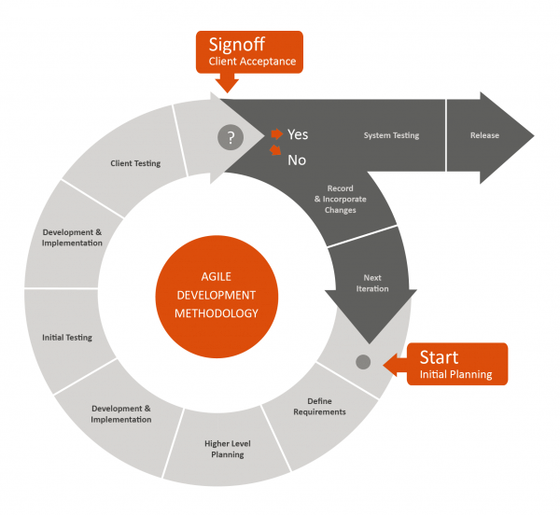

For more information, please refer to the website:

http://blogs.globalteckz.com/characteristics-of-agile-methodology-in-software-development/

1. **Roles and Responsibilities**

|  |  |  |
| --- | --- | --- |
| **Full name** | **Roles** | **Responsibilities** |
| Nguyễn Đức Khoan | Project Manager | * Give user requirements * Control developing process * Support |
| Lê Phước Việt | Team Leader | * Manage members and tasks * Designer * Developer * Tester |
| Nguyễn Xuân Sơn | Team Member | * Designer * Developer * Tester |

1. **Tools and Techniques**
2. **Back-end**

_ HTML 5

_ CSS 3

_ Javascript

_ Jquery

_ Ajax

1. **Front-end**

_ ASP.NET MVC 4

_ Linq

_ Android toolkit

_ Microsoft IIS 7

_ Microsoft SQL 2008 Express SP 2

1. **Project Management Plan**
   1. **Overview**

|  |  |  |  |  |
| --- | --- | --- | --- | --- |
| **Iteration** | **Description** | **Output** | **Time** | **Note** |
| **1** | * Study technology that will be used in the project. * Identify business and system requirements. | * Business of the Hospital Finder system. | 20 days | * Might have misunderstanding between user and project team. |
| **2** | * Finding suitable searching algorithm. * Prepare meta-data. | * Searching algorithms. * Data of hospitals, specialities, diseases, supporting services and facilities. | 20 days | * Need to combine and optimize search technology and algorithm. * Lack of medical published data. |
| **3** | * Implement search methods. * Implement method to display hospital detail. * Implement methods to manage doctors in a specific hospital or clinic. | * User can search hospitals base on 3 search options: Normal search, advanced search and location search. * View hospital details. * Methods to add, update and display doctors’ information. | 30 days | * Search methods return unexpected results. * Data in results page and hospital detail page might be confused. |
| **4** | * Implement methods to manage hospitals * Implement methods to manage meta-data and users. * Implement statistics methods. | * Method to add, update hospitals and display a list of them. * Method to manage specialities, diseases, supporting services and facilities. * Method to add, update users. * Method to view statistics. | 20 days | * Excel template need to be defined. * Lack of data of specialities, diseases, supporting services and facilities. |

* 1. **Detail**

1. **Iteration 1**

|  |  |  |
| --- | --- | --- |
| **Task** | **Description** | **Resource** |
| **Identify business of the system** | Decide which services will be provided to the users. | VietLP, SonNX, |
| **Report 1** | Create introduction report HospitalF system. | SonNX |
| **Project Management**  **Plan.** | Create plan for the whole project. | VietLP |
| **Website Prototype.** | Design website prototype | VietLP |
| **Design ERD diagram.** | Design entity relationship diagram. | SonNX |
| **Study Facebook service and Google APIs** | Study how to integrate Facebook and Google service to the project. | SonNX |

1. **Iteration 2**

|  |  |  |
| --- | --- | --- |
| **Task** | **Description** | **Resource** |
| **Find search algorithms** | Find and study search algorithms. | VietLP, SonNX |
| **Geographic information retrieval algorithm** | Study and implement geographic information retrieval algorithm | VietLP, SonNX |
| **Report 2** | Create project management report for HospitalF system. | SonNX |
| **Prepare meta-data** | Find data of hospitals, specialities, diseases, supporting services and facilities. | SonNX |
| **Report 3** | Create use case and SRS document. | VietLP, SonNX |

1. **Iteration 3**

|  |  |  |
| --- | --- | --- |
| **Task** | **Description** | **Resource** |
| **Normal search** | Implement normal search mode. | SonNX |
| **Advanced search** | Implement advanced search mode. | SonNX |
| **Location search** | Implement location search mode. | VietLP |
| **Hospital detail** | Implement hospital detail page. | VietLP |
| **Testing** | Test methods to search hospital and manage doctors of a specific hospital or clinic. | VietLP, SonNX |
| **Report 4** | Create UML diagrams and SDD document. | VietLP, SonNX |

1. **Iteration 4**

|  |  |  |
| --- | --- | --- |
| **Task** | **Description** | **Resource** |
| **Manage hospital methods** | Implement methods to add, update, and view list of hospitals. | SonNX |
| **Manage meta-data** | Implement methods to add, update, view list of specialities, diseases, supporting services and facilities. | SonNX |
| **Manage users** | Implement methods to add, update, and view list of users | VietLP |
| **Feedback** | Implement methods to create, and view list of feedbacks. | VietLP |
| **Statistics** | Implement statistics methods. | VietLP |
| **Testing** | Test methods that will be implemented in iteration 4. | VietLP, SonNX, AnhDTH |
| **Report 5** | Create test case and SIT document | VietLP, SonNX, AnhDTH |
| **Report 6** | Create user manual report. | SonNX |

1. **Convention Rules**

* Using C# coding convention at page:  
  http://msdn.microsoft.com/en-us/library/vstudio/ff926074.aspx

1. **System Requirements Specification (SRS)**
2. **User Requirement Specification**
   1. **Guest requirement**

Guests are the people who can use the system without any authentications process. They are supported with the following functions below:

_ Search hospitals and clinics base on:

+ Patients’ conditions.

+ Centers in a specific area in Vietnam.

+ Centers around current location or at a specific location address.

+ Centers that locate at a specific distance reference to current location.

_ View information of hospitals or clinics, and create feedback about the system.

* Feedback about information of the system.
  1. **Normal User requirement**

Normal Users are the people who use the system with their specific authenticated Facebook accounts. They have the right to use all the functions that supported for Guests (except Login), and the following functions below:

_ Create rating.

_ Comment or reply comments.

* 1. **Hospital User requirement**

Hospital Users are the people who have special accounts to manage information of a specific hospitals or clinic. They are supported with the following functions below:

_ Change password.

_ Manage information about their hospitals or clinics.

_ View users’ feedback about their hospitals or clinics.

_ Add doctors.

_ View statistics.

* 1. **Administrator requirement**

Administrators are the people who have the highest priorities in the system. They are supported with the following functions below:

* Create hospital users’ accounts.
* Manage normal and hospital users.
* View users’ feedback.
* Manage hospitals.
* Manage meta-data (Specialities, diseases, supporting services and facilities).
* View statistics.

1. **System Requirements Specification**
2. **External Interface Requirements**
3. **User Interfaces**

* User interface of the website must be clear and easy to use.
* Mobile interface must be compatible with multiple sizes of smart phone and tablet screens.
* Error messages must be highlight, easy to see and understand, and do not contain disturb or abused words or grammars.

1. **Software Interfaces**

* Web browser: Google Chrome and Fire Fox.
* Support Java Script and HTML5.

1. **Communication Protocol**

* HTTP Protocol will be used to communicate between web browsers, Android devices and web server.

1. **Function Requirements**
2. **System Overview**

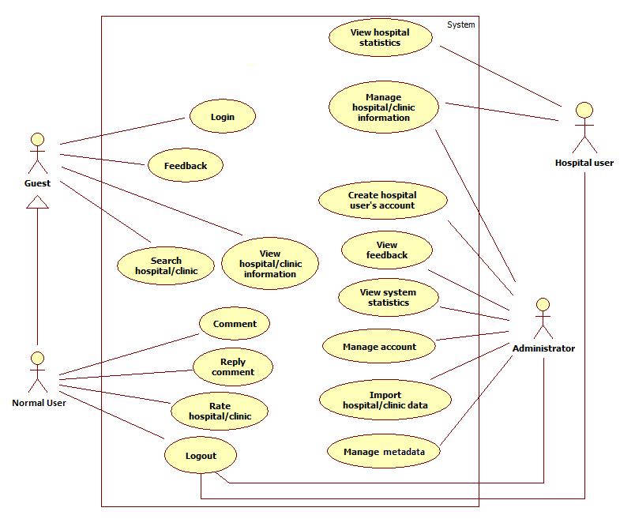

1. **Use case List**
   * + 1. **<GU> Overview Use Case**

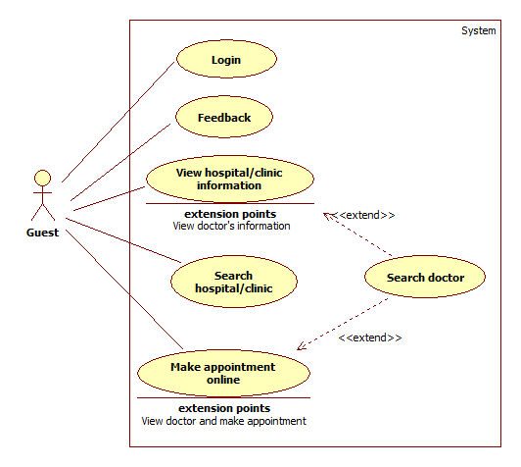

* + - 1. **<GU> Login**



|  |  |  |  |  |
| --- | --- | --- | --- | --- |
| **USE CASE – UC001** | | | | |
| **Use-case No.** | UC001 | **Use-case Version** | | 1.1 |
| **Use-case Name** | Login | | | |
| **Author** | Le Phuoc Viet | | | |
| **Date** | 27/05/2014 | **Priority** | High | |
| **Actor:** Guest  **Summary:** Guests use this case to login to the system.  **Goal:** Allow guests to login and gain more priorities to use the system depending on the role of the authorized account.  **Triggers:** Access login page for admins and hospital users.  **Preconditions:** N/A  **Post Conditions:**   * **Successful**: Account is authorized, the page will be transferred automatically to corresponding page according to account’s role. * **Fail**: User is only be able to access the system as the role of Guest. Error message will be displayed on the current page.   **Main Success Scenario:**   |  |  |  | | --- | --- | --- | | **Step** | **Action** | **System response** | | 1 | Access login page for admins and hospital users | Display login page that includes:   * Email: Textbox, email type, required. * Mật khẩu: Textbox, password type, required. * Ghi nhớ đăng nhập: Checkbox, optional. | | 2 | Fill email and password, then click “**Đăng Nhập**” button. | Account is authorized, the page will be transferred automatically to corresponding page according to account’s role. |   **Alternative Scenario:**  **A.**   |  |  |  | | --- | --- | --- | | **Step** | **Action** | **System response** | | 1 | Access homepage, then click Facebook icon on the top right side of the page. | If user has not been logged in to Facebook, the system displays Facebook login page that includes:   * Email hoặc điện thoại: Textbox, email type, required. * Mật khẩu: Textbox, password type, required. * Duy trì đăng nhập: Check box, optional * Quên mật khẩu?: Link | | 2 | Fill required input fields, then click “**Đăng nhập**” button. | User is redirect automatically to Facebook authentication page and ask for providing special permission as below:   * **HospitalF** will receive the following info: your [public profile](https://www.facebook.com/v2.0/dialog/oauth?redirect_uri=http%3A%2F%2Fstatic.ak.facebook.com%2Fconnect%2Fxd_arbiter%2FFX-Xf5fQjUk.js%3Fversion%3D41%23cb%3Df27f7497c8%26domain%3Dlocalhost%26origin%3Dhttp%253A%252F%252Flocalhost%253A18303%252Ff31048cb88%26relation%3Dopener%26frame%3Df124df4f4&display=popup&scope=publish_actions%2Cemail%2Cuser_friends%2Cuser_birthday%2Cuser_photos&response_type=token%2Csigned_request&domain=localhost&return_scopes=true&client_id=1403418919945133&ret=login&sdk=joey&ext=1408039198&hash=AeYvwzFEv20KqD0_), friend list, email address, birthday and photos. | | 3 | Click “**Cho phép**” button. | Transfer to previous page. |   **B.**   |  |  |  | | --- | --- | --- | | **Step** | **Action** | **System response** | | 1 | Access homepage, then click Facebook icon on the top right side of the page. | If Facebook account is currently logging in, and this is the first time user use the system through Facebook account, Facebook will ask for providing special permission as below:   * **HospitalF** will receive the following info: your [public profile](https://www.facebook.com/v2.0/dialog/oauth?redirect_uri=http%3A%2F%2Fstatic.ak.facebook.com%2Fconnect%2Fxd_arbiter%2FFX-Xf5fQjUk.js%3Fversion%3D41%23cb%3Df27f7497c8%26domain%3Dlocalhost%26origin%3Dhttp%253A%252F%252Flocalhost%253A18303%252Ff31048cb88%26relation%3Dopener%26frame%3Df124df4f4&display=popup&scope=publish_actions%2Cemail%2Cuser_friends%2Cuser_birthday%2Cuser_photos&response_type=token%2Csigned_request&domain=localhost&return_scopes=true&client_id=1403418919945133&ret=login&sdk=joey&ext=1408039198&hash=AeYvwzFEv20KqD0_), friend list, email address, birthday and photos. | | 2 | Click “**Cho phép**” button. | Transfer to previous page. |   **C.**   |  |  |  | | --- | --- | --- | | **Step** | **Action** | **System response** | | 1 | Access homepage, then click Facebook icon on the top right side of the page. | If Facebook account is currently logging in, and the Facebook account was authenticated to use the system before, the system will automatically authorize guest to become normal user. |   **Exceptions:**   |  |  |  | | --- | --- | --- | | **No** | **Case** | **System response** | | 1 | “Email” is blank | Display error message: “Xin hãy nhập Email.” | | 2 | “Mật khẩu” is blank | Display error message: “Xin hãy nhập Mật khẩu.” | | 3 | Invalid login information. | Display error message: “Sai thông tin đăng nhập.” | | 4 | Account is not active. | Display error message: “Tài khoản hiện đang tạm khóa, xin vui lòng liên hệ ban quản trị để mở khóa tài khoản.” | | 5 | System failure | Display error message: “Đã có lỗi xảy ra trong quá trình xử lý thông tin. Mong quý vị thông cảm và thử lại sau vài phút.” |   **Relationships**: N/A  **Business Rules:**  User must enter valid login information.  Only active account is allow to logging in the system.  In case that user role is hospital user or admin, the Captcha will be required if user fills wrong email or password greater than three times. | | | | | |

* + - 1. **<GU> Search Hospital**

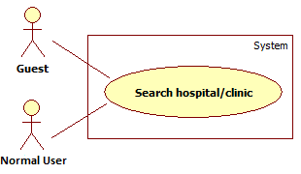

|  |  |  |  |  |
| --- | --- | --- | --- | --- |
| **USE CASE – UC002** | | | | |
| **Use-case No.** | UC002 | **Use-case Version** | | 1.1 |
| **Use-case Name** | Search Hospital | | | |
| **Author** | Nguyen Xuan Son | | | |
| **Date** | 27/05/2014 | **Priority** | High | |
| **Actor:** Guest, normal user  **Summary:** Guests and normal users use this case to search for suitable hospitals or clinics base on their needs.  **Goal:** A list of hospitals will be displayed with brief information including name, address and location on a visual Google map.  **Triggers:** Click “**Tìm kiếm**” button in one of three search options: “Tìm Kiếm Cơ Bản”, “Tìm Kiếm Nâng Cao” and “Tìm Kiếm Theo Vị Trí”  **Preconditions:** Access home page.  **Post Conditions:**   * **Successful**: A list of hospitals or clinics will be displayed. * **Failed**: Error message will be displayed on the current page.   **Main Success Scenario:**   |  |  |  | | --- | --- | --- | | **Step** | **Action** | **System response** | | 1 | Access home and choose “Tìm kiếm cơ bản” tab. | Display search option that includes:   * Thông tin tìm kiếm: Textbox, max length: 100, required | | 2 | Click “**Tìm kiếm**” button | The page will be transferred automatically to search result page with a list of found hospitals or clinics on the left and a Google map on the right displaying locations of visible hospitals or clinics. |   **Alternative Scenario:**  **A.**   |  |  |  | | --- | --- | --- | | **Step** | **Action** | **System response** | | 1 | Access home page and choose “Tìm kiếm nâng cao” tab. | Display search option that includes:   * Tỉnh / Thành phố: Drop down list, required * Quận / Huyện: Drop down list, optional * Chuyên Khoa: Drop down list, optional * Triệu Chứng: Drop down list, optional | | 2 | Click “**Tìm kiếm**” button | The page will be transferred automatically to search result page with a list of found hospitals or clinics on the left and a Google map on the right displaying locations of visible hospitals or clinics. |   **B.**   |  |  |  | | --- | --- | --- | | **Step** | **Action** | **System response** | | 1 | Access home page and choose “Tìm kiếm theo vị trí” tab. | Display search option that includes:   * Tìm theo: Drop down list, required * Vị trí cần tìm: Textbox, visible if “Tìm theo” drop down list is “**Nhập vị trí**” option, required. * Bán kính: Drop down list, required. | | 2 | Click “**Tìm kiếm**” button | The page will be transferred automatically to search result page with a list of found hospitals or clinics on the left and a Google map on the right displaying locations of visible hospitals or clinics. |   **Exceptions:**   |  |  |  | | --- | --- | --- | | **No.** | **Case** | **System response** | | 1 | “Thông tin tìm kiếm” is blank. | Display error message: “Xin hãy nhập Thông tin tìm kiếm.” | | 2 | “Thông tin tìm kiếm”’s length is more than 100 characters. | Display error message: “Thông tin tìm kiếm không thể vượt quá 100 ký tự.” | | 3 | “Tỉnh / Thành phố” is not selected. | Display error message: “Xin hãy chọn Tỉnh / Thành phố.” | | 4 | “Vị trí cần tìm” is blank (If visible). | Display error message: ”Xin hãy nhập Vị trí cần tìm.” | | 5 | System failure | Display error message: “Đã có lỗi xảy ra trong quá trình xử lý thông tin. Mong quý vị thông cảm và thử lại sau vài phút.” |   **Relationships**: N/A  **Business Rules:** The list of hospitals or clinics will be displayed as sorted order with the priority descending from tag values, rating point to number of rating counts. | | | | |

* + - 1. **<GU> View Hospital Information**

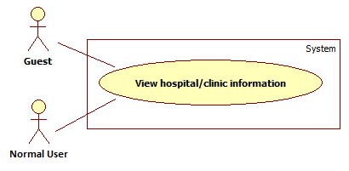

|  |  |  |  |  |
| --- | --- | --- | --- | --- |
| **USE CASE – UC003** | | | | |
| **Use-case No.** | UC003 | **Use-case Version** | | 1.1 |
| **Use-case Name** | View Hospital Information | | | |
| **Author** | Le Phuoc Viet | | | |
| **Date** | 27/05/2014 | **Priority** | High | |
| **Actor:** Guest, normal user  **Summary:** Guests and normal users use this case to view detailed information of a specific information or clinic.  **Goal:** Detailed information of a specific hospital or clinic will be displayed to users.  **Triggers:** After searching hospitals or clinics, click on a specific hospital or clinic’s name in search result page.  **Preconditions:** Use search function from home page.  **Post Conditions:**   * **Success:** Users can see detailed information of a specific hospital or clinic. * **Fail:** Error message will be displayed on current page.   **Main Success Scenario:**   |  |  |  | | --- | --- | --- | | **Step** | **Action** | **System response** | | 1 | Click on a specific hospital or clinic’s name in search result page after using search function at home page. | Hospital detail page that includes some general information as below:   * Hospital’s name: Text * Hospital’s full address: Text * Hospital’s phone numbers: Text * Hospital’s website: Text * Hospital’s email: Text * Hospital’s fax: Text * Rating point: Star label * Rating count: Text * Facebook comments * Tổng quan: Tab * Chuyên khoa và dịch vụ: Tab * Hình ảnh: Tab * Danh sách bác sỹ: Tab   “**Tổng quan**” tab will display the information as below:   * Hospital’s description: Text * Rating bar: Star label, default is 0 star. * Bình chọn: Button * Google map that display location of hospital or clinic. * Địa điểm xuất phát: Textbox, optional. * Magnifier icon search button.   “**Chuyên khoa và dịch vụ**” tab will display the information as below:   * Hospital’s specialities * Hospital’s supporting services * Hospital’s facilities   “**Hình ảnh**” tab will display photos of the hospital or clinics  “**Danh sách** **bác sỹ**” tab will display list of doctors in hospital or clinic. |   **Alternative Scenario:** N/A  **Exceptions:**   |  |  |  | | --- | --- | --- | | **No.** | **Case** | **System response** | | 1 | System failure | Display error message: “Đã có lỗi xảy ra trong quá trình xử lý thông tin. Mong quý vị thông cảm và thử lại sau vài phút.” |   **Relationships**: UC002 (Search hospital)  **Business Rules:**  Only authorized account with role of normal user can create rating and comments.  If user create rating more than three times simultaneously, Captcha will be displayed to make sure it not a bot is using the system. | | | | |

* + - 1. **<GU> Search Doctor**

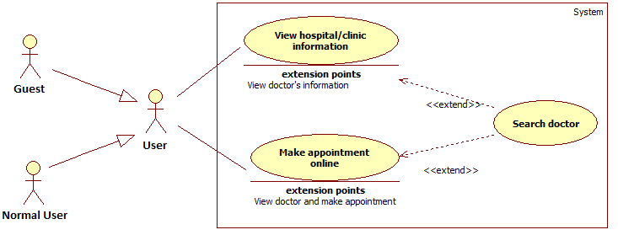

|  |  |  |  |  |
| --- | --- | --- | --- | --- |
| **USE CASE – UC004** | | | | |
| **Use-case No.** | UC004 | **Use-case Version** | | 1.1 |
| **Use-case Name** | Search doctor | | | |
| **Author** | Nguyen Xuan Son | | | |
| **Date** | 29/05/2014 | **Priority** | Normal | |
| **Actor:** Guest, normal user  **Summary:** This case allows guests and normal users to search and view doctor’s information.  **Goal:** Display information about doctors of a specific hospital or clinic.  **Triggers:** Click “**Tìm**” button after filling name of a specific doctor to searched textbox, or choose a specific speciality in speciality drop down list.  **Preconditions:** User is in “**Danh sách bác sĩ**” tab of Hospital Detail page.  **Post Conditions:**   * **Successful**: List of doctors and their information will be displayed. * **Failed**: Error message will be displayed on current page.   **Main Success Scenario:**   |  |  |  | | --- | --- | --- | | **Step** | **Action** | **System response** | | 1 | Enter the name of doctor in searched text box then click “**Tìm**” button | Display list of doctor as a table with:   * Hình ảnh: Photo * Họ tên: Text * Chuyên khoa: Text * Chứng chỉ/Bằng cấp: Text * Kinh nghiệm: Text * Lịch làm việc: Text |   **Alternative Scenario:**   |  |  |  | | --- | --- | --- | | **Step** | **Action** | **System response** | | 1 | Choose a specific speciality in drop down list then clicks “**Tìm**” button | Display list of doctors that are currently working at the chosen speciality. |   **Exceptions:**   |  |  |  | | --- | --- | --- | | **Step** | **Action** | **System response** | | 1 | No result are found. | Display error message: “Không có kết quả phù hợp.” | | 2 | Searched textbox is blank or speciality drop down list is not selected. | Display error message: “Xin hãy nhập tên bác sĩ hoặc chọn một chuyên khoa.” | | 3 | System failure | Display error message: ”Đã có lỗi xảy ra trong quá trình xử lý thông tin. Mong quý vị thông cảm và thử lại sau vài phút.” |   **Relationships**: UC003 (View hospital information)  **Business Rules:** The list will can be filtered by ascending or descending values of a specific table column. | | | | |

* + - 1. **<GU> Feedback**

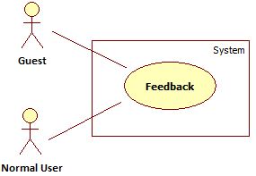

|  |  |  |  |  |
| --- | --- | --- | --- | --- |
| **USE CASE – UC005** | | | | |
| **Use-case No.** | UC005 | **Use-case Version** | | 1.1 |
| **Use-case Name** | Feedback | | | |
| **Author** | Nguyen Xuan Son | | | |
| **Date** | 27/05/2014 | **Priority** | Normal | |
| **Actor:** Guest, normal user  **Summary:** Guest and normal user can use this case to create feedback about a specific hospital or about the whole system.  **Goal:** Create feedback.  **Triggers:** Click on “**Phản Hồi**” link that located at the top right side of view hospital information page.  **Preconditions:** Users are staying at page view hospital information.  **Post Conditions:**   * **Success**: New feedback is created. * **Fail:** Error message will be displayed on current page.   **Main Success Scenario:**   |  |  |  | | --- | --- | --- | | **Step** | **Action** | **System response** | | 1 | Click “**Phản hồi**” link | Feedback form pop up will be displayed with the information below:   * Tiêu Đề: Textbox, max length: 64, required. * Dạng phản hồi: Drop down list, required. * Email: Textbox, email type, required. * Tên bệnh viện: Textbox, required (Visible if “Dạng phản hồi” is feedback about a specific hospital or clinic). * Nội dung: Text area, required. * Xác nhận: Button * Hủy: Button | | 2 | Click “**Xác nhận**” button | Display message: “Cám ơn bạn đã đóng góp ý kiến. Phản hồi sẽ được gửi qua Email được cung cấp nếu có.” |   **Alternative Scenario:**   |  |  |  | | --- | --- | --- | | **Step** | **Action** | **System response** | | 1 | Click “**Phản hồi**” link in home page’s footer | Feedback pop up will be displayed with the information below:   * Tiêu Đề: Textbox, max length: 64, required. * Dạng phản hồi: Drop down list, required. * Email: Textbox, email type, required. * Tên bệnh viện: Textbox, required (Visible if “Dạng phản hồi” is feedback about a specific hospital or clinic). * Nội dung: Text area, required. * Xác nhận: Button * HỦy: Button |   **Exceptions:**   |  |  |  | | --- | --- | --- | | **No** | **Case** | **System response** | | 1 | “Tiêu đề” is blank. | Display error message: “Xin hãy nhập Tiêu đề.” | | 2 | “Tiêu đề”’s length is more than 64 characters. | Display error message: “Tiêu đề không thể vượt quá 64 ký tự.” | | 3 | “Dạng phản hồi” is not selected. | Display error message: “Xin hãy chọn Dạng phản hồi.” | | 4 | “Email” is blank. | Display error message: “Xin hãy nhập Email.” | | 5 | “Email”’s format is not correct. | Display error message: “Email không hợp lệ.” | | 6 | “Tên bệnh viện” is blank. (If visible) | Display error message: “Xin hãy nhập Tên bệnh viện.” | | 7 | “Nội dung” is blank. | Display error message: “Xin hãy nhập Nội dung.” | | 8 | System failure | Display error message: “Đã có lỗi xảy ra trong quá trình xử lý thông tin. Mong quý vị thông cảm và thử lại sau vài phút.” |   **Relationships**: UC003 (View hospital information)  **Business Rules:** “Tên bệnh viện” must be valid if feedback type is about a specific hospital or clinic. | | | | |

* + - 1. **<NU> Overview Use Case**

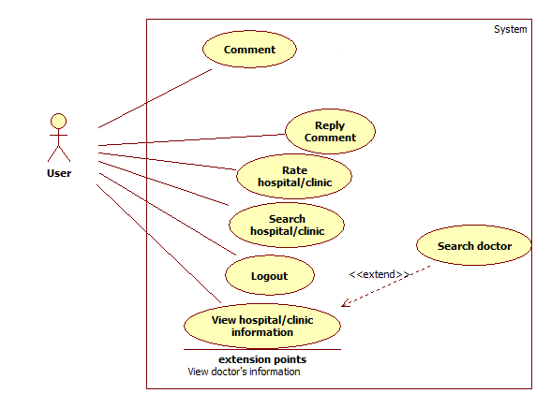

* + - 1. **<NU> Search Hospital**

Please refer to use case UC002.

* + - 1. **<NU> View Hospital Information**

Please refer to use case UC003.

* + - 1. **<NU> Search Doctor**

Please refer to use case UC004.

* + - 1. **<NU> Feedback**

Please refer to use case UC005.

* + - 1. **<NU> Comment**

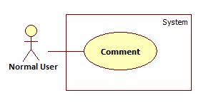

|  |  |  |  |  |
| --- | --- | --- | --- | --- |
| **USE CASE – UC011** | | | | |
| **Use-case No.** | UC011 | **Use-case Version** | | 1.0 |
| **Use-case Name** | Comment | | | |
| **Author** | Le Phuoc Viet | | | |
| **Date** | 29/05/2014 | **Priority** | Normal | |
| **Actor:** Normal user  **Summary:** Normal users use this case to comment upon an article.  **Goal:** Create comment about a hospital or clinic through Facebook comment  **Triggers:** Press Enter while staying in Facebook comment textbox  **Preconditions:** User must meet the requirements of use case **UC001** (Login) as the role of normal user.  **Post Conditions:**   * **Successful**: New comment will be created in comment area. * **Failed**: Error message will be displayed on current page.   **Main Success Scenario:**   |  |  |  | | --- | --- | --- | | **Step** | **Action** | **System response** | | 1 | Write a comment, and then press Enter | Comment will be posted in comment area. |   **Alternative Scenario:** N/A  **Exceptions:**   |  |  |  | | --- | --- | --- | | **No** | **Case** | **System response** | | 1 | Cannot post comment | Display error message: “Unable to post comment. Try again.” If you use Facebook in English, and “Không thể tạo bình luận. Xin thử lại.” if you use Facebook in Vietnamese |   **Relationships**: UC001 (Login)  **Business Rules:** Comments is not under the management of HospitalF system, but Facebook service. | | | | |

* + - 1. **<NU> Reply Comment**

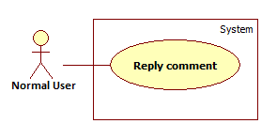

|  |  |  |  |  |
| --- | --- | --- | --- | --- |
| **USE CASE – UC012** | | | | |
| **Use-case No.** | UC012 | **Use-case Version** | | 1.0 |
| **Use-case Name** | Le Phuoc Viet | | | |
| **Author** | Nguyen Xuan Son | | | |
| **Date** | 29/05/2014 | **Priority** | Normal | |
| **Actor:** Normal user  **Summary:** Normal users use this case to reply to a comment upon an article.  **Goal:** Create reply comment about a hospital or clinic through Facebook comment  **Triggers:** Press Reply link in Facebook comment area  **Preconditions:** User must must meet the requirements of use case **UC001** (Login) as the role of normal user.  **Post Conditions:**   * **Successful**: New comment will be created in comment area. * **Failed**: Error message will be displayed on current page.   **Main Success Scenario:**   |  |  |  | | --- | --- | --- | | **Step** | **Action** | **System response** | | 1 | Write reply comment, and then press Enter | Comment will be posted under replied comment. |   **Alternative Scenario:** N/A  **Exceptions:**   |  |  |  | | --- | --- | --- | | **No** | **Case** | **System response** | | 1 | Cannot post comment | Display error message: “Unable to post comment. Try again.” If you use Facebook in English, and “Không thể tạo bình luận. Xin thử lại.” if you use Facebook in Vietnamese |   **Relationships**: UC001 (Login)  **Business Rules:** Comments or any replies is not under the management of HospitalF system, but Facebook service. | | | | |

* + - 1. **<NU> Rating Hospital**

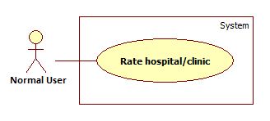

|  |  |  |  |  |
| --- | --- | --- | --- | --- |
| **USE CASE – UC013** | | | | |
| **Use-case No.** | UC013 | **Use-case Version** | | 1.0 |
| **Use-case Name** | Rate Hospital | | | |
| **Author** | Le Phuoc Viet | | | |
| **Date** | 27/05/2014 | **Priority** | Normal | |
| **Actor:** User  **Summary:** User use this case to give rating to a specific Hospital  **Goal:** User can rate a specific hospital’s quality by using five-stars rating system.  **Triggers:** Click one option in 5-stars rating icon (Predifined from 1 to 5 stars) to rate the hospital/clinic  **Preconditions:** User must meet the requirements of use case **UC001** (Login) as the role of normal user.  **Post Conditions:**   * **Success:** Newrating result is created. * **Fail:** Error message will be displayed on current page.   **Main Success Scenario:**   |  |  |  | | --- | --- | --- | | **Step** | **Action** | **System response** | | 1 | Click one option in 5-stars rating icon (Predefined from 1 to 5 stars) in hospital’s detailed information page. | Display message: “Cám ơn bạn đã tham gia đánh giá.”  The new rating result will be updated. |   **Alternative Scenario:** N/A  **Exceptions:**   |  |  |  | | --- | --- | --- | | **Step** | **Case** | **System response** | | 1 | System failure | Display error message: “Đã có lỗi xảy ra trong quá trình xử lý thông tin. Mong quý vị thông cảm và thử lại sau vài phút.” |   **Relationships**: N/A  **Business Rules:**  The criteria of 55 stars rating:   * Rate 5: Tuyệt vời * Rate 4: Rất tốt * Rate 3: Tốt * Rate 2: Được * Rate 1: Tạm được | | | | |

* + - 1. **<US> Logout**

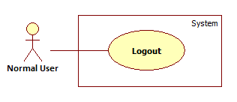

|  |  |  |  |  |
| --- | --- | --- | --- | --- |
| **USE CASE – UC014** | | | | |
| **Use-case No.** | UC014 | **Use-case Version** | | 1.0 |
| **Use-case Name** | Log out | | | |
| **Author** | Le Phuoc Viet | | | |
| **Date** | 27/05/2014 | **Priority** | High | |
| **Actor:** Normal user  **Summary:** Normal users use this case to log out of the system.  **Goal:** Allow user to log out of the system  **Triggers:** Click arrow icon on the top right side of header bar.  **Preconditions:** Actor must meet the requirements of use case **UC001** (Login).  **Post Conditions:**   * **Successful**: Current account will go back to use the system as the role of guest.   **Main Success Scenario:**   |  |  |  | | --- | --- | --- | | **Step** | **Action** | **System response** | | 1 | Click arrow icon on the top right side of header bar | Current account will go back to use the system as the role of guest |   **Alternative Scenario:** N/A  **Exceptions:** N/A  **Relationships**: UC001 (Login)  **Business Rules:** N/A | | | | |

* + - 1. **<HU> Overview Use Case**

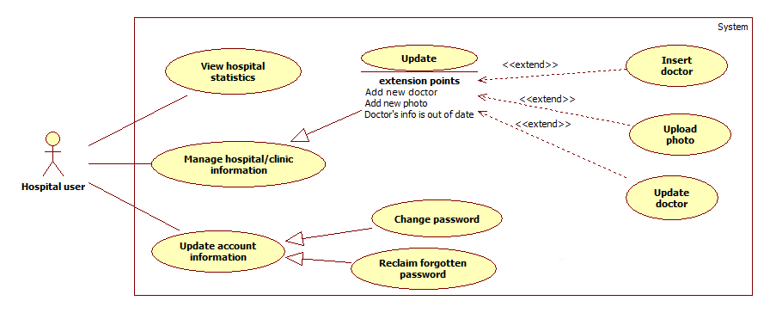

* + - 1. **<HU> Add New Doctor**
      2. **<HU> Search List of Doctors**
      3. **<HU> Update Doctor Information**
      4. **<HU> Upload Photo**

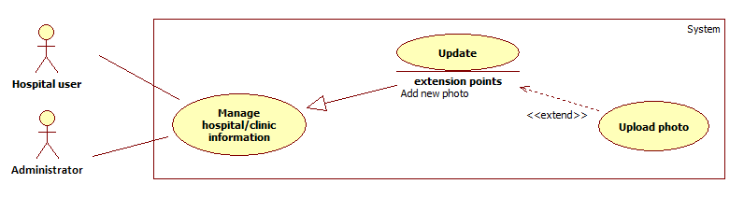

|  |  |  |  |  |
| --- | --- | --- | --- | --- |
| **USE CASE – UC019** | | | | |
| **Use-case No.** | UC019 | **Use-case Version** | | 1.1 |
| **Use-case Name** | Upload photo | | | |
| **Author** | Nguyen Xuan Son | | | |
| **Date** | 29/05/2014 | **Priority** | Normal | |
| **Actor:** Hospital users, administrators.  **Summary:** This case allows users to upload new photos for hospital or doctor.  **Goal:** Update new photos for hospital or doctor.  **Triggers:** Click “**Thêm hình ảnh**” button in “**Thư viện ảnh**” tab  **Preconditions:** Users are staying at update hospital page.  **Post Conditions:**   * **Successful**: New photos will be uploaded. * **Failed**: Error message will be displayed on current page.   **Main Success Scenario:**   |  |  |  | | --- | --- | --- | | **Step** | **Action** | **System response** | | 1 | Click the drop zone to choose which images will be uploaded or just click and drag them to the drop zone | Thumbnail images of uploaded photos will be displayed on dropzone | | 2 | Click “**Xác nhận**” button | New photos will be updated. |   **Alternative Scenario:** N/A  **Exceptions:**   |  |  |  | | --- | --- | --- | | **No** | **Case** | **System response** | | 1 | Image file is wrong format | Display error message: “Tập tin hình ảnh không đúng định dạng.” |   **Relationships**: UC020 (Update hospital)  **Business Rules:**  Only file with format .jpg, .JPG, .jpeg, .JPEG, .bmp, .BMP, .gif, .GIF, .png, .PNG are allow to be uploaded.  Users can only add or update 10 photos at a time. | | | | |

* + - 1. **<HU> Update Hospital Information**

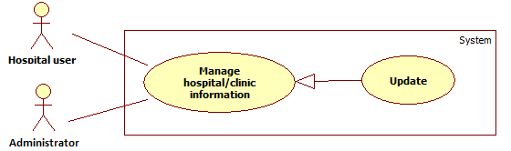

|  |  |  |  |  |
| --- | --- | --- | --- | --- |
| **USE CASE – UC020** | | | | |
| **Use-case No.** | UC020 | **Use-case Version** | | 1.1 |
| **Use-case Name** | Update hospital information | | | |
| **Author** | Nguyen Xuan Son | | | |
| **Date** | 29/05/2014 | **Priority** | High | |
| **Actor:** Hospital user, administrator  **Summary:** Users use this case to update information of a specific hospital or clinic.  **Goal:** Update information of a specific hospital or clinic.  **Triggers:** Click “**Thông tin bệnh viện**” on the left menu.  **Preconditions:** Users must meet the requirements of use case **UC001** (Login) as the role of hospital user.  **Post Conditions:**   * **Successful**: Information of a specific hospital or clinic will be updated. * **Failed**: Error message will be displayed.   **Main Success Scenario:**   |  |  |  | | --- | --- | --- | | **Step** | **Action** | **System response** | | 1 | Click “**Thêm mới bệnh viện**” on the left menu, then click “**Nhập liệu**” in the sub-menu. | Update hospital page will be displayed that includes:   * Tên bệnh viện: Textbox, min length: 2, max length: 64, required. * Loại bệnh viện: Drop down list, required. * Giờ khám ngày thường: Textbox, format: 99:99 – 99:99, required. * Giờ khám ngày lễ và cuối tuần: Textbox, format: 99:99 – 99:99, required. * Số địa chỉ: Textbox, max length: 32, required. * Tên đường: Textbox, max length: 32, required. * Tỉnh / Thành phố: Drop down list, required. * Quận / Huyện / Thị xã: Drop down list, required. * Phường / Xã: Drop down list, required. * Địa chỉ đầy đủ: Textbox, disabled, auto complete. * Lấy tọa độ từ địa chỉ: Button. * Google map * Số điện thoại chính: Textbox, min length: 8, max length: 13, required. * Số điện thoại thay thế: Textbox, min length: 8, max length: 13, optional. * Di động: Textbox, min length: 11, max length: 13, optional. * Email bệnh viện: Textbox, email type, optional. * Trang web bệnh viện: Textbox, URL type, optional. * Số fax bệnh viện: Textbox, min length: 8, max length: 16, optional. * Danh sách chuyên ngành: Drop down list, optional. * Danh sách dịch vụ: Drop down list, optional. * Danh sách cơ sở vật chất: Drop down list, optional. * Từ khóa tìm kiếm: Textbox, optional. * Hình ảnh: Drop zone, optional. * Miêu tả: Editor, optional. * Xác nhận: Button. * Nhập lại: Button | | 2 | Fill data in the form, then click button “**Xác nhận**” | New hospital or clinic will be updated, a message will display: “Thông tin của [ABCEF] được cập nhật thành công!”  All form data will be kept. |   **Alternative Scenario:** N/A  **Exceptions:**   |  |  |  | | --- | --- | --- | | **Step** | **Action** | **System response** | | 1 | “Tên bệnh viện” is blank. | Display error message: “Xin hãy nhập Tên bệnh viện.” | | 2 | “Tên bệnh viện”’s length is not suitable. | Display error message: “Tên bệnh viện phù hợp trong khoảng từ 2 đến 64 ký tự.” | | 3 | “Loại bệnh viện” is not selected. | Display error message: “Xin hãy chọn Loại bệnh viện”. | | 4 | “Giờ khám ngày thường” is blank. | Display error message: “Xin hãy nhập Giờ khám ngày thường.” | | 5 | “Giờ khám ngày lễ và cuối tuần” is blank. | Display error message: “Xin hãy nhập Giờ khám ngày lễ và cuối tuần.” | | 6 | “Số địa chỉ” is blank. | Display error message: “Xin hãy nhập số địa chỉ.” | | 7 | “Số địa chỉ”’s length is not suitable. | Display error message: “Số địa chỉ phù hợp trong khoảng từ 2 đến 32 ký tự.” | | 8 | “Tên đường” is blank | Display error message: “Xin hãy nhập tên đường.” | | 9 | “Tên đường”’s length is not suitable. | Display error message: “Tên đường phù hợp trong khoảng từ 2 đến 32 ký tự.” | | 10 | “Tỉnh / Thành phố” is not selected. | Display error message: “Xin hãy chọn Tỉnh / Thành phố.” | | 11 | “Quận / Huyện / Thị xã” is not selected. | Display error message: “Xin hãy chọn Quận / Huyện / Thị xã.” | | 12 | “Phường / Xã” is not selected. | Display error message: “Xin hãy chọn Phường / Xã.” | | 13 | “Số điện thoại chính” is blank. | Display error message: “Xin hãy nhập Số điện thoại chính.” | | 14 | “Số điện thoại chính”’s length is not suitable. | Display error message: “Số điện thoại chính phù hợp trong khoảng từ 8 đến 13 ký tự.” | | 15 | “Số điện thoại thay thế”’s length is not suitable. | Display error message: “Số điện thoại thay thế phù hợp trong khoảng từ 8 đến 13 ký tự.” | | 16 | “Di động”’s length is not suitable | Display error message: “Di động phù hợp trong khoảng từ 11 đến 13 ký tự.” | | 17 | “Email bệnh viện”’s format is not correct. | Display error message: “Email bệnh viện không phù hợp.” | | 18 | “Trang web bệnh viện”’s format is not correct. | Display error message: “Trang web bệnh viện không phù hợp.” | | 19 | “Số fax bệnh viện”’s length is not suitable. | Display error message: “Số fax bệnh viện phù hợp trong khoảng từ 8 đến 16 ký tự.” | | 20 | System failure | Display error message: “Đã có lỗi xảy ra trong quá trình xử lý thông tin. Mong quý vị thông cảm và thử lại sau vài phút.” |   **Relationships**: UC001 (Login)  **Business Rules:**   * “Địa chỉ đầy đủ” is an auto complete field that is combined from the values of “Số địa chỉ”, “Tên đường”, “Tỉnh / Thành phố”, “Quận / Huyện / Thị xã”, “Phường / Xã”. * “Danh sách chuyên ngành”, “Danh sách dịch vụ”, “Danh sách cơ sở vật chất” are multi value drop down list. Once a value is selected, it will be no more appear in the select list. * Every time user enters a value to “Từ khóa tìm kiếm”, value will be splited automatically as tag word. This field is not accept 2 text with identical value. * User can only upload at the maximum of 10 photos using “Drop zone”. * If user want to use the service from button “Lấy tọa độ từ địa chỉ”, firstly they have to fill all the value of those fields: “Số địa chỉ”, “Tên đường”, “Tỉnh / Thành phố”, “Quận / Huyện / Thị xã”, “Phường / Xã”. Secondly, they have to let Google service to identify their location through the Internet. | | | | |

* + - 1. **<HU> View Hospital’s Statistics**



|  |  |  |  |  |
| --- | --- | --- | --- | --- |
| **USE CASE – UC021** | | | | |
| **Use-case No.** | UC021 | **Use-case Version** | | 1.1 |
| **Use-case Name** | View hospital’s statistics | | | |
| **Author** | Le Phuoc Viet | | | |
| **Date** | 27/05/2014 | **Priority** | Normal | |
| **Actor:** Hospital Users  **Summary:** Hospital User accesses the system, uses View Hospital’s statistics function  **Goal:** Display list of statistics and chart demonstrating hospital’s activities  **Triggers:** Click “**Thống Kê**” on the left menu.  **Preconditions:** Users must meet the requirements of use case **UC001** (Login) as the role of hospital user.  **Post Conditions:**   * **Success:** Display diagram of statis. * **Fail:** Error message will be displayed on current page.   **Main Success Scenario:**   |  |  |  | | --- | --- | --- | | **Step** | **Action** | **System response** | | 1 | Click “**Thống Kê**” on the left menu. | Displays list of statistics include:   * Search query that provides the highest counting result Total number of appointments |   **Alternative Scenario:** N/A  **Exceptions:**   |  |  |  | | --- | --- | --- | | **No** | **Case** | **System response** | | 1 | System failure | Display error message: “Đã có lỗi xảy ra trong quá trình xử lý thông tin. Mong quý vị thông cảm và thử lại sau vài phút.” |   **Relationships**: UC001 (Login)  **Business Rules:** N/A | | | | |

* + - 1. **<HU> Change Password**

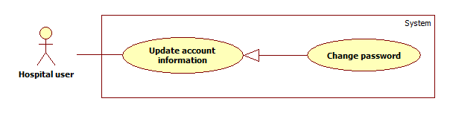

|  |  |  |  |  |
| --- | --- | --- | --- | --- |
| **USE CASE – UC022** | | | | |
| **Use-case No.** | UC022 | **Use-case Version** | | 1.0 |
| **Use-case Name** | Change password | | | |
| **Author** | Le Phuoc Viet | | | |
| **Date** | 29/05/2014 | **Priority** | Normal | |
| **Actor:** Hospital user  **Summary:** Hospital user use this case to change account’s password.  **Goal:** Update password for hospital user’s account  **Triggers:** Click “**Thay đổi mật khẩu**” option in drop down menu “**Thông tin tài khoản**”.  **Preconditions:** Hospital user must meet the requirements of use case **UC001** (Login) as the role of Hospital user.  **Post Conditions:**   * **Successful**: New password will be updated * **Failed**: Error message will be displayed on current page.   **Main Success Scenario:**   |  |  |  | | --- | --- | --- | | **Step** | **Action** | **System response** | | 1 | Click “**Thay đổi mật khẩu**” option in drop down menu “**Thông tin tài khoản**” | Display account update form include:   * Mật khẩu hiện tại: Textbox (Required, password) * Mật khẩu mới: Textbox (Required, password, min length: 6, max length: 32) * Nhập lại mật khẩu mớii: Textbox (Required, password) * Xác nhận: Button * Quay lại: Button | | 2 | Click “**Xác nhận**” button. | New password will be applied. A notification appears and displays a message: “Mật khẩu thay đổi thành công.” |   **Alternative Scenario:** N/A  **Exceptions:**   |  |  |  | | --- | --- | --- | | **No** | **Case** | **System response** | | 1 | “Mật khẩu hiện tại” is blank. | Display: “Xin hãy nhật Mật khẩu hiện tại.” | | 2 | “Mật khẩu mới” is blank | Display: “Xin hãy nhập Mật khẩu mới.” | | 3 | “Mật khẩu hiện tại” is incorrect | Display: “Mật khẩu hiện tại không chính xác.” | | 4 | “Mật khẩu mới” is duplicated with “Mật khẩu hiện tại” | Display: “Mật khẩu mới không được trùng với mật khẩu cũ.” | | 5 | Length of “Mật khẩu mới” is not in range. | Display: “Mật khẩu mới hợp lệ trong khoảng từ 6 đến 32 ký tự.” | | 6 | “Mật khẩu mới” does not match with “Xác nhận mật khẩu” | Display: “Mật khẩu mới không trùng khớp.” | | 7 | System failure | Display: “Đã có lỗi xảy ra trong quá trình xử lý thông tin. Mong quý vị thông cảm và thử lại sau vài phút.” |   **Relationships**: N/A  **Business Rules:** New password must be different with the current password. | | | | |

* + - 1. **<AD> Overview Use Case**

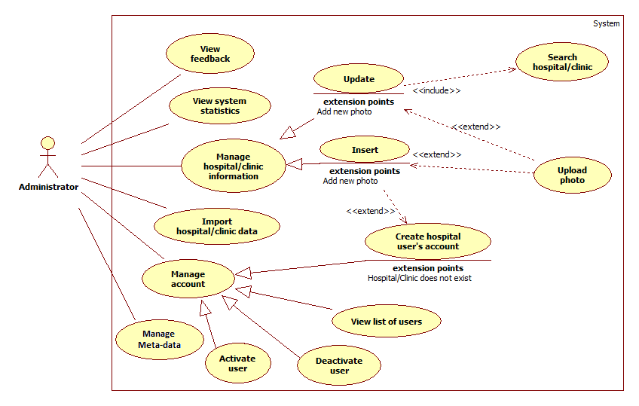

* + - 1. **<AD> Create Hospital User’s Account**

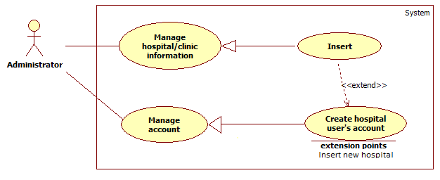

|  |  |  |  |  |
| --- | --- | --- | --- | --- |
| **USE CASE – UC028** | | | | |
| **Use-case No.** | UC028 | **Use-case Version** | | 1.1 |
| **Use-case Name** | Create hospital user’s account | | | |
| **Author** | Nguyen Xuan Son | | | |
| **Date** | 15/06/2014 | **Priority** | Normal | |
| **Actor:** Administrator  **Summary:** Administrators use this case to create hospital user accounts.  **Goal:** New hospital user accounts are created.  **Triggers:** Click “**Tạo tài khoản**” item in the left menu of administrator management page.  **Preconditions:** Users must meet the requirement of use case **UC001** (Login) as the role of administrator.  **Post Conditions:**   * **Successful**: New hospital user accounts will be created. * **Failed**: Error message will be displayed on current page.   **Main Success Scenario:**   |  |  |  | | --- | --- | --- | | **Step** | **Action** | **System response** | | 1 | Click “**Tạo tài khoản**” item in the left menu of administrator management page | Create hospital user account page will be displayed that includes:   * Email chính: Textbox, email type, required. * Email phụ: Textbox, email type, required. * Họ: Textbox, max length: 16, required. * Tên: Textbox, max length: 16, required. * Số điện thoại: Textbox, min length: 8, max length: 13, required. * Xác nhận: Button | | 2 | Fill in create hospital user account form and click “**Xác nhận**” button | Display message: “Tạo mới tài khoản thành công.” |   **Alternative Scenario:**   |  |  |  | | --- | --- | --- | | **Step** | **Action** | **System response** | | 1 | Click “**Thêm mới người dùng**” link under “**Người chịu trách nhiệm chính**” textbox (In case person in charged is not valid) in add hospital page. | Create hospital user account pup up will be displayed that includes:   * Email chính: Textbox, email type, required. * Email phụ: Textbox, email type, required. * Họ: Textbox, max length: 16, required. * Tên: Textbox, max length: 16, required. * Số điện thoại: Textbox, min length: 8, max length: 13, required. * Xác nhận: Button * Thoát: Button | | 2 | Fill in create hospital user account form and click “**Xác nhận**” button | Display message: “Tạo mới tài khoản thành công.” |   **Exceptions:**   |  |  |  | | --- | --- | --- | | **No** | **Case** | **System response** | | 1 | “Email chính” is blank. | Display error message: “Xin hãy nhập Email chính.” | | 2 | “Email chính”’s format is not correct. | Display error message: “Email chính không hợp lệ.” | | 3 | “Email phụ” is blank. | Display error message: “Xin hãy nhập Email phụ.” | | 4 | “Email phụ”’s format is nto correct. | Display error message: “Email phụ không hợp lệ.” | | 5 | “Email phụ” content is duplicated with “Email chính” | Display error message: “Email phụ không được trùng với Email chính.” | | 6 | “Email chính” is already has been used. | Display error message: “Email chính đã được sử dụng.” | | 7 | “Họ” is blank | Display error message: “Xin hãy nhập Họ.” | | 8 | “Họ”’s length is over 16 characters. | Display error message: “Họ không thể vượt quá 16 ký tự.” | | 9 | “Tên” is blank | Display error message: “Xin hãy nhập Tên.” | | 10 | “Tên”‘s length is over 16 characters. | Display error message: “Tên không thể vượt quá 16 ký tự.” | | 11 | “Số điện thoại” is blank | Display error message: “Xin hãy nhập Số Điện Thoại.” | | 12 | “Số điện thoại”’s format is nor correct. | Display error message: “Số ĐiệnThoại không hợp lệ.” | | 13 | System failure | Display: “Đã có lỗi xảy ra trong quá trình xử lý thông tin. Mong quý vị thông cảm và thử lại sau vài phút.” |   **Relationships**: UC0035 (Add hospital)  **Business Rules:**  “Email chính” must be unique for each hospital user accout, however “Email phụ” could be used more than once to register new hospital user account. | | | | |

* + - 1. **<AD> View List of Feedbacks**
      2. **<AD> View List of Users**
      3. **<AD> Activate User**
      4. **<AD> De-active User**
      5. **<AD> View System Statistics**

|  |  |  |  |  |
| --- | --- | --- | --- | --- |
| **USE CASE – UC029** | | | | |
| **Use-case No.** | UC029 | **Use-case Version** | | 1.1 |
| **Use-case Name** | View System statistics | | | |
| **Author** | Le Phuoc Viet | | | |
| **Date** | 27/05/2014 | **Priority** | Normal | |
| **Actor:** Hospital Users  **Summary:** Hospital User accesses the system, uses View Hospital’s statistics function  **Goal:** Display list of statistics and chart demonstrating hospital’s activities  **Triggers:** Click “**Thống Kê**” on the left menu.  **Preconditions:** Users must meet the requirements of use case **UC001** (Login) as the role of hospital user.  **Post Conditions:**   * **Success:** Display diagram of statis. * **Fail:** Error message will be displayed on current page.   **Main Success Scenario:**   |  |  |  | | --- | --- | --- | | **Step** | **Action** | **System response** | | 1 | Click “**Thống Kê**” on the left menu. | Displays list of statistics include:   * Search query that provides the highest counting result. * Pecentage of each type of hospital in the system. * Percentage of hospital that being managed by hospital user accounts. |   **Alternative Scenario:** N/A  **Exceptions:**   |  |  |  | | --- | --- | --- | | **No** | **Case** | **System response** | | 1 | System failure | Display error message: “Đã có lỗi xảy ra trong quá trình xử lý thông tin. Mong quý vị thông cảm và thử lại sau vài phút.” |   **Relationships**: UC001 (Login)  **Business Rules:** N/A | | | | |

* + - 1. **<AD> Import Hospital Using Excel**

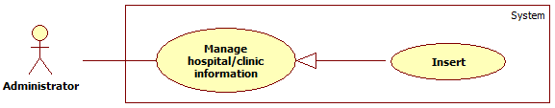

|  |  |  |  |  |
| --- | --- | --- | --- | --- |
| **USE CASE – UC030** | | | | |
| **Use-case No.** | UC030 | **Use-case Version** | | 1.1 |
| **Use-case Name** | Import hospital | | | |
| **Author** | Nguyen Xuan Son | | | |
| **Date** | 27/05/2014 | **Priority** | Normal | |
| **Actor:** Administrator  **Summary:** Administrators use this case to import a large number of hospitals to database.  **Goal:** Insert new hospitals to the system.  **Triggers:** Click “**Thêm mới bệnh viện**” on the left menu, then click “**Từ Excel**” in the sub-menu.  **Preconditions:** Users must meet the requirements of use case **UC001** (Login) as the role of administrator.  **Post Conditions:**   * **Success:** New hospitals or clinic will be inserted. * **Fail:** Error message will be displayed on current page.   **Main Success Scenario:**   |  |  |  | | --- | --- | --- | | **Step** | **Action** | **System response** | | 1 | Click button “**Chọn tập tin**” and choose Excel file from local folder. | Display message: “Tập tin phù hợp.” | | 2 | Click button “**Tải danh sách**”. | A list of valid records in Excel file will be displayed. | | 3 | Click button “**Xác nhận**”. | The list of valid hospitals will be added to database and display the list to user, then and display message: ”Thêm mới danh sách bệnh viện thành công!” |   **Alternative Scenario: N/A**  **Exceptions:**   |  |  |  | | --- | --- | --- | | **No** | **Case** | **System response** | | 1 | Input file is not Excel file | Display error message: “Tập tin không phù hợp.” | | 2 | Excel template is empty | Display error message: “Không có dữ liệu.” | | 3 | System failure | Display error message: “Đã có lỗi xảy ra trong quá trình xử lý thông tin. Mong quý vị thông cảm và thử lại sau vài phút.” |   **Relationships**: UC001 (Login)  **Business Rules:** The excel file must follow the below rules: | | | | |

* + - 1. **<AD> Add Hospital**

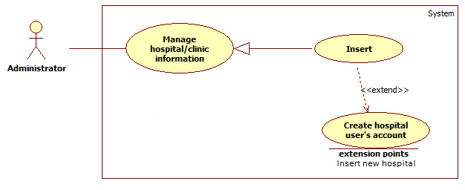

|  |  |  |  |  |
| --- | --- | --- | --- | --- |
| **USE CASE – UC031** | | | | |
| **Use-case No.** | UC031 | **Use-case Version** | | 1.1 |
| **Use-case Name** | Add Hospital | | | |
| **Author** | Nguyen Xuan Son | | | |
| **Date** | 27/05/2014 | **Priority** | High | |
| **Actor:** Administrator  **Summary:** Administrators use this case to add new hospital or clinic to the system manually.  **Goal:** Add new hospitals or clinics to the system.  **Triggers:** Click “**Thêm mới bệnh viện**” on the left menu, then click “**Nhập liệu**” in the sub-menu.  **Preconditions:** User must meet the requirements of use case **UC001** (Login) as the role of administrator.  **Post Conditions:**   * **Success**: New hospital or clinic will be created. * **Fail:** Error message will be displayed on current page.   **Main Success Scenario:**   |  |  |  | | --- | --- | --- | | **Step** | **Action** | **System response** | | 1 | Click “**Thêm mới bệnh viện**” on the left menu, then click “**Nhập liệu**” in the sub-menu. | Add hospital page will be displayed that includes:   * Tên bệnh viện: Textbox, min length: 2, max length: 64, required. * Loại bệnh viện: Drop down list, required. * Giờ khám ngày thường: Textbox, format: 99:99 – 99:99, required. * Giờ khám ngày lễ và cuối tuần: Textbox, format: 99:99 – 99:99, required. * Số địa chỉ: Textbox, max length: 32, required. * Tên đường: Textbox, max length: 32, required. * Tỉnh / Thành phố: Drop down list, required. * Quận / Huyện / Thị xã: Drop down list, required. * Phường / Xã: Drop down list, required. * Địa chỉ đầy đủ: Textbox, disabled, auto complete. * Lấy tọa độ từ địa chỉ: Button. * Google map * Số điện thoại chính: Textbox, min length: 8, max length: 13, required. * Số điện thoại thay thế: Textbox, min length: 8, max length: 13, optional. * Di động: Textbox, min length: 11, max length: 13, optional. * Email bệnh viện: Textbox, email type, optional. * Trang web bệnh viện: Textbox, url type, optional. * Người chịu trách nhiệm chính: Textbox, email type, optional. * Số fax bệnh viện: Textbox, min length: 8, max length: 16, optional. * Danh sách chuyên ngành: Drop down list, optional. * Danh sách dịch vụ: Drop down list, optional. * Danh sách cơ sở vật chất: Drop down list, optional. * Từ khóa tìm kiếm: Textbox, optional. * Hình ảnh: Drop zone, optional. * Miêu tả: Editor, optional. * Xác nhận: Button. * Nhập lại: Button | | 2 | Fill data in the form, then click button “**Xác nhận**” | New hospital or clinic will be created, a message will display: “Thêm mới [ABCEF] thành công!”.  All form data will be reset to their original state. |   **Alternative Scenario:** N/A  **Exceptions:**   |  |  |  | | --- | --- | --- | | **No** | **Case** | **System response** | | 1 | “Tên bệnh viện” is blank. | Display error message: “Xin hãy nhập Tên bệnh viện.” | | 2 | “Tên bệnh viện”’s length is not suitable. | Display error message: “Tên bệnh viện phù hợp trong khoảng từ 2 đến 64 ký tự.” | | 3 | “Loại bệnh viện” is not selected. | Display error message: “Xin hãy chọn Loại bệnh viện”. | | 4 | “Giờ khám ngày thường” is blank. | Display error message: “Xin hãy nhập Giờ khám ngày thường.” | | 5 | “Giờ khám ngày lễ và cuối tuần” is blank. | Display error message: “Xin hãy nhập Giờ khám ngày lễ và cuối tuần.” | | 6 | “Số địa chỉ” is blank. | Display error message: “Xin hãy nhập số địa chỉ.” | | 7 | “Số địa chỉ”’s length is not suitable. | Display error message: “Số địa chỉ phù hợp trong khoảng từ 2 đến 32 ký tự.” | | 8 | “Tên đường” is blank | Display error message: “Xin hãy nhập tên đường.” | | 9 | “Tên đường”’s length is not suitable. | Display error message: “Tên đường phù hợp trong khoảng từ 2 đến 32 ký tự.” | | 10 | “Tỉnh / Thành phố” is not selected. | Display error message: “Xin hãy chọn Tỉnh / Thành phố.” | | 11 | “Quận / Huyện / Thị xã” is not selected. | Display error message: “Xin hãy chọn Quận / Huyện / Thị xã.” | | 12 | “Phường / Xã” is not selected. | Display error message: “Xin hãy chọn Phường / Xã.” | | 13 | “Số điện thoại chính” is blank. | Display error message: “Xin hãy nhập Số điện thoại chính.” | | 14 | “Số điện thoại chính”’s length is not suitable. | Display error message: “Số điện thoại chính phù hợp trong khoảng từ 8 đến 13 ký tự.” | | 15 | “Số điện thoại thay thế”’s length is not suitable. | Display error message: “Số điện thoại thay thế phù hợp trong khoảng từ 8 đến 13 ký tự.” | | 16 | “Di động”’s length is not suitable | Display error message: “Di động phù hợp trong khoảng từ 11 đến 13 ký tự.” | | 17 | “Email bệnh viện”’s format is not correct. | Display error message: “Email bệnh viện không phù hợp.” | | 18 | “Trang web bệnh viện”’s format is not correct. | Display error message: “Trang web bệnh viện không phù hợp.” | | 19 | “Người chịu trách nhiệm chính”’s format is not correct | Display error mssage: “Email không phù hợp.” | | 20 | “Số fax bệnh viện”’s format is not correct. | Display error message: “Số fax bệnh viện không phù hợp.” | | 21 | “Số fax bệnh viện”’s length is not suitable. | Display error message: “Số fax bệnh viện phù hợp trong khoảng từ 8 đến 16 ký tự.” | | 22 | System failure | Display error message: “Đã có lỗi xảy ra trong quá trình xử lý thông tin. Mong quý vị thông cảm và thử lại sau vài phút.” |   **Relationships**: UC001 (Login)  **Business Rules:**   * “Địa chỉ đầy đủ” is an auto complete field that is combined from the values of “Số địa chỉ”, “Tên đường”, “Tỉnh / Thành phố”, “Quận / Huyện / Thị xã”, “Phường / Xã”. * “Danh sách chuyên ngành”, “Danh sách dịch vụ”, “Danh sách cơ sở vật chất” are multi value drop down list. Once a value is selected, it will be no more appear in the select list. * Every time user enters a value to “Từ khóa tìm kiếm”, value will be splited automatically as tag word. This field is not accept 2 text with identical value. * User can only upload at the maximum of 10 photos using “Drop zone”. * If user want to use the service from button “Lấy tọa độ từ địa chỉ”, firstly they have to fill all the value of those fields: “Số địa chỉ”, “Tên đường”, “Tỉnh / Thành phố”, “Quận / Huyện / Thị xã”, “Phường / Xã”. Secondly, they have to let Google service to identify their location through the Internet. | | | | |

* + - 1. **<AD> Upload Photo**

Please refer to use case UC019.

* + - 1. **<AD> Display List of Hospitals**

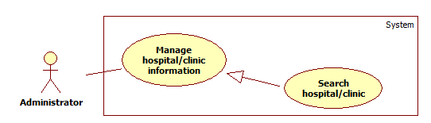

|  |  |  |  |  |
| --- | --- | --- | --- | --- |
| **USE CASE – UC033** | | | | |
| **Use-case No.** | UC033 | **Use-case Version** | | 1.1 |
| **Use-case Name** | Display list of hospitals | | | |
| **Author** | Nguyen Xuan Son | | | |
| **Date** | 27/05/2014 | **Priority** | Normal | |
| **Actor:** Administrator  **Summary:** Administrators use this case to view list of active and inactive hospitals in the system.  **Goal:** Display list of hospitals in the system.  **Triggers:** Click “**Danh sách bệnh viện**” on the left menu.  **Preconditions:** User must meet the requirements of use case **UC001** (Login) as the role of administrator.  **Post Conditions:**   * **Success**: List of hospitals will be displayed. * **Fail:** Error message will be displayed on current page.   **Main Success Scenario:**   |  |  |  | | --- | --- | --- | | **Step** | **Action** | **System response** | | 1 | Click “**Danh sách bệnh viện**” on the left menu. | Display hospital list page that includes:   * Drop down list for cities * Drop down list for districts in the chosen city. * Drop down list for hospital types. * Drop down list for hospital status. * Tìm kiếm tên bệnh viện: Textbox, optional. | | 2 | Choose any value in drop down list or enter a hospital name in search textbox. | Display list of hospitals or clinics with those value below:   * Tên bệnh viện * Địa chỉ * Loại * Trạng thái * Hành động |   **Alternative Scenario:** N/A  **Exceptions:**   |  |  |  | | --- | --- | --- | | **No.** | **Case** | **System response** | | 1 | System failure | Display error message: “Đã có lỗi xảy ra trong quá trình xử lý thông tin. Mong quý vị thông cảm và thử lại sau vài phút.” |   **Relationships**: N/A  **Business Rules:** Data must be paged with 5 records for each page. | | | | |

* + - 1. **<AD> Update Hospital Information**



|  |  |  |  |  |
| --- | --- | --- | --- | --- |
| **USE CASE – UC034** | | | | |
| **Use-case No.** | UC034 | **Use-case Version** | | 1.1 |
| **Use-case Name** | Update hospital information | | | |
| **Author** | Nguyen Xuan Son | | | |
| **Date** | 29/05/2014 | **Priority** | High | |
| **Actor:** Hospital user, administrator  **Summary:** Users use this case to update information of a specific hospital or clinic.  **Goal:** Update information of a specific hospital or clinic.  **Triggers:** Click on any hospital name in page view list of hospitals.  **Preconditions:** Users are staying at page view list of hospitals.  **Post Conditions:**   * **Successful**: Information of a specific hospital or clinic will be updated. * **Failed**: Error message will be displayed.   **Main Success Scenario:**   |  |  |  | | --- | --- | --- | | **Step** | **Action** | **System response** | | 1 | Click on any hospital name in page view list of hospitals. | Update hospital page will be displayed that includes:   * Tên bệnh viện: Textbox, min length: 2, max length: 64, required. * Loại bệnh viện: Drop down list, required. * Giờ khám ngày thường: Textbox, format: 99:99 – 99:99, required. * Giờ khám ngày lễ và cuối tuần: Textbox, format: 99:99 – 99:99, required. * Số địa chỉ: Textbox, max length: 32, required. * Tên đường: Textbox, max length: 32, required. * Tỉnh / Thành phố: Drop down list, required. * Quận / Huyện / Thị xã: Drop down list, required. * Phường / Xã: Drop down list, required. * Địa chỉ đầy đủ: Textbox, disabled, auto complete. * Lấy tọa độ từ địa chỉ: Button. * Google map * Số điện thoại chính: Textbox, min length: 8, max length: 13, required. * Số điện thoại thay thế: Textbox, min length: 8, max length: 13, optional. * Di động: Textbox, min length: 11, max length: 13, optional. * Email bệnh viện: Textbox, email type, optional. * Trang web bệnh viện: Textbox, URL type, optional. * Người chịu trách nhiệm chính: Textbox, email type, optional. * Số fax bệnh viện: Textbox, min length: 8, max length: 16, optional. * Danh sách chuyên ngành: Drop down list, optional. * Danh sách dịch vụ: Drop down list, optional. * Danh sách cơ sở vật chất: Drop down list, optional. * Từ khóa tìm kiếm: Textbox, optional. * Hình ảnh: Drop zone, optional. * Miêu tả: Editor, optional. * Xác nhận: Button. * Nhập lại: Button | | 2 | Fill data in the form, then click button “**Xác nhận**” | New hospital or clinic will be updated, a message will display: “Thông tin của [ABCEF] được cập nhật thành công!”  All form data will be kept. |   **Alternative Scenario:** N/A  **Exceptions:**   |  |  |  | | --- | --- | --- | | **Step** | **Action** | **System response** | | 1 | “Tên bệnh viện” is blank. | Display error message: “Xin hãy nhập Tên bệnh viện.” | | 2 | “Tên bệnh viện”’s length is not suitable. | Display error message: “Tên bệnh viện phù hợp trong khoảng từ 2 đến 64 ký tự.” | | 3 | “Loại bệnh viện” is not selected. | Display error message: “Xin hãy chọn Loại bệnh viện”. | | 4 | “Giờ khám ngày thường” is blank. | Display error message: “Xin hãy nhập Giờ khám ngày thường.” | | 5 | “Giờ khám ngày lễ và cuối tuần” is blank. | Display error message: “Xin hãy nhập Giờ khám ngày lễ và cuối tuần.” | | 6 | “Số địa chỉ” is blank. | Display error message: “Xin hãy nhập số địa chỉ.” | | 7 | “Số địa chỉ”’s length is not suitable. | Display error message: “Số địa chỉ phù hợp trong khoảng từ 2 đến 32 ký tự.” | | 8 | “Tên đường” is blank | Display error message: “Xin hãy nhập tên đường.” | | 9 | “Tên đường”’s length is not suitable. | Display error message: “Tên đường phù hợp trong khoảng từ 2 đến 32 ký tự.” | | 10 | “Tỉnh / Thành phố” is not selected. | Display error message: “Xin hãy chọn Tỉnh / Thành phố.” | | 11 | “Quận / Huyện / Thị xã” is not selected. | Display error message: “Xin hãy chọn Quận / Huyện / Thị xã.” | | 12 | “Phường / Xã” is not selected. | Display error message: “Xin hãy chọn Phường / Xã.” | | 13 | “Số điện thoại chính” is blank. | Display error message: “Xin hãy nhập Số điện thoại chính.” | | 14 | “Số điện thoại chính”’s length is not suitable. | Display error message: “Số điện thoại chính phù hợp trong khoảng từ 8 đến 13 ký tự.” | | 15 | “Số điện thoại thay thế”’s length is not suitable. | Display error message: “Số điện thoại thay thế phù hợp trong khoảng từ 8 đến 13 ký tự.” | | 16 | “Di động”’s length is not suitable | Display error message: “Di động phù hợp trong khoảng từ 11 đến 13 ký tự.” | | 17 | “Email bệnh viện”’s format is not correct. | Display error message: “Email bệnh viện không phù hợp.” | | 18 | “Trang web bệnh viện”’s format is not correct. | Display error message: “Trang web bệnh viện không phù hợp.” | | 19 | “Người chịu trách nhiệm chính”’s format is not correct | Display error mssage: “Email không phù hợp.” | | 20 | “Số fax bệnh viện”’s format is not correct. | Display error message: “Số fax bệnh viện không phù hợp.” | | 21 | “Số fax bệnh viện”’s length is not suitable. | Display error message: “Số fax bệnh viện phù hợp trong khoảng từ 8 đến 16 ký tự.” | | 22 | System failure | Display error message: “Đã có lỗi xảy ra trong quá trình xử lý thông tin. Mong quý vị thông cảm và thử lại sau vài phút.” |   **Relationships**: UC033 (Display list of hospitals)  **Business Rules:**   * “Địa chỉ đầy đủ” is an auto complete field that is combined from the values of “Số địa chỉ”, “Tên đường”, “Tỉnh / Thành phố”, “Quận / Huyện / Thị xã”, “Phường / Xã”. * “Danh sách chuyên ngành”, “Danh sách dịch vụ”, “Danh sách cơ sở vật chất” are multi value drop down list. Once a value is selected, it will be no more appear in the select list. * Every time user enters a value to “Từ khóa tìm kiếm”, value will be splited automatically as tag word. This field is not accept 2 text with identical value. * User can only upload at the maximum of 10 photos using “Drop zone”. * If user want to use the service from button “Lấy tọa độ từ địa chỉ”, firstly they have to fill all the value of those fields: “Số địa chỉ”, “Tên đường”, “Tỉnh / Thành phố”, “Quận / Huyện / Thị xã”, “Phường / Xã”. Secondly, they have to let Google service to identify their location through the Internet. * “Người chịu trách nhiệm chính” must be unique for every hospital. | | | | |

1. **Non-Functional Requirements**
2. **Reliability**

* Locations and information of hospitals and clinics must be precise as it be in reality.

1. **Availability**

* Services of the system must be provided 24/24.

1. **Security**

* Information of users must be kept secretly.
* Each type of user has a specific priorities in the system.
* Always check for authorization before executing any business.

1. **Maintainability**

* Code for Controller, Model, and View must be divided clearly.
* Complicated query must be written in Structure Query Language (SQL).
* All constant values and error messages

1. **Portability**

N/A

1. **Performance**

* Search process must be done in less than 5 seconds with network and hardware conditions are equal or better than development environments.
* Words and sentences suggestion must be showed in less than 3 seconds right after users input search query.

1. **Entity Relationship Diagram**

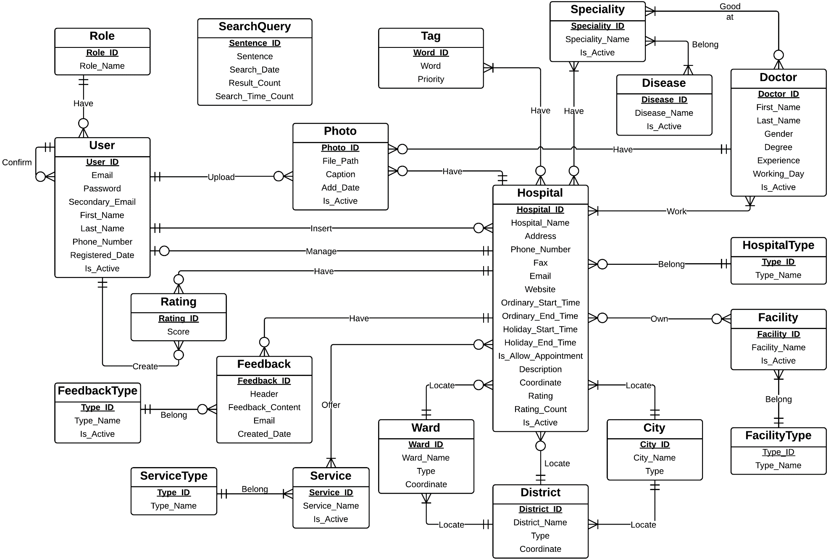

1. **System Design Description (SDD)**
2. **Design Overview**

This document describes the system design description for Hospital Finder system. It includes the architecture design, detailed designs for common functions and the design of database model.

The architecture design describes the overview architecture of the system.

Detailed design describes the structure of data and components in the system. Class diagram and its explanations either sequence diagrams are included in this section.

Database design describes the relationship between entities, how the data is organized and their explanations.

Design overview:

* Section 2: Architecture diagram
* Section 3: Component diagram
* Section 4: Class diagram and its explanations
* Section 5: Sequence diagrams of common functions
* Section 6: Database design

1. **System Architecture Design**

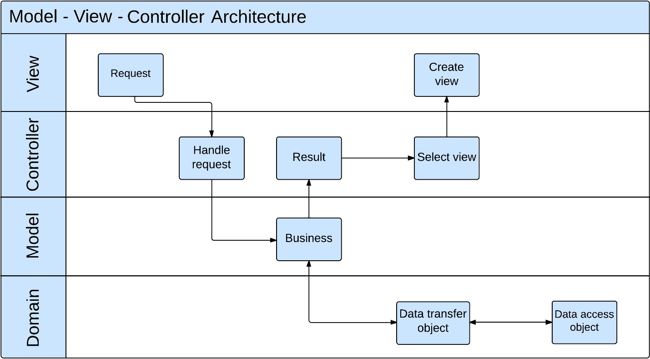

1. **Component Diagram**

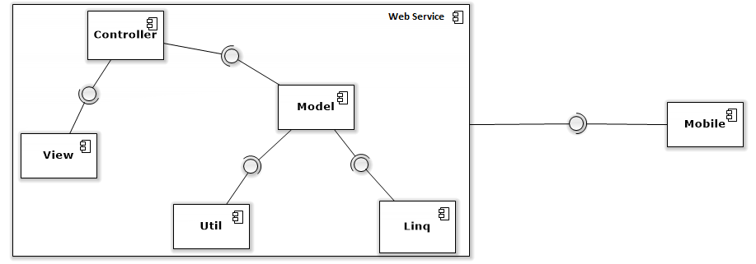

1. **Detailed Description of Components**

1. **Class Diagram**

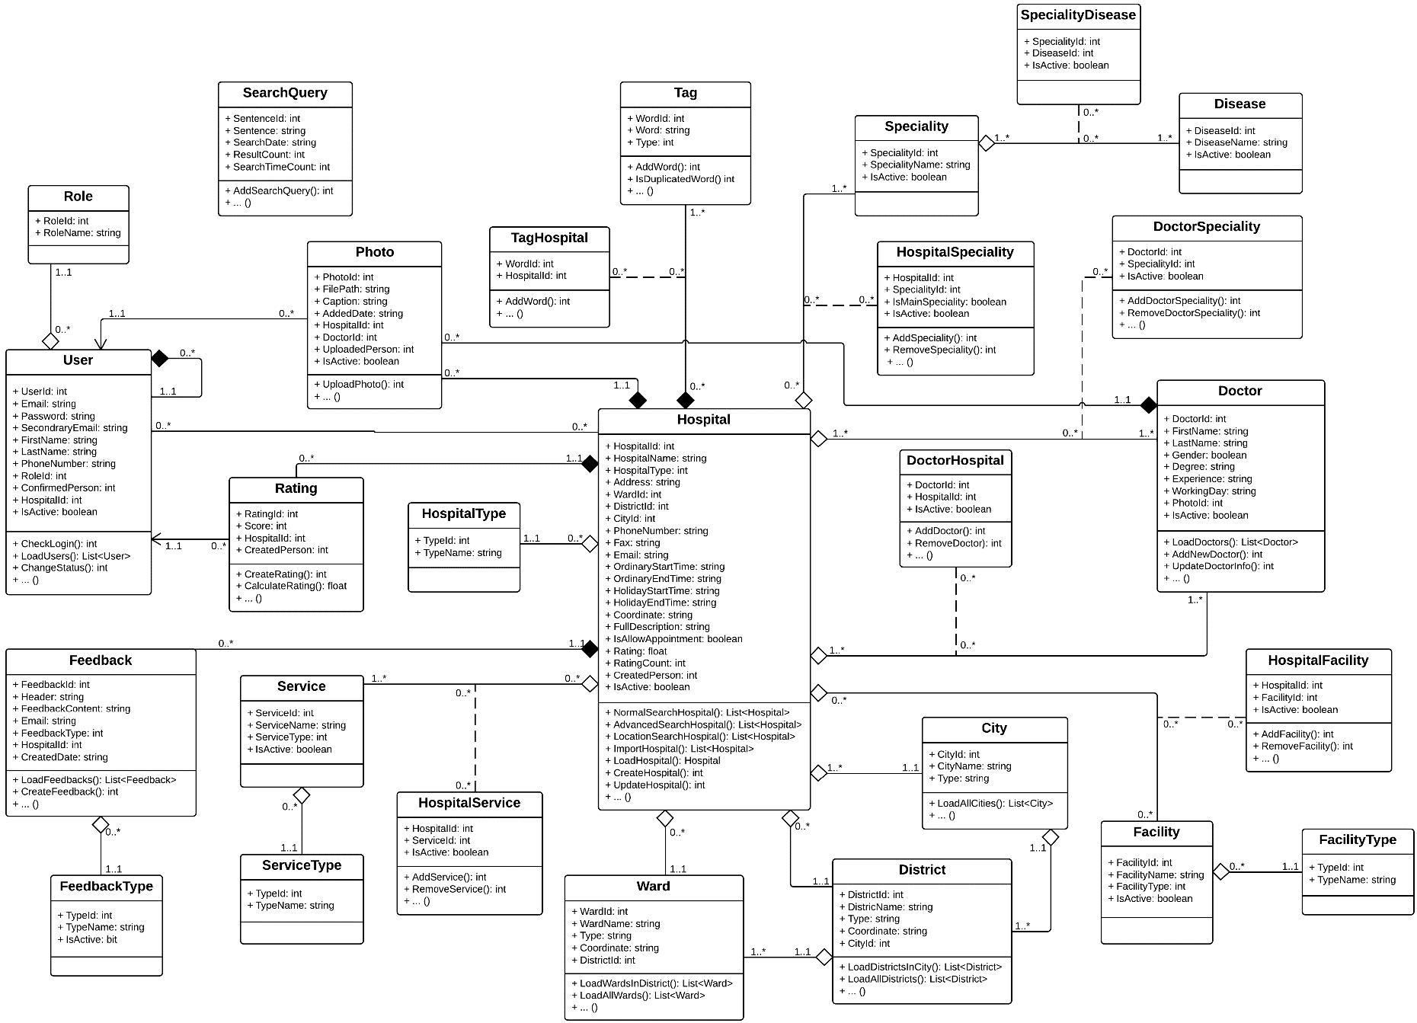

1. **Class Diagram Explanation**
2. **User**

**Attributes**

|  |  |  |  |
| --- | --- | --- | --- |
| **Attribute** | **Type** | **Visibility** | **Description** |
| UserId | Integer | Public | User ID |
| Email | String | Public | Email Address |
| Password | String | Public | Password |
| SecondaryEmail | String | Public | Secondary email |
| FirstName | String | Public | User’s first name |
| LastName | String | Public | User’s last name |
| PhoneNumber | String | Public | User’s phone number |
| RoleId | Integer | Public | Role ID |
| ConfirmedPerson | Integer | Public | ID of the administrator who confirmed the registration of a specific hospital user is right |
| HospitalId | Integer | Public | ID of the hospital that a hospital user have the responsibility to manage |
| IsActive | Boolean | Public | Indicate if a user is available in the system or not |

**Methods**

|  |  |  |  |
| --- | --- | --- | --- |
| **Attribute** | **Type** | **Visibility** | **Description** |
| CheckLogin | Integer | Public | Authenticate users |
| LoadUsers | List<User> | Public | Load a list of users |
| ChangeStatus | Integer | Public | Change current status of a user in the system |

1. **Hospital**

**Attributes**

|  |  |  |  |
| --- | --- | --- | --- |
| **Attribute** | **Type** | **Visibility** | **Description** |
| HospitalId | Integer | Public | Hospital ID |
| HospitalName | String | Public | Name of a hospital |
| HospitalType | Integer | Public | Type of a hospital |
| Address | String | Public | Full address of a hospital |
| WardId | Integer | Public | ID of the ward that a hospital is currently locating |
| DistrictId | Integer | Public | ID of the district that a hospital is currently locating |
| CityId | Integer | Public | ID of the city that a hospital is currently locating |
| PhoneNumber | String | Public | Hospital’s phone number |
| Fax | String | Public | Hospital’s fax number |
| Email | String | Public | Hospital’s email |
| OrdinaryStartTime | String | Public | Oridnary start working time of a hospital |
| OrdinaryEndTime | String | Public | Ordinary end working time of a hospital |
| HolidayStartTime | String | Public | Holiday start working time of a hospital |
| HolidayEndTime | String | Public | Holiday end working time of a hospital |
| Coordinate | String | Public | Coordinate of a hospital in the map |
| FullDescription | String | Public | Full description about a hospital |
| IsAllowAppointment | Boolean | Public | Indicate whether a hospital have online appointment system or not |
| Rating | Float | Public | Average rating point |
| RatingCount | Integer | Public | Total number of rating |
| CreatedPerson | Integer | Public | Indicate who was created a hosptail |
| IsActive | Boolean | Public | Indicate if a hospital is available in the system or not |

**Methods**

|  |  |  |  |
| --- | --- | --- | --- |
| **Attribute** | **Type** | **Visibility** | **Description** |
| NormalSearchHospital | List<Hospital> | Public | Load a list of hospitals base on input search query. |
| AdvancedSearchHospital | List<HospitaL> | Public | Load a list of hospitals base on city, district, speciality and disease conditions. |
| LocationSearchHospital | List<Hospital> | Public | Load a list of hospitals base on location and current address conditions. |
| ImportHospital | List<Hospital> | Public | Import a list of hospitals using Excel |
| LoadHospital | Hospital | Public | Load a specific hospital |
| CreateHospital | Integer | Public | Create a hospital |
| UpdateHospital | Integer | Public | Update information of a hospital |

1. **HospitalType**

**Attributes**

|  |  |  |  |
| --- | --- | --- | --- |
| **Attribute** | **Type** | **Visibility** | **Description** |
| TypeId | Integer | Public | Hospital type ID |
| TypeName | String | Public | Name of a hospital type |

**Methods**

N/A

1. **Doctor**

**Attributes**

|  |  |  |  |
| --- | --- | --- | --- |
| **Attribute** | **Type** | **Visibility** | **Description** |
| DoctorId | Integer | Public | Doctor ID |
| FirstName | String | Public | Doctor’s first name |
| LastName | String | Public | Doctor’s last name |
| Gender | Boolean | Public | Doctor’s gender |
| Degree | String | Public | Knowledge degree of a doctor |
| Experience | String | Public | Working experience of a doctor |
| WorkingDay | String | Public | Working day in a week of a doctor |
| PhotoId | Integer | Public | Photo picture of a doctor |
| IsActive | Boolean | Public | Indicate a doctor is available in the system or not |

**Methods**

|  |  |  |  |
| --- | --- | --- | --- |
| **Attribute** | **Type** | **Visibility** | **Description** |
| LoadDoctors | List<Doctor> | Public | Load a list of doctors in a hospital |
| AddNewDoctor | Integer | Public | Add new doctor |
| UpdateDoctorInfo | Integer | Public | Update profile of a doctor |

1. **DoctorSpeciality**

**Attributes**

|  |  |  |  |
| --- | --- | --- | --- |
| **Attribute** | **Type** | **Visibility** | **Description** |
| DoctorId | Integer | Public | Doctor ID |
| SpecialityId | Integer | Public | Speciality ID |
| IsActive | Boolean | Public | Indicate if a doctor is still good at a specific speciality or not |

**Methods**

|  |  |  |  |
| --- | --- | --- | --- |
| **Attribute** | **Type** | **Visibility** | **Description** |
| AddDoctorSpeciality | Integer | Public | Add new speciality for a doctor |
| RemoveDoctorSpeciality | Integer | Public | Remove specialities from a doctor |

1. **DoctorHospital**

**Attributes**

|  |  |  |  |
| --- | --- | --- | --- |
| **Attribute** | **Type** | **Visibility** | **Description** |
| DoctorId | Integer | Public | Doctor ID |
| HospitalId | Integer | Public | Hospital ID |
| IsActive | Boolean | Public | Indicate if a doctor is still work at a specific hospital or not |

**Methods**

|  |  |  |  |
| --- | --- | --- | --- |
| **Attribute** | **Type** | **Visibility** | **Description** |
| AddDoctorToHospital | Integer | Public | Add new doctor to hospital |
| RemoveDoctorFromHospital | Integer | Public | Remove doctors from a hospital |

1. **Role**

**Attributes**

|  |  |  |  |
| --- | --- | --- | --- |
| **Attribute** | **Type** | **Visibility** | **Description** |
| RoleId | Integer | Public | Role ID |
| RoleName | String | Public | Role name |

**Methods**

N/A

1. **Rating**

**Attributes**

|  |  |  |  |
| --- | --- | --- | --- |
| **Attribute** | **Type** | **Visibility** | **Description** |
| RatingId | Integer | Public | Rating ID |
| Score | Integer | Public | Score that made by user |
| HospitalId | Integer | Public | Hospital ID |
| CreatedPerson | Integer | Public | ID of the person who created a specific rating |

**Methods**

|  |  |  |  |
| --- | --- | --- | --- |
| **Attribute** | **Type** | **Visibility** | **Description** |
| CreateRating | Integer | Public | Create new rating |
| CalculateRating | Float | Public | Calculate total rating of a hospital |

1. **Feedback**

**Attributes**

|  |  |  |  |
| --- | --- | --- | --- |
| **Attribute** | **Type** | **Visibility** | **Description** |
| FeedbackId | Integer | Public | Feedback ID |
| Header | String | Public | Header of a feedback |
| FeedbackContent | String | Public | Content of a feedback |
| Email | String | Public | Email of the person who created a feedback |
| FeedbackType | Integer | Public | Feedback type ID |
| HospitalId | Integer | Public | Hospital ID |
| CreatedDate | String | Public | The date that a feedback was created |

**Methods**

|  |  |  |  |
| --- | --- | --- | --- |
| **Attribute** | **Type** | **Visibility** | **Description** |
| LoadFeedbacks | List<Feedback> | Public | Load a list of feedbacks |
| CreateFeedback | Integer | Public | Create new feedback |

1. **FeedbackType**

**Attributes**

|  |  |  |  |
| --- | --- | --- | --- |
| **Attribute** | **Type** | **Visibility** | **Description** |
| TypeId | Integer | Public | Feedback type ID |
| TypeName | String | Public | Feedback type’s name |
| IsActive | Boolean | Public | Indicate if a feedback type is available in the system or not |

**Methods**

N/A

1. **Facility**

**Attributes**

|  |  |  |  |
| --- | --- | --- | --- |
| **Attribute** | **Type** | **Visibility** | **Description** |
| FacilityId | Integer | Public | Facility ID |
| FacilityName | String | Public | Facility’s name |
| FacilityType | Integer | Public | Facility’s type |
| IsActive | Boolean | Public | Indicate if a facility is available in the system or not |

**Methods**

N/A

1. **FacilityType**

**Attributes**

|  |  |  |  |
| --- | --- | --- | --- |
| **Attribute** | **Type** | **Visibility** | **Description** |
| TypeId | Integer | Public | Facility type ID |
| TypeName | String | Public | Facility type’s name |

**Methods**

N/A

1. **HospitalFacility**

**Attributes**

|  |  |  |  |
| --- | --- | --- | --- |
| **Attribute** | **Type** | **Visibility** | **Description** |
| HospitalId | Integer | Public | Hospital ID |
| FacilityId | Integer | Public | Facility ID |
| IsActive | Boolean | Public | Indicate if a facility is still available in a hospital or not |

**Methods**

|  |  |  |  |
| --- | --- | --- | --- |
| **Attribute** | **Type** | **Visibility** | **Description** |
| AddFacility | Integer | Public | Add new facility to a hospital |
| Remove Facility | Integer | Public | Remove facilities from a hospital |

1. **Service**

**Attributes**

|  |  |  |  |
| --- | --- | --- | --- |
| **Attribute** | **Type** | **Visibility** | **Description** |
| ServiceId | Integer | Public | Service ID |
| ServiceName | String | Public | Service’s name |
| ServiceType | Integer | Public | Service’s type |
| IsActive | Boolean | Public | Indicate if a service is still available in a hospital or not |

**Methods**

N/A

1. **ServiceType**

**Attributes**

|  |  |  |  |
| --- | --- | --- | --- |
| **Attribute** | **Type** | **Visibility** | **Description** |
| TypeId | Integer | Public | Service type ID |
| TypeName | String | Public | Service type’s name |

**Methods**

N/A

1. **HospitalService**

**Attributes**

|  |  |  |  |
| --- | --- | --- | --- |
| **Attribute** | **Type** | **Visibility** | **Description** |
| HospitalId | Integer | Public | Hospital ID |
| Service | Integer | Public | Service ID |
| IsActive | Boolean | Public | Indicate if a service is still available in a hospital or not |

**Methods**

|  |  |  |  |
| --- | --- | --- | --- |
| **Attribute** | **Type** | **Visibility** | **Description** |
| AddService | Integer | Public | Add new service to a hospital |
| RemoveService | Integer | Public | Remove services from a hospital |

1. **Photo**

**Attributes**

|  |  |  |  |
| --- | --- | --- | --- |
| **Attribute** | **Type** | **Visibility** | **Description** |
| PhotoId | Integer | Public | Photo ID |
| FilePath | String | Public | File path of a photo |
| Caption | String | Public | Caption of a photo |
| AddedDate | String | Public | The date that a photo was added |
| TargetType | Integer | Public | Indicate if a photo is belong to a hospital or a doctor |
| TargetId | Integer | Public | ID of the item that a photo belonged to |
| UploadedPerson | Integer | Public | ID of the person who added the photo |
| IsActive | Boolean | Public | Indicate a photo is available in the system or not |

**Methods**

|  |  |  |  |
| --- | --- | --- | --- |
| **Attribute** | **Type** | **Visibility** | **Description** |
| UploadPhoto | Integer | Public | Add new photo to a hospital or doctor |

1. **Ward**

**Attributes**

|  |  |  |  |
| --- | --- | --- | --- |
| **Attribute** | **Type** | **Visibility** | **Description** |
| WardId | Integer | Public | Ward ID |
| WardName | String | Public | Name of a ward |
| Type | String | Public | Type of a ward |
| Coordinate | String | Public | Coordinate of a ward on the map |
| DistrictId | Integer | Public | ID of the district that a ward belonged to |

**Methods**

|  |  |  |  |
| --- | --- | --- | --- |
| **Attribute** | **Type** | **Visibility** | **Description** |
| LoadWardsInDistrict | List<Ward> | Public | Load a list of wards in a specific district |
| LoadAllWards | List<Ward> | Public | Load all wards in database |

1. **District**

**Attributes**

|  |  |  |  |
| --- | --- | --- | --- |
| **Attribute** | **Type** | **Visibility** | **Description** |
| DistrictId | Integer | Public | District ID |
| DistrictName | String | Public | Name of a district |
| Type | String | Public | Type of a district |
| Coordinate | String | Public | Coordinate of a district on the map |
| CityId | Integer | Public | ID of the city that a district belonged to |

**Methods**

|  |  |  |  |
| --- | --- | --- | --- |
| **Attribute** | **Type** | **Visibility** | **Description** |
| LoadWardsInCity | List<District> | Public | Load a list of districts in a specific city |
| LoadAllDistricts | List< District > | Public | Load all districts in database |

1. **City**

**Attributes**

|  |  |  |  |
| --- | --- | --- | --- |
| **Attribute** | **Type** | **Visibility** | **Description** |
| CityId | Integer | Public | City ID |
| CityName | String | Public | Name of a city |
| Type | String | Public | Type of a city |

**Methods**

|  |  |  |  |
| --- | --- | --- | --- |
| **Attribute** | **Type** | **Visibility** | **Description** |
| LoadAllCities | List<City> | Public | Load all cities in database |

1. **Speciality**

**Attributes**

|  |  |  |  |
| --- | --- | --- | --- |
| **Attribute** | **Type** | **Visibility** | **Description** |
| SpecialityId | Integer | Public | Speciality ID |
| SpecialityName | String | Public | Name of a speciality |
| IsActive | Boolean | Public | Indicate a speciality is available in the system or not |

**Methods**

N/A

1. **HospitalSpeciality**

**Attributes**

|  |  |  |  |
| --- | --- | --- | --- |
| **Attribute** | **Type** | **Visibility** | **Description** |
| HospitalId | Integer | Public | Hospital ID |
| SpecialityId | Integer | Public | Speciality ID |
| IsMainSpeciality | Boolean | Public | Indicate of a speciality is a main speciality of a hospital |
| IsActive | Boolean | Public | Indicate a speciality still belong to a hospital or not |

**Methods**

|  |  |  |  |
| --- | --- | --- | --- |
| **Attribute** | **Type** | **Visibility** | **Description** |
| AddSpeciality | Integer | Public | Add new speciality to a hospital |
| RemoveSpecilaity | Integer | Public | Remove specialities from a hospital |

1. **Disease**

**Attributes**

|  |  |  |  |
| --- | --- | --- | --- |
| **Attribute** | **Type** | **Visibility** | **Description** |
| DiseaseId | Integer | Public | Disease ID |
| DiseaseName | String | Public | Name of a disease |
| IsActive | Boolean | Public | Indicate a speciality still belong to a hospital or not |

**Methods**

N/A

1. **SpecialityDisease**

**Attributes**

|  |  |  |  |
| --- | --- | --- | --- |
| **Attribute** | **Type** | **Visibility** | **Description** |
| Speciality | Integer | Public | Speciality ID |
| DiseaseId | Integer | Public | Disease ID |
| IsActive | Boolean | Public | Indicate a disease is still belong to a speciliaty or not |

**Methods**

N/A

1. **Tag**

**Attributes**

|  |  |  |  |
| --- | --- | --- | --- |
| **Attribute** | **Type** | **Visibility** | **Description** |
| WordId | Integer | Public | Word ID |
| Word | String | Public | Word content |
| Type | Integer | Public | Priority of a word |

**Methods**

|  |  |  |  |
| --- | --- | --- | --- |
| **Attribute** | **Type** | **Visibility** | **Description** |
| AddWord | Integer | Public | Add new words |
| IsDuplicatedWord | Integer | Public | Check if a word is duplicated with another word in database |

1. **TagHospital**

|  |  |  |  |
| --- | --- | --- | --- |
| **Attribute** | **Type** | **Visibility** | **Description** |
| WordId | Integer | Public | Word ID |
| HospitalId | Integer | Public | Hospital ID |

**Methods**

|  |  |  |  |
| --- | --- | --- | --- |
| **Attribute** | **Type** | **Visibility** | **Description** |
| AddWord | Integer | Public | Add new words to a hospital |

1. **SearchQuery**

**Attributes**

|  |  |  |  |
| --- | --- | --- | --- |
| **Attribute** | **Type** | **Visibility** | **Description** |
| SentenceId | Integer | Public | Sentence ID |
| Sentence | String | Public | Sentence content |
| SearchDate | String | Public | The date that a specific search query was entered |
| ResultCount | Integer | Public | Count the number of results that a search query can find |
| SearchTimeCount | Integer | Public | Count the number of times that a search query has been used |

**Methods**

|  |  |  |  |
| --- | --- | --- | --- |
| **Attribute** | **Type** | **Visibility** | **Description** |
| AddSearchQuery | Integer | Public | Add new search query |

1. **Sequence Diagram**
   1. **Normal Search Hospital**

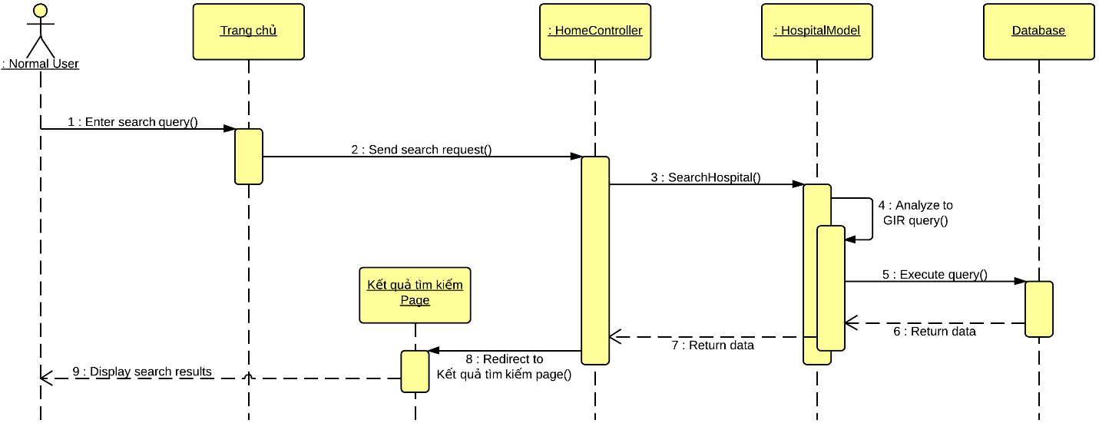

* 1. **Advanced Search Hospital**

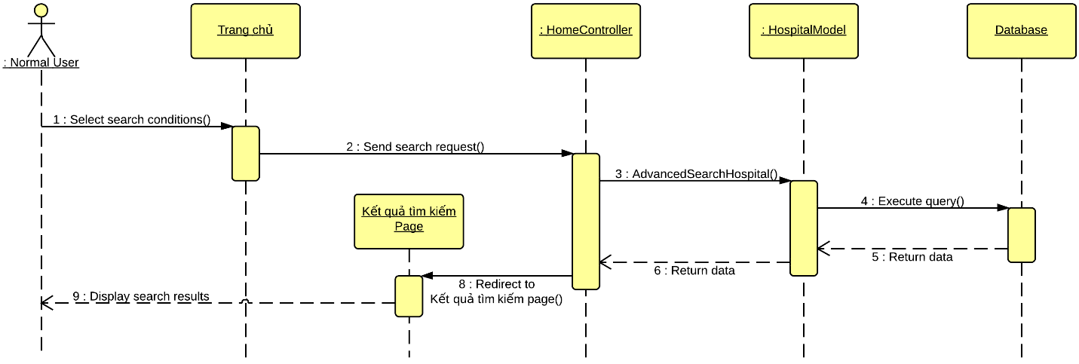

* 1. **Location Search Hospital**
  2. **Import Hospital Using Excel**

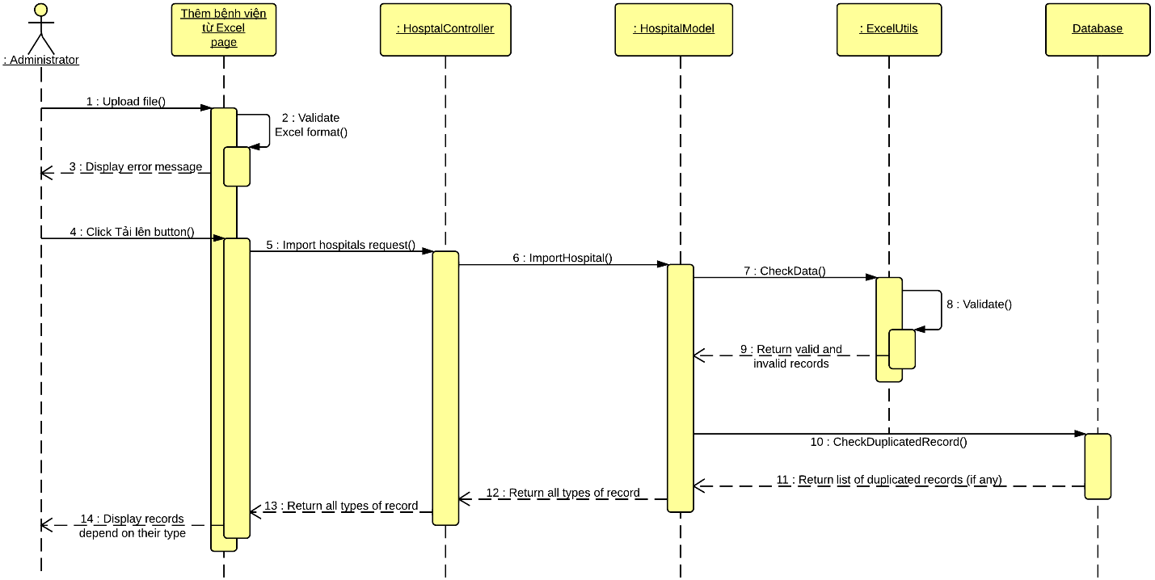

* 1. **Save valid Excel records**

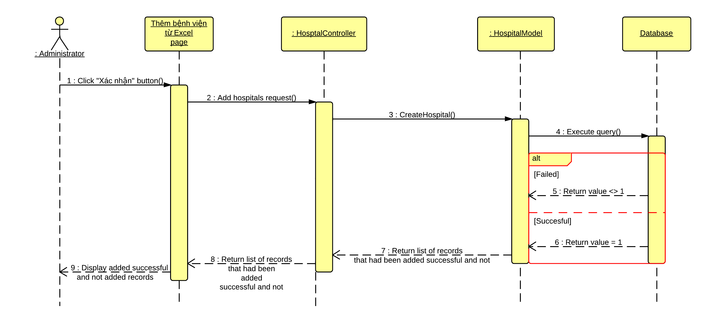

* 1. **Create Hospital**

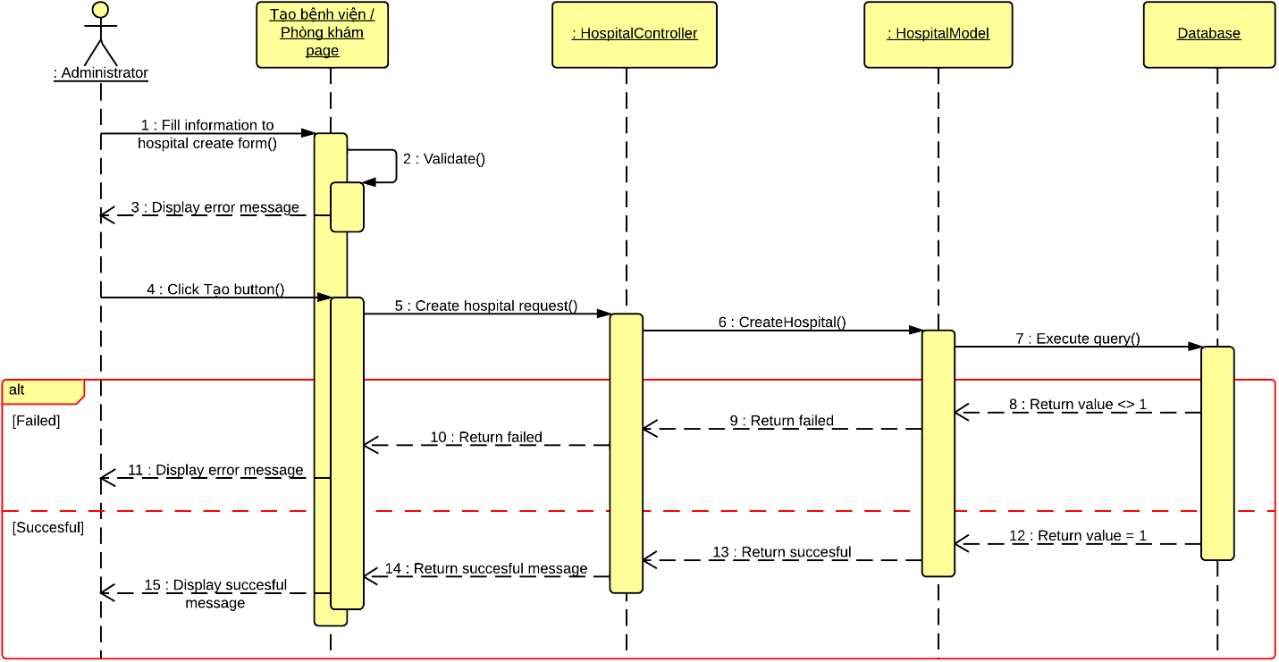

* 1. **View Hospital Detail**

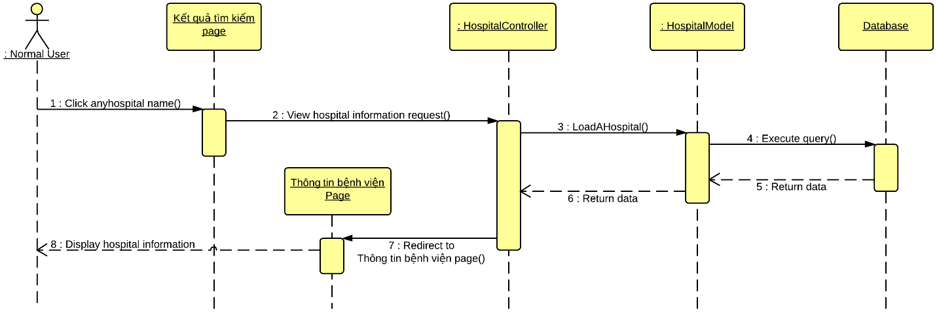

* 1. **Display list of hospitals**

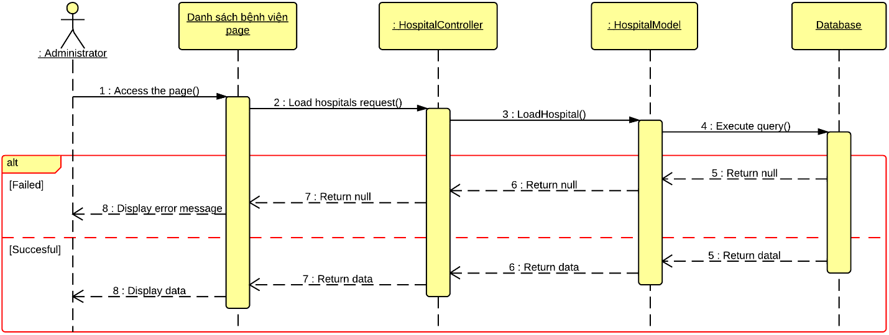

* 1. **Update Hospital Information**

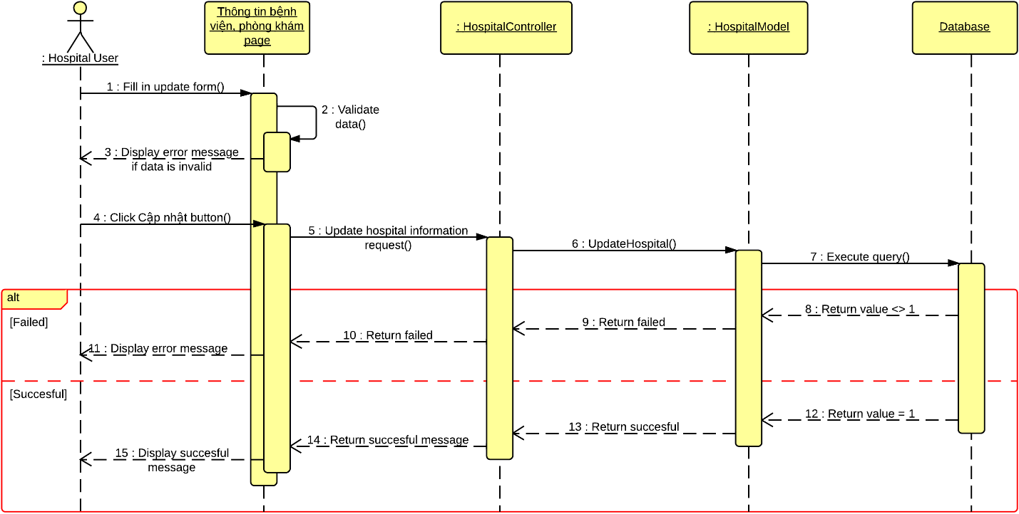

* 1. **Comment**

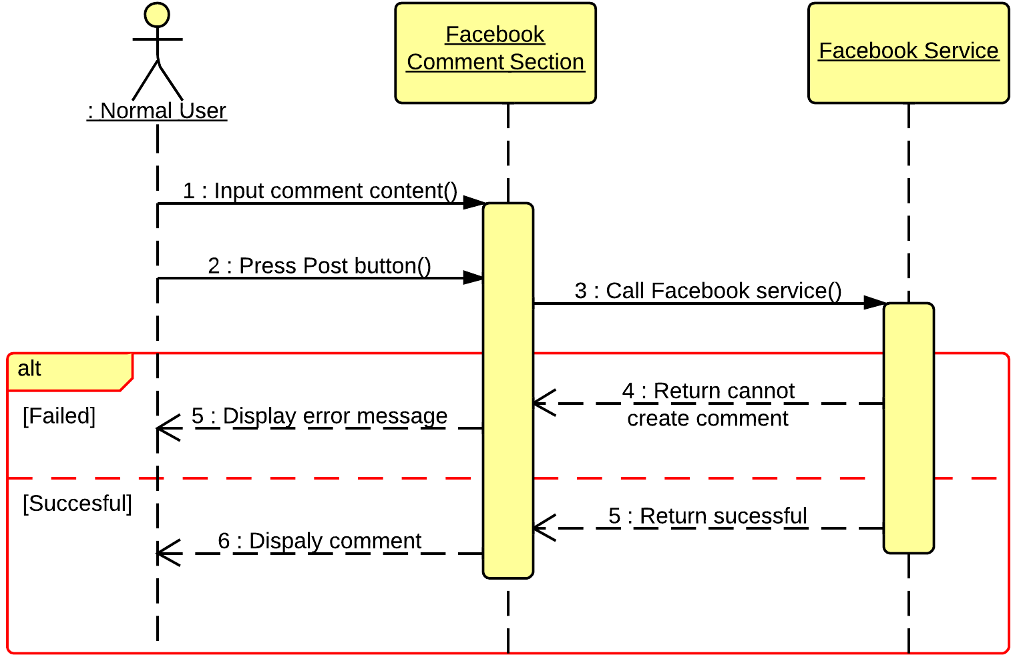

* 1. **View Statistics**

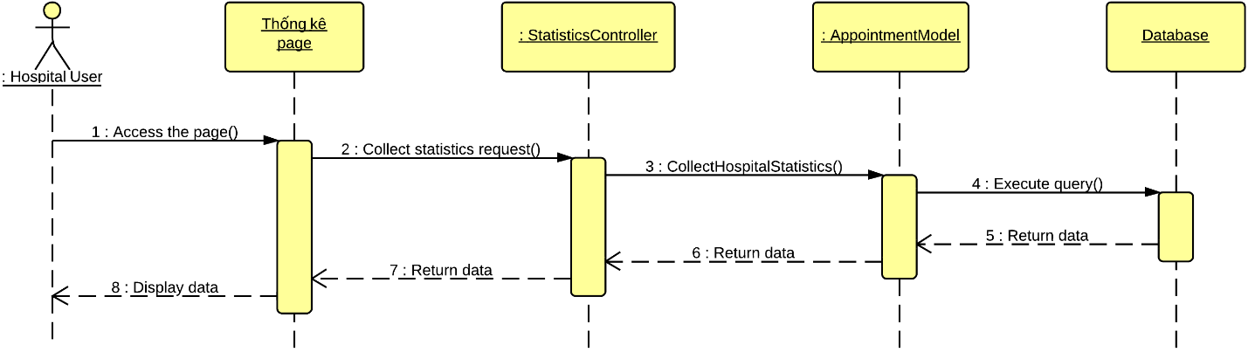

1. **User Interface Design**
   1. **Login**
   2. **Logout**
   3. **Change Password**
   4. **Reclaim Forgotten Password**
   5. **Search Hospital <GU> <US>**
   6. **Import Hospital Using Excel**
   7. **Create Hospital**
   8. **Create Hospital User’s Account**
   9. **View Hospital Information**
   10. **Search Doctor <GU> <US>**
   11. **Feedback**
   12. **Comment**
   13. **Reply Comment**
   14. **Rating Hosptial**
   15. **Add New Doctor**
   16. **Search List of Doctor <HU>**
   17. **Search List of Hospital <AD>**
   18. **Update Doctor Information**
   19. **Upload Photo**
   20. **Update Hospital Information**
   21. **View List of Feedbacks**
   22. **View List of Users**
   23. **Activate Users**
   24. **Deactivate Users**
   25. **View Hospital Statistics**
   26. **View System Statistics**
2. **Database Design**
   1. **Logical Database Design**
   2. **User**
   3. **Hospital**
   4. **HospitalType**
   5. **Doctor**
   6. **Doctor_Speciality**
   7. **Doctor_Hospital**
   8. **Role**
   9. **Rating**
   10. **Feedback**
   11. **FeedbackType**
   12. **Facility**
   13. **Hospital_Facility**
   14. **Service**
   15. **Hospital_Service**
   16. **Photo**
   17. **Ward**
   18. **District**
   19. **City**
   20. **Speciality**
   21. **Hospital_Speciality**
   22. **Disease**
   23. **Speciality_Disease**
   24. **WordDictionary**
   25. **Word_Hospital**
   26. **SentenceDictionary**
   27. **Sentence_Word**
3. **Algorithms**
4. **Geographic Information Retrieval**
   1. **Definition**
   2. **Examples**
5. **Boyer Moore Matching Algorithm**
   1. **Definition**
   2. **Examples**
6. **Haversine Formula**
7. **Definition**
8. **Example**
9. **System Implementation and Test (SIT)**
10. **Introduction**
11. **Database relationship Diagrams**
12. **Screen shots / Performance measures**
13. **Test Plan**
14. **Features to be tested**
15. **Features not to be tested**
16. **Testing Tools and Environment**
17. **Test Cases**
    1. **Login**
    2. **Search Hospital**
    3. **Import Hospital Using Excel**
    4. **Create Hospital**
    5. **Create Hospital User’s Account**
    6. **View Hospital Information**
    7. **Search Doctor <GU> <US>**
    8. **Feedback**
    9. **Rating Hospital**
    10. **Add New Doctor**
    11. **Search List of Doctor <HU>**
    12. **Search List of Hospital <AD>**
    13. **Update Doctor Information**
    14. **Upload Photo**
    15. **Update Hospital Information**
    16. **View Hospital Statistics**
18. **Checklists**
19. **System User’s Manual**
20. **Installation Guide**
21. **User’s Guide**