|  |  |  |  |  |  |
| --- | --- | --- | --- | --- | --- |
| |  |  |  | | --- | --- | --- | | **C:\Users\sonnx0907\Desktop\Untitled.png** | **MINISTRY OF EDUCATION AND RAINING** | | | **FPT UNIVERSITY** | | |
| Capstone Project Document |
| Hospital Finder |
| |  |  |  |  |  |  |  |  |  |  |  | | --- | --- | --- | --- | --- | --- | --- | --- | --- | --- | --- | | |  |  | | --- | --- | | **Group 11** | | | **Group Members** | Lê Phước Việt – Team Leader – SE60706  Nguyễn Xuân Sơn – Team Member – SE60727  Vũ Nhật Anh Khoa – Team Member – SE60817  Dương Thị Hoàng Anh – Team Member – 60434 | | **Supervisor** | Nguyễn Đức Khoan | | **Ext Supervisor** | N/A | | **Capstone Project code** | HospitalF | | |
| - Ho Chi Minh City, May / 2014 - |

**Table of Contents**

**2.1** **Problem Definition** 3

**2.1.1** **Name of this Capstone Project** 3

**2.1.2** **Problem Abstract** 3

**2.1.3** **Project Overview** 3

**2.1.3.1** **The Current System** 3

**2.1.3.2** **The Proposed System** 3

**2.1.3.2.1** **Computers** 3

**2.1.3.2.2** **Mobile Devices** 4

**2.1.3.3** **Boundaries of the System** 4

**2.1.3.4** **Development Environment** 5

**2.1.3.4.1** **Hardware requirements** 5

**2.1.3.4.2** **Software requirements** 5

**2.2** **Project Organization** 5

**2.2.1** **System Process Model** 5

**2.2.2** **Roles and Responsibilities** 6

**2.2.3** **Tools and Techniques** 7

**2.2.3.1** **Back-end** 7

**2.2.3.2** **Front-end** 7

**2.3** **Project Management Plan** 7

**2.4** **Convention Rules** 8

**Report No.2: Project Management Plan (PMP)**

1. **Problem Definition**
2. **Name of this Capstone Project**

Project name: Hospital Finder

1. **Problem Abstract**

The needs of health services for people is raising every day. A list of hospitals or clinics center in a specific region is not so difficult to find, but finding suitable health services for a specific illness or disease is a headache problem. A nearer and faster curing service, a better chance for a patient to improve his/her condition. The more health services people required, the more specific information people want to know about their chosen centers. Understanding that needs, we offer a brand new website system for hospital services in Vietnam, named Hospital Finder.

1. **Project Overview**
2. **The Current System**

A system for finding appropriate health services base on patients’ conditions is not yet published.

Vietnam doesn’t have an official published list of hospitals and clinics offer health services in the country, and many non-official websites provide different types of the list so the information is not consistent.

A better list is supported by Google Map by using “Hospital” or “Health” keywords, but some of the locations and names are not relevant to health services because of attached advertising tag keywords.

1. **The Proposed System**

The system is compatible with both computers and mobile devices:

* + 1. **Computers**

All methods are fully supported for all type of system’s roles.

**Guest:**

* Search hospitals and clinics base on:
  + - Patients’ conditions.
    - Centers with high rating base on patients’ conditions.
    - Centers in a specific area in Vietnam.
    - Centers around current location or at a specific location address.
    - Centers that locate at a specific distance reference to current location.
* They can also view information, comment or rating about a specific hospital or clinic.

**Users:**

* Have all priorities that supported for guests.
* Rating hospitals or clinics.
* Comment or reply comments about any hospitals or clinics.
* Feedback about information of the system.
* Make appointment online.

**Hospital users:**

* Have all priorities that supported for guests.
* Manage information about their hospitals or clinics.
* View users’ feedback about their hospitals or clinics.
* View statistics about their business.

**Administrators:**

* Have all priorities that supported for guests:
* Create hospital users’ accounts.
* Manage normal and hospital users.
* View users’ feedback.
* Manage and import list of hospitals or clinics.
* View statistics about the system.
  + 1. **Mobile Devices**

Only support functions for normal users.

1. **Boundaries of the System**

Hospital Finder can be used on both computers and mobile devices.

Services for Administrators and Hospital users are not supported on mobile version.

English and another foreign languages are not supported for searching.

The list of hospitals and clinics in a specific area is not automatically updated.

The system is only an intermediate service between users and hospitals. It is not provide any service or method to manage business a hospital or clinic online.

1. **Development Environment**
   * 1. **Hardware requirements**

For servers:

|  |  |  |
| --- | --- | --- |
| **Infrastructure** | **Minimum Requirements** | **Recommended** |
| Operating system | Window XP, 7 or 8 | Window 7 or 8 |
| Processor | Intel® Core 2 Duo | Intel® Core i5-460M |
| Memory | 1 GB RAM | 2GB or higher |
| Internet connection | Cable or wireless connection (512Mb) | Cable or wireless connection (2Mb) |

For mobiles devices:

|  |  |  |
| --- | --- | --- |
| **Infrastructure** | **Minimum Requirements** | **Recommended** |
| Operating system | Android 4.0 | Android 4.3 |
| Memory | 512 GB RAM | 1GB RAM or higher |
| Internet connection | Wireless connection (512Mp) | Wireless connection (2Mb) |

* + 1. **Software requirements**

Operating system: Window 7 Ultimate

Smart phone operating system: Android 4.3

IDE for server and web application: Microsoft Visual studio 2012 Ultimate

IDE for Android: Eclipse Kepler Service Release 1. Build: 20130919-0819

Java JDK: 7.0.45

Database: Microsoft SQL 2008 Express SP 2

Google code and Tortoise SVN

Browser: Google Chrome Version 34.0.1847.137

1. **Project Organization**
2. **System Process Model**

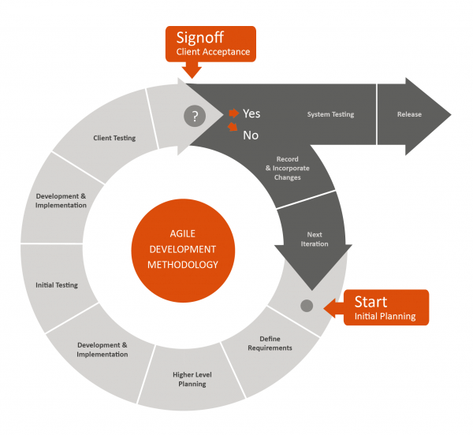

For more information, please refer to the website:

http://blogs.globalteckz.com/characteristics-of-agile-methodology-in-software-development/

1. **Roles and Responsibilities**

|  |  |  |
| --- | --- | --- |
| **Full name** | **Roles** | **Responsibilities** |
| Nguyễn Đức Khoan | Project Manager | * Give user requirements * Control developing process * Support |
| Lê Phước Việt | Team Leader | * Manage members and tasks * Designer * Developer * Tester |
| Nguyễn Xuân Sơn | Team Member | * Designer * Developer * Tester |
| Vũ Nhật Anh Khoa | Team Member | * Designer * Developer * Tester |
| Dương Thị Hoàng Anh | Team Member | * Designer * Developer * Tester |

1. **Tools and Techniques**
2. **Back-end**

* HTML 5
* CSS 3
* Javascript
* Jquery
* Ajax

1. **Front-end**

* ASP.NET MVC 4
* Linq
* Android toolkit
* Microsoft IIS 7
* Microsoft SQL 2008 Express SP 2

1. **Project Management Plan**
2. **Convention Rules**

Using C# coding convention at page:

http://msdn.microsoft.com/en-us/library/vstudio/ff926074.aspx