|  |  |  |  |  |  |
| --- | --- | --- | --- | --- | --- |
| |  |  |  | | --- | --- | --- | | **C:\Users\sonnx0907\Desktop\Untitled.png** | **MINISTRY OF EDUCATION AND RAINING** | | | **FPT UNIVERSITY** | | |
| Capstone Project Document |
| Hospital Finder |
| |  |  |  |  |  |  |  |  |  |  |  | | --- | --- | --- | --- | --- | --- | --- | --- | --- | --- | --- | | |  |  | | --- | --- | | **Group 11** | | | **Group Members** | Lê Phước Việt – Team Leader – SE60706  Nguyễn Xuân Sơn – Team Member – SE60727  Vũ Nhật Anh Khoa – Team Member – SE60817  Dương Thị Hoàng Anh – Team Member – 60434 | | **Supervisor** | Nguyễn Đức Khoan | | **Ext Supervisor** | N/A | | **Capstone Project code** | HospitalF | | |
| - Ho Chi Minh City, May / 2014 - |

**Table of Contents**

**3.1** **User Requirement Specification** 4

**3.1.1** **Guest requirement** 4

**3.1.2** **Normal User requirement** 4

**3.1.3** **Hospital User requirement** 4

**3.1.4** **Administrator requirement** 5

**3.2** **System Requirement Specification** 5

**3.2.1** **External Interface Requirements** 5

**3.2.1.1** **User Interfaces** 5

**3.2.1.2** **Software Interfaces** 5

**3.2.1.3** **Communication Protocol** 5

**3.2.2** **Function Requirements** 5

**3.2.2.1** **System Overview** 6

**3.2.2.2** **Use case List** 6

**3.2.2.2.1** **<GU> Overview Use Case** 6

**3.2.2.2.2** **<GU> Login** 7

**3.2.2.2.3** **<GU> Search Hospital <US>** 7

**3.2.2.2.4** **<GU> View Hospital Information <US>** 7

**3.2.2.2.5** **<GU> Search Doctor <US>** 7

**3.2.2.2.6** **<GU> Create Appointment Online <US>** 7

**3.2.2.2.7** **<GU> Cancel Appointment Online <US>** 7

**3.2.2.2.8** **<US> Overview Use Case** 7

**3.2.2.2.9** **<US> Search Hospital <GU>** 8

**3.2.2.2.10** **<US> View Hospital Information <GU>** 8

**3.2.2.2.11** **<US> Search Doctor <GU>** 8

**3.2.2.2.12** **<US> Make Appointment Online <GU>** 8

**3.2.2.2.13** **<US> Feedback** 8

**3.2.2.2.14** **<US> Comment** 8

**3.2.2.2.15** **<US> Reply Comment** 8

**3.2.2.2.16** **<US> Rating Hospital** 9

**3.2.2.2.17** **<US> Logout** 9

**3.2.2.2.18** **<HU> Overview Use Case** 9

**3.2.2.2.19** **<HU> Add New Doctor** 9

**3.2.2.2.20** **<HU> Search List of Doctors** 12

**3.2.2.2.21** **<HU> Update Doctor Information** 14

**3.2.2.2.22** **<HU> Upload Photo** 16

**3.2.2.2.23** **<HU> Update Hospital Information** 18

**3.2.2.2.24** **<HU> View List of Appointments** 21

**3.2.2.2.25** **<HU> View Hospital Statistics** 21

**3.2.2.2.26** **<HU> Change Password** 21

**3.2.2.2.27** **<HU> Reclaim Forgotten Password** 21

**3.2.2.2.28** **<AD> Overview Use Case** 21

**3.2.2.2.29** **<AD> View List of Feedbacks** 22

**3.2.2.2.30** **<AD> View List of Users** 22

**3.2.2.2.31** **<AD> Activate User** 22

**3.2.2.2.32** **<AD> De-active User** 24

**3.2.2.2.33** **<AD> View System Statistics** 25

**3.2.2.2.34** **<AD> Import Hospital Using Excel** 25

**3.2.2.2.35** **<AD> Create Hospital** 25

**3.2.2.2.36** **<AD> Create Hospital User’s Account** 25

**3.2.2.2.37** **<AD> Upload Photo** 28

**3.2.2.2.38** **<AD> Search List of Hospitals** 28

**3.2.2.2.39** **<AD> Update Hospital Information** 28

**3.2.3** **Non-Functional Requirements** 28

**3.2.3.1** **Reliability** 28

**3.2.3.2** **Availability** 28

**3.2.3.3** **Security** 28

**3.2.3.4** **Maintainability** 29

**3.2.3.5** **Portability** 29

**3.2.3.6** **Performance** 29

**3.3** **Entity Relationship Diagram** 30

**Report No.3: System Requirement Specification (SRS)**

1. **User Requirement Specification**
   1. **Guest requirement**

Guests are the people who can use the system without any authentications process. They are supported with the following functions below:

* Search hospitals and clinics base on:
  + - Patients’ conditions.
    - Centers with high rating base on patients’ conditions.
    - Centers in a specific area in Vietnam.
    - Centers around current location or at a specific location address.
    - Centers that locate at a specific distance reference to current location.
* They can also view information, comment or rating about a specific hospital or clinic.
* Make appointment online.
* Feedback about information of the system.
  1. **Normal User requirement**

Normal Users are the people who use the system with their specific authenticated Facebook accounts. They have the right to use all the functions that supported for Guests (except Login), and the following functions below:

* Rating hospitals or clinics.
* Comment or reply comments about any hospitals or clinics.
  1. **Hospital User requirement**

Hospital Users are the people who have special accounts to manage information of a specific hospitals or clinic. They are supported with the following functions below:

* Update account information
* Manage information about their hospitals or clinics.
* View users’ feedback about their hospitals or clinics.
* Add doctor
* View statistics about their business.
* Number of appointments in a month.
* Number of appointments throughout a year.
  1. **Administrator requirement**

Administrators are the people who have the highest priorities in the system. They are supported with the following functions below:

* Create hospital users’ accounts.
* Manage normal and hospital users.
* View users’ feedback.
* Manage and import list of hospitals or clinics.
* View statistics about the system:
* Number of visitors monthly
* Number of visitors throughout a year
* Number of new hospital users monthly

1. **System Requirement Specification**
2. **External Interface Requirements**
3. **User Interfaces**

User interface of the website must be clear and easy to use.

Mobile interface must be compatible with multiple sizes of smart phone and tablet screens.

Error messages must be highlight, easy to see and understand, and do not contain disturb or abused words or grammars.

1. **Software Interfaces**

Web browser: Google Chrome and Fire Fox

Support Java Script and HTML5

1. **Communication Protocol**

HTTP Protocol will be used to communicate between web browsers, Android devices and web server.

1. **Function Requirements**
2. **System Overview**

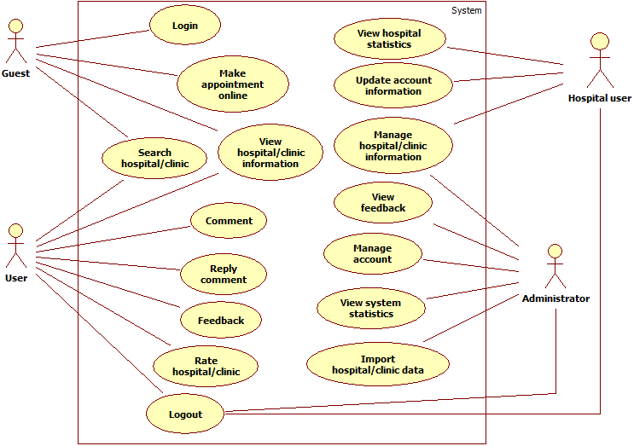

1. **Use case List**
   * 1. **<GU> Overview Use Case**

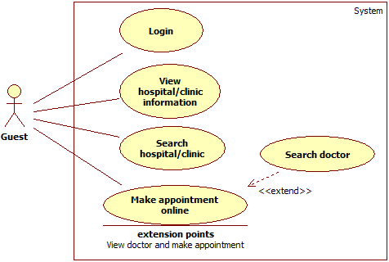

* + 1. **<GU> Login**
    2. **<GU> Search Hospital <US>**
    3. **<GU> View Hospital Information <US>**
    4. **<GU> Search Doctor <US>**
    5. **<GU> Create Appointment Online <US>**
    6. **<GU> Cancel Appointment Online <US>**
    7. **<US> Overview Use Case**

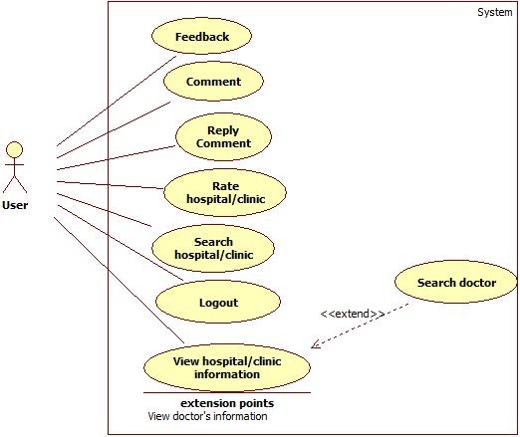

* + 1. **<US> Search Hospital <GU>**
    2. **<US> View Hospital Information <GU>**
    3. **<US> Search Doctor <GU>**
    4. **<US> Make Appointment Online <GU>**
    5. **<US> Feedback**
    6. **<US> Comment**
    7. **<US> Reply Comment**
    8. **<US> Rating Hospital**
    9. **<US> Logout**
    10. **<HU> Overview Use Case**

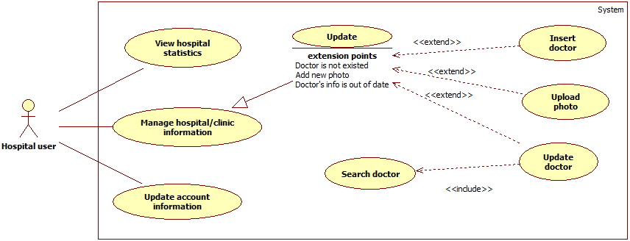

* + 1. **<HU> Add New Doctor**

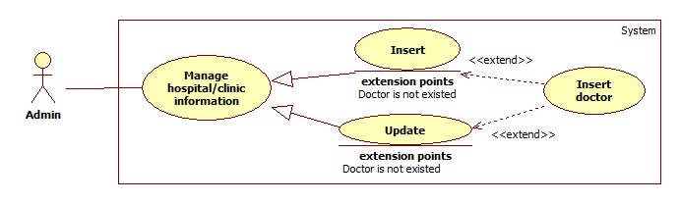

|  |  |  |  |  |
| --- | --- | --- | --- | --- |
| **USE CASE – US018** | | | | |
| **Use-case No.** | US018 | **Use-case Version** | | 1.0 |
| **Use-case Name** | Add new doctor | | | |
| **Author** | Duong Thi Hoang Anh | | | |
| **Date** | 29/05/2014 | **Priority** | Normal | |
| **Actor:** Hospital user.  **Summary:** This case allows Hospital user to add new doctors.  **Goal:** New doctors will be added to the list of doctors in a specific hospital or clinic.  **Triggers:** Click “**Thêm bác sĩ**” link in “**Danh sách bác sĩ**” page.  **Preconditions:** User must meet the requirements of use case **UC001** (Login) as the role of Hospital user.  **Post Conditions:**   * **Successful**: New doctors will be created. * **Failed**: Doctor will not be added to list and an error message will be displayed.   **Main Success Scenario:**   |  |  |  | | --- | --- | --- | | **Step** | **Action** | **System response** | | 1 | Click “**Thêm bác sĩ**” link in “**Danh sách bác sĩ**” page | Transfer to “**Tạo mới bác sĩ**” page that includes:   * Thông tin cơ bản: Active tab * Họ: Textbox (Required, max length: 16) * Tên: Textbox (Required, max length: 16) * Email: Textbox (Required, regular expression: @"^([a-zA-Z0-9_\-\.]+)@((\[[0-9]{1,3}\.[0-9]{1,3}\.[0-9]{1,3}\.)|(([a-zA-Z0-9\-]+\.)+))([a-zA-Z]{2,4}|[0-9]{1,3})(\]?)$") * Chuyên khoa: Drop down list (Required) * Thêm chuyên khoa: Link to add new speciality. * Chứng chỉ / Bằng cấp: Textbox (Required) * Kinh nghiệm: Text area. * Hình ảnh: text file (regular expression: “^([0-9a-zA-Z_\-~:\\])+ (.jpg|.JPG|.jpeg|.JPEG|.bmp|.BMP| * .gif|.GIF|.png|.PNG)$”) * Tiếp tục: Button * Lịch làm việc: De-active tab | | 2 | Enter required information in “**Thông tin cơ bản**” tab, then click “**Tiếp tục**” button | Transfer to “Lịch làm việc” page that includes:   * Ngày trong tuần: from Monday to Sunday: Check (Required) * Thời gian làm việc:   + From: drop down list   + To: drop down list * Tạo mới: Button | | 3 | Choose work schedule for doctor then click on “**Tạo mới**” button | New doctor will be created. A notification appears and display a message: “Bác sĩ được tạo thành công.” |   **Alternative Scenario: N/A**  **Exceptions:**   |  |  |  | | --- | --- | --- | | **Step** | **Case** | **System response** | | 1 | “Họ” is blank | Display: “Xin hãy nhập Họ.” | | 2 | “Họ”’s length is over 16 characters | Display: “Họ không thể vượt quá 16 ký tự.” | | 3 | “Tên” is blank | Display: “Xin hãy nhập Tên.” | | 4 | “Tên”‘s length is over 16 characters. | Display: “Tên không thể vượt quá 16 ký tự.” | | 5 | Email is blank | Display: “Xin hãy nhập Email.” | | 6 | Email expression is invalid | Display: “Địa chỉ Email không hợp lệ.” | | 7 | Email address is duplicated with an existed one in database | Display: “Địa chỉ Email này đã được sử dụng.” | | 8 | “Chuyên khoa” is blank | Display: “Xin hãy chọn Chuyên Khoa.” | | 9 | “Chứng chỉ/Bằng cấp” is blank | Display: “Xin hãy nhập Chứng chỉ / Bằng cấp.” | | 10 | Image file is wrong format | Display: “Tập tin hình ảnh không đúng định dạng.” | | 11 | System failure | Display: “Đã có lỗi xảy ra trong quá trình xử lý thông tin. Mong quý vị thông cảm và thử lại sau vài phút.” |   **Relationships**: N/A  **Business Rules:** Only the Hospital user who manage the hospital or clinic can have the right to add doctors to his / her center. | | | | |

* + 1. **<HU> Search List of Doctors**

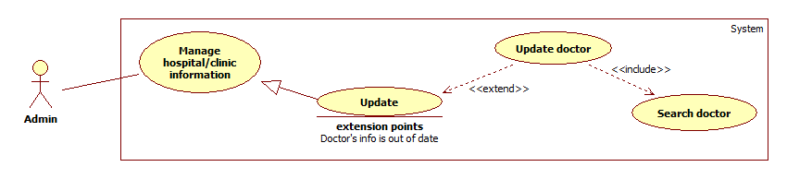

|  |  |  |  |  |
| --- | --- | --- | --- | --- |
| **USE CASE – US019** | | | | |
| **Use-case No.** | US019 | **Use-case Version** | | 1.0 |
| **Use-case Name** | Search list of doctors | | | |
| **Author** | Duong Thi Hoang Anh | | | |
| **Date** | 29/05/2014 | **Priority** | Normal | |
| **Actor:** Hospital user.  **Summary:** This case allows Hospital user to search and view doctors’ information of his / her hospital or clinic.  **Goal:** Display information of doctors.  **Triggers:** Click “**Tìm**” button after filling searched textbox the name of a doctor, or choose a specific speciality in speciality drop down list.  **Preconditions:** User must be in “**Danh sách bác sĩ**” page.  **Post Conditions:**   * **Successful**: Display a list doctors according to his / her name or speciality. * **Failed**: An error message will be displayed.   **Main Success Scenario:**   |  |  |  | | --- | --- | --- | | **Step** | **Action** | **System response** | | 1 | Enter the name of doctor in searched text box then click “**Tìm**” button | Display a table that contains a list of doctors with the following columns:   * Hình ảnh * Họ tên * Email * Chuyên khoa * Chứng chỉ / Bằng cấp * Kinh nghiệm * Lịch làm việc * Trạng thái | | 2 | Click “Họ tên” of a specific doctor. | Transfer to “Thông tin bác sĩ” page that includes:   * Thông tin cơ bản:   + Họ tên   + Email   + Chuyên khoa   + Chứng chỉ/Bằng cấp   + Kinh nghiệm   + Hình ảnh   + Chỉnh sửa: image refers to basic information update form. * Lịch làm việc:   + Ngày   + Thời gian   + Chỉnh sửa: Image refers to work schedule update form. |   **Alternative Scenario:**   |  |  |  | | --- | --- | --- | | **Step** | **Action** | **System response** | | 1 | Choose a specific speciality in drop down list then clicks “**Tìm**” button | Display list of all doctors that good at the chosen speciality. |   **Exceptions:**   |  |  |  | | --- | --- | --- | | **Step** | **Case** | **System response** | | 1 | No result are found | Display: “Không có kết quả phù hợp..” | | 2 | Enter nothing in searched text box and chooses nothing in speciality drop down list, and then click “**Tìm**” button | Display: “Xin hãy nhập tên bác sĩ hoặc chọn một chuyên khoa.” | | 3 | System failure | Display: ” Đã có lỗi xảy ra trong quá trình xử lý thông tin. Mong quý vị thông cảm và thử lại sau vài phút.” |   **Relationships**: N/A  **Business Rules:** The list will can be filtered by ascending or descending values in a column. | | | | |

* + 1. **<HU> Update Doctor Information**

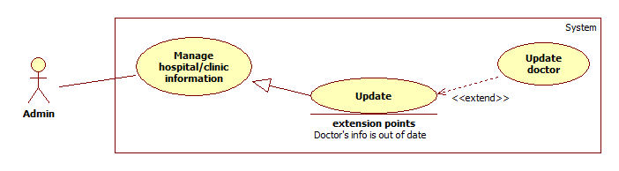

|  |  |  |  |  |
| --- | --- | --- | --- | --- |
| **USE CASE – US020** | | | | |
| **Use-case No.** | US020 | **Use-case Version** | | 1.0 |
| **Use-case Name** | Update doctor’s information | | | |
| **Author** | Duong Thi Hoang Anh | | | |
| **Date** | 29/05/2014 | **Priority** | Normal | |
| **Actor:** Hospital user.  **Summary:** This case allows Hospital user to update doctors’ information.  **Goal:** New information will be updated.  **Triggers:** Click “Chỉnh sửa” icon at each doctor’s information part in “Thông tin bác sĩ”  **Preconditions:** User must meet the requirements of use case **UC001** (Login) as the role of Hospital user.  **Post Conditions:**   * **Successful**: Selected doctor will be updated new information. * **Failed**: Doctor will not be updated. Error message is displayed.   **Main Success Scenario:**   |  |  |  | | --- | --- | --- | | **Step** | **Action** | **System response** | | 1 | Search the doctor and then click on his / her name | Transfer to “Thông tin bác sĩ” page that includes:   * Thông tin cơ bản: * Họ tên * Email * Chuyên khoa * Chứng chỉ/Bằng cấp * Kinh nghiệm * Hình ảnh * Chỉnh sửa: image refers to basic information update form. * Lịch làm việc: * Ngày * Thời gian * Chỉnh sửa: image refers to work schedule update form. | | 2 | User clicks on “Chỉnh sửa” image in “Thông tin cơ bản”. | Display “Cập nhật thông tin cơ bản” form that includes:   * Họ tên: Textbox (Read only) * Email: Textbox (Read only) * Chuyên khoa: Textbox (Read only) * Thêm chuyên khoa: Link to add new speciality. * Chứng chỉ / Bằng cấp: Textbox * Kinh nghiệm: Text area. * Hình ảnh: Input file (regular expression: “^([0-9a-zA-Z_\-~ :\\])+(.jpg|.JPG|.jpeg|.JPEG|   .bmp|.BMP|.gif|.GIF|png|.PNG)$”)   * Cập nhật: Button. * Hủy: Button | | 3 | Update information then Click “**Cập nhật**” button. | “Cập nhật thông tin cơ bản” form disappears and a notification appears and displays a message: “Cập nhật thông tin thành công.” | | 4 | Click “**Chỉnh sửa**” image in “**Lịch làm việc**” | Display “Cập nhật lịch làm việc” form include:   * Ngày trong tuần: from Monday to Sunday: checkbox * Thời gian làm việc:   + From: Drop down list   + To: Drop down list * Cập nhật: button * Hủy: button | | 5 | Update work schedule and then click “**Cập nhật**” button | “Cập nhật lịch làm việc” form disappear and a notification appears and displays a message: “Cập nhật lịch làm việc thành công.” |   **Alternative Scenario:**   |  |  |  | | --- | --- | --- | | **Step** | **Action** | **System response** | | 1 | User clicks on “**Hủy**” button in “**Cập nhật thông tin cơ bản**” to cancel. | No information is updated. “Cập nhật thông tin cơ bản” will disappear. System will return “Thông tin bác sĩ” page. | | 2 | User clicks on “**Hủy**” button in **“Cập nhật lịch làm việc**” to cancel. | No information is updated. “Cập nhật lịch làm việc” will disappear. System will return “Thông tin bác sĩ” page. |   **Exceptions:**   |  |  |  | | --- | --- | --- | | **Step** | **Case** | **System response** | | 1 | Image file is wrong format | Display: “Tập tin hình ảnh không đúng định dạng” |   **Relationships**: N/A  **Business Rules:** Only the Hospital user who manage the hospital or clinic can have the right to update doctors’ information from his / her center. | | | | |

* + 1. **<HU> Upload Photo**

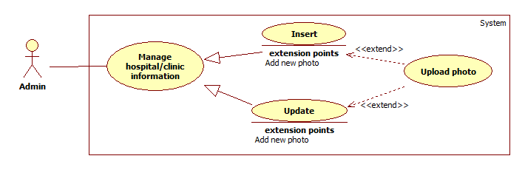

|  |  |  |  |  |
| --- | --- | --- | --- | --- |
| **USE CASE – UC021** | | | | |
| **Use-case No.** | UC021 | **Use-case Version** | | 1.0 |
| **Use-case Name** | Upload photo | | | |
| **Author** | Duong Thi Hoang Anh | | | |
| **Date** | 29/05/2014 | **Priority** | Normal | |
| **Actor:**   * Hospital users. * Administrators.   **Summary:** This case allows users to upload new photos for hospital or doctor.  **Goal:** Update new photos for hospital or doctor.  **Triggers:** Click “**Thêm hình ảnh**” button in “**Thư viện ảnh**” tab  **Preconditions:** Users are staying at “**Thông tin bệnh viện / phòng khám**” page  **Post Conditions:**   * **Successful**: New photos will be uploaded. * **Failed**: Error message will be displayed.   **Main Success Scenario:**   |  |  |  | | --- | --- | --- | | **Step** | **Action** | **System response** | | 1 | Click on tab “**Thư viện ảnh**” in “**Thông tin bệnh viện/phòng khám**” page. | Direct to “Thư viện ảnh” page which include:   * Thêm hình ảnh: button * List all of photos with “Xóa” icon on each photo. | | 2 | Click “**Thêm hình ảnh**” button | Display drop zone screen to upload photo. | | 3 | Click the drop zone | Display file explorer screen to choose image file. | | 4 | Choose photos to upload, then clicks on “**Open**” button | Display all selected photo with “Xóa” button below each photo. (Regular expression: “^([0-9a-zA-Z_\-~ :\\])+(.jpg|.JPG|.jpeg|.JPEG|.bmp|.BMP| .gif|.GIF|.png|.PNG)$”)) | | 5 | Click “**Tải lên**” button | All uploaded photos display in “Thư viện ảnh” |   **Alternative Scenario:**   |  |  |  | | --- | --- | --- | | **Step** | **Action** | **System response** | | 1 | User can drag image files from file explorer and drop into the drop zone to upload files. | Display all selected photo with “Xóa” button below each photo. |   **Exceptions:**   |  |  |  | | --- | --- | --- | | **Step** | **Case** | **System response** | | 1 | Image file is wrong format | Display: “Tập tin hình ảnh không đúng định dạng” |   **Relationships**: N/A  **Business Rules:**  Only file with format .jpg, .JPG, .jpeg, .JPEG, .bmp, .BMP, .gif, .GIF, .png, .PNG are allow to be uploaded. | | | | |

* + 1. **<HU> Update Hospital Information**

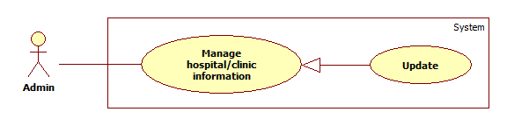

|  |  |  |  |  |
| --- | --- | --- | --- | --- |
| **USE CASE – US022** | | | | |
| **Use-case No.** | US022 | **Use-case Version** | | 1.0 |
| **Use-case Name** | Update hospital information | | | |
| **Author** | Duong Thi Hoang Anh | | | |
| **Date** | 29/05/2014 | **Priority** | High | |
| **Actor:**   * Administrator * Hospital user   **Summary:** Users use this case to update information of a specific hospital or clinic.  **Goal:** Update information of a specific hospital or clinic.  **Triggers:** Admin want to change some information of hospital or clinic.  **Preconditions:** Users must login with the role of Administrators or Hospital users.  **Post Conditions:**   * **Successful**: Information of a specific hospital or clinic will be updated. * **Failed**: An error message will be displayed.   **Main Success Scenario:**   |  |  |  | | --- | --- | --- | | **Step** | **Action** | **System response** | | 1 | Click “**Bệnh viện / phòng khám**” sub item in “**Quản lý bệnh viện/phòng khám**” item on the left menu | Transfer to “Danh sách bệnh viện/phòng khám” page that includes:   * Tên bệnh viện / phòng khám: Textbox * Tìm: Button | | 2 | Enter name of hospital or clinic then click “**Tìm**” button | Display a list of hospitals or clinics that have similar name with input value. | | 3 | Choose a name of a hospital or clinic | Transfer to “Thông tin bệnh viện/phòng khám” page that includes:   * Giới thiệu chung: Tab   + Tên bệnh viện   + Website   + Loại hình dịch vụ   + Địa chỉ   + Số điện thoại   + Fax   + Chỉnh sửa: image refers to basic information update form * Chuyên khoa: Tab   + List of speciality   + Chỉnh sửa: image refer to speciality update form * Danh sách bác sĩ: tab   + Tên bác sĩ: textbox   + Chọn chuyên khoa: drop down list   + Tìm: button   + Thêm bác sĩ: link refers to “Tạo mới bác sĩ” page to insert new doctor to system. * Lịch khám bệnh: tab   + Work schedule of hospital/center   + Chỉnh sửa: image refers to work schedule update form. * Danh sách cuộc hẹn:   + List of all appointment * Cơ sở vật chất: * Dịch vụ đi kèm: * Thư viện ảnh:   + Thêm hình ảnh: Button   + List all of photos with “Xóa” icon on each photo | | 4 | Click “**Chỉnh sửa**” image, and enter new information then click “**Cập nhật”** button | New information will be updated. A notification appears and displays a message: “Cập nhật thông tin thành công.” |   **Alternative Scenario:**   |  |  |  | | --- | --- | --- | | **Step** | **Action** | **System response** | | 1 | Admin clicks on “**Hủy**” button to cancel | No information is updated. Update form disappear. System will return current tab. |   **Exceptions:** N/A  **Relationships**: N/A  **Business Rules:**  Administrator must search hospital or clinic to update information.  Hospital user can update his / her hospital or clinic’s information without searching process. | | | | |

* + 1. **<HU> View List of Appointments**
    2. **<HU> View Hospital Statistics**
    3. **<HU> Change Password**

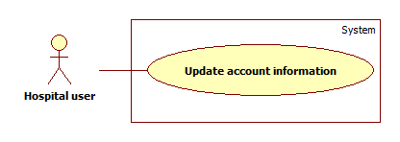

* + 1. **<HU> Reclaim Forgotten Password**



* + 1. **<AD> Overview Use Case**

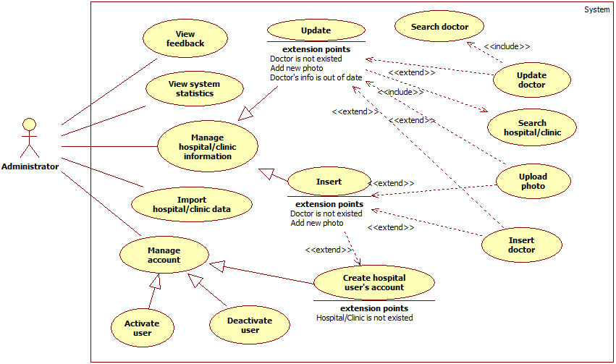

* + 1. **<AD> View List of Feedbacks**
    2. **<AD> View List of Users**
    3. **<AD> Activate User**

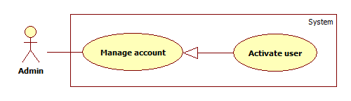

|  |  |  |  |  |
| --- | --- | --- | --- | --- |
| **USE CASE – US027** | | | | |
| **Use-case No.** | US027 | **Use-case Version** | | 1.0 |
| **Use-case Name** | Activate user | | | |
| **Author** | Duong Thi Hoang Anh | | | |
| **Date** | 29/05/2014 | **Priority** | Normal | |
| **Actor:** Administrators  **Summary:** Administrators use this case to activate users’ accounts.  **Goal:** Deactivated account will be activated again.  **Triggers:** Click the “**Kích hoạt**” link of column “**Trạng thái**” of an account.  **Preconditions:** Admin must meet the requirements of use case **UC001** (Login) as the role Administrator.  **Post Conditions:**   * **Successful**: Selected account will be activated. * **Failed**: An error message will be displayed.   **Main Success Scenario:**   |  |  |  | | --- | --- | --- | | **Step** | **Action** | **System response** | | 1 | Click the item “**Quản lý tài khoản**” on the left menu | Transfer to “Quản lý tài khoản” page that includes:   * A table with 5 columns:   + STT (Số thứ tự)   + Email: Link refer to “Thông tin người dùng” page.   + Loại người dùng   + Trạng thái: Contains the link “Kích hoạt / Dừng truy cập”   + Ngày đăng kí | | 2 | Click the “**Kích hoạt**” link of “**Trạng thái**” column of an account. | Account will be activated. |   **Alternative Scenario:** N/A  **Exceptions:**   |  |  |  | | --- | --- | --- | | **Step** | **Case** | **System response** | | 1 | System failure | Display “Đã có lỗi xảy ra trong quá trình xử lý thông tin. Mong quý vị thông cảm và thử lại sau vài phút.” |   **Relationships**: N/A  **Business Rules:**  Administrators cannot activate themselves or another administrators. | | | | |

* + 1. **<AD> De-active User**

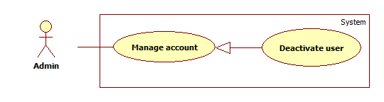

|  |  |  |  |  |
| --- | --- | --- | --- | --- |
| **USE CASE – US028** | | | | |
| **Use-case No.** | US028 | **Use-case Version** | | 1.0 |
| **Use-case Name** | De-activate user | | | |
| **Author** | Duong Thi Hoang Anh | | | |
| **Date** | 29/05/2014 | **Priority** | Normal | |
| **Actor:** Administrators  **Summary:** Administrators use this case to de-activate users’ accounts.  **Goal:** An account will not be accessed to the system as the role of User or Hospital user anymore.  **Triggers:** Click the “**Dừng truy cập**” link of column “**Trạng thái**” of an account.  **Preconditions:** Admin must meet the requirements of use case **UC001** (Login) as the role administrator.  **Post Conditions:**   * **Successful:** Selected account will be de-activated. * **Failed:** An error message will be displayed.   **Main Success Scenario:**   |  |  |  | | --- | --- | --- | | **Step** | **Action** | **System response** | | 1 | Click the item “**Quản lý tài khoản**” on the left menu | Transfer to “Quản lý tài khoản” page that includes:   * A table with 5 columns:   + STT (Số thứ tự)   + Email: Link refer to “Thông tin người dùng” page.   + Loại người dùng   + Trạng thái: Contains the link “Kích hoạt / Dừng truy cập”   + Ngày đăng kí | | 2 | Click the “**Dừng truy cập**” link of “**Trạng thái**” column of an account. | Account will be activated. |   **Alternative Scenario:** N/A  **Exceptions:**   |  |  |  | | --- | --- | --- | | **Step** | **Case** | **System response** | | 1 | System failure | Display “Đã có lỗi xảy ra trong quá trình xử lý thông tin. Mong quý vị thông cảm và thử lại sau vài phút.” |   **Relationships**: N/A  **Business Rules:**  Administrators cannot de-active themselves or another administrators. | | | | |

* + 1. **<AD> View System Statistics**
    2. **<AD> Import Hospital Using Excel**
    3. **<AD> Create Hospital**
    4. **<AD> Create Hospital User’s Account**

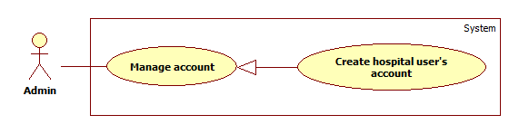

|  |  |  |  |  |
| --- | --- | --- | --- | --- |
| **USE CASE – UC032** | | | | |
| **Use-case No.** | UC032 | **Use-case Version** | | 1.0 |
| **Use-case Name** | Create hospital user’s account | | | |
| **Author** | Duong Thi Hoang Anh | | | |
| **Date** | 27/05/2014 | **Priority** | High | |
| **Actor:** Administrator  **Summary:** Administrators use this case to create accounts for hospital users.  **Goal:** Create account for hospital users.  **Triggers:** Click on “**Tạo tài khoản**” item on drop down menu “**Quản lý bệnh viện / phòng khám**”.  **Preconditions:** Administrators must meet the requirements of use case **UC001** (Login).  **Post Conditions:**   * **Successful**: New hospital account will be created. * **Failed**: An error message will be displayed.   **Main Success Scenario:**   |  |  |  | | --- | --- | --- | | **Step** | **Action** | **System response** | | 1 | Click on “**Tạo tài khoản**” option on “**Quản lý bệnh viện / phòng khám**” drop down list. | Display “Tạo tài khoản” page that includes:   * “Chọn bệnh viện / phòng khám”: Active tab that contains:   + A drop down list contains all hospitals and clinics of system.   + “Nếu bệnh viện / phòng khám chưa sẵn có hãy đăng ký tại đây”: Label. With “Tại đây” is a link that refers to page “Đăng ký bệnh viện / Phòng khám”.   + “Tiếp tục”: Button * “Thông tin tài khoản”: De-active tab. | | 2 | Choose a hospital / clinic in drop down list to assign for new hospital use and then and click “**Tiếp tục**” button. | “Thông tin tài khoản” tab change from de-active to active and display account creation form which include:   * Email: Textbox (required, regular expression: @"^([a-zA-Z0-9_\-\.]+)@((\[[0-9]{1,3}\.[0-9]{1,3}\.[0-9]{1,3}\.)|(([a-zA-Z0-9\-]+\.)+))([a-zA-Z]{2,4}|[0-9]{1,3})(\]?)$") * Họ: Textbox (Required, max length: 16) * Tên: Textbox (Required, max length: 16) * Số điện thoại: Textbox (Required) * Tạo mới: Button | | 3 | Enter required information, and then click “**Tạo mới**” button. | New hospital account will be created. The system then display a message: “Tài khoản đăng ký thành công. Vui lòng kiểm tra email để kích hoạt tài khoản.” |   **Alternative Scenario:**   |  |  |  | | --- | --- | --- | | **Step** | **Action** | **System response** | | 1 | Click on “**tại đây**” link in “**Nếu bệnh viện / phòng khám chưa sẵn có hãy đăng ký tại đây**” label in case hospital or clinic does not contain in the hospital list. | Redirect to “Đăng ký bệnh viện / phòng khám” page.  For more detail description please refer to use case US0031 (Create hospital) |   **Exceptions:**   |  |  |  | | --- | --- | --- | | **No** | **Case** | **System response** | | 1 | Email is blank | Display: “Xin hãy nhập Email.” | | 2 | Email expression is invalid. | Display: “Địa chỉ Email không hợp lệ.” | | 3 | Email’s existed already. | Display: “Địa chỉ Email này đã được sử dụng.” | | 4 | “Họ” is blank | Display: “Xin hãy nhập Họ.” | | 5 | “Họ”’s length is over 16 characters. | Display: “Họ không thể vượt quá 16 ký tự.” | | 6 | “Tên” is blank | Display: “Xin hãy nhập Tên.” | | 7 | “Tên”‘s length is over 16 characters. | Display: “Tên không thể vượt quá 16 ký tự.” | | 8 | “Số điện thoại” is blank | Display: “Xin hãy nhập Số Điện Thoại.” | | 9 | “Số điện thoại” expression is invalid. | Display: “Số ĐiệnThoại không hợp lệ.” | | 10 | System failure | Display: “Đã có lỗi xảy ra trong quá trình xử lý thông tin. Mong quý vị thông cảm và thử lại sau vài phút.” |   **Relationships**: N/A  **Business Rules:**  Password for hospital account will be created randomly and automatically, and will be sent to user through his / her email.  One hospital user’s account must be assigned with a specific hospital or clinic. If that hospital or clinic does not contain in database, administrator must create a new hospital base on provided information from user. | | | | |

* + 1. **<AD> Upload Photo**

Please refer to use case US021

* + 1. **<AD> Search List of Hospitals**
    2. **<AD> Update Hospital Information**

Please refer to use case US022

1. **Non-Functional Requirements**
2. **Reliability**

Locations and information of hospitals and clinics must be precise as it be in reality.

1. **Availability**

Services of the system must be provided 24/24.

1. **Security**

Information of users must be kept secretly.

Each type of user has a specific priorities in the system.

Always check for authorization before executing any business.

1. **Maintainability**

Code for Controller, Model, and View must be divided clearly.

Complicated query must be written in Structure Query Language (SQL).

All constant values and error messages

1. **Portability**

N/A

1. **Performance**

Search process must be done in less than 5 seconds with network and hardware conditions are equal or better than development environments.

Words and sentences suggestion must be showed in less than 3 seconds right after users input search query.

1. **Entity Relationship Diagram**

