|  |  |  |  |  |  |
| --- | --- | --- | --- | --- | --- |
| |  |  |  | | --- | --- | --- | | **C:\Users\sonnx0907\Desktop\Untitled.png** | **MINISTRY OF EDUCATION AND RAINING** | | | **FPT UNIVERSITY** | | |
| Capstone Project Document |
| Hospital Finder |
| |  |  |  |  |  |  |  |  |  |  |  | | --- | --- | --- | --- | --- | --- | --- | --- | --- | --- | --- | | |  |  | | --- | --- | | **Group 11** | | | **Group Members** | Lê Phước Việt – Team Leader – SE60706  Nguyễn Xuân Sơn – Team Member – SE60727  Vũ Nhật Anh Khoa – Team Member – SE60817  Dương Thị Hoàng Anh – Team Member – 60434 | | **Supervisor** | Nguyễn Đức Khoan | | **Ext Supervisor** | N/A | | **Capstone Project code** | HospitalF | | |
| - Ho Chi Minh City, May / 2014 - |

**Table of Contents**

**4.1** **Design Overview** 5

**4.2** **System Architecture Design** 5

**4.3** **Component Diagram** 5

**4.4** **Detailed Description of Components** 5

**4.4.1** **Class Diagram** 5

**4.4.2** **Class Diagram Explanation** 5

**4.4.2.1** **User** 5

**4.4.2.2** **Hospital** 5

**4.4.2.3** **HospitalType** 5

**4.4.2.4** **Doctor** 5

**4.4.2.5** **DoctorSpeciality** 5

**4.4.2.6** **DoctorHospital** 5

**4.4.2.7** **Appointment** 5

**4.4.2.8** **Role** 5

**4.4.2.9** **Rating** 5

**4.4.2.10** **Feedback** 5

**4.4.2.11** **FeedbackType** 5

**4.4.2.12** **Facility** 5

**4.4.2.13** **HospitalFacility** 5

**4.4.2.14** **Service** 6

**4.4.2.15** **HospitalService** 6

**4.4.2.16** **Photo** 6

**4.4.2.17** **Ward** 6

**4.4.2.18** **District** 6

**4.4.2.19** **City** 6

**4.4.2.20** **Speciality** 6

**4.4.2.21** **HospitalSpeciality** 6

**4.4.2.22** **Disease** 6

**4.4.2.23** **SpecialityDisease** 6

**4.4.2.24** **WordDictionary** 6

**4.4.2.25** **WordHospital** 6

**4.4.2.26** **SentenceDictionary** 6

**4.4.2.27** **SentenceWord** 6

**4.5** **Sequence Diagram** 6

**4.5.1** **Search Hospital** 6

**4.5.2** **Import Hospital Using Excel** 6

**4.5.3** **Create Hospital** 7

**4.5.4** **View Hospital Information** 7

**4.5.5** **Update Hospital Information** 8

**4.5.6** **Create Appointment Online** 8

**4.5.7** **Confirm Appointment** 8

**4.5.8** **Comment** 9

**4.5.9** **View List of Appointments** 9

**4.5.10** **View Statistics** 10

**4.6** **User Interface Design** 10

**4.6.1** **Login** 10

**4.6.2** **Logout** 10

**4.6.3** **Change Password** 10

**4.6.4** **Reclaim Forgotten Password** 10

**4.6.5** **Search Hospital <GU> <US>** 10

**4.6.6** **Import Hospital Using Excel** 10

**4.6.7** **Create Hospital** 10

**4.6.8** **Create Hospital User’s Account** 10

**4.6.9** **View Hospital Information** 10

**4.6.10** **Search Doctor <GU> <US>** 10

**4.6.11** **Create Appointment Online** 10

**4.6.12** **Cancel Appointment** 10

**4.6.13** **Feedback** 10

**4.6.14** **Comment** 10

**4.6.15** **Reply Comment** 10

**4.6.16** **Rating Hosptial** 10

**4.6.17** **Add New Doctor** 11

**4.6.18** **Search List of Doctor <HU>** 11

**4.6.19** **Search List of Hospital <AD>** 11

**4.6.20** **Update Doctor Information** 11

**4.6.21** **Upload Photo** 11

**4.6.22** **Update Hospital Information** 11

**4.6.23** **View List of Appointments** 11

**4.6.24** **View List of Feedbacks** 11

**4.6.25** **View List of Users** 11

**4.6.26** **Activate Users** 11

**4.6.27** **Deactivate Users** 11

**4.6.28** **View Hospital Statistics** 11

**4.6.29** **View System Statistics** 11

**4.7** **Database Design** 11

**4.7.1** **User** 11

**4.7.2** **Hospital** 11

**4.7.3** **HospitalType** 11

**4.7.4** **Doctor** 11

**4.7.5** **Doctor_Speciality** 11

**4.7.6** **Doctor_Hospital** 11

**4.7.7** **Appointment** 11

**4.7.8** **Role** 11

**4.7.9** **Rating** 11

**4.7.10** **Feedback** 11

**4.7.11** **FeedbackType** 11

**4.7.12** **Facility** 11

**4.7.13** **Hospital_Facility** 11

**4.7.14** **Service** 11

**4.7.15** **Hospital_Service** 11

**4.7.16** **Photo** 11

**4.7.17** **Ward** 11

**4.7.18** **District** 12

**4.7.19** **City** 12

**4.7.20** **Speciality** 12

**4.7.21** **Hospital_Speciality** 12

**4.7.22** **Disease** 12

**4.7.23** **Speciality_Disease** 12

**4.7.24** **WordDictionary** 12

**4.7.25** **Word_Hospital** 12

**4.7.26** **SentenceDictionary** 12

**4.7.27** **Sentence_Word** 12

**4.8** **Algoritms** 12

**4.8.1** **Geographic Information Retrieval** 12

**4.8.2** **Boyer Moore Matching Algorithm** 12

**Report No.4: System Design Description (SDD)**

1. **Design Overview**
2. **System Architecture Design**

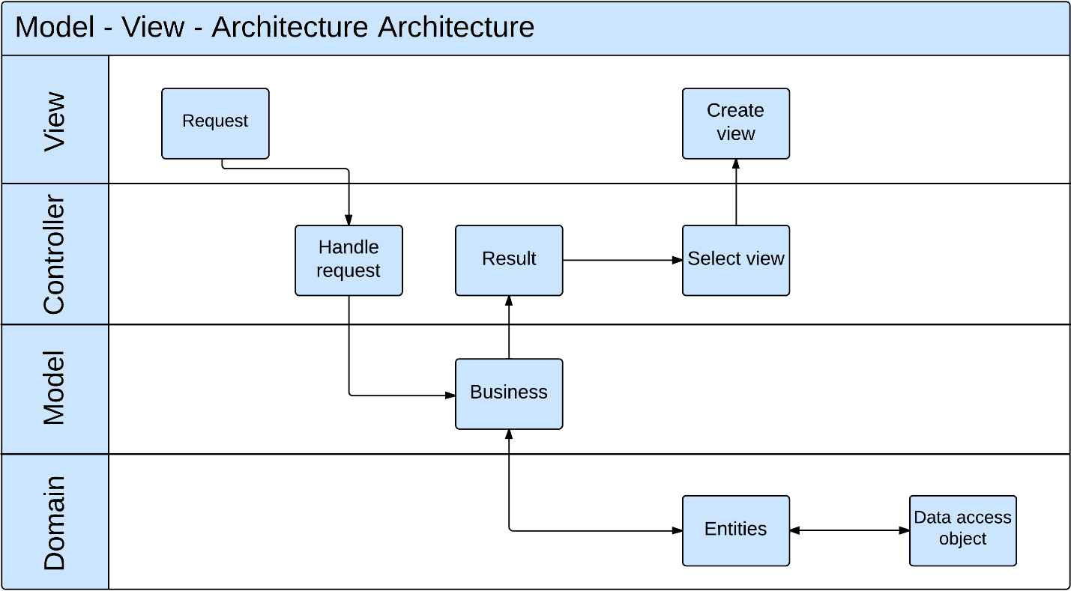

1. **Component Diagram**
2. **Detailed Description of Components**
3. **Class Diagram**
4. **Class Diagram Explanation**
5. **User**
6. **Hospital**
7. **HospitalType**
8. **Doctor**
9. **DoctorSpeciality**
10. **DoctorHospital**
11. **Appointment**
12. **Role**
13. **Rating**
14. **Feedback**
15. **FeedbackType**
16. **Facility**
17. **HospitalFacility**
18. **Service**
19. **HospitalService**
20. **Photo**
21. **Ward**
22. **District**
23. **City**
24. **Speciality**
25. **HospitalSpeciality**
26. **Disease**
27. **SpecialityDisease**
28. **WordDictionary**
29. **WordHospital**
30. **SentenceDictionary**
31. **SentenceWord**
32. **Sequence Diagram**
    1. **Search Hospital**

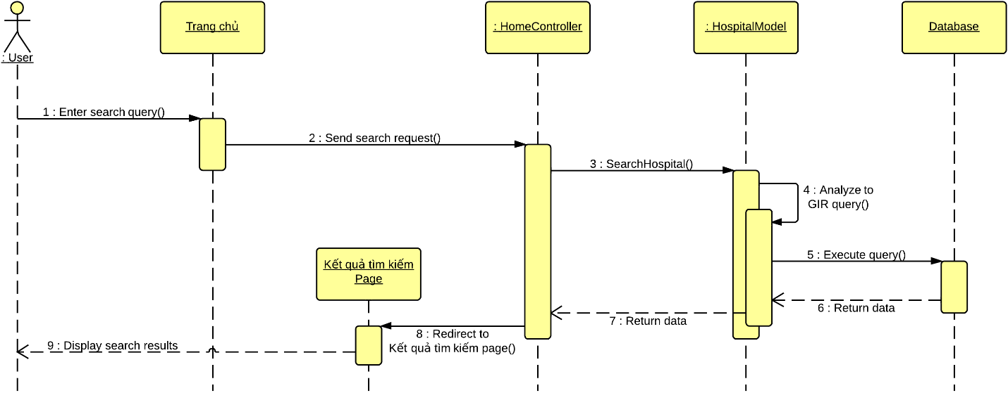

* 1. **Import Hospital Using Excel**

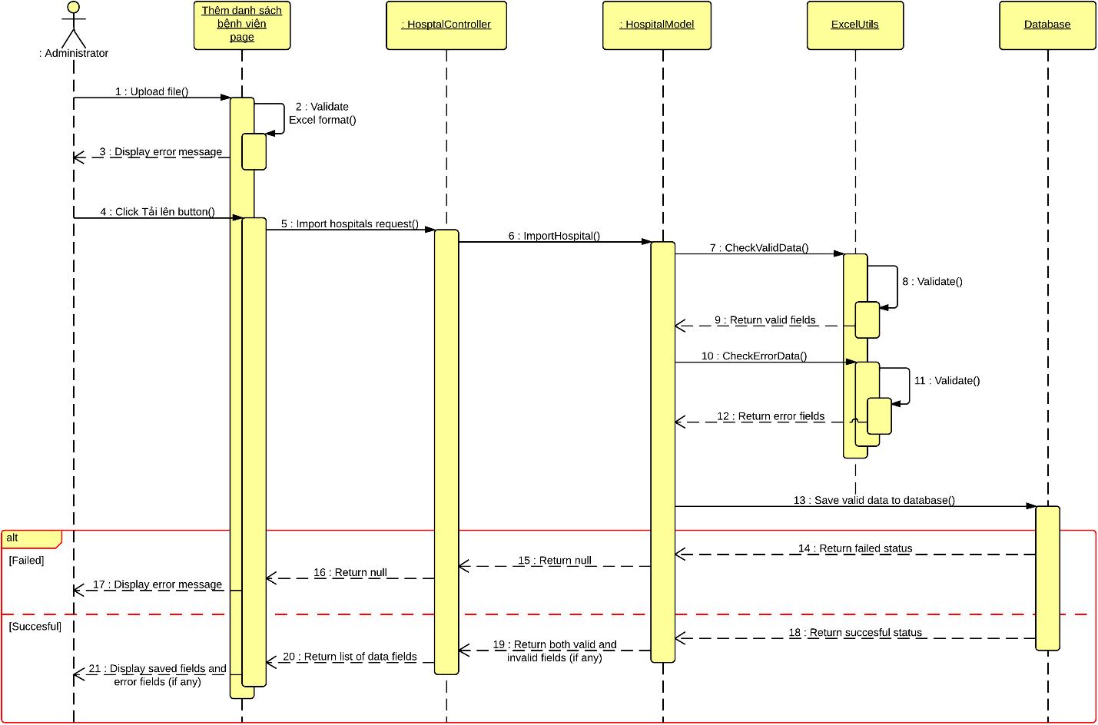

* 1. **Create Hospital**

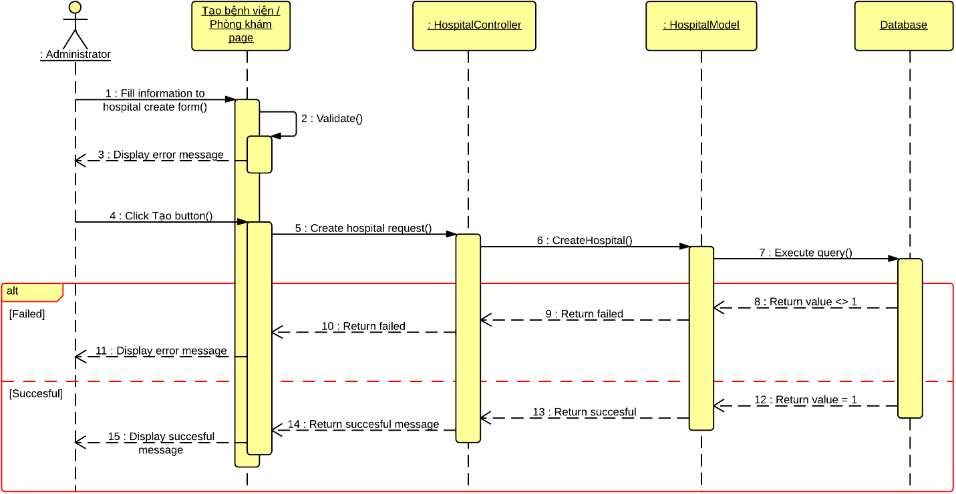

* 1. **View Hospital Information**

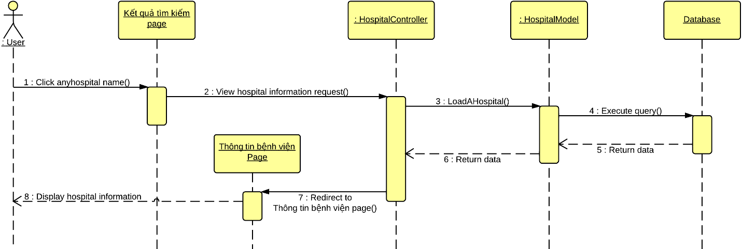

* 1. **Update Hospital Information**

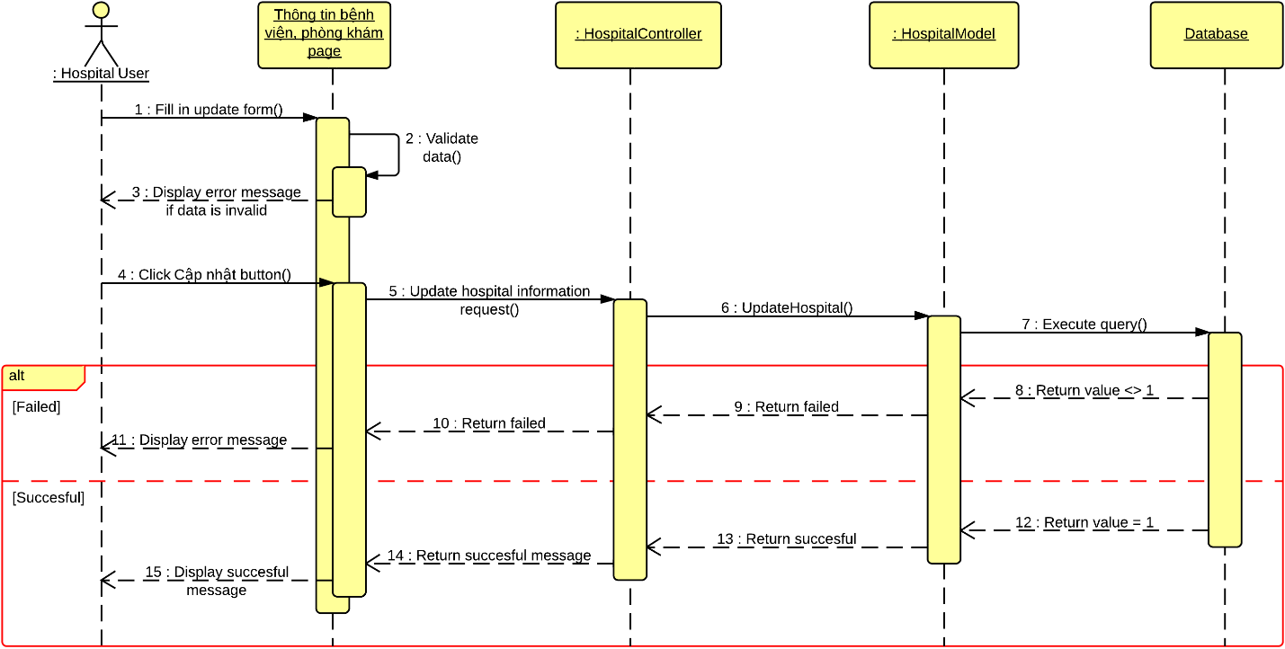

* 1. **Create Appointment Online**

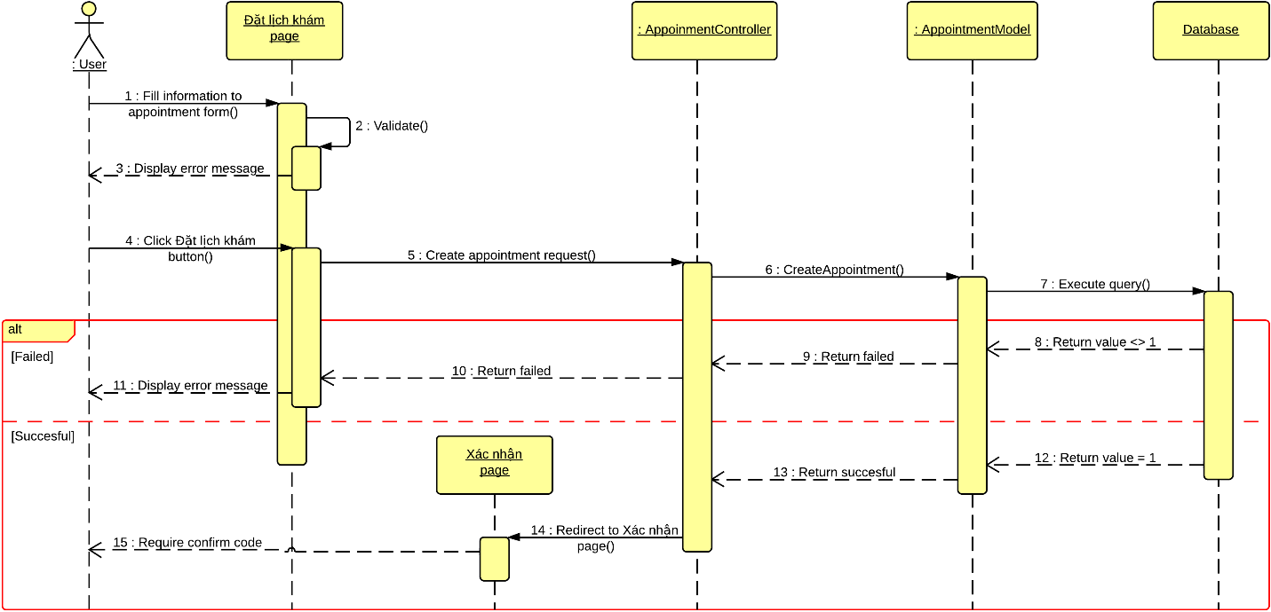

* 1. **Confirm Appointment**

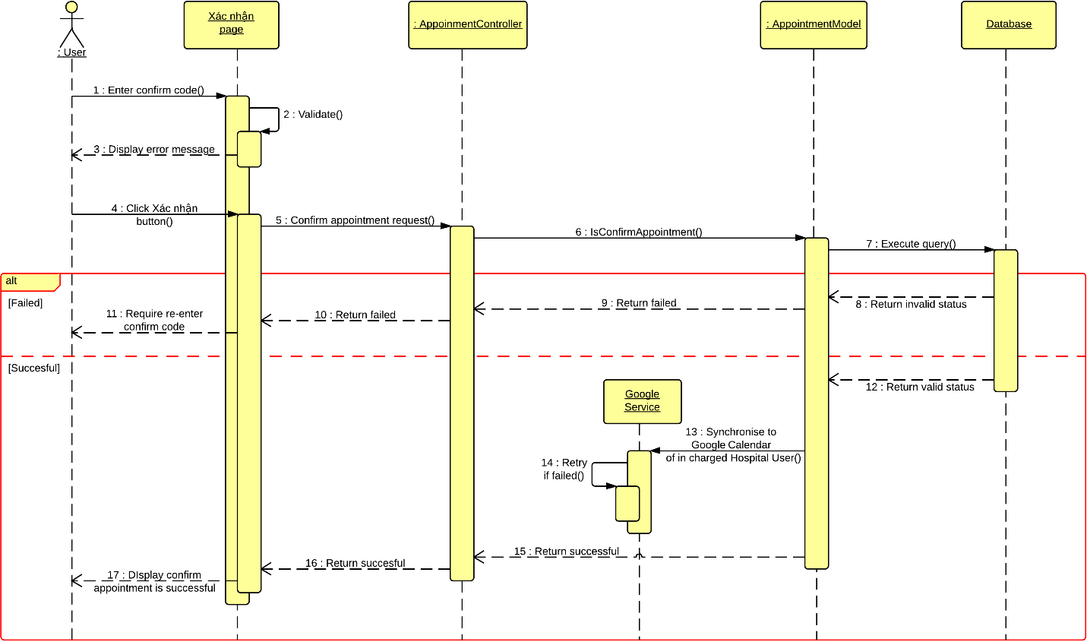

* 1. **Comment**

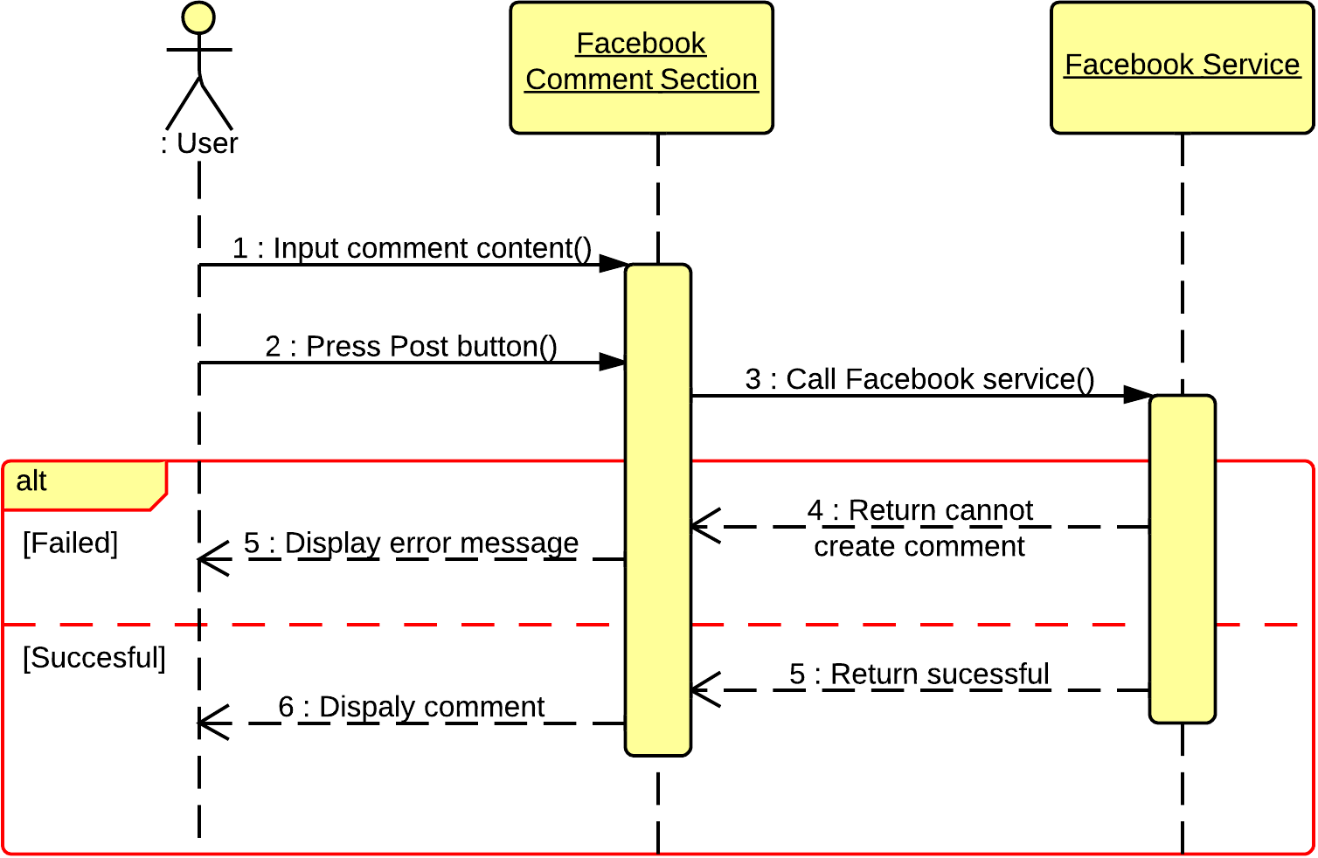

* 1. **View List of Appointments**

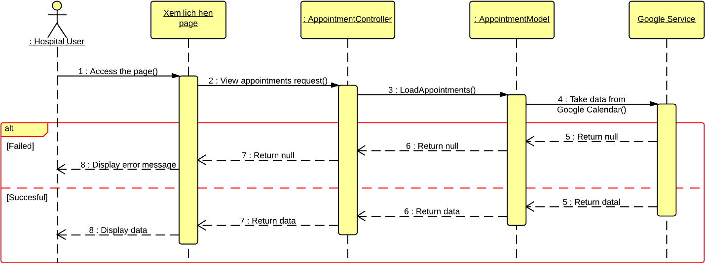

* 1. **View Statistics**

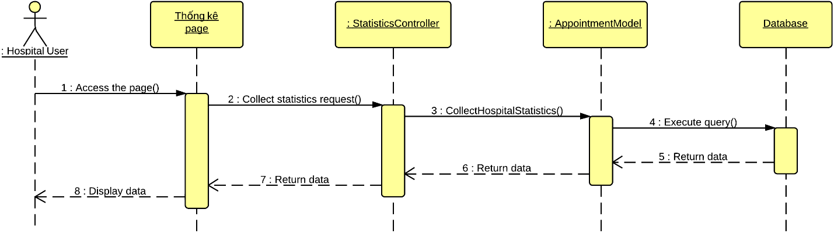

1. **User Interface Design**
   1. **Login**
   2. **Logout**
   3. **Change Password**
   4. **Reclaim Forgotten Password**
   5. **Search Hospital <GU> <US>**
   6. **Import Hospital Using Excel**
   7. **Create Hospital**
   8. **Create Hospital User’s Account**
   9. **View Hospital Information**
   10. **Search Doctor <GU> <US>**
   11. **Create Appointment Online**
   12. **Cancel Appointment**
   13. **Feedback**
   14. **Comment**
   15. **Reply Comment**
   16. **Rating Hosptial**
   17. **Add New Doctor**
   18. **Search List of Doctor <HU>**
   19. **Search List of Hospital <AD>**
   20. **Update Doctor Information**
   21. **Upload Photo**
   22. **Update Hospital Information**
   23. **View List of Appointments**
   24. **View List of Feedbacks**
   25. **View List of Users**
   26. **Activate Users**
   27. **Deactivate Users**
   28. **View Hospital Statistics**
   29. **View System Statistics**
2. **Database Design**
   1. **User**
   2. **Hospital**
   3. **HospitalType**
   4. **Doctor**
   5. **Doctor_Speciality**
   6. **Doctor_Hospital**
   7. **Appointment**
   8. **Role**
   9. **Rating**
   10. **Feedback**
   11. **FeedbackType**
   12. **Facility**
   13. **Hospital_Facility**
   14. **Service**
   15. **Hospital_Service**
   16. **Photo**
   17. **Ward**
   18. **District**
   19. **City**
   20. **Speciality**
   21. **Hospital_Speciality**
   22. **Disease**
   23. **Speciality_Disease**
   24. **WordDictionary**
   25. **Word_Hospital**
   26. **SentenceDictionary**
   27. **Sentence_Word**
3. **Algoritms**
4. **Geographic Information Retrieval**
5. **Boyer Moore Matching Algorithm**