|  |  |  |  |  |  |
| --- | --- | --- | --- | --- | --- |
| |  |  |  | | --- | --- | --- | | **C:\Users\sonnx0907\Desktop\Untitled.png** | **MINISTRY OF EDUCATION AND RAINING** | | | **FPT UNIVERSITY** | | |
| Capstone Project Document |
| Hospital Finder |
| |  |  |  |  |  |  |  |  |  |  |  | | --- | --- | --- | --- | --- | --- | --- | --- | --- | --- | --- | | |  |  | | --- | --- | | **Group 11** | | | **Group Members** | Lê Phước Việt – Team Leader – SE60706  Nguyễn Xuân Sơn – Team Member – SE60727  Vũ Nhật Anh Khoa – Team Member – SE60817  Dương Thị Hoàng Anh – Team Member – 60434 | | **Supervisor** | Nguyễn Đức Khoan | | **Ext Supervisor** | N/A | | **Capstone Project code** | HospitalF | | |
| - Ho Chi Minh City, May / 2014 - |

**Table of Contents**

**4.1** **Design Overview** 5

**4.2** **System Architecture Design** 5

**4.3** **Component Diagram** 5

**4.4** **Detailed Description of Components** 6

**4.4.1** **Class Diagram** 6

**4.4.2** **Class Diagram Explanation** 6

**4.4.2.1** **User** 7

**4.4.2.2** **Hospital** 7

**4.4.2.3** **HospitalType** 8

**4.4.2.4** **Doctor** 8

**4.4.2.5** **DoctorSpeciality** 8

**4.4.2.6** **DoctorHospital** 9

**4.4.2.7** **Appointment** 9

**4.4.2.8** **Role** 9

**4.4.2.9** **Rating** 9

**4.4.2.10** **Feedback** 10

**4.4.2.11** **FeedbackType** 10

**4.4.2.12** **Facility** 10

**4.4.2.13** **HospitalFacility** 10

**4.4.2.14** **Service** 11

**4.4.2.15** **HospitalService** 11

**4.4.2.16** **Photo** 11

**4.4.2.17** **Ward** 12

**4.4.2.18** **District** 12

**4.4.2.19** **City** 12

**4.4.2.20** **Speciality** 12

**4.4.2.21** **HospitalSpeciality** 13

**4.4.2.22** **Disease** 13

**4.4.2.23** **SpecialityDisease** 13

**4.4.2.24** **WordDictionary** 13

**4.4.2.25** **WordHospital** 13

**4.4.2.26** **SentenceDictionary** 14

**4.4.2.27** **SentenceWord** 14

**4.5** **Sequence Diagram** 14

**4.5.1** **Search Hospital** 14

**4.5.2** **Import Hospital Using Excel** 14

**4.5.3** **Create Hospital** 15

**4.5.4** **View Hospital Information** 15

**4.5.5** **Update Hospital Information** 16

**4.5.6** **Create Appointment Online** 16

**4.5.7** **Confirm Appointment** 16

**4.5.8** **Comment** 17

**4.5.9** **View List of Appointments** 17

**4.5.10** **View Statistics** 18

**4.6** **User Interface Design** 18

**4.6.1** **Login** 18

**4.6.2** **Logout** 18

**4.6.3** **Change Password** 18

**4.6.4** **Reclaim Forgotten Password** 18

**4.6.5** **Search Hospital <GU> <US>** 18

**4.6.6** **Import Hospital Using Excel** 18

**4.6.7** **Create Hospital** 18

**4.6.8** **Create Hospital User’s Account** 18

**4.6.9** **View Hospital Information** 18

**4.6.10** **Search Doctor <GU> <US>** 18

**4.6.11** **Create Appointment Online** 18

**4.6.12** **Cancel Appointment** 18

**4.6.13** **Feedback** 18

**4.6.14** **Comment** 18

**4.6.15** **Reply Comment** 18

**4.6.16** **Rating Hosptial** 18

**4.6.17** **Add New Doctor** 19

**4.6.18** **Search List of Doctor <HU>** 19

**4.6.19** **Search List of Hospital <AD>** 19

**4.6.20** **Update Doctor Information** 19

**4.6.21** **Upload Photo** 19

**4.6.22** **Update Hospital Information** 19

**4.6.23** **View List of Appointments** 19

**4.6.24** **View List of Feedbacks** 19

**4.6.25** **View List of Users** 19

**4.6.26** **Activate Users** 19

**4.6.27** **Deactivate Users** 19

**4.6.28** **View Hospital Statistics** 19

**4.6.29** **View System Statistics** 19

**4.7** **Database Design** 19

**4.7.1** **Logical Database Design** 19

**4.7.2** **User** 20

**4.7.3** **Hospital** 20

**4.7.4** **HospitalType** 20

**4.7.5** **Doctor** 20

**4.7.6** **Doctor_Speciality** 21

**4.7.7** **Doctor_Hospital** 21

**4.7.8** **Appointment** 21

**4.7.9** **Role** 21

**4.7.10** **Rating** 22

**4.7.11** **Feedback** 22

**4.7.12** **FeedbackType** 22

**4.7.13** **Facility** 22

**4.7.14** **Hospital_Facility** 22

**4.7.15** **Service** 22

**4.7.16** **Hospital_Service** 22

**4.7.17** **Photo** 23

**4.7.18** **Ward** 23

**4.7.19** **District** 23

**4.7.20** **City** 23

**4.7.21** **Speciality** 23

**4.7.22** **Hospital_Speciality** 23

**4.7.23** **Disease** 24

**4.7.24** **Speciality_Disease** 24

**4.7.25** **WordDictionary** 24

**4.7.26** **Word_Hospital** 24

**4.7.27** **SentenceDictionary** 24

**4.7.28** **Sentence_Word** 24

**4.8** **Algoritms** 24

**4.8.1** **Geographic Information Retrieval** 24

**4.8.2.1** **Definition** 24

**4.8.2.2** **Examples** 25

**4.8.2.3** **Complexity** 25

**4.8.2.4** **Flow chart** 25

**4.8.2** **Boyer Moore Matching Algorithm** 25

**4.8.2.1** **Definition** 25

**4.8.2.2** **Examples** 26

**4.8.2.3** **Complexity** 28

**4.8.2.4** **Flow chart** 28

**Report No.4: System Design Description (SDD)**

1. **Design Overview**

This document describes the system design description for Hospital Finder system. It includes the architecture design, detailed designs for common functions and the design of database model.

The architecture design describes the overview architecture of the system.

Detailed design describes the structure of data and components in the system. Class diagram and its explanation either sequence digrams are included in this section.

Database design describes the relationship between entities, how the data is organized and their explanations.

Document overview

* Section 2: Architecture diagram
* Section 3: Component diagram
* Section 4: Class diagram and its explanation
* Section 5: Sequence diagrams of common functions
* Section 6: Database design

1. **System Architecture Design**

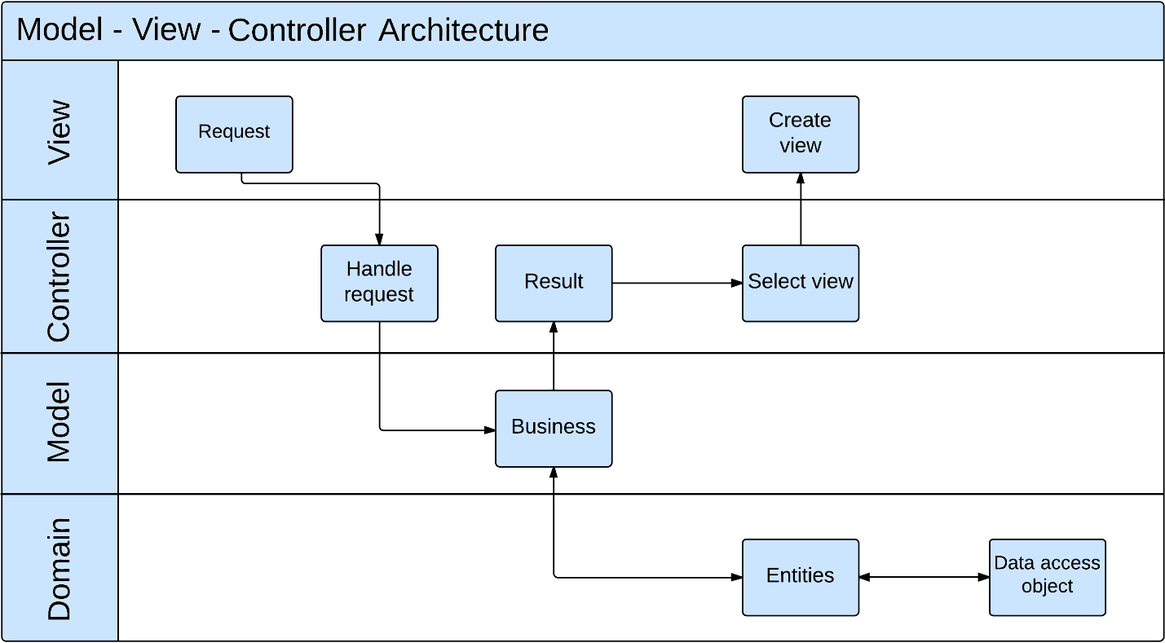

1. **Component Diagram**

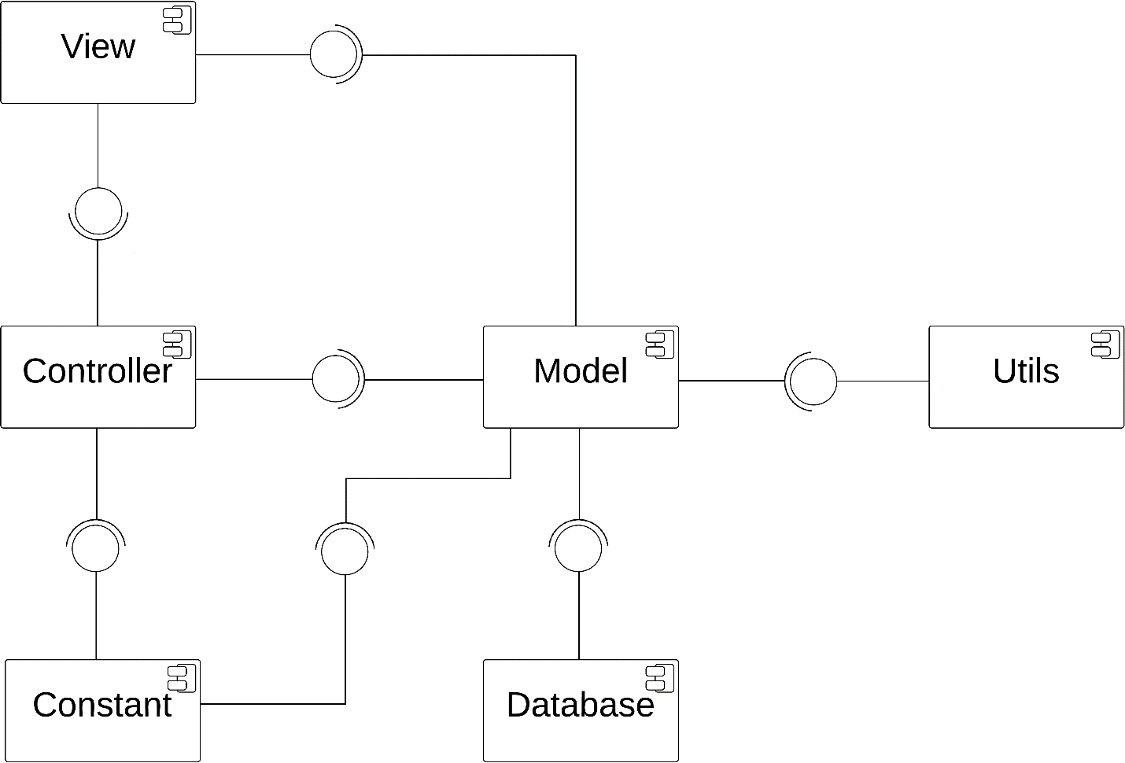

1. **Detailed Description of Components**
2. **Class Diagram**

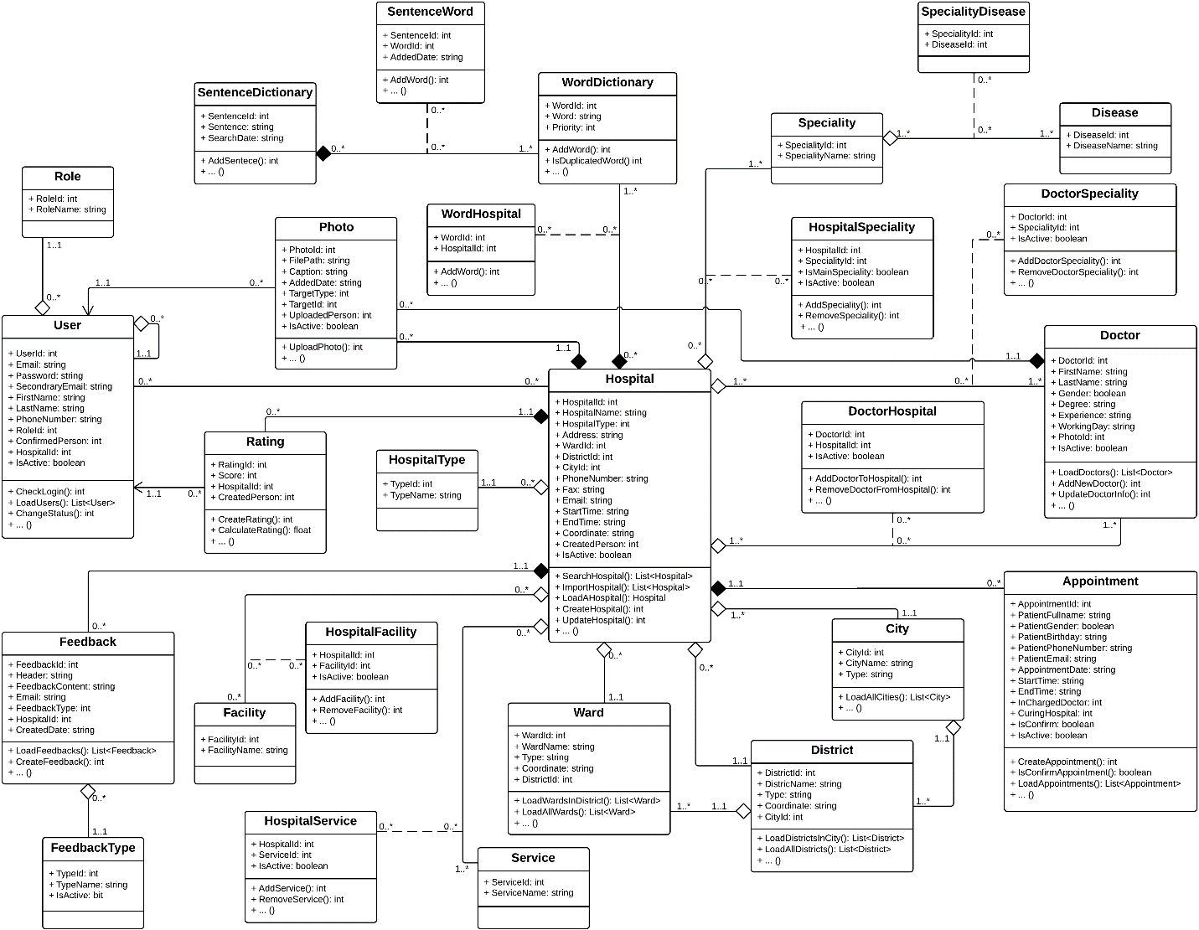

1. **Class Diagram Explanation**
2. **User**

**Attributes**

|  |  |  |  |
| --- | --- | --- | --- |
| **Attribute** | **Type** | **Visibility** | **Description** |
| UserId | Integer | Public | User ID |
| Email | String | Public | Email Address |
| Password | String | Public | Password |
| SecondaryEmail | String | Public | Secondary email |
| FirstName | String | Public | User’s first name |
| LastName | String | Public | User’s last name |
| PhoneNumber | String | Public | User’s phone number |
| RoleId | Integer | Public | Role ID |
| ConfirmedPerson | Integer | Public | ID of the administrator who confirmed the registration of a specific hospital user is right |
| HospitalId | Integer | Public | ID of the hospital that a hospital user have the responsibility to manage |
| IsActive | Boolean | Public | Indicate if a user is available in the system or not |

**Methods**

|  |  |  |  |
| --- | --- | --- | --- |
| **Attribute** | **Type** | **Visibility** | **Description** |
| CheckLogin | Integer | Public | Authenticate users |
| LoadUsers | List<User> | Public | Load a list of users |
| ChangeStatus | Integer | Public | Change current status of a user in the system |

1. **Hospital**

**Attributes**

|  |  |  |  |
| --- | --- | --- | --- |
| **Attribute** | **Type** | **Visibility** | **Description** |
| HospitalId | Integer | Public | Hospital ID |
| HospitalName | String | Public | Name of a hospital |
| HospitalType | Integer | Public | Type of a hospital |
| Address | String | Public | Full address of a hospital |
| WardId | Integer | Public | ID of the ward that a hospital is currently locating |
| DistrictId | Integer | Public | ID of the district that a hospital is currently locating |
| CityId | Integer | Public | ID of the city that a hospital is currently locating |
| PhoneNumber | String | Public | Hospital’s phone number |
| Fax | String | Public | Hospital’s fax number |
| Email | String | Public | Hospital’s email |
| StartTime | String | Public | Start working time of a hospital |
| EndTime | String | Public | End working time of a hospital |
| Coordinate | String | Public | Coordinate of a hospital in the map |
| IsActive | Boolean | Public | Indicate if a hospital is available in the system or not |

**Methods**

|  |  |  |  |
| --- | --- | --- | --- |
| **Attribute** | **Type** | **Visibility** | **Description** |
| SearchHospital | List<Hospital> | Public | Load a list of hospitals base on input search query |
| ImportHospital | List<Hospital> | Public | Import a list of hospitals using Excel |
| LoadAHospital | Hospital | Public | Load a specific hospital |
| CreateHospital | Integer | Public | Create a hospital |
| UpdateHospital | Integer | Public | Update information of a hospital |

1. **HospitalType**

**Attributes**

|  |  |  |  |
| --- | --- | --- | --- |
| **Attribute** | **Type** | **Visibility** | **Description** |
| TypeId | Integer | Public | Hospital type ID |
| TypeName | String | Public | Name of a hospital type |

**Methods**

N/A

1. **Doctor**

**Attributes**

|  |  |  |  |
| --- | --- | --- | --- |
| **Attribute** | **Type** | **Visibility** | **Description** |
| DoctorId | Integer | Public | Doctor ID |
| FirstName | String | Public | Doctor’s first name |
| LastName | String | Public | Doctor’s last name |
| Gender | Boolean | Public | Doctor’s gender |
| Degree | String | Public | Knowledge degree of a doctor |
| Experience | String | Public | Working experience of a doctor |
| WorkingDay | String | Public | Working day in a week of a doctor |
| PhotoId | Integer | Public | Photo picture of a doctor |
| IsActive | Boolean | Public | Indicate a doctor is available in the system or not |

**Methods**

|  |  |  |  |
| --- | --- | --- | --- |
| **Attribute** | **Type** | **Visibility** | **Description** |
| LoadDoctors | List<Doctor> | Public | Load a list of doctors in a hospital |
| AddNewDoctor | Integer | Public | Add new doctor |
| UpdateDoctorInfo | Integer | Public | Update profile of a doctor |

1. **DoctorSpeciality**

**Attributes**

|  |  |  |  |
| --- | --- | --- | --- |
| **Attribute** | **Type** | **Visibility** | **Description** |
| DoctorId | Integer | Public | Doctor ID |
| SpecialityId | Integer | Public | Speciality ID |
| IsActive | Boolean | Public | Indicate if a doctor is still good at a specific speciality or not |

**Methods**

|  |  |  |  |
| --- | --- | --- | --- |
| **Attribute** | **Type** | **Visibility** | **Description** |
| AddDoctorSpeciality | Integer | Public | Add new speciality for a doctor |
| RemoveDoctorSpeciality | Integer | Public | Remove specialities from a doctor |

1. **DoctorHospital**

**Attributes**

|  |  |  |  |
| --- | --- | --- | --- |
| **Attribute** | **Type** | **Visibility** | **Description** |
| DoctorId | Integer | Public | Doctor ID |
| HospitalId | Integer | Public | Hospital ID |
| IsActive | Boolean | Public | Indicate if a doctor is still work at a specific hospital or not |

**Methods**

|  |  |  |  |
| --- | --- | --- | --- |
| **Attribute** | **Type** | **Visibility** | **Description** |
| AddDoctorToHospital | Integer | Public | Add new doctor to hospital |
| RemoveDoctorFromHospital | Integer | Public | Remove doctors from a hospital |

1. **Appointment**

**Attributes**

|  |  |  |  |
| --- | --- | --- | --- |
| **Attribute** | **Type** | **Visibility** | **Description** |
| AppointmentId | Integer | Public | Appointment ID |
| PatientFullName | String | Public | Patient’s full name |
| PatientGender | Boolean | Public | Patient’s gender |
| PatientPhoneNumber | String | Public | Patient’s phone number |
| PatientEmail | String | Public | Patient’s email |
| AppointmentDate | String | Public | Appointmnet date |
| StartTime | String | Public | Time to start the appointment |
| EndTime | String | Public | Time to end the appointment |
| InChargedDoctor | Integer | Public | In charged curing doctor |
| CuringHospital | Integer | Public | Curing hospital for the appointment |
| IsConfirm | Boolean | Public | Indicate an appointment is confirmed or not |
| IsActive | Boolean | Public | Indicate an appointment is available in the system or not |

**Methods**

|  |  |  |  |
| --- | --- | --- | --- |
| **Attribute** | **Type** | **Visibility** | **Description** |
| CreateAppoinment | Integer | Public | Create new appointment |
| IsConfirmAppointment | Boolean | Public | Indicate an appointment is confirmed or not |
| LoadAppoinments | List<Appoinment> | Public | Load a list of appointments from Google Calendar |

1. **Role**

**Attributes**

|  |  |  |  |
| --- | --- | --- | --- |
| **Attribute** | **Type** | **Visibility** | **Description** |
| RoleId | Integer | Public | Role ID |
| RoleName | String | Public | Role name |

**Methods**

N/A

1. **Rating**

**Attributes**

|  |  |  |  |
| --- | --- | --- | --- |
| **Attribute** | **Type** | **Visibility** | **Description** |
| RatingId | Integer | Public | Rating ID |
| Score | Integer | Public | Score that made by user |
| HospitalId | Integer | Public | Hospital ID |
| CreatedPerson | Integer | Public | ID of the person who created a specific rating |

**Methods**

|  |  |  |  |
| --- | --- | --- | --- |
| **Attribute** | **Type** | **Visibility** | **Description** |
| CreateRating | Integer | Public | Create new rating |
| CalculateRating | Float | Public | Calculate total rating of a hospital |

1. **Feedback**

**Attributes**

|  |  |  |  |
| --- | --- | --- | --- |
| **Attribute** | **Type** | **Visibility** | **Description** |
| FeedbackId | Integer | Public | Feedback ID |
| Header | String | Public | Header of a feedback |
| FeedbackContent | String | Public | Content of a feedback |
| Email | String | Public | Email of the person who created a feedback |
| FeedbackType | Integer | Public | Feedback type ID |
| HospitalId | Integer | Public | Hospital ID |
| CreatedDate | String | Public | The date that a feedback was created |

**Methods**

|  |  |  |  |
| --- | --- | --- | --- |
| **Attribute** | **Type** | **Visibility** | **Description** |
| LoadFeedbacks | List<Feedback> | Public | Load a list of feedbacks |
| CreateFeedback | Integer | Public | Create new feedback |

1. **FeedbackType**

**Attributes**

|  |  |  |  |
| --- | --- | --- | --- |
| **Attribute** | **Type** | **Visibility** | **Description** |
| TypeId | Integer | Public | Feedback type ID |
| TypeName | String | Public | Feedback type’s name |
| IsActive | Boolean | Public | Indicate if a feedback type is available in the system or not |

**Methods**

N/A

1. **Facility**

**Attributes**

|  |  |  |  |
| --- | --- | --- | --- |
| **Attribute** | **Type** | **Visibility** | **Description** |
| FacilityId | Integer | Public | Facility ID |
| FacilityName | String | Public | Facility’s name |

**Methods**

N/A

1. **HospitalFacility**

**Attributes**

|  |  |  |  |
| --- | --- | --- | --- |
| **Attribute** | **Type** | **Visibility** | **Description** |
| HospitalId | Integer | Public | Hospital ID |
| FacilityId | Integer | Public | Facility ID |
| IsActive | Boolean | Public | Indicate if a facility is still available in a hospital or not |

**Methods**

|  |  |  |  |
| --- | --- | --- | --- |
| **Attribute** | **Type** | **Visibility** | **Description** |
| AddFacility | Integer | Public | Add new facility to a hospital |
| Remove Facility | Integer | Public | Remove facilities from a hospital |

1. **Service**

**Attributes**

|  |  |  |  |
| --- | --- | --- | --- |
| **Attribute** | **Type** | **Visibility** | **Description** |
| ServiceId | Integer | Public | Service ID |
| ServiceName | String | Public | Service’s name |

**Methods**

N/A

1. **HospitalService**

**Attributes**

|  |  |  |  |
| --- | --- | --- | --- |
| **Attribute** | **Type** | **Visibility** | **Description** |
| HospitalId | Integer | Public | Hospital ID |
| Service | Integer | Public | Service ID |
| IsActive | Boolean | Public | Indicate if a service is still available in a hospital or not |

**Methods**

|  |  |  |  |
| --- | --- | --- | --- |
| **Attribute** | **Type** | **Visibility** | **Description** |
| AddService | Integer | Public | Add new service to a hospital |
| RemoveService | Integer | Public | Remove services from a hospital |

1. **Photo**

**Attributes**

|  |  |  |  |
| --- | --- | --- | --- |
| **Attribute** | **Type** | **Visibility** | **Description** |
| PhotoId | Integer | Public | Photo ID |
| FilePath | String | Public | File path of a photo |
| Caption | String | Public | Caption of a photo |
| AddedDate | String | Public | The date that a photo was added |
| TargetType | Integer | Public | Indicate if a photo is belong to a hospital or a doctor |
| TargetId | Integer | Public | ID of the item that a photo belonged to |
| UploadedPerson | Integer | Public | ID of the person who added the photo |
| IsActive | Boolean | Public | Indicate a photo is available in the system or not |

**Methods**

|  |  |  |  |
| --- | --- | --- | --- |
| **Attribute** | **Type** | **Visibility** | **Description** |
| UploadPhoto | Integer | Public | Add new photo to a hospital or doctor |

1. **Ward**

**Attributes**

|  |  |  |  |
| --- | --- | --- | --- |
| **Attribute** | **Type** | **Visibility** | **Description** |
| WardId | Integer | Public | Ward ID |
| WardName | String | Public | Name of a ward |
| Type | String | Public | Type of a ward |
| Coordinate | String | Public | Coordinate of a ward on the map |
| DistrictId | Integer | Public | ID of the district that a ward belonged to |

**Methods**

|  |  |  |  |
| --- | --- | --- | --- |
| **Attribute** | **Type** | **Visibility** | **Description** |
| LoadWardsInDistrict | List<Ward> | Public | Load a list of wards in a specific district |
| LoadAllWards | List<Ward> | Public | Load all wards in database |

1. **District**

**Attributes**

|  |  |  |  |
| --- | --- | --- | --- |
| **Attribute** | **Type** | **Visibility** | **Description** |
| DistrictId | Integer | Public | District ID |
| DistrictName | String | Public | Name of a district |
| Type | String | Public | Type of a district |
| Coordinate | String | Public | Coordinate of a district on the map |
| CityId | Integer | Public | ID of the city that a district belonged to |

**Methods**

|  |  |  |  |
| --- | --- | --- | --- |
| **Attribute** | **Type** | **Visibility** | **Description** |
| LoadWardsInCity | List<District> | Public | Load a list of districts in a specific city |
| LoadAllDistricts | List< District > | Public | Load all districts in database |

1. **City**

**Attributes**

|  |  |  |  |
| --- | --- | --- | --- |
| **Attribute** | **Type** | **Visibility** | **Description** |
| CityId | Integer | Public | City ID |
| CityName | String | Public | Name of a city |
| Type | String | Public | Type of a city |

**Methods**

|  |  |  |  |
| --- | --- | --- | --- |
| **Attribute** | **Type** | **Visibility** | **Description** |
| LoadAllCities | List<City> | Public | Load all cities in database |

1. **Speciality**

**Attributes**

|  |  |  |  |
| --- | --- | --- | --- |
| **Attribute** | **Type** | **Visibility** | **Description** |
| SpecialityId | Integer | Public | Speciality ID |
| SpecialityName | String | Public | Name of a speciality |

**Methods**

N/A

1. **HospitalSpeciality**

**Attributes**

|  |  |  |  |
| --- | --- | --- | --- |
| **Attribute** | **Type** | **Visibility** | **Description** |
| HospitalId | Integer | Public | Hospital ID |
| SpecialityId | Integer | Public | Speciality ID |
| IsMainSpeciality | Boolean | Public | Indicate of a speciality is a main speciality of a hospital |
| IsActive | Boolean | Public | Indicate a speciality still belong to a hospital or not |

**Methods**

|  |  |  |  |
| --- | --- | --- | --- |
| **Attribute** | **Type** | **Visibility** | **Description** |
| AddSpeciality | Integer | Public | Add new speciality to a hospital |
| RemoveSpecilaity | Integer | Public | Remove specialities from a hospital |

1. **Disease**

**Attributes**

|  |  |  |  |
| --- | --- | --- | --- |
| **Attribute** | **Type** | **Visibility** | **Description** |
| DiseaseId | Integer | Public | Disease ID |
| DiseaseName | String | Public | Name of a disease |

**Methods**

N/A

1. **SpecialityDisease**

**Attributes**

|  |  |  |  |
| --- | --- | --- | --- |
| **Attribute** | **Type** | **Visibility** | **Description** |
| Speciality | Integer | Public | Speciality ID |
| DiseaseId | Integer | Public | Disease ID |

**Methods**

N/A

1. **WordDictionary**

**Attributes**

|  |  |  |  |
| --- | --- | --- | --- |
| **Attribute** | **Type** | **Visibility** | **Description** |
| WordId | Integer | Public | Word ID |
| Word | String | Public | Word content |
| Priority | Integer | Public | Priority of a word |

**Methods**

|  |  |  |  |
| --- | --- | --- | --- |
| **Attribute** | **Type** | **Visibility** | **Description** |
| AddWord | Integer | Public | Add new words |
| IsDuplicatedWord | Integer | Public | Check if a word is duplicated with another word in database |

1. **WordHospital**

**Attributes**

|  |  |  |  |
| --- | --- | --- | --- |
| **Attribute** | **Type** | **Visibility** | **Description** |
| WordId | Integer | Public | Word ID |
| HospitalId | Integer | Public | Hospital ID |

**Methods**

|  |  |  |  |
| --- | --- | --- | --- |
| **Attribute** | **Type** | **Visibility** | **Description** |
| AddWord | Integer | Public | Add new words to a hospital |

1. **SentenceDictionary**

**Attributes**

|  |  |  |  |
| --- | --- | --- | --- |
| **Attribute** | **Type** | **Visibility** | **Description** |
| SentenceId | Integer | Public | Sentence ID |
| Sentence | String | Public | Sentence content |
| SearchDate | String | Public | The date that a specific search query was entered |

**Methods**

|  |  |  |  |
| --- | --- | --- | --- |
| **Attribute** | **Type** | **Visibility** | **Description** |
| AddSentence | Integer | Public | Add new sentences |

1. **SentenceWord**

**Attributes**

|  |  |  |  |
| --- | --- | --- | --- |
| **Attribute** | **Type** | **Visibility** | **Description** |
| SentenceId | Integer | Public | Sentence ID |
| WordId | Integer | Public | Word ID |
| AddedDate | String | Public | The date that a specific search query was entered |

**Methods**

|  |  |  |  |
| --- | --- | --- | --- |
| **Attribute** | **Type** | **Visibility** | **Description** |
| AddWord | Integer | Public | Add new words from a sentence |

1. **Sequence Diagram**
   1. **Search Hospital**

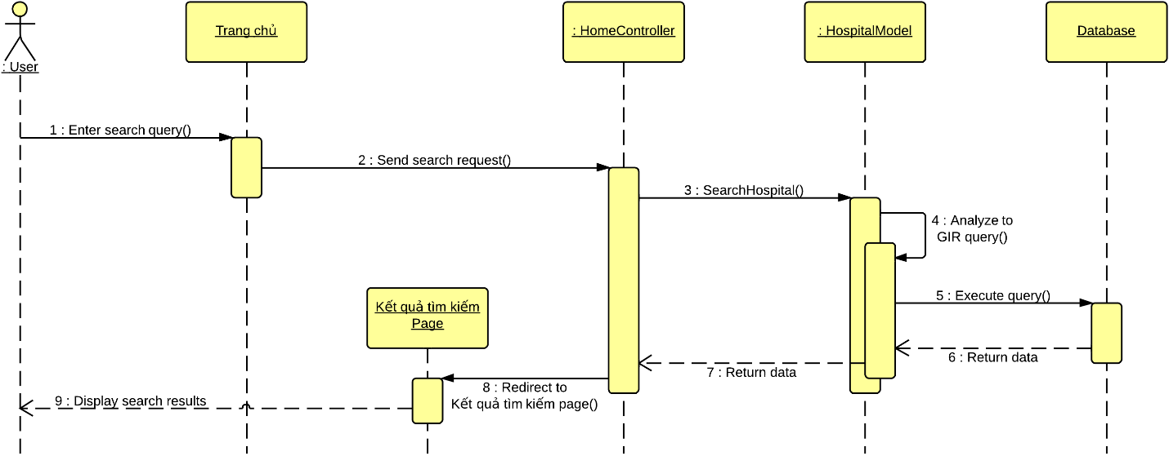

* 1. **Import Hospital Using Excel**

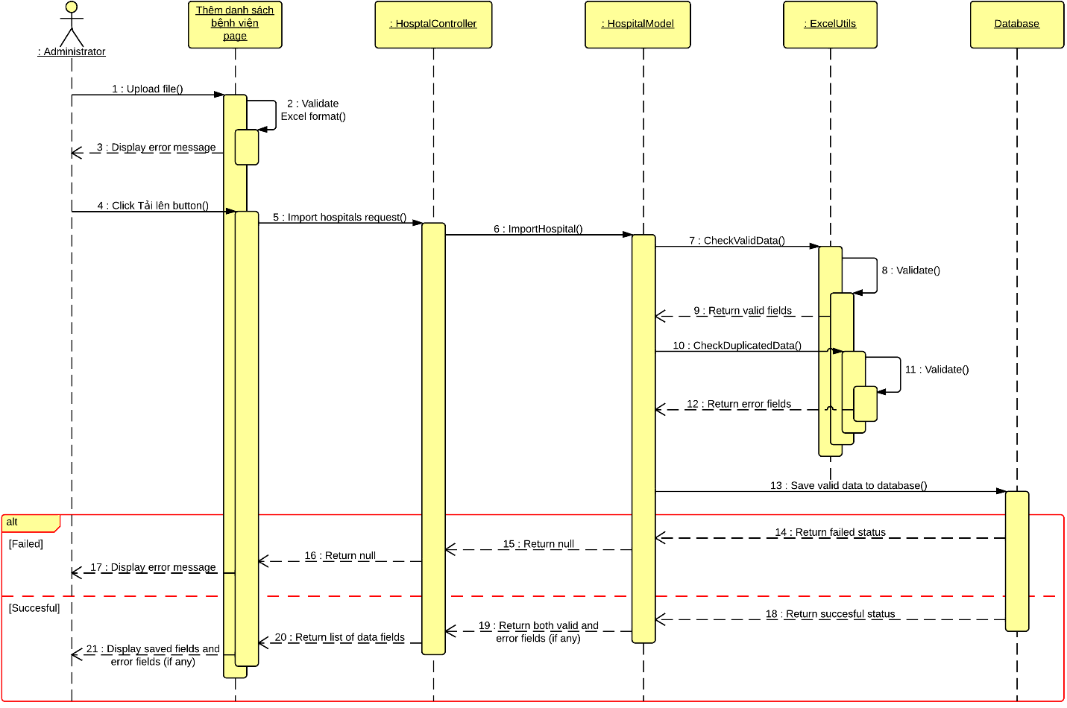

* 1. **Create Hospital**

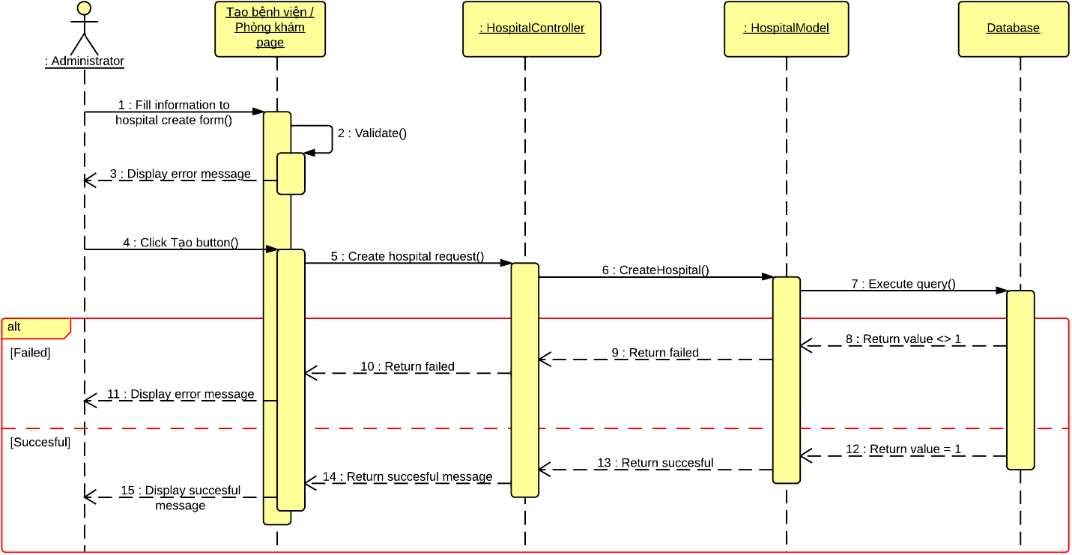

* 1. **View Hospital Information**

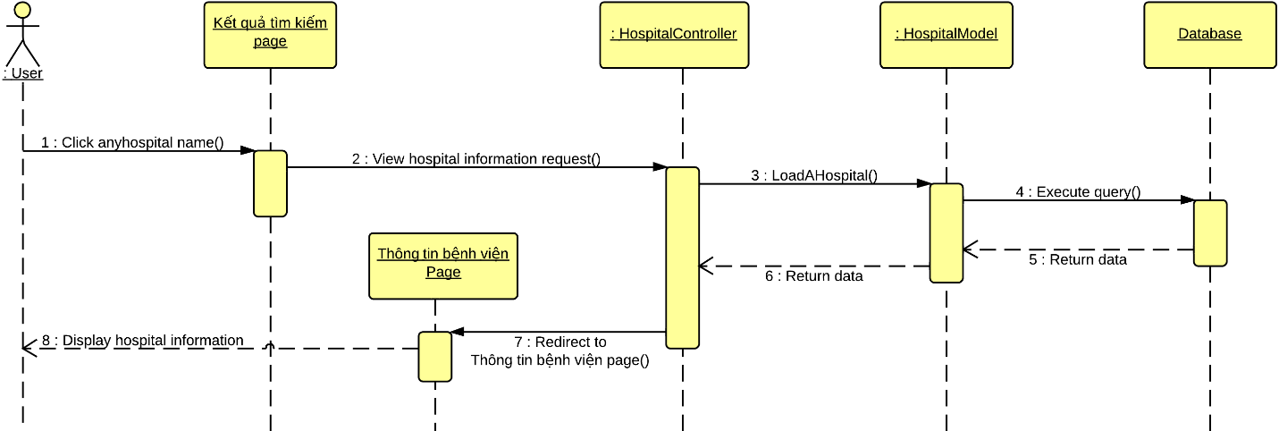

* 1. **Update Hospital Information**

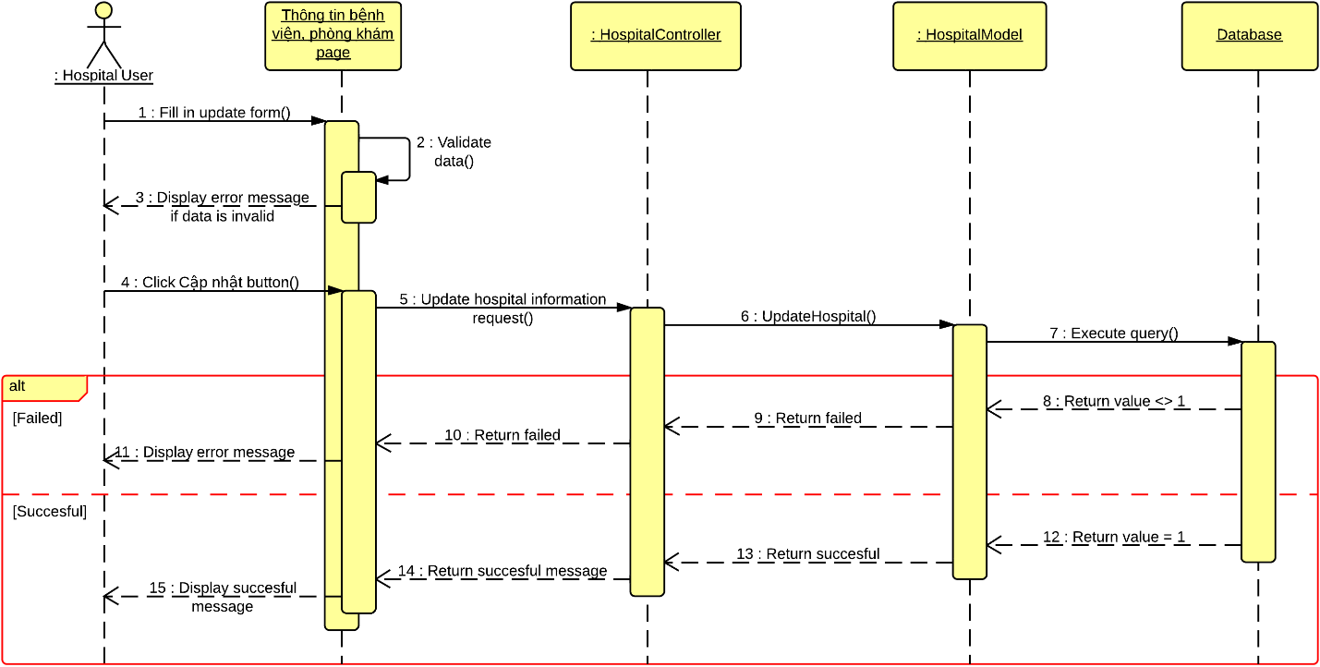

* 1. **Create Appointment Online**

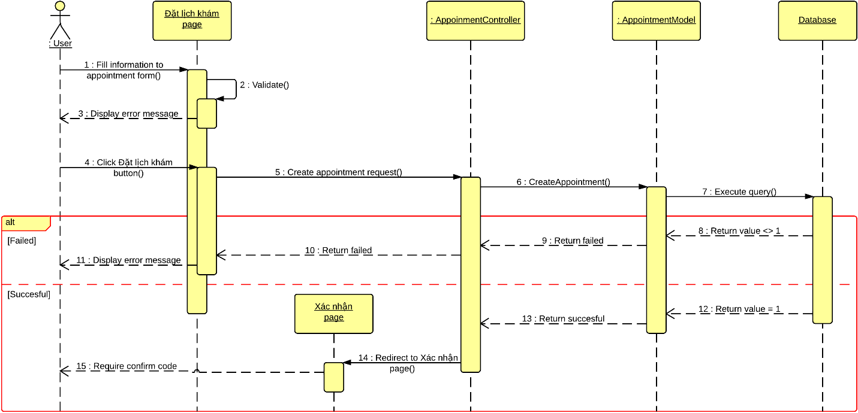

* 1. **Confirm Appointment**

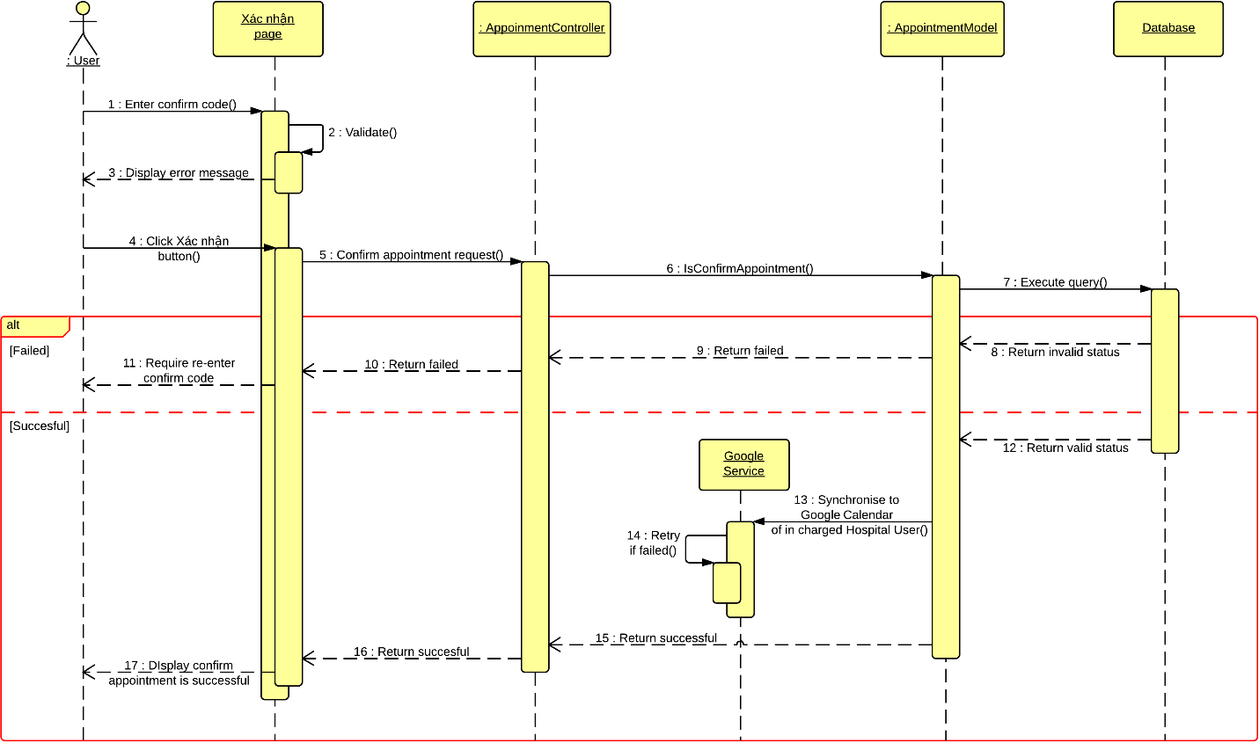

* 1. **Comment**

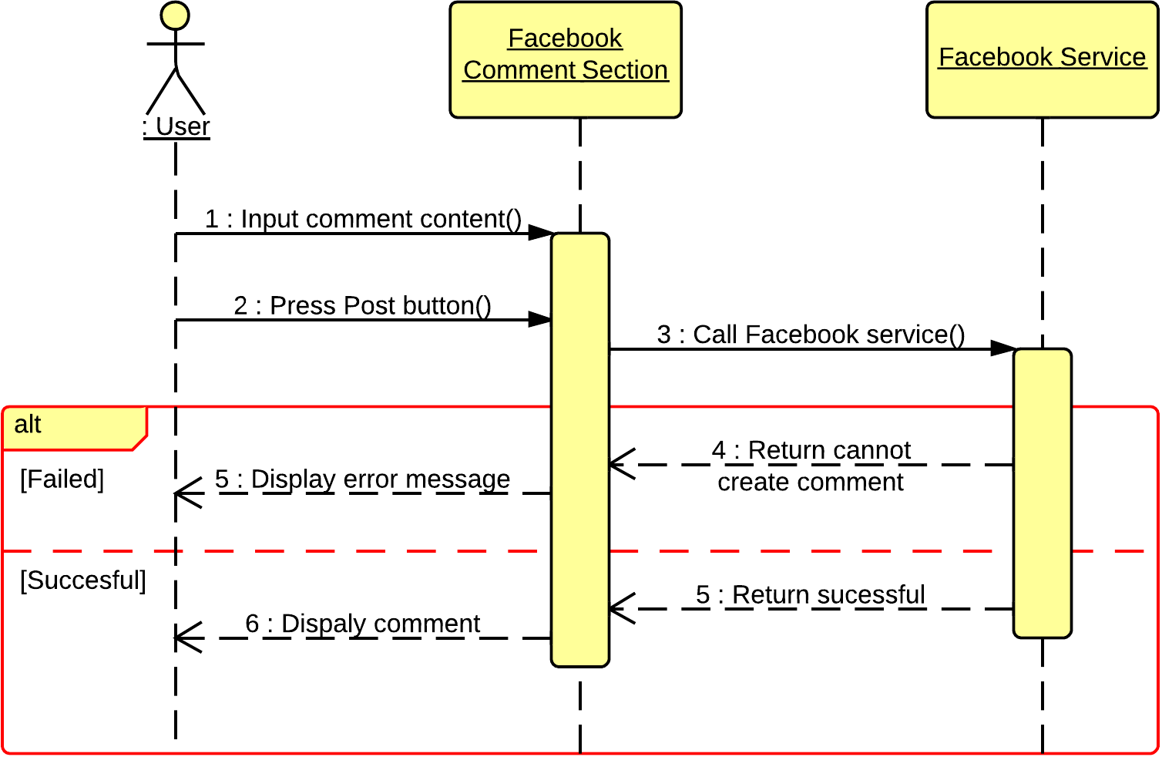

* 1. **View List of Appointments**

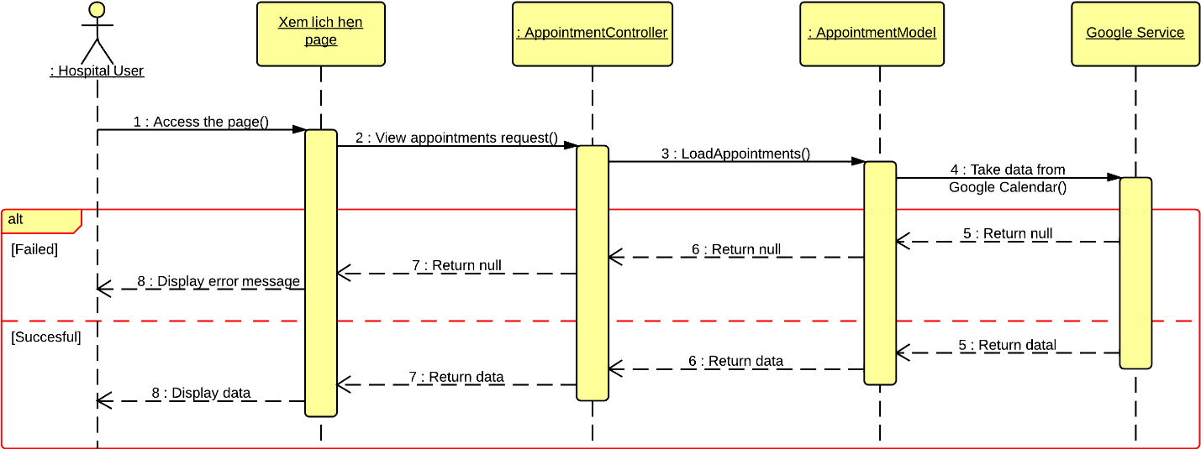

* 1. **View Statistics**

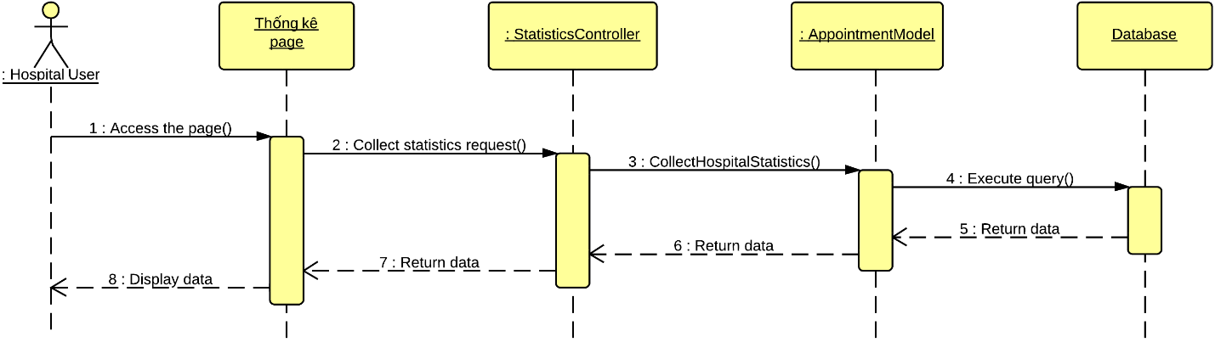

1. **User Interface Design**
   1. **Login**
   2. **Logout**
   3. **Change Password**
   4. **Reclaim Forgotten Password**
   5. **Search Hospital <GU> <US>**
   6. **Import Hospital Using Excel**
   7. **Create Hospital**
   8. **Create Hospital User’s Account**
   9. **View Hospital Information**
   10. **Search Doctor <GU> <US>**
   11. **Create Appointment Online**
   12. **Cancel Appointment**
   13. **Feedback**
   14. **Comment**
   15. **Reply Comment**
   16. **Rating Hosptial**
   17. **Add New Doctor**
   18. **Search List of Doctor <HU>**
   19. **Search List of Hospital <AD>**
   20. **Update Doctor Information**
   21. **Upload Photo**
   22. **Update Hospital Information**
   23. **View List of Appointments**
   24. **View List of Feedbacks**
   25. **View List of Users**
   26. **Activate Users**
   27. **Deactivate Users**
   28. **View Hospital Statistics**
   29. **View System Statistics**
2. **Database Design**
   1. **Logical Database Design**

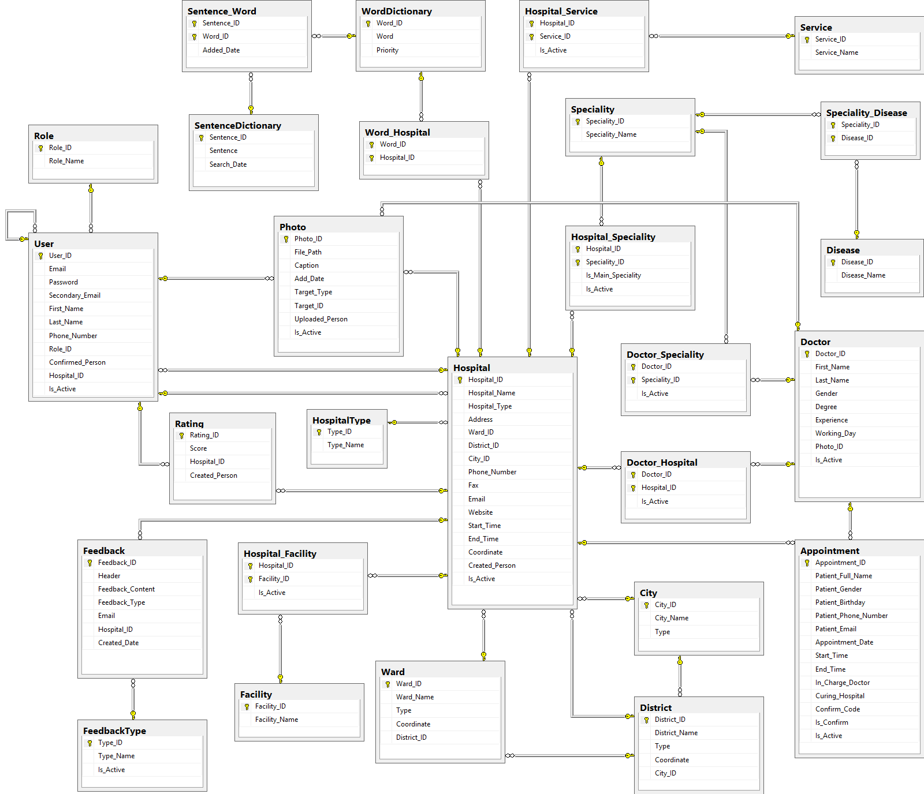

* 1. **User**

|  |  |  |  |
| --- | --- | --- | --- |
| **Attribute** | **Type** | **Null** | **Description** |
| User_ID {PK} | int | No | User ID |
| Email | varchar(64) | No | Email Address |
| Password | nvarchar(32) | No | Password |
| Secondary_Email | varchar(64) | Yes | Secondary email |
| First_Name | nvarchar(16) | No | User’s first name |
| Last_Name | nvarchar(16) | No | User’s last name |
| Phone_Number | varchar(13) | Yes | User’s phone number |
| Role_ID {FK} | int | No | Role ID |
| Confirmed_Person {FK} | int | Yes | ID of the administrator who confirmed the registration of a specific hospital user is right |
| Hospital_ID {FK} | int | Yes | ID of the hospital that a hospital user have the responsibility to manage |
| Is_Active | bit | No | Indicate if a user is available in the system or not |

* 1. **Hospital**

|  |  |  |  |
| --- | --- | --- | --- |
| **Attribute** | **Type** | **Null** | **Description** |
| Hospital_ID {PK} | int | No | Hospital ID |
| Hospital_Name | nvarchar(64) | No | Name of a hospital |
| Hospital_Type {FK} | int | No | Type of a hospital |
| Address | nvarchar(128) | No | Full address of a hospital |
| Ward_ID {FK} | int | No | ID of the ward that a hospital is currently locating |
| District_ID {FK} | int | No | ID of the district that a hospital is currently locating |
| City_ID {FK} | int | No | ID of the city that a hospital is currently locating |
| Phone_Number | varchar(32) | No | Hospital’s phone number |
| Fax | varchar(16) | Yes | Hospital’s fax number |
| Email | varchar(64) | Yes | Hospital’s email |
| Website | varchar(64) | Yes | Start working time of a hospital |
| Start_Time | time(7) | No | End working time of a hospital |
| End_Time | time(7) | No | Coordinate of a hospital in the map |
| Coordinate | varchar(26) | No | Indicate if a hospital is available in the system or not |
| Created_Person {FK} | int | No | Hospital ID |
| Is_Active | bit | No | Name of a hospital |

* 1. **HospitalType**

|  |  |  |  |
| --- | --- | --- | --- |
| **Attribute** | **Type** | **Null** | **Description** |
| Type_ID {PK} | int | No | Hospital typeID |
| Type_Name | nvarchar(32) | No | Name of a hospital type |

* 1. **Doctor**

|  |  |  |  |
| --- | --- | --- | --- |
| **Attribute** | **Type** | **Null** | **Description** |
| Doctor_ID {PK} | int | No | Doctor ID |
| First_Name | nvarchar(32) | No | Doctor’s first name |
| Last_Name | nvarchar(32) | No | Doctor’s last name |
| Gender | bit | No | Doctor’s gender |
| Degree | nvarchar(256) | Yes | Knowledge degree of a doctor |
| Experience | nvarchar(512) | Yes | Working experience of a doctor |
| Working_Day | varchar(33) | No | Working day in a week of a doctor |
| Photo_ID {FK} | int | Yes | Photo picture of a doctor |
| Is_Active | bit | No | Indicate a doctor is available in the system or not |

* 1. **Doctor_Speciality**

|  |  |  |  |
| --- | --- | --- | --- |
| **Attribute** | **Type** | **Null** | **Description** |
| Doctor_ID {PK} | int | No | Doctor ID |
| Speciality_ID {PK} | int | No | Speciality ID |
| Is_Active | bit | No | Indicate if a doctor is still good at a specific speciality or not |

* 1. **Doctor_Hospital**

|  |  |  |  |
| --- | --- | --- | --- |
| **Attribute** | **Type** | **Null** | **Description** |
| Doctor_ID {PK} | int | No | Doctor ID |
| Hospital_ID {PK} | int | No | Hospital ID |
| Is_Active | bit | No | Indicate if a doctor is still work at a specific hospital or not |

* 1. **Appointment**

|  |  |  |  |
| --- | --- | --- | --- |
| **Attribute** | **Type** | **Null** | **Description** |
| Appointment_ID {PK} | int | No | Appointment ID |
| Patient_Full_Name | nvarchar(32) | No | Patient’s full name |
| Patient_Gender | bit | No | Patient’s gender |
| Patient_Birthday | date | No | Patient’s phone number |
| Patient_Phone_Number | varchar(13) | No | Patient’s email |
| Patient_Email | varchar(64) | Yes | Appointmnet date |
| Appointment_Date | date | No | Time to start the appointment |
| Start_Time | time(7) | No | Time to end the appointment |
| End_Time | time(7) | No | In charged curing doctor |
| In_Charge_Doctor {FK} | int | No | Curing hospital for the appointment |
| Curing_Hospital {FK} | int | No | Indicate an appointment is confirmed or not |
| Confirm_Code | varchar(8) | No | Indicate an appointment is available in the system or not |
| Is_Confirm | bit | No | Appointment ID |
| Is_Active | bit | No | Patient’s full name |

* 1. **Role**

|  |  |  |  |
| --- | --- | --- | --- |
| **Attribute** | **Type** | **Null** | **Description** |
| Role_ID {PK} | int | No | Role ID |
| Role_Name | nvarchar(32) | No | Role name |

* 1. **Rating**

|  |  |  |  |
| --- | --- | --- | --- |
| **Attribute** | **Type** | **Null** | **Description** |
| Rating_ID {PK} | int | No | Rating ID |
| Score | int | No | Score that made by user |
| Hospital_ID {FK} | int | No | Hospital ID |
| Created_Person {FK} | int | No | ID of the person who created a specific rating |

* 1. **Feedback**

|  |  |  |  |
| --- | --- | --- | --- |
| **Attribute** | **Type** | **Null** | **Description** |
| Feedback_ID {PK} | int | No | Feedback ID |
| Header | nvarchar(64) | No | Header of a feedback |
| Feedback_Content | nvarchar(256) | No | Content of a feedback |
| Feedback_Type | int | No | Email of the person who created a feedback |
| Email | varchar(64) | No | Feedback type ID |
| Hospital_ID | int | No | Hospital ID |
| Created_Date | datetime | No | The date that a feedback was created |

* 1. **FeedbackType**

|  |  |  |  |
| --- | --- | --- | --- |
| **Attribute** | **Type** | **Null** | **Description** |
| Type_ID {PK} | int | No | Feedback type ID |
| Type_Name | nvarchar(256) | No | Feedback type’s name |
| Is_Active | bit | No | Indicate if a feedback type is available in the system or not |

* 1. **Facility**

|  |  |  |  |
| --- | --- | --- | --- |
| **Attribute** | **Type** | **Null** | **Description** |
| Facility_ID {PK} | int | No | Facility ID |
| Facility_Name | nvarchar(64) | No | Facility’s name |

* 1. **Hospital_Facility**

|  |  |  |  |
| --- | --- | --- | --- |
| **Attribute** | **Type** | **Null** | **Description** |
| Hospital_ID {PK} | int | No | Hospital ID |
| Facility_ID {PK} | int | No | Facility ID |
| Is_Active | bit | No | Indicate if a facility is still available in a hospital or not |

* 1. **Service**

|  |  |  |  |
| --- | --- | --- | --- |
| **Attribute** | **Type** | **Null** | **Description** |
| Service_ID {PK} | int | No | Service ID |
| Service_Name | nvarchar(64) | No | Service’s name |

* 1. **Hospital_Service**

|  |  |  |  |
| --- | --- | --- | --- |
| **Attribute** | **Type** | **Null** | **Description** |
| Hospital_ID {PK} | int | No | Hospital ID |
| Service_ID {PK} | int | No | Service ID |
| Is_Active | bit | No | Indicate if a service is still available in a hospital or not |

* 1. **Photo**

|  |  |  |  |
| --- | --- | --- | --- |
| **Attribute** | **Type** | **Null** | **Description** |
| Photo_ID {PK} | int | No | Photo ID |
| File_Path | varchar(128) | No | File path of a photo |
| Caption | nvarchar(128) | No | Caption of a photo |
| Add_Date | datetime | No | The date that a photo was added |
| Target_Type | int | No | Indicate if a photo is belong to a hospital or a doctor |
| Target_ID {FK} | int | No | ID of the item that a photo belonged to |
| Uploaded_Person {FK} | int | No | ID of the person who added the photo |
| Is_Active | bit | No | Indicate a photo is available in the system or not |

* 1. **Ward**

|  |  |  |  |
| --- | --- | --- | --- |
| **Attribute** | **Type** | **Null** | **Description** |
| Ward_ID {PK} | int | No | Ward ID |
| Ward_Name | nvarchar(32) | No | Name of a ward |
| Type | nvarchar(9) | No | Type of a ward |
| Coordinate | varchar(26) | No | Coordinate of a ward on the map |
| District_ID {FK} | int | No | ID of the district that a ward belonged to |

* 1. **District**

|  |  |  |  |
| --- | --- | --- | --- |
| **Attribute** | **Type** | **Null** | **Description** |
| District_ID {PK} | int | No | District ID |
| District_Name | nvarchar(32) | No | Name of a district |
| Type | nvarchar(9) | No | Type of a district |
| Coordinate | varchar(26) | No | Coordinate of a district on the map |
| City_ID {FK} | int | No | ID of the city that a district belonged to |

* 1. **City**

|  |  |  |  |
| --- | --- | --- | --- |
| **Attribute** | **Type** | **Null** | **Description** |
| City_ID {PK} | int | No | City ID |
| City_Name | nvarchar(32) | No | Name of a city |
| Type | nvarchar(9) | No | Type of a city |

* 1. **Speciality**

|  |  |  |  |
| --- | --- | --- | --- |
| **Attribute** | **Type** | **Null** | **Description** |
| Speciality_ID {PK} | int | No | Speciality ID |
| Speciality_Name | nvarchar(32) | No | Name of a speciality |

* 1. **Hospital_Speciality**

|  |  |  |  |
| --- | --- | --- | --- |
| **Attribute** | **Type** | **Null** | **Description** |
| Hospital_ID {PK} | int | No | Hospital ID |
| Speciality_ID {PK} | int | No | Speciality ID |
| Is_Main_Speciality | bit | No | Indicate of a speciality is a main speciality of a hospital |
| Is_Active | bit | No | Indicate a speciality still belong to a hospital or not |

* 1. **Disease**

|  |  |  |  |
| --- | --- | --- | --- |
| **Attribute** | **Type** | **Null** | **Description** |
| Disease_ID {PK} | int | No | Disease ID |
| Disease_Name | nvarchar(64) | No | Name of a disease |

* 1. **Speciality_Disease**

|  |  |  |  |
| --- | --- | --- | --- |
| **Attribute** | **Type** | **Null** | **Description** |
| Speciality_ID {PK} | int | No | Speciality ID |
| Disease_ID {PK} | int | No | Disease ID |

* 1. **WordDictionary**

|  |  |  |  |
| --- | --- | --- | --- |
| **Attribute** | **Type** | **Null** | **Description** |
| Word_ID {PK} | int | No | Word ID |
| Word | nvarchar(32) | No | Word content |
| Priority | int | No | Priority of a word |

* 1. **Word_Hospital**

|  |  |  |  |
| --- | --- | --- | --- |
| **Attribute** | **Type** | **Null** | **Description** |
| Word_ID {PK} | int | No | Word ID |
| Hospital_ID {PK} | int | No | Hospital ID |

* 1. **SentenceDictionary**

|  |  |  |  |
| --- | --- | --- | --- |
| **Attribute** | **Type** | **Null** | **Description** |
| Sentence_ID {PK} | int | No | Sentence ID |
| Sentence | nvarchar(64) | No | Sentence content |
| Search_Date | datetime | No | The date that a specific search query was entered |

* 1. **Sentence_Word**

|  |  |  |  |
| --- | --- | --- | --- |
| **Attribute** | **Type** | **Null** | **Description** |
| Sentence_ID {PK} | int | No | Sentence ID |
| Word_ID {PK} | int | No | Word ID |
| Added_Date | datetime | No | The date that a specific search query was entered |

1. **Algoritms**
2. **Geographic Information Retrieval**
   1. **Definition**

Gegographic Information Retrieval (GIR) is a technique of analyzing and breaking down input query into pre-defined well-known information.

GIR is applied in many systems that support searching specific locations base on unknown or undefined input search query from users.

More specifically, in Hospital Finder system, GIR is used to break down input search query into 3 stages: **{What}, {Relation}, {Where}**. With:

* **{What}**: Contains what people want to search for, or what information people want to know through the search engine.
* **{Relation}**: Contains mostly preposition.
* **{Where}**: Contains information of specific address or locations. For example:
* In English: In, at, on, of, between, near, located in, ….
* In Vietnamese: Ở, tại, thì, của, tọa lạc, nằm trên, ….
  1. **Examples**

For more details, the following examples will break down sentences into 3 stages of {What}, {Relation} and {Where} using GIR algorithms:

***Example 1***: **Bệnh viện răng hàm mặt ở thành phố Hồ Chí Minh.**

* After running GIR algorithm, the sentence above will be analyzed into 3 stages with:
* **{What}**: Bệnh viện răng hàm mặt
* **{Relation}**: ở
* **{Where}**: thành phố Hồ Chí Minh

***Example 2***: **Bệnh viện răng hàm mặt thành phố Hồ Chí Minh.**

* After running GIR algorithm, the sentence above will be analyzed into 3 stages with:
* **{What}**: Bệnh viện răng hàm mặt
* **{Relation}**: N/A
* **{Where}**: thành phố Hồ Chí Minh

***Example 3***: **Bệnh viện răng hàm mặt.**

* After running GIR algorithm, the sentence above will be analyzed into 3 stages with:
* **{What}**: Bệnh viện răng hàm mặt
* **{Raltion}**: N/A
* **{Where}**: N/A

1. **Boyer Moore Matching Algorithm**
   1. **Definition**

The Boyer-Moore algorithm searches for occurrences of a pattern (P) in a text (T) by performing explicit character comparisons at different alignments.

Boyer-Moore uses information gained by preprocessing the pattern (P) to skip as many alignments as possible.

Pattern (P) will be compared from the right to the left in the text (T)

The rule to skip how many alignments in a text is following the bad-match table that built from a pattern (P).

Bad-match table contains 2 columns, Index and Value

|  |  |
| --- | --- |
| **Index** | **Value** |
| * | Length(P) |
| Character {0} | Length(P) – index(0) - 1 |
| Character {1} | Length(P) – index(1) - 1 |
| Character {n - 1} | Length(P) – index(n - 1) - 1 |

The last charcter of pattern (P) is not consider in bad-match table because it always return the value of 0, means the pattern will not skip any alignment to continue the algorithm.

* 1. **Examples**

For more details, the following example will explain how to build a bad-match table from a pattern (P) and find matching result of the pattern in a text (T).

Text T = Chữa bệnh đau bụng ở quận 1 thành phố Hồ Chí Minh.

Pattern P = quận 1

From the given pattern, we can create a bad-match table according to each character in the pattern.

|  |  |
| --- | --- |
| **Index** | **Value** |
| * | Length(P) = 6 |
| q | Length(P) – index(q) – 1= 6 – 0 – 1 = 5 |
| u | Length(P) – index(u) – 1= 6 – 1 – 1 = 4 |
| ậ | Length(P) – index(ậ) – 1= 6 – 2 – 1 = 3 |
| n | Length(P) – index(n) – 1= 6 – 3 – 1 = 2 |
| [ ] | Length(P) – index( ) – 1= 6 – 4 – 1 = 1 |

Now the algorithm will find the pattern (P) in the text (T), the rule of skipping alligments is following the bad-match talbe.

***Step 1:***

* Character ‘b’ is not match with character ‘1’, and

|  |  |  |  |  |  |  |  |  |  |  |  |  |  |  |  |  |  |  |  |  |  |  |  |  |  |  |  |  |  |
| --- | --- | --- | --- | --- | --- | --- | --- | --- | --- | --- | --- | --- | --- | --- | --- | --- | --- | --- | --- | --- | --- | --- | --- | --- | --- | --- | --- | --- | --- |
| c | h | ữ | a |  | b | ệ | n | h |  | đ | a | u |  | b | ụ | n | g |  | ở |  | q | u | ậ | n |  | 1 |  | t | h |
| q | u | ậ | n |  | 1 |  |  |  |  |  |  |  |  |  |  |  |  |  |  |  |  |  |  |  |  |  |  |  |  |
| à | n | h |  | p | h | ố |  | h | ồ |  | c | h | í |  | m | i | n | h | . |  |  |  |  |  |  |  |  |  |  |
|  |  |  |  |  |  |  |  |  |  |  |  |  |  |  |  |  |  |  |  |  |  |  |  |  |  |  |  |  |  |

* ‘b’ is not appears in the bad-match table, so the pattern will be shifted to the right **6 allignments**.

|  |  |  |  |  |  |  |  |  |  |  |  |  |  |  |  |  |  |  |  |  |  |  |  |  |  |  |  |  |  |
| --- | --- | --- | --- | --- | --- | --- | --- | --- | --- | --- | --- | --- | --- | --- | --- | --- | --- | --- | --- | --- | --- | --- | --- | --- | --- | --- | --- | --- | --- |
| c | h | ữ | a |  | b | ệ | n | h |  | đ | a | u |  | b | ụ | n | g |  | ở |  | q | u | ậ | n |  | 1 |  | t | h |
|  |  |  |  |  |  | q | u | ậ | n |  | 1 |  |  |  |  |  |  |  |  |  |  |  |  |  |  |  |  |  |  |
| à | n | h |  | p | h | ố |  | h | ồ |  | c | h | í |  | m | i | n | h | . |  |  |  |  |  |  |  |  |  |  |
|  |  |  |  |  |  |  |  |  |  |  |  |  |  |  |  |  |  |  |  |  |  |  |  |  |  |  |  |  |  |

***Step 2:***

* Now it will compare character ‘1’ with character ‘a’

|  |  |  |  |  |  |  |  |  |  |  |  |  |  |  |  |  |  |  |  |  |  |  |  |  |  |  |  |  |  |
| --- | --- | --- | --- | --- | --- | --- | --- | --- | --- | --- | --- | --- | --- | --- | --- | --- | --- | --- | --- | --- | --- | --- | --- | --- | --- | --- | --- | --- | --- |
| c | h | ữ | a |  | b | ệ | n | h |  | đ | a | u |  | b | ụ | n | g |  | ở |  | q | u | ậ | n |  | 1 |  | t | h |
|  |  |  |  |  |  | q | u | ậ | n |  | 1 |  |  |  |  |  |  |  |  |  |  |  |  |  |  |  |  |  |  |
| à | n | h |  | p | h | ố |  | h | ồ |  | c | h | í |  | m | i | n | h | . |  |  |  |  |  |  |  |  |  |  |
|  |  |  |  |  |  |  |  |  |  |  |  |  |  |  |  |  |  |  |  |  |  |  |  |  |  |  |  |  |  |

* ‘1’ is not match with ‘a’, and ‘a’ is not appear in bad-match table, so the pattern will be shifted to the right **6 allignments**.

|  |  |  |  |  |  |  |  |  |  |  |  |  |  |  |  |  |  |  |  |  |  |  |  |  |  |  |  |  |  |
| --- | --- | --- | --- | --- | --- | --- | --- | --- | --- | --- | --- | --- | --- | --- | --- | --- | --- | --- | --- | --- | --- | --- | --- | --- | --- | --- | --- | --- | --- |
| c | h | ữ | a |  | b | ệ | n | h |  | đ | a | u |  | b | ụ | n | g |  | ở |  | q | u | ậ | n |  | 1 |  | t | h |
|  |  |  |  |  |  |  |  |  |  |  |  | q | u | ậ | n |  | 1 |  |  |  |  |  |  |  |  |  |  |  |  |
| à | n | h |  | p | h | ố |  | h | ồ |  | c | h | í |  | m | i | n | h | . |  |  |  |  |  |  |  |  |  |  |
|  |  |  |  |  |  |  |  |  |  |  |  |  |  |  |  |  |  |  |  |  |  |  |  |  |  |  |  |  |  |

***Step 3:***

* Now it will compare character ‘1’ with character ‘g’

|  |  |  |  |  |  |  |  |  |  |  |  |  |  |  |  |  |  |  |  |  |  |  |  |  |  |  |  |  |  |
| --- | --- | --- | --- | --- | --- | --- | --- | --- | --- | --- | --- | --- | --- | --- | --- | --- | --- | --- | --- | --- | --- | --- | --- | --- | --- | --- | --- | --- | --- |
| c | h | ữ | a |  | b | ệ | n | h |  | đ | a | u |  | b | ụ | n | g |  | ở |  | q | u | ậ | n |  | 1 |  | t | h |
|  |  |  |  |  |  |  |  |  |  |  |  | q | u | ậ | n |  | 1 |  |  |  |  |  |  |  |  |  |  |  |  |
| à | n | h |  | p | h | ố |  | h | ồ |  | c | h | í |  | m | i | n | h | . |  |  |  |  |  |  |  |  |  |  |
|  |  |  |  |  |  |  |  |  |  |  |  |  |  |  |  |  |  |  |  |  |  |  |  |  |  |  |  |  |  |

* ‘1’ is not match with ‘g’, and ‘g’ is not appear in bad-match table, so the pattern will be shifted to the right **6 allignments**.

|  |  |  |  |  |  |  |  |  |  |  |  |  |  |  |  |  |  |  |  |  |  |  |  |  |  |  |  |  |  |
| --- | --- | --- | --- | --- | --- | --- | --- | --- | --- | --- | --- | --- | --- | --- | --- | --- | --- | --- | --- | --- | --- | --- | --- | --- | --- | --- | --- | --- | --- |
| c | h | ữ | a |  | b | ệ | n | h |  | đ | a | u |  | b | ụ | n | g |  | ở |  | q | u | ậ | n |  | 1 |  | t | h |
|  |  |  |  |  |  |  |  |  |  |  |  |  |  |  |  |  |  | q | u | ậ | n |  | 1 |  |  |  |  |  |  |
| à | n | h |  | p | h | ố |  | h | ồ |  | c | h | í |  | m | i | n | h | . |  |  |  |  |  |  |  |  |  |  |
|  |  |  |  |  |  |  |  |  |  |  |  |  |  |  |  |  |  |  |  |  |  |  |  |  |  |  |  |  |  |

***Step 4:***

* Now it will compare character ‘1’ with character ‘ậ’

|  |  |  |  |  |  |  |  |  |  |  |  |  |  |  |  |  |  |  |  |  |  |  |  |  |  |  |  |  |  |
| --- | --- | --- | --- | --- | --- | --- | --- | --- | --- | --- | --- | --- | --- | --- | --- | --- | --- | --- | --- | --- | --- | --- | --- | --- | --- | --- | --- | --- | --- |
| c | h | ữ | a |  | b | ệ | n | h |  | đ | a | u |  | b | ụ | n | g |  | ở |  | q | u | ậ | n |  | 1 |  | t | h |
|  |  |  |  |  |  |  |  |  |  |  |  |  |  |  |  |  |  | q | u | ậ | n |  | 1 |  |  |  |  |  |  |
| à | n | h |  | p | h | ố |  | h | ồ |  | c | h | í |  | m | i | n | h | . |  |  |  |  |  |  |  |  |  |  |
|  |  |  |  |  |  |  |  |  |  |  |  |  |  |  |  |  |  |  |  |  |  |  |  |  |  |  |  |  |  |

* ‘1’ is not match with ‘ậ’, but ‘ậ’ is appear in bad-match table, so the pattern will be shifted to the right **3 allignments**.

|  |  |  |  |  |  |  |  |  |  |  |  |  |  |  |  |  |  |  |  |  |  |  |  |  |  |  |  |  |  |
| --- | --- | --- | --- | --- | --- | --- | --- | --- | --- | --- | --- | --- | --- | --- | --- | --- | --- | --- | --- | --- | --- | --- | --- | --- | --- | --- | --- | --- | --- |
| c | h | ữ | a |  | b | ệ | n | h |  | đ | a | u |  | b | ụ | n | g |  | ở |  | q | u | ậ | n |  | 1 |  | t | h |
|  |  |  |  |  |  |  |  |  |  |  |  |  |  |  |  |  |  |  |  |  | q | u | ậ | n |  | 1 |  |  |  |
| à | n | h |  | p | h | ố |  | h | ồ |  | c | h | í |  | m | i | n | h | . |  |  |  |  |  |  |  |  |  |  |
|  |  |  |  |  |  |  |  |  |  |  |  |  |  |  |  |  |  |  |  |  |  |  |  |  |  |  |  |  |  |

* Now the string is matched. The algorithm stops.

1. **Haversine Formula**
2. **Definition**

The haversine formula is an equation important in [navigation](http://en.wikipedia.org/wiki/Navigation), giving [great-circle distances](http://en.wikipedia.org/wiki/Great-circle_distance) between two points on a [sphere](http://en.wikipedia.org/wiki/Sphere) from their [longitudes](http://en.wikipedia.org/wiki/Longitude) and [latitudes](http://en.wikipedia.org/wiki/Latitude). It is a special case of a more general formula in [spherical trigonometry](http://en.wikipedia.org/wiki/Spherical_trigonometry), the law of haversines, relating the sides and angles of spherical triangles.

Great Circle Distance:

* d is the distance between the two points (along a great circle of the sphere; see spherical distance),
* r is the radius of the sphere,
* R is the radius of the earth (6371km)
* : latitude of point 1 and latitude of point 2
* : longitude of point 1 and longitude of point 2

1. **Example**

Give two points A(53,156; -1,8444), B A(52,2047; 0,1406)

Execute following javascript code:

/** Converts numeric degrees to radians */

if (typeof(Number.prototype.toRad) === "undefined") {

Number.prototype.toRad = function() {

return this * Math.PI / 180;

}

}

var R = 6371; // km

var dLat = (lat2-lat1).toRad();

var dLon = (lon2-lon1).toRad();

var h = Math.sin(dLat/2) * Math.sin(dLat/2) +

Math.cos(lat1.toRad())* Math.cos(lat2.toRad()) *

Math.sin(dLon/2) * Math.sin(dLon/2);

var c = 2 * Math.atan2(Math.sqrt(h), Math.sqrt(1-h));

var d = R * c;

Result: c = **105,8km**