|  |  |  |  |  |  |
| --- | --- | --- | --- | --- | --- |
| |  |  |  | | --- | --- | --- | | **C:\Users\sonnx0907\Desktop\Untitled.png** | **MINISTRY OF EDUCATION AND RAINING** | | | **FPT UNIVERSITY** | | |
| Capstone Project Document |
| Hospital Finder |
| |  |  |  |  |  |  |  |  |  |  |  | | --- | --- | --- | --- | --- | --- | --- | --- | --- | --- | --- | | |  |  | | --- | --- | | **Group 11** | | | **Group Members** | Lê Phước Việt – Team Leader – SE60706  Nguyễn Xuân Sơn – Team Member – SE60727  Vũ Nhật Anh Khoa – Team Member – SE60817  Dương Thị Hoàng Anh – Team Member – 60434 | | **Supervisor** | Nguyễn Đức Khoan | | **Ext Supervisor** | N/A | | **Capstone Project code** | HospitalF | | |
| - Ho Chi Minh City, May / 2014 - |

**Table of Contents**

**3.1** **User Requirement Specification** 4

**3.1.1** **Guest requirement** 4

**3.1.2** **Normal User requirement** 4

**3.1.3** **Hospital User requirement** 4

**3.1.4** **Administrator requirement** 5

**3.2** **System Requirement Specification** 5

**3.2.1** **External Interface Requirements** 5

**3.2.1.1** **User Interfaces** 5

**3.2.1.2** **Software Interfaces** 5

**3.2.1.3** **Communication Protocol** 5

**3.2.2** **Function Requirements** 5

**3.2.2.1** **System Overview** 6

**3.2.2.2** **Use case List** 6

**3.2.2.2.1** **<GU> Overview Use Case** 6

**3.2.2.2.2** **<GU> Login** 7

**3.2.2.2.3** **<GU> Search Hospital** 10

**3.2.2.2.4** **<GU> View Hospital Information <US>** 12

**3.2.2.2.5** **<GU> Search Doctor** 14

**3.2.2.2.6** **<GU> Make Appointment Online <US>** 16

**3.2.2.2.7** **<GU> Feedback** 19

**3.2.2.2.1** **<GU> Create Hospital User’s Account** 21

**3.2.2.2.8** **<US> Overview Use Case** 23

**3.2.2.2.9** **<US> Search Hospital** 24

**3.2.2.2.10** **<US> View Hospital Information <GU>** 24

**3.2.2.2.11** **<US> Search Doctor** 26

**3.2.2.2.12** **<US> Make Appointment Online** 26

**3.2.2.2.13** **<US> Comment** 26

**3.2.2.2.14** **<US> Reply Comment** 27

**3.2.2.2.15** **<US> Rating Hospital** 28

**3.2.2.2.16** **<US> Logout** 30

**3.2.2.2.17** **<HU> Overview Use Case** 31

**3.2.2.2.18** **<HU> Add New Doctor** 31

**3.2.2.2.19** **<HU> Search List of Doctors** 34

**3.2.2.2.20** **<HU> Update Doctor Information** 36

**3.2.2.2.21** **<HU> Upload Photo** 38

**3.2.2.2.22** **<HU> Update Hospital Information** 40

**3.2.2.2.23** **<HU> View List of Appointments** 45

**3.2.2.2.24** **<HU> View Hospital Statistics** 46

**3.2.2.2.25** **<HU> Change Password** 47

**3.2.2.2.26** **<HU> Reclaim Forgotten Password** 49

**3.2.2.2.2** **<AD> Overview Use Case** 51

**3.2.2.2.3** **<AD> View List of Feedbacks** 51

**3.2.2.2.4** **<AD> View List of Users** 53

**3.2.2.2.5** **<AD> Activate User** 55

**3.2.2.2.6** **<AD> De-active User** 56

**3.2.2.2.7** **<AD> View System Statistics** 58

**3.2.2.2.8** **<AD> Import Hospital Using Excel** 60

**3.2.2.2.9** **<AD> Create Hospital** 61

**3.2.2.2.10** **<AD> Upload Photo** 65

**3.2.2.2.11** **<AD> Search List of Hospitals** 65

**3.2.2.2.12** **<AD> Update Hospital Information** 67

**3.2.2.2.13** **<AD> Approve Hospital User’s Account** 67

**3.2.3** **Non-Functional Requirements** 70

**3.2.3.1** **Reliability** 70

**3.2.3.2** **Availability** 70

**3.2.3.3** **Security** 70

**3.2.3.4** **Maintainability** 70

**3.2.3.5** **Portability** 70

**3.2.3.6** **Performance** 71

**3.3** **Entity Relationship Diagram** 72

**Report No.3: System Requirement Specification (SRS)**

1. **User Requirement Specification**
   1. **Guest requirement**

Guests are the people who can use the system without any authentications process. They are supported with the following functions below:

* Search hospitals and clinics base on:
  + - Patients’ conditions.
    - Centers with high rating base on patients’ conditions.
    - Centers in a specific area in Vietnam.
    - Centers around current location or at a specific location address.
    - Centers that locate at a specific distance reference to current location.
* They can also view information, comment or rating about a specific hospital or clinic.
* Make appointment online.
* Feedback about information of the system.
  1. **Normal User requirement**

Normal Users are the people who use the system with their specific authenticated Facebook accounts. They have the right to use all the functions that supported for Guests (except Login), and the following functions below:

* Rating hospitals or clinics.
* Comment or reply comments about any hospitals or clinics.
  1. **Hospital User requirement**

Hospital Users are the people who have special accounts to manage information of a specific hospitals or clinic. They are supported with the following functions below:

* Update account information
* Manage information about their hospitals or clinics.
* View users’ feedback about their hospitals or clinics.
* Add doctor
* View statistics about their business.
* Number of appointments in a month.
* Number of appointments throughout a year.
  1. **Administrator requirement**

Administrators are the people who have the highest priorities in the system. They are supported with the following functions below:

* Create hospital users’ accounts.
* Manage normal and hospital users.
* View users’ feedback.
* Manage and import list of hospitals or clinics.
* View statistics about the system:
* Number of visitors monthly
* Number of visitors throughout a year
* Number of new hospital users monthly

1. **System Requirement Specification**
2. **External Interface Requirements**
3. **User Interfaces**

User interface of the website must be clear and easy to use.

Mobile interface must be compatible with multiple sizes of smart phone and tablet screens.

Error messages must be highlight, easy to see and understand, and do not contain disturb or abused words or grammars.

1. **Software Interfaces**

Web browser: Google Chrome and Fire Fox

Support Java Script and HTML5

1. **Communication Protocol**

HTTP Protocol will be used to communicate between web browsers, Android devices and web server.

1. **Function Requirements**
2. **System Overview**

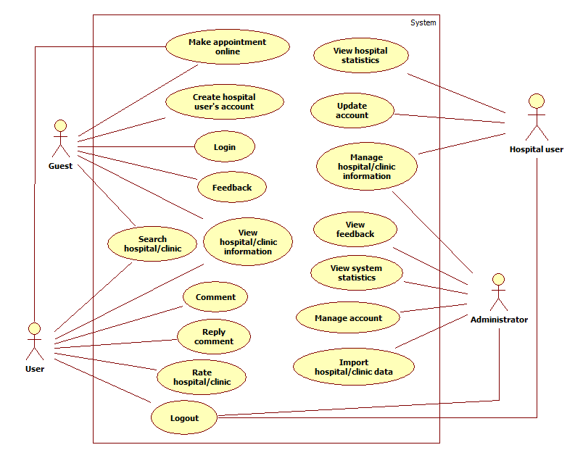

1. **Use case List**
   * 1. **<GU> Overview Use Case**

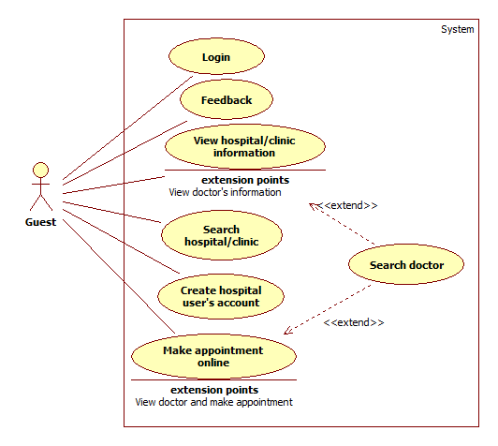

* + 1. **<GU> Login**



|  |  |  |  |  |
| --- | --- | --- | --- | --- |
| **USE CASE – UC001** | | | | |
| **Use-case No.** | UC001 | **Use-case Version** | | 1.0 |
| **Use-case Name** | Login | | | |
| **Author** | Vu Nhat Anh Khoa | | | |
| **Date** | 27/05/2014 | **Priority** | High | |
| **Actor:** Guests  **Summary:** Guests use this case to login to the system.  **Goal:** Allow guests to login and gain more priorities to use the system depending on the role of authorized account.  **Triggers:** Click “**Đăng Nhập**” button on browsers.  **Preconditions:** N/A  **Post Conditions:**   * **Successful**: Actors are automatically transfer back to homepage and be able to access the web’s functions assigned by their roles * **Fail**: Actors are only able to access the web’s functions as Guest. The system displays message: “Không đăng nhập được vào tài khoản của quý khách!”   **Main Success Scenario:**   |  |  |  | | --- | --- | --- | | **Step** | **Action** | **System response** | | 1 | Click “**Đăng Nhập**” button | Display login page that includes:   * Email: Textbox (Required, min length: 2, max length: 32) * Mật khẩu: Password (Required, min length: 8) * Ghi nhớ: Check box (optional) | | 2 | Enter Username and Password | Users is authorized to gain the priorities according to his/her role. The page automatically transfer to Homepage |   **Alternative Scenario:**  **A.**   |  |  |  | | --- | --- | --- | | **Step** | **Action** | **System response** | | 1 | Click “Đăng Nhập bằng Facebook” button image | If actor has not login to Facebook in their device, displays Facebook login page that includes:   * Email: Textbox (required, regular expression: @"^([a-zA-Z0-9_\-\.]+)@((\[[0-9]{1,3}\.[0-9]{1,3}\.[0-9]{1,3}\.)|(([a-zA-Z0-9\-]+\.)+))([a-zA-Z]{2,4}|[0-9]{1,3})(\]?)$") * Mật khẩu: Password (required, min length: 8) | | 2 | Fills required fields, then click “Đăng nhập” | Actor is directed to Facebook website and asked to authorize permissions to fetch their Facebook account’s information   * Allow “[www.timkiembenhvien.vn](http://www.timkiembenhvien.vn)” access your public information * Allow “[www.timkiembenhvien.vn](http://www.timkiembenhvien.vn)” access your email address * Allow “[www.timkiembenhvien.vn](http://www.timkiembenhvien.vn)” access your phone number | | 3 | Accept permission | The page automatically transfer to Homepage |   **B.**   |  |  |  | | --- | --- | --- | | **Step** | **Action** | **System response** | | 1 | Click “Đăng Nhập bằng Facebook” button image | If actor has login to Facebook in their device, displays Facebook page that asks permission for the following:   * Allow “[www.timkiembenhvien.vn](http://www.timkiembenhvien.vn)” access your public information * Allow “[www.timkiembenhvien.vn](http://www.timkiembenhvien.vn)” access your email address * Allow “[www.timkiembenhvien.vn](http://www.timkiembenhvien.vn)” access your phone number | | 2 | Accept permission | The page automatically transfer to Homepage |   **C.**   |  |  |  | | --- | --- | --- | | **Step** | **Action** | **System response** | | 1 | Click “Đăng Nhập bằng Facebook” button image | If actor has login to Facebook in their device, and the database has his/her account record. Then the system automatically transfers to Homepage |   **Exceptions:**   |  |  |  | | --- | --- | --- | | **No** | **Case** | **System response** | | 1 | Tên đăng nhập is blank | Display: “Xin hãy nhập Tên Đăng Nhập.” | | 2 | Mật khẩu is blank | Display: “Xin hãy nhập Mật Khẩu.” | | 3 | Email is incorrect | Display: “Email của bạn không đúng hoặc bạn chưa đăng ký thành viên” | | 4 | Mật khẩu is incorrect | Display: “Mật khẩu của bạn không đúng, xin hãy thử lại” | | 5 | Hospital account is expired | Display “Tài khoản đã hết hạn sử dụng. Xin liên hệ quản trị viên để kích hoạt tài khoản.” |   **Relationships**: N/A  **Business Rules:** Users must enter valid login information. If not, they cannot gain priorities to use services from Hospital Finder. | | | | |

* + 1. **<GU> Search Hospital**

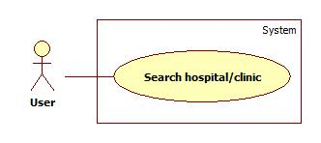

|  |  |  |  |  |
| --- | --- | --- | --- | --- |
| **USE CASE – UC002** | | | | |
| **Use-case No.** | UC002 | **Use-case Version** | | 1.0 |
| **Use-case Name** | Search Hospital | | | |
| **Author** | Vu Nhat Anh Khoa | | | |
| **Date** | 27/05/2014 | **Priority** | Normal | |
| **Actor:** Guests, Users  **Summary:** This case allows user search and view hospitals/clinics’ location.  **Goal:** Hospital/ Clinic’s location on embed Google Map will be shown.  **Triggers:**   * Actor goes to [www.timkiembenhvien.com](http://www.timkiembenhvien.com) to search * Actor choose basic search “Tìm kiếm cơ bản” or advanced search “Tìm kiếm nâng cao”   **Preconditions:** User must be able to access “[www.timkiembenhvien.com](http://www.timkiembenhvien.com)” page.  **Post Conditions:**   * **Successful**: Show search results which include a list of hospital/ clinic and a map that shows locations. * **Failed**: Show an error message.   **Main Success Scenario:**   |  |  |  | | --- | --- | --- | | **Step** | **Action** | **System response** | | 1 | Actor inputs the name of hospital/ clinic or type of disease or specialties into textbox and clicks “Tìm” button | Display list of hospitals/ clinics with relative name by link-boxes on the left of the screen with brief description   * Tên * Rating trung bình * Địa chỉ   Display an embed Google map on the right showing locations of searched hospitals/ clinics | | 2 | Actor chooses appropriate hospital/ clinic from the list. | Shows specific location of that hospital/ clinic on the map with pop-up screen displaying brief description:   * Tên * Rating trung bình * Địa chỉ * Số điện thoại * Image of that hospital/ clinic   Shows the direction from actor’s current location to the hospital/clinic’s location |   **Alternative Scenario:**   |  |  |  | | --- | --- | --- | | **Step** | **Action** | **System response** | | 1 | Actor choose “Tìm kiếm nâng cao” | Display following:   * Tên: Textbox * Chuyên khoa: Dropdown list * Địa chỉ: Textbox * “Tìm” button | | 2 | Click “Tìm” button | Display list of hospitals/ clinics with relative name by link-boxes on the left of the screen with brief description   * Tên * Rating trung bình * Địa chỉ   Display an embed Google map on the right showing locations of searched hospitals/ clinics | | 3 | Actor chooses appropriate hospital/ clinic from the list. | Shows specific location of that hospital/ clinic on the map with pop-up screen displaying brief description:   * Tên * Rating trung bình * Địa chỉ * Số điện thoại * Image of that hospital/ clinic   Shows the direction from actor’s current location to the hospital/clinic’s location |   **Exceptions:**   |  |  |  | | --- | --- | --- | | **Step** | **Action** | **System response** | | 1 | Actor inputs nothing in textbox in “Tìm kiếm cơ bản” | Display “Xin hãy nhập vào ô tìm kiếm” | | 2 | Actor inputs nothing in “Tìm kiếm nâng cao”’s fields | Display “Xin đừng để trống tất cả các mục, điền ít nhất một mục để tìm kiếm” |   **Relationships**: N/A  **Business Rules:** Result list will be ordered by matching percent. Actor can click on brief description pop-up screen to view details in the hospital/ clinic’s information page.  Actors can view direction from their current location to hospital/clinic’s location with type of transportation (by car, walking, bicycle or bus)  “Tìm kiếm nâng cao” requires at least one field is filled | | | | |

* + 1. **<GU> View Hospital Information <US>**



|  |  |  |  |  |
| --- | --- | --- | --- | --- |
| **USE CASE – UC003** | | | | |
| **Use-case No.** | UC003 | **Use-case Version** | | 1.0 |
| **Use-case Name** | View specific Hospital/Clinic ’s information | | | |
| **Author** | Vu Nhat Anh Khoa | | | |
| **Date** | 27/05/2014 | **Priority** | Normal | |
| **Actor:** Guests  **Summary:** Guests use this case to view specific hospital/clinics information  **Goal:** Allow guests to view specific hospital/clinics information.  **Triggers:** After using search function, click to specific hospital/clinic name, this will display a brief descriptions of that hospital/clinic, click to the name to view more details.  **Preconditions:** Used the search function to find group of hospitals/clinics  **Post Conditions:**   * **Success:** Direct actor to specific hospital/clinic information page * **Fail:** N/A   **Main Success Scenario:**   |  |  |  | | --- | --- | --- | | **Step** | **Action** | **System response** | | 1 | Clicks a hospital/clinic name on the pop-up | Display hospital/clinic information page that includes:   * Embed google map that shows the hospital/clinic location * “Đặt lịch hẹn” button * Tên bệnh viện * Rating trung bình * Địa chỉ * Số điện thoại * Fax * Email * Website * Mô tả   On the right side displays list of users’ comments and rating |   **Alternative Scenario:** N/A  **Exceptions:** N/A  **Relationships**: (Search Hospital use case)  **Business Rules:** Actor must use the search engine to narrow down hospitals/clinics based on location, department, urgent needs, services | | | | |

* + 1. **<GU> Search Doctor**

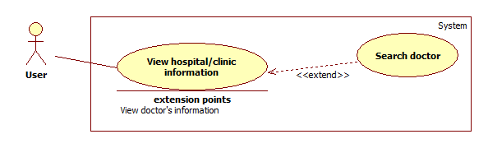

|  |  |  |  |  |
| --- | --- | --- | --- | --- |
| **USE CASE – UC004** | | | | |
| **Use-case No.** | UC004 | **Use-case Version** | | 1.0 |
| **Use-case Name** | Search doctor | | | |
| **Author** | Duong Thi Hoang Anh | | | |
| **Date** | 29/05/2014 | **Priority** | Normal | |
| **Actor:**   * User * Guest   **Summary:** This case allows user search and view doctor’s information.  **Goal:** Doctor’s information will be shown.  **Triggers:** Click “**Tìm**” button after filling searched textbox the name of a doctor, or choose a specific speciality in speciality drop down list.  **Preconditions:** User is in “**Danh sách bác sĩ**” page.  **Post Conditions:**   * **Successful**: Show search results which include a list of doctor. * **Failed**: An error message will be displayed.   **Main Success Scenario:**   |  |  |  | | --- | --- | --- | | **Step** | **Action** | **System response** | | 1 | Enter the name of doctor in searched text box then click “**Tìm**” button | Display list of doctor with relative name as a table with:   * Hình ảnh * Họ tên * Chuyên khoa * Chứng chỉ/Bằng cấp * Kinh nghiệm * Lịch làm việc * Đặt lịch khám: Link refers to make appointment online page. |   **Alternative Scenario:**   |  |  |  | | --- | --- | --- | | **Step** | **Action** | **System response** | | 1 | Choose a specific speciality in drop down list then clicks “**Tìm**” button | Display list of all doctors that good at the chosen speciality. |   **Exceptions:**   |  |  |  | | --- | --- | --- | | **Step** | **Action** | **System response** | | 1 | No result are found | Display: “Không có kết quả phù hợp” | | 2 | Enter nothing in searched text box and chooses nothing in speciality drop down list, and then click “**Tìm**” button | Display: “Xin hãy nhập tên bác sĩ hoặc chọn một chuyên khoa.” | | 3 | System failure | Display: ”Đã có lỗi xảy ra trong quá trình xử lý thông tin. Mong quý vị thông cảm và thử lại sau vài phút.” |   **Relationships**: N/A  **Business Rules:** The list will can be filtered by ascending or descending values in a column. | | | | |

* + 1. **<GU> Make Appointment Online <US>**

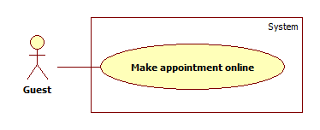

|  |  |  |  |  |
| --- | --- | --- | --- | --- |
| **USE CASE – UC005** | | | | |
| **Use-case No.** | UC005 | **Use-case Version** | | 1.0 |
| **Use-case Name** | Make appointment online | | | |
| **Author** | Duong Thi Hoang Anh | | | |
| **Date** | 29/05/2014 | **Priority** | Normal | |
| **Actor:**   * Guest * User   **Summary:** This case allows user to make an appointment online  **Goal:** User makes new appointment appropriate with his/her specific.  **Triggers:**   * User wants to make an appointment with hospital/clinic which allows appointment. * User clicks on “Đặt lịch khám” link in doctor search result * User can click on “Đặt lịch hẹn” image in hospital/clinic information page.   **Preconditions:** User must must meet the requirements of use case **UC001** (Login)  **Post Conditions:**   * **Successful**: New appointment is added and confirm message is sent to user’s mobile. * **Failed**: An error message will be displayed.   **Main Success Scenario:**   |  |  |  | | --- | --- | --- | | **Step** | **Action** | **System response** | | 1 | Click “**Đặt lịch hẹn**” image button in hospital / clinic information page. | Transfer to “Đặt lịch khám” page which include:   * Thông tin bệnh nhân:   + Giới tính: Drop down list.   + Ngày sinh: Datetime picker   + Họ tên: Textbox (Required, max length)   + Email: Textbox (Regular expression: @"^([a-zA-Z0-9_\-\.]+)@((\[[0-9]{1,3}\.[0-9]{1,3}\.[0-9]{1,3}\.)|(([a-zA-Z0-9\-]+\.)+))([a-zA-Z]{2,4}|[0-9]{1,3})(\]?)$")   + Số điện thoại: Textbox (required, max length: 13, regular expression: @"^\d{3,5}(-|\s)?\d{3}(-|\s)?\d{3,4}$") * Thông tin đặt hẹn: * Chuyên khoa: Drop down list * Bác sĩ: Drop down list (The list will be changed according to Chuyên khoa) * Calendar popup and time view popup (Required) * Captcha: Image * Hình ảnh mới: Link to change new Captcha image * Input captcha: Textbox (Required) * Đặt lịch khám: Button | | 2 | Enter required information, then click on “**Đặt lịch khám**” button. | A notification appears and displays a message: “Tin nhắn xác nhận đã được gửi theo số điện thoại đăng kí. Vui lòng xác nhận cuộc hẹn qua tin nhắn.” | | 3 | After receiving confirmation message from user. | The appointment will be synchronized to Google Calendar of the hospital user that manages the previous booking hospital. |   **Alternative Scenario:**   |  |  |  | | --- | --- | --- | | **Step** | **Action** | **System response** | | 1 | Click on “Đặt lịch khám” link on doctor search result | Transfer to “Đặt lịch khám” page that includes:   * Thông tin bệnh nhân:   + Giới tính: Drop down list.   + Ngày sinh: Datetime picker   + Họ tên: Textbox (Required, max length)   + Email: Textbox (Regular expression: @"^([a-zA-Z0-9_\-\.]+)@((\[[0-9]{1,3}\.[0-9]{1,3}\.[0-9]{1,3}\.)|(([a-zA-Z0-9\-]+\.)+))([a-zA-Z]{2,4}|[0-9]{1,3})(\]?)$")   + Số điện thoại: Textbox (required, max length: 13, regular expression: @"^\d{3,5}(-|\s)?\d{3}(-|\s)?\d{3,4}$") * Thông tin đặt hẹn: * Chuyên khoa: Drop down list (With default value is speciality of selected doctor) * Bác sĩ: Drop down list (With default value is the doctor who is selected on doctor search result) * Thời gian khám bệnh: Calendar popup and time view popup (Required) * Captcha: Image * Hình ảnh mới: Link to change new Captcha image * Input captcha: Textbox (Required) * Đặt lịch khám: Button | | 2 | Enter required information, then click on “**Đặt lịch khám**” button. | A notification appears and displays a message: “Tin nhắn xác nhận đã được gửi theo số điện thoại đăng kí. Vui lòng xác nhận cuộc hẹn qua tin nhắn.” | | 3 | After receiving confirmation message from user. | The appointment will be synchronized to Google Calendar of the hospital user that manages the previous booking hospital. |   **Exceptions:**   |  |  |  | | --- | --- | --- | | **2** | **Case** | **System response** | | 1 | “Giới tính” is not selected | Display “Xin hãy chọn Giới tính” | | 2 | “Năm sinh” is not selected | Display “Xin hãy chọn Năm sinh” | | 3 | “Họ tên” is blank | Display “Xin hãy nhập Họ tên” | | 4 | “Số điện thoại” is blank | Display “Xin hãy nhập Số điện thoại” | | 5 | “Số điện thoại” expression is invalid | Display “Số điện thoại không hợp lệ” | | 6 | “Thời gian khám bệnh” is blank | Display “Xin hãy nhập Thời gian khám bệnh” | | 7 | System failure | Display: “Đã có lỗi xảy ra trong quá trình xử lý thông tin. Mong quý vị thông cảm và thử lại sau vài phút.” |   **Relationships**: N/A  **Business Rules:** Users must confirm their appointments through mobile message, if not, the appointments will not be approved. | | | | |

* + 1. **<GU> Feedback**



|  |  |  |  |  |
| --- | --- | --- | --- | --- |
| **USE CASE – UC006** | | | | |
| **Use-case No.** | UC006 | **Use-case Version** | | 1.0 |
| **Use-case Name** | Feedback | | | |
| **Author** | Vũ Nhật Anh Khoa | | | |
| **Date** | 27/05/2014 | **Priority** | Normal | |
| **Actor:** Guest  **Summary:** User accesses the system, uses Feedback function and sends a review for specific hospital/clinic or the system  **Goal:** Stored user’s feedback to database successfully  **Triggers:** Click on “Phản hồi” item on menu bar.  **Preconditions:** User must meet the requirements of use case **UC001** (Login).  **Post Conditions:**   * **Success**: New feedback is stored in database * **Fail:** New feedback couldn’t be stored in database, display message to users: “Không thể gửi feedback, xin vui lòng thử lại”   **Main Success Scenario:**   |  |  |  | | --- | --- | --- | | **Step** | **Action** | **System response** | | 1 | User goes to Phản hồi page | Displays two option (using radio button):   * Phản hồi về bệnh viện with a dropdown list which display list of hospital/clinic * Phản hồi về hệ thống | | 2 | User chooses Feedback type | Directs User to Feedback form | | 3 | User fills Feedback form | Displays feedback creation form include:   * Tiêu đề: Text area (required) * Nội dung: Text area (required) * “Gửi” button * “Hủy” button | | 4 | User click “Gửi” button | The system validates input information then stores new feedback to database |   **Alternative Scenario:**   |  |  |  | | --- | --- | --- | | **Step** | **Action** | **System response** | | 1 | User clicks “Hủy” button | Direct user to homepage |   **Exceptions:**   |  |  |  | | --- | --- | --- | | **No** | **Case** | **System response** | | 1 | “Tiêu đề” is blank | Displays: “Vui lòng nhập tiêu đề.” | | 2 | “Nội dung” is blank | Displays: “Vui lòng nhập nội dung.” |   **Relationships**: UC001  **Business Rules:** N/A | | | | |

1. **<GU> Create Hospital User’s Account**

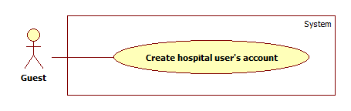

|  |  |  |  |  |
| --- | --- | --- | --- | --- |
| **USE CASE – UC007** | | | | |
| **Use-case No.** | UC007 | **Use-case Version** | | 1.0 |
| **Use-case Name** | Create hospital user’s account | | | |
| **Author** | Duong Thi Hoang Anh | | | |
| **Date** | 15/06/2014 | **Priority** | High | |
| **Actor:** Guest  **Summary:** Guest use this case to create account.  **Goal:** Guest want to register account to be hospital user who manage hospital/clinic  **Triggers:** Click on “**Tạo tài khoản**” item on drop down menu “**Quản lý bệnh viện / phòng khám**”.  **Preconditions: N/A**  **Post Conditions:**   * **Successful**: New hospital account will be created and wait to admin approves. * **Failed**: An error message will be displayed.   **Main Success Scenario:**   |  |  |  | | --- | --- | --- | | **Step** | **Action** | **System response** | | 1 | Click on “Đối tác bệnh viện” item on “Đối tác” menu in footer of website | Display “Dành cho bệnh viện/phòng khám” page which includes:   * Login form. * Đăng ký ngay: button | | 1 | Click on “Đăng ký ngay” button | Display “Tạo tài khoản” page that includes:   * “Chọn bệnh viện / phòng khám”: Active tab that contains:   + A drop down list contains all hospitals and clinics of system.   + “Nếu bệnh viện / phòng khám chưa sẵn có hãy đăng ký tại đây”: Label. With “Tại đây” is a link that refers to page “Đăng ký bệnh viện / Phòng khám”.   + “Tiếp tục”: Button * “Thông tin tài khoản”: De-active tab. | | 2 | Choose a hospital / clinic in drop down list to assign for new hospital use and then and click “**Tiếp tục**” button. | “Thông tin tài khoản” tab change from de-active to active and display account creation form which include:   * Email: Textbox (required, regular expression: @"^([a-zA-Z0-9_\-\.]+)@((\[[0-9]{1,3}\.[0-9]{1,3}\.[0-9]{1,3}\.)|(([a-zA-Z0-9\-]+\.)+))([a-zA-Z]{2,4}|[0-9]{1,3})(\]?)$") * Họ: Textbox (Required, max length: 16) * Tên: Textbox (Required, max length: 16) * Số điện thoại: Textbox (Required) * Tạo mới: Button | | 3 | Enter required information, and then click “**Tạo mới**” button. | New hospital account will be created. The system then display a message: “Tài khoản đăng ký thành công. Vui lòng kiểm tra email để kích hoạt tài khoản.” |   **Alternative Scenario:**   |  |  |  | | --- | --- | --- | | **Step** | **Action** | **System response** | | 1 | Click on “**tại đây**” link in “**Nếu bệnh viện / phòng khám chưa sẵn có hãy đăng ký tại đây**” label in case hospital or clinic does not contain in the hospital list. | Redirect to “Đăng ký bệnh viện / phòng khám” page.  For more detail description please refer to use case UC0031 (Create hospital) |   **Exceptions:**   |  |  |  | | --- | --- | --- | | **No** | **Case** | **System response** | | 1 | Email is blank | Display: “Xin hãy nhập Email.” | | 2 | Email expression is invalid. | Display: “Địa chỉ Email không hợp lệ.” | | 3 | Email’s existed already. | Display: “Địa chỉ Email này đã được sử dụng.” | | 4 | “Họ” is blank | Display: “Xin hãy nhập Họ.” | | 5 | “Họ”’s length is over 16 characters. | Display: “Họ không thể vượt quá 16 ký tự.” | | 6 | “Tên” is blank | Display: “Xin hãy nhập Tên.” | | 7 | “Tên”‘s length is over 16 characters. | Display: “Tên không thể vượt quá 16 ký tự.” | | 8 | “Số điện thoại” is blank | Display: “Xin hãy nhập Số Điện Thoại.” | | 9 | “Số điện thoại” expression is invalid. | Display: “Số ĐiệnThoại không hợp lệ.” | | 10 | System failure | Display: “Đã có lỗi xảy ra trong quá trình xử lý thông tin. Mong quý vị thông cảm và thử lại sau vài phút.” |   **Relationships**: N/A  **Business Rules:**  New account is created, however account is activated until admin approves account.  One hospital user’s account must be assigned with a specific hospital or clinic. If that hospital or clinic does not contain in database, administrator must create a new hospital base on provided information from user. | | | | |

* + 1. **<US> Overview Use Case**

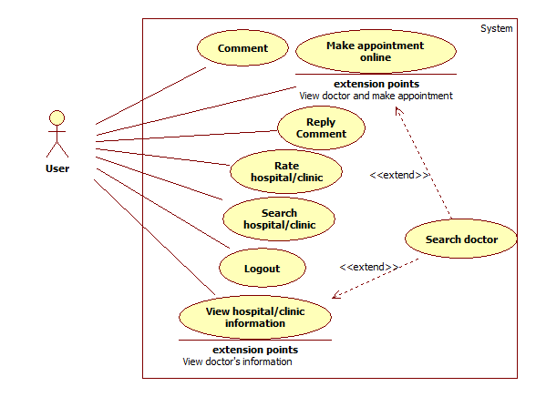

* + 1. **<US> Search Hospital**

Please refer to use case UC002

* + 1. **<US> View Hospital Information <GU>**



|  |  |  |  |  |
| --- | --- | --- | --- | --- |
| **USE CASE – UC009** | | | | |
| **Use-case No.** | UC009 | **Use-case Version** | | 1.0 |
| **Use-case Name** | View specific Hospital/Clinic ’s information | | | |
| **Author** | Vu Nhat Anh Khoa | | | |
| **Date** | 27/05/2014 | **Priority** | Normal | |
| **Actor:** Guests  **Summary:** Guests use this case to view specific hospital/clinics information  **Goal:** Allow guests to view specific hospital/clinics information.  **Triggers:** After using search function, click to specific hospital/clinic name, this will display a brief descriptions of that hospital/clinic, click to the name to view more details.  **Preconditions:** Used the search function to find group of hospitals/clinics  **Post Conditions:**   * **Success:** Direct actor to specific hospital/clinic information page * **Fail:** N/A   **Main Success Scenario:**   |  |  |  | | --- | --- | --- | | **Step** | **Action** | **System response** | | 1 | Clicks a hospital/clinic name on the pop-up | Display hospital/clinic information page that includes:   * Embed google map that shows the hospital/clinic location * “Đặt lịch hẹn” button * Tên bệnh viện * Rating trung bình * Địa chỉ * Số điện thoại * Fax * Email * Website * Mô tả   On the right side displays list of users’ comments and rating |   **Alternative Scenario:** N/A  **Exceptions:** N/A  **Relationships**: (Search Hospital use case)  **Business Rules:** Actor must use the search engine to narrow down hospitals/clinics based on location, department, urgent needs, services | | | | |

* + 1. **<US> Search Doctor**

Please refer to use case UC004

* + 1. **<US> Make Appointment Online**

Please refer to use case UC005

* + 1. **<US> Comment**

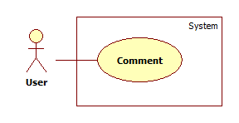

|  |  |  |  |  |
| --- | --- | --- | --- | --- |
| **USE CASE – UC012** | | | | |
| **Use-case No.** | UC012 | **Use-case Version** | | 1.0 |
| **Use-case Name** | Comment | | | |
| **Author** | Duong Thi Hoang Anh | | | |
| **Date** | 29/05/2014 | **Priority** | Normal | |
| **Actor:** Users  **Summary:** Users use this case to comment upon an article.  **Goal:** Create comment about a hospital or clinic through Facebook comment  **Triggers:** Press Enter while staying in Facebook comment textbox  **Preconditions:** User must must meet the requirements of use case **UC001** (Login) as the role of Normal user  **Post Conditions:**   * **Successful**: New comment will be created in comment area * **Failed**: Show error message.   **Main Success Scenario:**   |  |  |  | | --- | --- | --- | | **Step** | **Action** | **System response** | | 1 | Write a comment, and then press Enter | Comment will be posted in comment area. |   **Alternative Scenario:** N/A  **Exceptions:**   |  |  |  | | --- | --- | --- | | **No** | **Case** | **System response** | | 1 | Cannot post comment | Display: “Unable to post comment. Try again.” If you use Facebook in English, and “Không thể tạo bình luận. Xin thử lại.” if you use Facebook in Vietnamese |   **Relationships**: N/A  **Business Rules:** N/A | | | | |

* + 1. **<US> Reply Comment**

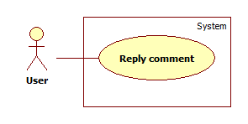

|  |  |  |  |  |
| --- | --- | --- | --- | --- |
| **USE CASE – UC013** | | | | |
| **Use-case No.** | UC013 | **Use-case Version** | | 1.0 |
| **Use-case Name** | Reply comment | | | |
| **Author** | Duong Thi Hoang Anh | | | |
| **Date** | 29/05/2014 | **Priority** | Normal | |
| **Actor:** Users  **Summary:** Users use this case to reply to a comment upon an article.  **Goal:** Create reply comment about a hospital or clinic through Facebook comment  **Triggers:** Press Reply link in Facebook comment area  **Preconditions:** User must must meet the requirements of use case **UC001** (Login) as the role of Normal user  **Post Conditions:**   * **Successful**: New comment will be created in comment area * **Failed**: Show error message.   **Main Success Scenario:**   |  |  |  | | --- | --- | --- | | **Step** | **Action** | **System response** | | 1 | Write reply comment, and then press Enter | Comment will be posted under replied comment. |   **Alternative Scenario:** N/A  **Exceptions:**   |  |  |  | | --- | --- | --- | | **No** | **Case** | **System response** | | 1 | Cannot post comment | Display: “Unable to post comment. Try again.” If you use Facebook in English, and “Không thể tạo bình luận. Xin thử lại.” if you use Facebook in Vietnamese |   **Relationships**: N/A  **Business Rules:** N/A | | | | |

* + 1. **<US> Rating Hospital**

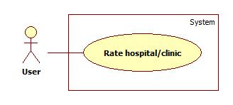

|  |  |  |  |  |
| --- | --- | --- | --- | --- |
| **USE CASE – UC014** | | | | |
| **Use-case No.** | UC014 | **Use-case Version** | | 1.0 |
| **Use-case Name** | Rate Hospital | | | |
| **Author** | Vu Nhat Anh Khoa | | | |
| **Date** | 27/05/2014 | **Priority** | Low | |
| **Actor:** Users  **Summary:** Users use this case to give rating to a specific Hospital  **Goal:** Users can determining a specific hospital’s quality by using five-stars rating system.  **Triggers:** After view specific Hospital/Clinic’s information, user can give rating by clicking the five-stars  **Preconditions:** User must fulfill View specific hospital/clinic use case  **Post Conditions:**   * **Success:** Average rating is showed to user * **Fail:** show error message “Không thể vote”   **Main Success Scenario:**   |  |  |  | | --- | --- | --- | | **Step** | **Action** | **System response** | | 1 | User on a specific Hospital/clinic description page | Display a five-star rating system on the left bellow Hospital/clinic’s name | | 2 | User determine how many stars the hospital/clinic get by clicking to the five-stars | Show the message: “Xin cảm ơn vì đã vote”  Calculate average rating then showed it to the screen |   **Alternative Scenario:** N/A  **Exceptions:**   |  |  |  | | --- | --- | --- | | **Step** | **Action** | **System response** | | 1 | User has already rate the hospital | Show message: “Bạn đã rate bệnh viện/phòng khám này rồi” |   **Relationships**: N/A  **Business Rules:**  The five stars rating is embed to the website with criteria:   * Rate 5: Excellent * Rate 4: Good * Rate 3: Average * Rate 2: Not very good * Rate 1: Poor | | | | |

* + 1. **<US> Logout**

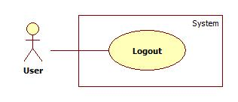

|  |  |  |  |  |
| --- | --- | --- | --- | --- |
| **USE CASE – UC015** | | | | |
| **Use-case No.** | UC015 | **Use-case Version** | | 1.0 |
| **Use-case Name** | Log out | | | |
| **Author** | Vu Nhat Anh Khoa | | | |
| **Date** | 27/05/2014 | **Priority** | High | |
| **Actor:** Users  **Summary:** User use this case to log out of the system.  **Goal:** Allow user to log out of the system and become guest  **Triggers:** Click “Đăng Xuất” button on browsers.  **Preconditions:** Actor must meet the requirements of use case **UC001** (Login).  **Post Conditions:**   * **Successful**: Actors are automatically transfer back to homepage and just only be able to access functions assigned to Guest * **Fail**: Show error message   **Main Success Scenario:**   |  |  |  | | --- | --- | --- | | **Step** | **Action** | **System response** | | 1 | Click “Đăng Xuất” button | The system log user out of the system, redirect to homepage |   **Alternative Scenario:**   |  |  |  | | --- | --- | --- | | **Step** | **Action** | **System response** | | 1 | User close the webpage or browser | The system automatically log user out |   **Exceptions:** N/A  **Relationships**: N/A  **Business Rules:** N/A | | | | |

* + 1. **<HU> Overview Use Case**

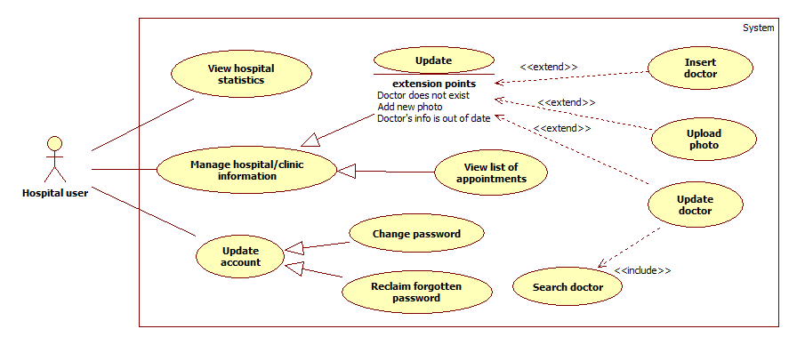

* + 1. **<HU> Add New Doctor**

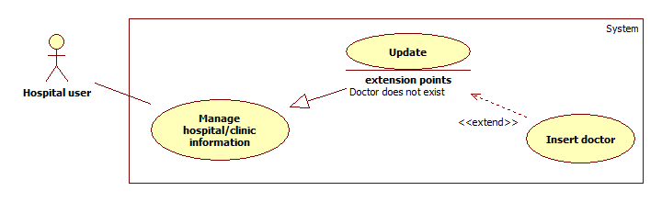

|  |  |  |  |  |
| --- | --- | --- | --- | --- |
| **USE CASE – UC016** | | | | |
| **Use-case No.** | UC016 | **Use-case Version** | | 1.0 |
| **Use-case Name** | Add new doctor | | | |
| **Author** | Duong Thi Hoang Anh | | | |
| **Date** | 29/05/2014 | **Priority** | Normal | |
| **Actor:** Hospital user.  **Summary:** This case allows Hospital user to add new doctors.  **Goal:** New doctors will be added to the list of doctors in a specific hospital or clinic.  **Triggers:** Click “**Thêm bác sĩ**” link in “**Danh sách bác sĩ**” page.  **Preconditions:** User must meet the requirements of use case **UC001** (Login) as the role of Hospital user.  **Post Conditions:**   * **Successful**: New doctors will be created. * **Failed**: Doctor will not be added to list and an error message will be displayed.   **Main Success Scenario:**   |  |  |  | | --- | --- | --- | | **Step** | **Action** | **System response** | | 1 | Click “**Thêm bác sĩ**” link in “**Danh sách bác sĩ**” page | Transfer to “**Tạo mới bác sĩ**” page that includes:   * Thông tin cơ bản: Active tab * Họ: Textbox (Required, max length: 16) * Tên: Textbox (Required, max length: 16) * Email: Textbox (Required, regular expression: @"^([a-zA-Z0-9_\-\.]+)@((\[[0-9]{1,3}\.[0-9]{1,3}\.[0-9]{1,3}\.)|(([a-zA-Z0-9\-]+\.)+))([a-zA-Z]{2,4}|[0-9]{1,3})(\]?)$") * Chuyên khoa: Drop down list (Required) * Thêm chuyên khoa: Link to add new speciality. * Chứng chỉ / Bằng cấp: Textbox (Required) * Kinh nghiệm: Text area. * Hình ảnh: text file (regular expression: “^([0-9a-zA-Z_\-~:\\])+ (.jpg|.JPG|.jpeg|.JPEG|.bmp|.BMP| * .gif|.GIF|.png|.PNG)$”) * Tiếp tục: Button * Lịch làm việc: De-active tab | | 2 | Enter required information in “**Thông tin cơ bản**” tab, then click “**Tiếp tục**” button | Transfer to “Lịch làm việc” page that includes:   * Ngày trong tuần: from Monday to Sunday: Check (Required) * Thời gian làm việc:   + From: drop down list   + To: drop down list * Tạo mới: Button | | 3 | Choose work schedule for doctor then click on “**Tạo mới**” button | New doctor will be created. A notification appears and display a message: “Bác sĩ được tạo thành công.” |   **Alternative Scenario: N/A**  **Exceptions:**   |  |  |  | | --- | --- | --- | | **No** | **Case** | **System response** | | 1 | “Họ” is blank | Display: “Xin hãy nhập Họ.” | | 2 | “Họ”’s length is over 16 characters | Display: “Họ không thể vượt quá 16 ký tự.” | | 3 | “Tên” is blank | Display: “Xin hãy nhập Tên.” | | 4 | “Tên”‘s length is over 16 characters. | Display: “Tên không thể vượt quá 16 ký tự.” | | 5 | Email is blank | Display: “Xin hãy nhập Email.” | | 6 | Email expression is invalid | Display: “Địa chỉ Email không hợp lệ.” | | 7 | Email address is duplicated with an existed one in database | Display: “Địa chỉ Email này đã được sử dụng.” | | 8 | “Chuyên khoa” is blank | Display: “Xin hãy chọn Chuyên Khoa.” | | 9 | “Chứng chỉ/Bằng cấp” is blank | Display: “Xin hãy nhập Chứng chỉ / Bằng cấp.” | | 10 | Image file is wrong format | Display: “Tập tin hình ảnh không đúng định dạng.” | | 11 | System failure | Display: “Đã có lỗi xảy ra trong quá trình xử lý thông tin. Mong quý vị thông cảm và thử lại sau vài phút.” |   **Relationships**: N/A  **Business Rules:** Only the Hospital user who manage the hospital or clinic can have the right to add doctors to his / her center. | | | | |

* + 1. **<HU> Search List of Doctors**

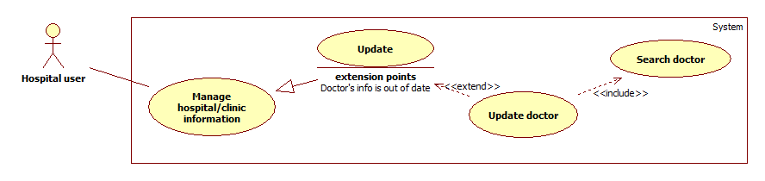

|  |  |  |  |  |
| --- | --- | --- | --- | --- |
| **USE CASE – UC017** | | | | |
| **Use-case No.** | UC017 | **Use-case Version** | | 1.0 |
| **Use-case Name** | Search list of doctors | | | |
| **Author** | Duong Thi Hoang Anh | | | |
| **Date** | 29/05/2014 | **Priority** | Normal | |
| **Actor:** Hospital user.  **Summary:** This case allows Hospital user to search and view doctors’ information of his / her hospital or clinic.  **Goal:** Display information of doctors.  **Triggers:** Click “**Tìm**” button after filling searched textbox the name of a doctor, or choose a specific speciality in speciality drop down list.  **Preconditions:** User must be in “**Danh sách bác sĩ**” page.  **Post Conditions:**   * **Successful**: Display a list doctors according to his / her name or speciality. * **Failed**: An error message will be displayed.   **Main Success Scenario:**   |  |  |  | | --- | --- | --- | | **Step** | **Action** | **System response** | | 1 | Enter the name of doctor in searched text box then click “**Tìm**” button | Display a table that contains a list of doctors with the following columns:   * Hình ảnh * Họ tên * Email * Chuyên khoa * Chứng chỉ / Bằng cấp * Kinh nghiệm * Lịch làm việc * Trạng thái | | 2 | Click “Họ tên” of a specific doctor. | Transfer to “Thông tin bác sĩ” page that includes:   * Thông tin cơ bản:   + Họ tên   + Email   + Chuyên khoa   + Chứng chỉ/Bằng cấp   + Kinh nghiệm   + Hình ảnh   + Chỉnh sửa: image refers to basic information update form. * Lịch làm việc:   + Ngày   + Thời gian   + Chỉnh sửa: Image refers to work schedule update form. |   **Alternative Scenario:**   |  |  |  | | --- | --- | --- | | **Step** | **Action** | **System response** | | 1 | Choose a specific speciality in drop down list then clicks “**Tìm**” button | Display list of all doctors that good at the chosen speciality. |   **Exceptions:**   |  |  |  | | --- | --- | --- | | **No** | **Case** | **System response** | | 1 | No result are found | Display: “Không có kết quả phù hợp.” | | 2 | Enter nothing in searched text box and chooses nothing in speciality drop down list, and then click “**Tìm**” button | Display: “Xin hãy nhập tên bác sĩ hoặc chọn một chuyên khoa.” | | 3 | System failure | Display: ” Đã có lỗi xảy ra trong quá trình xử lý thông tin. Mong quý vị thông cảm và thử lại sau vài phút.” |   **Relationships**: N/A  **Business Rules:** The list will can be filtered by ascending or descending values in a column. | | | | |

* + 1. **<HU> Update Doctor Information**

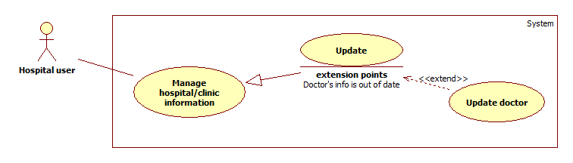

|  |  |  |  |  |
| --- | --- | --- | --- | --- |
| **USE CASE – UC018** | | | | |
| **Use-case No.** | UC018 | **Use-case Version** | | 1.0 |
| **Use-case Name** | Update doctor’s information | | | |
| **Author** | Duong Thi Hoang Anh | | | |
| **Date** | 29/05/2014 | **Priority** | Normal | |
| **Actor:** Hospital user.  **Summary:** This case allows Hospital user to update doctors’ information.  **Goal:** New information will be updated.  **Triggers:** In “Thông tin bác sĩ” page, click on “Chỉnh sửa” icon at basic information or work schedule.  **Preconditions:** User must meet the requirements of use case **UC001** (Login) as the role of Hospital user.  **Post Conditions:**   * **Successful**: Selected doctor will be updated new information. * **Failed**: Doctor will not be updated. Error message is displayed.   **Main Success Scenario:**   |  |  |  | | --- | --- | --- | | **Step** | **Action** | **System response** | | 1 | Search the doctor and then click on his / her name | Transfer to “Thông tin bác sĩ” page that includes:   * Thông tin cơ bản: * Họ tên * Email * Chuyên khoa * Chứng chỉ/Bằng cấp * Kinh nghiệm * Hình ảnh * Chỉnh sửa: image refers to basic information update form. * Lịch làm việc: * Ngày * Thời gian * Chỉnh sửa: image refers to work schedule update form. | | 2 | User clicks on “Chỉnh sửa” image in “Thông tin cơ bản”. | Display “Cập nhật thông tin cơ bản” form that includes:   * Họ tên: Textbox * Email: Textbox (regular expression: @"^([a-zA-Z0-9_\-\.]+)@((\[[0-9]{1,3}\.[0-9]{1,3}\.[0-9]{1,3}\.)|(([a-zA-Z0-9\-]+\.)+))([a-zA-Z]{2,4}|[0-9]{1,3})(\]?)$") * Chuyên khoa: Textbox * Thêm chuyên khoa: Link to add new speciality. * Chứng chỉ / Bằng cấp: Textbox * Kinh nghiệm: Text area.   + Hình ảnh: Input file (regular expression: “^([0-9a-zA-Z_\-~ :\\])+(.jpg|.JPG|.jpeg|.JPEG|.bmp|.BMP|png|.PNG)$”) * Cập nhật: Button. * Hủy: Button | | 3 | Update information then Click “**Cập nhật**” button. | “Cập nhật thông tin cơ bản” form disappears and a notification appears and displays a message: “Cập nhật thông tin thành công.” | | 4 | Click “**Chỉnh sửa**” image in “**Lịch làm việc**” | Display “Cập nhật lịch làm việc” form include:   * Ngày trong tuần: from Monday to Sunday: checkbox * Thời gian làm việc:   + From: Drop down list   + To: Drop down list * Cập nhật: button * Hủy: button | | 5 | Update work schedule and then click “**Cập nhật**” button | “Cập nhật lịch làm việc” form disappear and a notification appears and displays a message: “Cập nhật lịch làm việc thành công.” |   **Alternative Scenario:**   |  |  |  | | --- | --- | --- | | **Step** | **Action** | **System response** | | 1 | User clicks on “**Hủy**” button in “**Cập nhật thông tin cơ bản**” to cancel. | No information is updated. “Cập nhật thông tin cơ bản” will disappear. System will return “Thông tin bác sĩ” page. | | 2 | User clicks on “**Hủy**” button in **“Cập nhật lịch làm việc**” to cancel. | No information is updated. “Cập nhật lịch làm việc” will disappear. System will return “Thông tin bác sĩ” page. |   **Exceptions:**   |  |  |  | | --- | --- | --- | | **No** | **Case** | **System response** | | 1 | Image file is wrong format | Display: “Tập tin hình ảnh không đúng định dạng” | | 2 | Email expression is invalid. | Display: “Địa chỉ Email không hợp lệ.” |   **Relationships**: N/A  **Business Rules:** Only the Hospital user who manage the hospital or clinic can have the right to update doctors’ information from his / her center. | | | | |

* + 1. **<HU> Upload Photo**

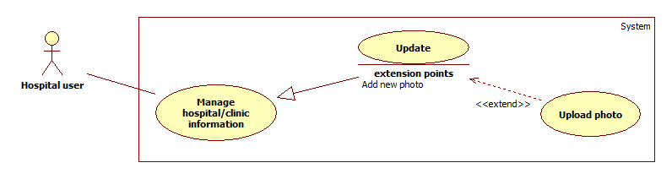

|  |  |  |  |  |
| --- | --- | --- | --- | --- |
| **USE CASE – UC019** | | | | |
| **Use-case No.** | UC019 | **Use-case Version** | | 1.0 |
| **Use-case Name** | Upload photo | | | |
| **Author** | Duong Thi Hoang Anh | | | |
| **Date** | 29/05/2014 | **Priority** | Normal | |
| **Actor:**   * Hospital users. * Administrators.   **Summary:** This case allows users to upload new photos for hospital or doctor.  **Goal:** Update new photos for hospital or doctor.  **Triggers:** Click “**Thêm hình ảnh**” button in “**Thư viện ảnh**” tab  **Preconditions:** Users are staying at “**Thông tin bệnh viện / phòng khám**” page  **Post Conditions:**   * **Successful**: New photos will be uploaded. * **Failed**: Error message will be displayed.   **Main Success Scenario:**   |  |  |  | | --- | --- | --- | | **Step** | **Action** | **System response** | | 1 | Click on tab “**Thư viện ảnh**” in “**Thông tin bệnh viện/phòng khám**” page. | Direct to “Thư viện ảnh” page which include:   * Thêm hình ảnh: button * List all of photos with “Xóa” icon on each photo. | | 2 | Click “**Thêm hình ảnh**” button | Display drop zone screen to upload photo. | | 3 | Click the drop zone | Display file explorer screen to choose image file. | | 4 | Choose photos to upload, then clicks on “**Open**” button | Display all selected photo with “Xóa” button below each photo. (Regular expression: “^([0-9a-zA-Z_\-~ :\\])+(.jpg|.JPG|.jpeg|.JPEG|.bmp|.BMP| .gif|.GIF|.png|.PNG)$”)) | | 5 | Click “**Tải lên**” button | All uploaded photos display in “Thư viện ảnh” |   **Alternative Scenario:**   |  |  |  | | --- | --- | --- | | **Step** | **Action** | **System response** | | 1 | User can drag image files from file explorer and drop into the drop zone to upload files. | Display all selected photo with “Xóa” button below each photo. |   **Exceptions:**   |  |  |  | | --- | --- | --- | | **No** | **Case** | **System response** | | 1 | Image file is wrong format | Display: “Tập tin hình ảnh không đúng định dạng” |   **Relationships**: N/A  **Business Rules:**  Only file with format .jpg, .JPG, .jpeg, .JPEG, .bmp, .BMP, .gif, .GIF, .png, .PNG are allow to be uploaded. | | | | |

* + 1. **<HU> Update Hospital Information**

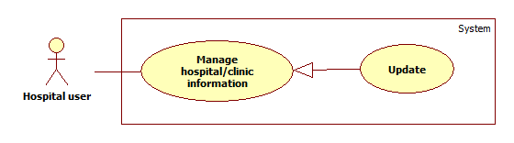

|  |  |  |  |  |
| --- | --- | --- | --- | --- |
| **USE CASE – UC020** | | | | |
| **Use-case No.** | UC020 | **Use-case Version** | | 1.0 |
| **Use-case Name** | Update hospital information | | | |
| **Author** | Duong Thi Hoang Anh | | | |
| **Date** | 29/05/2014 | **Priority** | High | |
| **Actor:**   * Administrator * Hospital user   **Summary:** Users use this case to update information of a specific hospital or clinic.  **Goal:** Update information of a specific hospital or clinic.  **Triggers:** On “Thông tin bệnh viện/phòng khám” page, click on “Chỉnh sửa” icon at basic information, specialites,…  **Preconditions:** Users must login with the role of Administrators or Hospital users.  **Post Conditions:**   * **Successful**: Information of a specific hospital or clinic will be updated. * **Failed**: An error message will be displayed.   **Main Success Scenario:**   |  |  |  | | --- | --- | --- | | **Step** | **Action** | **System response** | | 1 | Click on “Thông tin bệnh viện/phòng khám” item on dropdown menu. | Transfer to “Thông tin bệnh viện/phòng khám” page that includes:   * Giới thiệu chung: Tab   + Tên bệnh viện   + Website   + Loại hình dịch vụ   + Địa chỉ   + Số điện thoại   + Fax   + Chỉnh sửa: image refers to basic information update form * Chuyên khoa: Tab   + List of speciality   + Chỉnh sửa: image refer to speciality update form * Danh sách bác sĩ: tab   + Tên bác sĩ: textbox   + Chọn chuyên khoa: drop down list   + Tìm: button   + Thêm bác sĩ: link refers to “Tạo mới bác sĩ” page to insert new doctor to system. * Lịch khám bệnh: tab   + Work schedule of hospital/center   + Chỉnh sửa: image button refers to work schedule update form. * Danh sách cuộc hẹn:   + List of all appointment * Cơ sở vật chất: * Dịch vụ đi kèm: * Thư viện ảnh:   + Thêm hình ảnh: Button   + List all of photos with “Xóa” icon on each photo | | 2 | Click “**Chỉnh sửa**” image button in “Thông tin chung” tab | “Cập nhật thông tin chung” form appears that includes:   * Tên bệnh viện: read only * Website: textbox * Loại hình dịch vụ: drop down list (with default value is current service of hospital. * Địa chỉ: textbox * Số điện thoại: textbox (regular expression: @"^(?:\(\d{2}\))\s?\d{2}\s?\d{2}\s?\d{2}\s?\d{2}$") * Fax: textbox (regular expression: @"^(?:\(\d{2}\))\s?\d{2}\s?\d{2}\s?\d{2}\s?\d{2}$") * Cập nhật: button | | 3 | Input information then click on “Cập nhật” button. | “Cập nhật thông tin chung” form disappears and a notification appears and displays a message: “Cập nhật thông tin thành công.” | | 4 | Click “Chỉnh sửa” image button in “Chuyên khoa” tab | “Cập nhật chuyên khoa” form appears that includes:   * List of speciality display as label with “X” button to remove. * Thêm chuyên khoa: Link to add new speciality. * Cập nhật: button | | 5 | Update specialities then click on “Cập nhật” button | “Cập nhật chuyên khoa” form disappears and a notification appears and display a message: “Cập nhât thông tin thành công” | | 6 | Update doctor information | Refer to UC019 |   **Alternative Scenario:**   |  |  |  | | --- | --- | --- | | **Step** | **Action** | **System response** | | 1 | Click “**Bệnh viện / phòng khám**” sub item in “**Quản lý bệnh viện/phòng khám**” item on the left menu of administrator screen. | Transfer to “Danh sách bệnh viện/phòng khám” page that includes:   * Tên bệnh viện / phòng khám: Textbox * Tìm: Button | | 2 | Enter name of hospital or clinic then click “**Tìm**” button | Display a list of hospitals or clinics that have similar name with input value. | | 3 | Click on name of hospital which wants to update information | Transfer to “Thông tin bệnh viện/phòng khám” page that includes:   * Giới thiệu chung: Tab   + Tên bệnh viện   + Website   + Loại hình dịch vụ   + Địa chỉ   + Số điện thoại   + Fax   + Chỉnh sửa: image refers to basic information update form * Chuyên khoa: Tab   + List of speciality   + Chỉnh sửa: image refer to speciality update form * Danh sách bác sĩ: tab   + Tên bác sĩ: textbox   + Chọn chuyên khoa: drop down list   + Tìm: button   + Thêm bác sĩ: link refers to “Tạo mới bác sĩ” page to insert new doctor to system. * Lịch khám bệnh: tab   + Work schedule of hospital/center   + Chỉnh sửa: image button refers to work schedule update form. * Danh sách cuộc hẹn:   + List of all appointment * Cơ sở vật chất: * Dịch vụ đi kèm: * Thư viện ảnh:   + Thêm hình ảnh: Button   + List all of photos with “Xóa” icon on each photo | | 4 | Click on “Chỉnh sửa” image button in content of each tab, fill information then click “Cập nhật” button | Update form disappears, a notification appears and display a message: “Cập nhật thông tin thành công”. |   **Exceptions:**   |  |  |  | | --- | --- | --- | | **Step** | **Action** | **System response** | | 1 | “Số điện thoại” expression is invalid | “Số điện thoại không hợp lệ” | | 2 | Fax number expression is invalid | “Số Fax không hợp lệ” |   **Relationships**: N/A  **Business Rules:**  Administrator must search hospital or clinic to update information. After updating, an email is sent to hospital user’s email to report updated contents.  Hospital user can update his / her hospital or clinic’s information without searching process. | | | | |

* + 1. **<HU> View List of Appointments**



|  |  |  |  |  |
| --- | --- | --- | --- | --- |
| **USE CASE – UC021** | | | | |
| **Use-case No.** | UC021 | **Use-case Version** | | 1.0 |
| **Use-case Name** | View list of appointments | | | |
| **Author** | Vũ Nhật Anh Khoa | | | |
| **Date** | 27/05/2014 | **Priority** | Normal | |
| **Actor:** Hospital Users  **Summary:** Administrator accesses the system, uses View appointments function and views a list of appointments  **Goal:** Display a list of appointments on Google Calendar  **Triggers:** Click on “Xem Appointments” item on menu bar.  **Preconditions:** Hospital User must meet the requirements of use case **UC001** (Login).  **Post Conditions:**   * **Success**: System displays Embed Google Calendar on website   **Main Success Scenario:**   |  |  |  | | --- | --- | --- | | **Step** | **Action** | **System response** | | 1 | Hospital User is on “Xem Appointments” page | Displays Embed Google Calendar with event tittle is Patient’s Last name + Patient’s First name + Phone number | | 2 | Hospital User clicks on specific event panel | Displays a pop-up with more details:   * “Họ” + “Tên” + “Số Điện thoại” * Ngày + giờ khám * Địa điểm * Email |   **Alternative Scenario:** N/A  **Exceptions:** N/A  **Relationships**: UC001  **Business Rules:** Using Google Calendar to view appointments | | | | |

* + 1. **<HU> View Hospital Statistics**



|  |  |  |  |  |
| --- | --- | --- | --- | --- |
| **USE CASE – UC022** | | | | |
| **Use-case No.** | UC022 | **Use-case Version** | | 1.0 |
| **Use-case Name** | View Hospital’s statistics | | | |
| **Author** | Vũ Nhật Anh Khoa | | | |
| **Date** | 27/05/2014 | **Priority** | Normal | |
| **Actor:** Hospital Users  **Summary:** Hospital User accesses the system, uses View Hospital’s statistics function  **Goal:** Display list of statistics and chart demonstrating Hospital’s activities  **Triggers:** Click on “Xem Thống Kê” item on menu bar.  **Preconditions:** Administrator must meet the requirements of use case **UC001** (Login).  **Post Conditions:**   * **Success:** Direct actors to statistic page of their respective hospital * **Fail:** Direct actors to homepage   **Main Success Scenario:**   |  |  |  | | --- | --- | --- | | **Step** | **Action** | **System response** | | 1 | Hospital User is on “Xem Thống kê” page | Displays list of statistics include   * Tổng số người đã xem * Tổng số đăng ký khám bệnh * Charts display the three statistics above overtime (support various type of chart) * Tổng số comment * Tổng số feedback * Charts display the three statistics above overtime (support various type of chart) * Rating * Chart display the rating overtime (in line-chart) |   **Alternative Scenario:** N/A  **Exceptions:** N/A  **Relationships**: UC001  **Business Rules:**   * Tổng số người đã xem: The total number of visitors that view the actor’s hospital * Tổng số đăng ký khám bệnh: The total number of appointments requests has been sent to the actor’s respective hospital * Tổng số comment: The total number of comment on the actor’s respective hospital * Tổng số feedback: The total number of feedbacks on the actor’s respective hospital * Rating: The average rating | | | | |

* + 1. **<HU> Change Password**

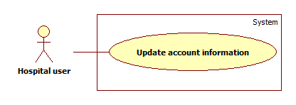

|  |  |  |  |  |
| --- | --- | --- | --- | --- |
| **USE CASE – UC023** | | | | |
| **Use-case No.** | UC023 | **Use-case Version** | | 1.0 |
| **Use-case Name** | Change password | | | |
| **Author** | Duong Thi Hoang Anh | | | |
| **Date** | 29/05/2014 | **Priority** | Normal | |
| **Actor:** Hospital user  **Summary:** Hospital user use this case to change account’s password.  **Goal:** Update password for hospital user’s account  **Triggers:** Click “**Thay đổi mật khẩu**” option in drop down menu “**Thông tin tài khoản**”.  **Preconditions:** Hospital user must meet the requirements of use case **UC001** (Login) as the role of Hospital user.  **Post Conditions:**   * **Successful**: New password will be updated * **Failed**: An error message will be displayed.   **Main Success Scenario:**   |  |  |  | | --- | --- | --- | | **Step** | **Action** | **System response** | | 1 | Click “**Thay đổi mật khẩu**” option in drop down menu “**Thông tin tài khoản**” | Display account update form include:   * Mật khẩu hiện tại: Textbox (Required, password) * Mật khẩu mới: Textbox (Required, password, min length: 6, max length: 32) * Nhập lại mật khẩu mớii: Textbox (Required, password) * Xác nhận: Button * Quay lại: Button | | 2 | Click “**Xác nhận**” button. | New password will be applied. A notification appears and displays a message: “Mật khẩu thay đổi thành công” |   **Alternative Scenario:** N/A  **Exceptions:**   |  |  |  | | --- | --- | --- | | **No** | **Case** | **System response** | | 1 | “Mật khẩu hiện tại” is blank. | Display: “Xin hãy nhật Mật khẩu hiện tại.” | | 2 | “Mật khẩu mới” is blank | Display: “Xin hãy nhập Mật khẩu mới.” | | 3 | “Mật khẩu hiện tại” is incorrect | Display: “Mật khẩu hiện tại không chính xác.” | | 4 | “Mật khẩu mới” is duplicated with “Mật khẩu hiện tại” | Display: “Mật khẩu mới không được trùng với mật khẩu cũ.” | | 5 | Length of “Mật khẩu mới” is not in range. | Display: “Mật khẩu mới hợp lệ trong khoảng từ 6 đến 32 ký tự.” | | 6 | “Mật khẩu mới” does not match with “Xác nhận mật khẩu” | Display: “Mật khẩu mới không trùng khớp.” | | 7 | System failure | Display: “Đã có lỗi xảy ra trong quá trình xử lý thông tin. Mong quý vị thông cảm và thử lại sau vài phút.” |   **Relationships**: N/A  **Business Rules:** New password must be different with the current password. | | | | |

* + 1. **<HU> Reclaim Forgotten Password**



|  |  |  |  |  |
| --- | --- | --- | --- | --- |
| **USE CASE – UC024** | | | | |
| **Use-case No.** | UC024 | **Use-case Version** | | 1.0 |
| **Use-case Name** | Reclaim forgotten password | | | |
| **Author** | Vu Nhat Anh Khoa | | | |
| **Date** | 27/05/2014 | **Priority** | Normal | |
| **Actor:** Hospital user  **Summary:** Hospital user use this case to reclaim their password once forgotten  **Goal:** Actor receives his/her password by email  **Preconditions:** Access the website through browsers at the address: “[www.timkiembenhvien.vn](http://www.timkiembenhvien.vn)”.  **Post Conditions:**   * **Success:** New password is sent to actor’s email * **Fail:**  Actor doesn’t receive any email containing their password   **Main Success Scenario:**   |  |  |  | | --- | --- | --- | | **Step** | **Action** | **System response** | | 1 | Clicks “Quên Mật khẩu” button | Display Forgotten password page that includes:   * Email đăng ký: Textbox (required, regular expression: @"^([a-zA-Z0-9_\-\.]+)@((\[[0-9]{1,3}\.[0-9]{1,3}\.[0-9]{1,3}\.)|(([a-zA-Z0-9\-]+\.)+))([a-zA-Z]{2,4}|[0-9]{1,3})(\]?)$") * “Gửi” button | | 2 | Fills required field | The system validates the entered email then send the password that match with the email in database to the actor  Displays following scene:   * Show messages: “Chúng tôi đã gửi Mật khẩu của bạn qua hộp mail bạn dùng để đăng nhập, xin vui lòng kiểm tra” * “Gửi lại” button | | 3 | Clicks “Gửi lại” | The system resend the email to actor’s login email |   **Alternative Scenario:** N/A  **Exceptions:**   |  |  |  | | --- | --- | --- | | **No** | **Case** | **System response** | | 1 | Email đăng ký is blank | Display: “Xin hãy nhập Email bạn dùng để đăng ký tài khoản.” |   **Relationships**: N/A  **Business Rules:** Users must enter valid email address in order to receive an email containing password from the system. | | | | |

1. **<AD> Overview Use Case**

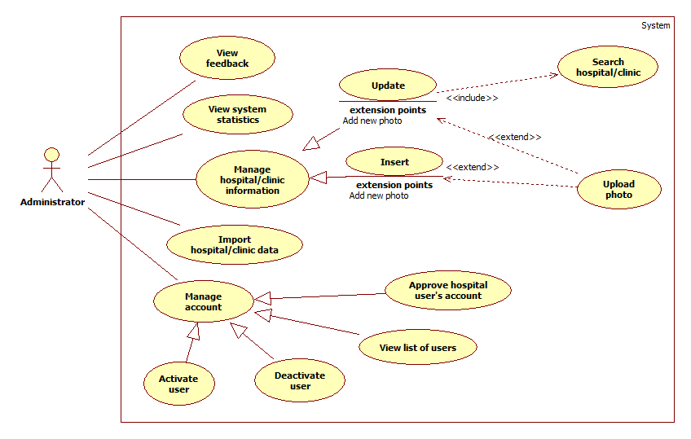

1. **<AD> View List of Feedbacks**



|  |  |  |  |  |
| --- | --- | --- | --- | --- |
| **USE CASE – UC025** | | | | |
| **Use-case No.** | UC025 | **Use-case Version** | | 1.0 |
| **Use-case Name** | View list of Feedback | | | |
| **Author** | Vũ Nhật Anh Khoa | | | |
| **Date** | 27/05/2014 | **Priority** | Normal | |
| **Actor:** Administrator  **Summary:** Administrator accesses the system, uses View feedback function and views a list of feedback  **Goal:** Display a list of feedback supporting column sort, filter and paging. Administrator can click to the feedback to view detail review  **Triggers:** Click on “Xem Feedback” item on menu bar.  **Preconditions:** Administrator must meet the requirements of use case **UC001** (Login).  **Post Conditions:**   * **Success:** Administrator can use filter to sort the list and change page, and can view feedback detail * **Fail:** Display a message: “Không có feedback trong database”   **Main Success Scenario:**   |  |  |  | | --- | --- | --- | | **Step** | **Action** | **System response** | | 1 | Administrator is on “Xem Feedback” page | Displays list of Feedback include   * Tiêu đề (link-text) * Loại (Hospital/Clinic or System) * Ngày nhận * Số trang (page number) (clickable, use to change page) * “Tiếp” button, “Quay lại” button | | 2 | Administrator sorts the list by clicking the column title | If the list was sorted in ascending order, sort the list again in descending order. Otherwise, sort the list in ascending order | | 3 | Administrator filters the list by:   * Theo tiêu đề * Theo loại * Theo ngày nhận | Display appropriated list of feedback | | 4 | Administrator changes page by click “Tiếp” button, “Quay lại” button, Số trang (page number) button | Displays the next page if clicked “Tiếp” button, previous page if clicked “Quay lại” button.  Display the specific page by clicking “Số trang” (page number) | | 5 | Administrator view a specific feedback detail by click to specific “Tiêu đề” | System directs to feedback’s content form includes:   * Tiêu đề * Loại * Ngày nhận * Nội dung |   **Alternative Scenario:** N/A  **Exceptions:** N/A  **Relationships**: UC001  **Business Rules:** N/A | | | | |

1. **<AD> View List of Users**

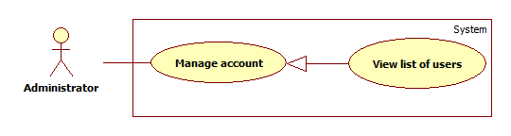

|  |  |  |  |  |
| --- | --- | --- | --- | --- |
| **USE CASE – UC026** | | | | |
| **Use-case No.** | UC026 | **Use-case Version** | | 1.0 |
| **Use-case Name** | View list of users | | | |
| **Author** | Vũ Nhật Anh Khoa | | | |
| **Date** | 27/05/2014 | **Priority** | Normal | |
| **Actor:** Administrator  **Summary:** Administrator accesses the system, uses Manage Accounts function and views a list of users that supports column sort, filter and paging  **Goal:** Display a list of users supporting column sort, filter and paging  **Triggers:** Click on “**Quản lý tài khoản**” to view list of users.  **Preconditions:** Administrator must meet the requirements of use case **UC001** (Login).  **Post Conditions:**   * **Success:** Administrator can use filter to sort the list and change page for more users * **Fail:** The system does not display the users’ list   **Main Success Scenario:**   |  |  |  | | --- | --- | --- | | **Step** | **Action** | **System response** | | 1 | Administrator is on “Quản lý tài khoản” page | Displays list of Users table include following columns:   * Email * Tên * Họ * Điện thoại * Loại người dùng * Ngày đăng ký * Trạng thái (Active/Inactive) checkbox * Display the following at the end of the table * Số trang (page number) (link-text, use to change page) * “Tiếp” button, “Quay lại” button | | 2 | Administrator sorts the list by clicking the column title | If the list was sorted in ascending order, sort the list again in descending order. Otherwise, sort the list in ascending order | | 3 | Administrator filters the list by “Vai trò” (Hospital Users, Users), “Trạng thái” (active/inactive) | Display appropriated list of users | | 4 | Administrator changes page by click “Tiếp” button, “Quay lại” button, Số trang (page number) button | Displays the next page if clicked “Tiếp” button, previous page if clicked “Quay lại” button.  Display the specific page by clicking “Số trang” (page number) |   **Alternative Scenario:** N/A  **Exceptions:**   |  |  |  | | --- | --- | --- | | **No** | **Case** | **System response** | | 1 | There’s no user in database | Display: “Không có bất kỳ người dùng nào trong database.” |   **Relationships**: UC001  **Business Rules:** | | | | |

1. **<AD> Activate User**

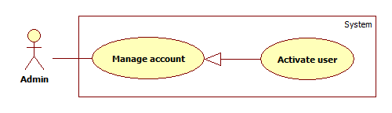

|  |  |  |  |  |
| --- | --- | --- | --- | --- |
| **USE CASE – UC027** | | | | |
| **Use-case No.** | UC027 | **Use-case Version** | | 1.0 |
| **Use-case Name** | Activate user | | | |
| **Author** | Duong Thi Hoang Anh | | | |
| **Date** | 29/05/2014 | **Priority** | Normal | |
| **Actor:** Administrators  **Summary:** Administrators use this case to activate users’ accounts.  **Goal:** Deactivated account will be activated again.  **Triggers:** Click the “**Kích hoạt**” link of column “**Trạng thái**” of an account.  **Preconditions:** Admin must meet the requirements of use case **UC001** (Login) as the role Administrator.  **Post Conditions:**   * **Successful**: Selected account will be activated. * **Failed**: An error message will be displayed.   **Main Success Scenario:**   |  |  |  | | --- | --- | --- | | **Step** | **Action** | **System response** | | 1 | Click the item “**Quản lý tài khoản**” on the left menu | Transfer to “Quản lý tài khoản” page that includes:   * A table with 5 columns:   + STT (Số thứ tự)   + Email: Link refer to “Thông tin người dùng” page.   + Loại người dùng   + Trạng thái: Contains the link “Kích hoạt / Dừng truy cập”   + Ngày đăng kí | | 2 | Click the “**Kích hoạt**” link of “**Trạng thái**” column of an account. | Account will be activated. |   **Alternative Scenario:** N/A  **Exceptions:**   |  |  |  | | --- | --- | --- | | **No** | **Case** | **System response** | | 1 | System failure | Display “Đã có lỗi xảy ra trong quá trình xử lý thông tin. Mong quý vị thông cảm và thử lại sau vài phút.” |   **Relationships**: N/A  **Business Rules:**  Administrators cannot activate themselves or another administrators. | | | | |

1. **<AD> De-active User**

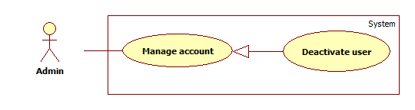

|  |  |  |  |  |
| --- | --- | --- | --- | --- |
| **USE CASE – UC028** | | | | |
| **Use-case No.** | UC028 | **Use-case Version** | | 1.0 |
| **Use-case Name** | De-activate user | | | |
| **Author** | Duong Thi Hoang Anh | | | |
| **Date** | 29/05/2014 | **Priority** | Normal | |
| **Actor:** Administrators  **Summary:** Administrators use this case to de-activate users’ accounts.  **Goal:** An account will not be accessed to the system as the role of User or Hospital user anymore.  **Triggers:** Click the “**Dừng truy cập**” link of column “**Trạng thái**” of an account.  **Preconditions:** Admin must meet the requirements of use case **UC001** (Login) as the role administrator.  **Post Conditions:**   * **Successful:** Selected account will be de-activated. * **Failed:** An error message will be displayed.   **Main Success Scenario:**   |  |  |  | | --- | --- | --- | | **Step** | **Action** | **System response** | | 1 | Click the item “**Quản lý tài khoản**” on the left menu | Transfer to “Quản lý tài khoản” page that includes:   * A table with 5 columns:   + STT (Số thứ tự)   + Email: Link refer to “Thông tin người dùng” page.   + Loại người dùng   + Trạng thái: Contains the link “Kích hoạt / Dừng truy cập”   + Ngày đăng kí | | 2 | Click the “**Dừng truy cập**” link of “**Trạng thái**” column of an account. | Account will be activated. |   **Alternative Scenario:** N/A  **Exceptions:**   |  |  |  | | --- | --- | --- | | **No** | **Case** | **System response** | | 1 | System failure | Display “Đã có lỗi xảy ra trong quá trình xử lý thông tin. Mong quý vị thông cảm và thử lại sau vài phút.” |   **Relationships**: N/A  **Business Rules:**  Administrators cannot de-active themselves or another administrators. | | | | |

1. **<AD> View System Statistics**



|  |  |  |  |  |
| --- | --- | --- | --- | --- |
| **USE CASE – UC029** | | | | |
| **Use-case No.** | UC029 | **Use-case Version** | | 1.0 |
| **Use-case Name** | View administrator statistics | | | |
| **Author** | Vũ Nhật Anh Khoa | | | |
| **Date** | 27/05/2014 | **Priority** | Normal | |
| **Actor:** Administrator  **Summary:** Administrator accesses the system, uses View administrator statistics function  **Goal:** Display list of statistics and chart demonstrating website’s activities  **Triggers:** Click on “Xem Thống Kê” item on menu bar.  **Preconditions:** Administrator must meet the requirements of use case **UC001** (Login).  **Post Conditions:**   * **Success:** Direct actors to statistic page * **Fail:** Direct actors to homepage   **Main Success Scenario:**   |  |  |  | | --- | --- | --- | | **Step** | **Action** | **System response** | | 1 | Administrator is on “Xem Thống kê” page | Displays list of statistics include   * Tổng số người truy cập * Tổng số người dùng thông thường * Tổng số người dùng từ Bệnh viện * Charts display the three statistics above overtime (can display in various type of chart) * Tổng số comment * Tổng số feedback * Charts display the two statistics above overtime (can display in various type of chart) |   **Alternative Scenario:** N/A  **Exceptions:** N/A  **Relationships**: UC001  **Business Rules:**   * Tổng số người truy cập: The total number of visitors including guests, users and hospital users * Tổng số người dùng thông thường: The total number of visitors whose roles are User * Tổng số người dùng từ Bệnh viện: The total number of visitors whose roles are Hospital User * Tổng số comment: The total number of comments * Tổng số feedback: The total number of feedbacks | | | | |

1. **<AD> Import Hospital Using Excel**



|  |  |  |  |  |
| --- | --- | --- | --- | --- |
| **USE CASE – UC030** | | | | |
| **Use-case No.** | UC030 | **Use-case Version** | | 1.0 |
| **Use-case Name** | Import hospital/clinic data | | | |
| **Author** | Vũ Nhật Anh Khoa | | | |
| **Date** | 27/05/2014 | **Priority** | Normal | |
| **Actor:** Administrator  **Summary:** Administrator accesses the system, uses Import hospital/clinic data function and select an pre-defined Excel spreadsheet to import to database  **Goal:** Stored new hospital/clinic data successfully  **Triggers:** Click on “Nhập dữ liệu bệnh viện” item on menu bar.  **Preconditions:** Administrator must meet the requirements of use case **UC001** (Login).  **Post Conditions:**   * **Success:** New hospital/clinic data is stored into database * **Fail:** Display message: “Không thể lưu danh sách bệnh viện vào database”   **Main Success Scenario:**   |  |  |  | | --- | --- | --- | | **Step** | **Action** | **System response** | | 1 | Clicks on “Nhập dữ liệu bệnh viện” item on menu bar | Displays pop-up File Browsing screen for Administrator to choose an Excel spreadsheet | | 2 | Administrator choose an Excel spreadsheet and click “OK” button | System validates input data, then imports columns from Excel spreadsheet to database and throw back successful message |   **Alternative Scenario:**   |  |  |  | | --- | --- | --- | | **Step** | **Action** | **System response** | | 1 | Clicks on “Hủy” button on pop-up window | Close pop-up windows |   **Exceptions:**   |  |  |  | | --- | --- | --- | | **No** | **Case** | **System response** | | 1 | Fields in spreadsheet incorrect | Displays: “Định dạng trong file Excel không phù hợp” | | 2 | The file is not in Excel format | Displays: “Đây không phải là file Excel” |   **Relationships**: UC001  **Business Rules:** The excel file must follow the below rules: | | | | |

1. **<AD> Create Hospital**



|  |  |  |  |  |
| --- | --- | --- | --- | --- |
| **USE CASE – UC031** | | | | |
| **Use-case No.** | UC031 | **Use-case Version** | | 1.0 |
| **Use-case Name** | Create Hospital/ Clinic | | | |
| **Author** | Vũ Nhật Anh Khoa | | | |
| **Date** | 27/05/2014 | **Priority** | Normal | |
| **Actor:** Administrator  **Summary:** Administrator accesses the system, uses Feedback function and sends a review for specific hospital/clinic or the system  **Goal:** Stored new hospital/ clinic to database successfully  **Triggers:** Click on “Tạo bệnh viện/ phòng khám” item on menu bar.  **Preconditions:** User must meet the requirements of use case **UC001** (Login).  **Post Conditions:**   * **Success**: New hospital/clinic is stored in database * **Fail:** New hospital couldn’t be stored in database, display message to users: “Không thể tạo bệnh viện/ phòng khám mới, xin vui lòng thử lại”   **Main Success Scenario:**   |  |  |  | | --- | --- | --- | | **Step** | **Action** | **System response** | | 1 | User goes to Tạo bệnh viện/ phòng khám page | Display the followings:   * Loại: Dropdown list, includes “Bệnh viện” option and “Phòng khám” option * “Chọn” button * “Hủy” button | | 2 | Choose “Bệnh viện” option from dropdown list, then click “Chọn” button | Displays following fields:   * Tên bệnh viện: Textbox (required) * Địa chỉ: Textbox (required) * Số điện thoại: Textbox (required, regular expression: 0/d{9,10} * Fax: Textbox (required, regular expression: 0/d{8}) * Email: Textbox (required, regular expression: @"^ ([a-zA-Z0-9_\-\.]+)@((\[[0-9]{1,3}\.[0-9]{1,3}\.[0-9]{1,3}\.)|(([a-zA-Z0-9\-]+\.)+))([a-zA-Z]{2,4}|[0-9]{1,3})(\]?)$") * Website: Textbox (required, regular expression: (http://|)(www\.)?([^\.]+)\.(\w{2}| (com|net|org|edu|info))$) ) * Mô tả: Text area (required) * Tọa độ: Textbox (required) * “Tạo” button * “Hủy” button | | 3 | User fills the form, then click “Tạo” button | The system validates information then stores new hospital to database |   **Alternative Scenario:**  **A.**   |  |  |  | | --- | --- | --- | | **Step** | **Action** | **System response** | | 1 | User goes to Tạo bệnh viện/ phòng khám page | Display   * Loại: Dropdown list, includes “Bệnh viện” option and “Phòng khám” option * “Chọn” button * “Hủy” button | | 2 | Choose “Phòng khám” option from dropdown list, then click “Chọn” button | Displays following fields:   * Tên phòng khám: Textbox (required) * Địa chỉ: Textbox (required) * Số điện thoại: Textbox (required, regular expression: 0/d{9,10} * Fax: Textbox (required, regular expression: 0/d{8}) * Email: Textbox (required, regular expression: @"^ ([a-zA-Z0-9_\-\.]+)@((\[[0-9]{1,3}\.[0-9]{1,3}\.[0-9]{1,3}\.)|(([a-zA-Z0-9\-]+\.)+))([a-zA-Z]{2,4}|[0-9]{1,3})(\]?)$") * Website: Textbox (required, regular expression: (http ://|)(www\.)?([^\.]+)\.(\w{2}| (com|net|org|edu|info))$) ) * Mô tả: Text area (required) * Giờ mở cửa: Text box (required) * Giờ đóng cửa: Text box (required) * Tọa độ: Textbox (required) * “Tạo” button * “Hủy” button | | 3 | User fills the form, then click “Tạo” button | The system validates information then stores new clinic to database |   **B.**   |  |  |  | | --- | --- | --- | | **Step** | **Action** | **System response** | | 1 | User clicks “Hủy” buttons | Direct user to homepage |   **Exceptions:**   |  |  |  | | --- | --- | --- | | **No** | **Case** | **System response** | | 1 | “Loại“ is blank | Displays: “Vui lòng chọn loại (bệnh viện hoặc phòng khám.” | | 2 | “Tên bệnh viện“ is blank | Displays: “Vui lòng nhập Tên bệnh viện.” | | 3 | “Địa chỉ“ is blank | Displays: “Vui lòng nhập Địa chỉ.” | | 4 | “Số điện thoại“ is blank | Displays: “Vui lòng nhập Số điện thoại.” | | 5 | “Số điện thoại“ is not number 0~9 | Displays: “Vui lòng chỉ nhập số từ 0 đến 9.” | | 6 | “Fax“ is blank | Displays: “Vui lòng nhập số Fax.” | | 7 | “Fax“ is not number 0~9 | Displays: “Vui lòng chỉ nhập số từ 0 đến 9.” | | 8 | “Email“ is blank | Displays: “Vui lòng nhập địa chỉ Email.” | | 9 | “Website“ is blank | Displays: “Vui lòng nhập địa chỉ website.” | | 10 | “Mô tả“ is blank | Displays: “Vui lòng nhập mô tả sơ bộ.” | | 11 | Either “Giờ mở cửa“ or “Phút“ is blank | Displays: “Vui lòng không để trống giờ/phút.” | | 12 | “Giờ“or “Phút “ is not number 0~9 | Displays: “Vui lòng chỉ nhập số từ 0 đến 9.” | | 13 | “Giờ“ is bigger than 23 | Displays: “Giờ chỉ từ 00 đến 23.” | | 14 | “Phút“ is bigger than 59 | Displays: “Phút chỉ từ 00 đến 59.” | | 15 | “Tọa độ“ is blank | Displays: “Vui lòng nhập tọa độ.” | | 16 | “Tọa độ“ is in incorrect format | Displays: “Không có tọa độ này.” |   **Relationships**: UC001  **Business Rules:** Users must enter valid information in order to successfully store new hospital/ clinic to database | | | | |

1. **<AD> Upload Photo**

Please refer to use case UC019

1. **<AD> Search List of Hospitals**

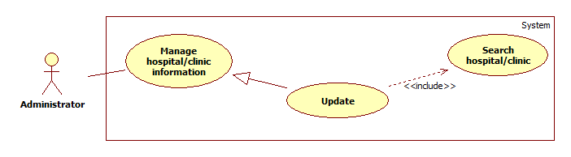

|  |  |  |  |  |
| --- | --- | --- | --- | --- |
| **USE CASE – UC033** | | | | |
| **Use-case No.** | UC033 | **Use-case Version** | | 1.0 |
| **Use-case Name** | Search Hospital (Admin) | | | |
| **Author** | Vu Nhat Anh Khoa | | | |
| **Date** | 27/05/2014 | **Priority** | Normal | |
| **Actor:** Administrator  **Summary:** This case allows user search and view hospital/clinic’s information.  **Goal:** Hospital/ Clinic’s information will be shown.  **Triggers:**   * Choose “Tìm bệnh viện/ phòng khám” on menu bar * Actor inputs to a blank textbox or chooses specialty and type (hospital or clinic) then click “Tìm” button.   **Preconditions:** User must be in “Danh sách bệnh viện/ phòng khám” page.  **Post Conditions:**   * **Successful**: Show search results which include a list of hospital/ clinic. * **Failed**: Show an error message.   **Main Success Scenario:**   |  |  |  | | --- | --- | --- | | **Step** | **Action** | **System response** | | 1 |  | Display list of all hospitals/ clinics | | 2 | Actor inputs the name of hospital/ clinic into textbox then clicks on “Tìm” button | Display list of hospitals/ clinics with relative name as a table with following columns:   * Tên * Rating trung bình * Địa chỉ * Số điện thoại * Fax * Email * Website | | 3 | Actor chooses appropriate hospital/ clinic from the list and clicks on “Tên” link. | Direct to “Thông tin bệnh viện/phòng khám” page which include:   * Thông tin cơ bản:   + Tên bệnh viện   + Rating trung bình   + Địa chỉ   + Số điện thoại   + Fax   + Email   + Website   + Mô tả   + Giờ mở cửa/ đóng cửa (for clinic only) * Các cơ sở:   + Số điện thoại   + Fax * Chuyên khoa: List hospital/ clinic specialties |   **Alternative Scenario:**   |  |  |  | | --- | --- | --- | | **Step** | **Action** | **System response** | | 1 | Actor filters the list by “Quận”, “Thành phố” | Display list of all appropriated hospitals/ clinics. | | 2 | Actor chooses appropriate hospital/ clinic from the list and clicks on “Tên” link. | Direct to “Thông tin bệnh viện/phòng khám” page which include:   * Thông tin cơ bản:   + Tên bệnh viện   + Rating trung bình   + Địa chỉ   + Số điện thoại   + Fax   + Email   + Website   + Mô tả   + Giờ mở cửa/ đóng cửa (for clinic only) * Các cơ sở:   + Số điện thoại   + Fax * Chuyên khoa: List hospital/ clinic specialties |   **Exceptions:**   |  |  |  | | --- | --- | --- | | **No.** | **Case** | **System response** | | 1 | Actor inputs nothing in textbox then clicks “Tìm” button | Display “Xin hãy nhập tên bệnh viện/ phòng khám cần tìm” | | 2 | No items in database or the search pattern is not appropriated | Display “Không tìm thấy” |   **Relationships**: N/A  **Business Rules:** Result list will be ordered by matching percent. | | | | |

1. **<AD> Update Hospital Information**

Please refer to use case UC020

1. **<AD> Approve Hospital User’s Account**

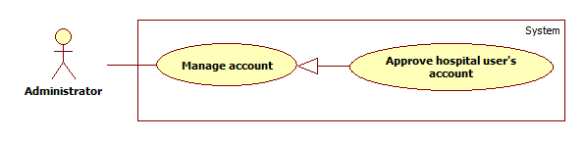

|  |  |  |  |  |
| --- | --- | --- | --- | --- |
| **USE CASE – UC035** | | | | |
| **Use-case No.** | UC035 | **Use-case Version** | | 1.0 |
| **Use-case Name** | Approve hospital user’s account | | | |
| **Author** | Duong Thi Hoang Anh | | | |
| **Date** | 15/06/2014 | **Priority** | Normal | |
| **Actor:** Administrator  **Summary:** Administrators use this case to approve hospital user’s account.  **Goal:** Approve account to hospital user can manage hospital/clinic.  **Triggers:** Click on “**Tạo tài khoản**” item on drop down menu “**Quản lý bệnh viện / phòng khám**”.  **Preconditions:** Administrators must meet the requirements of use case **UC001** (Login).  **Post Conditions:**   * **Successful**: New hospital account will be created. * **Failed**: An error message will be displayed.   **Main Success Scenario:**   |  |  |  | | --- | --- | --- | | **Step** | **Action** | **System response** | | 1 | Click on “**Tạo tài khoản**” option on “**Quản lý bệnh viện / phòng khám**” drop down list. | Display “Tạo tài khoản” page that includes:   * “Chọn bệnh viện / phòng khám”: Active tab that contains:   + A drop down list contains all hospitals and clinics of system.   + “Nếu bệnh viện / phòng khám chưa sẵn có hãy đăng ký tại đây”: Label. With “Tại đây” is a link that refers to page “Đăng ký bệnh viện / Phòng khám”.   + “Tiếp tục”: Button * “Thông tin tài khoản”: De-active tab. | | 2 | Choose a hospital / clinic in drop down list to assign for new hospital use and then and click “**Tiếp tục**” button. | “Thông tin tài khoản” tab change from de-active to active and display account creation form which include:   * Email: Textbox (required, regular expression: @"^([a-zA-Z0-9_\-\.]+)@((\[[0-9]{1,3}\.[0-9]{1,3}\.[0-9]{1,3}\.)|(([a-zA-Z0-9\-]+\.)+))([a-zA-Z]{2,4}|[0-9]{1,3})(\]?)$") * Họ: Textbox (Required, max length: 16) * Tên: Textbox (Required, max length: 16) * Số điện thoại: Textbox (Required) * Tạo mới: Button | | 3 | Enter required information, and then click “**Tạo mới**” button. | New hospital account will be created. The system then display a message: “Tài khoản đăng ký thành công. Vui lòng kiểm tra email để kích hoạt tài khoản.” |   **Alternative Scenario:**   |  |  |  | | --- | --- | --- | | **Step** | **Action** | **System response** | | 1 | Click on “**tại đây**” link in “**Nếu bệnh viện / phòng khám chưa sẵn có hãy đăng ký tại đây**” label in case hospital or clinic does not contain in the hospital list. | Redirect to “Đăng ký bệnh viện / phòng khám” page.  For more detail description please refer to use case UC0031 (Create hospital) |   **Exceptions:**   |  |  |  | | --- | --- | --- | | **No** | **Case** | **System response** | | 1 | Email is blank | Display: “Xin hãy nhập Email.” | | 2 | Email expression is invalid. | Display: “Địa chỉ Email không hợp lệ.” | | 3 | Email’s existed already. | Display: “Địa chỉ Email này đã được sử dụng.” | | 4 | “Họ” is blank | Display: “Xin hãy nhập Họ.” | | 5 | “Họ”’s length is over 16 characters. | Display: “Họ không thể vượt quá 16 ký tự.” | | 6 | “Tên” is blank | Display: “Xin hãy nhập Tên.” | | 7 | “Tên”‘s length is over 16 characters. | Display: “Tên không thể vượt quá 16 ký tự.” | | 8 | “Số điện thoại” is blank | Display: “Xin hãy nhập Số Điện Thoại.” | | 9 | “Số điện thoại” expression is invalid. | Display: “Số ĐiệnThoại không hợp lệ.” | | 10 | System failure | Display: “Đã có lỗi xảy ra trong quá trình xử lý thông tin. Mong quý vị thông cảm và thử lại sau vài phút.” |   **Relationships**: N/A  **Business Rules:**  Password for hospital account will be created randomly and automatically, and will be sent to user through his / her email.  One hospital user’s account must be assigned with a specific hospital or clinic. If that hospital or clinic does not contain in database, administrator must create a new hospital base on provided information from user. | | | | |

1. **Non-Functional Requirements**
2. **Reliability**

Locations and information of hospitals and clinics must be precise as it be in reality.

1. **Availability**

Services of the system must be provided 24/24.

1. **Security**

Information of users must be kept secretly.

Each type of user has a specific priorities in the system.

Always check for authorization before executing any business.

1. **Maintainability**

Code for Controller, Model, and View must be divided clearly.

Complicated query must be written in Structure Query Language (SQL).

All constant values and error messages

1. **Portability**

N/A

1. **Performance**

Search process must be done in less than 5 seconds with network and hardware conditions are equal or better than development environments.

Words and sentences suggestion must be showed in less than 3 seconds right after users input search query.

1. **Entity Relationship Diagram**

