|  |  |  |  |  |  |
| --- | --- | --- | --- | --- | --- |
| |  |  |  | | --- | --- | --- | | **C:\Users\sonnx0907\Desktop\Untitled.png** | **MINISTRY OF EDUCATION AND RAINING** | | | **FPT UNIVERSITY** | | |
| Capstone Project Document |
| Hospital Finder |
| |  |  |  |  |  |  |  |  |  |  |  | | --- | --- | --- | --- | --- | --- | --- | --- | --- | --- | --- | | |  |  | | --- | --- | | **Group 11** | | | **Group Members** | Lê Phước Việt – Team Leader – SE60706  Nguyễn Xuân Sơn – Team Member – SE60727  Vũ Nhật Anh Khoa – Team Member – SE60817  Dương Thị Hoàng Anh – Team Member – 60434 | | **Supervisor** | Nguyễn Đức Khoan | | **Ext Supervisor** | N/A | | **Capstone Project code** | HospitalF | | |
| - Ho Chi Minh City, May / 2014 - |

**Table of Contents**

**4.1** **Design Overview** 5

**4.2** **System Architecture Design** 5

**4.3** **Component Diagram** 5

**4.4** **Detailed Description of Components** 5

**4.4.1** **Class Diagram** 5

**4.4.2** **Class Diagram Explanation** 5

**4.4.2.1** **User** 5

**4.4.2.2** **Hospital** 5

**4.4.2.3** **HospitalType** 5

**4.4.2.4** **Doctor** 5

**4.4.2.5** **DoctorSpeciality** 5

**4.4.2.6** **DoctorHospital** 5

**4.4.2.7** **Appointment** 5

**4.4.2.8** **Role** 5

**4.4.2.9** **Rating** 5

**4.4.2.10** **Feedback** 5

**4.4.2.11** **FeedbackType** 5

**4.4.2.12** **Facility** 5

**4.4.2.13** **HospitalFacility** 5

**4.4.2.14** **Service** 6

**4.4.2.15** **HospitalService** 6

**4.4.2.16** **Photo** 6

**4.4.2.17** **Ward** 6

**4.4.2.18** **District** 6

**4.4.2.19** **City** 6

**4.4.2.20** **Speciality** 6

**4.4.2.21** **HospitalSpeciality** 6

**4.4.2.22** **Disease** 6

**4.4.2.23** **SpecialityDisease** 6

**4.4.2.24** **WordDictionary** 6

**4.4.2.25** **WordHospital** 6

**4.4.2.26** **SentenceDictionary** 6

**4.4.2.27** **SentenceWord** 6

**4.5** **Sequence Diagram** 6

**4.5.1** **Search Hospital** 6

**4.5.2** **Import Hospital Using Excel** 6

**4.5.3** **Create Hospital** 7

**4.5.4** **View Hospital Information** 7

**4.5.5** **Update Hospital Information** 8

**4.5.6** **Create Appointment Online** 8

**4.5.7** **Confirm Appointment** 8

**4.5.8** **Comment** 9

**4.5.9** **View List of Appointments** 9

**4.5.10** **View Statistics** 10

**4.6** **User Interface Design** 10

**4.6.1** **Login** 10

**4.6.2** **Logout** 10

**4.6.3** **Change Password** 10

**4.6.4** **Reclaim Forgotten Password** 10

**4.6.5** **Search Hospital <GU> <US>** 10

**4.6.6** **Import Hospital Using Excel** 10

**4.6.7** **Create Hospital** 10

**4.6.8** **Create Hospital User’s Account** 10

**4.6.9** **View Hospital Information** 10

**4.6.10** **Search Doctor <GU> <US>** 10

**4.6.11** **Create Appointment Online** 10

**4.6.12** **Cancel Appointment** 10

**4.6.13** **Feedback** 10

**4.6.14** **Comment** 10

**4.6.15** **Reply Comment** 10

**4.6.16** **Rating Hosptial** 10

**4.6.17** **Add New Doctor** 11

**4.6.18** **Search List of Doctor <HU>** 11

**4.6.19** **Search List of Hospital <AD>** 11

**4.6.20** **Update Doctor Information** 11

**4.6.21** **Upload Photo** 11

**4.6.22** **Update Hospital Information** 11

**4.6.23** **View List of Appointments** 11

**4.6.24** **View List of Feedbacks** 11

**4.6.25** **View List of Users** 11

**4.6.26** **Activate Users** 11

**4.6.27** **Deactivate Users** 11

**4.6.28** **View Hospital Statistics** 11

**4.6.29** **View System Statistics** 11

**4.7** **Database Design** 11

**4.7.1** **User** 11

**4.7.2** **Hospital** 11

**4.7.3** **HospitalType** 11

**4.7.4** **Doctor** 11

**4.7.5** **Doctor_Speciality** 11

**4.7.6** **Doctor_Hospital** 11

**4.7.7** **Appointment** 11

**4.7.8** **Role** 11

**4.7.9** **Rating** 11

**4.7.10** **Feedback** 11

**4.7.11** **FeedbackType** 11

**4.7.12** **Facility** 11

**4.7.13** **Hospital_Facility** 11

**4.7.14** **Service** 11

**4.7.15** **Hospital_Service** 11

**4.7.16** **Photo** 11

**4.7.17** **Ward** 11

**4.7.18** **District** 12

**4.7.19** **City** 12

**4.7.20** **Speciality** 12

**4.7.21** **Hospital_Speciality** 12

**4.7.22** **Disease** 12

**4.7.23** **Speciality_Disease** 12

**4.7.24** **WordDictionary** 12

**4.7.25** **Word_Hospital** 12

**4.7.26** **SentenceDictionary** 12

**4.7.27** **Sentence_Word** 12

**4.8** **Algoritms** 12

**4.8.1** **Geographic Information Retrieval** 12

**4.8.2** **Boyer Moore Matching Algorithm** 12

**Report No.4: System Design Description (SDD)**

1. **Design Overview**

This document describes the system design description for Hospital Finder system. It includes the architecture design, detailed designs for common functions and the design of database model.

The architecture design describes the overview architecture of the system.

Detailed design describes the structure of data and components in the system. Class diagram and its explanation either sequence digrams are included in this section.

Database design describes the relationship between entities, how the data is organized and their explanations.

Document overview

* Section 2: Architecture diagram
* Section 3: Component diagram
* Section 4: Class diagram and its explanation
* Section 5: Sequence diagrams of common functions
* Section 6: Database design

1. **System Architecture Design**

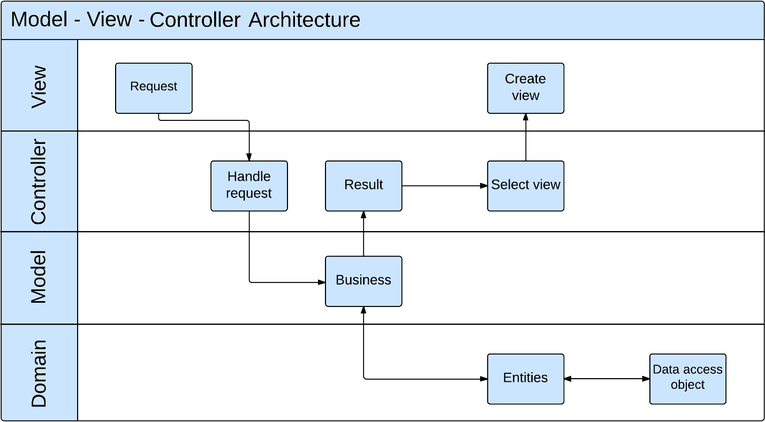

1. **Component Diagram**

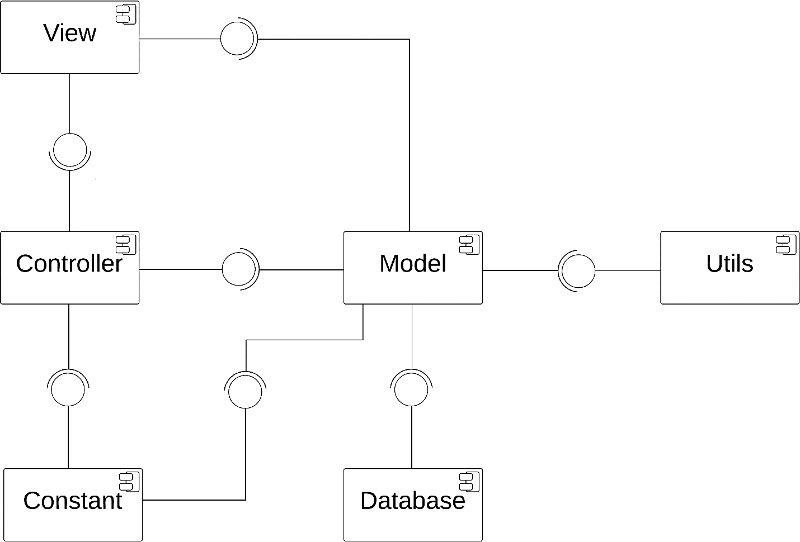

1. **Detailed Description of Components**
2. **Class Diagram**

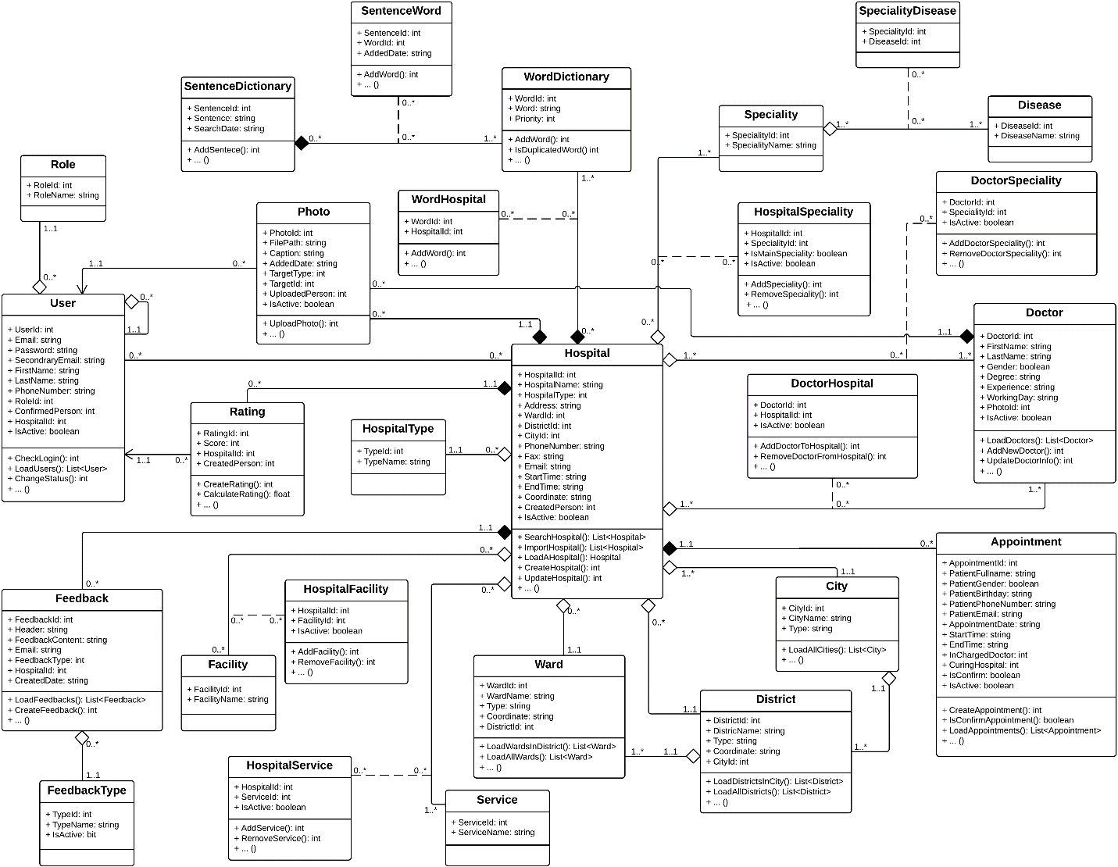

1. **Class Diagram Explanation**
2. **User**

**Attributes**

|  |  |  |  |
| --- | --- | --- | --- |
| **Attribute** | **Type** | **Visibility** | **Description** |
| UserId | Integer | Public | User ID |
| Email | String | Public | Email Address |
| Password | String | Public | Password |
| SecondaryEmail | String | Public | Secondary email |
| FirstName | String | Public | User’s first name |
| LastName | String | Public | User’s last name |
| PhoneNumber | String | Public | User’s phone number |
| RoleId | Integer | Public | Role ID |
| ConfirmedPerson | Integer | Public | ID of the administrator who confirmed the registration of a specific hospital user is right |
| HospitalId | Integer | Public | ID of the hospital that a hospital user have the responsibility to manage |
| IsActive | Boolean | Public | Indicate if a user is available in the system or not |

**Methods**

|  |  |  |  |
| --- | --- | --- | --- |
| **Attribute** | **Type** | **Visibility** | **Description** |
| CheckLogin | Integer | Public | Authenticate users |
| LoadUsers | List<User> | Public | Load a list of users |
| ChangeStatus | Integer | Public | Change current status of a user in the system |

1. **Hospital**

**Attributes**

|  |  |  |  |
| --- | --- | --- | --- |
| **Attribute** | **Type** | **Visibility** | **Description** |
| HospitalId | Integer | Public | Hospital ID |
| HospitalName | String | Public | Name of a hospital |
| HospitalType | Integer | Public | Type of a hospital |
| Address | String | Public | Full address of a hospital |
| WardId | Integer | Public | ID of the ward that a hospital is currently locating |
| DistrictId | Integer | Public | ID of the district that a hospital is currently locating |
| CityId | Integer | Public | ID of the city that a hospital is currently locating |
| PhoneNumber | String | Public | Hospital’s phone number |
| Fax | String | Public | Hospital’s fax number |
| Email | String | Public | Hospital’s email |
| StartTime | String | Public | Start working time of a hospital |
| EndTime | String | Public | End working time of a hospital |
| Coordinate | String | Public | Coordinate of a hospital in the map |
| IsActive | Boolean | Public | Indicate if a hospital is available in the system or not |

**Methods**

|  |  |  |  |
| --- | --- | --- | --- |
| **Attribute** | **Type** | **Visibility** | **Description** |
| SearchHospital | List<Hospital> | Public | Load a list of hospitals base on input search query |
| ImportHospital | List<Hospital> | Public | Import a list of hospitals using Excel |
| LoadAHospital | Hospital | Public | Load a specific hospital |
| CreateHospital | Integer | Public | Create a hospital |
| UpdateHospital | Integer | Public | Update information of a hospital |

1. **HospitalType**

**Attributes**

|  |  |  |  |
| --- | --- | --- | --- |
| **Attribute** | **Type** | **Visibility** | **Description** |
| TypeId | Integer | Public | Hospital type ID |
| TypeName | String | Public | Name of a hospital type |

**Methods**

N/A

1. **Doctor**

**Attributes**

|  |  |  |  |
| --- | --- | --- | --- |
| **Attribute** | **Type** | **Visibility** | **Description** |
| DoctorId | Integer | Public | Doctor ID |
| FirstName | String | Public | Doctor’s first name |
| LastName | String | Public | Doctor’s last name |
| Gender | Boolean | Public | Doctor’s gender |
| Degree | String | Public | Knowledge degree of a doctor |
| Experience | String | Public | Working experience of a doctor |
| WorkingDay | String | Public | Working day in a week of a doctor |
| PhotoId | Integer | Public | Photo picture of a doctor |
| IsActive | Boolean | Public | Indicate a doctor is available in the system or not |

**Methods**

|  |  |  |  |
| --- | --- | --- | --- |
| **Attribute** | **Type** | **Visibility** | **Description** |
| LoadDoctors | List<Doctor> | Public | Load a list of doctors in a hospital |
| AddNewDoctor | Integer | Public | Add new doctor |
| UpdateDoctorInfo | Integer | Public | Update profile of a doctor |

1. **DoctorSpeciality**

**Attributes**

|  |  |  |  |
| --- | --- | --- | --- |
| **Attribute** | **Type** | **Visibility** | **Description** |
| DoctorId | Integer | Public | Doctor ID |
| SpecialityId | Integer | Public | Speciality ID |
| IsActive | Boolean | Public | Indicate if a doctor is still good at a specific speciality or not |

**Methods**

|  |  |  |  |
| --- | --- | --- | --- |
| **Attribute** | **Type** | **Visibility** | **Description** |
| AddDoctorSpeciality | Integer | Public | Add new speciality for a doctor |
| RemoveDoctorSpeciality | Integer | Public | Remove specialities from a doctor |

1. **DoctorHospital**

**Attributes**

|  |  |  |  |
| --- | --- | --- | --- |
| **Attribute** | **Type** | **Visibility** | **Description** |
| DoctorId | Integer | Public | Doctor ID |
| HospitalId | Integer | Public | Hospital ID |
| IsActive | Boolean | Public | Indicate if a doctor is still work at a specific hospital or not |

**Methods**

|  |  |  |  |
| --- | --- | --- | --- |
| **Attribute** | **Type** | **Visibility** | **Description** |
| AddDoctorToHospital | Integer | Public | Add new doctor to hospital |
| RemoveDoctorFromHospital | Integer | Public | Remove doctors from a hospital |

1. **Appointment**

**Attributes**

|  |  |  |  |
| --- | --- | --- | --- |
| **Attribute** | **Type** | **Visibility** | **Description** |
| AppointmentId | Integer | Public | Appointment ID |
| PatientFullName | String | Public | Patient’s full name |
| PatientGender | Boolean | Public | Patient’s gender |
| PatientPhoneNumber | String | Public | Patient’s phone number |
| PatientEmail | String | Public | Patient’s email |
| AppointmentDate | String | Public | Appointmnet date |
| StartTime | String | Public | Time to start the appointment |
| EndTime | String | Public | Time to end the appointment |
| InChargedDoctor | Integer | Public | In charged curing doctor |
| CuringHospital | Integer | Public | Curing hospital for the appointment |
| IsConfirm | Boolean | Public | Indicate an appointment is confirmed or not |
| IsActive | Boolean | Public | Indicate an appointment is available in the system or not |

**Methods**

|  |  |  |  |
| --- | --- | --- | --- |
| **Attribute** | **Type** | **Visibility** | **Description** |
| CreateAppoinment | Integer | Public | Create new appointment |
| IsConfirmAppointment | Boolean | Public | Indicate an appointment is confirmed or not |
| LoadAppoinments | List<Appoinment> | Public | Load a list of appointments from Google Calendar |

1. **Role**

**Attributes**

|  |  |  |  |
| --- | --- | --- | --- |
| **Attribute** | **Type** | **Visibility** | **Description** |
| RoleId | Integer | Public | Role ID |
| RoleName | String | Public | Role name |

**Methods**

N/A

1. **Rating**

**Attributes**

|  |  |  |  |
| --- | --- | --- | --- |
| **Attribute** | **Type** | **Visibility** | **Description** |
| RatingId | Integer | Public | Rating ID |
| Score | Integer | Public | Score that made by user |
| HospitalId | Integer | Public | Hospital ID |
| CreatedPerson | Integer | Public | ID of the person who created a specific rating |

**Methods**

|  |  |  |  |
| --- | --- | --- | --- |
| **Attribute** | **Type** | **Visibility** | **Description** |
| CreateRating | Integer | Public | Create new rating |
| CalculateRating | Float | Public | Calculate total rating of a hospital |

1. **Feedback**

**Attributes**

|  |  |  |  |
| --- | --- | --- | --- |
| **Attribute** | **Type** | **Visibility** | **Description** |
| FeedbackId | Integer | Public | Feedback ID |
| Header | String | Public | Header of a feedback |
| FeedbackContent | String | Public | Content of a feedback |
| Email | String | Public | Email of the person who created a feedback |
| FeedbackType | Integer | Public | Feedback type ID |
| HospitalId | Integer | Public | Hospital ID |
| CreatedDate | String | Public | The date that a feedback was created |

**Methods**

|  |  |  |  |
| --- | --- | --- | --- |
| **Attribute** | **Type** | **Visibility** | **Description** |
| LoadFeedbacks | List<Feedback> | Public | Load a list of feedbacks |
| CreateFeedback | Integer | Public | Create new feedback |

1. **FeedbackType**

**Attributes**

|  |  |  |  |
| --- | --- | --- | --- |
| **Attribute** | **Type** | **Visibility** | **Description** |
| TypeId | Integer | Public | Feedback type ID |
| TypeName | String | Public | Feedback type’s name |
| IsActive | Boolean | Public | Indicate if a feedback type is available in the system or not |

**Methods**

N/A

1. **Facility**

**Attributes**

|  |  |  |  |
| --- | --- | --- | --- |
| **Attribute** | **Type** | **Visibility** | **Description** |
| FacilityId | Integer | Public | Facility ID |
| FacilityName | String | Public | Facility’s name |

**Methods**

N/A

1. **HospitalFacility**

**Attributes**

|  |  |  |  |
| --- | --- | --- | --- |
| **Attribute** | **Type** | **Visibility** | **Description** |
| HospitalId | Integer | Public | Hospital ID |
| FacilityId | Integer | Public | Facility ID |
| IsActive | Boolean | Public | Indicate if a facility is still available in a hospital or not |

**Methods**

|  |  |  |  |
| --- | --- | --- | --- |
| **Attribute** | **Type** | **Visibility** | **Description** |
| AddFacility | Integer | Public | Add new facility to a hospital |
| Remove Facility | Integer | Public | Remove facilities from a hospital |

1. **Service**

**Attributes**

|  |  |  |  |
| --- | --- | --- | --- |
| **Attribute** | **Type** | **Visibility** | **Description** |
| ServiceId | Integer | Public | Service ID |
| ServiceName | String | Public | Service’s name |

**Methods**

N/A

1. **HospitalService**

**Attributes**

|  |  |  |  |
| --- | --- | --- | --- |
| **Attribute** | **Type** | **Visibility** | **Description** |
| HospitalId | Integer | Public | Hospital ID |
| Service | Integer | Public | Service ID |
| IsActive | Boolean | Public | Indicate if a service is still available in a hospital or not |

**Methods**

|  |  |  |  |
| --- | --- | --- | --- |
| **Attribute** | **Type** | **Visibility** | **Description** |
| AddService | Integer | Public | Add new service to a hospital |
| RemoveService | Integer | Public | Remove services from a hospital |

1. **Photo**

**Attributes**

|  |  |  |  |
| --- | --- | --- | --- |
| **Attribute** | **Type** | **Visibility** | **Description** |
| PhotoId | Integer | Public | Photo ID |
| FilePath | String | Public | File path of a photo |
| Caption | String | Public | Caption of a photo |
| AddedDate | String | Public | The date that a photo was added |
| TargetType | Integer | Public | Indicate if a photo is belong to a hospital or a doctor |
| TargetId | Integer | Public | ID of the item that a photo belonged to |
| UploadedPerson | Integer | Public | ID of the person who added the photo |
| IsActive | Boolean | Public | Indicate a photo is available in the system or not |

**Methods**

|  |  |  |  |
| --- | --- | --- | --- |
| **Attribute** | **Type** | **Visibility** | **Description** |
| UploadPhoto | Integer | Public | Add new photo to a hospital or doctor |

1. **Ward**

**Attributes**

|  |  |  |  |
| --- | --- | --- | --- |
| **Attribute** | **Type** | **Visibility** | **Description** |
| WardId | Integer | Public | Ward ID |
| WardName | String | Public | Name of a ward |
| Type | String | Public | Type of a ward |
| Coordinate | String | Public | Coordinate of a ward on the map |
| DistrictId | Integer | Public | ID of the district that a ward belonged to |

**Methods**

|  |  |  |  |
| --- | --- | --- | --- |
| **Attribute** | **Type** | **Visibility** | **Description** |
| LoadWardsInDistrict | List<Ward> | Public | Load a list of wards in a specific district |
| LoadAllWards | List<Ward> | Public | Load all wards in database |

1. **District**

**Attributes**

|  |  |  |  |
| --- | --- | --- | --- |
| **Attribute** | **Type** | **Visibility** | **Description** |
| DistrictId | Integer | Public | District ID |
| DistrictName | String | Public | Name of a district |
| Type | String | Public | Type of a district |
| Coordinate | String | Public | Coordinate of a district on the map |
| CityId | Integer | Public | ID of the city that a district belonged to |

**Methods**

|  |  |  |  |
| --- | --- | --- | --- |
| **Attribute** | **Type** | **Visibility** | **Description** |
| LoadWardsInCity | List<District> | Public | Load a list of districts in a specific city |
| LoadAllDistricts | List< District > | Public | Load all districts in database |

1. **City**

**Attributes**

|  |  |  |  |
| --- | --- | --- | --- |
| **Attribute** | **Type** | **Visibility** | **Description** |
| CityId | Integer | Public | City ID |
| CityName | String | Public | Name of a city |
| Type | String | Public | Type of a city |

**Methods**

|  |  |  |  |
| --- | --- | --- | --- |
| **Attribute** | **Type** | **Visibility** | **Description** |
| LoadAllCities | List<City> | Public | Load all cities in database |

1. **Speciality**

**Attributes**

|  |  |  |  |
| --- | --- | --- | --- |
| **Attribute** | **Type** | **Visibility** | **Description** |
| SpecialityId | Integer | Public | Speciality ID |
| SpecialityName | String | Public | Name of a speciality |

**Methods**

N/A

1. **HospitalSpeciality**

**Attributes**

|  |  |  |  |
| --- | --- | --- | --- |
| **Attribute** | **Type** | **Visibility** | **Description** |
| HospitalId | Integer | Public | Hospital ID |
| SpecialityId | Integer | Public | Speciality ID |
| IsMainSpeciality | Boolean | Public | Indicate of a speciality is a main speciality of a hospital |
| IsActive | Boolean | Public | Indicate a speciality still belong to a hospital or not |

**Methods**

|  |  |  |  |
| --- | --- | --- | --- |
| **Attribute** | **Type** | **Visibility** | **Description** |
| AddSpeciality | Integer | Public | Add new speciality to a hospital |
| RemoveSpecilaity | Integer | Public | Remove specialities from a hosital |

1. **Disease**

**Attributes**

|  |  |  |  |
| --- | --- | --- | --- |
| **Attribute** | **Type** | **Visibility** | **Description** |
| DiseaseId | Integer | Public | Disease ID |
| DiseaseName | String | Public | Name of a disease |

**Methods**

N/A

1. **SpecialityDisease**

**Attributes**

|  |  |  |  |
| --- | --- | --- | --- |
| **Attribute** | **Type** | **Visibility** | **Description** |
| Speciality | Integer | Public | Speciality ID |
| DiseaseId | Integer | Public | Disease ID |

**Methods**

N/A

1. **WordDictionary**

**Attributes**

|  |  |  |  |
| --- | --- | --- | --- |
| **Attribute** | **Type** | **Visibility** | **Description** |
| WordId | Integer | Public | Word ID |
| Word | String | Public | Word content |
| Priority | Integer | Public | Priority of a word |

**Methods**

|  |  |  |  |
| --- | --- | --- | --- |
| **Attribute** | **Type** | **Visibility** | **Description** |
| AddWord | Integer | Public | Add new words |
| IsDuplicatedWord | Integer | Public | Check if a word is duplicated with another word in database |

1. **WordHospital**

**Attributes**

|  |  |  |  |
| --- | --- | --- | --- |
| **Attribute** | **Type** | **Visibility** | **Description** |
| WordId | Integer | Public | Word ID |
| HospitalId | Integer | Public | Hospital ID |

**Methods**

|  |  |  |  |
| --- | --- | --- | --- |
| **Attribute** | **Type** | **Visibility** | **Description** |
| AddWord | Integer | Public | Add new words to a hospital |

1. **SentenceDictionary**

**Attributes**

|  |  |  |  |
| --- | --- | --- | --- |
| **Attribute** | **Type** | **Visibility** | **Description** |
| SentenceId | Integer | Public | Sentence ID |
| Sentence | String | Public | Sentence content |
| SearchDate | String | Public | The date that a specific search query was entered |

**Methods**

|  |  |  |  |
| --- | --- | --- | --- |
| **Attribute** | **Type** | **Visibility** | **Description** |
| AddSentence | Integer | Public | Add new sentences |

1. **SentenceWord**

**Attributes**

|  |  |  |  |
| --- | --- | --- | --- |
| **Attribute** | **Type** | **Visibility** | **Description** |
| SentenceId | Integer | Public | Sentence ID |
| WordId | Integer | Public | Word ID |
| AddedDate | String | Public | The date that a specific search query was entered |

**Methods**

|  |  |  |  |
| --- | --- | --- | --- |
| **Attribute** | **Type** | **Visibility** | **Description** |
| AddWord | Integer | Public | Add new words from a sentence |

1. **Sequence Diagram**
   1. **Search Hospital**

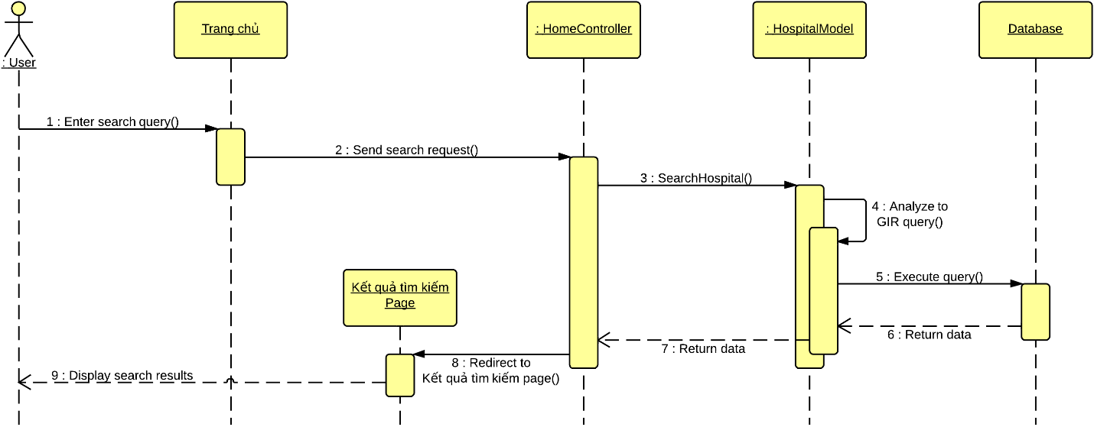

* 1. **Import Hospital Using Excel**

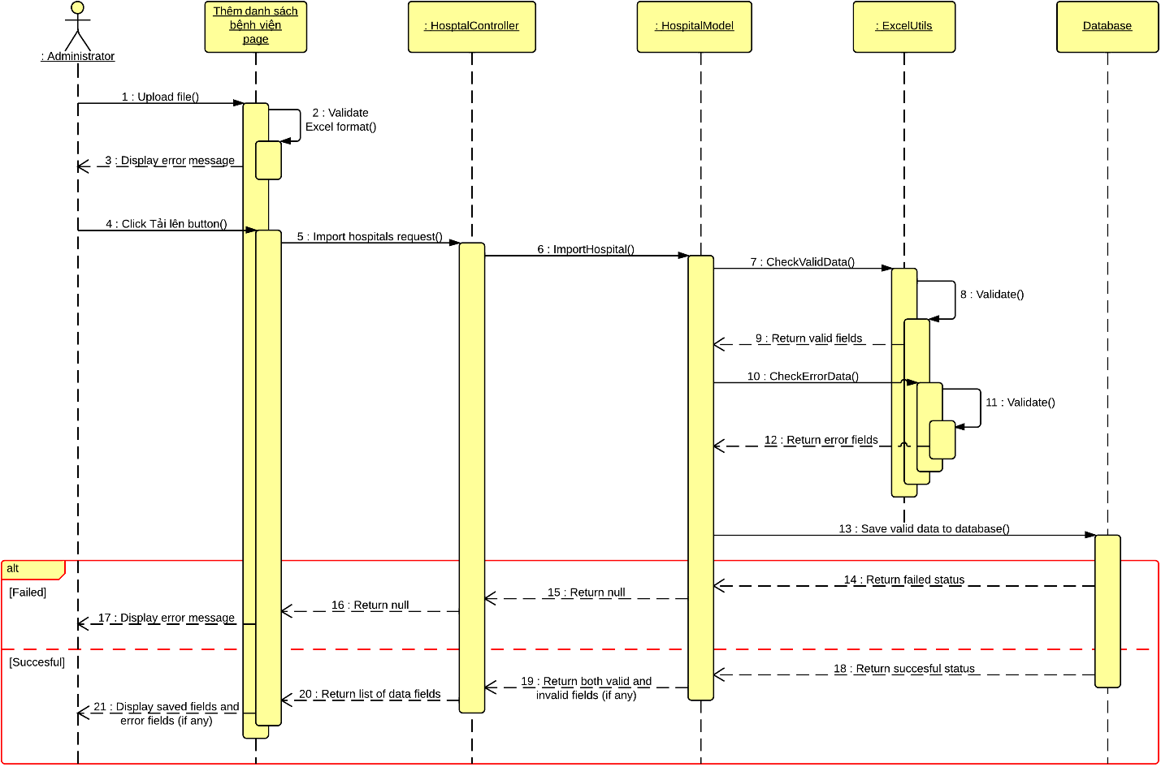

* 1. **Create Hospital**

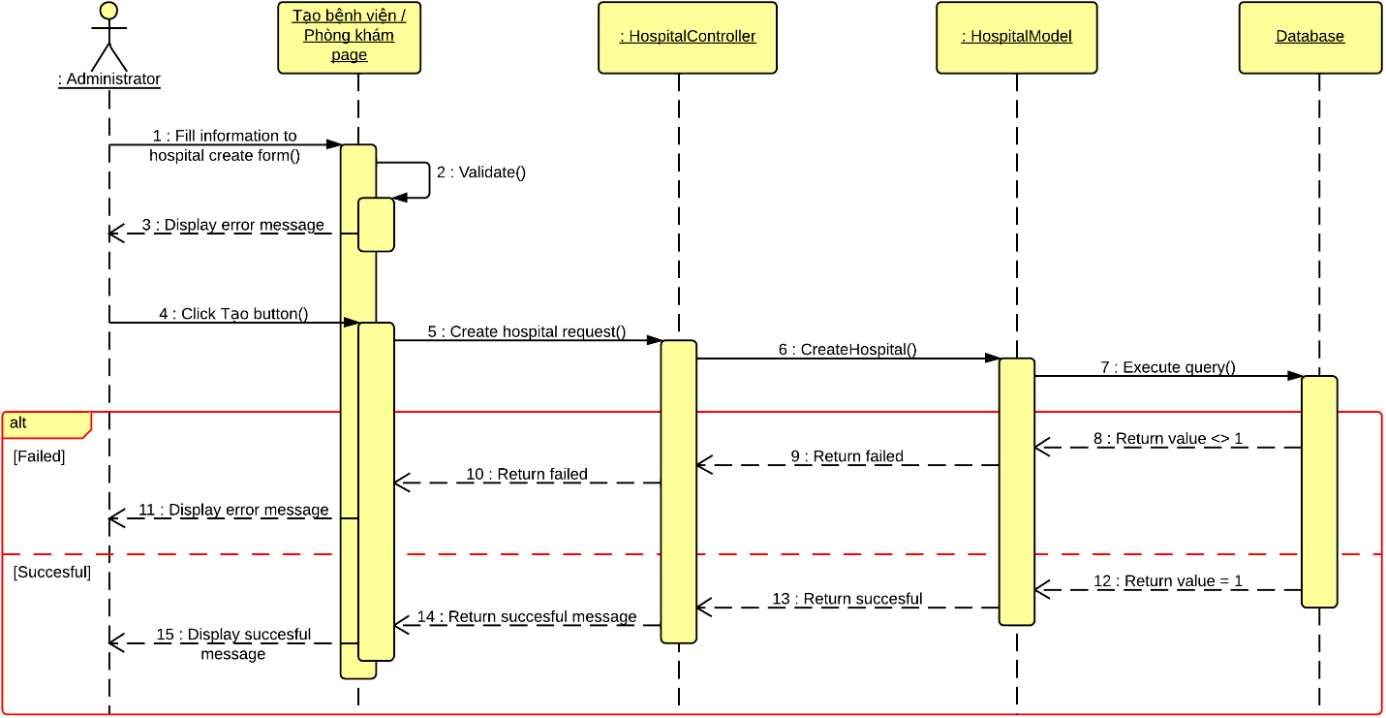

* 1. **View Hospital Information**

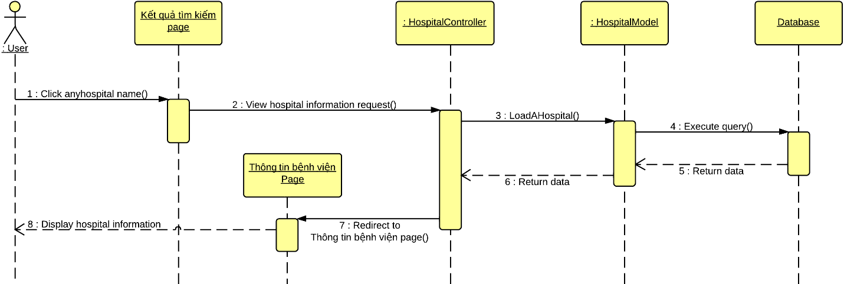

* 1. **Update Hospital Information**

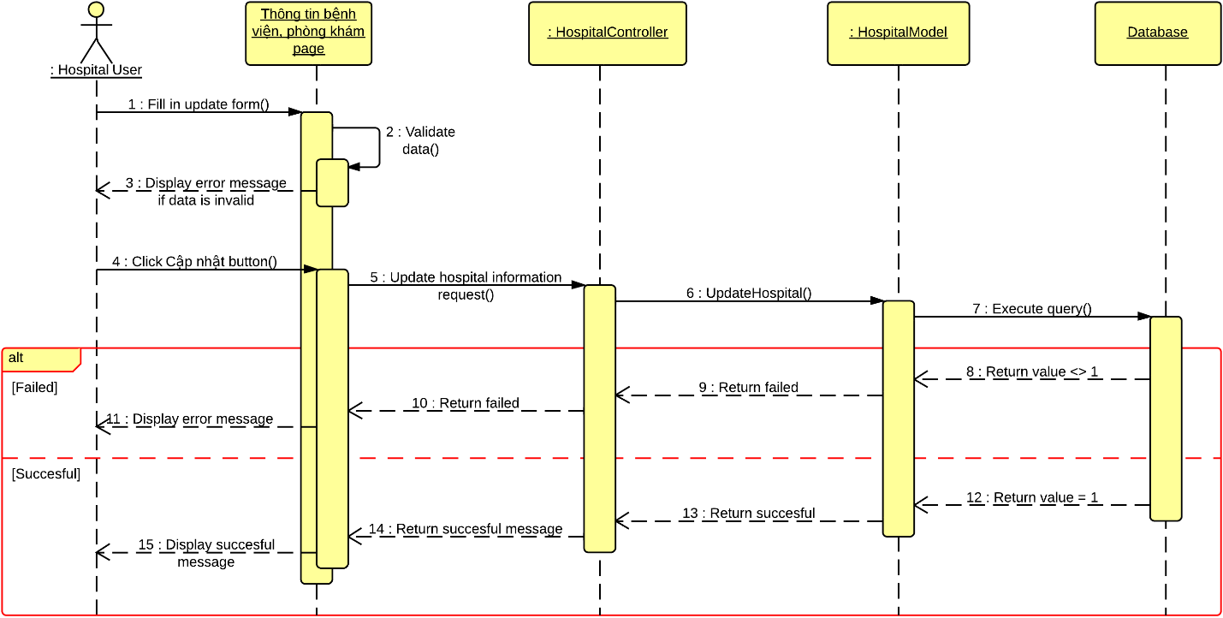

* 1. **Create Appointment Online**

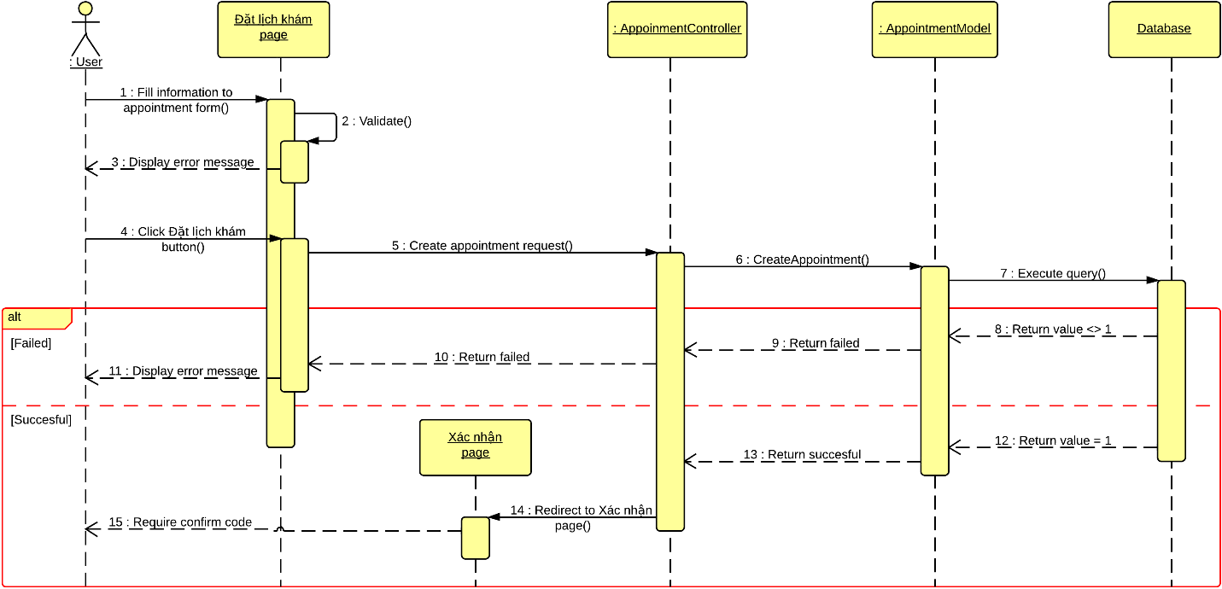

* 1. **Confirm Appointment**

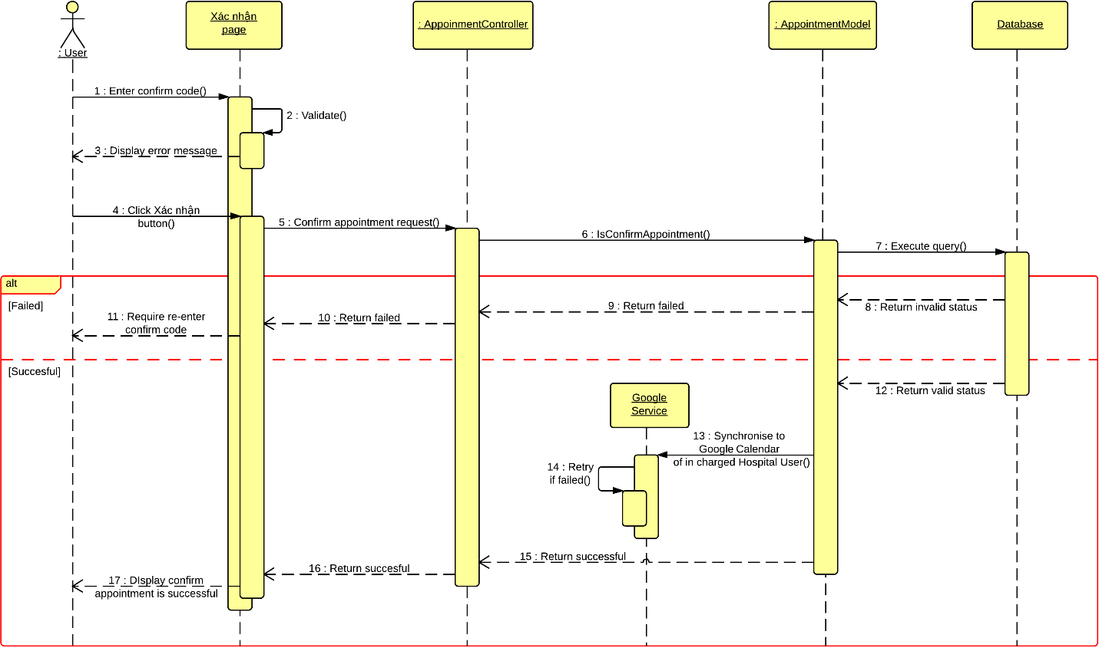

* 1. **Comment**

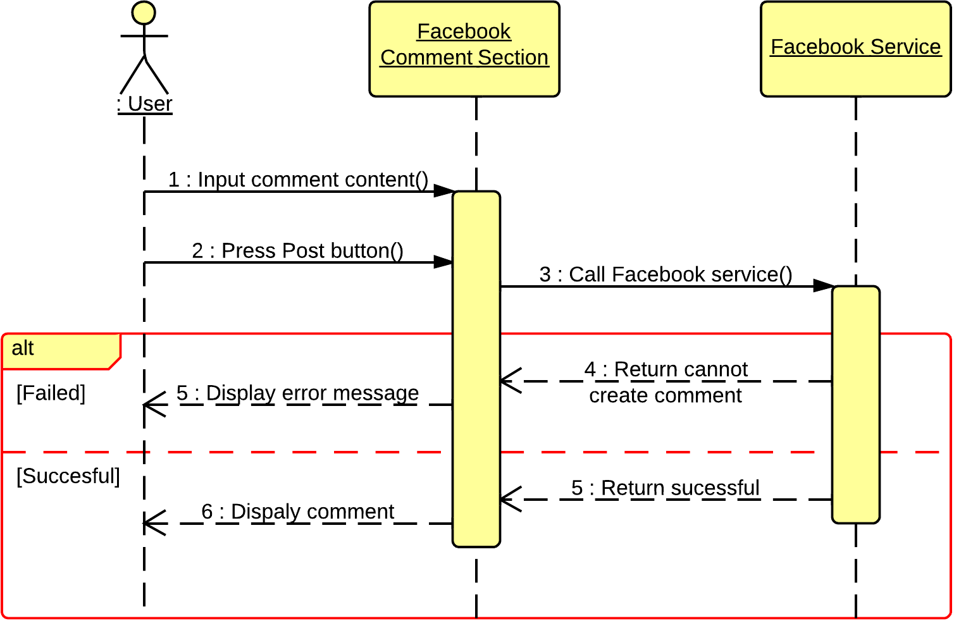

* 1. **View List of Appointments**

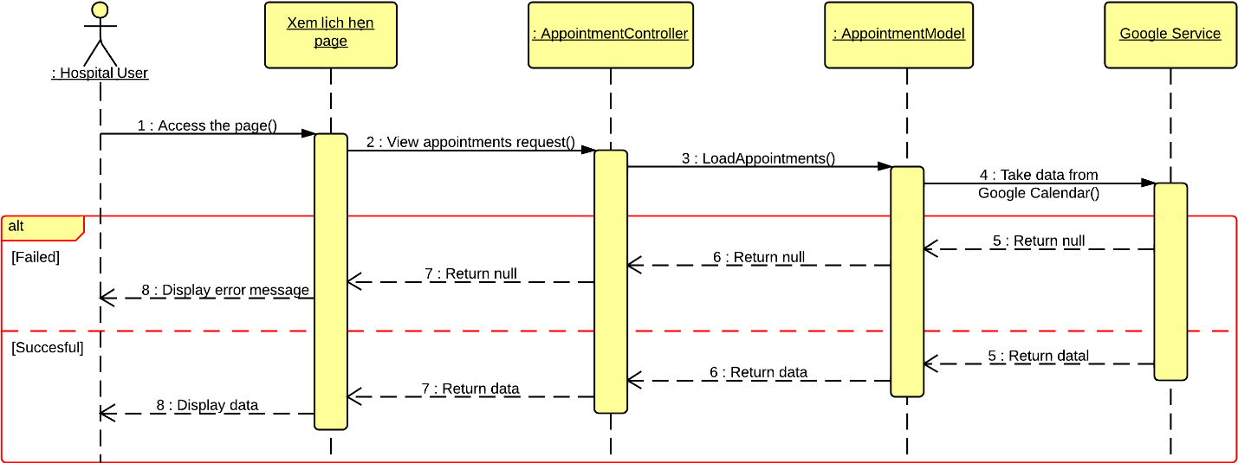

* 1. **View Statistics**

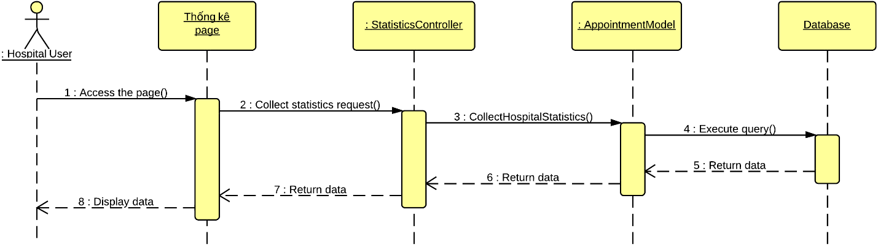

1. **User Interface Design**
   1. **Login**
   2. **Logout**
   3. **Change Password**
   4. **Reclaim Forgotten Password**
   5. **Search Hospital <GU> <US>**
   6. **Import Hospital Using Excel**
   7. **Create Hospital**
   8. **Create Hospital User’s Account**
   9. **View Hospital Information**
   10. **Search Doctor <GU> <US>**
   11. **Create Appointment Online**
   12. **Cancel Appointment**
   13. **Feedback**
   14. **Comment**
   15. **Reply Comment**
   16. **Rating Hosptial**
   17. **Add New Doctor**
   18. **Search List of Doctor <HU>**
   19. **Search List of Hospital <AD>**
   20. **Update Doctor Information**
   21. **Upload Photo**
   22. **Update Hospital Information**
   23. **View List of Appointments**
   24. **View List of Feedbacks**
   25. **View List of Users**
   26. **Activate Users**
   27. **Deactivate Users**
   28. **View Hospital Statistics**
   29. **View System Statistics**
2. **Database Design**
   1. **User**

|  |  |  |  |
| --- | --- | --- | --- |
| **Attribute** | **Type** | **Null** | **Description** |
| User_ID {PK} | int | Unchecked | User ID |
| Email | varchar(64) | Unchecked | Email Address |
| Password | nvarchar(32) | Unchecked | Password |
| Secondary_Email | varchar(64) | Checked | Secondary email |
| First_Name | nvarchar(16) | Unchecked | User’s first name |
| Last_Name | nvarchar(16) | Unchecked | User’s last name |
| Phone_Number | varchar(13) | Checked | User’s phone number |
| Role_ID {FK} | int | Unchecked | Role ID |
| Confirmed_Person {FK} | int | Checked | ID of the administrator who confirmed the registration of a specific hospital user is right |
| Hospital_ID {FK} | int | Checked | ID of the hospital that a hospital user have the responsibility to manage |
| Is_Active | bit | Unchecked | Indicate if a user is available in the system or not |

* 1. **Hospital**

|  |  |  |  |
| --- | --- | --- | --- |
| **Attribute** | **Type** | **Null** | **Description** |
| Hospital_ID {PK} | int | Unchecked | Hospital ID |
| Hospital_Name | nvarchar(64) | Unchecked | Name of a hospital |
| Hospital_Type {FK} | int | Unchecked | Type of a hospital |
| Address | nvarchar(128) | Unchecked | Full address of a hospital |
| Ward_ID {FK} | int | Unchecked | ID of the ward that a hospital is currently locating |
| District_ID {FK} | int | Unchecked | ID of the district that a hospital is currently locating |
| City_ID {FK} | int | Unchecked | ID of the city that a hospital is currently locating |
| Phone_Number | varchar(32) | Unchecked | Hospital’s phone number |
| Fax | varchar(16) | Checked | Hospital’s fax number |
| Email | varchar(64) | Checked | Hospital’s email |
| Website | varchar(64) | Checked | Start working time of a hospital |
| Start_Time | time(7) | Unchecked | End working time of a hospital |
| End_Time | time(7) | Unchecked | Coordinate of a hospital in the map |
| Coordinate | varchar(26) | Unchecked | Indicate if a hospital is available in the system or not |
| Created_Person {FK} | int | Unchecked | Hospital ID |
| Is_Active | bit | Unchecked | Name of a hospital |

* 1. **HospitalType**

|  |  |  |  |
| --- | --- | --- | --- |
| **Attribute** | **Type** | **Null** | **Description** |
| Type_ID {PK} | int | Unchecked | Hospital typeID |
| Type_Name | nvarchar(32) | Unchecked | Name of a hospital type |

* 1. **Doctor**

|  |  |  |  |
| --- | --- | --- | --- |
| **Attribute** | **Type** | **Null** | **Description** |
| Doctor_ID {PK} | int | Unchecked | Doctor ID |
| First_Name | nvarchar(32) | Unchecked | Doctor’s first name |
| Last_Name | nvarchar(32) | Unchecked | Doctor’s last name |
| Gender | bit | Unchecked | Doctor’s gender |
| Degree | nvarchar(256) | Checked | Knowledge degree of a doctor |
| Experience | nvarchar(512) | Checked | Working experience of a doctor |
| Working_Day | varchar(33) | Unchecked | Working day in a week of a doctor |
| Photo_ID {FK} | int | Checked | Photo picture of a doctor |
| Is_Active | bit | Unchecked | Indicate a doctor is available in the system or not |

* 1. **Doctor_Speciality**

|  |  |  |  |
| --- | --- | --- | --- |
| **Attribute** | **Type** | **Null** | **Description** |
| Doctor_ID {PK} | int | Unchecked | Doctor ID |
| Speciality_ID {PK} | int | Unchecked | Speciality ID |
| Is_Active | bit | Unchecked | Indicate if a doctor is still good at a specific speciality or not |

* 1. **Doctor_Hospital**

|  |  |  |  |
| --- | --- | --- | --- |
| **Attribute** | **Type** | **Null** | **Description** |
| Doctor_ID {PK} | int | Unchecked | Doctor ID |
| Hospital_ID {PK} | int | Unchecked | Hospital ID |
| Is_Active | bit | Unchecked | Indicate if a doctor is still work at a specific hospital or not |

* 1. **Appointment**

|  |  |  |  |
| --- | --- | --- | --- |
| **Attribute** | **Type** | **Null** | **Description** |
| Appointment_ID {PK} | int | Unchecked | Appointment ID |
| Patient_Full_Name | nvarchar(32) | Unchecked | Patient’s full name |
| Patient_Gender | bit | Unchecked | Patient’s gender |
| Patient_Birthday | date | Unchecked | Patient’s phone number |
| Patient_Phone_Number | varchar(13) | Unchecked | Patient’s email |
| Patient_Email | varchar(64) | Checked | Appointmnet date |
| Appointment_Date | date | Unchecked | Time to start the appointment |
| Start_Time | time(7) | Unchecked | Time to end the appointment |
| End_Time | time(7) | Unchecked | In charged curing doctor |
| In_Charge_Doctor {FK} | int | Unchecked | Curing hospital for the appointment |
| Curing_Hospital {FK} | int | Unchecked | Indicate an appointment is confirmed or not |
| Confirm_Code | varchar(8) | Unchecked | Indicate an appointment is available in the system or not |
| Is_Confirm | bit | Unchecked | Appointment ID |
| Is_Active | bit | Unchecked | Patient’s full name |

* 1. **Role**

|  |  |  |  |
| --- | --- | --- | --- |
| **Attribute** | **Type** | **Null** | **Description** |
| Role_ID {PK} | int | Unchecked | Role ID |
| Role_Name | nvarchar(32) | Unchecked | Role name |

* 1. **Rating**

|  |  |  |  |
| --- | --- | --- | --- |
| **Attribute** | **Type** | **Null** | **Description** |
| Rating_ID {PK} | int | Unchecked | Rating ID |
| Score | int | Unchecked | Score that made by user |
| Hospital_ID {FK} | int | Unchecked | Hospital ID |
| Created_Person {FK} | int | Unchecked | ID of the person who created a specific rating |

* 1. **Feedback**

|  |  |  |  |
| --- | --- | --- | --- |
| **Attribute** | **Type** | **Null** | **Description** |
| Feedback_ID {PK} | int | Unchecked | Feedback ID |
| Header | nvarchar(64) | Unchecked | Header of a feedback |
| Feedback_Content | nvarchar(256) | Unchecked | Content of a feedback |
| Feedback_Type | int | Unchecked | Email of the person who created a feedback |
| Email | varchar(64) | Unchecked | Feedback type ID |
| Hospital_ID | int | Unchecked | Hospital ID |
| Created_Date | datetime | Unchecked | The date that a feedback was created |

* 1. **FeedbackType**

|  |  |  |  |
| --- | --- | --- | --- |
| **Attribute** | **Type** | **Null** | **Description** |
| Type_ID {PK} | int | Unchecked | Feedback type ID |
| Type_Name | nvarchar(256) | Unchecked | Feedback type’s name |
| Is_Active | bit | Unchecked | Indicate if a feedback type is available in the system or not |

* 1. **Facility**

|  |  |  |  |
| --- | --- | --- | --- |
| **Attribute** | **Type** | **Null** | **Description** |
| Facility_ID {PK} | int | Unchecked | Facility ID |
| Facility_Name | nvarchar(64) | Unchecked | Facility’s name |

* 1. **Hospital_Facility**

|  |  |  |  |
| --- | --- | --- | --- |
| **Attribute** | **Type** | **Null** | **Description** |
| Hospital_ID {PK} | int | Unchecked | Hospital ID |
| Facility_ID {PK} | int | Unchecked | Facility ID |
| Is_Active | bit | Unchecked | Indicate if a facility is still available in a hospital or not |

* 1. **Service**

|  |  |  |  |
| --- | --- | --- | --- |
| **Attribute** | **Type** | **Null** | **Description** |
| Service_ID {PK} | int | Unchecked | Service ID |
| Service_Name | nvarchar(64) | Unchecked | Service’s name |

* 1. **Hospital_Service**

|  |  |  |  |
| --- | --- | --- | --- |
| **Attribute** | **Type** | **Null** | **Description** |
| Hospital_ID {PK} | int | Unchecked | Hospital ID |
| Service_ID {PK} | int | Unchecked | Service ID |
| Is_Active | bit | Unchecked | Indicate if a service is still available in a hospital or not |

* 1. **Photo**

|  |  |  |  |
| --- | --- | --- | --- |
| **Attribute** | **Type** | **Null** | **Description** |
| Photo_ID {PK} | int | Unchecked | Photo ID |
| File_Path | varchar(128) | Unchecked | File path of a photo |
| Caption | nvarchar(128) | Unchecked | Caption of a photo |
| Add_Date | datetime | Unchecked | The date that a photo was added |
| Target_Type | int | Unchecked | Indicate if a photo is belong to a hospital or a doctor |
| Target_ID {FK} | int | Unchecked | ID of the item that a photo belonged to |
| Uploaded_Person {FK} | int | Unchecked | ID of the person who added the photo |
| Is_Active | bit | Unchecked | Indicate a photo is available in the system or not |

* 1. **Ward**

|  |  |  |  |
| --- | --- | --- | --- |
| **Attribute** | **Type** | **Null** | **Description** |
| Ward_ID {PK} | int | Unchecked | Ward ID |
| Ward_Name | nvarchar(32) | Unchecked | Name of a ward |
| Type | nvarchar(9) | Unchecked | Type of a ward |
| Coordinate | varchar(26) | Unchecked | Coordinate of a ward on the map |
| District_ID {FK} | int | Unchecked | ID of the district that a ward belonged to |

* 1. **District**

|  |  |  |  |
| --- | --- | --- | --- |
| **Attribute** | **Type** | **Null** | **Description** |
| District_ID {PK} | int | Unchecked | District ID |
| District_Name | nvarchar(32) | Unchecked | Name of a district |
| Type | nvarchar(9) | Unchecked | Type of a district |
| Coordinate | varchar(26) | Unchecked | Coordinate of a district on the map |
| City_ID {FK} | int | Unchecked | ID of the city that a district belonged to |

* 1. **City**

|  |  |  |  |
| --- | --- | --- | --- |
| **Attribute** | **Type** | **Null** | **Description** |
| City_ID {PK} | int | Unchecked | City ID |
| City_Name | nvarchar(32) | Unchecked | Name of a city |
| Type | nvarchar(9) | Unchecked | Type of a city |

* 1. **Speciality**

|  |  |  |  |
| --- | --- | --- | --- |
| **Attribute** | **Type** | **Null** | **Description** |
| Speciality_ID {PK} | int | Unchecked | Speciality ID |
| Speciality_Name | nvarchar(32) | Unchecked | Name of a speciality |

* 1. **Hospital_Speciality**

|  |  |  |  |
| --- | --- | --- | --- |
| **Attribute** | **Type** | **Null** | **Description** |
| Hospital_ID {PK} | int | Unchecked | Hospital ID |
| Speciality_ID {PK} | int | Unchecked | Speciality ID |
| Is_Main_Speciality | bit | Unchecked | Indicate of a speciality is a main speciality of a hospital |
| Is_Active | bit | Unchecked | Indicate a speciality still belong to a hospital or not |

* 1. **Disease**

|  |  |  |  |
| --- | --- | --- | --- |
| **Attribute** | **Type** | **Null** | **Description** |
| Hospital_ID {PK} | int | Unchecked | Disease ID |
| Hospital_Name | nvarchar(64) | Unchecked | Name of a disease |

* 1. **Speciality_Disease**

|  |  |  |  |
| --- | --- | --- | --- |
| **Attribute** | **Type** | **Null** | **Description** |
| Hospital_ID {PK} | int | Unchecked | Speciality ID |
| Hospital_Name | nvarchar(64) | Unchecked | Disease ID |

* 1. **WordDictionary**

|  |  |  |  |
| --- | --- | --- | --- |
| **Attribute** | **Type** | **Null** | **Description** |
| Hospital_ID {PK} | int | Unchecked | Word ID |
| Hospital_Name | nvarchar(64) | Unchecked | Word content |
| Hospital_Type {FK} | int | Unchecked | Priority of a word |

* 1. **Word_Hospital**

|  |  |  |  |
| --- | --- | --- | --- |
| **Attribute** | **Type** | **Null** | **Description** |
| Hospital_ID {PK} | int | Unchecked | Word ID |
| Hospital_Name | nvarchar(64) | Unchecked | Hospital ID |

* 1. **SentenceDictionary**

|  |  |  |  |
| --- | --- | --- | --- |
| **Attribute** | **Type** | **Null** | **Description** |
| Hospital_ID {PK} | int | Unchecked | Sentence ID |
| Hospital_Name | nvarchar(64) | Unchecked | Sentence content |
| Hospital_Type {FK} | int | Unchecked | The date that a specific search query was entered |

* 1. **Sentence_Word**

|  |  |  |  |
| --- | --- | --- | --- |
| **Attribute** | **Type** | **Null** | **Description** |
| Hospital_ID {PK} | int | Unchecked | Sentence ID |
| Hospital_Name | nvarchar(64) | Unchecked | Word ID |
| Hospital_Type {FK} | int | Unchecked | The date that a specific search query was entered |

1. **Algoritms**
2. **Geographic Information Retrieval**
3. **Boyer Moore Matching Algorithm**