THANK YOU FOR WATCHING!  谢谢观看！    普林斯顿中文剧社 | 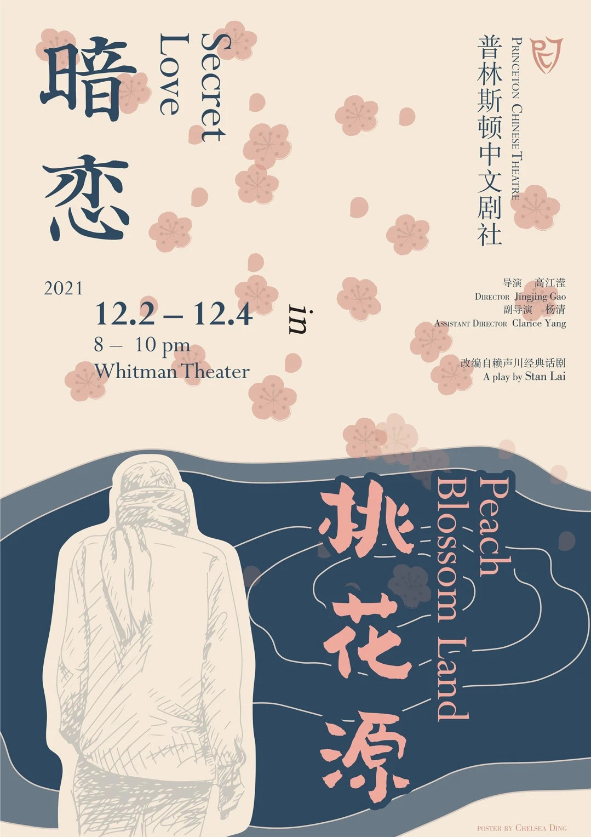
Director  Jingjing Gao ‘23  Assistant Director  Clarice Yang  A play by Stan Lai | 特别鸣谢  普林斯顿中国学生学者联盟  福里斯特票务中心  惠特曼剧场  演艺委员会
ACKNOWLEDGEMENT  ACSSPU  Frist Ticketing Office  Whitman Theater  Performing Arts Council (PAC)  Due to COVID regulations, we are requiring audiences to stay masked throughout the show. Our performers are testing three times this week and will stay unmasked.  受疫情影响，我们要求观众在演出过程中全程佩戴口罩。PCT全体演员本周都有进行三次及以上的核酸测试，并在演出中不会佩戴口罩。 | 导演  高江滢 ‘23  副导演  杨清  改编自赖声川经典话剧
CAST  Zhifan Yun……………………………………………Julie Fang ‘22  Binliu Jiang……………………………………..….Jiaxin Guan ‘GS  Ms. Jiang……………...……………………………….Jiatong Yu ‘24  The Nurse….....…….………………….…….…………..Kelsey Ji ‘24  Master Yuan………………………….…………Christopher Guan ‘22  Theater Operations Manager…….…..….Donald Della Pietra ‘22  Scenic Artist………………………….…….…………Jennifer Zeng ‘25  Shun Zi………………………………….…………Steven Wang ‘24  Old Tao………………………………………….…………Hank Lin ‘24  Chun Hua (Spring Flower)………………….…………Yuewen Wu ‘22  Peach Blossom Tree………………….………………Bofan Ji ‘24  Production Team  Set Designer….…Qingan Zhang, Jennifer Zeng ‘25, Xinyan He ‘24  Lighting Designer……….…………….…………….…..Qingan Zhang  Lighting Operator………….…………….……………..Bowei Liu ‘23  Sound Designer………..……....Ruohui Cui ‘22, Binglun Shao ‘22  Makeup Artist………………………Haoyuan He ‘23, Jenny Jiang ‘25  Stage Manager…………………………………….…..Yingxi Lin ‘GS  Photographer...……….……………Everett Shen ‘23, Zheyi Zhu ‘GS  Costume & Prop Manager…..…..…..……...……..….Chelsea Ding ‘22  Costume & Prop Assistant…..…..…...…Rosalind Huang ‘25,  Gracie Yao ‘GS, Shirley Xue ‘25 | 普林斯顿中文剧社  普林斯顿中文剧社由五位大二与一位大三中文话剧爱好者于二零零八年四月创立。剧社是一个独立的学生社团，从运作，导演，演员到技术支持都由学生负责。 剧社有自主的财务能力，不受学校院系的管理，但与中文系有紧密的交流关系。本社致力于纯中文话剧表演，旨在丰富同学的艺术生活，扩大中文在普林斯顿社区的影响。中文剧社每年上演两部中文话剧作品，并不时举办相声小品等其它舞台艺术的晚会。  支持我们：  https://www.facebook.com/PrincetonChineseTheatre  微信: @普林斯顿中文剧社  
PRINCETON CHINESE THEATRE  Princeton Chinese Theatre is the nation's first undergraduate Chinese theater company run entirely by students. Since its founding in April 2008, the company has successfully staged twelve productions, including both original student works and classical Chinese plays. In 2010, PCT performed the well-known play "Thunderstorm" in New York City, receiving wide acclaim from both the media and the general audience. The company aims at promoting Chinese culture by producing stage plays in Chinese, both on campus as well as outside the University.  Like us on：  Facebook: https://www.facebook.com/PrincetonChineseTheatre  WeChat: @普林斯顿中文剧社 | 演员表  云之凡…………………………………………方成之’22  江滨柳…………………………………………管佳鑫’GS  江太太…………………………………………于佳彤’24  小护士…………………………………………计新格’24  袁老板……………………………………………管曜’22  剧场管理员……………………………………石萧寒’22  绘景师…………………………………………曾元芳’25  顺子……………………………………………王则语’24  老陶……………………………………………林浩溢’24  春花……………………………………………吴越雯’22  桃树……………………………………………冀波帆’24  制作组  舞台设计师.............................................张卿安, 曾元芳’25, 贺欣妍’24  灯光设计师....................................................................................张卿安  灯光负责人...............................................................................刘伯伟’23  声音设计师............................................................崔若晖’22, 邵冰轮’22  化妆师……………....…….…......……...………..和昊原’23, 姜靖雯’25  舞台监督……………..….………………………..……….…林颖希’GS  摄影师……………....….…………....………..…沈博初’23, 朱哲毅’GS  服装 & 道具负责人…….……….…………………………....丁如仪’22  服装 & 道具助理.……….....………黄垲茵’25, 姚昕彤’GS, 薛淇芸’25

This student-directed and student-casted adaptation of the classic Taiwanese play Secret Love in Peach Blossom Land takes place in a Princeton University theater, when two theatrical groups run into conflict with each other, fighting over the rehearsal space. They each rehearse a separate play: Secret Love, which is about two lovers separated by political turmoil in China in the 1950s; and Peach Blossom Land, which traces the journey of a fisherman who accidentally finds an utopian village. Gradually, the two plays and the space-time outside the plays get intertwined until we realize that it was one story all along. | 普林斯顿中文剧社校友理事会  会长………………………………………………彭英之’10  成员………………………………………………王逸丰’11  成员………………………………………………朱元亨’11  成员………………………………………………马质含’11  成员………………………………………………孙梅岑’12  成员………………………………………………孙天姝’12  成员………………………………………………朱诚铭’13  成员………………………………………………徐培文’13  成员...……………………………………………陈嘉伟’GS

PRINCETON CHINESE THEATER  BOARD OF TRUSTEES  President…………..….….…………............Yingzhi Peng ‘10  Trustee…………...…….…..……………......Yifeng Wang ‘11  Trustee…..…….….…………………………..Henry Chu ‘11  Trustee……..…….……….…….…………….Zhihan Ma ‘11  Trustee……......…………..…………………..Meicen Sun ‘12  Trustee…...………..…………….…………...Tianshu Sun ‘12  Trustee.…..………………….….………..Chengming Zhu ‘13  Trustee…….....…………….………………….Peiwen Xu ‘13  Trustee…....….…………….………………..Jiawei Chen ‘GS  Cast Biographies (演员介绍)  Yuewen Wu 吴越雯 ’22  Hi, I am Yuewen, a senior majoring in Computer Science. This is my last year before graduation to act in PCT productions, and I have had a great time playing the challenging role of Chun Hua. It is great to see Lao Tao and Yuan Laoban fighting for me, though I sometimes wonder if their "Bromance" will be considered as a more beautiful existence in the “Peach Blossom Land”:)  来自江苏苏州，计算机系大四学生。4年PCT忠实成员，加入”桃花源”剧组后，彻底放飞自我。作为”桃花源”一枝花，坐看两位男人争风吃醋，实乃风光，然而时常会因为“陶袁”过于美好的兄弟情，而为自己感到一丝多余..  Christopher Guan 管曜 ’22  Chris Guan, a senior in the Molecular Biology Department, is just as much of a clown off-stage as the character he portrays in this production. In fact, that was the only reason he landed the role. Outside of Princeton Chinese Theater, he is part of Princeton Tora Taiko, Terrace Club, McGraw and Rockefeller College tutoring, and the Myhrvold Lab. Chris has lived in China for five years, but his rapidly deteriorating Chinese skills demanded that someone else translate this bio for him. He enjoys traveling, singing (mostly in the showers), and reminding people that he's from Nashville, Tennessee after every conversation.  分子生物学系的大四学生管曜就像他在这部作品中所描绘的角色一样有趣。在PCT之外，他是普林斯顿Tora Taiko、Terrace Club、McGraw和洛克菲勒学院学生辅导以及 Myhrvold 实验室的一员。管曜在中国生活了五年，但他飞速下降的中文能力让他只能依靠别人来翻译自己的介绍。他热爱旅行、唱歌、并十分为自己的家乡纳什维尔感到骄傲。  Jiatong Yu 于佳彤 ’24  Just like every finance / cos kid who secretly wanted to be a filmmaker/novelist/artist but now stuck in 6 STEM courses.  这个人很懒 什么都没有留下。  PRINCETON CHINESE THEATER BOARD  President……..……………..……..….………Youqi Gang ‘22  Artistic Director……..….........…..……..Chelsea Ding ‘22  Artistic Director…………….....…..…….………Jiatong Yu ‘24  Artistic Director……..……….....…………...Yuewen Wu ‘22  Technical Director………......………..…...…Bowei Liu ‘23  Technical Director…….……….…….…...….Cady Feng ‘24  Outreach Director……....………...…Michelle Wang ‘22  Publicity Director………......…….………Yutong Shen ‘23  Publicity Director….....……...….……..…Grace Wang ‘23  Video Producer……..……..…...………..…Everett Shen ‘23  Music Director……..….….....….....……….…Cindy Han ‘22  Secretary and Social Chair……..…..……..…Bofan Ji ‘24  Culture Director………......……………..…Jingjing Gao ‘23  Treasurer……..……….....…...…………..…..…Xiaorun Wu ‘22  Fashion Designer……..……...…………..…Haoyuan He ‘23  Jiaxin Guan 管佳鑫 ’GS  Jiaxin Guan is a PhD student in the COS department. He is excited to play Mr. Jiang in this production!  管佳鑫是一名计算机系的博士学生。他很荣幸能在本剧中饰演江先生。  Kelsey Ji 计新格 ‘24  Kelsey (Xinge) Ji ’24 is an Operations Research & Financial Engineering major from Beijing. When she’s not dancing the night away, you can find her learning a new fingerstyle guitar song, working on her startup venture, or formulating her next opinion article for the Prince. For all inquiries business or casual, she can be reached at xingej@princeton.edu.  计新格是普林斯顿ORFE专业大二学生。她出生于北京，十一岁时随家人移居麻州波士顿。当她晚上不熬夜练舞时，她可能在学习弹奏一首新的吉他曲，在为她的初创企业工作，或在为Prince 撰写下一篇评论文章。若有任何事宜，可以通过 xingej@princeton.edu 与她取得联系。  Steven Wang 王则语 ‘24  The things I do for fun are frisbee, board/card games, watching sports, playing guitar/bass, and listening to music. My favorite card game is bridge, my favorite teams are all from Boston, and my favorite bands are Pink Floyd and Coldplay. Also, I’m from Ningbo, China, and we have the best seafood and niangao one could ever find.  喜欢玩飞盘、各种纸牌游戏、看体育比赛、弹吉他和听歌儿。最近尤其上头桥牌，努力说服大家和我一起整活。最喜欢的球队都来自波士顿，最喜欢的乐队是 Pink Floyd 和 Coldplay。哦对，我是宁波人。家乡的海鲜和年糕只能说是yyds。 | 《暗恋桃花源》是一部由普林斯顿学生导演与改编的经典台湾戏剧，讲述一个在普林斯顿大学剧院发生的奇特故事：《暗恋》与《桃花源》剧组因为场地冲突争执不下，因而不得不同时在剧场排练，《暗恋》是一出现代悲剧，一对恋人因50年代中国动荡的时局而不得不分开；《桃花源》则是一出古代喜剧，渔夫在旅程中意外发现一处乌托邦的村庄。古今悲喜交错，难分彼此，两出戏最终合二为一。  普林斯顿中文剧社董事会  主席………………………………………………冮又亓’22  艺术总监…………………………………………丁如仪’22  艺术总监…………………………………………于佳彤’24  艺术总监…………………………………………吴越雯’22  技术总监…………………………………………刘伯伟’23  技术总监…………………………………………冯依茗’24  外联总监…..……………………………………..王 涵’22  宣传总监…………………………………………沈昱彤’23  宣传总监…………………………………………王蔚亭’23  视频总监…………………………………………沈博初’23  音乐总监…………………………………………韩心怡’22  秘书及活动总监…………………………………冀波帆’24  文化总监…………………………………………高江滢’23  财务总监…………………………………………吴肖润’22  服装设计…………………………………………和昊原’23  Donald Della Pietra 石萧寒 ‘22  Donald Della Pietra is a senior majoring in Psychology. He has a deep interest in Chinese culture and Classical Chinese. He has previously acted in L'Avant-Scène, the principal French theater group on campus. This is his first time doing Chinese theater, and he is delighted to be a part of the production!  石萧寒是四年级的心理学学生。他对中国文化和文言文很感兴趣。他前几年一直在法语话剧社L'Avant-Scène表演，但这个学期他想尝试演中文的话剧。他很高兴他有机会参加这次演出！  Jennifer Zeng 曾元芳 ‘25  Loves painting and drinking so playing the drunk set painter in Secret love. Also a member of the set design crew in real life.  因为热爱艺术和喝酒所以被选中饰演“暗恋桃花源”中喝醉了酒的绘景师一角。在现实生活中也是PCT剧组负责布景设计的一员。  Hank Lin 林浩溢 ‘24  After practicing 40 hours a day since he was 69 days old, Hank Lin made his Broadway debut in the critically acclaimed musical Hamilton; you may have seen him as Christine Daaé in the Broadway classic Phantom of the Opera or heard his solo in Taylor Swift’s new album. He has also written, directed, and acted in, if you can’t tell yet, Cap. Enjoy the show!  林浩溢自从他还只有69天大时就每天练习40小时，最终在广受好评的《汉密尔顿》中完成了他的百老汇首秀；您可能也在百老汇经典《歌剧魅影》中看到他以克里斯汀·戴伊的形象出现，又或是在泰勒·斯威夫特的新专辑中听到过他的独唱。同时，他也自编、自导、自演了，如果您还没有看出来的话，《扯淡》。享受今天的表演！  Julie Fang 方成之 ’22  Hello everyone! I am Julie, a senior in the ECO department. I love reading, singing, watching movies, and cafe hopping. Already missing Princeton before graduating!  大家好我是Julie, 今年大四经济系。闲暇时候，我喜欢小说，电影，唱歌，还有每天散步去咖啡店。作为一个senior，我还没有离开就开始想念普林小镇了。  Special Thanks to ACSSPU  特别感谢：普林斯顿中国学生学者联盟  

Binglun Shao 邵冰轮 ’22  这里曾经有一只小羊驼，后来因为不想写bio迷路了。  Xinyan He 贺昕妍 ’24  My name is Nicky He, a sophomore planning to major in physics. I participate in this show as a crew member in set design and props. Hope you will enjoy the show.  贺昕妍，24届本科物理学生。在本次PCT演出中负责布景设计和道具，希望大家能喜欢我们的演出。  Jenny Jiang 姜靖雯 ’25  Hi, I am Jenny, a freshman at Princeton University. I am planning to major in economics and during my free time I like watching k-drama and c-drama, exploring food places, and shopping!!  大家好，我叫姜靖雯，是大一的新生。我准备主修Economics，辅修Finance. 我平时喜欢购物，看电影，跟朋友一起出去吃饭，和滑雪。  Everett Shen 沈博初 ’23  I love photography!  "我喜欢拍照."  Cady Feng 冯依茗 ’24  Undergraduate sophomore, ECE/PHY, from Beijing, high spice tolerance. In need of life advice.  本科大二，物理/电子，北京人，能吃辣。需要人生忠告。  Production Team Biographies (舞美团队介绍)  Haoyuan He 和昊原 ’23  Loves Peking Opera & Three Kingdoms.  京剧、三国爱好者｜甄嬛传十级学者。  Bowei Liu 刘伯伟 ’23  Fake physics major who hates math.  讨厌数学的假物理人。  Chelsea Ding 丁如仪 ’22  Chelsea is a physics senior. She used to be a perfectionist and a try-hard, but now she's just chilling.  大四老朋友～物理专业～喜欢吃吃喝喝。  Ruohui Cui 崔若晖 ’22  Not a fan of writing self intros. Feel free to add me on wechat!  一个不喜欢写自我介绍的人。欢迎直接加微信找我玩呀～  Yingxi Lin 林颖希 ‘GS  A COS first year master student. Happy to be in PCT!  计算机系的硕一生。很高兴参加PCT！  Rosalind Huang 黄垲茵 ’25  Hi, I'm Rosalind Huang, and I'm a freshman at Princeton. I plan on majoring in ORFE and obtaining certificates in finance and statistics & machine learning. I practice Chinese calligraphy, play badminton, paint, and travel during my spare time. Listening to music and taking a nap help me unwind.  大家好，我是Rosalind黄垲茵，是大一新生。我打算主修ORFE，辅修finance和statistics & machine learning。我平时的兴趣爱好为写书法，打羽毛球，绘画，和旅行。我主要通过听音乐和睡觉来解压。 | Bofan Ji 冀波帆 ’24  Hi guys I’m Bofan!  大家好，我是冀波帆！  Gracie Yao 姚昕彤 ’GS  I'm a second-year graduate student studying finance. Before coming to Princeton, I studied statistics and IEOR at UC Berkeley. I enjoy writing novels and poems and I'm passionate about Chinese literature. I'm also a new photography learner :)  我是金融专业二年级研究生。 本科在加州大学伯克利分校学习统计和工业工程。我喜欢写作，主要是小说和诗歌，很热爱中国文学。最近空闲的时候在努力学习摄影 :)  Shirley Xue 薛淇芸 ’25  Shirley Xue is a freshman from Shanghai, China. She loves working behind the scenes for theater and movie production. In her free time, she likes playing table tennis, taking photographs, and listening to folk music.  薛淇芸是来自中国上海的一名大一新生。她热爱参与话剧和电影制作的幕后工作。在闲暇时间，她喜欢打乒乓球，摄影，和听民谣。  Qingan Zhang 张卿安  Qingan Zhang is a New York-based space designer, director, stage manager and producer. She graduated from Boston College with dual bachelor degrees in Theatre and Psychology and holds an MFA in interior design from Pratt Institute. She has worked with MIT Wuming Theatre Group in Boston as a director for in-person and online works. She was also the visual designer for the 2021 B·O·N·D International Virtual Performance Festival. It's been a pleasant journey for Qingan to collaborate with PCT for the first time!  张卿安，空间设计师、导演、舞监、制作人。本科毕业于Boston College，主修戏剧、心理，Pratt Institute 室内设计MFA。主要舞台设计作品包括Eurydice （2017, 波士顿学院）、A Midsummer Night's Dream （2017, 导演Lisa Wolpe，Prague Shakespeare Company SSI）、第二届维·国际虚拟演出展视觉总监。多次与波士顿地区MIT無名剧社合作，导演线下作品《暗恋桃花源之桃花源》(2016)、《天堂隔壁是疯人院》(2016)、线上作品《谁杀了罗伯特》(2021)。曾参与ArchDaily中英翻译，致力于探索实体及虚体空间、表演艺术与观众之间的关系。

