THANK YOU FOR WATCHING!  谢谢观看！    普林斯顿中文剧社 |     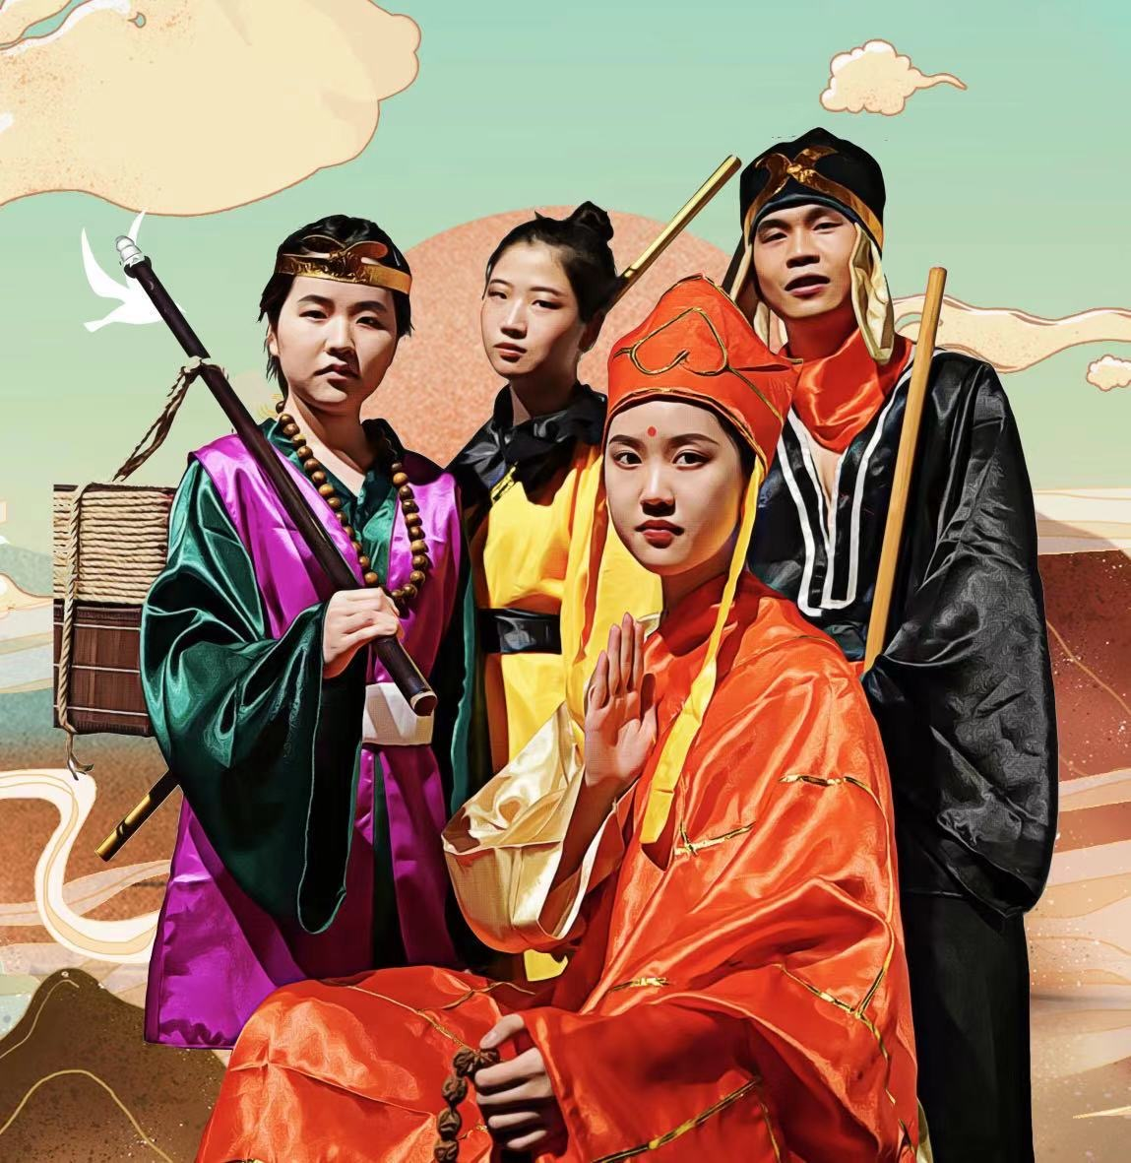  
Directors  Cindy Han ’22  Yuewen Wu ’22  Jiaxin Guan ’GS  Script  Cindy Han ’22  Philip Wang ’25  Music  Cindy Han ’22 | Bowei Liu 刘伯伟 ’23  I hate physics  我讨厌物理  Leyuan Ma 马乐原 ’25  404 not found  这个人最懒还没什么创意，所以什么也没留下。  Grace Wang 王蔚亭 ’23  …you will likely find me crying & procrastinating in j-street  每天都在卑微赶due的大三econ人 :)  Yutong Shen 沈昱彤 ’23  A COS junior who likes calligraphy and video games  中老年民间书法艺人  Xinyan He 贺昕妍 ’24  Am only a half-dead salted-fish dragged here to do animations.  “只是一只被捉过来做动画的半死不活咸鱼”
Tiffanie Cheng 郑梓怡 ’24  I'm tiff and i'm a sophomore in the psychology department. Besides doing self care activities like yoga and taking naps, I enjoy harassing other people about taking care of themselves. Enjoy the show and laugh!!  嘿我叫郑梓怡。我在读大二专业是心理学。平时我喜欢做瑜伽和打瞌睡，我还喜欢叮嘱别人要照顾好自己。希望你们会大笑并喜欢这个剧:)  Haoyuan He 和昊原 ’23  Loves Peking Opera & Three Kingdoms.  京剧、三国爱好者｜甄嬛传十级学者。  Rosalind Huang 黄垲茵 ’25  Hi, I'm Rosalind 黄垲茵, a frosh planning on majoring in ORFE. I practice Chinese calligraphy and love to paint and travel. Listening to music and taking naps help me unwind.  大家好，我是Rosalind黄垲茵，是大一新生。我打算主修ORFE，辅修finance和statistics & machine learning。我平时的兴趣爱好为写书法，打羽毛球，绘画，和旅行。我主要通过听音乐和睡觉来解压。  Charlie He 何书忱 ’25  Hi I am Shuchen, now a freshman, potentially ORFE major. I love reading ancient Chinese history and literature, playing Chinese chess, and eating steaks. I am glad that I can make a contribution to the PCT.  哈喽，我是何书忱Charlie，大一，或许ORFE Major。 我喜欢中国历史和古典文学、下中国象棋、吃牛排。很高兴为PCT做出贡献。  Ivy Wang 王珺 ’23  Ivy loved Journey to the West as a kid and is happy to be bringing a fresh version to life on stage with PCT. In her free time she likes playing League of Legends in the library and dancing with Koko Pops.  王珺小时候很欣赏《西游记》。她最喜欢的人物是红孩儿。她的中文  不好但是希望跟PCT继续练习。 | 导演  韩心怡 ’22  吴越雯 ’22  管佳鑫 ’GS  剧本  韩心怡 ’22  王品 ’25  歌曲  韩心怡 ’22  Production Team Biographies (舞美团队介绍)
ACKNOWLEDGEMENT  ACSSPU  Frist Ticketing Office  Lewis Center for the Arts  and associated staff  Program in Theater  and associated staff  Due to COVID regulations, we are requiring audiences to stay masked throughout the show.  Philip Wang 王品 ’25  Heyo! I’m Philip, a first-year undergrad considering majoring in SPIA. I love writing short stories (that I forget to finish), playing tennis, practicing Brazilian Jiu-Jitsu, and walking to Forbes brunch with my friends. I also take a little too much inspiration from Jin Yong and Stephen Chow.  欢迎来你我看我们的表演！ 我叫王品。我是普大的一个大一本科生，还没有决定专业 （有可能SPIA吧！）。我喜欢写写不完的短篇小说、和朋友打网球、练习巴西柔术，以及和朋友一起去Forbes吃brunch。我从小就特别崇拜金庸和周星驰，所以在这部能够“大闹天宫”的戏中，很有可能会出现他们的影子！  Angela Tan 谭力博 ’25  Hi everyone! I'm Angela, I'm in charge of sound design and act as various other ensemble roles that don't have names! My favorite instrument is the oboe. i don’t play it, i just like the sound of it :p  大家好，我是谭力博！我负责声响设计以及群演。我真人没有照片上那么凶 :p  Christine Chen 陈依诺 ’25  Christine Chen is a freshman from Shanghai, China looking forward to convincing people that concentrating in Philosophy is the right path for her. They love a good Marvel marathon, going through her writing folder with her roommates at midnight, and randomly singing show tunes in the shower.  陈依诺是来自上海的一名新生。 她希望接下来不用一直面对身边人对她选择学哲学再作出质疑了。 平时她喜欢跟朋友安利漫威，大半夜跟室友分享自己写的作品。你永远也猜不到她什么时候会开始突然嗨歌。  Jiatong Yu 于佳彤 ’24  Just like every finance / cos kid who secretly wanted to be a filmmaker/novelist/artist but now stuck in 6 STEM courses.  这个人很懒 什么都没有留下。  PRINCETON CHINESE THEATRE  Princeton Chinese Theatre is the nation's first undergraduate Chinese theater company run entirely by students. Since its founding in April 2008, the company has successfully staged twelve productions, including both original student works and classical Chinese plays. In 2010, PCT performed the well-known play "Thunderstorm" in New York City, receiving wide acclaim from both the media and the general audience. The company aims at promoting Chinese culture by producing stage plays in Chinese, both on campus as well as outside the University.  Like us on：  Facebook: https://www.facebook.com/PrincetonChineseTheatre  WeChat: @普林斯顿中文剧社   | Jennifer Zeng 曾元芳 ’25  Heyyy this is Jennifer, the stage manager of this production, and I am in charge of a little bit of everything. Hope you enjoy the show!  这里是曾元芳，“元芳你怎么看？”的元芳。希望各位看官能够多多喜欢和支持这次中文系剧社的制作呀！  Steven Wang 王则语 ’24  Hello I’m Steven, a sophomore from the math department. Things I love the most are spending some private time with my playlist, playing frisbee, and taking a study break near Carnegie Lake  大家好我是数学系的大二学生王则语 我平时喜欢听音乐扔飞盘和去carnegie lake散步  Jingjing Gao 高江滢 ’23  A very old 2022/2023er from Beijing who’s responsible for light design and a bit of set design in this production. I’m so proud of the original musical we’re able to bring to our audience (and the amazing songwriting by Cindy). I hope you guys enjoy the story of Journey to the West as much as I have since I was three years old basically…;)  来自北京的一名大三（本来应该大四，奈何我gap了一年）老人，在继茶馆，北京折叠和暗恋桃花源之后继续为PCT打工，只因为孙悟空是我的童年男神，以及这次Cindy写的歌儿实在太太太好听了！  Cady Feng 冯依茗 ’24  Undergraduate sophomore, ECE/PHY, from Beijing, high spice tolerance. In need of life advice.  本科大二，物理/电子，北京人，能吃辣。需要人生忠告。  特别鸣谢  普林斯顿中国学生学者联盟  福里斯特票务中心  李维斯艺术中心  普林斯顿戏剧系  受疫情影响，我们要求观众在演出过程中全程佩戴口罩。  Hank Lin 林浩溢 ’24  Designated Clown  (and bboy) of PCT  PCT唯一指定小丑 (and bboy)  Briony Zhao 赵顶如 ’24  Briony is a sophomore in the comparative literature department. She likes cats but is allergic to them. She likes writing but doesn’t read. She likes harmony but is full of contradictions. You can find her Rapunzeled next to Blair Arch, in that tiny window where a crow sits behind. She refuses to be rescued.  赵顶如是北京市五环外朝阳群众的一员。她抽烟喝酒烫头，在宿舍里讲单口相声，像林黛玉一样身子弱、爱好阴阳怪气。但她也希望能每日读书看报，争做一个新青年。她小时候最喜欢看谍战剧，整日研究密码和伪装。所以，她说的话，一个字也不能信。  Anne Wen 温静萍 (安妮) ’23  Hi! I'm an East Asian Studies major from Guam studying China. In my free time, you'll find me gobbling free cookies at Murray-Dodge cafe –all hours of the day!  你好，我来自关岛，读东亚文化。一有空就会往 Murray Dodge Cafe 跑，吃甜点 ～  Youqi Gang 冮又亓 ’22  Emperor or just sleep-deprived college student?  我超民主的！骄傲.jpg
Cast Biographies (演员介绍)  Cindy Han 韩心怡 ’22  A (hopefully) soon-to-graduate computer science major who speaks in Python but writes musicals in Chinese (ngl partially cuz it's easier to rhyme in). Loves writing nonsense. Loves cats.  一个杭州出生、温哥华和苏州长大、现居上海的地球人。主修计算机，但在毕业前心血来潮想写一部中文的音乐剧，所以就写了，希望各位喜欢~  Icey Siyi Ai 艾思屹 ’25  PCT most dedicated reactor, chanter, and fangirl for all the couples❤.  艾·PCT首席笑声贡献者·心无旁骛只会念经·什么cp都能磕·思屹  Helia Cui 崔若晖 ’23  I’m Helia, a junior in the music department who was once COS BSE.  if you read Chinese:  read the below  else:  if you’re reading this line:  print(’Welcome! I hope you enjoy the show :) ’)  非典型音乐系大三学生。PCT编外人员。脑子比手快型选手。万物皆可研究的理论派。喜欢花，喜欢狗。梦想是拥有一棵树。 | 普林斯顿中文剧社  普林斯顿中文剧社由五位大二与一位大三中文话剧爱好者于二零零八年四月创立。剧社是一个独立的学生社团，从运作，导演，演员到技术支持都由学生负责。 剧社有自主的财务能力，不受学校院系的管理，但与中文系有紧密的交流关系。本社致力于纯中文话剧表演，旨在丰富同学的艺术生活，扩大中文在普林斯顿社区的影响。中文剧社每年上演两部中文话剧作品，并不时举办相声小品等其它舞台艺术的晚会。  支持我们：  https://www.facebook.com/PrincetonChineseTheatre  微信: @普林斯顿中文剧社
CAST  Wukong (Monkey)…………………………………….Cindy Han ’22  Tangseng (Monk)……………...……………………….….Icey Ai ’25  Wujing (Sandy)….....…….……………….……………..Helia Cui ’23  Bajie (Piggy)………………………….…………………Hank Lin ’24  Yingying……………………………...……….…..….Briony Zhao ’24  Little Monk, Tree………………………….……………Anne Wen ’23  Emperor Taizong of Tang……….…………….………Youqi Gang ’22  Ensemble…....…Philip Wang ’25, Angela Tan ’25, Christine Chen ’25,  Jiatong Yu ’24  Production Team  Stage Manager…………………...…….……….…..Jennifer Zeng ’25  Set Design….….…….....….….….Leyuan Ma ’25, Jennifer Zeng ’25  Projection Operator…………………….……………..Leyuan Ma ’25  Lighting Design……...….……….Steven Wang ’24, Jingjing Gao ’23  Lighting Operator………….……………..……………Bowei Liu ’23  Sound Design………….…..…....…..……...…..…..….Angela Tan’25  Sound Operator……………………………………...Steven Wang ’24  Translation…………………….…..….Charlie He ’25, Cady Feng ’24  Translation Operator………………….………………..Charlie He ’25  Choreographer…….…………...…….………………….Ivy Wang ’23  Costume & Prop ………..……Tiffanie Cheng ’24, Jacqueline He ’23,  Rosalind Huang ’25, Charlie He ’25  Makeup……..Haoyuan He ’23, Jennifer Zeng ’25, Tiffanie Cheng ’24  Playbill……………….………..….Yutong Shen ’23, Grace Wang ’23  Poster…………………….…..….…….……………Jennifer Zeng ’25  Cast Album Audio Engineer…….……….……………..Helia Cui ’23  Video Illustrations………………...…….………………Nicky He ’24  SPECIAL THANKS  Photography: Shoichi Hayashi ’22, Frank Wojciechowski, Everett Shen ‘23  Buddhism Consultant: Julie Fang ’22  Opera recordings: Murong Fang  Translation Consultant: Jeremy Tiang  PRINCETON CHINESE THEATER BOARD  President……..……………..……..….……Jingjing Gao ’23  Vice President……..………………………….Hank Lin ’24  Artistic Director……..….........…..……….Jennifer Zeng ’25  Technical Director………......………..…...…Bowei Liu ’23  Technical Director…….……….…….….....Haoyuan He ’23  Outreach Director……....………...……………Bofan Ji ’24  Publicity Director………......…….……….Yutong Shen ’23  Publicity Director….....……...….……..…..Grace Wang ’23  Special Events Director……………………..Jiatong Yu ’24  Video Producer……..……..…...………….Everett Shen ’23  Treasurer……..……….....…...…………..….Bowei Liu ’23  This musical features the four main characters of Journey to the West in an original story of their journey back home after they’ve successfully obtained scriptures at the end of their journey westward. It’s a story about partings and reunions: about the different paths that people take, and where those paths split and reconnect (much like when we march out of the FitzRandolph gate upon graduation).  The production is presented in a combination of Chinese and English with the alternate language provided as supertitles. | 普林斯顿中文剧社董事会  主席………………………………………………高江滢’23  副主席....…………………………………………林浩溢’24  艺术总监…………………………………………曾元芳’25  技术总监…………………………………………和昊原’23  外联总监…..……………………………………..冀波帆’24  宣传总监…………………………………………沈昱彤’23  宣传总监…………………………………………王蔚亭’23  视频总监…………………………………………沈博初’23  特别活动总监....…………………………………于佳彤’24  财务总监…………………………………………刘伯伟’23  演员表  悟空……………….…………………….…………韩心怡’22  唐僧……………...……………….………..………艾思屹’25  沙僧…………...………………………...…………崔若晖’23  八戒…………...………………………...…………林浩溢’24  莹莹………………………………………..………赵顶如’24  小和尚、桃树…….……………………….………温静萍’25  唐太宗…………………...………………...………冮又亓’22  服务员、乞丐假悟空、平民…………………..……王品’25  乞丐假唐僧、宫女……………….………………谭力博 ’25  乞丐假八戒、宫女、桃树…………………..……陈依诺’25  桃树、平民、太监………….………….…………于佳彤’24  制作组  舞台设计..............................................................马乐原’25, 曾元芳’25  灯光设计...............................................................王则语’24,高江滢’23  灯光负责人.............................................................................刘伯伟’23  声音设计.................................................................................谭力博’25  化妆师……………….…….....……和昊原’23, 曾元芳’25, 郑梓怡’24  舞台监督………………..….………………………..………曾元芳’25  编舞…………………….……….....….…………....………..…王珺’23  声音负责人.............................................................................王则语’24  投影负责人.............................................................................马乐原’25  翻译负责人.............................................................................何书忱’25  翻译......................................................................何书忱’25, 冯依茗’24  戏单......................................................................沈昱彤’23, 王蔚亭’23  海报.........................................................................................曾元芳’25  专辑音频工程师.....................................................................崔若晖’23  视频动画.............................................................高江滢’23, 贺昕妍’24  服装 & 道具………..…郑梓怡’24, 和昊原’23, 黄垲茵’25, 何书忱’25  特别感谢  摄像：Shoichi Hayashi ’22, Frank Wojciechowski, 沈博初 ’23  佛教指导：方成之 ’22  歌剧录音：方沐蓉 (上海京剧院演员)  翻译指导：Jeremy Tiang  普林斯顿中文剧社校友理事会  会长………………………………………………彭英之’10  成员………………………………………………王逸丰’11  成员………………………………………………朱元亨’11  成员………………………………………………马质含’11  成员………………………………………………孙梅岑’12  成员………………………………………………孙天姝’12  成员………………………………………………朱诚铭’13  成员………………………………………………徐培文’13  成员...……………………………………………陈嘉伟’GS

PRINCETON CHINESE THEATER  BOARD OF TRUSTEES  President…………..….….…………............Yingzhi Peng ’10  Trustee…………...…….…..……………......Yifeng Wang ’11  Trustee…..…….….……………………….…..Henry Chu ’11  Trustee……..…….……….…….…..………….Zhihan Ma ’11  Trustee……......…………..…………………..Meicen Sun ’12  Trustee…...………..…………….…………...Tianshu Sun ’12  Trustee.…..………………….….………..Chengming Zhu ’13  Trustee…….....…………….………………….Peiwen Xu ’13  Trustee…....….…………….………………..Jiawei Chen ’GS | 这部作品基于《西游记》中的人物，讲述了师徒四人成功取经后从天竺国回到大唐的旅程。这是一个关于一群好友逐渐因为个人选择而分道扬镳，又在多年后重聚的故事。#毕业季!  本作品以中英文结合的形式呈现，并提供英文字幕。

