**Supplement**

Evaluating realized fisheries classification

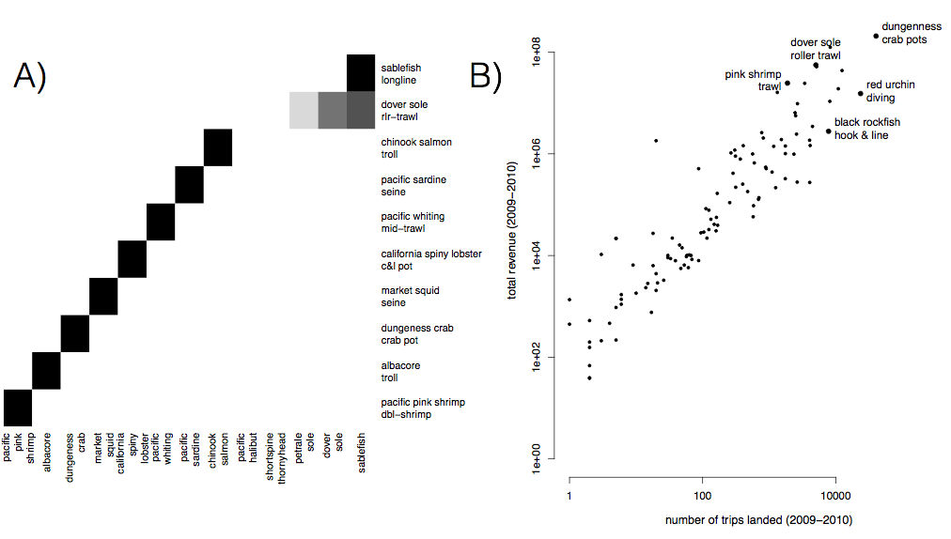

S1: A) Species composition for top ten realized fisheries (rows). Cell color represents the proportion of landings for which each species (column) is responsible. Most of the biggest realized fisheries are composed of primarily a single species, but groundfish trawl is multispecies. B) Comparison of effort and revenue for all realized fisheries between 2009-2010.

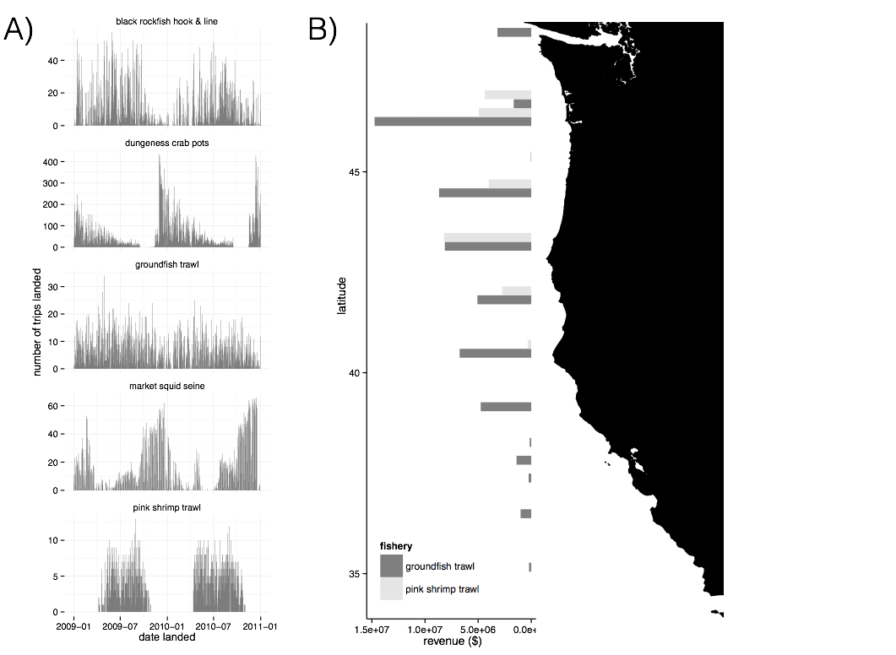

S2: A) Seasonality of five major realized fisheries between 2009-2010. Distinct seasonal patterns are observed in dungeness crab, market squid and pink shrimp fisheries. B) Spatial structure of landings for two example fisheries between 2009-2010. Landings are binned by latitude. Pink shrimp trawl is landed further north, while groundfish trawl landings are distributed more evenly across the coast.

Table S1: Akaike Information Criterion (AIC) values for the models with and without terms for catch shares. Values for the best model at each level are in boldface.

|  |  |  |  |  |  |  |
| --- | --- | --- | --- | --- | --- | --- |
| Level | *Hpre* | Catch shares | No. Parameters (*K*) | AIC | ΔAIC | Adjusted R2 |
| Vessel | Yes | No | 1 | 3140.767 | 30.916 | 0.2392 |
|  | **Yes** | **Yes** | **2** | **3109.851** | **0** | **0.2471** |
|  | No | Yes | 1 | 3643.718 | 533.867 | 0.01007 |
| Port | **Yes** | **No** | **1** | **186.1041** | **0** | **0.136** |
|  | Yes | Yes | 2 | 188.9555 | 2.8514 | 0.125 |
|  | No | Yes | 1 | 199.7547 | 13.6506 | 0 |

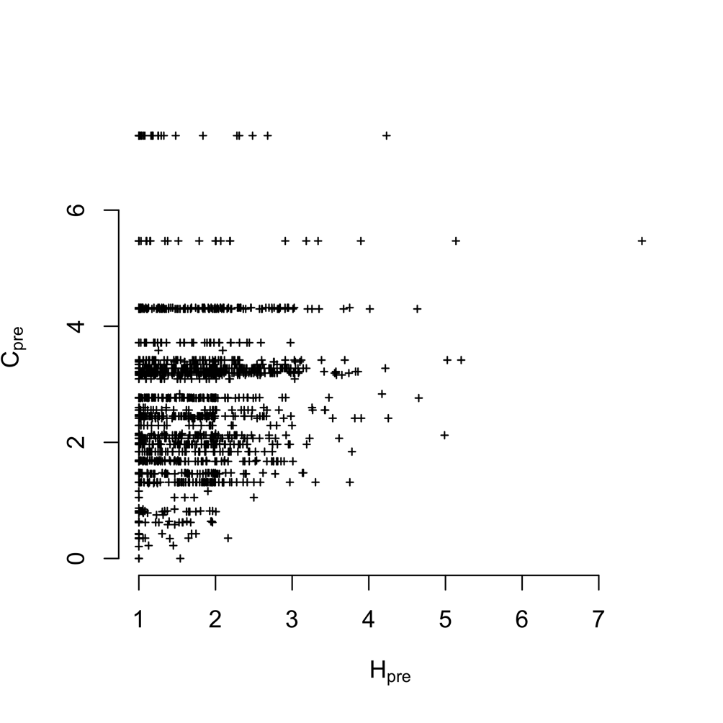

S3) Plotting vessel participation diversity (2009-2010) against port interconnectivity (2009-2010). We find vessel and port level diversity weakly correlated (Pearsons correlation 0.149, p = 4 x 10^-12). But the most diverse vessels tend to be found in the most diverse ports.

**Testing based on ITQs**

ITQs went in for the limited entry trawl fishery that targets federally managed groundfish species in 2011. Therefore we’d expect to see any metiers that are trawl based to have an IFQ flag in their landings. However when we examine our landings for trips landed after 2011, we find a number of trips that both use trawl gear, but do not use quota to land.

with(subset(trips, year**>**2011 **&** grgroup**==**"TWL" **&** **!**(trips**$**drvid **%in%** ak_ves)), table(ifq_landing, metier.2010))

ifq_landing TWL_1 TWL_2 TWL_3 TWL_4 TWL_5 TWL_6 TWL_7

0 1146 156 0 482 944 0

N 5 0 0 0 0 0 0

Y 2215 78 225 167 0 0 30

Here TWL_1 corresponds to DTS, TWL_2 is california halibut, TWL_3 is chinook salmon caught with midwater trawl (bycatch for hake), TWL_4 is whiting, TWL_5 is bait shrimp, TWL_6 is sea cucumber, TWL_7 is yellowtail bycatch for whiting.

We wouldn’t expect bait shrimp or sea cucumbers to involve species in ITQs, so the lack of ITQ flags makes sense. Similarly TWL_4 and TWL_7 having exclusively quota landings after 2011 makes sense both hake and yellowtail are quota species. TWL_3 having both quota and non-quota makes sense since some chinook catches are mixed with hake, and sometimes chinook are caught alone. The concerning sets of catches are the 5 TWL_1 catches and the fact that TWL_2 is split. TWL_2 is california halibut. California halibut are often caught with bottom trawls, but near shore. There’s two sectors for CA halibut, open access and federally manged limited entry. Limited entry boats are allowed to fish only in federal waters, can fish year round, but require quota. Limited entry boats are allowed to trawl in state waters and have to observe a 3 month closed period (March 15-June 15) for CA halibut spawning. Thus the split in TWL_2 is not suprising. However if the sector split can explain this, we’d expect all TWL_2 landings, reported afte 2011, landed without ifq quota, would not be present between March 15 and June 15. Instead, we see that while April and May are the lowest months, there are still TWL_2 landings without quota.

Rt

Here the numbers are months, and the color is whether or not there is quota present. “Y” is quota, the blank means no quota (although it’s coded as “Y”, “N” and “” in the fish tickets).

**Parking lot**

What about 2012 metiers?