# Fisheries connectivity and the effects of management on an interconnected marine socio-ecological system

Emma Fuller1, Jameal Samhouri2, Joshua Stoll3, James Watson4

1Department of Ecology and Evolutionary Biology, Princeton University, USA

2Conservation Biology Division, Northwest Fisheries Science Center, National Marine Fisheries Service, National Oceanic and Atmospheric Administration, Seattle, Washington, USA

3School of Marine Sciences, University of Maine, Orono, Maine, USA

4Stockholm Resilience Center, Stockholm University, Sweden

# Abstract

# Introduction

Ecosystem based fisheries management (EBFM) focuses on interactions, both between species and species and the biophysical environment. Because of the focus on interactions, EBFM is often described as managing an ecosystem as a whole, rather than individual species. This approach recognizes that other species, abiotic conditions, and human harvest are all drivers of system dynamics and seeks to manage them holistically. As such, much work on EBFM has been to build food webs, and to account for how abiotic conditions may drive species interactions.

The push for EBFM also comes at a time when the importance of considering the role people have in food webs is growing: increasingly, natural-resource management and conservation efforts are framing approaches in terms of ecosystem services and characterizing ecosystems more broadly as social-ecological systems (Millennium Ecosystem Assessment 2005). EBFM dovetails with these trends and advises managers that human impacts should be included both to better represent the ecological impacts fisheries have and to capture livelihoods and human well-being derived from harvest (Levin et al. 2009).

These efforts to model both social and ecological dynamics of these commercial fishery systems represent progress but tend to have higher resolution for the ecological components and lower resolution for the social or economic interactions. This is especially true of fishing fleets, which are largely modeled as independent populations of specialist vessels with no exchange among fisheries. Yet just as predators can couple disparate food chains (Baskerville et al. 2011), there is evidence that that vessels often are generalists: strategically entering and exiting fisheries depending on shot term fluctuations in market, regulatory and ecological conditions (Hentati-Sundberg et al. 2014; Kasperski and Holland 2013; Sethi, Reimer, and Knapp 2014); and that multiple fleets target the same species (Coleman et al. 2004). This lack of realism is problematic both because uncertainty in how vessels respond to changes in management has been identified as a major source of uncertainty in fisheries science (Fulton et al. 2010) and because mapping the flows of ecosystem services and incorporating “human dimensions” is often an explicit goal of management (Mace 2014; Levin et al. 2009). Quantifying and understanding the human connectivity in marine systems, i.e. how vessels link fisheries together by contemporaneous participation, therefore represent an important frontier to EBFM science.

Previous work examining vessel participation diversity has implicated management (Hentati-Sundberg et al. 2014; Kasperski and Holland 2013) as a driver of fishing specialization. We take advantage of a change in management on the US west coast to test whether implementation of catch shares in the limited access groundfish trawl fishery affected participation patterns for vessels. We also examine whether changing management in a single fishery affects how fisheries are linked to one another at the port level.

Towards this objective, we developed a novel classification method to identify distinct fishing practices used by fishers along the US west-coast and constructed a comprehensive database of commercial fisheries participation. Specifically, the classification method was used to: (i) calculate vessel-level participation in individual fisheries, (ii) determine emergent diversification of a vessel’s participation across fisheries, and (iii) describe networks of fisheries participation for entire communities (ports). We found that the majority of vessels examined were generalists, defined as those participating in more than one commercial fishery between 2009 and 2013. In addition, the interconnectedness of fisheries participation varied strongly across ports. Using these individual and community-level measures of fisheries diversification, we evaluated how the introduction of the Pacific Trawl Rationalization (catch share) program in the federal groundfish fishery in 2011 influenced vessel-level participation in the fishery, along with the diversification of vessels and ports as a function of their participation in the fishery.

# Methods

## Description of Data Sources

We used landings tickets that record all commercial landings on the US west coast between 2009-2013 from the Pacific Fisheries Information Network (PacFIN) database ([www.psmfc.org](http://www.psmfc.org/)). We restricted our analyses to vessels with an average of at least $5,000 in annual revenue and removed vessels that landed commercial catch in Alaska. We did not analyze landings from 2011, a management transition year in which catch shares were established. We also removed landings from vessels which that participated in the California Halibut trawl fishery due to concerns about inconsistencies in landing tickets. This left 2,413 vessels that were responsible for approximately 93% of the total revenue and biomass commercially landed during this period.

## Defining realized fisheries

Fisheries are defined as harvest assemblages caught with a specific gear (van Putten et al. 2012; Boonstra and Hentati Sundberg 2014), although in the following we use terms *fishing practice* and *fishery* interchangeably. The Pacific Fisheries Management Council (PFMC) has developed a set of sector-based definitions similar to this approach for the federally managed groundfish landings (www.pcouncil.org), but no equivalent exists for non-groundfish fisheries (Northwest Fisheries Science Center 2015). In order to treat the landings dataset uniformly, we applied a métier-like analysis to this landing data (Deporte et al. 2012).

A métier analysis identifies fishing practices by clustering the species composition of landings. This methodology requires choices in the way similarity among trips are measured, a clustering algorithm for grouping similar trips together, and a constraint that the methods can scale across hundreds of thousands of landings. In the following we specify and briefly outline our rational for these choices.

For our distance metric we used the Hellinger distance *D* (P. Legendre and Legendre 2012) to calculate the similarity in revenue profiles between trips and generated a pairwise distance matrix. This distance metric has the benefit that it is asymmetric, where the presence of a species in both trips is considered more informative than the absence of a species. The Hellinger distance between the species composition of two fishing trips *A* and *B* is defined as

|  |  |
| --- | --- |
|  | (1) |

where *ai* is the fraction of revenue derived from species *i* on trip *A*, *bi* is the fraction of revenue derived from species *i* on trip *B*, and *S* indicates the total number of species collected in both trips. With this metric, trips *A* and *B* become increasingly similar (and the Hellinger distance declines) as the proportion of revenue attributable to each of the *S* species becomes increasingly matched.

We identified groups of trips with similar target assemblages using the infoMap community detection algorithm (Rosvall and Bergstrom 2008). This algorithm examines networks for subgraphs more interconnected to one another than the network in which it is embedded. To generate the required network we transformed the distance matrix into a similarity matrix by subtracting the distance metric’s upper limit () from each pairwise distance. The result is a weighted, undirected network where trips are connected by edges proportional to their similarity.

However, because our dataset contained 340,466 unique trips, it was computationally intractable for us to construct a single matrix containing all pairwise similarities. To obtain manageable matrix sizes we used one year of landings (2010) which we split by gear. Pairwise distances among trips and community detection were calculated within each gear partition, which grouped trips into target assemblage categories. To classify the 2009, 2012 and 2013 trips to fishing practices, we assigned each unclassified trip to the same fishing practice as the 2010 trip to which it was closest in multi-dimensional space using a k-nearest neighbors algorithm.

A challenge in testing the effectiveness of this classification method, and part of the reason for its need, is that there is not an independent classification of US west coast fisheries that we could use to compare the results. To address this issue, we tested the reliability of our classification approach by evaluating the extent to which it identified known spatial and temporal structure of well-described US west coast fisheries and fishery sectors. Specifically, because we did not bound our clusters spatially, temporally, or by vessel characteristics, we were able to compare our emergent fishing strategies to existing sector definitions of groundfish, and groundfish impacting fisheries provided by the Northwest Fisheries Science Center Observer Program (Northwest Fisheries Science Center 2015).

## Calculating changes in vessel and community level fishing diversity

Vessel revenue diversity is calculated using the effective Shannon index *H* (Jost 2006). This metric quantifies variability in the proportion of revenue *pf* derived from each fishery *f*, such that *H* for vessel *j* is calculated as

where *F* is the number of realized fisheries. We define specialist vessels as those that land in a single fishery (*H* = 1) and generalist vessels are vessels that land in more than fishery (*H* > 1).

To represent connectivity among fisheries at the port level we built directed, weighted networks where nodes represented a fishery, and the strength of the connections between nodes represented the number of vessels that landed catch in both over a given period. More formally, for each port *k* we built a network *Gk,X🡪Y* in which an edge weight between two nodes *X* and *Y* was the number of vessels participating in fishery *X* and *Y* divided by the total number of vessels that participated in fishery *X*. Similarly, is the number of vessels participating in both fisheries divided by the total number of vessels that participated in fishery *Y* (Fig. 1)*.*

Figure 1: Using landing tickets we aggregated to catch to trips and defined realized fisheries. Using these realized fisheries we measured vessel and port level fisheries diversification.

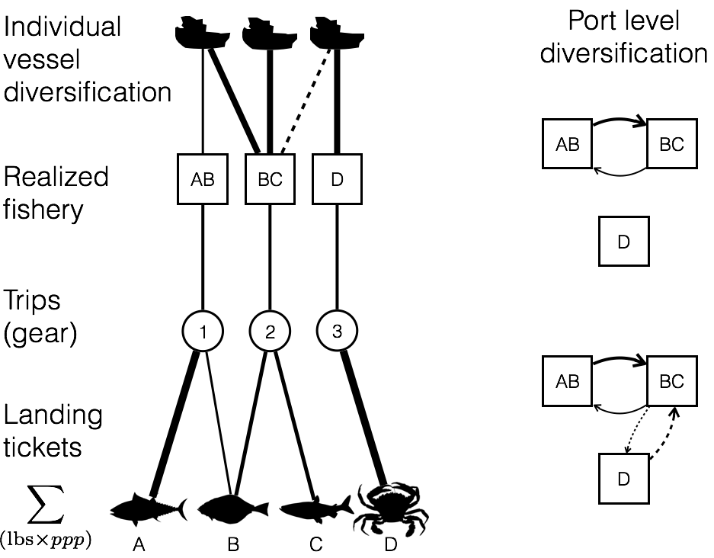

To measure port-level fisheries connectivity we calculated the link density (*LD)* (number of edges divided by nodes) which scales both with network size and interconnectedness. Because the network is directed, this value can be interpreted as the two times the average number of fisheries to which a fishery is connected (i.e. all vessels participate in both fisheries) at port *k*. Hereafter we refer to port connectance and link density interchangeably.

## Mapping participation as related to catch shares

We hypothesized that vessel participation would change as a function of how a vessel’s participation in catch shares affected fisheries. To this end we traced patterns of vessel participation as it relates to catch shares. We assigned vessels and ports to one of three categories *Mn*. First, we defined vessels/ports unaffected by catch shares as the *general fleet*, which included only those vessels/ports for which we observed no commercial landings in the catch-shares affected fishery in 2009-2010 or 2012-2013 (*M1, nvessels* = 1,878, *nports* = 52). Second, we defined *catch share participants* as those vessels/ports that fished in the limited entry trawl fishery prior to 2011 and continued to fish by using catch share quota to land fish after 2011 (*M2, nvessels* = 71, *nports* = 16). Third, we defined *limited entry exits* as those vessels that fished in the limited entry trawl fishery prior to 2011, but exited the fishery with the implementation of catch shares (*M3, nvessels =* 35, *nports* = 10, Fig. 2). By comparing the general fleet to vessels/ports affected by catch shares (*catch share participants* and *limit entry exits*) we’re able to control for exogenous inter-annual variation in revenue diversity present in both groups of vessels/ports.

## Analysis of changes in revenue diversity and port connectance due to catch shares

We used linear regressions to determine whether a change to catch shares management in the limited entry groundfish trawl sector was associated with a change in revenue diversity or a change in port connectance. For each vessel (henceforth we drop the indices for vessel and port for brevity)we calculated change in revenue diversity as the difference in revenue diversity before (*Hpre*) and after (*Hpost*) the implementation of catch shares,

|  |  |
| --- | --- |
|  | (4) |

We defined a change in connectance for each port as the difference in connectance before (*Cpre*) and after (*Cpost*) the implementation of catch shares,

|  |  |
| --- | --- |
|  | (5) |

Thus a value of zero for Δ*H* or Δ*C* indicated there was no change in revenue diversity or connectance for a given port, respectively, between the two periods, and a positive value indicated the vessel or port increased the evenness and/or the number of fisheries from which it received revenue.

At the vessel level, if catch shares allowed more flexiblity in fisheries participation, we would expect that catch share participants would, on average, demonstrate increased revenue diversity after the implementation of catch shares. To this end, we conducted a linear regression to determine the relationship between Δ*H* and *Mn*. However the ability to change diversity between two periods is related to the starting period diversity. For example, if a vessel is a specialist (i.e. *H* = 1), then it is impossible for that vessel to drop in diversity and any random variation will bias *ΔH* upwards. Similarly, if a vessel was maximally diversified, then the vessel could either remain the same or with random variation drop in diversity. Thus, we also evaluated a model in which the pre-catch share revenue diversity *Hpre* of each vessel was a covariate.

At the port level, we paralleled the vessel level analysis and used similar regressions to determine whether a change to catch shares management in the limited entry groundfish trawl sector was associated with a change in fishery connectance. Thus we also regressed the Δ*C* against catch shares participation with and without *Cpre* to catch shares as a covariate.

In both the vessel and port level analyses, we compared alternative models using the information theoretic approach that allows direct comparison of the models’ goodness of fit using model likelihoods (Burnham and Anderson 2002). The Akaike Information Criterion (AIC) was used to find the most parsimonious model which balanced both the goodness of fit (as measured by likelihood) and model complexity (as measured by the number of parameters). Here the lower the AIC, the better the model (Burnham and Anderson 2002). We calculated 95% confidence intervals on the model parameters by bootstrapping to determine whether the confidence intervals overlapped with zero. To do so, we randomly selected data with replacement from our vessel and port datasets until we had a dataset the same size as our original and then refit the models. This procedure was repeated 10,000 times and the resulting distribution give the 95% confidence intervals for each parameter.

# Results

## Definitions of realized fisheries

Our clustering algorithm identified 109 realized fisheries (Appendix, Table 1). Realized fisheries often consisted of a single species, but could also comprise assemblages of species (Fig. S1a). Whether their catch consisted of a single species or multiple species, the realized fisheries were characterized by distinct patterns of temporal and spatial structure (Fig. S2a, b). These patterns suggested strong agreement between our realized fisheries and NWFSC Observer sector designations, as did comparisons of vessel sizes and catch composition (single- vs. multi-species, Table 1).

Table 1: We summarize fleet characteristics for three realized fisheries and compare to the corresponding NWFSC Observer sector description. Parenthetical values represent the percentage of trips which fell within expected ranges. The following fisheries represent (with pink shrimp and limited entry groundfish) the top ten realized fisheries by revenue. Fleet characteristics for which no corresponding NWSFC observer sector is present are presented as 95 percentiles for length, latitude and seasonality.

|  |  |  |  |  |
| --- | --- | --- | --- | --- |
| **Fishery**  Sector name if applicable | **Latitude**  decimal degrees | **Catch composition**  % trips multispecies | **Seasonality**  fishing season | **Vessel Length**  ± 1 ft |
| Limited entry groundfish trawl/catch shares | 35.4-49  (97.9%) | 100%  (98.2%) | year-round | 35-95  (99.5%) |
| Pink shrimp trawl | 35.8-49  (97.9%) | NA | Apr 1 – Oct 31  (99.8%) | 38-105  (100%) |
| California halibut trawl | 37.4 – 34.05  (96.5%) | CA halibut dominated | year-round | 29-71  (99.8%) |
| Dungeness crab pots | 36.8-47.6 | 0.9% | Oct 26 – Aug 8 | 22-67 |
| Market squid seine | 33.7-36.8 | 6.8% | May 24 – Feb 25 | 36-80 |
| Albacore troll | 37.5-46.9 | 0.6% | Jul 10-Oct 22 | 23-72.5 |
| Sablefish long-line | 33.2-48.4 | 70% | Jan 16-Dec 15 | 20-57 |
| Shore-side Hake | 43.3-46.9 | 92% | Jun 16-Nov 15 | 65-129 |
| Chinook salmon troll | 35.4-48.4 | 14% | Apr 11-Oct 22 | 20-50 |
| Sardine seine | 33.7-46.9 | 42% | Jan 8-Oct 22 | 45-80 |
| Spiny lobster pot | 32.7-34.4 | 8.3% | Oct 5-Mar 12 | 18-42 |

The realized fisheries also varied by several orders of magnitude in effort (number of trips) and revenue (Fig. S1b), with a small number of fisheries accounting for the majority of effort and revenue. For example, only 10 of the 109 fisheries were responsible for 90% of ex-vessel revenue and landings (pounds) in the time period we examined (Table 1). These fisheries included sectors which have been well-studied, but not quantitatively described prior to now e.g., dungeness crab pots (Botsford and Wickham 1978), spiny lobster pots (Kay et al. 2012), or red urchin diving (Smith and Wilen 2003) (Table 1).

## Changes in vessel and community level fishing diversity

We found that between 2009-2010, 66% of commercial vessels on the west coast participated in more than one realized fishery (Fig. 2a) although the degree to which vessels diversified varied. Breaking these patterns down regionally using PFMC management regions, generalists outnumbered specialists (Fig. 2b). The distribution of diversity varied among the generalists, from vessels that were highly specialized, but had a few landings in additional fisheries to those that fished in many fisheries evenly (Fig. 2c). Notably, the majority of diversified vessels revenue was dominated by revenue from a single fishery (71%), with very small percentages coming from alternatives. However almost a quarter (24%) of diversified vessels were participating in at least two fisheries equally, with some vessels (4%) participating evenly in more than three fisheries (Fig. 2c).

Figure 2: Distribution of fisheries diversity at the vessel level; A) coastwide, B) by management region, C) breakdown of generalism for each management sector. Generalists are vessels that land > 1 realized fishery.

../../../../../../../../../Desktop/CNH/Analysis/Metiers/bin/05_figur

The preceding analysis focused on fishing strategies employed by individual vessels, without consideration of how those strategies came together to create characteristic fisheries participation networks for specific ports. We found differences in the number and interconnectedness of fisheries across ports (Fig. 3). Ports had anywhere between 0-7 fisheries connected. This variation is exemplified by participation networks in Santa Barbara, CA, Eureka, CA, and Oakland, CA (Fig 3abc). Santa Barbara was characterized by a complex participation network, with more than double the average fishery connectance of Eureka (see Appendix for all port participation networks). The ports had a spectrum of vessels landing at them and we found that there was a positive, albeit weak, relationship between vessel and port level diversity (Spearman’s correlation 0.185, p < 2.2e-16, Fig S3).

Figure 3: Diversity of fishing communities on the US west coast. A) Fisheries participation network for all landings in Santa Barbara, CA between 2009-2010, B) Fisheries participation network for all landings in Eureka, CA between 2009-2010, C) Fisheries participation network for all landings in Oakland, CA for all landings in Oakland, CA between 2009-2010, D) fishery connectance values for all ports on US west coast with > 3 vessels landing between 2009-2010. Dark bars correspond to the network above them.

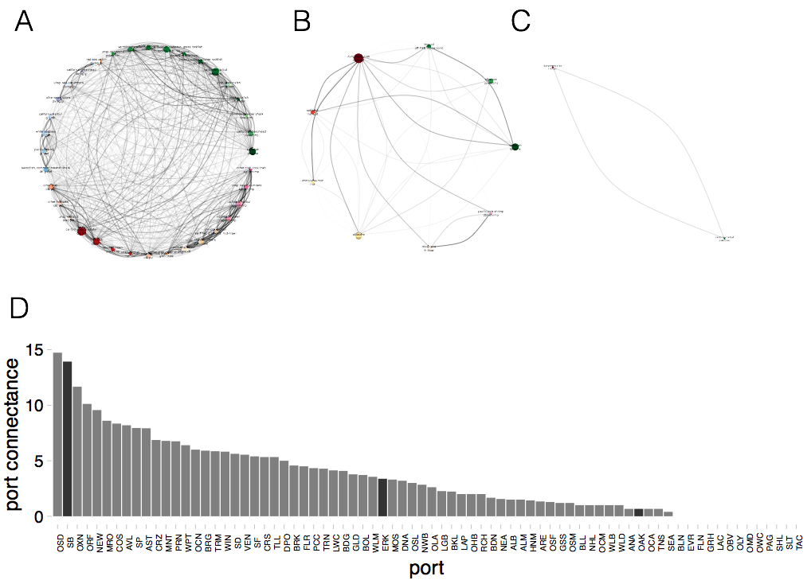

## Mapping participation as related to catch shares

We found that the implementation of catch shares was associated with a minority (6%) of vessels leaving commercial fishing altogether while 66% of vessels continued to participate in the affected fishery. Of vessels which continued fishing in the affect fishery, only 13% of vessels continued to participate with fishing participation unchanged. A third group consisted of vessels that exited catch shares but continued to fish commercially (28%) (Fig 4). These vessels showed a mixed response, with increased and decreased fishing diversity observed.

Figure 4: We map the ways that a vessel can respond to the implementation of catch shares. Vessels that were directly affected by catch share implementation are those that fished in the limited entry (LE) groundfish fleet between 2009-2010. After 2011, vessels either continue to participate in the groundfish trawl fishery by landing with quota, or leave the catch share fishery and either leave fishing entirely or continue to fish in other commercial fisheries. The width of the bar in the decision tree is proportional to the absolute number of vessels which follow a given path given by the number. Percentages are relative to each decision point.

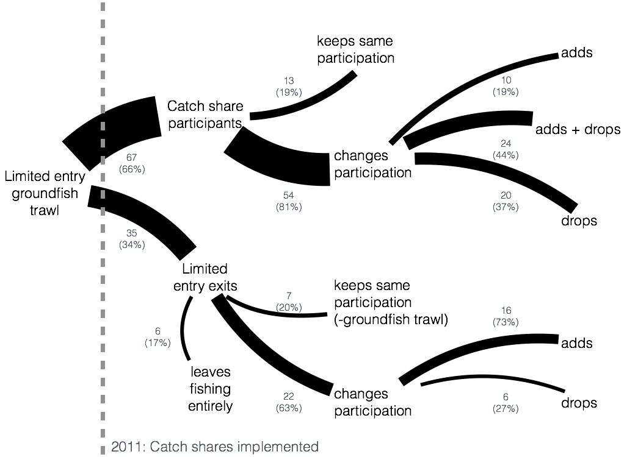

## Analysis of changes in revenue diversity and port connectance due to catch shares

Over our study time period, vessels become more diversified on average (Fig 4). We found though that the change in revenue diversity was strongly explained by the revenue diversity the vessels had in 2009-2010. Vessels with higher participation diversity prior to catch shares were more likely to show a reduction in diversity following catch shares (Table S2). We also found that and a vessel’s participation in catch shares was related to changes in revenue diversity. Vessels that participated in catch shares saw an increase in their revenue diversity that was twice what vessels which exited the catch share fishery in 2011 experienced. At the port level we found that ports decreased their connectance on average, and this was strongly predicted by connectance prior to 2011 (Table S1, S2). We find that the model which best explains the change does not include terms for a port’s relationship to catch shares.

Figure 4: Estimated effects of catch shares on diversity for vessels, bars are 95% confidence intervals. Vessels that participate in catch shares, increase in diversity more than either the general fleet or those that exited catch shares. At the port level the best model does not include a term for participation in catch shares.

../bin/05_figures/fig4a.pdf

# Discussion

There is widespread recognition that ecosystem management requires an understanding of the interconnectivity within and between the human and ecological dimensions of marine systems (J. L. Anderson et al. 2015). Mapping these social-ecological connections have resulted in considerable insight, often by identifying drivers unobservable from the social or ecological studies alone (Brashares et al. 2004; Lade et al. 2015). This interconnectivity is particularly important in fisheries, where socioeconomic or ecological changes in one fishery often have cascading effects that ultimately influence others (Steneck et al. 2011; Lade et al. 2015). Yet despite this recognition, social dynamics are often missing and fishing fleets are often represented as homogenous (Field 2004). Yet there is no question that fishing fleets are highly heterogeneous and continually change in size, effort levels, and composition as numerous exogenous and endogenous forces influence them (Opaluch and Bockstael 1984). For example Hentati-Sundberg et al. (2014) show how Swedish commercial fishermen have grown increasingly specialized as management became more restrictive and Steneck et al. (2011) document how Maine fishermen have increasingly become dependent on a single species due to interactions among markets and ecological conditions. Acknowledging this issue, we use this paper to investigate the socioeconomic connectivity within and across fisheries on the west coast of the US.

## Implications of fisheries connectivity for social and ecological dynamics

We found that more than 60% of commercial fishing vessels on the US west coast fisheries were generalists, participating in more than one fishery. The revenue streams of each of these generalists is thus tied to multiple fisheries, effectively connecting fisheries and setting up the potential for linked social dynamics and coupled ecological dynamics of target species that do not otherwise interact directly.

The social implications of generalist fishing practices have been most directly related to reduced exposure to financial risk (Kasperski and Holland 2013; Sethi, Reimer, and Knapp 2014). Previous work has demonstrated that vessels with increased revenue diversity have less variable revenues, and that changes in management have been associated with reduced revenue diversity in these fisheries (Kasperski and Holland 2013). Thus measuring revenue diversity across vessels before and after a management change helps to understand how changes in system characteristics affect one facet of human well-being.

Failing to account for the socioeconomic connectivity among fisheries may result in changes in one fishery unexpectedly affecting the participation in a fishery targeting a species which is ecologically unconnected. Dungeness crab and albacore tuna fisheries on the US west coast provide an appealing, but untested example. Here, we find these two fishing practices to be commonly connected by vessels at the port level, yet these species do not interact directly in the ocean. Examining changes in revenue diversity and vessel participation in the albacore tuna fishery after the recent closure of the Dungeness crab fishery in Washington and Oregon would be an excellent test of how connectivity influences fisheries participation. It is likely that perturbations, whether they be environmental or due to a management change, will ripple through these networks, and that the topology of these networks (from port to port) will largely determine how individual fishers experience these perturbations.

## Management change and fisheries connectivity

Studies that have documented fisheries connectivity have highlighted the impact that management can have (Hentati-Sundberg et al. 2014; Kasperski and Holland 2013). This existing empirical work is important to provide intuition on how fisheries connectivity should be included in EBFM models. We add to this body of literature by examining how fisheries connectivity is influenced in the short tem in response to a change in management.

If previously documented relationships between vessel participation diversity and revenue variability hold, catch shares thus has reduced these vessels’ exposure to risk. However, not all groundfish trawl boats made the transition into the catch shares regime. Most analyses of the impacts of catch shares have focused on the vessels that continue fishing, assuming that vessels that exit also exit commercial fishing. This work demonstrates that the majority of vessels continued fishing, albeit in other fisheries. Closely examining what happens to trawlers that exited groundfish fisheries, and whether these patterns in of connectivity can predict new entries is an important next step for this work as we seek to more fully account for the socioeconomic connectivity of the system.

Outside of the empirical fisheries diversification literature, most analyses of catch shares have focused on changes in the target fishery rather than the wider fisheries system {Costello:2008hz, Worm:2009dg}. Our results suggest that considering how vessels shift participation beyond their role in a target fishery is important for fully understanding the impact changes in management can have, both at the vessel and community level.

## Conclusion

Ecosystem-based management (EBM) and its many variants appear prominently in an array of highly visible ocean and coastal conservation and stewardship policy documents

(Pew Oceans Commission 2003; President Barack Obama 2010; Commonwealth of Australia 1998; Canada 1996; European Commission 2008; Secretariat of the Convention on Biological Diversity 2004). However, despite the increasing emphasis on EBM, the transition from EBM in theory and policy to practice has been slow (Pitcher et al. 2009). This slowness, in part, underscores the technical and scientific challenges that underlie EBM and the uneven, sometimes contradictory, and difficult task of understanding the often complex social-ecological context of marine ecosystems (Evans and Klinger 2008).

Here we argue that social and ecological consequences of fisheries management need to be examined in a way that recognizes the interactions between social nodes and social network dynamics. With EBFM, fisheries scientists have increasingly employed community ecology to understand food web interactions. To fully model and manage linked social-ecological systems, social connectivity needs to be better integrated.

**Acknowledgements**

We thank PacFin for access to the data, the observers and fishermen on the US west coast for insightful discussions, and Emily Klein for discussions on this project. E. Fuller acknowledges support from the National Science Foundation (GRFP, GEO-1211972) and GreenMar (Consortium Agreement GreeMar-AGMT dtd 05-05-2014, Prime Nordforsk Project Number: 61582); J. Samhouri acknowledges support from …; J. Stoll acknowleges support from …; and J. Watson acknowledges support from …

# References:

Anderson, James L, Christopher M Anderson, Jingjie Chu, Jennifer Meredith, Frank Asche, Gil Sylvia, Martin D Smith, et al. 2015. “The Fishery Performance Indicators: a Management Tool for Triple Bottom Line Outcomes.” Edited by George Tserpes. *PloS One* 10 (5): e0122809–20. doi:10.1371/journal.pone.0122809.

Baskerville, Edward B, Andy P Dobson, Trevor Bedford, Stefano Allesina, T Michael Anderson, and Mercedes Pascual. 2011. “Spatial Guilds in the Serengeti Food Web Revealed by a Bayesian Group Model.” Edited by Lauren Ancel Meyers. *PLoS Computational Biology* 7 (12). Public Library of Science: e1002321. doi:10.1371/journal.pcbi.1002321.

Boonstra, Wiebren J, and Jonas Hentati Sundberg. 2014. “Classifying Fishers' Behaviour. an Invitation to Fishing Styles,” August, n–a–n–a. doi:10.1111/faf.12092.

Botsford, Louis W, and Daniel E Wickham. 1978. “Behavior of Age-Specific, Density-Dependent Models and the Northern California Dungeness Crab ( Cancer Magister) Fishery.” *Journal of the Fisheries Research Board of Canada* 35 (6): 833–43. doi:10.1139/f78-134.

Brashares, Justin S, Peter Arcese, Moses K Sam, Peter B Coppolillo, A R E Sinclair, and Andrew Balmford. 2004. “Bushmeat Hunting, Wildlife Declines, and Fish Supply in West Africa.” *Science (New York, N.Y.)* 306 (5699). American Association for the Advancement of Science: 1180–83. doi:10.1126/science.1102425.

Burnham, Kenneth P, and David R Anderson. 2002. *Model Selection and Multimodel Inference: a Practical Information-Theoretic Approach*. Edited by Springer Science & Business Media.

Coleman, Felicia C, Will F Figueira, Jeffrey S Ueland, and Larry B Crowder. 2004. “The Impact of United States Recreational Fisheries on Marine Fish Populations..” *Science (New York, N.Y.)* 305 (5692): 1958–60. doi:10.1126/science.1100397.

Costello, Christopher, Steven D Gaines, and John Lynham. 2008. “Can Catch Shares Prevent Fisheries Collapse?.” *Science (New York, N.Y.)* 321 (5896): 1678–81. doi:10.1126/science.1159478.

Deporte, N, C Ulrich, S Mahevas, S Demaneche, and F Bastardie. 2012. “Regional Metier Definition: a Comparative Investigation of Statistical Methods Using a Workflow Applied to International Otter Trawl Fisheries in the North Sea.” *ICES Journal of Marine Science* 69 (2): 331–42. doi:10.1093/icesjms/fsr197.

Field, John C. 2004. “Application of Ecosystem-Based Fishery Management Approaches in the Northern California Current .” Edited by Robert C Francis.

Fulton, Elizabeth A, Anthony D M Smith, David C Smith, and Ingrid E van Putten. 2010. “Human Behaviour: the Key Source of Uncertainty in Fisheries Management.” *Fish and Fisheries* 12 (1): 2–17. doi:10.1111/j.1467-2979.2010.00371.x.

Hentati-Sundberg, J, J Hjelm, W J Boonstra, and H Österblom. 2014. “Management Forcing Increased Specialization in a Fishery System.” *Ecosystems* 18 (1). Springer US: 45–61. doi:10.1007/s10021-014-9811-3.

Jost, Lou. 2006. “Entropy and Diversity.” *Oikos* 113 (2): 363–75.

Kasperski, S, and D S Holland. 2013. “Income Diversification and Risk for Fishermen.” *Proceedings of the National Academy of Sciences*. doi:10.1073/pnas.1212278110/-/DCSupplemental.

Kay, Matthew C, Hunter S Lenihan, Carla M Guenther, Jono R Wilson, Christopher J Miller, and Samuel W Shrout. 2012. “Collaborative Assessment of California Spiny Lobster Population and Fishery Responses to a Marine Reserve Network..” *Ecological Applications : a Publication of the Ecological Society of America* 22 (1): 322–35.

Lade, Steven J, Susa Niiranen, Jonas Hentati Sundberg, Thorsten Blenckner, Wiebren J Boonstra, Kirill Orach, Martin F Quaas, Henrik Österblom, and Maja Schlüter. 2015. “An Empirical Model of the Baltic Sea Reveals the Importance of Social Dynamics for Ecological Regime Shifts..” *Proceedings of the National Academy of Sciences of the United States of America* 112 (35): 11120–25. doi:10.1073/pnas.1504954112.

Legendre, P, and L Legendre. 2012. *Numerical Ecology*. Elsevier.

Levin, Phillip S, Michael J Fogarty, Steven A Murawski, and David Fluharty. 2009. “Integrated Ecosystem Assessments: Developing the Scientific Basis for Ecosystem-Based Management of the Ocean.” *PLoS Biology* 7 (1): e1000014–16. doi:10.1371/journal.pbio.1000014.

Mace, Georgina M. 2014. “Ecology. Whose Conservation?.” *Science (New York, N.Y.)* 345 (6204). American Association for the Advancement of Science: 1558–60. doi:10.1126/science.1254704.

Millennium Ecosystem Assessment. 2005. “*Ecosystems and Human Well-Being: Synthesis*.” *Island Press*. Washington, DC.

Northwest Fisheries Science Center. 2015. “Data Analysis and Products.” *Fisheries Observation Science*. Seattle, WA. Accessed December 8. http://www.nwfsc.noaa.gov/research/divisions/fram/observation/data\_products/bottom\_trawl.cfm#description.

Opaluch, J J, and N E Bockstael. 1984. “Behavioral Modeling and Fisheries Management.” *Marine Resource Economics*. doi:10.2307/42628847.

Rosvall, Martin, and Carl T Bergstrom. 2008. “Maps of Random Walks on Complex Networks Reveal Community Structure.” *Proceedings of the National Academy of Sciences* 105 (4). National Acad Sciences: 1118–23. doi:10.1073/pnas.0706851105.

Sethi, S A, M Reimer, and G Knapp. 2014. “Alaskan Fishing Community Revenues and the Stabilizing Role of Fishing Portfolios.” *Marine Policy*. doi:10.1016/j.marpol.2014.03.027.

Smith, Martin D, and James E Wilen. 2003. “Economic Impacts of Marine Reserves: the Importance of Spatial Behavior.” *Journal of Environmental Economics and Management* 46 (2): 183–206. doi:10.1016/S0095-0696(03)00024-X.

Steneck, R S, T P Hughes, J E CINNER, W N ADGER, S N ARNOLD, F BERKES, S A BOUDREAU, et al. 2011. “Creation of a Gilded Trap by the High Economic Value of the Maine Lobster Fishery.” *Conservation Biology* 25 (5): 904–12. doi:10.1111/j.1523-1739.2011.01717.x.

van Putten, Ingrid E, Soile Kulmala, Olivier Thébaud, Natalie Dowling, Katell G Hamon, Trevor Hutton, and Sean Pascoe. 2012. “Theories and Behavioural Drivers Underlying Fleet Dynamics Models.” *Fish and Fisheries* 13 (2): 216–35. doi:10.1111/j.1467-2979.2011.00430.x.

**Appendix**

A) Realized Fisheries

|  | | **Métier** | | **Major species** | | **Major gear** | | **CA** | | **OR** | | **WA** | | **Trips** | | **Multi-species** | | **Number vessels** | |
| --- | --- | --- | --- | --- | --- | --- | --- | --- | --- | --- | --- | --- | --- | --- | --- | --- | --- | --- | --- |
|  | POT\_1 | | Dungeness crab | | crab pot | | 45 | | 23 | | 32 | | 105532 | | no | | 1194 | |
|  | MSC\_1 | | red sea urchin | | diving gear | | 80 | | 20 | | NA | | 58224 | | no | | 211 | |
|  | TLS\_1 | | chinook salmon | | troll | | 50 | | 25 | | 25 | | 39383 | | no | | 1481 | |
|  | POT\_2 | | California spiny lobster | | crab & lobster pot | | 100 | | NA | | NA | | 28588 | | no | | 253 | |
|  | HKL\_1 | | sablefish | | longline | | 66 | | 15 | | 19 | | 25026 | | no | | 595 | |
|  | NET\_1 | | market squid | | seine | | 100 | | NA | | NA | | 20325 | | no | | 154 | |
|  | HKL\_2 | | black rockfish | | other hook & line | | 67 | | 33 | | NA | | 18358 | | no | | 342 | |
|  | TLS\_2 | | albacore | | troll | | 42 | | 26 | | 32 | | 13851 | | no | | 1260 | |
|  | POT\_3 | | rock crab | | crab & lobster pot | | 100 | | NA | | NA | | 11806 | | no | | 203 | |
|  | HKL\_4 | | brown rockfish, gopher rockfish | | pole (commercial) | | 90 | | 10 | | NA | | 10200 | | yes | | 209 | |
|  | HKL\_3 | | California halibut | | pole (commercial) | | 100 | | NA | | NA | | 9350 | | no | | 630 | |
|  | TWL\_1 | | dover sole | | roller-trawl | | 59 | | 23 | | 18 | | 8305 | | no | | 125 | |
|  | NET\_2 | | pacific sardine | | seine | | 74 | | 16 | | 11 | | 7169 | | no | | 116 | |
|  | TWS\_1 | | pacific pink shrimp | | double-shrimp trawl | | 20 | | 50 | | 30 | | 6208 | | no | | 105 | |
|  | POT\_5 | | spotted prawn | | prawn trap | | 81 | | NA | | 19 | | 5823 | | no | | 37 | |
|  | POT\_6 | | unsp. hagfish | | fish pot | | 50 | | 18 | | 32 | | 5630 | | no | | 137 | |
|  | HKL\_5 | | lingcod | | other hook & line, pole (commercial) | | 63 | | 25 | | 12 | | 5502 | | no | | 612 | |
|  | POT\_4 | | sablefish | | fish pot | | 62 | | 25 | | 12 | | 5393 | | no | | 283 | |
|  | NET\_3 | | California halibut | | gillnet | | 100 | | NA | | NA | | 4946 | | no | | 63 | |
|  | TWL\_2 | | California halibut | | groundfish trawl<8 | | 100 | | NA | | NA | | 4703 | | no | | 55 | |
|  | HKL\_6 | | black-and-yellow rockfish, Cabazon, grass rockfish | | pole (commercial), vertical hook & line | | 74 | | 26 | | NA | | 4634 | | yes | | 201 | |
|  | MSC\_2 | | unsp. sea cucumbers | | diving gear | | 95 | | 5 | | NA | | 4384 | | no | | 92 | |
|  | HKL\_7 | | white seabass | | pole (commercial) | | 100 | | NA | | NA | | 3372 | | no | | 387 | |
|  | NET\_4 | | white seabass | | gillnet | | 100 | | NA | | NA | | 3292 | | no | | 55 | |
|  | NET\_5 | | pacific herring | | gillnet | | 89 | | NA | | 11 | | 3270 | | no | | 157 | |
|  | TWL\_3 | | unsp. bait shrimp | | beam trawl | | 100 | | NA | | NA | | 2384 | | no | | 10 | |
|  | TWS\_2 | | ridgeback prawn | | single-shrimp trawl | | 85 | | NA | | 15 | | 2203 | | no | | 24 | |
|  | TWL\_4 | | unsp. sea cucumbers | | groundfish trawl | | 100 | | NA | | NA | | 2106 | | no | | 48 | |
|  | HKL\_8 | | vermilion rockfish | | pole (commercial) | | 79 | | 21 | | NA | | 1878 | | no | | 263 | |
|  | NET\_7 | | swordfish, common thresher shark | | drift gillnet | | 100 | | NA | | NA | | 1510 | | yes | | 82 | |
|  | NET\_6 | | unsp. shad | | dip net | | 100 | | NA | | NA | | 1362 | | no | | 10 | |
|  | NET\_8 | | chub mackerel | | dip net | | 90 | | 10 | | NA | | 1283 | | no | | 51 | |
|  | TWS\_3 | | California halibut | | single-shrimp trawl | | 69 | | 23 | | 8 | | 1239 | | no | | 43 | |
|  | POT\_8 | | other shrimp | | prawn trap | | 67 | | 33 | | NA | | 1177 | | no | | 33 | |
|  | NET\_9 | | northern anchovy | | seine | | 81 | | 6 | | 12 | | 1170 | | no | | 45 | |
|  | HKL\_9 | | unsp. sanddabs | | pole (commercial) | | 100 | | NA | | NA | | 1159 | | no | | 97 | |
|  | MSC\_4 | | Dungeness crab | | other-known | | 17 | | 83 | | NA | | 1102 | | no | | 92 | |
|  | POT\_11 | | Cabazon, gopher rockfish | | fish pot | | 80 | | 20 | | NA | | 1087 | | yes | | 70 | |
|  | MSC\_5 | | basket cockle | | other-known | | 73 | | 27 | | NA | | 985 | | no | | 44 | |
|  | MSC\_3 | | unsp. bait shrimp | | other-known | | 25 | | NA | | 75 | | 922 | | no | | 11 | |
|  | HKL\_10 | | albacore | | pole (commercial) | | 91 | | 3 | | 6 | | 780 | | no | | 285 | |
|  | POT\_9 | | California sheephead | | fish pot | | 100 | | NA | | NA | | 722 | | no | | 40 | |
|  | TWL\_5 | | chinook salmon | | selective flat fish trawl, groundfish trawl<8, mid-water trawl | | 70 | | 20 | | 10 | | 615 | | yes | | 83 | |
|  | TWL\_7 | | pacific whiting | | mid-water trawl | | 29 | | 43 | | 29 | | 599 | | no | | 29 | |
|  | MSC\_6 | | swordfish | | other-known | | 100 | | NA | | NA | | 515 | | no | | 35 | |
|  | TWS\_8 | | unsp. bait shrimp | | single-shrimp trawl | | 100 | | NA | | NA | | 402 | | no | | 3 | |
|  | POT\_10 | | other crab | | crab & lobster pot | | 89 | | 11 | | NA | | 378 | | no | | 84 | |
|  | HKL\_11 | | California sheephead | | pole (commercial) | | 94 | | 6 | | NA | | 375 | | no | | 50 | |
|  | MSC\_8 | | gaper clam | | other-known | | NA | | 100 | | NA | | 342 | | no | | 10 | |
|  | HKL\_13 | | California scorpionfish | | pole (commercial) | | 100 | | NA | | NA | | 329 | | no | | 14 | |
|  | TWS\_4 | | unsp. sea cucumbers | | single-shrimp trawl | | 100 | | NA | | NA | | 324 | | no | | 20 | |
|  | POT\_7 | | Dungeness crab, rock crab | | crab & lobster pot | | 69 | | 19 | | 11 | | 318 | | yes | | 156 | |
|  | HKL\_15 | | pacific halibut | | longline | | 6 | | 69 | | 25 | | 297 | | no | | 115 | |
|  | HKL\_18 | | surfperch spp. | | pole (commercial) | | 100 | | NA | | NA | | 262 | | no | | 32 | |
|  | HKL\_17 | | yellowtail | | pole (commercial) | | 100 | | NA | | NA | | 232 | | no | | 68 | |
|  | TLS\_5 | | California halibut | | troll | | 100 | | NA | | NA | | 228 | | no | | 53 | |
|  | POT\_12 | | other mollusks | | crab & lobster pot | | 100 | | NA | | NA | | 226 | | no | | 56 | |
|  | HKL\_14 | | common thresher shark | | pole (commercial) | | 100 | | NA | | NA | | 213 | | no | | 47 | |
|  | NET\_12 | | pacific barracuda | | drift gillnet | | 100 | | NA | | NA | | 209 | | no | | 16 | |
|  | HKL\_12 | | Bluefin tuna, pacific sanddab | | pole (commercial) | | 78 | | 22 | | NA | | 207 | | yes | | 117 | |
|  | NET\_11 | | other crab | | gillnet | | 100 | | NA | | NA | | 194 | | no | | 16 | |
|  | HKL\_16 | | unsp. smelt | | pole (commercial) | | 100 | | NA | | NA | | 173 | | no | | 13 | |
|  | TWL\_11 | | other crab, other shrimp | | groundfish trawl | | 100 | | NA | | NA | | 163 | | yes | | 14 | |
|  | MSC\_11 | | unsp. mollusks | | diving gear | | 100 | | NA | | NA | | 149 | | no | | 8 | |
|  | HKL\_19 | | shortfin mako shark | | pole (commercial) | | 100 | | NA | | NA | | 145 | | no | | 34 | |
|  | POT\_13 | | unsp. octopus | | crab pot | | 67 | | 33 | | NA | | 145 | | no | | 70 | |
|  | MSC\_9 | | other sea urchins | | diving gear | | 100 | | NA | | NA | | 136 | | no | | 44 | |
|  | HKL\_26 | | chinook salmon | | pole (commercial) | | 100 | | NA | | NA | | 114 | | no | | 53 | |
|  | TLS\_4 | | unsp. sanddabs | | troll | | 71 | | 21 | | 8 | | 108 | | yes | | 77 | |
|  | TLS\_8 | | lingcod | | troll | | 44 | | 44 | | 12 | | 103 | | no | | 60 | |
|  | HKL\_24 | | unsp. reds rockfish | | pole (commercial) | | 100 | | NA | | NA | | 98 | | no | | 28 | |
|  | MSC\_10 | | butter clam | | other-known | | NA | | 100 | | NA | | 86 | | no | | 6 | |
|  | TWL\_12 | | yellowtail rockfish | | selective flat fish trawl, mid-water trawl, roller-trawl | | NA | | 40 | | 60 | | 86 | | no | | 26 | |
|  | TWL\_8 | | lingcod | | selective flat fish trawl, mid-water trawl, roller-trawl | | 25 | | 38 | | 38 | | 84 | | no | | 27 | |
|  | TWS\_6 | | unsp. flatfish | | single-shrimp trawl | | 100 | | NA | | NA | | 83 | | no | | 7 | |
|  | HKL\_20 | | unsp. shelf rockfish | | pole (commercial) | | 100 | | NA | | NA | | 82 | | no | | 6 | |
|  | HKL\_22 | | pacific barracuda | | pole (commercial) | | 100 | | NA | | NA | | 76 | | no | | 45 | |
|  | HKL\_21 | | leopard shark | | pole (commercial) | | 100 | | NA | | NA | | 65 | | no | | 29 | |
|  | MSC\_12 | | other mollusks | | diving gear | | 78 | | 22 | | NA | | 65 | | no | | 29 | |
|  | HKL\_23 | | swordfish | | longline | | 100 | | NA | | NA | | 57 | | no | | 16 | |
|  | TLS\_7 | | yellowtail rockfish | | troll | | 38 | | 38 | | 25 | | 48 | | no | | 29 | |
|  | TWL\_9 | | nor. unsp. slope rockfish | | roller-trawl | | NA | | 75 | | 25 | | 44 | | no | | 28 | |
|  | HKL\_25 | | unsp. squid | | longline, other hook & line, pole (commercial) | | 70 | | 30 | | NA | | 41 | | no | | 12 | |
|  | HKL\_27 | | unsp. rockfish | | pole (commercial) | | 92 | | NA | | 8 | | 37 | | no | | 21 | |
|  | TWS\_9 | | other crab, rock crab | | single-shrimp trawl | | 100 | | NA | | NA | | 37 | | yes | | 10 | |
|  | POT\_14 | | unsp. eels | | fish pot | | 100 | | NA | | NA | | 36 | | no | | 13 | |
|  | TWL\_10 | | pop | | roller-trawl | | NA | | 100 | | NA | | 36 | | no | | 17 | |
|  | TWL\_13 | | canary rockfish, spiny dogfish | | mid-water trawl | | NA | | 75 | | 25 | | 34 | | yes | | 19 | |
|  | TWL\_14 | | spiny dogfish | | selective flat fish trawl, groundfish trawl<8, mid-water trawl | | 50 | | 25 | | 25 | | 33 | | no | | 7 | |
|  | MSC\_14 | | California sheephead | | diving gear | | 100 | | NA | | NA | | 27 | | no | | 6 | |
|  | TLS\_9 | | sablefish | | troll | | 64 | | NA | | 36 | | 27 | | no | | 22 | |
|  | TWS\_7 | | other shrimp | | single-shrimp trawl | | 100 | | NA | | NA | | 23 | | no | | 3 | |
|  | MSC\_13 | | black-and-yellow rockfish | | diving gear | | 100 | | NA | | NA | | 22 | | no | | 6 | |
|  | MSC\_16 | | unsp. echinoderm | | diving gear | | 100 | | NA | | NA | | 21 | | no | | 5 | |
|  | TLS\_3 | | albacore | | troll | | 47 | | 20 | | 33 | | 21 | | no | | 21 | |
|  | TWL\_6 | | petrale sole | | groundfish trawl<8 | | 100 | | NA | | NA | | 20 | | yes | | 6 | |
|  | TWS\_10 | | other skates | | single-shrimp trawl | | 100 | | NA | | NA | | 19 | | no | | 5 | |
|  | MSC\_7 | | unsp. sea cucumbers | | diving gear | | 100 | | NA | | NA | | 18 | | no | | 7 | |
|  | TLS\_6 | | white seabass | | troll | | 100 | | NA | | NA | | 18 | | no | | 7 | |
|  | MSC\_18 | | unsp. flatfish | | diving gear | | 100 | | NA | | NA | | 17 | | no | | 6 | |
|  | NET\_10 | | pacific sardine | | seine | | 100 | | NA | | NA | | 14 | | no | | 10 | |
|  | MSC\_15 | | unsp. shad | | unknown gear | | 100 | | NA | | NA | | 10 | | no | | 2 | |
|  | MSC\_17 | | shortfin mako shark | | other-known | | 100 | | NA | | NA | | 9 | | no | | 6 | |
|  | HKL\_28 | | unsp. octopus | | longline, other hook & line, pole (commercial) | | 25 | | 75 | | NA | | 8 | | no | | 6 | |
|  | HKL\_29 | | nor. unsp. shelf rockfish | | other hook & line | | NA | | 100 | | NA | | 5 | | no | | 4 | |
|  | TWS\_5 | | hornyhead turbot, ridgeback prawn, unsp. hagfish | | single-shrimp trawl | | 100 | | NA | | NA | | 4 | | yes | | 3 | |
|  | TLS\_10 | | yellowtail | | troll | | NA | | 100 | | NA | | 3 | | no | | 3 | |
|  | TWS\_11 | | white seabass | | single-shrimp trawl | | 100 | | NA | | NA | | 3 | | no | | 2 | |
|  | TWS\_12 | | vermilion rockfish | | single-shrimp trawl | | 100 | | NA | | NA | | 3 | | no | | 2 | |

B) Evaluating realized fisheries classification

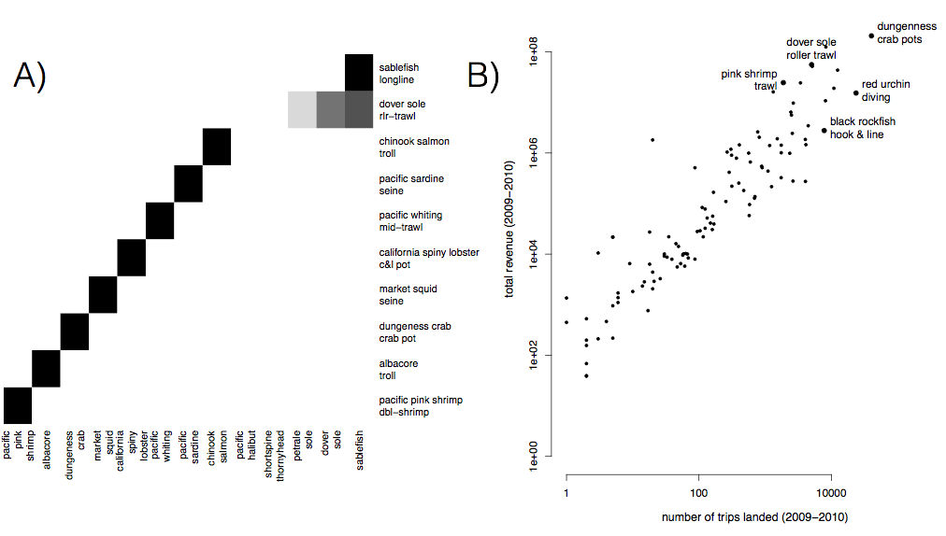

S1: A) Species composition for top ten realized fisheries (rows). Cell color represents the proportion of landings for which each species (column) is responsible. Most of the biggest realized fisheries are composed of primarily a single species, but groundfish trawl is multispecies. B) Comparison of effort and revenue for all realized fisheries between 2009-2010.

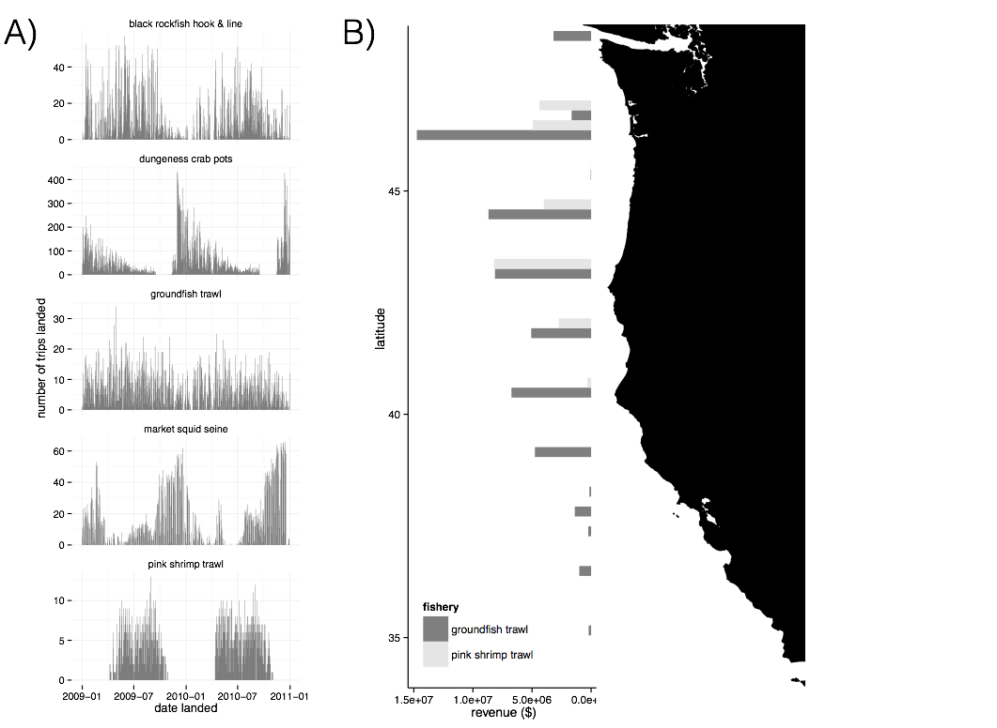

S2: A) Seasonality of five major realized fisheries between 2009-2010. Distinct seasonal patterns are observed in dungeness crab, market squid and pink shrimp fisheries. B) Spatial structure of landings for two example fisheries between 2009-2010. Landings are binned by latitude. Pink shrimp trawl is landed further north, while groundfish trawl landings are distributed more evenly across the coast.

C) Port participation networks

[will be here eventually, makes word document unweildy at the moment, below is one as an example]

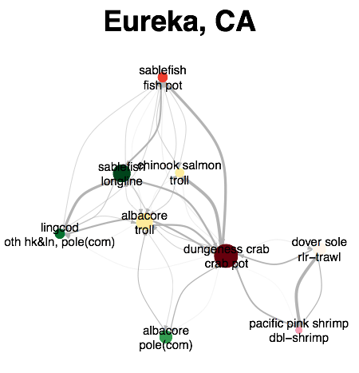

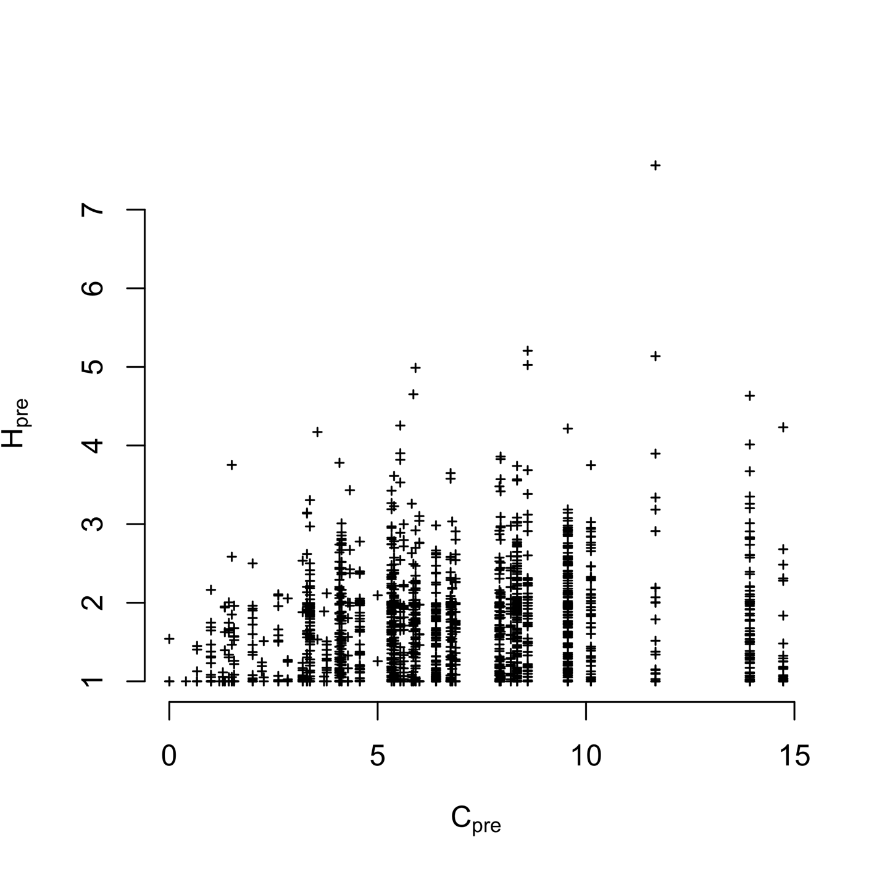S3) Plotting vessel participation diversity (H, 2009-2010) against port connectivity (C, 2009-2010). We find vessel and port level diversity weakly correlated (Spearman’s correlation 0.1849745, p < 2.2e-16). But the most diverse vessels tend to be found in the most diverse ports.

Table S2: Akaike Information Criterion (AIC) values for the models with and without terms for catch shares. Values for the best model at each level are in boldface.

|  |  |  |  |  |  |  |
| --- | --- | --- | --- | --- | --- | --- |
| Level | *Hpre* | Catch shares | No. Parameters (*K*) | AIC | ΔAIC | Adjusted R2 |
| Vessel | Yes | No | 1 | 3140.767 | 30.916 | 0.2392 |
|  | **Yes** | **Yes** | **2** | **3109.851** | **0** | **0.2471** |
|  | No | Yes | 1 | 3643.718 | 533.867 | 0.01007 |
| Port | **Yes** | **No** | **1** | **184.1367** | **0** | **0.8866** |
|  | Yes | Yes | 2 | 186.5804 | 2.4437 | 0.8858 |
|  | No | Yes | 1 | 325.8152 | 141.6785 | 0.2404 |

Table S3: Coefficient values for two best fit models for each scale of analysis

|  |  |  |  |
| --- | --- | --- | --- |
| Level | Variable | Best model | Second best |
| Vessel | *Hpre* | -0.46 (0.02) | -0.46 (0.10) |
|  | General fleet | 0.74 (0.03) | 0.74 (0.03) |
|  | Catch share participant | 0.27 (0.07) | - |
|  | Limited entry exit | -0.24 (0.10) | - |
| Port | *Cpre* | -0.67 (0.03) | -0.66 (0.03) |
|  | General fleet | - | 0.29 (0.27) |
|  | Catch share participant | - | 0.19 (0.28) |
|  | Limited entry exit | - | 0.33 (0.33) |
|  |  |  |  |