Fleet connectivity across West Coast fisheries: quantifying the effect of a management intervention on revenue diversity in an interconnected socioeconomic environment

Emma Fuller, Jameal Samhouri, James Watson, Joshua Stoll

Oct 10, 2015

# Introduction

Much of the research on EBM has sought to illuminate the connectivity within and between the biotic and abiotic components of these systems. These efforts focus almost exclusively on the ecological components of these systems, without consideration of the social or economic influences that interact across time and space. Understanding these human interactions therefore represent an important frontier to EBM science. In this talk paper we present an approach for measuring human connectivity of fisheries at a vessel and port level and use it to evaluate how a change in management affects fisheries connectivity in US west coast commercial fisheries. By comparing changes in fisheries connectivity for vessels and ports which have ITQ landings, we find evidence that catch shares have increased the diversity of vessel participation, but not affected the connectivity among fisheries at a port level. Further we demonstrate that these port-level patterns of participation contain information that can predict what fisheries vessels exiting the groundfish trawl fishery added to their fishing portfolios.

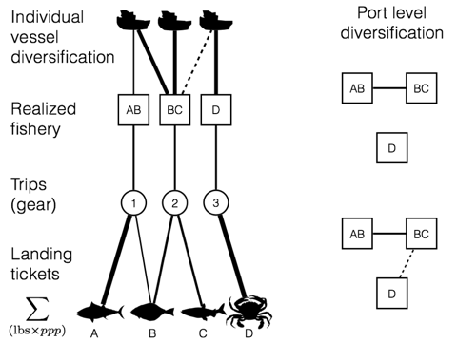

Figure 1: We use landings data to calculate the participation diversity of US west coast vessels and ports. At the vessel level, participation diversity is an index, which measures the number of fisheries a vessel participates is weighted by the evenness of revenue derived. At a port level participation diversity is measured by the number of realized fisheries, which are landed and how connected they are by vessel’s participation.

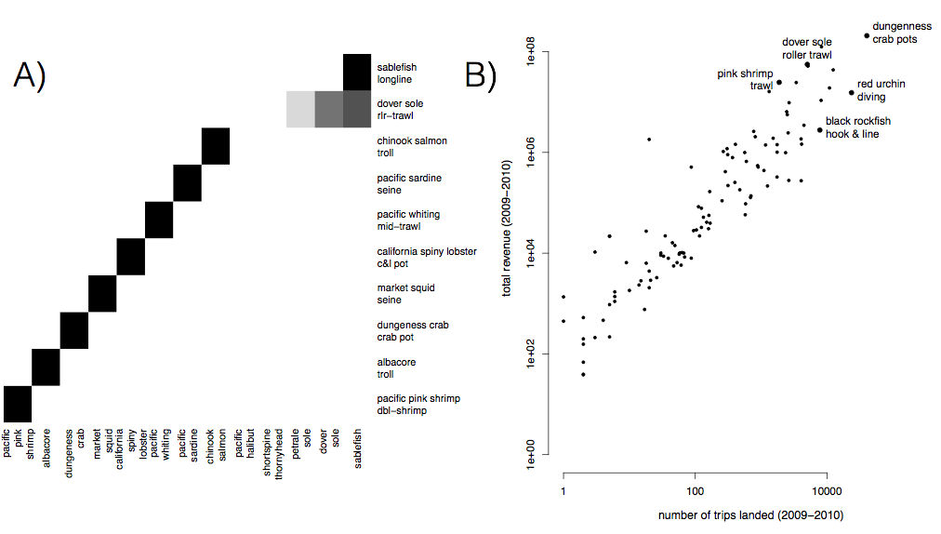

Figure 2: A) Realized fisheries are often distinguished by a single species (i.e. pink shrimp) but can also characterized by assemblages of species (dover sole roller trawl). Here we plot the top ten realized fisheries by revenue on the US west coast with the darkness of the cell proportional to the relative proportion of revenue due to each species. Eight of these fisheries are characterized by a single species, while dover sole roller trawl and sablefish long line is characterized by multiple species. B) The realized fisheries vary by an order of magnitude in effort and revenue.

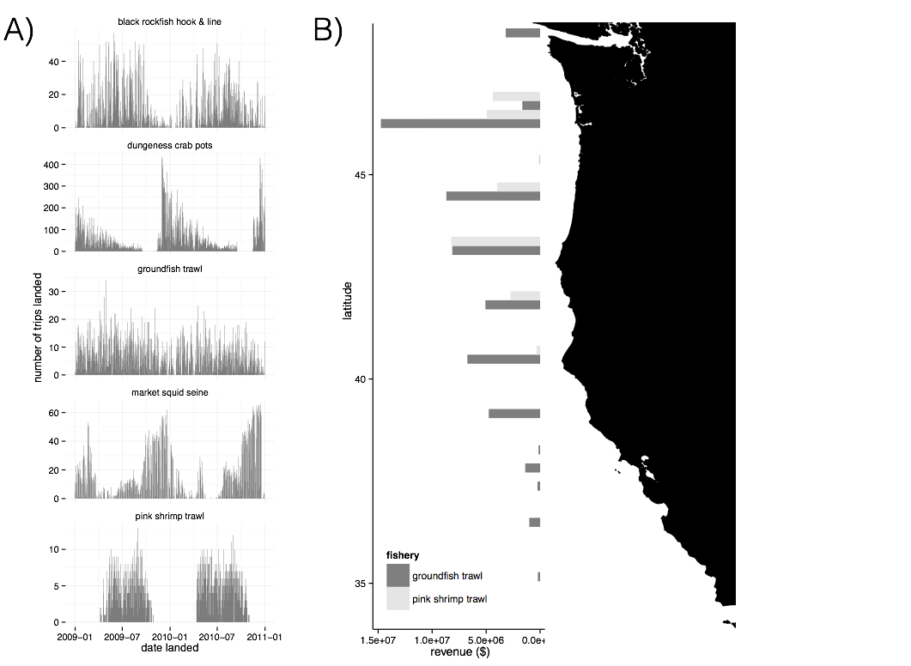

Figure 3: A) These fisheries demonstrate different levels of temporal structure: they vary from strictly seasonal (i.e. pink shrimp trawl) to year round (groundfish trawl). B) These fisheries also exhibit varying degrees of spatial structure, here we plot two realized fisheries as examples highlighting how spatially disaggregated they can be.

# Results

## Revenue diversity

We find that between 2009-2010, 80% of commercial vessels on the west coast participate in more than one realized fishery, although the degree to which vessels diversified varies. The majority of diversified vessels revenue are dominated by revenue from a single fishery (71%), with very small percentages coming from alternatives. However almost a fifth (22%) of diversified vessels are at least participating in two fisheries evenly, with some vessels (3%) participating evenly in more than three fisheries.

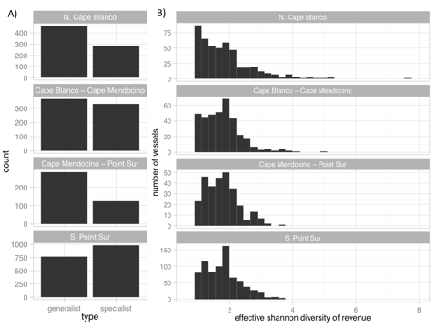

Figure 4: A) For three out of the four management regions on the west coast, generalists (vessels which land > 1 realized fishery) outnumber the specialists (vessels which land in a single realized fishery). B) The distribution of diversity varies among the generalists, from vessels that are highly specialized by have a few landings in additional fisheries (to left) to those that fish in many fisheries evenly (to right).

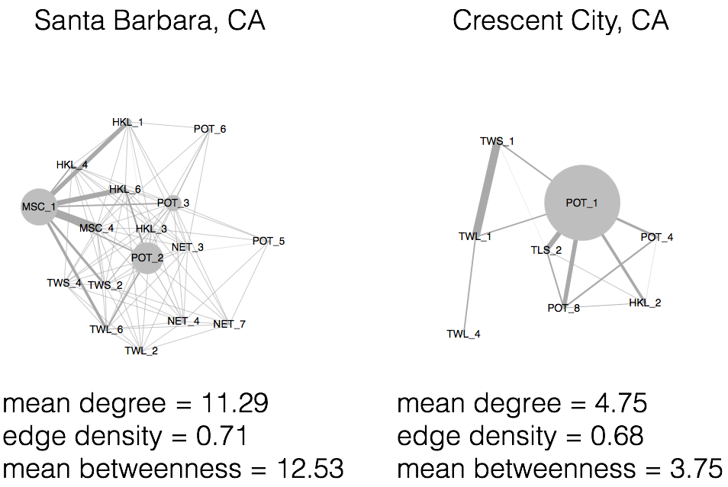

Figure 5: Fig Examples of port level participation networks. Here nodes represent a realized fishery, and strength of connections between nodes represent the number of vessels which land both of these fisheries. We measure the diversity of these port participation networks by using measures of the the interconnectedness of these networks.

## Impacts of management change

Most vessels declined in revenue diversity between our pre and post periods. However we find that vessels which participated in catch shares are associated with a smaller decline on average than those that did not. At the community level we find no evidence to suggest that ports which have catch share quota landed at them become more diverse after catch shares.



Figure 6: We find that a vessel’s participation in IFQs is significantly associated with an increase in revenue diversity. At the port level, we find no indication that IFQ landings affect interconnectedness of fisheries.