Fleet connectivity across West Coast fisheries: quantifying the effect of a management intervention on revenue diversity in an interconnected socioeconomic environment

Emma Fuller, Jameal Samhouri, James Watson, Joshua Stoll

Nov 6, 2015

# Introduction

We employed a novel clustering algorithm to determine commercial fishing strategies along the US west coast. We found that the algorithm correctly identified spatial and temporal patterns of known single – and multispecies fisheries, and used the classification method to (i) determine vessel-level participation in individual fisheries and emergent diversification of their participation across fisheries, and (ii) describe networks of fisheries participation for entire communities (ports). We found that the majority of vessels examined were generalists, which participated in more than one commercial fishery in our time-period. In addition, interconnectedness of fisheries participation varied strongly across ports. Using these individual and community-level measures of fisheries diversification, we evaluated how the introduction of a new management structure influenced vessel-level participation in the affected, along with diversity measures for vessels and ports as a function of their participation in the affected fishery. We hypothesized that catch shares would affect fishing strategies in one of two ways: causing vessels to either drop out of the fishery or, for those that remained in the fishery, allowing them to diversify by participating more heavily in other fisheries. For port communities, we tested whether changes at the vessel level were reflected at the port-level. We found that the implementation of catch shares caused a minority (6%) of vessels to leave commercial fishing altogether, while 53% of vessels continued to participate in the affected fishery and diversified by participating in additional fisheries, only 13% of vessels continued to participate in the affected fishery with fishing participation unchanged A third group consisted of vessels that exited catch shares but continued to fish commercially (28%). These vessels showed a mixed response, with increased and decreased fishing diversity observed. We also found that these changes at the vessel-level did not affect participation among fisheries at a community level. This work helps to formalize and quantify social ecological linkages across scales.

**Methods**

**Description of Data Sources**

We used landings tickets which record all commercial landings on the US west coast between 2009-2013. While rich, this dataset lacked information on outside employment and/or any commercial fishing landings outside of the US west coast EEZ. To account for this, we restricted our analyses to vessels with an average of at least $5000 in annual revenue and remove vessels which landed commercial catch in Alaska. We also discarded landings from 2011, the year in which catch shares were established. This left 3,040 vessels which were responsible for approximately 99% of the total revenue and biomass commercially landed during this period.

**Defining Realized Fisheries**

We defined realized fisheries as a gear-type which targeted a coherent species assemblage (van Putten et al. 2011). The Pacific Management Council has developed a set of sector based definitions similar to this approach for the federally managed groundfish landings, but no equivalent existed for non-groundfish fisheries (The Northwest Fisheries Science Center 2015). In order to treat the landings dataset uniformly, we applied a métier-like analysis to this landing data (Deporte et al. 2012).

To construct these realized fisheries we defined species targets through clustering species composition of landings. We used the Hellinger distance *D* (P. Legendre and Legendre 2012) to calculate the similarity in revenue profiles between trips and generated a pairwise distance matrix. The Hellinger distance between the species composition of two fishing trips *A* and *C* is defined as

|  |  |
| --- | --- |
| $$D= \sqrt{\sum_{i=1}^{S}{{\left(\frac{a_{i}}{a_{+}}-\frac{c_{i}}{c_{+}}\right)}^{2}}}$$ | (1) |

with

|  |  |
| --- | --- |
| $$a_{+}=\sum_{i=1}^{S}{a_{i}}$$ | (1a) |

where *ai* is the revenue derived from species *i* on trip *A*, and *ci* is the revenue derived from species *i* on trip *C* where there are *S* total species.

We transformed the distance matrix into a similarity matrix by subtracting $\sqrt{2}$ from each pairwise distance and used these similarities to generate a weighted, undirected network where nodes were fishing trips and edge weights were pairwise similarity. We used the infoMap community detection algorithm (Rosvall and Bergstrom 2008) and identified groups of trips with similar target assemblages. Because our dataset contained 340,466 unique trips, it was computationally impossible for us to construct a single matrix containing all pairwise similarities. To facilitate data analysis, we used one year of landings (2010) which we split by gear, which resulted in manageable matrix sizes. Pairwise distances among trips and community detection were used within each gear partition which grouped trips to in target assemblage categories. To make the final assignment of realized fishery, we linked the species-composition clusters to gear used for the trip. To classify the 2009, 2011, 2012 and 2013 trips to realized fisheries, we used the 2010 realized fisheries assignments as a dictionary and implemented a k-nearest neighbor (*k=*1) search which used the Hellinger Distance (eq. 1).

A drawback of this classification method, and part of the reason for its need, is that there exists no independent classification of US west coast fisheries to which we could compare. To address this drawback, we relied on our ability to recover patterns already documented for US west coast fisheries. Specifically, because we did not bound our clusters spatially, temporally, or by vessel characteristics we would expect to recover known spatial and temporal structure if our classification approach was reliable. We also compared our realized fisheries to existing sector definitions of groundfish, and groundfish impacting fisheries provided by the Northwest Fisheries Science Center Observer Program (The Northwest Fisheries Science Center 2015).

**Calculating changes in vessel and community level fishing diversity**

To measure diversity for vessels, we calculated the effective Shannon index *H* of revenue diversity (Lou Jost 2006). *H* for vessel *j* is calculated as

|  |  |
| --- | --- |
| $$H_{j}=e^{\sum_{i=1}^{F}{p_{i}\ln{p_{i}}}},$$ | (2) |

where *F* is the number of realized fisheries and *pi* is the proportion of revenue derived from realized fishery *i*.

To represent connectivity among fisheries at the port level we built directed, weighted networks. Nodes represented a realized fishery, and the strength of the connections between nodes represented the number of vessels which land both. More formally, we built a network *Gi* for each port *i* in which an edge *AB* is the number of vessels which participate in both fisheries *A* and *B* divided by the total number of vessels that participate in fishery *A*. Similarly, edge *BA* is the number of vessels which participate in both fisheries divided by the total number of vessels that participate in fishery *B* (Fig. 1)*.*

To measure port-level fishing diversity we developed a metric which increases as both the number of fisheries and the evenness in which they are participated increases. Common network topology measures such as shortest path and centrality metrics capture the evenness of connectivity across the network but don’t reflect the difference between a port with many or few fisheries present. To address these concerns we develop an index of average fishery connectance *C* for port *j* defined as the sum of edge weights *w* present in network *Gj* divided by the number of nodes *V* in *Gj*.

|  |  |
| --- | --- |
|  | (3) |

Because edge weights are constrained to be between 0-1, this value can be interpreted as the average number of fisheries to which a fishery is fully connected (i.e. all vessels participate in both fisheries) in port *j*.

Figure 1: Using landing tickets we aggregated to catch to trips and defined realized fisheries. Using these realized fisheries we measured vessel and port level fisheries diversification.

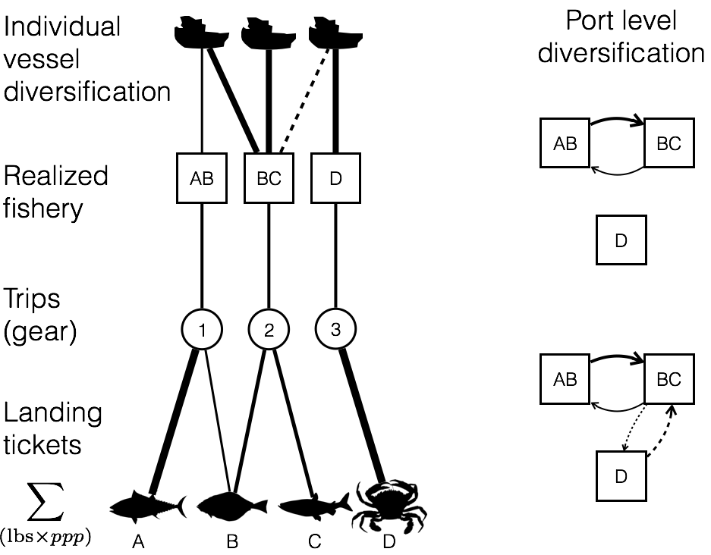

**Analysis of management change**

To determine whether a change in management is associated with a change in participation diversity we used a simple linear regression to compare the change in diversity between vessels/ports which were and were not affected by catch shares. At the vessel level we calculated change in diversity as

|  |  |
| --- | --- |
| $$ΔH_{j}=H_{j,post}-H_{j, pre}.$$ | (4) |

Thus a value of zero means there was no change in diversity between the two periods, a positive value means the vessel increased the evenness and/or the number of fisheries from which it received revenue.

We hypothesize that if management change is associated with a change in the way vessels participate across fisheries, participation in the affected fishery should be a significantly associated with the way in which fishing diversity changes. In this analysis, vessels could be affected by catch shares in one of two ways: 1) those vessels that fished in the limited entry trawl fishery prior to 2011 and continued to fish by using catch share quota to land fish after 2011 (labeled *catch share participants*, *n* = 71) or 2) fished in the limited entry trawl fishery prior to 2011, but exited the fishery with the implementation of catch shares (labeled *limited entry exits*, *n =* 35, Fig. 2). A vessel was considered unaffected by the implementation of catch shares in the limited entry groundfish trawl fishery if we observed no commercial landings in that fishery prior to 2011, and did not use quota to land in 2012-2013 (labeled *general fleet*, *n* = 1,878).

To examine changes at the port level, we compared the change in average fishery connectance Δ*C* as a function of how ports were affected by catch shares. Paralleling our vessel-level analysis, a port was considered unaffected by catch shares if there was no record of vessels landing groundfish with trawl gear prior to 2011 and no quota used to land commercial catches after 2011 (*n* = 48). Ports were affected by catch share if there were landings of groundfish trawl prior to 2011 and either continued to land quota after 2011 (*n* = 16) or no longer had groundfish trawl landings after 2011 (*n* = 10).

If catch shares allowed vessels to be more flexible in their fisheries participation, we’d expect the catch share vessels would, on average, demonstrate increased diversity after the implementation of catch shares. If this vessel-level effect translates to the port level, we expected an increase in fisheries connectance for ports where catch share quota is landed. To this end we fit the following regression at the vessel and port level,

|  |  |
| --- | --- |
| $$Δ\text{diversity}=α+β_{1}\text{catch shares}+ϵ.$$ | (5) |

Due to the nature of our response variable, we also included models in which pre-catch share diversity was a covariate. This is because the ability to change diversity between two periods is related to the starting period diversity. For example, if a vessel is a specialist (i.e. diversity = 0), then it is impossible for that vessel to drop in diversity and any random variation will bias Δdiversity upwards. Similarly, if a vessel was maximally diversified, then the vessel could either remain the same or with random variation drop in diversity. Because there are many sources of variation separate from that induced by management change (i.e weather, market conditions) we expect this effect to be significant. Thus the model is

|  |  |
| --- | --- |
| $$Δ\text{diversity}=α+β_{1}H_{pre}+β_{2}\text{catch shares}+ϵ.$$ | (6) |

We compared alternative models using the information theoretic approach which allows direct comparison of the models’ goodness of fit using model likelihoods (Burnham and Anderson 2002). The Akaike Information Criterion (AIC) was used to find the most parsimonious model which balanced both the goodness of fit (as measured by likelihood) and model complexity (as measured by the number of parameters). Here the lower the AIC, the better the model (Burnham and Anderson 2002). We calculated 95% confidence intervals on the model parameters by bootstrapping to determine whether the confidence intervals overlapped with zero. To do so, we randomly selected data with replacement from our vessel and port datasets until we had a dataset the same size as our original and then refit the models. This procedure was repeated 10,000 times and the resulting distribution give the 95% confidence intervals for each parameter.

**Results**

**Data driven definition of realized fisheries**

Our clustering algorithm identified 109 realized fisheries. Realized fisheries often consisted of a single species but could also comprise assemblages of species (Fig. S1a). Whether their catch consisted of a single species or multiple species, the realized fisheries were characterized by distinct patterns of temporal and spatial structure (Fig. S2a, b). These patterns suggested strong agreement between our realized fisheries and NWFSC Observer sector designations, as did comparisons of vessel sizes and catch composition (single- vs. multi-species) (Table 1).

The realized fisheries also varied by several orders of magnitude in effort (number of trips) and revenue (Fig. S1b), with a small number of fisheries accounting for the majority of effort and revenue. For example, only 10 of the 102 fisheries were responsible for 90% of ex-vessel revenue in the time period we examined (Table 1). These fisheries included sectors which have been well-studied but not quantitatively described prior to now (e.g., dungeness crab pots (Botsford & Wickham 1978), spiny lobster pots (Kay et al. 2012), or red urchin diving (Smith & Wilen 2003)) (Table 1).

Table 1: We summarize fleet characteristics for three realized fisheries and compare to the corresponding NWFSC Observer sector description. Parenthetical values represent the percentage of trips which fell within expected ranges. The following fisheries represent (with pink shrimp and limited entry groundfish) the top ten realized fisheries by revenue. Fleet characteristics for which no corresponding NWSFC observer sector is present are presented as 95 percentiles for length, latitude and seasonality.

|  |  |  |  |  |
| --- | --- | --- | --- | --- |
| **Fishery**  Sector name if applicable | **Latitude**  decimal degrees | **Catch composition**  % trips multispecies | **Seasonality**  fishing season | **Vessel Length**  ± 1 ft |
| Limited entry groundfish trawl/catch shares | 35.4-49  (97.9%) | 100%  (98.2%) | NA | 35-95  (99.5%) |
| Pink shrimp trawl | 35.8-49  (97.9%) | NA | Apr 1 – Oct 31  (99.8%) | 38-105  (100%) |
| California halibut trawl | 37.4 – 34.05  (96.5%) | NA | NA | 29-71  (99.8%) |
| Dungeness crab pots | 36.8-47.6 | 0.9% | Oct 26 – Aug 8 | 22-67 |
| Market squid seine | 33.7-36.8 | 6.8% | May 24 – Feb 25 | 36-80 |
| Albacore troll | 37.5-46.9 | 0.6% | Jul 10-Oct 22 | 23-72.5 |
| Sablefish long-line | 33.2-48.4 | 70% | Jan 16-Dec 15 | 20-57 |
| Shore-side Hake | 43.3-46.9 | 92% | Jun 16-Nov 15 | 65-129 |
| Chinook salmon troll | 35.4-48.4 | 14% | Apr 11-Oct 22 | 20-50 |
| Sardine seine | 33.7-46.9 | 42% | Jan 8-Oct 22 | 45-80 |
| Spiny lobster pot | 32.7-34.4 | 8.3% | Oct 5-Mar 12 | 18-42 |

**Changes in vessel and community level fishing diversity**

The existence of 109 realized fisheries on the US west coast opens up a variety of opportunities for diversification of fishing practices by individual vessels. We find that between 2009-2010, 66% of commercial vessels on the west coast participated in more than one realized fishery (Fig. 3a) although the degree to which vessels diversified varied regionally. For all four of the management regions on the west coast, generalists (vessels which landed > 1 realized fishery) outnumbered specialists (vessels which landed in a single realized fishery) (Fig. 3b). The distribution of diversity varied among the generalists, from vessels that were highly specialized but had a few landings in additional fisheries to those that fished in many fisheries evenly (Fig. 3c). Notably, the majority of diversified vessels revenue was dominated by revenue from a single fishery (71%), with very small percentages coming from alternatives. However almost a quarter (24%) of diversified vessels were participating in at least two fisheries equally, with some vessels (4%) participating evenly in more than three fisheries (Fig. 3c).

Figure : Distribution of fisheries diversity at the vessel level; A) coastwide, B) by management region, C) breakdown of generalism for each management sector. Generalists are vessels which land > 1 realized fishery.

../bin/05_figures/fig_2.pdf

The preceding analysis focused on fishing strategies employed by individual vessels, without consideration of how those strategies came together to create characteristic fisheries participation networks for specific ports. We found differences in the number and interconnectedness of fisheries across ports (Fig. 3a). Ports had anywhere between 0-7 fisheries connected. This variation is exemplified by participation networks in Santa Barbara, CA and Neah Bay, WA (Fig 3ab). Santa Barbara was characterized by a much more complex participation network, with more than double the average fishery connectance of Neah Bay.

Figure : : Diversity of fishing communities on the US west coast. A) Fisheries participation network for all landings in Santa Barbara, CA between 2009-2010, B) Fisheries participation network for all landings in Neah Bay, WA between 2009-2010, C) C values for all ports on US west coast with > 3 vessels landing between 2009-2010.

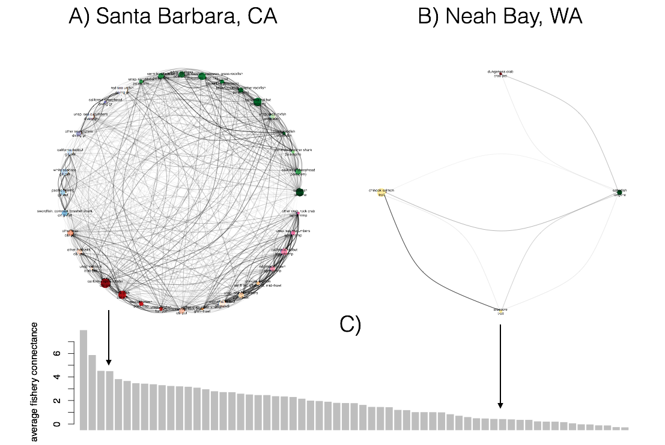

**Effect of management change**

Between the period before (2009-2010) and after (2012-2013) catch shares, vessels in the general fleet showed a modest, but significant, 3% increase in fisheries diversification (p = 0.0191). However, we found that vessels in fisheries with catch shares demonstrated a four-fold higher (12%) increase in diversification as compared to vessels not subject to catch shares management, this change was not significant (p = 0.06951) likely due to smaller sample sizes of the catch share fleet. We also found vessels which participated in the limited entry groundfish fishery were 22% more diverse than vessels in the general fleet prior to 2011 (p = 4.359e-07).

After fitting the linear regressions, we find that adding a term describing a vessels relationship to the management change significantly improves the model fit (Table 2). At the port level, we found that the model that only included diversity prior to 2011 was the best fit to the data, suggesting that vessel level changes in participation don’t translate clearly to port level measures of diversity we measured. For all the models, the adjusted R2 are low, with a maximum of 0.2471. We find this unsurprising, as changes in management are only one of many economic, environmental and social variables that may influence fisheries participation.

Table : Akaike Information Criterion (AIC) values for the models with and without terms for catch shares. Values for the best model at each level are in boldface.

|  |  |  |  |  |  |  |
| --- | --- | --- | --- | --- | --- | --- |
| Level | *Hpre* | Catch shares | No. Parameters (*K*) | AIC | ΔAIC | Adjusted R2 |
| Vessel | Yes | No | 1 | 3140.767 | 30.916 | 0.2392 |
|  | **Yes** | **Yes** | **2** | **3109.851** | **0** | **0.2471** |
|  | No | Yes | 1 | 3643.718 | 533.867 | 0.01007 |
| Port | **Yes** | **No** | **1** | **186.1041** | **0** | **0.136** |
|  | Yes | Yes | 2 | 188.9555 | 2.8514 | 0.125 |
|  | No | Yes | 1 | 199.7547 | 13.6506 | 0 |

Examining the best fit model, we find that vessels which landed quota after 2011, for a given level of diversity prior to 2011, dropped in diversity less than those in the general fleet while vessels that exited the limited entry groundfish fishery, but still fished commercially after 2011, declined in fisheries participation diversity suggesting that these vessels were unable to compensate completely for the role limited entry groundfish fishing playing in their fisheries portfolio (Fig. 4).

Figure 4: Estimated effects, bars are 95% confidence intervals. Hpre and ΔH are strongly negatively related across all catch share participation types for both vessel and port level analyses. Vessels that participate in catch shares, however decline less in diversity that either the general fleet or those that exited catch shares. At the port level the best model does not include a term for participation in catch shares.

../bin/05_figures/fig_6.pdf

We also examined how vessels changed their fishing portfolio after catch shares, particularly vessels which exited the groundfish trawl fishery. We found that over 80% of vessels that exited when catch shares were implemented to not stop commercial fishing altogether and that approximately 75% of these vessels added new fisheries (Fig. 5).

Figure 5: We map the ways in which a vessel can respond to the implementation of catch shares. Vessels that were directly affected by catch share implementation are those that fished in the limited entry (LE) groundfish fleet. After 2011, vessels either continue to participate in the groundfish trawl fishery by landing with quota, or leave the catch share fishery and either leave fishing entirely or continue to fish in other commercial fisheries.

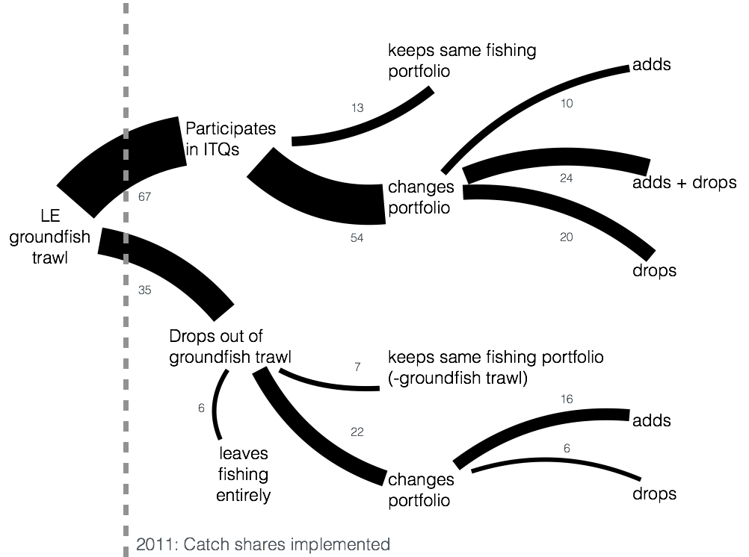

**Discussion**

1. Generalist fishing the norm, not the exception
   1. Models of fishing typically model fleets as homogenous groups of vessels. Following theoretical formulations, most empirical fleet analyses take a similar approach, focusing on a group of boats which participate in catching a set of species with a particular gear and ignoring the other fisheries in which the vessels may participate. Fishing on the US west coast however, is better described as a heterogeneous group of multi-purpose vessels fishing in many different combinations of fisheries.
2. Catch shares has increased revenue diversity at the vessel level
   1. Find that catch shares do allow better diversification at vessel, and so if relationship with revenue variability holds, then we expect that catch shares make revenue less variable for these vessels.
   2. Is a good thing for those boats that continued to fish in groundfish trawl. But not all boats made the transition, and it seems like the smaller, more diversified trawlers were more likely to not make it into the new management regime. Examining what happens to these fisheries, and whether these patterns of connectivity can predict new entries is an important next step of this work.
3. Scale of analysis matters
   1. Results highlight the importance of scale, catch shares are a “success” in terms of fishing diversity at the vessel level, but policy discusses community level. And there is no effect there.
   2. Realized fisheries also have a particular scale, and it is slightly different resolution than permit: i.e. there are multiple distinct target assemblages within the open-access nearshore fishery but multiple permit-types contribute to the sablefish long-line fishery. It’s not clear which, realized fishery or permitted sector, is the better measure of resilience or adaptability. Realized fisheries capture the ecological structure of the fishery, and provides information on how diversified a vessel/community is ecologically. But permits reflect anthropogenic limitations on movement among fisheries, which realized fisheries, as presently defined, lack.

**Figures**

**Supplement**

Evaluating realized fisheries classification

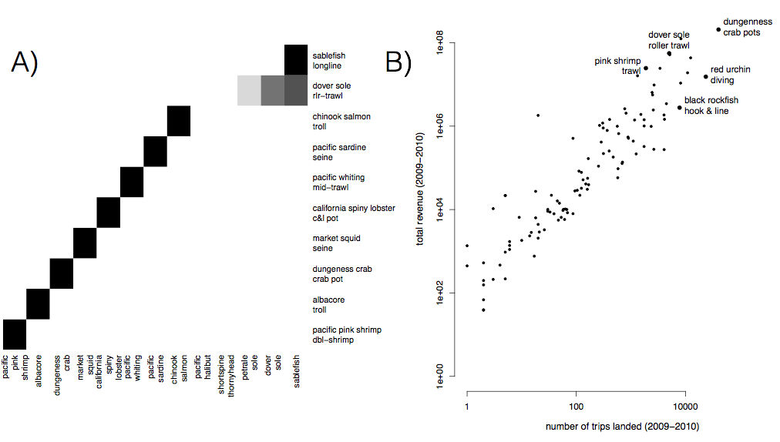

S1: A) Species composition for top ten realized fisheries (rows). Cell color represents the proportion of landings for which each species (column) is responsible. Most of the biggest realized fisheries are composed of primarily a single species, but groundfish trawl is multispecies. B) Comparison of effort and revenue for all realized fisheries between 2009-2010.

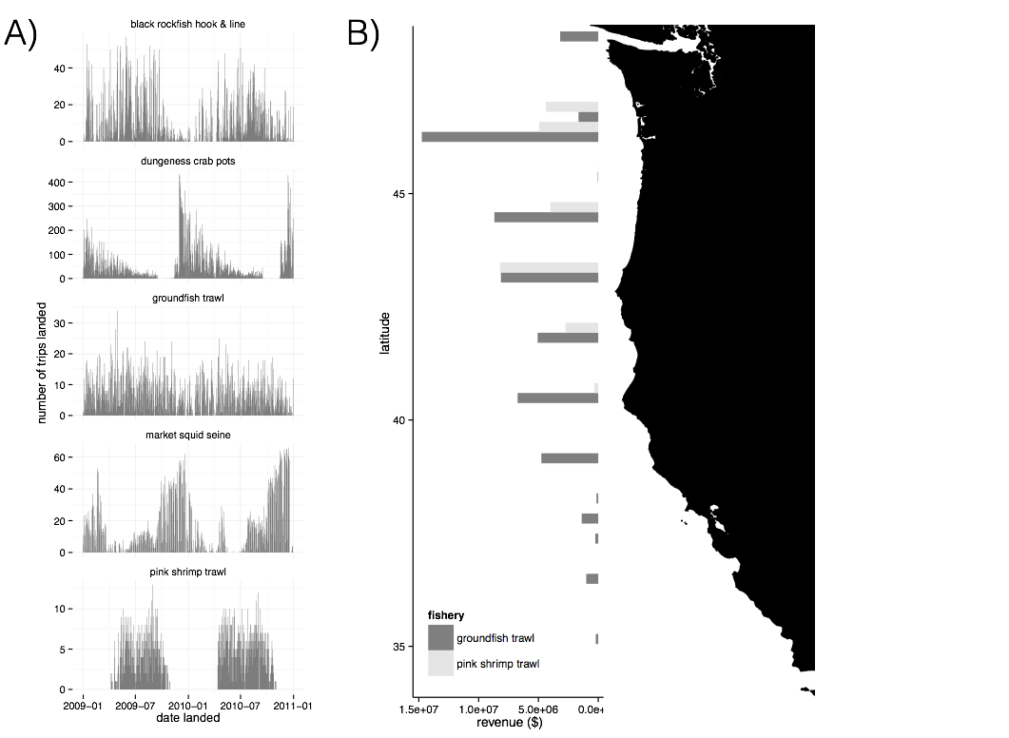

S2: A) Seasonality of five major realized fisheries between 2009-2010. Distinct seasonal patterns are observed in dungeness crab, market squid and pink shrimp fisheries. B) Spatial structure of landings for two example fisheries between 2009-2010. Landings are binned by latitude. Pink shrimp trawl is landed further north, while groundfish trawl landings are distributed more evenly across the coast.

**Testing based on ITQs**

ITQs went in for the limited entry trawl fishery which targets federally managed groundfish species in 2011. Therefore we’d expect to see any metiers that are trawl based to have an IFQ flag in their landings. However when we examine our landings for trips landed after 2011, we find a number of trips which both use trawl gear, but do not use quota to land.

with(subset(trips, year**>**2011 **&** grgroup**==**"TWL" **&** **!**(trips**$**drvid **%in%** ak\_ves)), table(ifq\_landing, metier.2010))

ifq\_landing TWL\_1 TWL\_2 TWL\_3 TWL\_4 TWL\_5 TWL\_6 TWL\_7

0 1146 156 0 482 944 0

N 5 0 0 0 0 0 0

Y 2215 78 225 167 0 0 30

Here TWL\_1 corresponds to DTS, TWL\_2 is california halibut, TWL\_3 is chinook salmon caught with midwater trawl (bycatch for hake), TWL\_4 is whiting, TWL\_5 is bait shrimp, TWL\_6 is sea cucumber, TWL\_7 is yellowtail bycatch for whiting.

We wouldn’t expect bait shrimp or sea cucumbers to involve species in ITQs, so the lack of ITQ flags makes sense. Similarly TWL\_4 and TWL\_7 having exclusively quota landings after 2011 makes sense both hake and yellowtail are quota species. TWL\_3 having both quota and non-quota makes sense since some chinook catches are mixed with hake, and sometimes chinook are caught alone. The concerning sets of catches are the 5 TWL\_1 catches and the fact that TWL\_2 is split. TWL\_2 is california halibut. California halibut are often caught with bottom trawls, but near shore. There’s two sectors for CA halibut, open access and federally manged limited entry. Limited entry boats are allowed to fish only in federal waters, can fish year round, but require quota. Limited entry boats are allowed to trawl in state waters and have to observe a 3 month closed period (March 15-June 15) for CA halibut spawning. Thus the split in TWL\_2 is not suprising. However if the sector split can explain this, we’d expect all TWL\_2 landings, reported afte 2011, landed without ifq quota, would not be present between March 15 and June 15. Instead, we see that while April and May are the lowest months, there are still TWL\_2 landings.

Rt

Here the numbers are months, and the color is whether or not there is quota present. “Y” is quota, the blank means no quota (although it’s coded as “Y”, “N” and “” in the fish tickets).

**Parking lot**

Where are Alaska boats coming from?

Does dropping California Halibut effect results?

What about 2012 metiers?

**References**:

Burnham, Kenneth P, and David R Anderson. 2002. *Model Selection and Multimodel Inference: a Practical Information-Theoretic Approach*. Edited by Springer Science & Business Media.

Deporte, N, C Ulrich, S Mahevas, S Demaneche, and F Bastardie. 2012. “Regional Metier Definition: a Comparative Investigation of Statistical Methods Using a Workflow Applied to International Otter Trawl Fisheries in the North Sea.” *ICES Journal of Marine Science* 69 (2): 331–42. doi:10.1093/icesjms/fsr197.

Legendre, P, and L Legendre. 2012. *Numerical Ecology*. Elsevier.

Lou Jost. 2006. “Entropy and Diversity.” *Oikos* 113 (2): 363–75.

Rosvall, Martin, and Carl T Bergstrom. 2008. “Maps of Random Walks on Complex Networks Reveal Community Structure.” *Proceedings of the National Academy of Sciences* 105 (4). National Acad Sciences: 1118–23. doi:10.1073/pnas.0706851105.

The Northwest Fisheries Science Center. 2015. “Data Analysis and Products.” *Fisheries Observation Science*. Seattle, WA. Accessed December 8. http://www.nwfsc.noaa.gov/research/divisions/fram/observation/data\_products/bottom\_trawl.cfm#description.