People in EBM

Emma Fuller

January 3, 2015

# Introduction

Fisheries are central to modeling, managing and understanding marine systems in which fishing vessels operate, yet the definition of a fishery is generally imprecise. Most work on the economic/sociological/anthropological side of fisheries either conceptualizes fisheries in terms of "effort", an abstract, multi-dimensional term (Wilen 1979), or as fishing communities (Jentoft 2000). There have been increasing calls for conservation and resource management to better include people (i.e. ecosystem services, social ecological systems, co-management)[1] which require an understanding of how social and ecological systems are linked and interact. Further, the social relationships and context of fishing communities have been suggested as crucial for viable fisheries (Jentoft 2000)[2] and the success of co-management schemes (Wilson, Acheson, and Johnson 2013). Clearly both fishing effort and the communities responsible for this effort are crucial for understanding human impacts' on marine systems and vice versa, but it's not obvious how to draw connections between effort and fishing communities (but see St. Martin (2008) for work in this direction). This gap is problematic if we are to link these human systems to the ecological webs on which they depend. Fishing fleets (i.e. fisheries) sit between fishing communities and effort and the ecological system, translating human decisions into fishing mortality. Characterizing the dynamics of fishing fleets are thus central to being able to understand the linkages and feedbacks in these social and ecological systems.



Work studying fleet dynamics (i.e. the dynamics of the human harvesters in a commercial fishery system) commonly consider only one fleet at a time (i.e. location choice models, discarding, compliance)(Putten et al. 2011). Both fisheries science and marine ecology have moved from single species models to consider multiple species in ecological analyses, and indeed ecosystem-based management (EBM) takes this to the extreme, arguing that the to manage any one species well, the entire system's dynamics must be taken into account. In EBM "the system" is commonly interpreted as the ecological system, with humans participants remaining external forces. However to truly take an EBM approach, all fishing fleets need to be included, just as all species need to be. Thus multi-fleet models are required.

Historically little work exists to define fleets concurrently. Analyses that examine multiple fleets have used management expertise to choose either gear/area/fish to define fisheries (Kasperski and Holland 2013), or existing management jurisdictions (Sethi, Reimer, and Knapp 2014) to define fisheries. Recently European Union fishing policies have prompted work in this area (Deporte et al. 2012). Instead of fisheries or fleets, these sectors are termed métiers, and defined as a target species assemblage/gear combination. These analyses are characterized by clustering catch data to look for commonality and combine with gear to define sectors. Recent work by Lucey and Fogarty (2013) has applied a similar analyses to US east coast commercial fishing data.

Here I use a métier-like approach to define commercial fishing fleets on the US west coast. As in a métier analysis, I define fisheries based on the composition of catch and type of gear used. I highlight the benefits of this methodology from previous work, use this definition to map both ecological and social connectivity of these systems, and demonstrate how this could be used to holistically study commercial fisheries systems and thus better incorporate the human actors into EBM schemes.

# Data and Methods

## Catch Data

This work uses landings (fish ticket) data from the US west coast commercial fisheries from 2009-2013, a total of 455,469 trips and 3,569 vessels. PacFin records species by "market category". For most easily identifiable and highly marketable species this is equivalent to species name. However for a number of rockfish that are difficult to distinguish, their market category is some flavor of "unspecified rockfish". We keep the raw market categories in this analysis with the argument that the resolution of the market and the targeting behavior of fishermen are equivalent.

Catch by species was totaled for each trip. We drop species from consideration that are caught in fewer than 100 trips over 5 years and with a median catch off less than 100 lbs. This drops 121 trips (less than half of one percent of total trips) and 60 market categories (i.e. species). A list of these species, along with median catch and number of trips found in is in the Appendix. We also drop any trips with the grgroup of DRG (dredge) as there are fewer than 5 trips overall for this gear type and any trips that recorded more than one gear type per trip.

## Defining fisheries

A métier is defined as a gear-species target combination (Deporte et al. 2012). We first define species targets and then assign these targets to gear to make the final metier designation.

To classify target species assemblages we first subset to 2010 trips and search for characteristic catch assemblages. To find these assemblages we split trips by gear type (using PacFin grgroups designation). This results in six gear designations: hook and line (HKL), trawl (TWL), troll (TLS), shrimp trawl (TWS), miscellaneous (MSC), and net (NET). We then calcluate a pairwise Hellinger distance for each trip within a gear/year subset. This metric has the advantage of avoiding the double-zero problem common in species count data (P. Legendre and Legendre 2012). The Hellinger ($H$) distance is defined as

$$H=\sqrt{\sum_{j=1}^{p}{{\left[\sqrt{\frac{y_{1j}}{y_{1+}}}-\sqrt{\frac{y_{2j}}{y_{2+}}}\right]}^{2}}}$$

where $y_{ij}$ is the biomass of species $j$ in trip $i$ and $p$ is the total number of speices. This index ranges between $0$ and $\sqrt{2}$, with $0$ meaning the sites have the same composition and $\sqrt{2}$ meaning they share no species.

We transform the disimilarity index to be a measure of similarity

$$Similarity=1-H$$

and build an undirected, weighted network in which nodes are trips, and edge widths are the similarity in species composition between trips. With this network we use the *infoMap* algorithm to find communities (clusters or subgraphs) within the network (Rosvall and Bergstrom 2008; Rosvall, Axelsson, and Bergstrom 2009).[3]

*InfoMap* is an information theoretic approach which uses the probability flow of a random walker on a network as a proxy for the information flows in a real system. The objective of *infoMap* is to compress the description of the probability flow, and in doing so partitions the network into modules. *InfoMap* works by computing the fraction of time a node is visted by a random walker using a deterministically greedy search algorithm. Merges between modules that give the largest decrease in description length are made until further merging leads to increases of description length. Results are refined with a simulated annealing approach, starting at several different temperatures, with the run selected as the one that gives the shortest description of the network.

We found that other commonly used clustering algorithms (i.e. k-means, clara, hierarchical clustering) did poorly with this data. Many clustering algorithms do best when clusters have low dimensionality, are spherical in n-dimensional space, similarly sized, and/or require the number of clusters decided *a priori*. In this data we have fisheries participation which may vary by an order of magnitude (100s of trips to 100,000s of trips), is extremely high dimension (over 100 species) and we wanted to avoid having to decide subjectively on the number of clusters.

After dropping any subgraphs that have fewer than 5 trips, we use a knn classifier to assign all other trips of each gear subset to those possible metiers.[4] The nearest neighbor to each trip was found using the Hellinger distance (transformed into a similarity) and all analyses were performed using R aside from the infoMap clustering which was performed using the original C++ code.[5]

## Mapping ecological connectivity

We build a bipartite network using the previously defined metiers. The interaction strength between metier and species is the volume of species caught over the 5 year dataset. All analyses are performed in R.

## Mapping social connectivity

We build a participation network which has as métiers as nodes. The strength of connection between the fisheries is the number of individuals which participated in both fisheries averaged over 5 years.[6] All analyses are performed in R. The size of nodes are the number of trips landed in the fishery over the given time period.

# Results

## Improvements this method offers

### Clustering

Commonly suggested heuristics to define species targeted often center on species that make up the majority of a trip's catch either by weight or revenue. We compare our derived métiers and find our approach reduces the number of fisheries by about 80% (from ~500 to ~100).

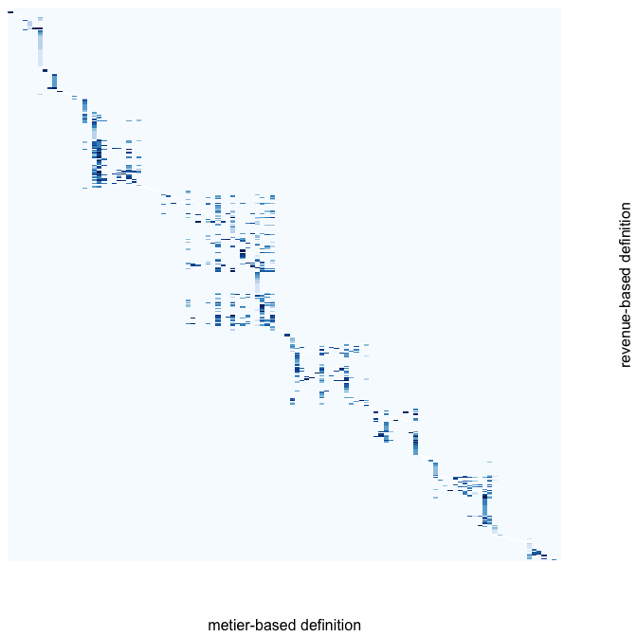

Here I plot a matrix where columns are the metiers, and rows are fisheries defined as major species by revenue. The cell shows the $log$ number of trips in which that species was the majority catch by revenue.[7] Darker colors indicate many trips with this species as majority, lighter colors indicate relatively few species as a majority.[8] The metiers are ordered using a detrended correspondance analysis to aid in visualization (decorana function in the vegan package, R). The plot demonstrates the reduction in dimensionality as a number of rare species are grouped into a single fishery in the clustering process, avoiding the need to make decisions subjectively.

### Emergent temporal and spatial structure

Métier-like analyes have been performed in the Northeast US, classifying fishing data to define "operational fisheries" of New England (Lucey and Fogarty 2013). While promising as a way to classify fisheries for use in ecosystem-based management, these methods introduced spatial and temporal structure prior to defining fisheries. In our analysis such structure emerges from the data, and we are able to recover the commonly recognized major fisheries and their seasonality, along with more spatially and temporally restricted fisheries. These methods have the additional benefit of only requiring the catch composition of trips, making it possible to integrate data from both state and federal management databases regardless of availability of management information.

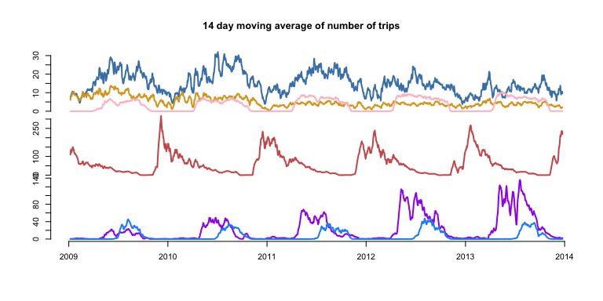 Here I plot the 14-day moving average of the number of trips for 6 fisheries (from top to bottom): sablefish longline, dover trawl, pink shrimp trawl, dungness crab pot, chinook salmon troll, albacore troll.[9] Here we can see the seasonal pattern where groundfish (blue, goldenrod) starts as seasonal in 2009, but seems to even out over time.[10] Pink shrimp is a summer fishery, as are salmon and albacore troll fisheries (bottom plot). Salmon has gotten more and more popular (in line with accounts of salmon populations going up, more catch allowed). Dungeness crab has a strong peak in winter, steadily declining into the summer.

Spatial structure can be observed in the Appendix dataframe by the proportion of trips taking place in Washington, Oregon and California. Many fisheries are restricted exclusively to California.[11]

## Mapping ecological connectivity

Ecosystem based management strives to manage an ecosystem holistically, and include humans in the analysis (Larkin 1996; Lucey and Fogarty 2013). Here we demonstrate such a foodweb.

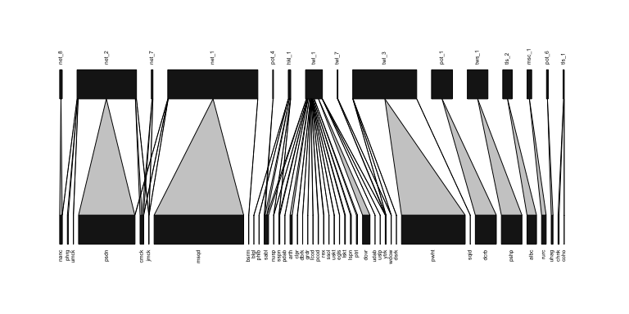 Here I plot a bipartite network in which upper nodes are metier-defined fisheries and the lower nodes are fish species. The strength of interaction is to the total volume harvested over the 5 year dataset. For visual clarity, this network is retricted to showing the top 15 fisheries by volume and the species harvested. Further the species caught are restricted to those which had at least an average of 100,000 lbs caught per year coast-wide. The width of the bars are the relative proportions by volume each fishery contributed to the total fishery-wide catch.[12]

We can see the major fisheries represented, from left to right: purse-seining of pelagics (net_8, net_2, net_7) and squid (net_1), sablefish fish pots (pot_4), sablefish long-line (hkl_1), groundfish trawl (twl_1), whiting mid-water trawl (twl_3), dungenss crab pots (pot_1), pink shrimp trawl (tws_1), albacore troll (tls_2), red urchin diving (msc_1), hagfish pots (pot_6), and salmon troll (tls_1).[13]

## Mapping social connectivity

Here I show catches across the top ten ports by number of vessels which landed trips (unique vessel IDs -- drvids). I subset to metiers which are responsible for a cumulative 95% of all trips landed in the specified port/year subset (if any). The size of the node is proportional to the total number of trips which were landed and the width of the edges is proportional to the number of vessels which landed trips in both métiers.[14] The colors represent another *infoMap* clustering to look for groups of métiers more tightly connected to each other than the rest of the network, these are provided for visual clarity. Across years these networks are too interconnected to be usefully visualized, breaking them apart by port provides a much better understanding (but see Appendix for coast-wide versions).

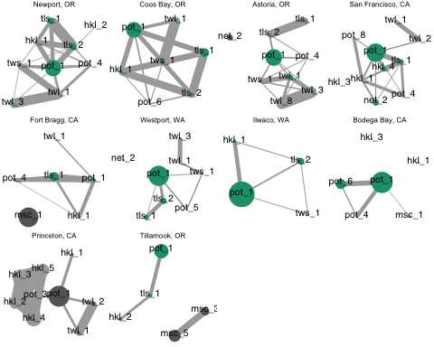

# Discussion

## Ecological insights

Using the full network, we can estimate the vulnerability of species by the number of seperate fisheries which exploit them, and the intensity with which they do so.

## generality.HL vulnerability.LL   
## 1.470880 1.065407

Or restrict to the major fisheries by volume.

## generality.HL vulnerability.LL   
## 1.480641 1.025117

## Social insights

Visual inspection of the port participation networks show that POT_1 (dungeness crab) appears highly connected and central to many of these networks.

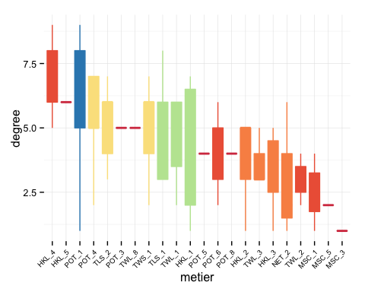

Here the distribution of degrees is shown, ordered from highest to lowest median degree and colored by the number of ports where the metier is found (blue is high i.e all 10, red is low -- only 1).[15] And indeed, the dungeness crab fishery is the only fishery present in all networks and typically very highly connected. The central position of this fishery could suggest this métier is important for everyone, operating as a sort of "refuge fishery". Based on informal discussions with Oregon commerical fishermen, the dungess crab fishery has been described as both lucrative, and relatively unrestricted in terms of gear or expertise needed for entry (i.e. any size boat can patricipate, gear needed is a crab pot, gear deployment is relatively straightforward as compared to dragging a trawl net, for example, or setting long-lines).

The participation networks also may provide a more nuanced definitions of fisheries communities. The networks are non-random, and vary from port to port. There are sub-graphs present (indicated by the colors), and a similar analyses of clustering on metiers could be performed to find groups of fishermen which participate in similar fisheries.

## Social-ecological insights

* management ripples: human connections between ecologically unrelated species (i.e. tuna and crab)
* motif analysis:
* including processor to species paths

In general métier-type analyses are an objective way to define fleets, and such analysis is crucial if we hope to rigorously connect social and ecological systems.

# Appendix

## Filtered species

To focus on species commonly caught, we remove species that were caught in fewer than 100 trips with a median catch weight of less than 100 lbs. Boxplots showing distribution of catch by species is shown, red boxes are species that were dropped from the analysis.

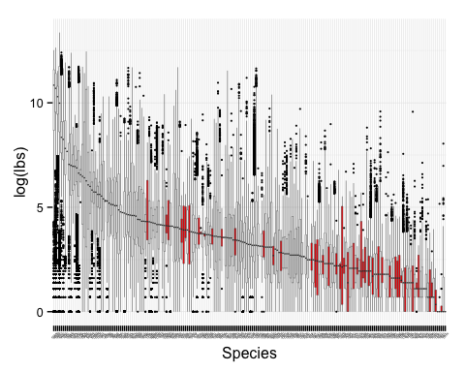 Species excluded are shown below with the number of trips they were found in and their median catch in pounds.

|  |  |  |  |
| --- | --- | --- | --- |
| spid | common name | number of trips | median catch (lbs) |
| EELS | unsp. eels | 96 | 46.5 |
| CWCD | cowcod rockfish | 92 | 4 |
| BSOL | butter sole | 84 | 6 |
| RSTN | rosethorn rockfish | 83 | 9 |
| MEEL | monkeyface prickleback (eel) | 82 | 3 |
| SPKL | speckled rockfish | 82 | 5 |
| OGRN | other groundfish | 80 | 62 |
| UTCR | unsp. tanner crab | 71 | 4 |
| WEEL | wolf eel | 70 | 9 |
| ISRK | bigeye thresher shark | 58 | 170 |
| DRDO | dorado/dolphinfish | 56 | 59 |
| GBLC | greenblotched rockfish | 54 | 12 |
| MSHP | plainfin midshipman | 52 | 9 |
| RCK6 | unsp. rosefish rckfsh | 44 | 8 |
| GSRK | greenstriped rockfish | 43 | 2 |
| SQR1 | nom. squarespot | 43 | 7 |
| BSRK | blue shark | 41 | 35 |
| YTNA | yellowfin tuna | 36 | 181 |
| STLH | steelhead | 33 | 8.5 |
| STNA | skipjack tuna | 32 | 75 |
| RCK2 | unsp. bolina rckfsh | 30 | 12 |
| USRM | unsp. ocean shrimp | 29 | 4.5 |
| ETNA | bigeye tuna | 27 | 1094 |
| OBAS | other bass | 24 | 5.5 |
| NUSR | nor. unsp. near-shore rockfish | 21 | 7 |
| CSKT | california skate | 19 | 52 |
| WSTG | white sturgeon | 17 | 31 |
| USHR | unsp. near-shore rockfish | 16 | 5 |
| FNTS | fantail sole | 14 | 7 |
| RCK7 | unsp. gopher rckfsh | 14 | 13 |
| EULC | eulachon | 13 | 1 |
| MXRF | mexican rockfish | 13 | 3 |
| HNYC | honeycomb rockfish | 12 | 1 |
| QFSH | queenfish | 12 | 42.5 |
| GSTG | green sturgeon | 11 | 38 |
| PSRK | pelagic thresher shark | 11 | 68.5 |
| RCK5 | unsp. small reds rckfsh | 11 | 10 |
| UCLM | unsp. clam | 10 | 12 |
| PRRK | pinkrose rockfish | 9 | 7 |
| RCKG | rock greenling | 9 | 2 |
| UDNR | unsp. deep near-shore rf | 9 | 41 |
| CMSL | california mussel | 6 | 22.5 |
| USMN | unsp. salmon | 5 | 11 |
| LDAB | longfin sanddab | 4 | 1.5 |
| PNKR | pink rockfish | 4 | 8.5 |
| SLNS | slender sole | 4 | 6.5 |
| SSDB | speckled sanddab | 4 | 90 |
| STRK | stripetail rockfish | 4 | 4.5 |
| UTNA | unsp. tuna | 4 | 703 |
| KFSH | giant kelpfish | 3 | 50 |
| PROW | prowfish | 3 | 9 |
| TCOD | pacific tomcod | 3 | 17 |
| BRNZ | bronzespotted rockfish | 2 | 21 |
| CLCO | calico rockfish | 2 | 1 |
| CMEL | chameleon rockfish | 2 | 202 |
| CEEL | spotted cusk-eel | 1 | 2151 |
| CHLB | california halibut | 1 | 12 |
| LCLM | native littleneck | 1 | 23 |
| OCRK | other croaker | 1 | 35 |
| ORCK | other rockfish | 1 | 14 |
| RCK1 | bocaccio+chilipepper rckfsh | 1 | 60 |
| RCK8 | canary+vermilion rckfsh | 1 | 3 |
| RZCL | rosy razor clam | 1 | 6 |
| SCLM | soft-shelled clam | 1 | 115 |
| UHLB | unsp. halibut | 1 | 64 |
| USTR | unsp. oyster | 1 | 1 |

## Metiers

|  |  |  |  |  |  |  |  |  |
| --- | --- | --- | --- | --- | --- | --- | --- | --- |
| Metier | Major Species | Major gear types | CA | OR | WA | trips | multispecies | vessels |
| POT_1 | dungeness crab | crab pot | 50 | 21 | 29 | 108679 | no | 1356 |
| MSC_1 | red sea urchin | diving gr | 76 | 24 | NA | 58691 | no | 196 |
| TLS_1 | chinook salmon | troll | 54 | 23 | 23 | 40412 | no | 1406 |
| POT_2 | california spiny lobster | c&l pot | 100 | NA | NA | 28011 | no | 231 |
| HKL_1 | sablefish | longline | 62 | 17 | 21 | 27438 | no | 695 |
| NET_1 | market squid | seine | 100 | NA | NA | 20555 | no | 150 |
| HKL_2 | black rockfish | oth hk&ln | 71 | 29 | NA | 17141 | no | 256 |
| TLS_2 | albacore | troll | 42 | 26 | 32 | 13071 | no | 1437 |
| POT_3 | rock crab | c&l pot | 100 | NA | NA | 12468 | no | 215 |
| HKL_3 | brown rockfish, gopher rockfish | pole(com) | 90 | 10 | NA | 9741 | yes | 168 |
| NET_2 | pacific sardine | seine | 75 | 12 | 12 | 9694 | no | 174 |
| TWL_1 | dover sole | rlr-trawl | 58 | 21 | 21 | 9276 | no | 171 |
| HKL_4 | calif halibut | pole(com) | 100 | NA | NA | 6655 | no | 307 |
| TWS_1 | pacific pink shrimp | dbl-shrimp | 33 | 42 | 25 | 6236 | no | 135 |
| POT_5 | spotted prawn | prwn trap | 81 | NA | 19 | 5545 | no | 36 |
| POT_6 | unsp. hagfish | fish pot | 51 | 17 | 31 | 5526 | no | 138 |
| POT_4 | sablefish | fish pot | 61 | 24 | 15 | 5497 | no | 294 |
| NET_3 | calif halibut | gill net | 100 | NA | NA | 4951 | no | 56 |
| TWL_2 | calif halibut | gftrawl<8 | 76 | 12 | 12 | 4834 | no | 64 |
| HKL_5 | lingcod | oth hk&ln, pole(com) | 61 | 26 | 13 | 4821 | no | 471 |
| MSC_2 | unsp. sea cucumbers | diving gr | 95 | 5 | NA | 4376 | no | 86 |
| HKL_6 | black-and-yellow rockfish, cabezon, grass rockfish | pole(com), vrtcl hkl | 75 | 25 | NA | 4285 | yes | 182 |
| TWL_3 | pacific whiting | mid-trawl | 38 | 38 | 25 | 4147 | no | 67 |
| NET_4 | white seabass | gill net | 100 | NA | NA | 3634 | no | 54 |
| MSC_3 | ghost shrimp | oth-known | NA | 100 | NA | 3343 | no | 43 |
| HKL_7 | white seabass | pole(com) | 100 | NA | NA | 2695 | no | 216 |
| MSC_4 | razor clam | oth-known | NA | 100 | NA | 2286 | no | 26 |
| TWS_2 | ridgeback prawn | sgl-shrimp | 81 | 6 | 12 | 2284 | no | 26 |
| TWL_5 | unsp. sea cucumbers | gfsh-trawl | 100 | NA | NA | 2104 | no | 46 |
| TWL_4 | unsp. bait shrimp | beam trawl | 100 | NA | NA | 1975 | no | 7 |
| MSC_5 | basket cockle | oth-known | 78 | 22 | NA | 1816 | no | 53 |
| NET_5 | swordfish, common thresher shark | drf gl net | 86 | NA | 14 | 1637 | yes | 84 |
| HKL_8 | vermillion rockfish | pole(com) | 79 | 18 | 3 | 1314 | no | 199 |
| TWS_3 | calif halibut, hornyhead turbot | sgl-shrimp | 91 | 9 | NA | 1305 | yes | 37 |
| NET_7 | chub mackerel | dip net | 90 | 10 | NA | 1261 | no | 53 |
| POT_8 | other shrimp | prwn trap | 67 | 33 | NA | 1190 | no | 32 |
| NET_8 | northern anchovy | seine | 81 | 6 | 12 | 1174 | no | 43 |
| NET_6 | unsp. shad | dip net | 100 | NA | NA | 1123 | no | 5 |
| HKL_9 | california scorpionfish, unsp. sanddabs | longline, pole(com) | 95 | NA | 5 | 1085 | yes | 77 |
| POT_13 | cabezon, gopher rockfish | fish pot | 70 | 19 | 11 | 901 | yes | 76 |
| MSC_7 | dungeness crab | oth-known | 17 | 83 | NA | 891 | no | 59 |
| TWL_8 | chinook salmon | mid-trawl | 17 | 50 | 33 | 850 | no | 40 |
| MSC_6 | unsp. bait shrimp | oth-known | NA | NA | 100 | 761 | no | 4 |
| POT_10 | california sheephead | fish pot | 100 | NA | NA | 717 | no | 42 |
| TWL_7 | yellowtail rockfish | mid-trawl | 22 | 33 | 44 | 707 | no | 68 |
| HKL_10 | albacore | pole(com) | 86 | 3 | 10 | 636 | no | 231 |
| TWL_6 | spiny dogfish | mid-trawl | 43 | 43 | 14 | 593 | no | 47 |
| MSC_12 | gaper clam | oth-known | NA | 100 | NA | 555 | no | 10 |
| MSC_9 | unsp. mollusks | diving gr | 100 | NA | NA | 462 | no | 7 |
| MSC_8 | swordfish | oth-known | 100 | NA | NA | 461 | no | 21 |
| POT_7 | rock crab | c&l pot | 100 | NA | NA | 414 | no | 63 |
| POT_9 | other crab | c&l pot | 89 | 11 | NA | 368 | no | 80 |
| HKL_11 | california sheephead | pole(com) | 93 | 7 | NA | 362 | no | 42 |
| MSC_10 | other sea urchins | diving gr | 100 | NA | NA | 325 | no | 43 |
| TWS_4 | unsp. sea cucumbers | sgl-shrimp | 100 | NA | NA | 324 | no | 20 |
| NET_10 | sockeye salmon | gill net | 33 | NA | 67 | 252 | no | 36 |
| POT_11 | other mollusks | c&l pot | 100 | NA | NA | 219 | no | 60 |
| NET_11 | pacific barracuda | drf gl net | 100 | NA | NA | 217 | no | 16 |
| TLS_4 | calif halibut | troll | 100 | NA | NA | 184 | no | 41 |
| HKL_14 | surfperch spp. | pole(com) | 100 | NA | NA | 174 | no | 16 |
| NET_12 | other crab | gill net | 100 | NA | NA | 165 | no | 14 |
| TWL_11 | lingcod | sel ff twl | 14 | 43 | 43 | 158 | no | 34 |
| POT_14 | unsp. octopus | crab pot | 69 | 31 | NA | 156 | no | 75 |
| HKL_13 | unsp. smelt | pole(com) | 100 | NA | NA | 152 | no | 8 |
| HKL_12 | common thresher shark | pole(com) | 100 | NA | NA | 151 | no | 39 |
| TWL_15 | other crab | gfsh-trawl | 100 | NA | NA | 149 | no | 13 |
| HKL_15 | yellowtail | pole(com) | 100 | NA | NA | 144 | no | 38 |
| TWL_16 | pacific halibut | mid-trawl | NA | 60 | 40 | 127 | no | 36 |
| HKL_23 | chinook salmon | pole(com) | 89 | NA | 11 | 119 | no | 58 |
| MSC_13 | blue mud shrimp | oth-known | NA | 100 | NA | 112 | no | 11 |
| HKL_16 | unsp. shelf rockfish | pole(com) | 100 | NA | NA | 86 | no | 4 |
| HKL_20 | unsp. reds rckfsh | pole(com) | 100 | NA | NA | 81 | no | 19 |
| NET_17 | pacific bonito | seine | 100 | NA | NA | 78 | no | 19 |
| TWS_6 | unsp. flatfish | sgl-shrimp | 100 | NA | NA | 76 | no | 6 |
| MSC_14 | other mollusks | diving gr | 86 | 14 | NA | 66 | no | 23 |
| HKL_18 | swordfish | longline | 100 | NA | NA | 59 | no | 18 |
| TWL_12 | canary rockfish | mid-trawl | NA | 60 | 40 | 58 | no | 28 |
| TWL_14 | nor. unsp. shelf rockfish | mid-trawl | NA | 50 | 50 | 58 | no | 11 |
| HKL_17 | pacific barracuda | pole(com) | 100 | NA | NA | 53 | no | 32 |
| POT_12 | spotted prawn | c&l pot | 100 | NA | NA | 50 | no | 7 |
| TWL_9 | nor. unsp. slope rockfish | mid-trawl | NA | 75 | 25 | 48 | no | 32 |
| TWS_9 | rock crab | sgl-shrimp | 100 | NA | NA | 48 | no | 9 |
| NET_13 | giant sea bass | gill net | 100 | NA | NA | 44 | no | 18 |
| NET_14 | other shark | gill net | 100 | NA | NA | 41 | no | 11 |
| HKL_21 | leopard shark | pole(com) | 100 | NA | NA | 41 | no | 21 |
| NET_16 | rock crab | gill net | 100 | NA | NA | 41 | no | 12 |
| HKL_22 | unsp. squid | longline, oth hk&ln, pole(com) | 70 | 30 | NA | 40 | no | 14 |
| TWL_13 | pop | rlr-trawl | NA | 100 | NA | 39 | no | 18 |
| TLS_3 | albacore | troll | 47 | 12 | 41 | 35 | no | 30 |
| NET_15 | soupfin shark | gill net | 100 | NA | NA | 33 | no | 7 |
| HKL_19 | shortfin mako shark | pole(com) | 100 | NA | NA | 32 | no | 19 |
| TLS_7 | sablefish | troll | 62 | 6 | 31 | 30 | no | 25 |
| MSC_16 | california sheephead | diving gr | 100 | NA | NA | 27 | no | 6 |
| TWS_7 | other skates | sgl-shrimp | 100 | NA | NA | 27 | no | 8 |
| MSC_15 | black-and-yellow rockfish | diving gr | 100 | NA | NA | 22 | no | 6 |
| TWS_8 | other shrimp | sgl-shrimp | 100 | NA | NA | 22 | no | 3 |
| NET_9 | pacific sardine | seine | 100 | NA | NA | 21 | no | 13 |
| NET_18 | unsp. smelt | seine | 100 | NA | NA | 20 | no | 5 |
| MSC_19 | unsp. flatfish | diving gr | 100 | NA | NA | 17 | no | 6 |
| TLS_5 | white seabass | troll | 100 | NA | NA | 15 | no | 4 |
| TWL_10 | petrale sole, sand sole | sel ff twl, gftrawl<8 | 75 | 25 | NA | 14 | yes | 9 |
| MSC_11 | unsp. sea cucumbers | diving gr | 100 | NA | NA | 14 | no | 5 |
| TWS_5 | unsp. skate | sgl-shrimp | 75 | NA | 25 | 11 | no | 6 |
| HKL_24 | unsp. octopus | longline, oth hk&ln, pole(com) | 25 | 75 | NA | 8 | no | 6 |
| MSC_18 | shortfin mako shark | oth-known | 100 | NA | NA | 7 | no | 5 |
| MSC_17 | misc. fish | diving gr | 100 | NA | NA | 5 | no | 3 |
| TLS_8 | vermillion rockfish | btm-troll | 100 | NA | NA | 5 | no | 3 |
| TLS_6 | nor. unsp. shelf rockfish | troll | NA | 50 | 50 | 3 | no | 3 |
| HKL_25 | pacific angel shark | pole(com) | 100 | NA | NA | 3 | no | 3 |
| TLS_9 | yellowtail | troll | NA | 100 | NA | 3 | no | 3 |
| TWS_10 | white seabass | sgl-shrimp | 100 | NA | NA | 3 | no | 2 |
| TWS_11 | vermillion rockfish | sgl-shrimp | 100 | NA | NA | 3 | no | 2 |

## Participation networks across years

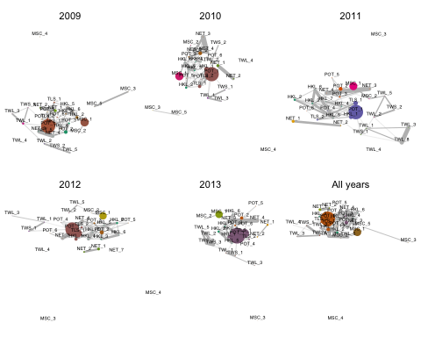

# References

Deporte, Nicolas, Clara Ulrich, Stéphanie Mahévas, Sébastien Demanèche, and Francois Bastardie. 2012. “Regional Métier Definition: a Comparative Investigation of Statistical Methods Using a Workflow Applied to International Otter Trawl Fisheries in the North Sea.” *ICES Journal of Marine Science: Journal Du Conseil*. Oxford University Press, fsr197.

Jentoft, Svein. 2000. “The Community: a Missing Link of Fisheries Management.” *Marine Policy* 24 (January): 53–59.

Kasperski, Stephen, and Daniel S Holland. 2013. “Income Diversification and Risk for Fishermen.” *Proceedings of the National Academy of Sciences* 110 (6). National Acad Sciences: 2076–81.

Larkin, Peter Anthony. 1996. “Concepts and Issues in Marine Ecosystem Management.” *Reviews in Fish Biology and Fisheries* 6 (2). Springer: 139–64.

Legendre, Pierre, and Loic FJ Legendre. 2012. *Numerical Ecology*. Vol. 20. Elsevier.

Lucey, Sean M, and Michael J Fogarty. 2013. “Operational Fisheries in New England: Linking Current Fishing Patterns to Proposed Ecological Production Units.” *Fisheries Research* 141. Elsevier: 3–12.

Putten, Ingrid E van, Soile Kulmala, Olivier Thébaud, Natalie Dowling, Katell G Hamon, Trevor Hutton, and Sean Pascoe. 2011. “Theories and Behavioural Drivers Underlying Fleet Dynamics Models.” *Fish and Fisheries* 13 (2): 216–35.

Rosvall, Martin, and Carl T Bergstrom. 2008. “Maps of Random Walks on Complex Networks Reveal Community Structure.” *Proceedings of the National Academy of Sciences* 105 (4). National Acad Sciences: 1118–23.

Rosvall, Martin, Daniel Axelsson, and Carl T Bergstrom. 2009. “The Map Equation.” *The European Physical Journal-Special Topics* 178 (1). Springer: 13–23.

Sethi, Suresh Andrew, Matthew Reimer, and Gunnar Knapp. 2014. “Alaskan Fishing Community Revenues and the Stabilizing Role of Fishing Portfolios.” *Marine Policy* 48. Elsevier: 134–41.

St. Martin, Kevin. 2008. “Mapping Community Use of Fisheries Resources in the US Northeast.” *Journal of Maps* 4 (1). Taylor & Francis: 38–49.

Wilen, James E. 1979. “Fisherman Behavior and the Design of Efficient Fisheries Regulation Programs.” *Journal of the Fisheries Board of Canada* 36 (7). NRC Research Press: 855–58.

Wilson, James A, James M Acheson, and Teresa R Johnson. 2013. “The Cost of Useful Knowledge and Collective Action in Three Fisheries.” *Ecological Economics* 96. Elsevier: 165–72.

1. conservation debate, etc.
2. Kevin St. Martin, Bonnie McCay's work, need to revisit. Also NW fisheries social scientists.
3. D. Edler and M. Rosvall, The MapEquation software package, available online at <http://www.mapequation.org>
4. In 2011 ITQs went in to a subset of the fisheries, namely the trawl groundfish fisheries. This change in management may change the assemblage of species caught together. To check for sensitivity based on year chosen as training year, we trained the knn classifier on both pre- (2010) and post- (2012) catch share implementation. We found no significant difference in how trips were assigned to metiers. But see the appendix for futher details.
5. D. Edler and M. Rosvall, The MapEquation software package, available online at <http://www.mapequation.org>
6. Actually right now it's not still need to change. It's the bray-curtis derived similarity between the composition of fishing fleets. This is harder to explain, which is why I opted for the number of vessels as an edge width instead. I expect results to qualitatively similar.
7. Using the Adjusted Rand Index ($ARI$) I find no difference between classification using volume or revenue ( $ARI=$ 0.9909052)
8. Need a legend, will fix.
9. Needs legends, will fix.
10. Due to ITQs? could look for seasonal signature declining over time?
11. Needs work, not sure best way to demonstrate yet -- place holder
12. Dataset only includes shore-side whiting fishery, hence the lower volume reported here. At sea processors not included.
13. twl_7 is an interesting case, it's a mid-water trawl (see Appendix) that catches primarily rockfish. I think this may be lightning-strike hauls of rockfish by whiting-trawlers. But because volumes are so large, it shows up as it's own fishery.
14. Actually right now it's not still need to change. It's the bray-curtis derived similarity between the composition of fishing fleets. This is harder to explain, which is why I opted for the number of vessels as an edge width instead. I expect results to qualitatively similar.
15. Also the idea that some of these metiers could be structured not only by states, but by ports. Certainly the species sampling for rockfish show port/time of year structure. And haven't looked these through time, really] And should think about the ratio of trips to vessels. If each vessel does it once (at the extreme) it's unlikely that it's a fishery, so much as a particular assemblage that's hit randomly]