**Accounting for Human Connectivity in Social-Ecological Systems**

*In order to foster resilient social-ecological systems, governance should quantify and account for human connectivity*

Emma Fuller1*, Jameal Samhouri2, Simon Levin1, James Watson,3 Josh Stoll (order TBD)

1Department of Ecology and Evolutionary Biology, Princeton University

2NOAA

3Stockholm Resilience Centre

4 University of Maine

*To whom correspondence should be addressed: emma.cassel.fuller@gmail.com

Understanding how to balance human well-being and ecological integrity is one of the fundamental challenges in conservation and natural resource management. As our human-footprint on ecosystems expands and deepens, we are increasingly realizing that human well-being is crucial to understanding the dynamics of social-ecological systems and managing them sustainably. Despite the growing focus on valuing, and therefore measuring, human well-being alongside ecological quality indicators (i.e. biodiversity, ecosystem function), we still lack clear ways to operationalize these goals (Mace 2014). Developing new, nuanced methods for understanding how people interact with their environment and ways to describe them is important for advancing sustainability science (Hicks et al. 2016).

This challenge is particularly acute in commercial fisheries where the dynamics of marine ecosystems and the well-being of fishermen are inherently tied to one another. Desire to account for multiple interacting actors is reflected in the growing recognition that ecosystem-based fisheries management (EBFM) – which aims to account for human and natural connectivity within marine systems – is vital to sustaining fisheries long-term. This sentiment is displayed in innumerable high-level policy documents including the new Ecosystem-Based Fisheries Management policy that was released by the National Marine Fisheries Service in May 2016. But while there has been much work to support the ecological side of EBFM, there is little work to help managers quantitatively capture, let alone manage, how humans connect and shift effort among fisheries. Developing new and innovative methods to understand these complex systems and their dynamics is therefore a critical step towards moving EBFM from theory to practice and ultimately advancing sustainability science (Hicks et al. 2016). To this end, this paper presents an analysis of socioeconomic connectivity of the commercial fisheries in the California Current ecosystem that illustrates the diverse cross-fishery linkages that exist in coastal communities along the west coast of the United States. We focus on the California Current ecosystem because the natural science to support EBFM in this region is world class, yet little work has been done to account for human connections among fisheries that exist in the region.

To improve understanding of fishery linkages for policy makers, stakeholders and managers, we developed and applied a novel approach to build and describe *participation networks*. In doing so we find (i) general, consistent social linkages among fisheries that are currently unaccounted for in existing fisheries policy and management, (ii) that people diversify across jurisdictions/institutions (state and federal fisheries) and across trophic levels. i.e. that ecological distant taxa (benthic nearshore crab and offshore pelagic tuna) are tightly linked by the people who fish for them both and (iii) while there appear to be scale-invariant motifs in these networks, we find variation in the composition and structure from community to community suggesting heterogeneity in both the impact to, and the ability of, fishing communities to deal with to environmental, management and/or market changes.

This study presents a first effort to systematically measure human linkages among commercial fisheries. Accounting for the human connectivity in these systems can help management avoid unintended consequences for people or ecosystems. This work also emphasizes the importance of governance structures that cross jurisdictional boundaries (analogous to the way that political borders rarely reflect ecological boundaries). More work is required to link structure and composition of participation networks to human-wellbeing in these coastal communities however network approaches have long been a valuable tool to understand interactions among communities of species, and many quantitative measures of these webs might provide metrics to measure policy efficacy in the management of social-ecological systems (i.e. Mace 2014).

Building methods that can operationalize goals of integrating human wellbeing and ecological integrity is one of the largest challenges in building sustainable social ecological systems (Mace et al. 2014), and fisheries are no exception. Most regions globally supporting large industrial fisheries document diversity in the way fishermen distribute effort across marine resources, not to mention highly diverse tropical subsistence fishing. We hope that by quantitatively illustrating the human connectivity of these systems and the connectivity across institutions and trophic levels, that we can stimulate the development of operational policies which can be quantitatively assessed for their efficacy.

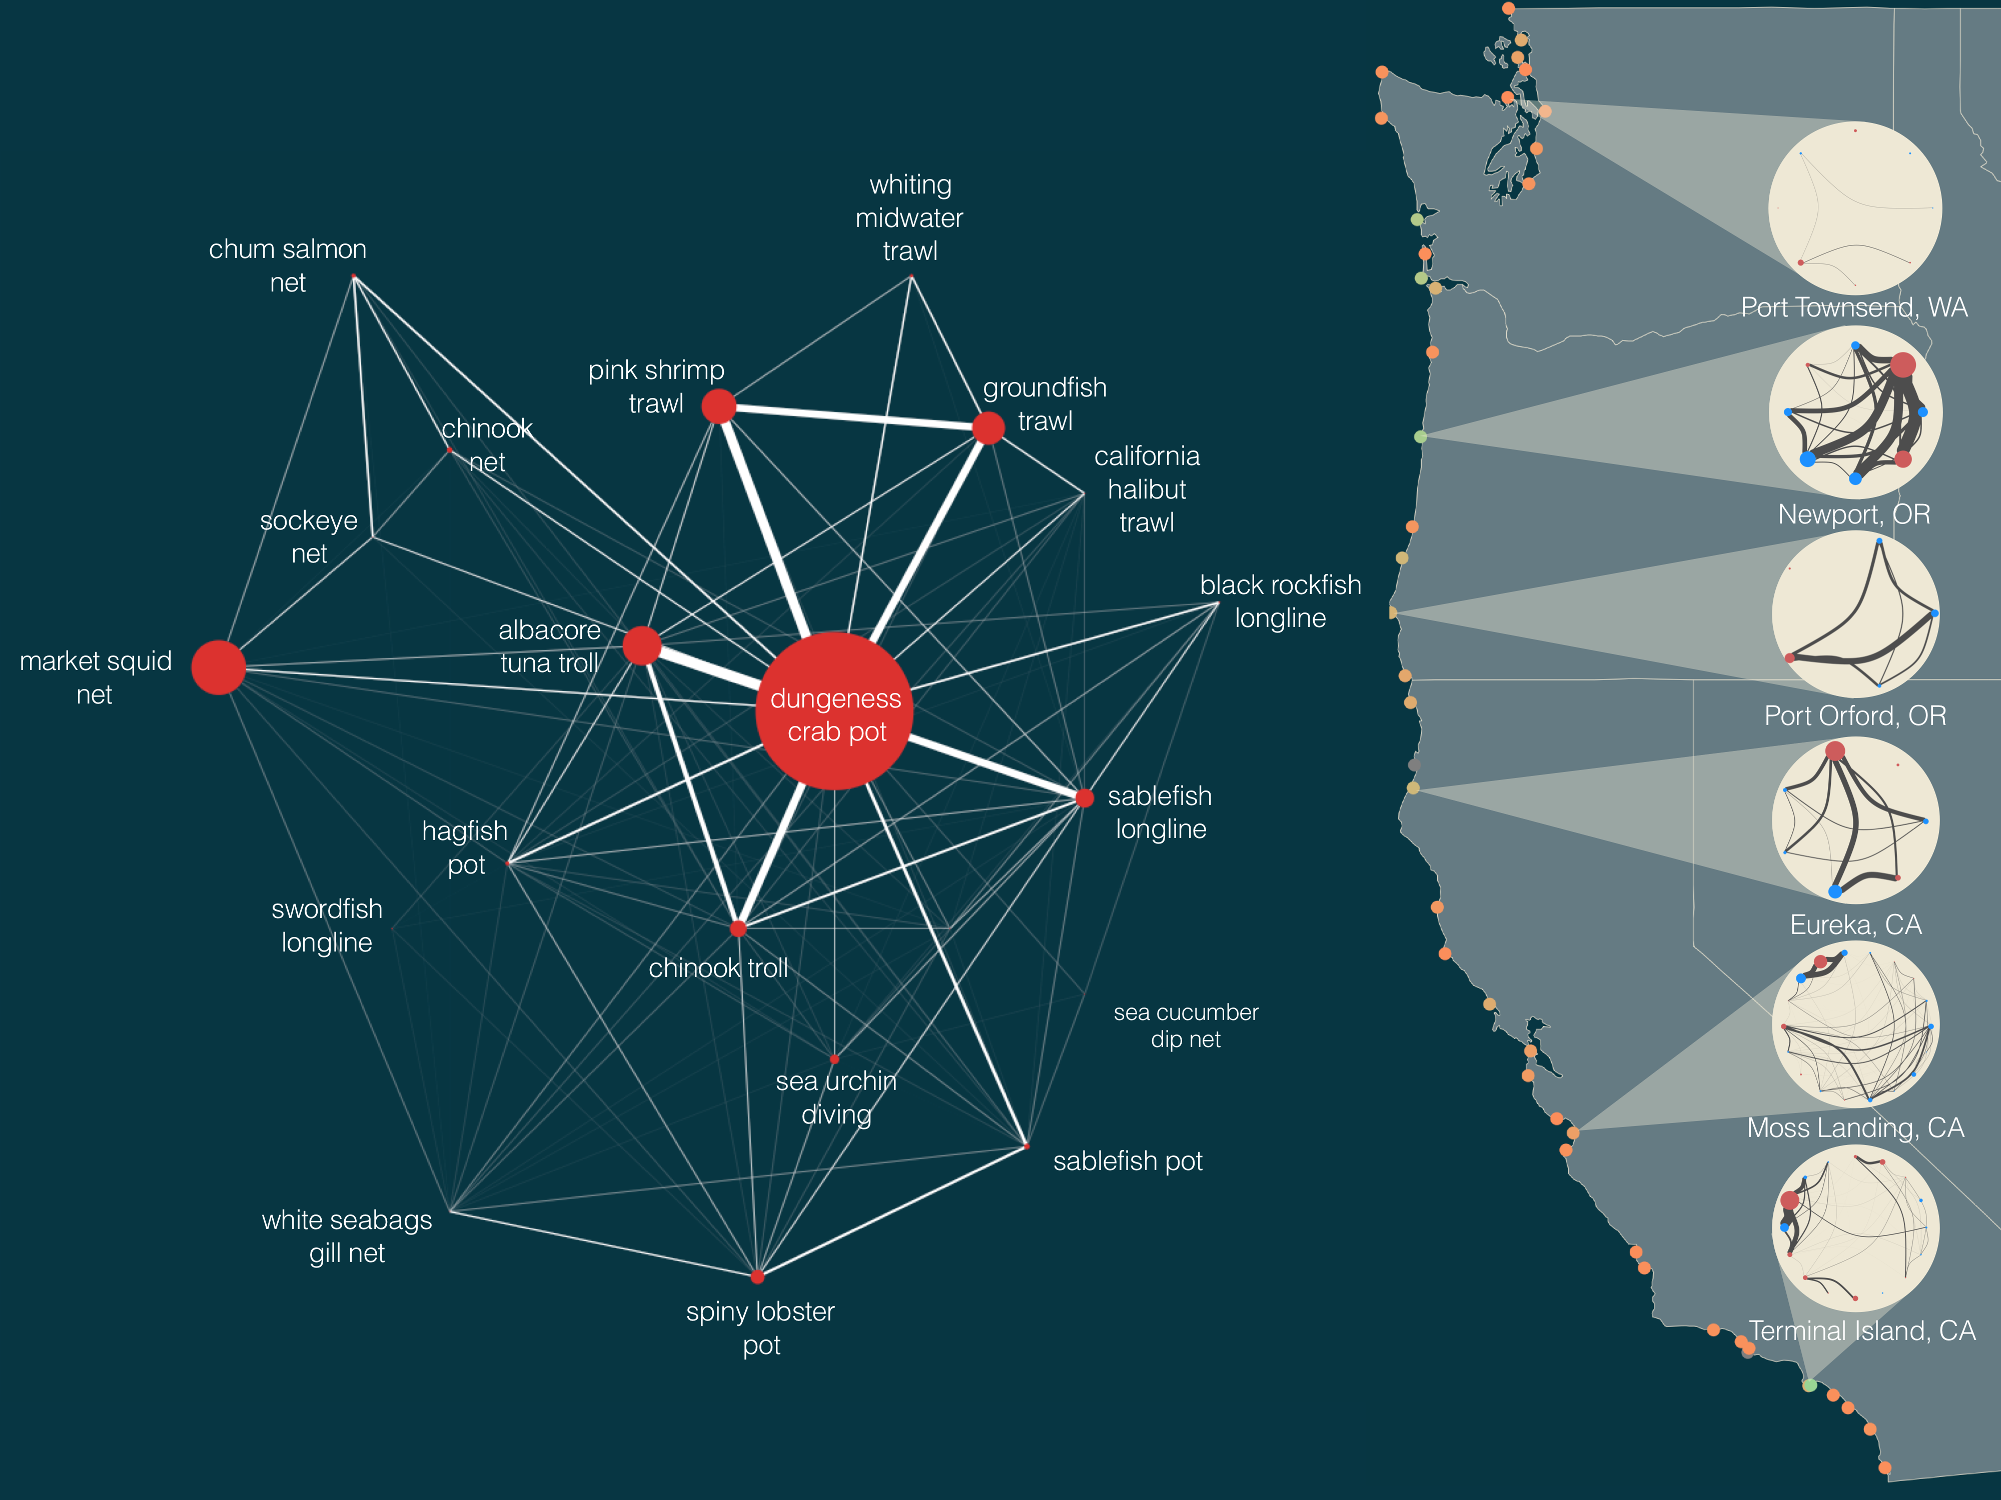

**Human connectivity of commercial fisheries in the California Current Ecosystem.** Fisheries in the California Current are strongly connected by human participation. While some fisheries dominate the coast wide network, notably the Dungeness crab pot fishery, the network highlights the connectivity among fisheries which target different trophic levels, using different gears. We find that ports vary in their network structure both in the number of fisheries (nodes), the heterogeneity in fishery size and strength of interconnections. These differences in structure may correspond to differences in community resilience. We color ports using one potential metric of network resilience to highlight this heterogeneity. On the right we plot ports colored by their adaptive capacity (see Supplementary Materials for details) and show port-level participation networks with nodes colored by management jurisdiction (federally managed fisheries are blue, state managed are red, fisheries where both state and federal have a role in management (i.e. nearshore rockfish, are purple). We find consistent motifs across scales: salmon fishermen = crab fishermen = tuna fishermen, that there are links between disparate parts of the food web and variation among ports in their adaptive capacity. All this highlights the need for policies to be sensitive to weakest links. For visual clarity we only include fisheries that had at least 3 vessels which participated and accounted for, on average, 25% of a vessel’s annual income.