**Accounting for Human Connectivity in Social-Ecological Systems**

*In order to foster resilient social-ecological systems, governance should quantify and account for the links people create when dependent on multiple components of an ecosystem.*

Emma Fuller1*, Jameal F. Samhouri2,Josh Stoll3, James Watson4, Simon Levin1 (order TBD)

1Department of Ecology and Evolutionary Biology, Princeton University

2NOAA

3 University of Maine

4Stockholm Resilience Centre

*To whom correspondence should be addressed: emma.cassel.fuller@gmail.com

Understanding how to balance human well-being and ecological integrity is one of the fundamental challenges in conservation and natural resource management. As our human-footprint on ecosystems expands and deepens, we are increasingly realizing that human well-being is crucial to understanding the dynamics of social-ecological systems and managing them sustainably. Despite the growing focus on valuing, and therefore measuring, human well-being alongside ecological quality indicators (i.e. biodiversity, ecosystem function), we still lack clear ways to operationalize these goals (Mace 2014). Developing methods for understanding how people interact with their environment and ways to describe them is a major part of advancing sustainability science (Hicks et al. 2016).

This challenge is particularly acute in commercial fisheries where the dynamics of marine ecosystems and the well-being of fishermen are inherently tied to one another. Philosophically, the desire to account for connections between fish and fishermen is present, as seen in numerous policy directives including the recently released NOAA Fisheries Climate Science Strategy and Ecosystem Based Fisheries Management (EBFM) technical reports. But while these policies call for the incorporation of the complexity and adaptive nature of these social-ecological systems into ocean management, attention to food-web interactions dominates, marginalizing the equally complex human networks resulting from how people participate and shift effort among fisheries. Developing new and innovative methods to understand these complex systems and their dynamics is therefore a critical, and largely unaddressed, step towards moving EBFM from theory to practice and ultimately advancing sustainability science (Hicks et al. 2016). To this end, this paper presents an analysis of socioeconomic connectivity of the commercial fisheries in the California Current ecosystem that illustrates the diverse cross-fishery linkages that exist in coastal communities along the west coast of the United States. We focus on the California Current ecosystem because the natural science to support EBFM in this region is world class, yet little work has been done to account for human connections among fisheries that exist in the region.

To improve understanding of fishery linkages for policy makers, stakeholders and managers, we developed and applied a novel approach to build and describe *participation networks*. In doing so we find (i) general, consistent social linkages among fisheries that are currently unaccounted for in existing fisheries policy and management, (ii) that people diversify across jurisdictions/institutions (state and federal fisheries), and (iii) while there appear to be scale-invariant motifs in these networks, we find variation in the composition and structure from community to community suggesting heterogeneity in both the impact to, and the ability of, fishing communities to deal with environmental, management, and/or market shocks.

This study presents a first effort to systematically measure human linkages among commercial fisheries. It validates the need for EBFM that embraces these connections in order to optimize benefits from fisheries, for instance by quantifying how ecologically distant taxa (e.g., benthic nearshore crab and offshore pelagic tuna) are tightly linked by the people who fish for them both. For example, measuring the impact of a crab closure alone would fail to account for the fact that of the 75% Dungeness crab fishermen are generalists, participating in an average of four other fisheries in a given year, drawing attention to the possibility of cascading effects across fisheries with a change in Dungeness crab management.

These participation networks also point to the value of governance structures that reflect dynamics crossing jurisdictional boundaries (Crowder et al. 2006). For example, on the US West coast state-level management of crab vessels would fail to account for an average of 35% of landings and 30% of revenue to those vessels, 99% of which comes from federally managed stocks. Governance that acknowledges these types of cross-jurisdictional issues are not without precedent, even on the US West Coast where Pacific hake are jointly assessed and managed by the US and Canada.

Last, quantitative measures of these networks provide the means to evaluate policy efficacy in the management of social-ecological systems (i.e. Mace 2014). Across coastal communities in the US California current, network complexity varies five-fold. Simply naming this variability can help policymakers determine the extent to which a coast-wide management action (e.g. the recent implementation of catch shares in the groundfish fishery) will create comparable versus wildly different social and ecological consequences from place to place, in a way that would be impossible without observing human connectivity in the ecosystem.

We have focused here on recent ocean policy advances in the US, but the importance of quantifying human connectivity extends beyond American borders. Most regions supporting large industrial fisheries document diversity in the way fishermen distribute effort across marine resources (Australia, New Zealand, Baltic), not to mention highly diverse tropical subsistence fishing. Considering fisheries as network components linked together through the behavior of fishermen will help to advance understanding of ecosystem processes, implement ecosystem-level planning, prioritize vulnerabilities and risks, explore trade-offs of fisheries management alternatives, fully inform EBFM advice with ecosystem considerations, and develop operating protocols to maintain resilient ecosystems

Building methods that can operationalize goals of integrating human wellbeing and ecological integrity is one of the largest challenges in building sustainable social ecological systems (Mace et al. 2014), and fisheries are no exception. We hope that by quantitatively illustrating the human connectivity of these systems and the connectivity across institutions and trophic levels, that we can stimulate the development of operational policies which can be quantitatively assessed for their efficacy.

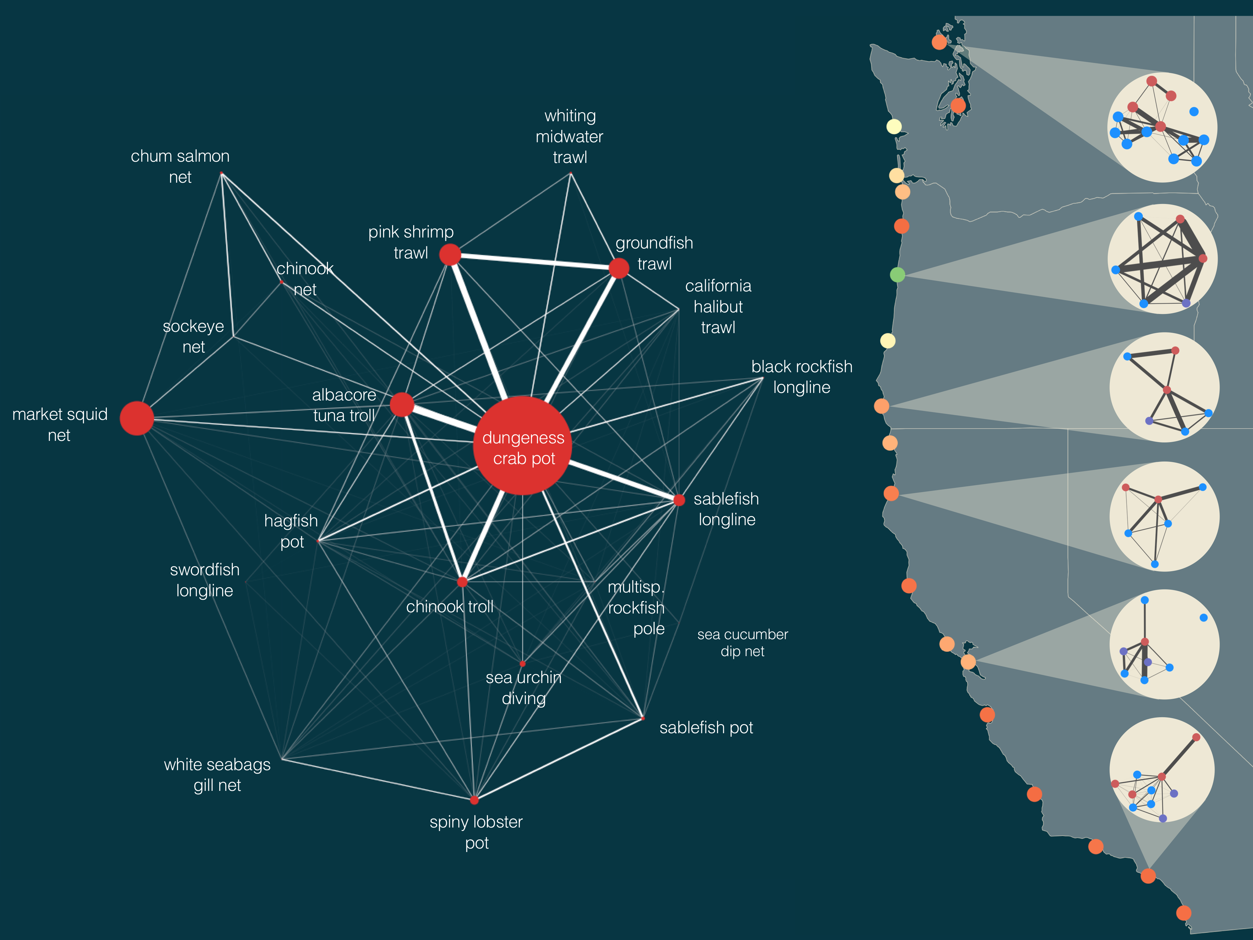

**Human connectivity of commercial fisheries in the California Current Ecosystem.** Fisheries in the California Current are strongly connected by human participation. Some fisheries dominate the coast-wide network, notably the Dungeness crab pot fishery. Connected fisheries, such as the groundfish trawl and albacore tuna troll fisheries, clearly target different trophic levels, using different gears. We find that ports vary in their network structure both in the number of fisheries (nodes), the heterogeneity in fishery size and strength of interconnections. These differences in structure may correspond to differences in community resilience. We color ports using one potential metric of network resilience to highlight this heterogeneity. On the right we plot ports colored by their adaptive capacity (see Supplementary Materials for details) and show port-level participation networks with nodes colored by management jurisdiction (federally managed fisheries are blue, state managed are red, fisheries where both state and federal have a role in management (i.e. nearshore rockfish, are purple). For visual clarity we only include fisheries that had at least 3 vessels which participated and accounted for, on average, 25% of a vessel’s annual income.