**Accounting for human connectivity in social ecological systems**

*In order to foster resilient (adaptive capacity) coastal communities, EBFM should quantify and account for human connectivity.*

**Introduction – motivation – problem statement**

* Marine ecosystems are complex. There are lots of ecological linkages that have to be considered. Fisheries Management has has realized this and is addressing these indirect effects by adopting EBFM principles to manage these systems more holistically.
* But commercial fisheries also have major human linkages as well. Conceptually EBFM recognizes people as part of these systems, and many policy documents have language instructing management to value human wellbeing and livelihoods alongside goals of ecological integrity. But while there has been much work in developing management that accounts for interactions among species harvested, there is little work to help managers quantitatively capture, let alone manage, how humans connect and shift effort fisheries. This is particularly problematic because some large marine problems (roving bandits, gilded traps and sequential exploitation) are all an outcome of unrealized human connectivity.
* But it doesn’t have to be this way. We show how we have the data available now to quantify human connectivity in marine fishing systems and highlight the insights available from these methods.
* California Current ecosystem illustrates the potential for insights. This system experiences huge climatic and oceanographic variability that drives ecological dynamics across a range of spatial scales. Fisheries in this system are highly diversified and valuable: the groundfish complex alone has six times the number of species federally managed as compared the US Northeast and landings in 2014 (the most recent for which records exist) were worth more than 700 million dollars. Between 2014 and 2015, as a result of “the blob”, a mass of unusually warm water occurred along the Pacific Coast. Salmon catches were directly affected, and disrupted marine ecosystems and shifted distributions of species. But because we lack methods to measure how fishing communities reacted, there are no measures of these human impacts.
* To address this mismatch between fishing communities and fisheries, we…

**Results**

1. We quantify/demonstrate general, consistent social linkages among fisheries that are unaccounted for in existing policy/management.
   1. **Policy**: These linkages can help management avoid unintended consequences for people or ecosystems.
2. We reveal people diversify across jurisdictions/institutions (state and federal fisheries) and across trophic levels. i.e. that ecological distant taxa (benthic nearshore crab and offshore pelagic tuna) are tightly linked by the people who fish for them both.
   1. **policy** emphasizing the importance of governance structures that cross jurisdictional boundaries (analogous to the way that ecology doesn’t respect to political boundaries).
3. Despite general motifs, we find variation from community to community and their potential to adapt to environmental, management and/or market changes (measured by Gao et al. beta_eff metric)
   1. **policy** calling attention to attention to the “do no harm” approach to setting policy (don’t hurt the small guy/weak stock stuff/regressive).
   2. Gao et al. beta_eff (Gao et al. 2016) applied to port-level networks is an example of a metric to use to measure policy efficacy in managing social-ecological systems (i.e. Mace 2014).

**Conclusion**

**This challenge is ubiquitous in fisheries**: zoom out to say how fisheries managers in New Zealand, Australia, Baltic, rest of US face similar issues. If we could throw in tropical developing countries that would be great too.

**This is a grand challenge for CNH systems in general:** Building methods that can operationalize goals of integrating human wellbeing and ecological integrity is one of the largest challenges in building sustainable social ecological systems (Mace et al. 2014).

**We provide the beginning**: we hope that by quantitatively illustrating the human connectivity of these systems and the connectivity across institutions and trophic levels, that we can stimulate the development of operational policies which can be quantitatively assessed for their efficacy.

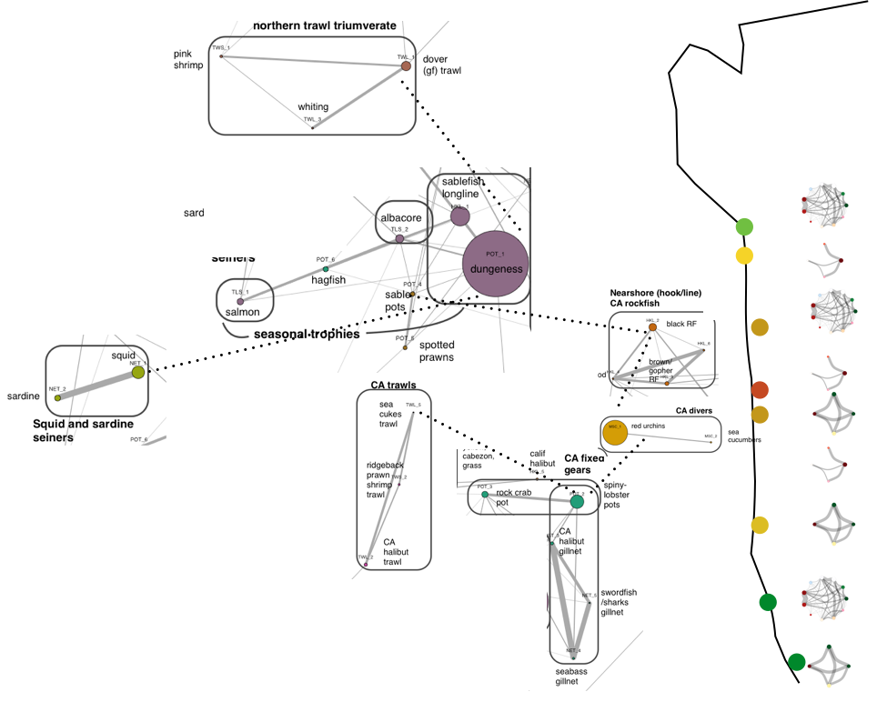

**Fisheries connectivity in the California Current Ecosystem.** On the left we map the human connectivity of commercial fisheries in the California current. On the right we plot ports colored by their adaptive capacity and show port-level participation networks with nodes colored by management jurisdiction (blue federal, red state). We find that salmon fishermen = crab fishermen = tuna fishermen, that there are links between disparate parts of the food web and variation among ports in their adaptive capacity. All this highlights the need for policies to be sensitive to weakest links.