**Appendix**

A) Realized Fisheries

|  | | **Métier** | | **Major species** | | **Major gear** | | **CA** | | **OR** | | **WA** | | **Trips** | | **Multi-species** | | **Number vessels** | |
| --- | --- | --- | --- | --- | --- | --- | --- | --- | --- | --- | --- | --- | --- | --- | --- | --- | --- | --- | --- |
|  | POT_1 | | Dungeness crab | | crab pot | | 45 | | 23 | | 32 | | 105532 | | no | | 1194 | |
|  | MSC_1 | | red sea urchin | | diving gear | | 80 | | 20 | | NA | | 58224 | | no | | 211 | |
|  | TLS_1 | | chinook salmon | | troll | | 50 | | 25 | | 25 | | 39383 | | no | | 1481 | |
|  | POT_2 | | California spiny lobster | | crab & lobster pot | | 100 | | NA | | NA | | 28588 | | no | | 253 | |
|  | HKL_1 | | sablefish | | longline | | 66 | | 15 | | 19 | | 25026 | | no | | 595 | |
|  | NET_1 | | market squid | | seine | | 100 | | NA | | NA | | 20325 | | no | | 154 | |
|  | HKL_2 | | black rockfish | | other hook & line | | 67 | | 33 | | NA | | 18358 | | no | | 342 | |
|  | TLS_2 | | albacore | | troll | | 42 | | 26 | | 32 | | 13851 | | no | | 1260 | |
|  | POT_3 | | rock crab | | crab & lobster pot | | 100 | | NA | | NA | | 11806 | | no | | 203 | |
|  | HKL_4 | | brown rockfish, gopher rockfish | | pole (commercial) | | 90 | | 10 | | NA | | 10200 | | yes | | 209 | |
|  | HKL_3 | | California halibut | | pole (commercial) | | 100 | | NA | | NA | | 9350 | | no | | 630 | |
|  | TWL_1 | | dover sole | | roller-trawl | | 59 | | 23 | | 18 | | 8305 | | no | | 125 | |
|  | NET_2 | | pacific sardine | | seine | | 74 | | 16 | | 11 | | 7169 | | no | | 116 | |
|  | TWS_1 | | pacific pink shrimp | | double-shrimp trawl | | 20 | | 50 | | 30 | | 6208 | | no | | 105 | |
|  | POT_5 | | spotted prawn | | prawn trap | | 81 | | NA | | 19 | | 5823 | | no | | 37 | |
|  | POT_6 | | unsp. hagfish | | fish pot | | 50 | | 18 | | 32 | | 5630 | | no | | 137 | |
|  | HKL_5 | | lingcod | | other hook & line, pole (commercial) | | 63 | | 25 | | 12 | | 5502 | | no | | 612 | |
|  | POT_4 | | sablefish | | fish pot | | 62 | | 25 | | 12 | | 5393 | | no | | 283 | |
|  | NET_3 | | California halibut | | gillnet | | 100 | | NA | | NA | | 4946 | | no | | 63 | |
|  | TWL_2 | | California halibut | | groundfish trawl<8 | | 100 | | NA | | NA | | 4703 | | no | | 55 | |
|  | HKL_6 | | black-and-yellow rockfish, Cabazon, grass rockfish | | pole (commercial), vertical hook & line | | 74 | | 26 | | NA | | 4634 | | yes | | 201 | |
|  | MSC_2 | | unsp. sea cucumbers | | diving gear | | 95 | | 5 | | NA | | 4384 | | no | | 92 | |
|  | HKL_7 | | white seabass | | pole (commercial) | | 100 | | NA | | NA | | 3372 | | no | | 387 | |
|  | NET_4 | | white seabass | | gillnet | | 100 | | NA | | NA | | 3292 | | no | | 55 | |
|  | NET_5 | | pacific herring | | gillnet | | 89 | | NA | | 11 | | 3270 | | no | | 157 | |
|  | TWL_3 | | unsp. bait shrimp | | beam trawl | | 100 | | NA | | NA | | 2384 | | no | | 10 | |
|  | TWS_2 | | ridgeback prawn | | single-shrimp trawl | | 85 | | NA | | 15 | | 2203 | | no | | 24 | |
|  | TWL_4 | | unsp. sea cucumbers | | groundfish trawl | | 100 | | NA | | NA | | 2106 | | no | | 48 | |
|  | HKL_8 | | vermilion rockfish | | pole (commercial) | | 79 | | 21 | | NA | | 1878 | | no | | 263 | |
|  | NET_7 | | swordfish, common thresher shark | | drift gillnet | | 100 | | NA | | NA | | 1510 | | yes | | 82 | |
|  | NET_6 | | unsp. shad | | dip net | | 100 | | NA | | NA | | 1362 | | no | | 10 | |
|  | NET_8 | | chub mackerel | | dip net | | 90 | | 10 | | NA | | 1283 | | no | | 51 | |
|  | TWS_3 | | California halibut | | single-shrimp trawl | | 69 | | 23 | | 8 | | 1239 | | no | | 43 | |
|  | POT_8 | | other shrimp | | prawn trap | | 67 | | 33 | | NA | | 1177 | | no | | 33 | |
|  | NET_9 | | northern anchovy | | seine | | 81 | | 6 | | 12 | | 1170 | | no | | 45 | |
|  | HKL_9 | | unsp. sanddabs | | pole (commercial) | | 100 | | NA | | NA | | 1159 | | no | | 97 | |
|  | MSC_4 | | Dungeness crab | | other-known | | 17 | | 83 | | NA | | 1102 | | no | | 92 | |
|  | POT_11 | | Cabazon, gopher rockfish | | fish pot | | 80 | | 20 | | NA | | 1087 | | yes | | 70 | |
|  | MSC_5 | | basket cockle | | other-known | | 73 | | 27 | | NA | | 985 | | no | | 44 | |
|  | MSC_3 | | unsp. bait shrimp | | other-known | | 25 | | NA | | 75 | | 922 | | no | | 11 | |
|  | HKL_10 | | albacore | | pole (commercial) | | 91 | | 3 | | 6 | | 780 | | no | | 285 | |
|  | POT_9 | | California sheephead | | fish pot | | 100 | | NA | | NA | | 722 | | no | | 40 | |
|  | TWL_5 | | chinook salmon | | selective flat fish trawl, groundfish trawl<8, mid-water trawl | | 70 | | 20 | | 10 | | 615 | | yes | | 83 | |
|  | TWL_7 | | pacific whiting | | mid-water trawl | | 29 | | 43 | | 29 | | 599 | | no | | 29 | |
|  | MSC_6 | | swordfish | | other-known | | 100 | | NA | | NA | | 515 | | no | | 35 | |
|  | TWS_8 | | unsp. bait shrimp | | single-shrimp trawl | | 100 | | NA | | NA | | 402 | | no | | 3 | |
|  | POT_10 | | other crab | | crab & lobster pot | | 89 | | 11 | | NA | | 378 | | no | | 84 | |
|  | HKL_11 | | California sheephead | | pole (commercial) | | 94 | | 6 | | NA | | 375 | | no | | 50 | |
|  | MSC_8 | | gaper clam | | other-known | | NA | | 100 | | NA | | 342 | | no | | 10 | |
|  | HKL_13 | | California scorpionfish | | pole (commercial) | | 100 | | NA | | NA | | 329 | | no | | 14 | |
|  | TWS_4 | | unsp. sea cucumbers | | single-shrimp trawl | | 100 | | NA | | NA | | 324 | | no | | 20 | |
|  | POT_7 | | Dungeness crab, rock crab | | crab & lobster pot | | 69 | | 19 | | 11 | | 318 | | yes | | 156 | |
|  | HKL_15 | | pacific halibut | | longline | | 6 | | 69 | | 25 | | 297 | | no | | 115 | |
|  | HKL_18 | | surfperch spp. | | pole (commercial) | | 100 | | NA | | NA | | 262 | | no | | 32 | |
|  | HKL_17 | | yellowtail | | pole (commercial) | | 100 | | NA | | NA | | 232 | | no | | 68 | |
|  | TLS_5 | | California halibut | | troll | | 100 | | NA | | NA | | 228 | | no | | 53 | |
|  | POT_12 | | other mollusks | | crab & lobster pot | | 100 | | NA | | NA | | 226 | | no | | 56 | |
|  | HKL_14 | | common thresher shark | | pole (commercial) | | 100 | | NA | | NA | | 213 | | no | | 47 | |
|  | NET_12 | | pacific barracuda | | drift gillnet | | 100 | | NA | | NA | | 209 | | no | | 16 | |
|  | HKL_12 | | Bluefin tuna, pacific sanddab | | pole (commercial) | | 78 | | 22 | | NA | | 207 | | yes | | 117 | |
|  | NET_11 | | other crab | | gillnet | | 100 | | NA | | NA | | 194 | | no | | 16 | |
|  | HKL_16 | | unsp. smelt | | pole (commercial) | | 100 | | NA | | NA | | 173 | | no | | 13 | |
|  | TWL_11 | | other crab, other shrimp | | groundfish trawl | | 100 | | NA | | NA | | 163 | | yes | | 14 | |
|  | MSC_11 | | unsp. mollusks | | diving gear | | 100 | | NA | | NA | | 149 | | no | | 8 | |
|  | HKL_19 | | shortfin mako shark | | pole (commercial) | | 100 | | NA | | NA | | 145 | | no | | 34 | |
|  | POT_13 | | unsp. octopus | | crab pot | | 67 | | 33 | | NA | | 145 | | no | | 70 | |
|  | MSC_9 | | other sea urchins | | diving gear | | 100 | | NA | | NA | | 136 | | no | | 44 | |
|  | HKL_26 | | chinook salmon | | pole (commercial) | | 100 | | NA | | NA | | 114 | | no | | 53 | |
|  | TLS_4 | | unsp. sanddabs | | troll | | 71 | | 21 | | 8 | | 108 | | yes | | 77 | |
|  | TLS_8 | | lingcod | | troll | | 44 | | 44 | | 12 | | 103 | | no | | 60 | |
|  | HKL_24 | | unsp. reds rockfish | | pole (commercial) | | 100 | | NA | | NA | | 98 | | no | | 28 | |
|  | MSC_10 | | butter clam | | other-known | | NA | | 100 | | NA | | 86 | | no | | 6 | |
|  | TWL_12 | | yellowtail rockfish | | selective flat fish trawl, mid-water trawl, roller-trawl | | NA | | 40 | | 60 | | 86 | | no | | 26 | |
|  | TWL_8 | | lingcod | | selective flat fish trawl, mid-water trawl, roller-trawl | | 25 | | 38 | | 38 | | 84 | | no | | 27 | |
|  | TWS_6 | | unsp. flatfish | | single-shrimp trawl | | 100 | | NA | | NA | | 83 | | no | | 7 | |
|  | HKL_20 | | unsp. shelf rockfish | | pole (commercial) | | 100 | | NA | | NA | | 82 | | no | | 6 | |
|  | HKL_22 | | pacific barracuda | | pole (commercial) | | 100 | | NA | | NA | | 76 | | no | | 45 | |
|  | HKL_21 | | leopard shark | | pole (commercial) | | 100 | | NA | | NA | | 65 | | no | | 29 | |
|  | MSC_12 | | other mollusks | | diving gear | | 78 | | 22 | | NA | | 65 | | no | | 29 | |
|  | HKL_23 | | swordfish | | longline | | 100 | | NA | | NA | | 57 | | no | | 16 | |
|  | TLS_7 | | yellowtail rockfish | | troll | | 38 | | 38 | | 25 | | 48 | | no | | 29 | |
|  | TWL_9 | | nor. unsp. slope rockfish | | roller-trawl | | NA | | 75 | | 25 | | 44 | | no | | 28 | |
|  | HKL_25 | | unsp. squid | | longline, other hook & line, pole (commercial) | | 70 | | 30 | | NA | | 41 | | no | | 12 | |
|  | HKL_27 | | unsp. rockfish | | pole (commercial) | | 92 | | NA | | 8 | | 37 | | no | | 21 | |
|  | TWS_9 | | other crab, rock crab | | single-shrimp trawl | | 100 | | NA | | NA | | 37 | | yes | | 10 | |
|  | POT_14 | | unsp. eels | | fish pot | | 100 | | NA | | NA | | 36 | | no | | 13 | |
|  | TWL_10 | | pop | | roller-trawl | | NA | | 100 | | NA | | 36 | | no | | 17 | |
|  | TWL_13 | | canary rockfish, spiny dogfish | | mid-water trawl | | NA | | 75 | | 25 | | 34 | | yes | | 19 | |
|  | TWL_14 | | spiny dogfish | | selective flat fish trawl, groundfish trawl<8, mid-water trawl | | 50 | | 25 | | 25 | | 33 | | no | | 7 | |
|  | MSC_14 | | California sheephead | | diving gear | | 100 | | NA | | NA | | 27 | | no | | 6 | |
|  | TLS_9 | | sablefish | | troll | | 64 | | NA | | 36 | | 27 | | no | | 22 | |
|  | TWS_7 | | other shrimp | | single-shrimp trawl | | 100 | | NA | | NA | | 23 | | no | | 3 | |
|  | MSC_13 | | black-and-yellow rockfish | | diving gear | | 100 | | NA | | NA | | 22 | | no | | 6 | |
|  | MSC_16 | | unsp. echinoderm | | diving gear | | 100 | | NA | | NA | | 21 | | no | | 5 | |
|  | TLS_3 | | albacore | | troll | | 47 | | 20 | | 33 | | 21 | | no | | 21 | |
|  | TWL_6 | | petrale sole | | groundfish trawl<8 | | 100 | | NA | | NA | | 20 | | yes | | 6 | |
|  | TWS_10 | | other skates | | single-shrimp trawl | | 100 | | NA | | NA | | 19 | | no | | 5 | |
|  | MSC_7 | | unsp. sea cucumbers | | diving gear | | 100 | | NA | | NA | | 18 | | no | | 7 | |
|  | TLS_6 | | white seabass | | troll | | 100 | | NA | | NA | | 18 | | no | | 7 | |
|  | MSC_18 | | unsp. flatfish | | diving gear | | 100 | | NA | | NA | | 17 | | no | | 6 | |
|  | NET_10 | | pacific sardine | | seine | | 100 | | NA | | NA | | 14 | | no | | 10 | |
|  | MSC_15 | | unsp. shad | | unknown gear | | 100 | | NA | | NA | | 10 | | no | | 2 | |
|  | MSC_17 | | shortfin mako shark | | other-known | | 100 | | NA | | NA | | 9 | | no | | 6 | |
|  | HKL_28 | | unsp. octopus | | longline, other hook & line, pole (commercial) | | 25 | | 75 | | NA | | 8 | | no | | 6 | |
|  | HKL_29 | | nor. unsp. shelf rockfish | | other hook & line | | NA | | 100 | | NA | | 5 | | no | | 4 | |
|  | TWS_5 | | hornyhead turbot, ridgeback prawn, unsp. hagfish | | single-shrimp trawl | | 100 | | NA | | NA | | 4 | | yes | | 3 | |
|  | TLS_10 | | yellowtail | | troll | | NA | | 100 | | NA | | 3 | | no | | 3 | |
|  | TWS_11 | | white seabass | | single-shrimp trawl | | 100 | | NA | | NA | | 3 | | no | | 2 | |
|  | TWS_12 | | vermilion rockfish | | single-shrimp trawl | | 100 | | NA | | NA | | 3 | | no | | 2 | |

B) Evaluating realized fisheries classification

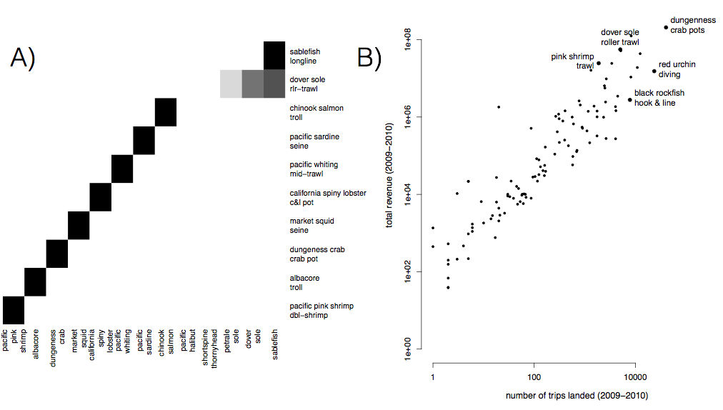

S1: A) Species composition for top ten realized fisheries (rows). Cell color represents the proportion of landings for which each species (column) is responsible. Most of the biggest realized fisheries are composed of primarily a single species, but groundfish trawl is multispecies. B) Comparison of effort and revenue for all realized fisheries between 2009-2010.

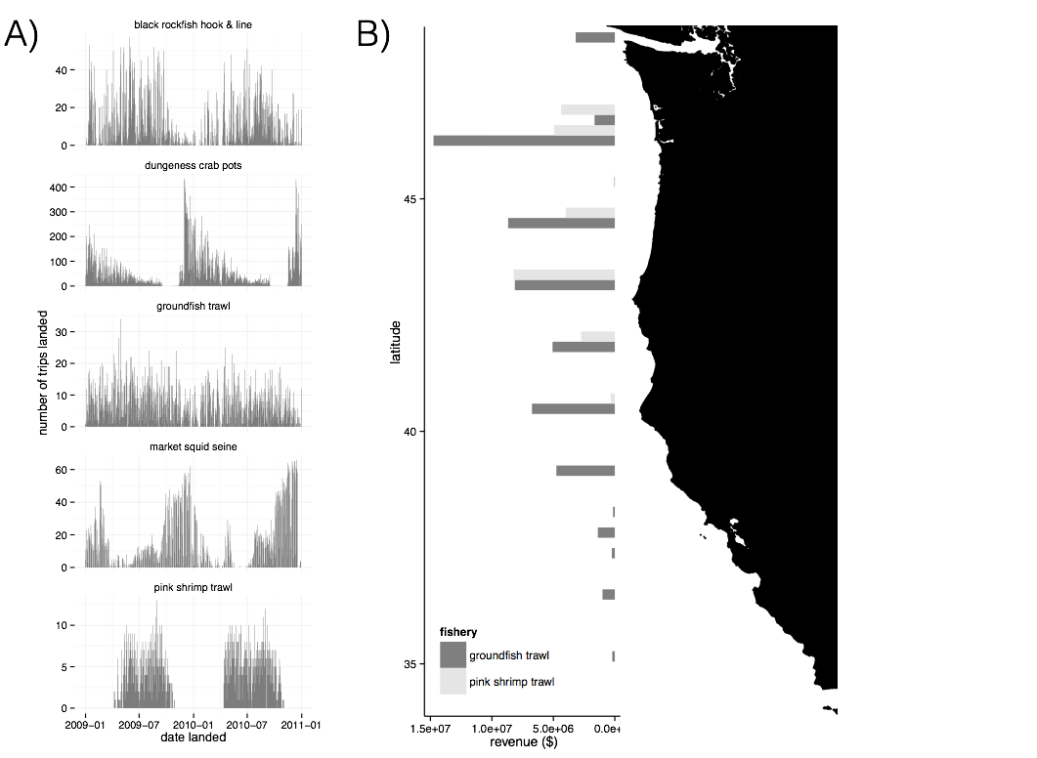

S2: A) Seasonality of five major realized fisheries between 2009-2010. Distinct seasonal patterns are observed in dungeness crab, market squid and pink shrimp fisheries. B) Spatial structure of landings for two example fisheries between 2009-2010. Landings are binned by latitude. Pink shrimp trawl is landed further north, while groundfish trawl landings are distributed more evenly across the coast.

C) Port participation networks

[will be here eventually, makes word document unweildy at the moment, below is one as an example]

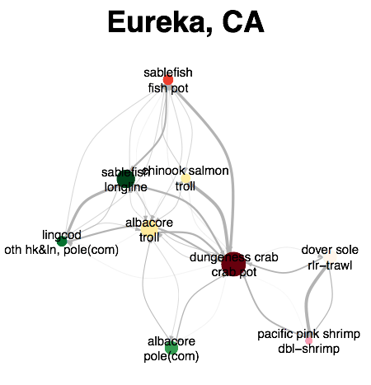

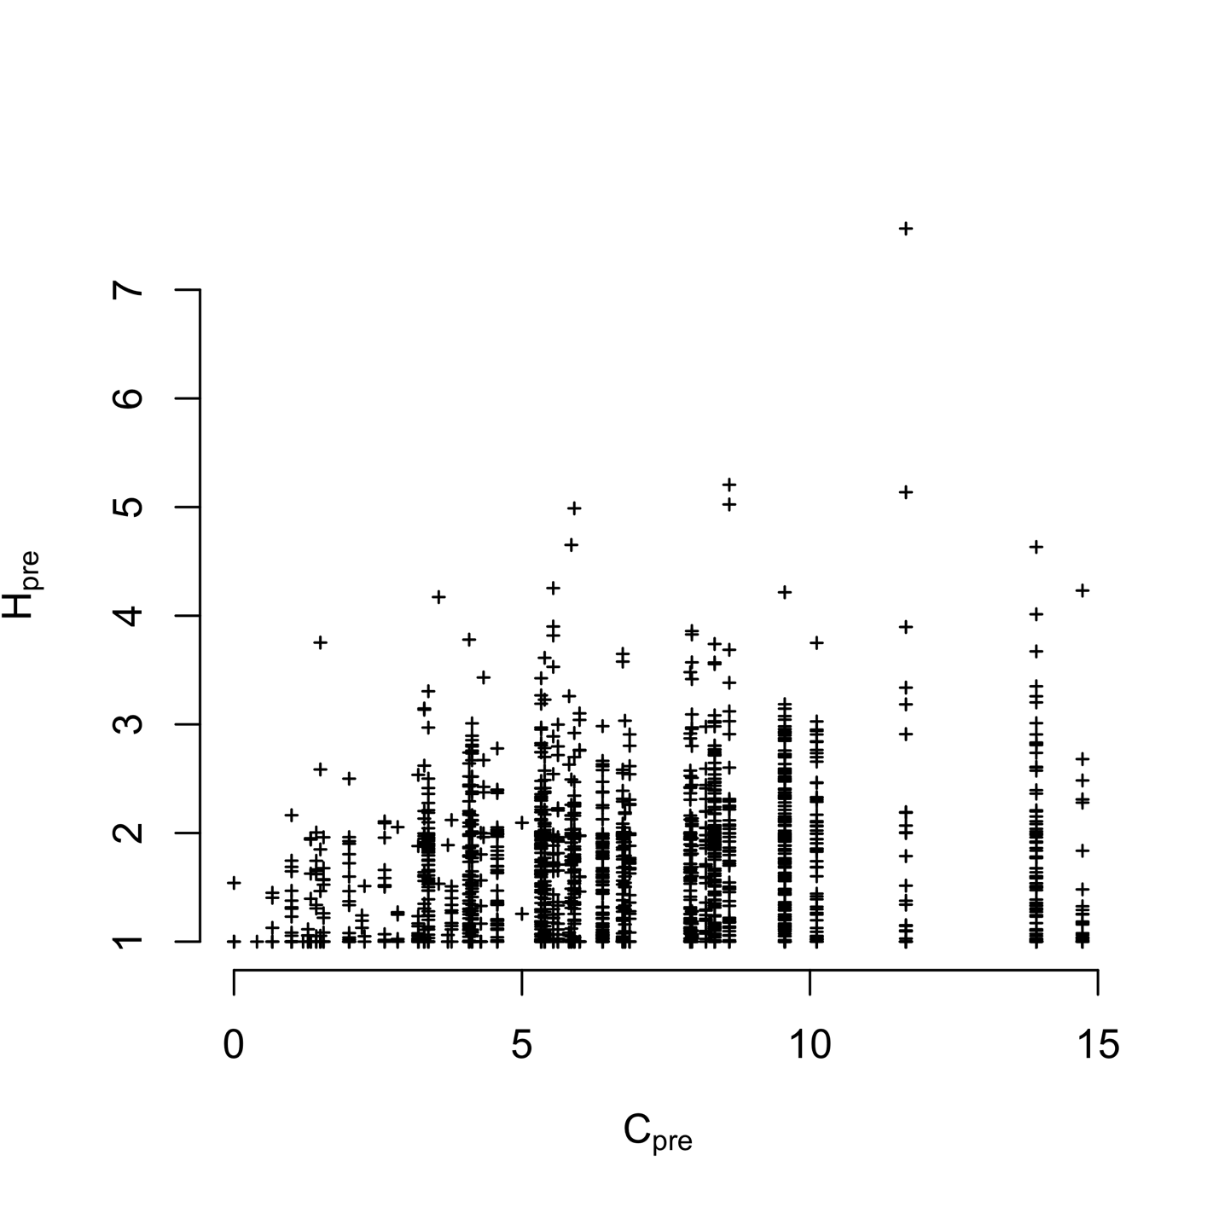S3) Plotting vessel participation diversity (H, 2009-2010) against port connectivity (C, 2009-2010). We find vessel and port level diversity weakly correlated (Spearman’s correlation 0.1849745, p < 2.2e-16). But the most diverse vessels tend to be found in the most diverse ports.

Table S1: Akaike Information Criterion (AIC) values for the models with and without terms for catch shares. Values for the best model at each level are in boldface.

|  |  |  |  |  |  |  |
| --- | --- | --- | --- | --- | --- | --- |
| Level | *Hpre* | Catch shares | No. Parameters (*K*) | AIC | ΔAIC | Adjusted R2 |
| Vessel | Yes | No | 1 | 3140.767 | 30.916 | 0.2392 |
|  | **Yes** | **Yes** | **2** | **3109.851** | **0** | **0.2471** |
|  | No | Yes | 1 | 3643.718 | 533.867 | 0.01007 |
| Port | **Yes** | **No** | **1** | **184.1367** | **0** | **0.8866** |
|  | Yes | Yes | 2 | 186.5804 | 2.4437 | 0.8858 |
|  | No | Yes | 1 | 325.8152 | 141.6785 | 0.2404 |

Table S2: Coefficient values for two best fit models for each scale of analysis

|  |  |  |  |
| --- | --- | --- | --- |
| Level | Variable | Best model | Second best |
| Vessel | *Hpre* | -0.46 (0.02) | -0.46 (0.10) |
|  | General fleet | 0.74 (0.03) | 0.74 (0.03) |
|  | Catch share participant | 0.27 (0.07) | - |
|  | Limited entry exit | -0.24 (0.10) | - |
| Port | *Cpre* | -0.67 (0.03) | -0.66 (0.03) |
|  | General fleet | - | 0.29 (0.27) |
|  | Catch share participant | - | 0.19 (0.28) |
|  | Limited entry exit | - | 0.33 (0.33) |
|  |  |  |  |