Fleet connectivity across West Coast fisheries: quantifying the effect of a management intervention on revenue diversity in an interconnected socioeconomic environment

Emma Fuller, Jameal Samhouri, James Watson, Joshua Stoll

Oct 10, 2015

# Introduction

Ecosystem-based management (EBM) has become the approach du jour of ocean and coastal conservation and stewardship, appearing prominently in an array of highly visible policy documents *(Pew 2003, USCOP 2004, and EO 13547 2010, Australia’s Ocean Policy (DEWR 1998), Canada’s Ocean Act (GC 1996), the European Marine Strategy Framework (EC 2008), and the Convention on Biological Diversity’s Ecosystem Approach (CBD 2000)*. The shift towards EBM is motivated by a combination of real and perceived concerns, including conflict between ocean users (Crowder and Norse 2008), poor coordination across governing bodies (Norse 2010), failure to adequately sustain living marine resources through single-species management (Jackson 2001, Worm et al 2006), and increasing recognition of the complex, non-linear, and coupled human-natural interactions within marine systems (Wilson…). However, despite the increasing emphasis on EBM, the transition from EBM in theory and policy to practice has been slow (Pitcher et al. 2008). This slowness, in part, underscores the technical and scientific challenges that underlie EBM and the uneven, sometimes contradictory, and difficult task of understandings of the social-ecological structure of marine ecosystems (Evans and Klinger 2008).

In the last decade, numerous efforts have been waged to better define (e.g., Slocombe 1998, EPAP 1999, Pikitch et al. 2004, McLeod et al. 2005) and forward EBM (e.g., Curtin and Prellezo 2010, SPC 2010, Heenan et al. 2013, Pomeroy et al. 2013). This progress is often cast as a sharp departure from traditional, single-species management regimes (Chapin et al. 2009), though Link (2002:19) has challenged the “apparent duality” between existing fisheries management and proposed EBM strategies, arguing that there is a “gradient of approaches” along the continuum of management decisions that exist. Aswani et al. (2011:1) offer a similar view, arguing that EBM “is best thought of as an expansion of customary management and integrated coastal management, rather than a paradigm shift.”

Much of the research in this burgeoning domain of science has sought to illuminate the connectivity within and between the biotic and abiotic components of these systems, using sophisticated modeling approaches such as OSMOSE, Ecopath/Ecosim, and Atlantis. For example, the latter is used in the integrated ecosystem assessment (IEA) framework proposed by Levin et al (2009) and adopted by the National Marine Fisheries Service to guide management decisions. Atlantis, like others, can be used to model simple trophic interactions and more highly complex ecological structures (Flower et al. 2013). These efforts represent progress along Link’s conceptual gradient, but focus almost exclusively on the ecological components of these systems, without consideration of the social or economic influences that interact across time and space. Understanding these human interactions therefore represent an important frontier to EBM science.

In this paper we aim to contribute to this gap by presenting an approach for measuring human connectivity of fisheries at individual and community level and use it to evaluate how a change in management affects anthropogenic connectivity in US west coast commercial fisheries. Here we use the implementation of ITQs for the west coast groundfish trawl fishery as a natural experiment to see how it affected communities. Previous work has hypothesized that ITQs will allow vessels to be more flexible, since they face less of an opportunity cost with ITQs. We measured both the individual level of diversity for vessels which fished in the groundfish ITQ fishery before and after ITQ implementation. We also examined the changes in network statistics. By comparing vessel-level changes with those observed in the larger place-based communities, we find evidence that catch shares have increased the diversity of vessel participation, but not affected the connectivity among fisheries at a port level.

**West Coast fisheries as an opportunity to study fleet connectivity**

Fisheries on the west coast of the US are valued at approximately $XX, contributing to the economies of many ports from San Diego, California to Blaine, Washington (ref). XX, XX, and XX account for XX% of the total ex-vessel value of these fisheries, but at least XX species are harvested commercially. These fisheries are managed by multiple and interlinked state, inter-state, and national agencies that share responsibility for balancing different socioeconomic and stewardship objectives across multiple and interrelated spatial and temporal scales. This dynamic has resulted in a highly heterogeneous governance regime in which the specific management strategies used across fisheries is highly variable, as are the socioeconomic and ecological outcomes that have emerged (ref). For instance, in the dungeness crab fishery, the commercial fishing fleet is managed by way of parametric measures in which … In contrast, managers have taken a markets-based strategy to govern XX, which has resulted in ….

In practice, these management strategies act to influence the fisheries that they are applied to as well as those that they are connected to in some way. This connectivity can represent an ecological link (e.g., in instances where the target species is a part of a broader food web) or a socioeconomic coupling (e.g., in instances where a fisher harvests multiple species). Both are important, but relatively limited empirical research has investigated how socioeconomic components of marine systems are connected. This is particularly important on the west coast where more than 60% of fishers participate in multiple fisheries, whereby creating direct links between fisheries and the management interventions that are used.

In this paper, we aim to bring attention to the socioeconomic connectivity of fisheries on the west coast by examining how the implementation of an individual transferable quota system (ITQ) in the Pacific Trawl Rationalization program for the trawl fishery on the west coast of the US reverberated through the fishing fleet and how it has ultimately influenced revenue diversification.

# Methods

We examined how participation across fisheries changed before and after catch share implementation in the groundfish trawl fishery in 2011 at both the individual commercial fishing vessel and port levels. Using vessel-level landings data we classified landings into realized fisheries via a métier analysis, and used these fisheries designations to characterize vessels' participation in fisheries before and after the implementation of catch shares. For each port, we also compared participation networks before and after catch shares. All analyses are performed using R (R Core Team 2015) unless otherwise noted.

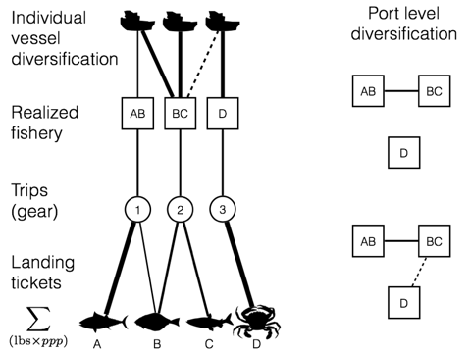

Figure 1: We use landings data to calculate the participation diversity of US west coast vessels and ports. At the vessel level, participation diversity is an index, which measures the number of fisheries a vessel participates is weighted by the evenness of revenue derived. At a port level participation diversity is measured by the number of realized fisheries, which are landed and how connected they are by vessel’s participation.

## Data

Fisheries landings data came from the Pacific Fishery Information Network database (PacFIN 2014), and include commercial landings from all vessels fishing in the US Exclusive Economic Zone (EEZ) off the US west coast between 2009 and 2013. Landings receipts report the pounds of fish landed by market category. These market categories are approximately equivalent to species-level identification, although not exact. Rockfish are most likely an approximation, as species are often difficult to distinguish. However, the bigger the price differential between species, the more accurate the market categories.[1] Thus in the following work we assumed that vessels are targeting market categories, rather than species, as that is the economically relevant determination.

For each market category, landing tickets report price per pound, date, port of landing, and vessel identifying information. After adjusting for inflation using the 2009 Consumer Price Index, we calculated vessel revenues by multiplying the price per pound by the number of pounds landed.[2]

## Realized Fisheries

We define a realized fishery as a gear-type targeting a coherent species assemblage (Putten et al. 2011). The Pacific Management Council has developed a set of sector based definitions similar to this approach for the federally managed groundfish landings, but no equivalent exists for non-groundfish fisheries. In order to treat the landings dataset uniformly, we apply a metier analysis to this landing data (Deporte et al. 2012). Métier analyses bin trips based on gear employed and use a clustering method to find combinations of species commonly caught together. We follow this broad outline with some modifications, which are explained below.

Clustering methods seek to find natural breaks in multivariate data by constructing groups which are the most similar (or least dissimilar) to one another. There exist a wide range of measures of similarity, here we use the Hellinger distance () to calculate a pairwise distance for each trip’s revenue composition within a gear/year subset. This metric has the advantage of avoiding the double-zero problem common in species count data and retains statistical properties of raw species-abundance data (Legendre and Legendre 2012). Using the same notation as Legendre and Gallagher (2001), we consider a species abundance data table of size () with catches (rows) and species (columns) . Here row (catch) sums are noted as and column (species) sums as with the overall sum being . Here, because species are weighted by revenue, species that generate more revenue more important in calculating distances and devalue incidental catch (often valued at or close to zero). The Hellinger distance between two landings represented by vectors of species revenues and is defined as

This distance ranges between zero and , with zero meaning the sites have identical compositions and meaning they share no species.

To find target assemblages, we cluster species composition of landings, weighted by revenue. There exists a number methods by which to find characteristic assemblages in data, and previous métier analyses have used a variety of clustering algorithms including k-means (Lucey and Fogarty 2013), hierarchical algomorative clustering (Deporte et al. 2012), and hierarchical ascending classification (Pelletier and Ferraris 2000). Catch data is a high dimensional dataset, due to the fact that a single groundfish trawl can bring in > 20 species. Because these clustering methods do poorly with high-dimensional data [CITE], dimensionality reducing approaches in the form of PCAs are often applied prior to the clustering step.

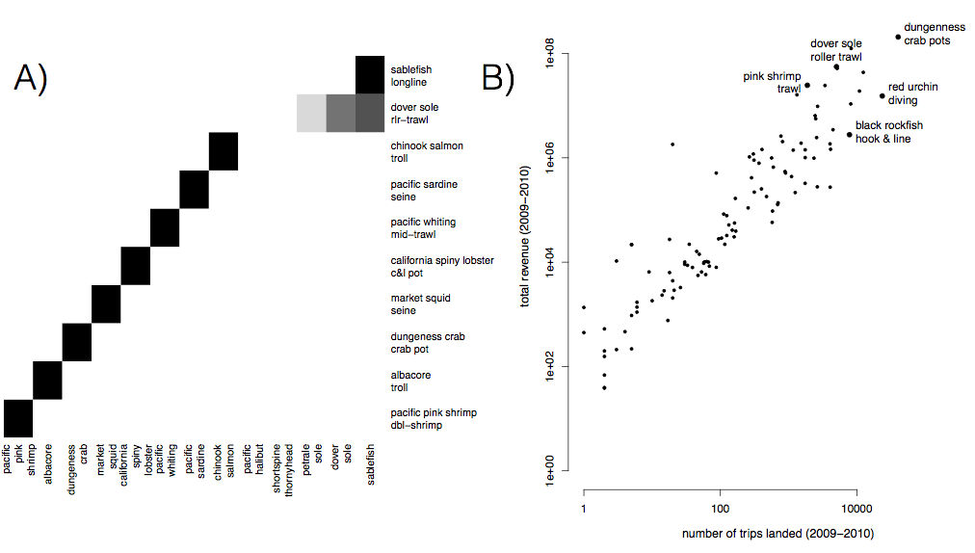

Figure 2: A) Realized fisheries are often distinguished by a single species (i.e. pink shrimp) but can also characterized by assemblages of species (dover sole roller trawl). Here we plot the top ten realized fisheries by revenue on the US west coast with the darkness of the cell proportional to the relative proportion of revenue due to each species. Eight of these fisheries are characterized by a single species, while dover sole roller trawl and sablefish long line is characterized by multiple species. B) The realized fisheries vary by an order of magnitude in effort and revenue.

Because our goal is to develop a single analysis pipeline to classify fisheries coast-wide (rather than within a multi-species sector as has been done previously), our dimensionality was three times the dimensionality of previously analyzed landings data. With this degree of complexity in our data, ordination techniques were not sufficient to reduce the data to two to three principal axes for which k-means and hierarchical clustering do best. To address these challenges we used the infoMap algorithm. infoMap is an information theoretic approach, which uses the probability flow of a random walker on a network as a proxy for the information flows in a real system. The objective of infoMap is to compress the description of the probability flow, and in doing so partitions the network into modules. infoMap works by computing the fraction of time a node is visited by a random walker. Merges between modules that give the largest decrease in description length are made until further merging leads to increases of description length. Results are refined with a simulated annealing approach, starting at several different temperatures, with the run selected as the one that gives the shortest description of the network.

To use infoMap, we transform the dissimilarity index to be a measure of similarity

and build an undirected, weighted network in which nodes are trips, and edge widths are the similarity in species composition between trips.[3] This allows a vessel to be represented in multiple nodes if it makes trips that vary substantially in catch composition.

Because we are calculating pair-wise distances between trips, a distance matrix of all trips becomes intractable quickly, and we are unable to construct a single distance matrix which contains the pairwise distances of all trips. Instead we use 2010 as the base-year, making the assumption that all fisheries present in the time period of our data (2009-2013) are landed in 2010, although we also complete the analysis using 2012 as the base year and find no substantial difference in classification (see Appendix). To reduce the size of the distance matrices we split the trips by gear type (using PacFIN grgroups designation, see table below).

Table 1: PacFin gear groups, participation, and descriptions for US west coast landings data 2009-2013

|  |  |  |  |
| --- | --- | --- | --- |
| gear.group | n.vessels | n.trips | description |
| tls | 2642 | 59228 | troll gear |
| hkl | 2266 | 85776 | hook and line gear except troll |
| pot | 1797 | 170870 | pot and trap gear |
| msc | 1104 | 84261 | other miscellaneous gear |
| net | 489 | 45724 | net gear except trawl |
| twl | 304 | 25577 | trawls except shrimp trawls |
| tws | 157 | 10568 | shrimp trawls |

We used a k-nearest-neighbor (knn) classifier using a single nearest neighbor to assign all other trips of each gear subset to those possible métiers. The nearest neighbor to each trip was found using the Hellinger distance defined above.

In our analysis temporal and spatial structure emerges from the data, and we are able to recover the commonly recognized major fisheries and their seasonality, along with more spatially and temporally restricted fisheries.

In these fisheries we see the expected seasonality, suggesting that the unsupervised classification of landings into realized fisheries accurately reflects the fisheries present on the west coast. This is a useful complement to previous analyses since it largely validates the species groups used to define fisheries. There are some improvements offered in this approach, namely that it can distinguish between fisheries targeting the same species in different ways (i.e. there is a long line, pot and trawl fishery for sablefish), adds important targeted fisheries previously overlooked (e.g. lingcod) and adds some nuance to more regional, state-managed fisheries: i.e. finds a spiny-lobster fishery, red urchin fishery, along with a number of nearshore rockfish realized fisheries (e.g one dominated by lingcod), all of which are restricted to California. Our methods have the additional benefit of only requiring the catch composition of trips, making it possible to integrate data from both state and federal management databases which lack consistent permitting data across states. See the appendix for a full list of realized fisheries.

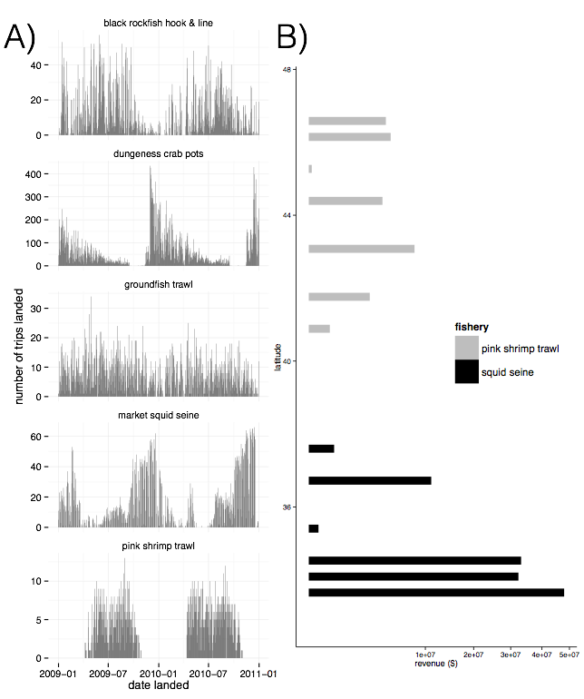

Figure 3: A) These fisheries demonstrate different levels of temporal structure: they vary from strictly seasonal (i.e. pink shrimp trawl) to year round (groundfish trawl). B) These fisheries also exhibit varying degrees of spatial structure, here we plot two realized fisheries as examples highlighting how spatially disaggregated they can be.

## Measuring Diversity

To determine whether catch shares affects the extent of fisheries diversification on the US west coast, we develop two methods: one at the vessel level and the second at the port level.

### Vessel Level

To measure the change in the number of fisheries a vessel participates in we calculate the effective Shannon index (Jost 2006) for each vessel each year, such that the number of métiers and the amount of revenue represented by each métier together determine a vessel’s diversification. Here then the diversity () for a single vessel is

where is the total number of fisheries and is the proprotion of total revenue a total vessel obtained for fishery in some time period. Thus the effective Shannon index of revenue diversity reflects both the number of fisheries in which a vessel participates, but also the evenness with which a vessel's effort is spread.

We measure the change in diversity as the the difference between pre- (2009-2010) and post- (2012-2013) revenue diversity for each vessel. Participation in catch shares is defined as the presence of any landing using quota in the period 2012-2013. We restricted this analysis to vessels which have have an average annual revenue of more than $5000 (adjusted for 2009 dollars) across this five year period and had commercial landings before and after the implementation of catch shares in 2011. This leaves us with 2151 vessels which are responsible for 88% of total revenue and 89% landings of landed commercial catch over the examined time period (2009, 2010, 2012, 2013).

A feature of our response variable is that we expect a relationship between pre-catch shares diversity and the change in diversity. With some random fluctuation, we expect a negative relationship between the revenue diversity in the first time step and revenue diversit. Thus we fit a linear regression which includes revenue diversity prior to catch shares, and a dummy variable for IFQ participation.

Where is the change in participation diversity of vessel's fishery landings, is a dummy variable for participation in catch shares, and is the participation diversity pre-catch shares, is the error term which we assume is IID.

Catch share presence is defined as the presence of any vessel using catch share quota to land at the port in the period 2012-2013.

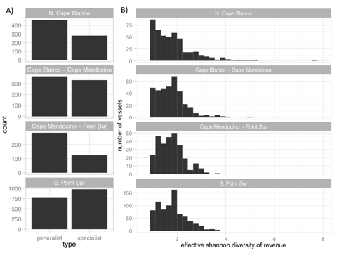

Figure 4: A) For three out of the four management regions on the west coast, generalists (vessels which land > 1 realized fishery) outnumber the specialists (vessels which land in a single realized fishery). B) The distribution of diversity varies among the generalists, from vessels that are highly specialized by have a few landings in additional fisheries (to left) to those that fish in many fisheries evenly (to right).

### Port level

Here each node is a realized fishery. The width of the edges are proportional to the number of vessels which participate in both fisheries. Thus wide edges are fisheries that have vessels moving back and forth between them while thin/absent edges mean these fisheries have few/no vessels in common. As with the realized fisheries, the width of the edges is calculated as the Hellinger similarity between the fleet (i.e. vessel) composition in each of the two connected fisheries. 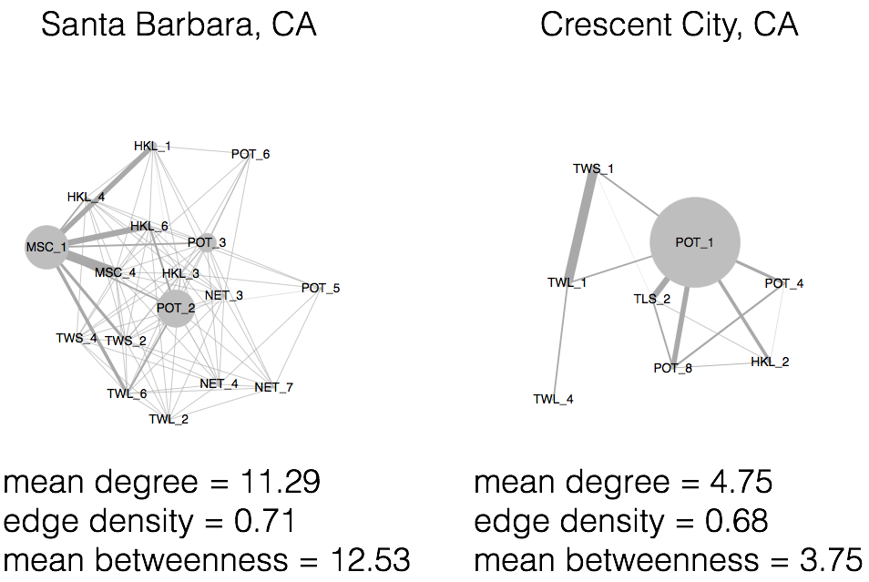

Figure 5:: Fig Examples of port level participation networks. Here nodes represent a realized fishery, and strength of connections between nodes represent the number of vessels which land both of these fisheries. We measure the diversity of these port participation networks by using measures of the the interconnectedness of these networks.

These networks allow the application of existing network statistics to characterize how participation varies across communities of fishers. In this case, we consider the port the unit of community, based in part on the previous work NOAA has done in characterizing port communities.

We measure community diversity as mean degree of the network. This measure has the benefit of being simple, but reflecting both the total number of fisheries (nodes) that are landed at a given port, and the connectivity between them. Thus to calculate the change in mean degree of a port's participation network we use landings in the period pre- (2009-2010) and post-catch shares (2012-2013) to construct two networks for each plot, calculate the mean degree, and take the difference. In our data, landings were reported at 85, however 9 ports did not have landings before and/or after 2011 to be able to compare the change in port level revenue diversity. We report the results for the remaining 76 ports below. The linear regression fit is identical to that at the vessel level, although the units become ports rather than vessels and catch shares is defined as a port which has quota landed in the period 2012-2013.

# Results

## Impacts of management change

At a vessel level, we find revenue diversity prior to catch share implementation to be strongly related to the change in revenue diversity, revenue diversity prior to 2011 negatively related to the change in diversity between the two time periods (p value 0)

Most vessels declined in revenue diversity between our pre and post periods. However wWe find that vessels which participated in catch shares are associated with a smaller decline on average than those that did not.



Figure 6: We find that a vessel’s participation in IFQs is significantly associated with an increase in revenue diversity. At the port level, we find no indication that IFQ landings affect interconnectedness of fisheries.

We find that a model including an effect for IFQ participation improves the fit (AIC = 13.45).

At the community level we find no evidence to suggest that ports which have catch share quota landed at them become more diverse after catch shares.

# Discussion

We might not expect that degree distributions would change as result of increasing vessel switching. The fact that we do not see an effect of IFQs might indicate that the increased diversity of vessels are occuring not because vessels are entering new fisheries (and thus creating new connections between fisheries) but instead evening their participaton across the fisheries in which these vessels already participate.

# 

# Appendix

## Using 2012 as a base year

To check whether our metier designations were sensitive to the year used to train the k-nearest-neighbors classifier we trained the knn classifier on years before (2010) and after (2012) ITQ implementation. To check agreement between partition results, we used the adjusted Rand index (ARI) (Rand 1971). The Rand index measures the accuracy of the partitions, and weights equally false positives and false negatives. The Rand index is calculated as

where can be considered as the number of agreements between the two partititions, and as the number of disagreements between the partitions. The Rand index can take a value between zero and one, with indicating the partitions are identical. The Rand index does not take into account the possibility that agreements happen between the two partitions due to chance (i.e. the expected of a randomly partitioned dataset is not zero), and as the number of clusters increases approaches one. The adjusted Rand index () has been proposed to address these limitations (Hubert and Arabie 1985) and is calculated as

I calculated the adjusted Rand Index using the R library mclust, function adjustedRandIndex() overall and then for each gear group and each year that wasn't trained (2009, 2011, 2013). Results are as follows.

Agreement between training sets are high, across all data 0.97. Breaking it down by gear-type, almost all gears have very close agreement with the exception of the hook and line gear group (HKL).

|  |  |  |  |  |  |
| --- | --- | --- | --- | --- | --- |
|  | y2009 | y2010 | y2011 | y2012 | y2013 |
| **TLS** | 0.9974 | 0.9962 | 0.9953 | 0.9952 | 0.9953 |
| **TWL** | 0.9653 | 0.9792 | 0.9654 | 0.9598 | 0.9878 |
| **TWS** | 0.9388 | 0.9882 | 0.974 | 0.9912 | 0.982 |
| **NET** | 0.9775 | 0.9898 | 0.9713 | 0.9838 | 0.95 |
| **POT** | 0.996 | 0.9967 | 0.9967 | 0.9962 | 0.9971 |
| **HKL** | 0.6301 | 0.6976 | 0.6014 | 0.5297 | 0.4508 |
| **MSC** | 0.9983 | 0.9969 | 0.998 | 0.9967 | 0.9989 |

Examining hook-and-line in detail we plot the agreement between classifications and find the main source of disagreement is limited to a few fisheries. Here base years 2012 is along the top and 2010 based classifications are along the bottom. The width of the connection is proportional to the number of trips, and any connections representing fewer than 5 trips have been removed for visual clarity.

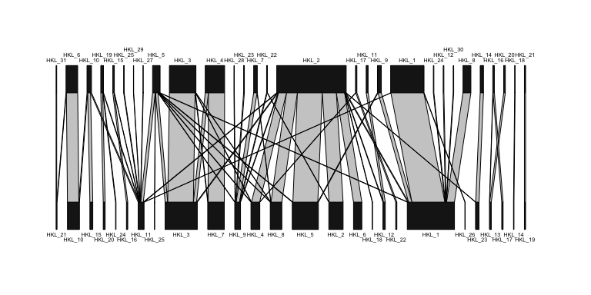

Here we see the difference is driven largely by two groups of fisheries: metier HKL_2 in 2012 grouping together several fisheries that are found when using 2010 based landings and by HKL_1 from 2010 grouping together HKL_1 and HKL_8 from 2012.

Examining these subsets independently, we find that all these fisheries appear distinct (i.e. a non-random collection of species targeted). We plot these below, but briefly those landings that were classified as HKL_2 in 2012 but

* and are HKL_2 in 2010, represent largely black rockfish
* are HKL_6 in 2010 (bottom) are landings largely dominated by grass rockfish, cabezon, and black and yellow rockfish
* are HKL_4 in 2010
* classified as HKL_2 in both classifications are dominated by black rockfish

Despite these differences using the 2012 derived realized fisheries we find similar results, the diversity measures are highly correlated with one another. 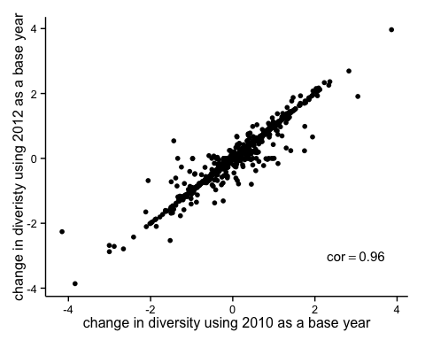

When fitting the model using 2012 realized fisheries, we find the order and magnitude of effects matching and a similar improvement in model fit.

lm3 = lm(delta.eff.shannon_2012 ~ eff.shannon_2012, sub_data)  
summary(lm3)

##   
## Call:  
## lm(formula = delta.eff.shannon_2012 ~ eff.shannon_2012, data = sub_data)  
##   
## Residuals:  
## Min 1Q Median 3Q Max   
## -1.9977 -0.3826 -0.0967 0.3131 3.7828   
##   
## Coefficients:  
## Estimate Std. Error t value Pr(>|t|)   
## (Intercept) 0.93788 0.03473 27.01 <2e-16 ***  
## eff.shannon_2012 -0.55533 0.02000 -27.77 <2e-16 ***  
## ---  
## Signif. codes: 0 '***' 0.001 '**' 0.01 '*' 0.05 '.' 0.1 ' ' 1  
##   
## Residual standard error: 0.5491 on 1754 degrees of freedom  
## Multiple R-squared: 0.3054, Adjusted R-squared: 0.305   
## F-statistic: 771.2 on 1 and 1754 DF, p-value: < 2.2e-16

lm4 = lm(delta.eff.shannon_2012 ~ eff.shannon_2012 + ifq, sub_data)  
summary(lm4)

##   
## Call:  
## lm(formula = delta.eff.shannon_2012 ~ eff.shannon_2012 + ifq,   
## data = sub_data)  
##   
## Residuals:  
## Min 1Q Median 3Q Max   
## -1.9707 -0.3740 -0.0972 0.3037 3.7930   
##   
## Coefficients:  
## Estimate Std. Error t value Pr(>|t|)   
## (Intercept) 0.93388 0.03460 26.994 < 2e-16 ***  
## eff.shannon_2012 -0.55990 0.01995 -28.071 < 2e-16 ***  
## ifq1 0.24941 0.06268 3.979 7.2e-05 ***  
## ---  
## Signif. codes: 0 '***' 0.001 '**' 0.01 '*' 0.05 '.' 0.1 ' ' 1  
##   
## Residual standard error: 0.5468 on 1753 degrees of freedom  
## Multiple R-squared: 0.3116, Adjusted R-squared: 0.3108   
## F-statistic: 396.8 on 2 and 1753 DF, p-value: < 2.2e-16

AIC(lm3) - AIC(lm4)

## [1] 13.78802

## 

## Ports evaluated

# will add port, state, percentage of revenue/lbs landed in time period, and list those ports that we excluded

## 

## Realized Fisheries

|  |  |  |  |  |  |  |  |  |
| --- | --- | --- | --- | --- | --- | --- | --- | --- |
| Metier | Major_species | Major_gear | CA | OR | WA | number_trips | multi_species | number_vessels |
| pot_1 | dungeness crab | crab pot | 46 | 22 | 31 | 108963 | no | 1271 |
| msc_1 | red sea urchin | diving gr | 76 | 24 | NA | 59117 | no | 250 |
| tls_1 | chinook salmon | troll | 49 | 25 | 26 | 44757 | no | 1951 |
| pot_2 | california spiny lobster | c&l pot | 100 | NA | NA | 28846 | no | 257 |
| hkl_1 | sablefish | longline | 61 | 17 | 22 | 27660 | no | 843 |
| net_1 | market squid | seine | 100 | NA | NA | 20343 | no | 155 |
| hkl_2 | black rockfish | oth hk&ln | 67 | 33 | NA | 18437 | no | 351 |
| tls_2 | albacore | troll | 43 | 25 | 31 | 13879 | no | 1268 |
| pot_3 | rock crab | c&l pot | 97 | 3 | NA | 12049 | no | 216 |
| hkl_4 | brown rockfish, gopher rockfish | pole(com) | 93 | 7 | NA | 10234 | yes | 200 |
| hkl_3 | california halibut | pole(com) | 100 | NA | NA | 9398 | no | 638 |
| twl_1 | dover sole | rlr-trawl | 55 | 23 | 23 | 8766 | no | 168 |
| net_2 | pacific sardine | seine | 70 | 15 | 15 | 7649 | no | 123 |
| msc_2 | razor clam | oth-known | NA | 100 | NA | 7397 | no | 309 |
| tws_1 | pacific pink shrimp | dbl-shrimp | 20 | 50 | 30 | 6212 | no | 105 |
| pot_5 | spotted prawn | prwn trap | 81 | NA | 19 | 5819 | no | 37 |
| msc_3 | ghost shrimp | oth-known | NA | 100 | NA | 5645 | no | 144 |
| pot_6 | unsp. hagfish | fish pot | 51 | 17 | 31 | 5644 | no | 141 |
| hkl_5 | lingcod | oth hk&ln, pole(com) | 63 | 24 | 14 | 5503 | no | 619 |
| pot_4 | sablefish | fish pot | 61 | 24 | 15 | 5466 | no | 289 |
| net_3 | california halibut | gill net | 100 | NA | NA | 4940 | no | 63 |
| twl_2 | california halibut | gftrawl<8 | 100 | NA | NA | 4726 | no | 58 |
| hkl_6 | black-and-yellow rockfish, cabezon, grass rockfish | pole(com), vrtcl hkl | 74 | 26 | NA | 4617 | yes | 202 |
| msc_4 | unsp. sea cucumbers | diving gr | 95 | 5 | NA | 4396 | no | 96 |
| twl_4 | pacific whiting | mid-trawl | 29 | 43 | 29 | 4126 | no | 60 |
| net_5 | pacific herring | gill net | 71 | 3 | 26 | 3482 | no | 203 |
| hkl_7 | white seabass | pole(com) | 100 | NA | NA | 3406 | no | 397 |
| net_4 | white seabass | gill net | 100 | NA | NA | 3310 | no | 53 |
| msc_5 | basket cockle | oth-known | 62 | 35 | 4 | 2994 | no | 238 |
| twl_3 | chinook salmon | mid-trawl | 64 | 20 | 16 | 2789 | yes | 147 |
| twl_5 | unsp. bait shrimp | beam trawl | 100 | NA | NA | 2384 | no | 10 |
| tws_2 | ridgeback prawn | sgl-shrimp | 85 | NA | 15 | 2210 | no | 25 |
| twl_6 | unsp. sea cucumbers | gfsh-trawl | 100 | NA | NA | 2108 | no | 48 |
| hkl_8 | vermilion rockfish | pole(com) | 78 | 20 | 2 | 1912 | no | 268 |
| hkl_9 | unsp. sanddabs | pole(com) | 96 | NA | 4 | 1530 | no | 125 |
| net_7 | swordfish, common thresher shark | drf gl net | 100 | NA | NA | 1510 | yes | 84 |
| net_6 | unsp. shad | dip net | 100 | NA | NA | 1363 | no | 10 |
| net_8 | chub mackerel | dip net | 90 | 10 | NA | 1286 | no | 52 |
| tws_3 | california halibut, hornyhead turbot | sgl-shrimp | 69 | 23 | 8 | 1244 | yes | 43 |
| pot_8 | other shrimp | prwn trap | 67 | 33 | NA | 1194 | no | 33 |
| net_9 | northern anchovy | seine | 81 | 6 | 12 | 1180 | no | 47 |
| msc_7 | dungeness crab | oth-known | 17 | 83 | NA | 1108 | no | 98 |
| pot_11 | cabezon, gopher rockfish | fish pot | 80 | 20 | NA | 1050 | yes | 69 |
| msc_6 | unsp. bait shrimp | oth-known | 20 | NA | 80 | 938 | no | 12 |
| hkl_10 | albacore | pole(com) | 91 | 3 | 6 | 788 | no | 289 |
| pot_9 | california sheephead | fish pot | 100 | NA | NA | 716 | no | 40 |
| twl_7 | yellowtail rockfish | mid-trawl | NA | 33 | 67 | 678 | no | 83 |
| msc_11 | gaper clam | oth-known | NA | 100 | NA | 645 | no | 33 |
| msc_8 | swordfish | oth-known | 100 | NA | NA | 516 | no | 35 |
| msc_9 | unsp. mollusks | diving gr | 78 | 22 | NA | 471 | no | 11 |
| tws_7 | unsp. bait shrimp | sgl-shrimp | 100 | NA | NA | 402 | no | 3 |
| hkl_12 | california sheephead | pole(com) | 88 | 12 | NA | 375 | no | 53 |
| pot_10 | other crab | c&l pot | 89 | 11 | NA | 372 | no | 84 |
| msc_10 | other sea urchins | diving gr | 71 | 29 | NA | 345 | no | 48 |
| pot_7 | dungeness crab, rock crab | c&l pot, fish pot | 65 | 19 | 16 | 339 | yes | 173 |
| tws_4 | unsp. sea cucumbers | sgl-shrimp | 100 | NA | NA | 324 | no | 20 |
| hkl_11 |  | pole(com) | 70 | 22 | 8 | 288 | yes | 144 |
| msc_14 | butter clam | oth-known | NA | 100 | NA | 272 | no | 30 |
| hkl_16 | surfperch spp. | pole(com) | 100 | NA | NA | 262 | no | 32 |
| hkl_15 | yellowtail | pole(com) | 100 | NA | NA | 235 | no | 71 |
| pot_12 | other mollusks | c&l pot | 100 | NA | NA | 228 | no | 58 |
| tls_5 | california halibut | troll | 100 | NA | NA | 227 | no | 53 |
| hkl_13 | common thresher shark | pole(com) | 100 | NA | NA | 215 | no | 48 |
| net_13 | pacific barracuda | drf gl net | 100 | NA | NA | 210 | no | 16 |
| net_12 | other crab | gill net | 100 | NA | NA | 194 | no | 16 |
| hkl_14 | unsp. smelt | pole(com) | 100 | NA | NA | 173 | no | 13 |
| net_10 | sockeye salmon | gill net | NA | NA | 100 | 156 | no | 37 |
| hkl_23 | chinook salmon | pole(com) | 89 | NA | 11 | 155 | no | 82 |
| msc_13 | blue mud shrimp | oth-known | NA | 100 | NA | 153 | no | 22 |
| pot_13 | unsp. octopus | crab pot | 60 | 33 | 7 | 149 | no | 73 |
| hkl_17 | shortfin mako shark | pole(com) | 100 | NA | NA | 146 | no | 34 |
| tls_3 | chinook salmon | troll | 53 | 17 | 30 | 142 | yes | 95 |
| tls_8 | lingcod | troll | 47 | 41 | 12 | 104 | no | 62 |
| hkl_22 | unsp. reds rckfsh | pole(com) | 100 | NA | NA | 99 | no | 29 |
| net_14 | chinook salmon | set net | 40 | NA | 60 | 87 | no | 26 |
| tws_6 | unsp. flatfish | sgl-shrimp | 100 | NA | NA | 83 | no | 7 |
| hkl_18 | unsp. shelf rockfish | pole(com) | 100 | NA | NA | 82 | no | 6 |
| msc_15 | rock crab | oth-known | 50 | 50 | NA | 80 | no | 16 |
| hkl_20 | pacific barracuda | pole(com) | 100 | NA | NA | 78 | no | 47 |
| msc_16 | other mollusks | diving gr | 100 | NA | NA | 70 | no | 26 |
| hkl_19 | leopard shark | pole(com) | 100 | NA | NA | 67 | no | 29 |
| hkl_21 | swordfish | longline | 100 | NA | NA | 57 | no | 15 |
| tls_6 | yellowtail rockfish | troll | 33 | 33 | 33 | 48 | no | 30 |
| hkl_24 | unsp. squid | longline, oth hk&ln, pole(com) | 73 | 27 | NA | 43 | no | 14 |
| pot_14 | unsp. eels | fish pot | 100 | NA | NA | 35 | no | 12 |
| tws_10 | other crab, rock crab | sgl-shrimp | 100 | NA | NA | 34 | yes | 10 |
| msc_18 | california sheephead | diving gr | 100 | NA | NA | 27 | no | 6 |
| tls_10 | sablefish | troll | 64 | NA | 36 | 27 | no | 22 |
| tws_9 | other skates | sgl-shrimp | 100 | NA | NA | 26 | no | 7 |
| tws_8 | other shrimp | sgl-shrimp | 100 | NA | NA | 23 | no | 3 |
| msc_17 | black-and-yellow rockfish | diving gr | 100 | NA | NA | 22 | no | 6 |
| tls_4 | albacore | troll | 47 | 20 | 33 | 20 | no | 20 |
| msc_12 | unsp. sea cucumbers | diving gr | 100 | NA | NA | 18 | no | 7 |
| tls_7 | white seabass | troll | 100 | NA | NA | 18 | no | 7 |
| msc_23 | unsp. flatfish | diving gr | 100 | NA | NA | 17 | no | 6 |
| net_11 | pacific sardine | seine | 100 | NA | NA | 14 | no | 10 |
| msc_19 | unsp. shad | unkn-gear | 100 | NA | NA | 10 | no | 2 |
| msc_22 | shortfin mako shark | oth-known | 100 | NA | NA | 10 | no | 7 |
| hkl_25 | unsp. octopus | longline, oth hk&ln, pole(com) | 25 | 75 | NA | 8 | no | 6 |
| msc_20 | unsp. eels, misc. fish | diving gr | 80 | 20 | NA | 8 | yes | 6 |
| hkl_26 | nor. unsp. shelf rockfish | longline, oth hk&ln | NA | 67 | 33 | 6 | no | 5 |
| tws_5 | hornyhead turbot, ridgeback prawn, unsp. hagfish | sgl-shrimp | 100 | NA | NA | 4 | yes | 3 |
| tls_11 | yellowtail | troll | NA | 100 | NA | 3 | no | 3 |
| tls_9 | nor. unsp. shelf rockfish | troll | NA | 50 | 50 | 3 | no | 3 |
| tws_11 | white seabass | sgl-shrimp | 100 | NA | NA | 3 | no | 2 |
| tws_12 | vermilion rockfish | sgl-shrimp | 100 | NA | NA | 3 | no | 2 |
| hkl_27 | pacific angel shark | pole(com) | 100 | NA | NA | 2 | no | 2 |
| msc_21 | other crab | oth-known | NA | 100 | NA | 2 | no | 1 |

# References

Deporte, N., C. Ulrich, S. Mahevas, S. Demaneche, and F. Bastardie. 2012. Regional metier definition: a comparative investigation of statistical methods using a workflow applied to international otter trawl fisheries in the North Sea. ICES Journal of Marine Science 69:331–342.

Hubert, L., and P. Arabie. 1985. Comparing partitions. Journal of classification 2:193–218.

Jost, L. 2006. Entropy and diversity. Oikos 113:363–375.

Legendre, P., and E. D. Gallagher. 2001. Ecologically meaningful transformations for ordination of species data. Oecologia 129:271–280.

Legendre, P., and L. Legendre. 2012. Numerical ecology. Developments in environmental modelling. Elsevier.

Lucey, S. M., and M. J. Fogarty. 2013. Operational fisheries in New England: Linking current fishing patterns to proposed ecological production units. Fisheries Research.

PacFIN. 2014. Pacific Fisheries Information Network retrieval dated 2014-07-09. Pacific States Marine Fisheries Commission, Portland, Oregon (www.psmfc.org).

Pelletier, D., and J. Ferraris. 2000. A multivariate approach for defining fishing tactics from commercial catch and effort data. Canadian Journal of Fisheries and Aquatic Sciences 57:51–65.

Putten, I. E. van, S. Kulmala, O. Thébaud, N. Dowling, K. G. Hamon, T. Hutton, and S. Pascoe. 2011. Theories and behavioural drivers underlying fleet dynamics models. Fish and Fisheries 13:216–235.

R Core Team. 2015. R: A language and environment for statistical computing. R Foundation for Statistical Computing, Vienna, Austria.

Rand, W. M. 1971. Objective criteria for the evaluation of clustering methods. Journal of the American Statistical association 66:846–850.

1. Personal communication from Brad Stenberg
2. Revenue = ppp*landed_wt
3. although technically I make any similarity into . We get very small negative numbers (i.e. ) due to rounding errors. See [here](http://stackoverflow.com/questions/19444674/approximation-rounding-errors-in-r-in-simple-situations) for some explanation of rounding errors in R.