Title:

Human Connectivity in Social-Ecological Systems

**Authors:** Emma Fuller1*, Jameal F. Samhouri2, Josh Stoll3, James R. Watson4, Simon Levin1

**Affiliations:**

1 Department of Ecology and Evolutionary Biology, Princeton University, Princeton, NJ, USA.

2 Conservation Biology Division, Northwest Fisheries Science Center, National Marine Fisheries Service, National Oceanic and Atmospheric Administration, 2725 Montlake Blvd E., Seattle, WA 98112

3University of Maine.

4Stockholm Resilience Centre, Stockholm University

*Correspondence to: emma.cassel.fuller@gmail.com.

**One Sentence Summary:** Fostering resilience requires that resource managers account for the social and ecological links users create when they are dependent on multiple components of an ecosystem.

**Main Text:**

Balancing human well-being and ecological integrity is one of the fundamental goals of conservation and natural resource management. Despite the growing focus on valuing human well-being alongside ecological integrity, tractable means to operationalize these goals, especially at large spatial and temporal scales, are lacking (1).

This challenge is particularly acute in commercial fisheries, where the well-being of fishermen is inherently tied to the distribution and abundance of marine species. Accordingly, human well-being has received considerable attention in marine policy directives. In the US for example, both the NOAA Fisheries Climate Science Strategy (3) and Ecosystem Based Fisheries Management (EBFM) technical report (4) call for increased research on coastal communities and their linkages to ocean ecosystems. But while these policies, and many others, call for the incorporation of the dynamic, complex, and adaptive nature of marine social-ecological systems into management, attention to food-web interactions dominates, marginalizing the equally complex human networks resulting from how people participate and shift effort among fisheries. Developing new and innovative methods to understand these complex systems and their dynamics is therefore a critical and largely unaddressed step towards moving EBFM from theory to practice and ultimately advancing sustainability science (2). To this end, this paper presents an analysis of socioeconomic connectivity of the commercial fisheries in the California Current ecosystem, illustrating the diverse intra-fishery connectivity that exists in coastal communities along the west coast of the United States. We focus on the California Current ecosystem because the natural science to support EBFM in this region is cutting-edge, yet little work has been done to account for human connections among fisheries that exist in the region.

To improve understanding of human connectivity among fisheries for policy makers, stakeholders and managers, we developed and applied a novel approach to build and describe what we term “participation networks”. Participation networks are comprised of nodes, in this case fisheries, connected by the vessels that participate in both (Materials and methods are available as supplementary materials at the Science website). This network approach is most similar to identifying alternative sources of livelihood {Cinner:2010fe}, but rather than examine how people move across sectors, zooms in on the interactions in a single social-ecological system, allowing linkages to be drawn between species and the people who depend on them. In building and systematically measuring the human connectivity among commercial fisheries we find (i) general, consistent social linkages among fisheries that are currently unaccounted for in existing fisheries policy and management; (ii) that people diversify across jurisdictional and institutional boundaries (state and federal fisheries); and (iii) while there appears to be general motifs in these networks, we find variation in the composition and structure from community to community suggesting heterogeneity in both the impact upon fishing communities, and their ability to deal with environmental, management, and market shocks.

In order to maintain benefits across fisheries, these patterns suggest that management must account for these connections, especially when ecologically distant taxa are transitively connected by the people who fish for both of them. For example, on the US west-coast a closure in the crab fishery could have cascading ecological impacts on numerous other fisheries because 75% of the Dungeness crab fishermen are generalists, participating in an average of four other fisheries in a given year (e.g., tuna-groundfish-salmon-crab). Such generalism suggests that fishermen will shift their effort from one fishery to another, in order to maximize or satisfy their income needs. This would likely result in cascading management effects, as policy makers play catch-up with fishermen as they redistribute their effort.

These participation networks also point to the value of cross-scale and trans-boundary governance institutions (*5*). For example, the state-managed Dungeness crab fishery is tightly connected to federal fisheries: on average crab fishers make 30% of their annual revenue on non-crab fisheries, and 99% of these non-crab fisheries are federally managed. While governance institutions that acknowledge cross-scale and trans-boundary issues are not without precedent, as on the US West Coast where Pacific hake are jointly assessed and managed by the US and Canada, formal management structures that recognize human connectivity of fisheries across jurisdictions are the exception, not the rule.

Last, quantitative measures of these participation networks provide the means to evaluate policy efficacy. Participation networks of the coastal communities in the US California current vary in both composition and topology (Table S2). Recognition of this variability can help managers anticipate how the effects of a coastwide policy change might vary spatially. The recent implementation of a national catch shares policy for groundfish in the US is one example where the different forms of human connectivity revealed here suggests inconsistent social and ecological consequences from community to community (FULLER ET AL. IN REVIEW).

We have focused here on the importance of human connectivity to advancing marine policy for the US, but its importance extends to other systems in other places around the world. For example, most marine systems support a diversity of industrial and subsistence fishing fleets, each extracting different living resources {Hilborn:2003fe}. So too for freshwater and terrestrial systems, where people gain income and sustenance from numerous natural sources {Brashares:2004ji}. As a consequence, measuring and designing policies that account for both ecological and human connectivity will improve sustainability now and in a future under climate change and human population growth.

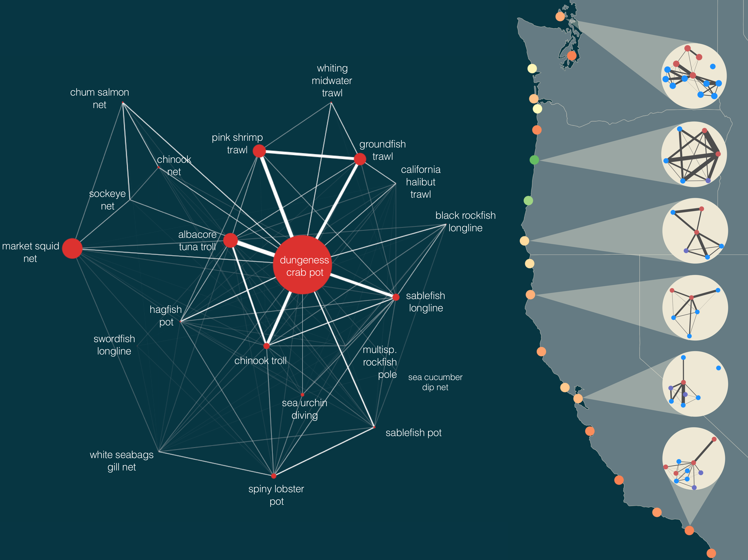

**Fig. 1. Human connectivity of commercial fisheries in the California Current Ecosystem.** Fisheries in the California Current are strongly connected by human participation. Some fisheries, notably the Dungeness crab-pot fishery, dominate the coast-wide network. The human connections among fisheries also frequently connect ecologically distant species, i.e. Dungeness crab and Albacore Tuna or benthic groundfish and pink shrimp. Examining networks generated for port groups, we find that these networks vary in their structure in the number of fisheries (nodes), the heterogeneity in fishery size, and strength of interconnections. These differences in structure may correspond to differences in community resilience. We color ports using one potential metric of network resilience to highlight this heterogeneity (see supplementary materials for additional metrics). On the right port groups are colored by their adaptive capacity and show port-level participation networks with nodes colored by management jurisdiction (federally managed fisheries are blue, state managed are red, fisheries where both state and federal have a role in management, i.e. nearshore rockfish, are purple). For visual clarity we only include fisheries that had at least 3 vessels participating, and accounted for, on average, 25% of a vessel’s annual income (Materials and methods are available as supplementary materials at the Science website).

**References and Notes:**

1. G. M. Mace, Ecology. Whose conservation? *Science*. **345**, 1558–1560 (2014).
2. C. C. Hicks *et al.*, Engage key social concepts for sustainability. *Science*. **352**, 38–40 (2016).
3. J. S. Link, R. Griffis, S. Busch, “NOAA Fisheries Climate Science Strategy” (NOAA Technical Memorandum NMFS-F/SPO-155, 2015; http://spo.nmfs.noaa.gov/tm/).
4. J. S. Link, “Ecosystem-Based Fisheries Management Policy of the National Marine Fisheries Service National Oceanic and Atmospheric Administration” (National Marine Fisheries Service Policy Directive 01-120, 2016; http://www.nmfs.noaa.gov/op/pds/index.html).
5. L. B. Crowder *et al.*, Resolving Mismatches in U.S. Ocean Governance. *Science*. **313**, 617–618 (2006).
6. I. E. van Putten *et al.*, Theories and behavioural drivers underlying fleet dynamics models. *Fish and Fisheries*. **13**, 216–235 (2012).
7. W. J. Boonstra, J. Hentati Sundberg, Classifying fishers' behaviour. An invitation to fishing styles. *Fish and Fisheries*. **17**, 78–100 (2014).
8. Northwest Fisheries Science Center, "Data Analysis and Products". available at <http://www.nwfsc.noaa.gov/research/divisions/fram/observation/data_products/bottom_trawl.cfm#description)>.
9. N. Deporte, C. Ulrich, S. Mahevas, S. Demaneche, F. Bastardie, Regional metier definition: a comparative investigation of statistical methods using a workflow applied to international otter trawl fisheries in the North Sea. *ICES Journal of Marine Science*. **69**, 331–342 (2012).
10. J. Gao, B. Barzel, A.-L. Barabási, Universal resilience patterns in complex networks. *Nature*. **530**, 307–312 (2016).

**Acknowledgments:** Data for this analysis was provided by the Pacific Fisheries Information Network (PacFIN) database (www.psmfc.org). This work supported by funding from the National Science Foundation (GRFP, GEO-1211972).

Supplementary Materials:

Materials and Methods

References (*6-10*)

Supplementary Materials:

**Materials and Methods:**

Data

We collected vessel landings tickets for all commercial landings on the US West-Coast between 2006-2014 from the Pacific Fisheries Information Network (PacFIN) database {PacificFisheriesIn:UF3vzZRw}. These commercial landings accounted for approximately 2.7 million metric tons of 228 species, resulting in 3.7 billion dollars in revenue (adjusted to 2009 levels) by a total of 6,862 vessels. We discard any fisheries for which vessel-identifying information is unavailable, which precludes analysis of patterns of individual participation. This primarily affects bivalve fisheries (i.e. pacific oyster and geoduck fisheries in Washington).

Date preparation

To examine patterns of participation, we grouped landings into distinct fisheries. Fisheries are defined as harvest assemblages caught with a specific gear (*6*, *7*). The Pacific Fisheries Management Council (PFMC) has developed a set of sector-based definitions similar to this approach for the federally managed groundfish landings (www.pcouncil.org), but no equivalent exists for non-groundfish fisheries (*8*). In order to treat the landings dataset uniformly, we applied a métier analysis to this landing data (*9*) to build a set of fisheries.

|  |  |  |
| --- | --- | --- |
| **Port Group** | **Port ID** | **Name** |
| BDA | BDG | Bodega Bay |
| BDA | OSM | other Sonoma and Marin county outer coast ports |
| BDA | BOL | Bolinas |
| BDA | RYS | Point Reyes |
| BDA | TML | Tomales Bay |
| BGA | BRG | Fort Bragg |
| BGA | ALB | Albion |
| BGA | ARE | Point Arena |
| BGA | OMD | other Mendocino county ports |
| BRA | BRK | Brookings |
| BRA | ORF | Port Orford |
| BRA | GLD | Gold Beach |
| CBA | WIN | Winchester Bay |
| CBA | COS | Charleston (Coos Bay) |
| CBA | BDN | Bandon |
| CBA | FLR | Florence |
| CCA | CRS | Crescent City |
| CCA | ODN | other del Norte county ports |
| CLO | AST | Astoria |
| CLO | CNB | Cannon Beach |
| CLO | GSS | Seaside-Gearhart |
| CLW | LWC | Ilwaco/Chinook |
| CLW | OCR | other Columbia river ports |
| CWA | WPT | Westport |
| CWA | LAP | La Push |
| CWA | OWC | other Washington coastal ports |
| CWA | WLB | Willapa Bay |
| CWA | GRH | Grays Harbor |
| ERA | TRN | Trinidad |
| ERA | OHB | other Humboldt county ports |
| ERA | ERK | Eureka |
| ERA | FLN | Fields Landing |
| LAA | LGB | Long Beach |
| LAA | SP | San Pedro |
| LAA | OLA | other LA and Orange county ports |
| LAA | DNA | Dana Point |
| LAA | TRM | Terminal Island |
| LAA | NWB | Newport Beach |
| LAA | WLM | Willmington |
| MNA | CRZ | Santa Cruz |
| MNA | MOS | Moss Landing |
| MNA | MNT | Monterey |
| MNA | OCM | other Santa Cruz and Monterey county ports |
| MRA | MRO | Morro Bay |
| MRA | AVL | Avila |
| MRA | OSL | other San Luis Obispo county ports |
| NPA | NEW | Newport |
| NPA | DPO | Depoe Bay |
| NPA | WLD | Waldport |
| NPA | SLZ | Siletz bay |
| NPS | BLL | Bellingham Bay |
| NPS | TNS | Port Townsend |
| NPS | PAG | Port Angeles |
| NPS | ANA | Anacortes |
| NPS | SEQ | Sequim |
| NPS | LAC | La Conner |
| NPS | NEA | Neah Bay |
| NPS | FRI | Friday Harbor |
| NPS | BLN | Blaine |
| NPS | ONP | other north Puget Sound ports |
| SBA | SB | Santa Barbara |
| SBA | HNM | Port Hueneme |
| SBA | OBV | other Santa Barbara and Ventura county ports |
| SBA | OXN | Oxnard |
| SBA | VEN | Ventura |
| SDA | OCN | Oceanside |
| SDA | SD | San Diego |
| SDA | OSD | other San Diego county ports |
| SFA | PRN | Princeton / Half Moon Bay |
| SFA | SF | San Francisco |
| SFA | OSF | other San Francisco Bay and San Mateo county ports |
| SFA | BKL | Berkeley |
| SFA | RCH | Richmond |
| SFA | OAK | Oakland |
| SFA | SLT | Sausalito |
| SFA | ALM | Alameda |
| SPS | SEA | Seattle |
| SPS | OLY | Olympia |
| SPS | EVR | Everett |
| SPS | SHL | Shelton |
| SPS | TAC | Tacoma |
| TLA | TLL | Tillamook/Garibaldi |
| TLA | PCC | Pacific City |
| TLA | NTR | Netarts Bay |
| TLA | NHL | Nehalem Bay |

Constructing Participation Networks

Fisheries are linked by fisher-mediated interactions. If a vessel *k* fishes in two fisheries *i* and *j*, they are linked in vessel *k*’s yearly strategy. Thus changes in fishery *i* can change the cost-benefit decisions for vessel *k* fishing in fishery *j*. The weight of the interaction between the two fisheries is determined by the density of the vessel linkages between fishery *i* and *j*. For a vessel *k*,link density scales with the amount of total revenue derived between the two fisheries *Rijk* and the evenness with which the vessel that participates in both fisheries *i* and *j,* but the more fisheries vessel *k* participates in, the smaller contribution to each fishery. So each vessel contributes to the link weight between fishery *i* and *j*. This results in a fishery-participation network

|  |  |
| --- | --- |
|  | (S1) |

One limitation of using vessels as a proxy for individual fishermen is that it’s impossible to know if vessels changed hands. With a short enough time series, the risk of this might be slight, but with 8 years of data, it’s probable that at least some vessels were transferred. This is especially likely because some major changes occurred (i.e. the chinook salmon troll fishery closed and the general economic recession in 2008-2009; implementation of individual-transferable quotas in groundfish trawl fishery in 2011). Grouping across years, and across possible transfers in those cases, would smear the patterns of participation and obscure common subsets of fisheries that co-occur. To address the problem of vessel transfer, I split up vessels into vessel-year replicates.

To examine regional participation networks, we grouped landings by port-group. These port groups have been constructed to combine together ports that are part of the same fishing community (i.e. all San Diego-area ports, Table S1).

**Table S1.**

Port groups for the US west coast are composed of indivudal port communities grouped based on geographic distance.

|  |  |  |
| --- | --- | --- |
| **Port Group** | **Port ID** | **Name** |
| NPS | BLL | bellingham bay |
| NPS | TNS | port townsend |
| NPS | PAG | port angeles |
| NPS | ANA | anacortes |
| NPS | SEQ | sequim |
| NPS | LAC | la conner |
| NPS | NEA | neah bay |
| NPS | FRI | friday harbor |
| NPS | BLN | blaine |
| NPS | ONP | other north puget sound ports |
| SPS | SEA | seattle |
| SPS | OLY | olympia |
| SPS | EVR | everett |
| SPS | SHL | shelton |
| SPS | TAC | tacoma |
| CWA | WPT | westport |
| CWA | LAP | la push |
| CWA | OWC | other washingtion coastal ports |
| CWA | WLB | willapa bay |
| CWA | GRH | grays harbor |
| CLW | LWC | ilwaco/chinook |
| CLW | OCR | other columbia river ports |
| CLO | AST | astoria |
| CLO | CNB | cannon beach |
| CLO | GSS | seaside-gearhart |
| TLA | TLL | tillamook/garibaldi |
| TLA | PCC | pacific city |
| TLA | NTR | netarts bay |
| TLA | NHL | nehalem bay |
| NPA | NEW | newport |
| NPA | DPO | depoe bay |
| NPA | WLD | waldport |
| NPA | SLZ | siletz bay |
| CBA | WIN | winchester bay |
| CBA | COS | charleston (coos bay) |
| CBA | BDN | bandon |
| CBA | FLR | florence |
| BRA | BRK | brookings |
| BRA | ORF | port orford |
| BRA | GLD | gold beach |
| CCA | CRS | crescent city |
| CCA | ODN | other del norte county ports |
| ERA | TRN | trinidad |
| ERA | OHB | other humboldt county ports |
| ERA | ERK | eureka |
| ERA | FLN | fields landing |
| BGA | BRG | fort bragg |
| BGA | ALB | albion |
| BGA | ARE | point arena |
| BGA | OMD | other mendocino county ports |
| BDA | BDG | bodega bay |
| BDA | OSM | other sonoma and marin county outer coast ports |
| BDA | BOL | bolinas |
| BDA | RYS | point reyes |
| BDA | TML | tomales bay |
| SFA | PRN | princeton / half moon bay |
| SFA | SF | san francisco |
| SFA | OSF | other s. f. bay and san mateo county ports |
| SFA | BKL | berkeley |
| SFA | RCH | richmond |
| SFA | OAK | oakland |
| SFA | SLT | sausalito |
| SFA | ALM | alameda |
| MNA | CRZ | santa cruz |
| MNA | MOS | moss landing |
| MNA | MNT | monterey |
| MNA | OCM | other santa cruz and monterey county ports |
| MRA | MRO | morro bay |
| MRA | AVL | avila |
| MRA | OSL | other san luis obispo county ports |
| SBA | SB | santa barbara |
| SBA | HNM | port hueneme |
| SBA | OBV | other santa barbara and ventura county ports |
| SBA | OXN | oxnard |
| SBA | VEN | ventura |
| LAA | LGB | long beach |
| LAA | SP | san pedro |
| LAA | OLA | other la and orange cnty ports |
| LAA | DNA | dana point |
| LAA | TRM | terminal island |
| LAA | NWB | newport beach |
| LAA | WLM | willmington |
| SDA | OCN | oceanside |
| SDA | SD | san diego |
| SDA | OSD | other san diego county ports |

Analyzing Participation Networks:

Network approaches have long been a valuable tool to understand interactions among communities of species (i.e. foodwebs). To analyze these participation networks we have used two measures that have direct analogies to food-webs. The first is node centrality, which has been used to identify keystone species in food-webs (Jordan 2009), those that if removed from the food-web would lead to a disproportionately large impact on the whole system. Applied to the participation networks, measures of centrality identify “keystone fisheries”, those that most vessels in a fishing community would participate in (and possibly gain most of their revenue from) at some point of the year. These fisheries are likely ones that, regardless of ecological function or vulnerability, may from a human perspective of high management importance.

While many measures of network centrality exist, here we chose simple measures which have clear interpretations. Centrality of each node (fishery) in a participation network was measured in two ways, by node strength and betweenness centrality. Node strength is a generalization of degree for weighted networks. Degree, or the number of connections to a given node, is an intuitive measure where the more connected a node is, the more central we assume to be in the network. To make use of the information contained in edge weight I calculated node strength (Barrat et al. 2004) where node strength of node *v* is

|  |  |
| --- | --- |
|  | ((S2) |

in a graph with *N* total nodes (Barrat et al. 2004). Because networks varied orders of magnitude in the total number of vessels moving among nodes, we normalized this value by the sum of all edge weights in a graph, thus providing a measure ranging between 0 and 1 where 1 indicates that all connections in the network were to node *v*, and 0 means that no connections involved node *v*, and it grows such that larger edges drive up the score. Fisheries with node strength close to one are fisheries that were consistently connected to the majority of other fisheries in the network and/or were involved the strongest connections present. Thus these fisheries that scored highly in node strength across all port networks can be thought of as fisheries that are consistently central (i.e. strongly connected to most of the nodes in the network) in all the networks in which they appear.

This measure of node strength, while intuitive, only takes into account the local structure around each node. To incorporate both node strength and network structure I calculated betweenness centrality. Betweenness centrality was developed to better incorporate the topological structure of the network and specifically to capture whether nodes connected two relatively distant parts of a network (Freeman, Roeder, and Mulholland 1979). This metric is particularly useful in cases where we wish to know something about traffic or how information flows across a network, both of which are relevant when we think about fisheries participation. This metric is calculated as the number of shortest paths which travel through a given node *b(v)*.

|  |  |
| --- | --- |
|  | ((S3) |

where is the number of shortest paths between node *s* and node *t* and is the number of shortest paths that pass through vertex *v*. Because betweenness will scale with network size, and participation networks vary in size, I normalized this value by dividing by the number of pairs of nodes *((N-1)(N-2)/2*) that do not include *v*, so that *b* is in the interval *[0, 1]*. To incorporate weights of edges I summed the edge strength such that shortest paths that involve edges with larger weights contribute more to betweenness scores.

The second set of measures relate to the topology of the networks. This includes measures of modularity, connectance and size, along with a composite measure of resilience or adaptive capacity. These first order properties of the participation networks may be key to quantifying how any perturbation – a management or environmental change – will affect the whole marine social-ecological system.

To measure the connectivity and size of these participation networks we calculated the link density (*LD,* number of edges divided by nodes) which scales both with network size and interconnectedness. Because the network is undirected, this value can be interpreted as the average number of fisheries to which a fishery is connected (i.e. all vessels participate in both fisheries) at port *k*.

To estimate the potential resilience of these networks, we use the universal resilience function from Gao et al. (*10*), for each network we calculated , where is the average edge weight across all, is the edge symmetry (here, because networks are undirected, symmetry is equal to one) and is the edge heterogeneity measured as variance in edge weights divided by .

Modules have long been of interest for biological and social networks, however they are difficult to define formally. Most recent approaches consider that a partition of the nodes of a graph represent true structure if the proportion of edges inside the module is large when compared to the number links between them and the rest of the graph. We use this definition here and defined modules as groups of fisheries more tightly connected to one another than the rest of the network. These were identified using the walktrap algorithm(Pons and Latapy 2005). The algorithm’s name comes from the observation that random walks on networks often get “stuck” in densely connected subgraphs. The algorithm proceeds by building an agglomerative dendrogram by computing pairwise distances among all nodes and merging adjacent (i.e. sharing at least one edge) nodes/communities to form larger groupings. The weight of the edge *vu* is converted to distance by averaging all edge weights and dividing by edge weight *vu*. At each step, a pair of edges is merged based on the move that results in the greatest reduction in the variation in the mean squared pairwise distance within the candidate community. This process is repeated until all communities are fused to a single large entity. To choose the optimal partition, the modularity *Q* of each partition *P* is calculated as

|  |  |
| --- | --- |
|  | ((S4) |

where *ec* represents the edges inside community *C* and *ac* is the number of edges between the community and the rest of the network (Pons and Latapy 2005). For each step in the dendrogram, the modularity was computed, and the partition with the largest modularity was chosen.

**Supplementary Text**

Fisheries of Management Importance

In contrast to typical portrayals of fleets as independent units of fishing effort, virtually all fisheries were connected to at least one other fishery by vessel participation. These connections varied, but some clear patterns emerged. Across all networks where present, the Dungeness crab pot and spiny lobster pot fisheries were consistently central in both node strength and betweenness centrality: these two fisheries had the highest node strength and betweenness centrality in 16/19 and 3/3 port group networks in which these fisheries were present, respectively (Figure S1). Large node strength implies that these two fisheries are much more connected than the rest of the nodes in a given network, which suggests that many different fishing strategies likely include these two fisheries as a component. High scores of betweenness suggest that the different strategies employed by those participating in a fishery like the Dungeness crab pot fishery are diverse, such that the population involved in Dungeness crab pot fishing is highly heterogeneous.

**Figure S1**

Ordered from most to least are measures of A) node strength and B) betweenness for portgoup-level participation networks. Dungeness crab pots (POT_1) and spiny lobster pot (POT_2) have the greatest node strength and betweenness, but other fisheries shift their ordering depending on the metric used.

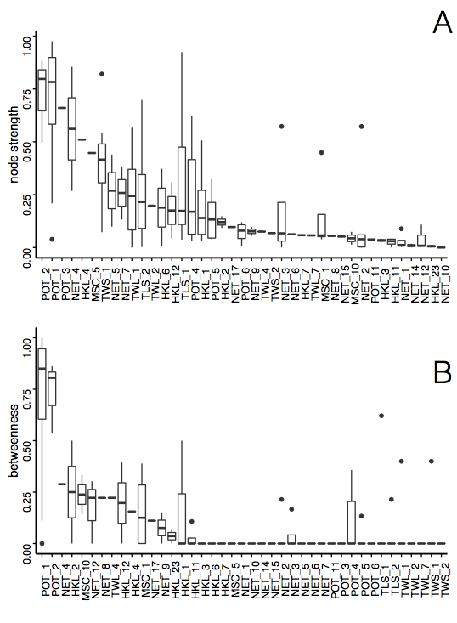

Analyzing Participation Networks: Connectivity, Size, Modularity, Resilience

We found differences in the number and interconnectedness of fisheries across ports (Figure S1). Port group participation networks had between 3 and 13 fisheries (nodes) and between 0 and 49 edges with a median of 7 and 14, respectively. Fisheries in these networks were connected to anywhere between 0 and 12 other fisheries. Linkage density for these networks varied between 0.91 and 3.77. This variation is exemplified by participation networks of landings in the Santa Cruz and Monterey area ports (MNA) and Puget Sound ports (SPS) (Figure S2). MNA was characterized by a complex participation network, with more than double the average link density of SPS.

**Figure S2.**

Spectrum of fisheries connectivity present in participation networks on the US west coast as illustrated by participation networks for A) South Puget Sound port group; and B) Santa Cruz and Monterey port group. Here nodes represent fisheries where edge width is proportional to the number of vessels that participate in the connected fisheries. Color of nodes represents gear type and is consistent across networks: Orange indicate pots, yellow is hook and line, teal is net, pink is shrimp trawls, brown is groundfish trawl, purple is miscellaneous and green is troll fisheries. Bar plot shows fisheries connectivity, measured as link-density for all port groups on US west coast. Light bars correspond to the network above them.

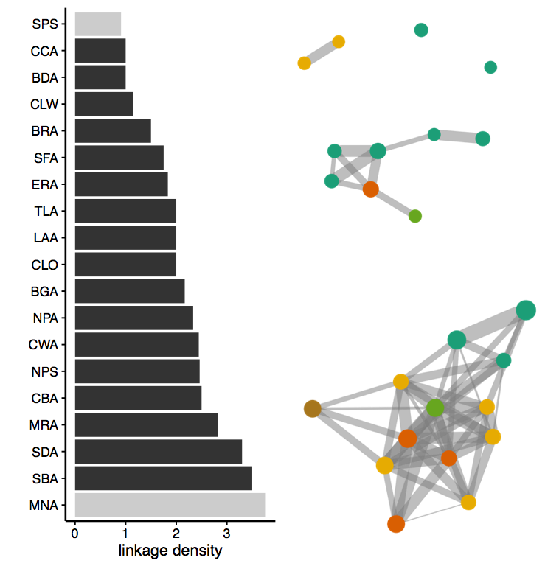

**Figures S3-S21**

Port group participation networks with fisheries labelled. Colors represent broad gear groups, yellow = hook and line, green = troll, brown = trawl, pink = shrimp trawl, teal = nets, purple = miscellaneous, and orange = pots.

z