Title:

Human Connectivity in Social-Ecological Systems

**Authors:** Emma Fuller1*, Jameal F. Samhouri2, Joshua S. Stoll3, James R. Watson4, Simon Levin1

**Affiliations:**

1 Department of Ecology and Evolutionary Biology, Princeton University, Princeton, NJ, USA.

2 Conservation Biology Division, Northwest Fisheries Science Center, National Marine Fisheries Service, National Oceanic and Atmospheric Administration, 2725 Montlake Blvd E., Seattle, WA 98112

3School of Marine Sciences, University of Maine, Orono, Maine.

4Stockholm Resilience Centre, Stockholm University

*Correspondence to: emma.cassel.fuller@gmail.com.

**One Sentence Summary:** Fostering resilience requires that resource managers account for the social and ecological links users create when they are dependent on multiple components of an ecosystem.

**Main Text:**

Balancing human well-being and ecological integrity is one of the fundamental goals of conservation and natural resource management. Despite the growing focus on valuing human well-being alongside ecological integrity, tractable means to operationalize these goals, especially at large spatial and temporal scales, are lacking (*1*).

This challenge is particularly acute in commercial fisheries, where the well-being of fishermen is inherently tied to the distribution and abundance of marine species. Accordingly, the need to manage for human well-being has received considerable attention in marine policy directives. In the US, for example, both the NOAA Fisheries Climate Science Strategy (*2*) and Ecosystem Based Fisheries Management (EBFM) policy statement (*3*) call for increased research on coastal communities and their linkages to ocean ecosystems. Despite this focus, attention to food-web interactions dominates, marginalizing the equally complex human networks resulting from how people participate and shift effort among fisheries. Developing new and innovative methods to understand these complex systems and their dynamics is therefore a critical and largely unaddressed step towards moving EBFM from theory to practice and ultimately advancing sustainability science (*4*). To this end, this paper presents an analysis of socioeconomic connectivity of the commercial fisheries in the California Current ecosystem, illustrating the diverse intra-fishery connectivity that exists in coastal communities along the west coast of the United States. We focus on the California Current ecosystem because the natural science to support EBFM in this region is cutting-edge, yet little work has been done to account for human connections among fisheries that exist in the region.

To improve understanding of human connectivity among fisheries for policy makers, stakeholders and managers, we developed and applied a novel approach to build and describe what we term “participation networks”. Participation networks are comprised of nodes, in this case fisheries, connected by the vessels that participate in both (Materials and methods are available as supplementary materials at the Science website). This network approach is most similar to identifying alternative sources of livelihood (*5*), but rather than examine how people move across sectors, focuses in on the interactions in a single social-ecological system, allowing linkages to be drawn between species and the people who depend on them. This approach allows us to take advantage of metrics developed to estimate resilience of networks of interacting actors (*6*). Such network statistics allow us to calculate how coastal communities might respond to perturbations. In building and systematically measuring the human connectivity among commercial fisheries we find (i) general social linkages among fisheries that are currently unaccounted for in existing fisheries policy and management (see figures S4-S21 in Supplement); (ii) that people diversify across jurisdictional and institutional boundaries (state and federal fisheries); and (iii) while there appears to be general patterns in these networks, we find variation in the composition and structure from community to community suggesting heterogeneity in both the impact upon fishing communities, and their ability to deal with environmental, management, and market shocks (see Figure).

In order to maintain benefits across fisheries, these patterns suggest that management must account for these connections, especially when ecologically distant taxa are transitively connected by the people who fish for both of them. For example, on the US West Coast a closure in the crab fishery could have cascading ecological impacts on numerous other fisheries because 75% of the Dungeness crab fishermen are generalists, participating in an average of four other fisheries in a given year (e.g., tuna-groundfish-salmon-crab). Such generalism suggests that fishermen will shift their effort from one fishery to another, in order to maximize or satisfy their income needs. This would likely result in cascading management effects, as policy makers play catch-up with fishermen as they redistribute their effort.

These participation networks also point to the value of cross-scale and trans-boundary governance institutions (*7*). For example, the state-managed Dungeness crab fishery is tightly connected to federal fisheries: on average crab fishers make 30% of their annual revenue on non-crab fisheries, and 99% of these non-crab fisheries are federally managed. While governance institutions that acknowledge cross-scale and trans-boundary issues are not without precedent, as on the US West Coast where Pacific hake are jointly assessed and managed by the US and Canada, formal management structures that recognize human connectivity of fisheries across jurisdictions are the exception, not the rule.

Last, quantitative measures of these participation networks provide the means to evaluate policy efficacy. Participation networks of the coastal communities in the US California current vary in both composition and topology, with the most complex networks having four times the connectivity of the simplest ones (Figure S2). Recognition of this variability can help managers anticipate the extent to which coast-wide policy change will create comparable social and ecological consequences from place to place. The recent implementation of catch shares in the US West Coast groundfish fishery is one example where the different structure of human connectivity revealed here suggests inconsistent social and ecological consequences.

We have focused here on the importance of human connectivity to advancing marine policy for the US, but its importance extends to other systems in other places around the world. For example, most marine systems support a diversity of industrial and subsistence fishing fleets, each extracting different living resources (*8*). This research is also relevant to freshwater and terrestrial systems, where people gain income and sustenance from numerous natural sources (*9*). As a consequence, measuring and designing policies that account for both ecological and human connectivity will improve sustainability now and in a future under climate change and human population growth.

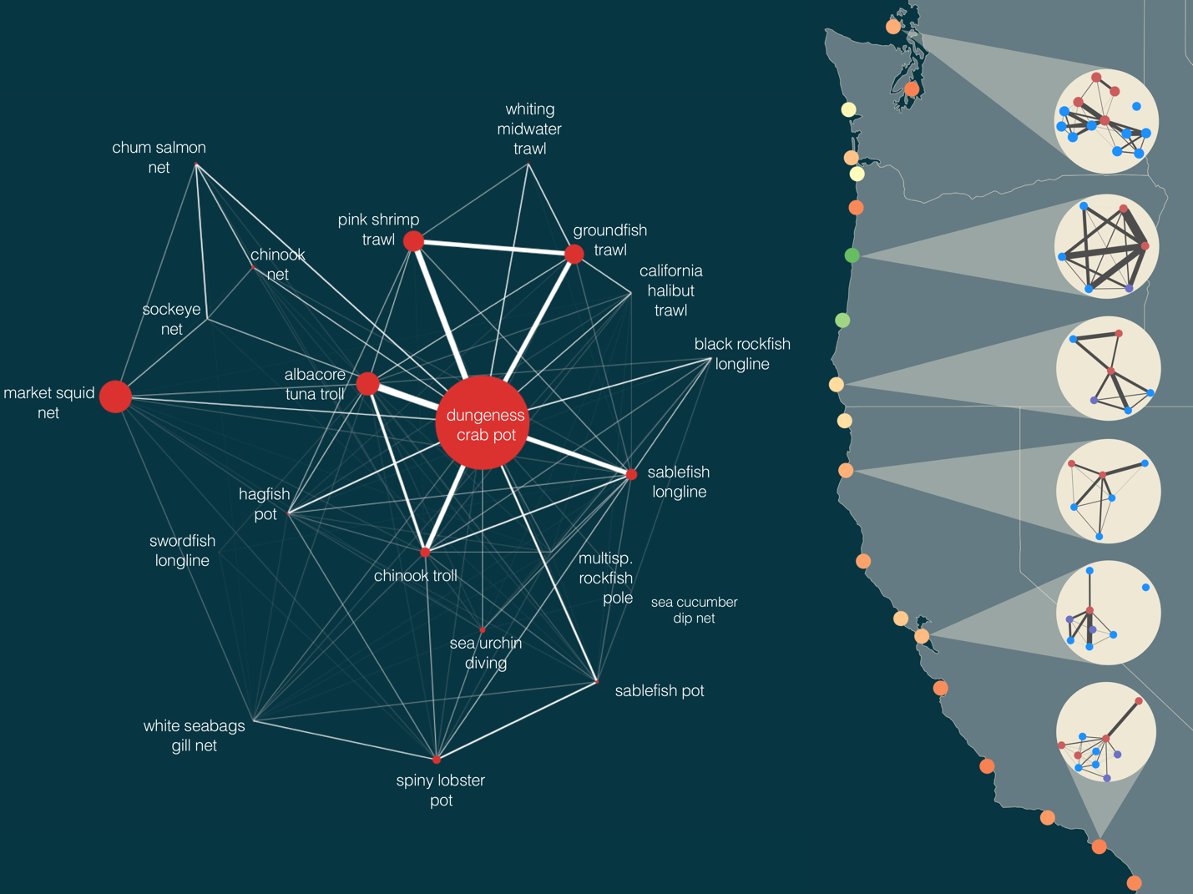

**Fig. 1. Human connectivity of commercial fisheries in the California Current Ecosystem.** Fisheries in the California Current are strongly connected by human participation. Some fisheries, notably the Dungeness crab-pot fishery, dominate the coast-wide network. The human connections among fisheries also frequently connect ecologically distant species, i.e. Dungeness crab and Albacore Tuna or benthic groundfish and pink shrimp. Examining networks generated for port groups on the right, we find that these networks vary in the number of fisheries (nodes) and strength of interconnections. These differences in structure may correspond to differences in community resilience. We color ports using one potential metric of network resilience to highlight this heterogeneity (see supplementary materials for additional metrics). On the right port groups are colored by their adaptive capacity and show port-level participation networks with nodes colored by management jurisdiction (federally managed fisheries are blue, state managed are red, fisheries where both state and federal have a role in management, i.e. nearshore rockfish, are purple). For visual clarity we only include fisheries that had at least 3 vessels participating, and accounted for, on average, 25% of a vessel’s annual income (Materials and methods are available as supplementary materials at the Science website).

**References and Notes:**

1. G. M. Mace, Ecology. Whose conservation? *Science*. **345**, 1558–1560 (2014).
2. J. S. Link, R. Griffis, S. Busch, “NOAA Fisheries Climate Science Strategy” (NOAA Technical Memorandum NMFS-F/SPO-155, 2015), p. 70p.
3. J. S. Link, “Ecosystem-Based Fisheries Management Policy of the National Marine Fisheries Service National Oceanic and Atmospheric Administration” (2016), pp. 1–8.
4. C. C. Hicks *et al.*, Engage key social concepts for sustainability. *Science*. **352**, 38–40 (2016).
5. J. E. Cinner, Ö. Bodin, Livelihood Diversification in Tropical Coastal Communities: A Network-Based Approach to Analyzing “Livelihood Landscapes.” **5**, e11999–13 (2010).
6. J. Gao, B. Barzel, A.-L. Barabási, Universal resilience patterns in complex networks. *Nature*. **530**, 307–312 (2016).
7. L. B. Crowder *et al.*, Resolving Mismatches in U.S. Ocean Governance. *Science*. **313**, 617–618 (2006).
8. R. Hilborn *et al.*, State of the World's Fisheries. *Annu. Rev. Environ. Resourc.* **28**, 359–399 (2003).
9. J. S. Brashares *et al.*, Bushmeat Hunting, Wildlife Declines, and Fish Supply in West Africa. *Science*. **306**, 1180–1183 (2004).
10. Pacific Fisheries Information Network (PacFIN), (available at www.psmfc.org).I. E. van Putten *et al.*, Theories and behavioural drivers underlying fleet dynamics models. *Fish and Fisheries*. **13**, 216–235 (2012).
11. W. J. Boonstra, J. Hentati Sundberg, Classifying fishers' behaviour. An invitation to fishing styles. *Fish and Fisheries*. **17**, 78–100 (2014).
12. The Northwest Fisheries Science Center, (NWFSC), "Data Products" (https://www.nwfsc.noaa.gov/research/divisions/fram/observation/data_products/index.cfm).
13. N. Deporte, C. Ulrich, S. Mahevas, S. Demaneche, F. Bastardie, Regional metier definition: a comparative investigation of statistical methods using a workflow applied to international otter trawl fisheries in the North Sea. *ICES Journal of Marine Science*. **69**, 331–342 (2012).
14. F. Jordan, Keystone species and food webs. *Philos. Trans. R. Soc. Lond., B, Biol. Sci.* **364**, 1733–1741 (2009).
15. Barrat, M. Barthelemy, R. Pastor-Satorras, A. Vespignani, The architecture of complex weighted networks. *PNAS*. **101**, 3747–3752 (2004).
16. L. C. Freeman, D. Roeder, R. R. Mulholland, Centrality in Social Networks: II. Experimental Results. *Social Networks*. **2**, 119–141 (1979).
17. P. Pons, M. Latapy, Computing communities in large networks using random walks. *ArXiv Physics e-prints* (2005), (available at http://arxiv.org/abs/physics/0512106#).

**Acknowledgments:** Data for this analysis was provided by the Pacific Fisheries Information Network (PacFIN) database (www.psmfc.org). This work supported by funding from the National Science Foundation (GRFP, GEO-1211972) and we thank the observers and fishermen on the US West Coast for their time and insightful discussions on the topic.

Supplementary Materials:

Materials and Methods

Figures S1-S3

Table S1

Supplementary Text

References (*10-17*)