

Supplementary Materials for

Human Connectivity in Social-Ecological Systems

Emma Fuller1*, Jameal F. Samhouri2, Joshua S. Stoll3, James R. Watson4, Simon Levin1

correspondence to: [efuller@princeton.edu](mailto:xxxxx@xxxx.xxx)

**This PDF file includes:**

Materials and Methods

SupplementaryText

Figs. S1 to S3

Tables S1

Caption for figures S4 to S23

**Other Supplementary Materials for this manuscript includes the following:**

Figures S4 to S23

**Materials and Methods:**

Data

We collected vessel landings tickets for all commercial landings on the US West Coast between 2006-2014 from the Pacific Fisheries Information Network (PacFIN) database (*9*). These commercial landings accounted for approximately 2.7 million metric tons of 228 species, resulting in 3.7 billion dollars in revenue (adjusted to 2009 levels) by a total of 6,862 vessels. We discard any fisheries for which vessel-identifying information is unavailable, which precludes analysis of patterns of individual participation. This primarily affects bivalve fisheries (i.e. pacific oyster and geoduck fisheries in Washington).

Date preparation

To examine patterns of participation, we grouped landings into distinct fisheries. Fisheries are defined as harvest assemblages caught with a specific gear (*10*, *11*). The Pacific Fisheries Management Council (PFMC) has developed a set of sector-based definitions similar to this approach for the federally managed groundfish landings (www.pcouncil.org), but no equivalent exists for non-groundfish fisheries (*12*). In order to treat the landings dataset uniformly, we applied a métier analysis to this landing data (*13*) to build a set of fisheries. In the following, fisheries are named based on species that dominate catch revenues and gear used to land the majority of the trips: i.e. Dungeness crab-pot fishery, albacore tuna troll fishery, etc. If there is no majority species, any species making up at least 30% of revenue on average is listed (i.e. i.e. the gopher rockfish, grass rockfish, cabezon pole fishery).

Constructing Participation Networks

Fisheries are linked by fisher-mediated interactions. If a vessel *k* fishes in two fisheries *i* and *j*, they are linked in vessel *k*’s yearly strategy. Thus changes in fishery *i* can change the cost-benefit decisions for vessel *k* fishing in fishery *j*. The weight of the interaction between the two fisheries is determined by the density of the vessel linkages between fishery *i* and *j*. For a vessel *k*,link density scales with the amount of total revenue derived between the two fisheries *Rijk* and the evenness with which the vessel that participates in both fisheries *i* and *j,* but the more fisheries vessel *k* participates in, the smaller contribution to each fishery. So each vessel contributes $\frac{R_{ik}R_{jk}}{R_{k}}R_{ijk}$ to the link weight between fishery *i* and *j*. This results in a fishery-participation network

|  |  |
| --- | --- |
| $$A_{ij}=\sum_{k=1}^{m}{\frac{R_{ik}R_{jk}}{R_{k}}R_{ijk}}$$ | (S1) |

One limitation of using vessels as a proxy for individual fishermen is that it’s impossible to know if vessels changed hands. With a short enough time series, the risk of this might be slight, but with 8 years of data, it’s probable that at least some vessels were transferred. This is especially likely because some major changes occurred (i.e. the chinook salmon troll fishery closed and the general economic recession in 2008-2009; implementation of individual-transferable quotas in groundfish trawl fishery in 2011). Grouping across years, and across possible transfers in those cases, would smear the patterns of participation and obscure common subsets of fisheries that co-occur. To address the problem of vessel transfer, we split up vessels into vessel-year replicates.

To examine regional participation networks, we grouped landings by port-group. These port groups have been constructed to combine together ports that are part of the same fishing community (i.e. all San Diego-area ports, Table S1).

**Table S1.**

Port groups for the US West Coast are composed of individual port communities grouped based on geographic distance. Landings are reported by port ID, which are then grouped into port groups as defined below.

|  |  |  |
| --- | --- | --- |
| **Port Group** | **Port ID** | **Name** |
| NPS | BLL | Bellingham Bay |
| TNS | Port Townsend |
| PAG | Port Angeles |
| ANA | Anacortes |
| SEQ | Sequim |
| LAC | La Conner |
| NEA | Neah Bay |
| FRI | Friday Harbor |
| BLN | Blaine |
| ONP | other north Puget Sound ports |
| SPS | SEA | Seattle |
| OLY | Olympia |
| EVR | Everett |
| SHL | Shelton |
| TAC | Tacoma |
| CWA | WPT | Westport |
| LAP | La Push |
| WLB | Willapa bay |
| GRH | Grays Harbor |
| OWC | other Washington coastal ports |
| CLW | LWC | Ilwaco/Chinook |
| OCR | other Columbia River ports |
| CLO | AST | Sstoria |
| CNB | Cannon beach |
| GSS | Seaside-Gearhart |
| TLA | TLL | Tillamook/Garibaldi |
| PCC | Pacific City |
| NTR | Netarts Bay |
| NHL | Nehalem Bay |
| NPA | NEW | Newport |
| DPO | Depoe Bay |
| WLD | Waldport |
| SLZ | Siletz Bay |
| CBA | WIN | Winchester Bay |
| COS | Charleston (Coos Bay) |
| BDN | Bandon |
| FLR | Florence |
| BRA | BRK | Brookings |
| ORF | Port Orford |
| GLD | Gold Beach |
| CCA | CRS | Crescent City |
| ODN | other Del Norte county ports |
| ERA | TRN | Trinidad |
| ERK | Eureka |
| FLN | Fields landing |
| OHB | other Humboldt county ports |
| BGA | BRG | Fort Bragg |
| ALB | Albion |
| ARE | Point Arena |
| OMD | other Mendocino county ports |
| BDA | BDG | Bodega Bay |
| BOL | Bolinas |
| RYS | Point Reyes |
| TML | Tomales Bay |
| OSM | other Sonoma and Marin county outer coast ports |
| SFA | PRN | Princeton/Half Moon Bay |
| SF | San Francisco |
| BKL | Berkeley |
| RCH | Richmond |
| OAK | Oakland |
| SLT | Sausalito |
| ALM | Alameda |
| OSF | other SF Bay and San Mateo county ports |
| MNA | CRZ | Santa Cruz |
| MOS | Moss Landing |
| MNT | Monterey |
| OCM | other Santa Cruz and Monterey county ports |
| MRA | MRO | Morro Bay |
| AVL | Avila |
| OSL | other San Luis Obispo county ports |
| SBA | SB | Santa Barbara |
| HNM | Port Hueneme |
| OXN | Oxnard |
| VEN | Ventura |
| OBV | other Santa Barbara and Ventura county ports |
| LAA | LGB | Long Beach |
| SP | San Pedro |
| DNA | Dana Point |
| TRM | Terminal Island |
| NWB | Newport Beach |
| WLM | Wilmington |
| OLA | other LA and Orange county ports |
| SDA | OCN | Oceanside |
| SD | San Diego |
| OSD | other San Diego county ports |

Analyzing Participation Networks:

Network approaches have long been a valuable tool to understand interactions among communities of species (i.e. foodwebs). To analyze these participation networks we have used two measures that have direct analogies to food-webs. The first is node centrality, which has been used to identify keystone species in food-webs (*14*), those that if removed from the food-web would lead to a disproportionately large impact on the whole system. Applied to the participation networks, measures of centrality identify “keystone fisheries”, those that most vessels in a fishing community would participate in (and possibly gain most of their revenue from) at some point of the year. These fisheries are likely ones that, regardless of ecological function or vulnerability, may from a human perspective of high management importance.

While many measures of network centrality exist, here we chose simple measures which have clear interpretations. Centrality of each node (fishery) in a participation network was measured in two ways, by node strength and betweenness centrality. Node strength is a generalization of degree for weighted networks. Degree, or the number of connections to a given node, is an intuitive measure where the more connected a node is, the more central we assume to be in the network. To make use of the information contained in edge weight we calculated node strength (*15*) where node strength of node *v* is

|  |  |
| --- | --- |
| $$s_{v}=\sum_{u=1}^{N}{g_{vu},}$$ | ((S2) |

in a graph with *N* total nodes (*15*). Because networks varied orders of magnitude in the total number of vessels moving among nodes, we normalized this value by the sum of all edge weights in a graph, thus providing a measure ranging between 0 and 1 where 1 indicates that all connections in the network were to node *v*, and 0 means that no connections involved node *v*, and it grows such that larger edges drive up the score. Fisheries with node strength close to one are fisheries that were consistently connected to the majority of other fisheries in the network and/or were involved the strongest connections present. Thus these fisheries that scored highly in node strength across all port networks can be thought of as fisheries that are consistently central (i.e. strongly connected to most of the nodes in the network) in all the networks in which they appear.

This measure of node strength, while intuitive, only takes into account the local structure around each node. To incorporate both node strength and network structure we calculated betweenness centrality. Betweenness centrality was developed to better incorporate the topological structure of the network and specifically to capture whether nodes connected two relatively distant parts of a network (*16*). This metric is particularly useful in cases where we wish to know something about traffic or how information flows across a network, both of which are relevant when we think about fisheries participation. This metric is calculated as the number of shortest paths which travel through a given node *b(v)*.

|  |  |
| --- | --- |
| $$b\left(v\right)= \sum_{s}{\frac{σ_{st}\left(v\right)}{σ_{st}}},$$ | (S3) |

where σ*st* is the number of shortest paths between node *s* and node *t* and σ*st(v)* is the number of shortest paths that pass through vertex *v*. Because betweenness will scale with network size, and participation networks vary in size, we normalized this value by dividing by the number of pairs of nodes *((N-1)(N-2)/2*) that do not include *v*, so that *b* is in the interval *[0, 1]*. To incorporate weights of edges we summed the edge strength such that shortest paths that involve edges with larger weights contribute more to betweenness scores.

The second set of measures relate to the topology of the networks. This includes measures of modularity, connectance and size, along with a composite measure of resilience or adaptive capacity. These first order properties of the participation networks may be key to quantifying how any perturbation – a management or environmental change – will affect the whole marine social-ecological system.

To measure the connectivity and size of these participation networks we calculated the link density (*LD,* number of edges divided by nodes) which scales both with network size and interconnectedness. Because the network is undirected, this value can be interpreted as the average number of fisheries to which a fishery is connected (i.e. all vessels participate in both fisheries) at port *k*. To estimate the potential resilience of these networks, we use the universal resilience function from Gao et al. (*6*), for each network we calculated *βeff* = 〈*s*〉 + SH, where 〈*s*〉 is the average edge weight across all, S is the edge symmetry (here, because networks are undirected, symmetry is equal to one) and H is the edge heterogeneity measured as variance in edge weights divided by 〈*s*〉. Modules have long been of interest for biological and social networks, however they are difficult to define formally. Most recent approaches consider that a partition of the nodes of a graph represent true structure if the proportion of edges inside the module is large when compared to the number links between them and the rest of the graph. We use this definition here and defined modules as groups of fisheries more tightly connected to one another than the rest of the network. These were identified using the walktrap algorithm(*17*). The algorithm’s name comes from the observation that random walks on networks often get “stuck” in densely connected subgraphs. The algorithm proceeds by building an agglomerative dendrogram by computing pairwise distances among all nodes and merging adjacent (i.e. sharing at least one edge) nodes/communities to form larger groupings. The weight of the edge *vu* is converted to distance by averaging all edge weights and dividing by edge weight *vu*. At each step, a pair of edges is merged based on the move that results in the greatest reduction in the variation in the mean squared pairwise distance within the candidate community. This process is repeated until all communities are fused to a single large entity. To choose the optimal partition, the modularity *Q* of each partition *P* is calculated as

|  |  |
| --- | --- |
| $$Q\left(P\right)= \sum_{C∈P}{e_{c}-a_{c}^{2}},$$ | (S4) |

where *ec* represents the edges inside community *C* and *ac* is the number of edges between the community and the rest of the network (*17*). For each step in the dendrogram, the modularity was computed, and the partition with the largest modularity was chosen. We report the modularity for the chosen partition.

**Supplementary Text**

Fisheries of Management Importance

In contrast to typical portrayals of fleets as independent units of fishing effort, virtually all fisheries were connected to at least one other fishery by vessel participation. These connections varied, but some clear patterns emerged. Across all networks either Dungeness crab pot or spiny lobster pot fisheries were central in both node strength and betweenness centrality (Figure S1). Large node strength implies that these two fisheries are much more connected than the rest of the nodes in a given network, which suggests that many different fishing strategies likely include one these two fisheries as a component. High scores of betweenness suggest that the different strategies employed by those participating in a fishery like the Dungeness crab pot fishery are diverse, such that the population involved in Dungeness crab pot fishing is highly heterogeneous.

These fisheries are also likely ones that, regardless of ecological function or vulnerability, may be extremely important to manage sustainably due to the central position these fisheries have in human livelihoods. While the Dungeness crab fishery is well known as an important fishery due to the proportion of revenue derived from those landings. However this work highlights that it is also a fishery that is central in many fishing communities measured either by node strength or betweenness centrality, suggesting that many people depend on it as a part of their livelihood strategy. This position in these participation networks may be due to a combination of factors. While vessels on the US west coast are diverse (Kasperski and Holland 2013), participation in commercial fisheries are likely, at least in part, constrained by vessel size. Dungeness crab is a unique fishery that draws both large and small vessels. However the regional variability in the fisheries participation networks is worth considering, since few southern port participation networks contain Dungeness crab, instead being replaced by spiny lobster pot fishing.

**Fig. S1.**

Ordered from most to least are measures of A) node strength and B) betweenness for port goup-level participation networks. Dungeness crab pots and spiny lobster pots have the greatest node strength and betweenness, but other fisheries shift their ordering depending on the metric used.

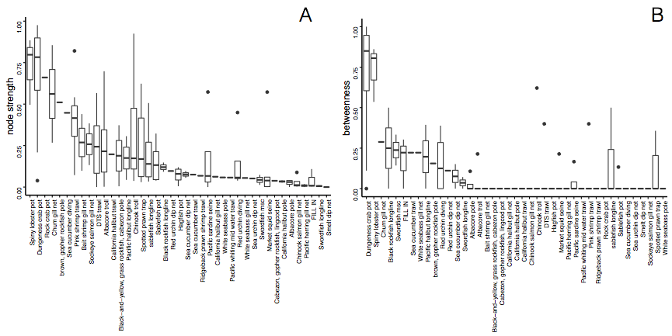

Analyzing Participation Networks: Connectivity, Size, Modularity, Resilience

We found differences in the number and interconnectedness of fisheries across ports (Figure S1). Port group participation networks had between 3 and 13 fisheries (nodes) and between 0 and 49 edges with a median of 7 and 14, respectively. Fisheries in these networks were connected to anywhere between 0 and 12 other fisheries. Linkage density for these networks varied between 0.91 and 3.77. This variation is exemplified by participation networks of landings in the Santa Cruz and Monterey area ports (MNA) and Puget Sound ports (SPS) (Figure S2). MNA was characterized by a complex participation network, with more than double the average link density of SPS. We found that the modularity (*Q*) of these networks varied between -0.33 and 0.305. Values of *Q* > 0 indicate that the network is clustered, whereas networks with *Q* < 0 indicate a lack of clustering. Estimates of resilience (*βeff*) also varied, with the highest value of *βeff* twenty times the value of the lowest participation network (Figure S2). Interestingly, while these network statistics measure similar properties of the networks, they had little correlation to one another (Figure S3).

**Fig. S2.**

Spectrum of fisheries connectivity present in participation networks on the US West Coast as illustrated by participation networks for A) Linkage density; and B) Modularity and C) estimates of resilience.

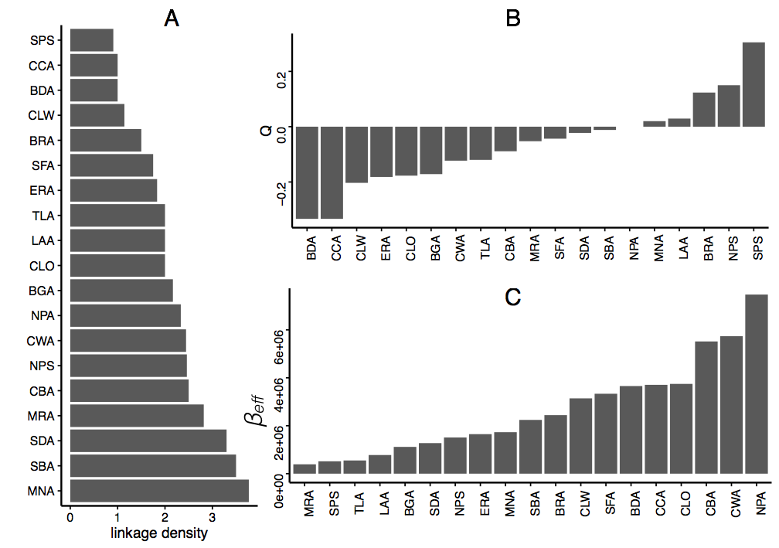

**Fig. S3.**

Pair plots of linkage density, modularity (*Q*) and resilience *βeff*. Histograms of each metrics distribution are plotted on the diagonal, and correlations are computed using Pearson’s correlation coefficient.

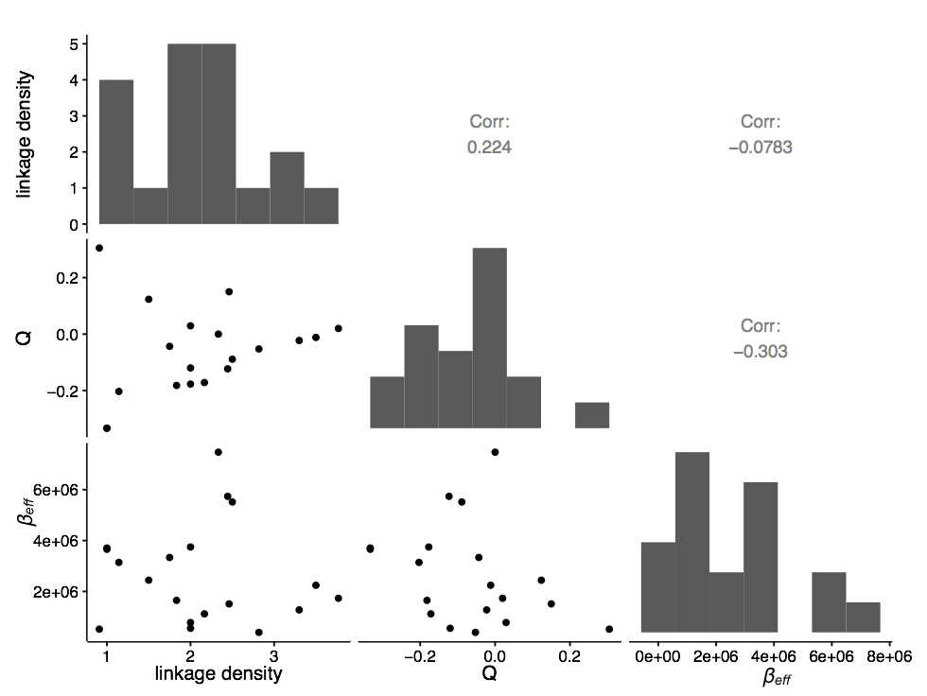

Using these participation networks we were also able to identify characteristic combinations of fisheries, which helps to move towards operationalizing the goal of making management match the scale of the system in which it’s embedded (Figures S3-S21). These linkages emphasize the importance of taking a systems perspective in these complex and highly interconnected systems. There are common combinations of fisheries that appear among these participation networks: pelagic purse seining dominated by market squid purse seine, combining pink shrimp and dover, thornyhead, sablefish trawl, albacore and chinook trolling. In the northern part of the coast, Dungeness crab appeared to be a general partner, to pairing well with all fisheries, in the south, spiny lobster had a similar role.

These participation motifs contribute novel observations that are unavailable from a solely ecological perspective. Many of the fisheries that are tightly connected by participation target species that are distantly related in food webs. The linkage between albacore tuna and Dungeness crab, for example, are two single species fisheries that are ecologically disparate (pelagic and benthic) and managed under two different systems (Dungeness crab is managed by states while Albacore is managed federally as a highly migratory species), yet are frequently found together in these participation networks. Understanding how management may cascade from one fishery to another, especially after the Dungeness crab pot fishery closure in 2015 is a natural next step of this work.

Other extensions include examination of second order properties of the participation networks. In particular, not only are the links between realized fisheries heterogeneous, they are changing over time as fishermen re-tool and learn new skills. Thus another key property may be the transitivity of the participation networks. Transitivity describes multi-step connections, and these are particularly important when considering how information may flow through these networks. Betweenness centrality is not unrelated to transitivity, but additional work on how information flow may be related to these network properties might provide management with a useful heuristic for determining a fishing community’s adaptive capacity.

This is the first time to our knowledge that the diversity and evenness of fisheries participation and interconnectivity has been examined across regions. This work has highlighted, in particular, that fisheries are not comprised of specialist fleets, and there appears to be strong regional variation in participation structure and network. This analysis has also highlighted the centrality of the Dungeness crab pot fishery across scales and along the coast and is the first to formally describe common participation strategies in the US West Coast commercial fisheries.

**Figs. S4-S23.**

Port group participation networks with fisheries labelled. Colors represent broad gear groups, yellow = hook and line, green = troll, brown = trawl, pink = shrimp trawl, teal = nets, purple = miscellaneous, and orange = pots.