**Accounting for human connectivity in social ecological systems**

*Mapping human connectivity provides new insights into ecosystem based management that may help to improve resilience in the face of global change.*

Emma Fuller, Jameal Samhouri, James Watson, Simon Levin

The rise and fall of California sardines and anchovies; Maine cod and lobster, Baltic cod, herring, and sprat are classic examples of fisheries dynamics that have driven major ecosystem-level changes with effects that rippled through coastal communities. In an era of accelerating rates of change and novel perturbations, understanding and predicting how such changes cascade throughout social-ecological systems is critical. This understanding is often challenged by a lack of empirical data and an operational, quantitative framework for organizing dynamical linkages between social and natural systems {Mace:2014bl}. This is a critical gap as most often it is people and social systems that are managed directly, rather than natural systems alone. Ecosystem based management (EBM), by recognizing the linkages among species, the biophysical environment and the people which depend on these intact systems, in many ways is a response to these types of far reaching disturbances. At this time, national and international marine ecosystem-based fisheries management policies are being implemented {NMFS:2015tp} but remain surprisingly silent on how to link fishermen, fisheries, and fish stocks in order to encourage thriving social and ecological systems.

The California Current large marine ecosystem is a good example. This system experiences huge climatic and oceanographic variability that drives ecological dynamics across a range of spatial scales. Fisheries in this system are highly diversified and valuable: the groundfish complex alone has six times the number of species federally managed as compared the US Northeast and landings in 2014 (the most recent for which records exist) were worth more than 700 million dollars. Between 2014 and 2015, as a result of “the blob”, a mass of unusually warm water occurred along the Pacific Coast. Salmon catches were directly affected, and disrupted marine ecosystems and shifted distributions of species. But because we lack methods to measure how fishing communities reacted, there are no measures of these human impacts. To address this mismatch between fishing communities and fisheries, we develop and apply a novel approach to identify links between disparate parts of the social system (i.e. vessels and fishing communities) and reveal connections among distinct portions of the ecological system (the fishes), and demonstrate how the architecture of networks can provide critical information for developing EBM advice.

In this paper we make use of landings records for for all commercial vessels on the US west-coast between 2009-2013 {PacificStatesMarineFisheriesCommission:l7asaLk3}. In this period commercial landings accounted for 1.6 million tons of 196 species, resulting in 1.8 billion dollars in revenue (adjusted to 2009 levels) by a total of 4,316 vessels at 88 ports. We classify these trips to fisheries (supp.) and build directed, weighted networks (hereafter ‘participation networks’) in which fisheries are connected by vessel participation (Figure). These edges then represent flows of fishing effort and/or information which may readjust in response to perturbations.

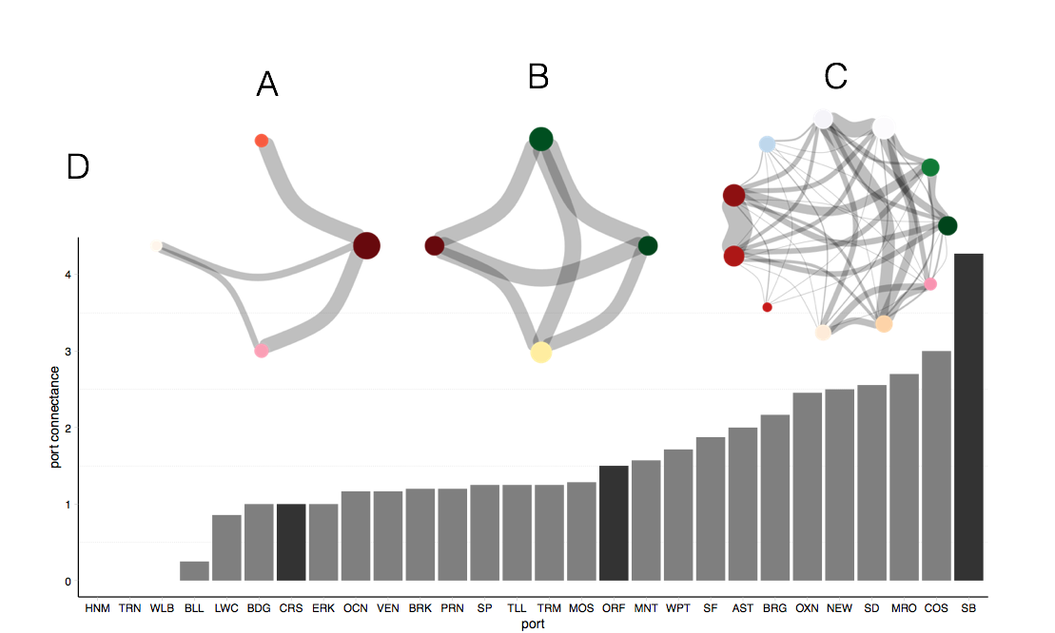

Applying classic network theory to these networks generate general, novel insights. These networks demonstrate a tradeoff in resilience at scales. At community (port) level more modular and heterogeneous networks (small world type) should be more resilient to perturbation, with perturbations restricted in the number of nodes affected. However higher connectance should increase individual resilience in that local losses tend to be repaired by subsidiary inputs from linked units until a critical stress level. Diassortivity in network connectance (highly connected nodes connected to many unconnected nodes) has previously been shown to be important in predicting how far impacts of a disturbance can spread. We find most networks are highly diassortive, organized around participation in relatively few fisheries. This means a perturbation at a single fishery, depending on its placement in a participation network could have much larger impacts than expected. We also find connections between ecologically unrelated species, suggesting that impacts from perturbations are likely to be move in ways counter-intuitive if the foodweb is all that is looked at.

This insight comes just as the Dungeness crab fishery experienced a widespread closure in 2015 due to toxic levels of domoic acid, likely related to ‘the blob’. We find that the Dungeness crab fishery is both central and dissassortive in most port participation networks, and thus important to most fishermen. Because of this fishery’s disassortative properties, the perturbation in this highly connected node has far reaching effects in most communities. But not all communities are equally likely to be affected: ones where connectance is heterogeneous and networks are more modular are likely to be in better shape. Importantly total crab revenue (or average proportion of revenue for fishermen) is not correlated with network structure, this allows nuance in how and where effects of crab closure will be felt.

This analysis provides a guide for what features should be included in ecosystem models, and helps to define the social fabric that underpins any understanding of social and social-ecological dynamics related to fisheries, and ocean ecosystems more generally (because fisheries are the most ubiquitous of human activities in the ocean). The approach represents a starting point, dissasortivity could incorporate, rather than connectance, more ecological measures to identify ports where people are poorly diversified across ecological gradients and/or market gradients. If you don’t measure it, you can’t manage it (Peter Drucker). Discussion of whether being ecologically rich protects social system