CHAPTER THREE
The effects of a management action on the broader marine socio-ecological system

Abstract
There is widespread recognition that ecosystem-based management requires an understanding of the connectivity within and between the human and ecological subcomponents of marine systems. Mapping these social-ecological connections have resulted in considerable insight, often by identifying drivers unobservable from social or ecological studies alone. This connectivity is particularly important in fisheries, where socioeconomic or ecological changes in one fishery often have cascading effects that ultimately influence another. Yet despite this recognition, social dynamics are often missing and fishing fleets are usually represented as homogenous, specialist, and static. My results highlight that on the contrary commercial fishing fleets on the US west coast are highly heterogeneous with the majority of vessels being generalists, and that a change in management is associated with a shift in patterns of participation across fisheries.

Introduction
The introduction of the Pacific Trawl Rationalization (catch share) program in the federal groundfish fishery in 2011 (cite the Federal Register) is just the kind of decision that is likely to create a cascade of social and ecological effects (Essington et al. PNAS, Costello et al. Science). Previous work examining the participation of vessels across fisheries has shown that in the absence of catch shares, management can act as a driver of fishing specialization (Hentati-Sundberg et al. 2014; Kasperski and Holland 2013) and lead to inefficiencies. A catch shares system guarantees each fisher an individual and tradeable quota, in theory ending the race to fish (CITE). It has also been shown that catch shares make fisheries more “efficient”, that is poor performing fishermen generally sell their quota to more successful fishermen. In the long run though, there is evidence to suggest that catch shares can lead to diminished participation in a fishery (REF). It is thus unclear how quota guarantees and changes in efficiency together influence entries and exits from fisheries, overall participation, and consequent diversification and connectivity among fisheries.
Here I use US west coast fisheries as a case study to develop a novel classification to: (i) describe participation of fishing vessels in fisheries with distinct ecological compositions, (ii) characterize the diversity of revenue streams and and participation across fisheries for individual vessels, and (iii) describe networks of fisheries participation for entire communities (ports). Our detailed study of fishery connectivity highlights the heterogeneous and dynamic nature of the social component of marine systems. In so doing, it underscores the gains to be had by incorporating such detail into existing conceptual and mathematical frameworks for EBFM.

Methods

Description of Data Sources
I collected vessel landings tickets for all commercial landings on the US west-coast between 2009-2013 from the Pacific Fisheries Information Network (PacFIN) database (www.psmfc.org). These data were filtered for vessels with an average of at least $5,000 in annual revenue and I further removed vessels that landed commercial catch in Alaska. I did not analyze landings from 2011, a management transition year in which catch shares were established. In doing so I restricted our analysis to fisheries landings before and after the implementation of catch shares. I also removed landings from vessels that participated in the California Halibut trawl fishery due to concerns about inconsistencies in landing tickets (REF?). This left 2,413 vessels that were responsible for approximately 93% of the total revenue and biomass commercially landed on the US west-coast during this period.

Defining Realized Fisheries
Fisheries are defined as harvest assemblages caught with a specific gear (van Putten et al. 2012; Boonstra and Hentati Sundberg 2014). The Pacific Fisheries Management Council (PFMC) has developed a set of sector-based definitions similar to this approach for the federally managed groundfish landings (www.pcouncil.org), but no equivalent exists for non-groundfish fisheries (Northwest Fisheries Science Center 2015). In order to treat the landings dataset uniformly, I applied a métier analysis to this landing data (Deporte et al. 2012) to build a set of realized fisheries. A métier analysis identifies realized fisheries by clustering the species composition of landings. This methodology requires choices in the way similarity among trips are measured, a clustering algorithm for grouping similar trips together, and a constraint that the methods can scale across hundreds of thousands of landings. In the following I specify our rational for these choices.
For our distance metric I used the Hellinger distance D (P. Legendre and Legendre 2012) to calculate the similarity in revenue profiles between trips and generated a pairwise distance matrix. This distance metric has the benefit that it is asymmetric, where the presence of a species in both trips is considered more informative than the absence of a species. The Hellinger distance between the species composition of two fishing trips A and B is defined as
$$D_{AB}= \sqrt{\sum_{i=1}^{S}{{\left(a_{i}-b_{i}\right)}^{2},}}$$ | (1)
where a_{i} is the fraction of revenue derived from species i on trip A, b_{i} is the fraction of revenue derived from species i on trip B, and S indicates the total number of species collected in both trips. With this metric, trips A and B become increasingly similar (and the Hellinger distance declines) as the proportion of revenue attributable to each of the S species becomes increasingly matched.
We identified realized fisheries as groups of trips with similar target assemblages using the infoMap community detection algorithm (Rosvall and Bergstrom 2008). This algorithm examines networks for subgraphs more interconnected to one another than the network in which it is embedded. To generate the required network I transformed the distance matrix into a similarity matrix by subtracting the distance metric’s upper limit (i.e. $\sqrt{2}$) from each pairwise distance. The result is a weighted, undirected network where trips are connected by edges proportional to their similarity. However, because our dataset contained 340,466 unique trips, I were not able to perform clustering using a single matrix containing all pairwise similarities. To obtain manageable matrix sizes I used one year of landings (2010) which I split by gear. Pairwise distances among trips and community detection were calculated within each gear partition, which grouped trips into target assemblage categories. To classify the 2009, 2012 and 2013 trips to fisheries, I assigned each unclassified trip to the same realized fishery as the 2010 trip to which it was closest in multi-dimensional space using a k-nearest neighbors algorithm.
A challenge in testing the effectiveness of this classification method, and part of the reason for its need, is that there is not an independent classification of US west coast fisheries that I could use to compare the results. To address this issue, I tested the reliability of our classification approach by evaluating the extent to which it identified known spatial and temporal structure of well-described US west coast fisheries and fishery sectors. Specifically, because I did not bound our clusters spatially, temporally, or by vessel characteristics, I were able to compare our emergent realized fisheries to existing sector definitions of groundfish, and groundfish impacting fisheries provided by the Northwest Fisheries Science Center Observer Program (Northwest Fisheries Science Center 2015).

Calculating Changes in Vessel and Community Level Fishing Diversity
Vessel revenue diversity is calculated using the effective Shannon index H (Jost 2006). This metric quantifies variability in the proportion of revenue p_{f} derived from each realized fishery f (identified from the clustering approach described above), such that revenue diversity H for vessel j is calculated as
$$H_{j}=e^{\sum_{f=1}^{F}{p_{f}\ln{p_{f}}}},$$
where F is the number of realized fisheries. I define specialist vessels as those that land in a single realized fishery (H = 1) and generalist vessels are vessels that land in more than realized fishery (H > 1).
To represent connectivity among realized fisheries at the port level I built directed, weighted networks where nodes represented a realized fishery, and the strength of the connections between nodes represented the number of vessels that landed catch in both over a given period. More formally, for each port k I built a network G_{k,XY} in which an edge weight between two nodes X and Y $E_{X→Y}$ was the number of vessels participating in fishery X and Y divided by the total number of vessels that participated in fishery X. Similarly, $E_{Y→X}$ is the number of vessels participating in both fisheries divided by the total number of vessels that participated in fishery Y (Fig. 1).
To measure port-level fisheries connectivity I calculated the link density (LD, number of edges divided by nodes) which scales both with network size and interconnectedness. Because the network is directed, this value can be interpreted as two times the average number of fisheries to which a fishery is connected (i.e. all vessels participate in both fisheries) at port k.
In order to test whether realized fishery participation at the vessel or port level changes as a function of the implementation of catch shares, I assigned vessels and ports to one of three categories: M₁, M₂ or M₃. M₁: vessels (ports) unaffected by catch shares were termed the general participants, which included only those vessels (ports) for which I observed no commercial landings in the catch-shares affected fishery in 2009-2010 or 2012-2013 (n_{vessels} = 1,878, n_{ports} = 52). M₁: catch share participants were those vessels (ports) had landings in the limited entry trawl fishery prior to 2011 and continued to have catch share quota landings after 2011 (n_{vessels} = 71, n_{ports} = 16). M₃:, limited entry exits were those vessels (ports) that landed in the limited entry trawl fishery prior to 2011, but had no landings using catch shares quota after 2011 (M₃, n_{vessels} = 35, n_{ports} = 10, Fig. 2). By comparing the general participants to vessels (ports) affected by catch shares (catch share participants and limit entry exits) I were able to control for exogenous inter-annual variation in revenue diversity present in both groups of vessels.

Effects of Catch Shares on Revenue Diversity and Fisheries Connectivity
We used linear regressions to determine whether a change from limited-entry to catch-shares management in the limited entry groundfish trawl sector was associated with a change in revenue diversity at the vessel level and/or a change in fisheries connectivity at the port level. For each vessel and port (henceforth I drop the indices for vessel and port for brevity) I calculated the change in revenue diversity as the difference in revenue diversity before (H_{pre}) and after (H_{post}) the implementation of catch shares as ΔH = H_{post} – H_{pre}. I defined a change in fisheries connectivity for each port as the difference in link density before (C_{pre}) and after (C_{post}) the implementation of catch shares as ΔC = C_{post} – C_{pre}. Thus a value of zero for ΔH or ΔC indicated there was no change in revenue diversity or fisheries connectivity for a given port, respectively, between the two periods, and a positive value indicated the vessel or port increased the evenness and/or the number of fisheries from which it received revenue.
At the vessel level, if catch shares allowed more flexibility in fisheries participation, I would expect that catch share participants would, on average, demonstrate increased revenue diversity after the implementation of catch shares. To this end, I conducted a linear regression to determine the relationship between ΔH and the three vessel categories M₁ (general participants), M₂ (catch share participants) and M₃ (limited entry exits). However, the ability to change diversity between two periods is related to the starting period diversity. For example, if a vessel is a specialist (i.e. H = 1), then it is impossible for that vessel to have a drop in diversity and any random variation will bias ΔH upwards. Similarly, if a vessel was maximally diversified, then the vessel could either remain the same or with a random drop in diversity. Thus, I also evaluated a model in which the pre-catch share revenue diversity H_{pre} of each vessel was a covariate.
At the port level, I used similar regressions to those employed at the vessel level, to determine whether a change to catch shares management in the limited entry groundfish trawl sector was associated with a change in fishery connectivity. Thus I also regressed ΔC against catch shares participation with and without C_{pre} to catch shares as a covariate.
In both the vessel and port level analyses, the Akaike Information Criterion (AIC) was used to find the most parsimonious model which balanced both the goodness of fit, as measured by likelihood, and model complexity, as measured by the number of parameters (Burnham and Anderson 2002). I calculated 95% confidence intervals by randomly selected data with replacement, from both the vessel and port datasets, and repeated this procedure 10,000 times.

Results

Realized Fisheries of the US West-coast
Applied to the landing ticket data, our clustering algorithm identified 109 realized fisheries (Appendix, Table 1). Realized fisheries often consisted of a single species, but could also comprise assemblages of species (Fig. S1a). Whether their catch consisted of a single species or multiple species, the realized fisheries were characterized by distinct temporal and spatial structure (Fig. S2a, b). This structure showed strong agreement with the NWFSC Observer sector designations, as did comparisons of vessel sizes and catch composition (single- vs. multi-species, Table 1).
The realized fisheries also varied by several orders of magnitude in effort (number of trips) and revenue (Fig. S1b), with a small number of fisheries accounting for the majority of effort and revenue. For example, only 10 of the 109 fisheries were responsible for 90% of ex-vessel revenue and landings (pounds) in the time period I examined (Table 1). These fisheries include well-studied, but not quantitatively described sectors such as the dungeness crab pot (Botsford and Wickham 1978), spiny lobster pot (Kay et al. 2012), and red urchin diving (Smith and Wilen 2003).

Vessel and Community Level Fishing Diversity
We found that between the start of 2009 and the end of 2010, 66% of commercial vessels on the west coast participated in more than one realized fishery (Fig. 2a) although the degree to which vessels diversified varied. Breaking these patterns down regionally using PFMC management regions, generalists outnumbered specialists (Fig. 2b). The distribution of diversity varied among the generalists, from vessels that were highly specialized, but had a few landings in additional fisheries to those that fished in many fisheries evenly (Fig. 2c). Notably, the majority of diversified vessels revenue was dominated by revenue from a single fishery (71%), with very small percentages coming from alternatives. However almost a quarter (24%) of diversified vessels were participating in at least two fisheries equally, with some vessels (4%) participating evenly in more than three fisheries (Fig. 2c).
We also found differences in the number and interconnectedness of fisheries across ports (Fig. 3). Ports had between 0 and 7 fisheries that were connected. This variation is exemplified by participation networks in Santa Barbara, CA, Eureka, CA, and Oakland, CA (Figs. 3a-c). Santa Barbara was characterized by a complex participation network, with more than double the average link density of Eureka (see Appendix for all port participation networks). Most ports had a spectrum of vessels landing at them and I found that there was a positive, albeit weak, relationship between vessel and port level diversity (Spearman’s correlation 0.185, p < 2.2e-16, Fig S3).

Effects of catch shares management on individual vessel diversification and community-level participation networks
Two-thirds (66%) of vessels that operated in the catch shares affected fishery continued to participate in it following the implementation of catch shares, while only a minority (6%) of vessels left commercial fishing altogether. Of vessels which continued fishing in the catch-shares fishery, 87% of vessels adjusted their fishing participation, entering or exiting new fisheries. A third group consisted of vessels that exited catch shares but continued to fish commercially (28%) (Fig 4). These vessels showed a mixed response, with increased and decreased fishing diversity observed.
Over our study time period, vessels that continued to fish became more diversified on average (Fig 4). Vessels that participated in catch shares, post 2011, saw an increase in their revenue diversity that was twice that for vessels which exited the catch share fishery. Notably, the change in revenue diversity was strongly explained by the revenue diversity the vessels had prior to the implementation of catch shares (in 2009-2010). Vessels with higher (lower) participation diversity prior to catch shares were more likely to show a reduction (increase) in diversity following catch shares (Table S2).
At the port level I found that ports that there was a non-significant increase in fisheries connectivity by approximately 5% on average (two sided t-test p-value = 0.3287), and this was predicted by previous fisheries connectivity (C_{pre}) (Table S1, S2). However, the model which best explained the change in fisheries connectivity did not include terms for a port’s relationship to catch shares (M_{n}).

Discussion
There is widespread recognition that ecosystem-based fishery management requires an understanding of the connectivity within and between the human and ecological subcomponents of marine systems (Anderson et al. 2015). Mapping these social-ecological connections has resulted in considerable insight, often by identifying drivers unobservable from social or ecological studies alone (Brashares et al. 2004; Lade et al. 2015). This connectivity is particularly important in fisheries, where socioeconomic or ecological changes in one fishery can have cascading effects that ultimately influence others (Steneck et al. 2011; Lade et al. 2015). Yet despite this recognition, social dynamics are often missing and fishing fleets are usually represented as homogenous and non-interacting (Field 2004). Our results highlight that on the contrary fishing fleets are highly heterogeneous and continually changing in size, effort level, and composition, as numerous exogenous and endogenous forces influence them (Opaluch and Bockstael 1984). More generally, this study highlights a perhaps underappreciated aspect of social-ecological systems: as in food webs and social networks, the consequences of environmental and management changes are determined large part by the connectivity between nodes.
We found that the majority of vessels on the US west coast engage in multiple fisheries and that the implementation of the Pacific Trawl Rationalization program appears to have changed patterns of participation across fisheries. Greater than 60% of commercial fishing vessels were generalists, participating in more than one realized fishery. The revenue of each of these generalists was thus tied to multiple fisheries, effectively connecting them and setting up the potential for linked social-ecological dynamics that were previously invisible. The social implications of generalist fishing practices with corresponding diversified revenue portfolios have been most directly related to reduced exposure to income risk (Kasperski and Holland 2013; Sethi, Reimer, and Knapp 2014), with previous work identifying that vessels with more diverse revenue streams have less variable revenues (Kasperski and Holland 2013). In contrast to US west coast fisheries, Steneck et al. (2011) has documented how Maine fishermen have increasingly become dependent on a single species due to interactions among markets and ecological conditions. In addition, Hentati-Sundberg et al. (2014) and Stoll et al. (2016) have shown how commercial fishermen in Sweden and the Gulf of Maine respectively have grown increasingly specialized as management became more restrictive. Thus, while many forms of management can be constraining, reducing the portfolio of fisheries prosecuted by individual fishermen, catch shares management may expand portfolios. Further study is needed to determine whether the ubiquity of generalists on the US west-coast is indicative of systemic risk-adverse behavior, and whether revenue diversity confers a general resilience in fishermen’s revenues to perturbation, such as diminished catch due to exogenous environmental factors or a change in management or markets of particular fisheries.
Much of the previous research on fishery diversity and revenue variability (REFs) has focused primarily on the impacts of catch shares on the vessels that have continued to operate within the fishery of interest, assuming that vessels that exit also exit commercial fishing entirely. Our analysis shows that for the US west-coast, the majority of vessels that participated in the groundfish fishery prior to the implementation of catch shares, continued to operate after the management change albeit in other realized fisheries. This highlights the need to quantify how a management change, or any other perturbation, is felt throughout the marine social-ecological system as vessels/individuals reorganize their participation across realized fisheries.
The redistribution of fishing effort across a fisheries participation network is directly analogous to (changes in) predation pressure in a food-web. Specifically, if I think of vessels as predators, then the realized fisheries that they participate in are their prey. As I have shown, there are many specialist vessel/predators, but the majority of fishermen/vessels are generalist predators with a broad diet preference. In natural systems, a predator’s diet preference is largely determined by the physiological adaptations of the predator. Here, the analogy extends to the gear and skill that each vessel has.
This is relevant when considering the redistribution of fishing effort across participation networks. Vessels geared and skilled at harvesting certain sets of species, will not immediately start harvesting other target species that require completely different gear and skills. This is reflected in the different realized fisheries that any one vessel participates in over a given year, and in general it is related to the topology of the participation networks.
For example, if there is a pair of species that are unconnected ecologically (i.e. there is no link between them in the food-web), but there are vessels that harvest both (i.e. there is a link in the participation network between these species’ realized fisheries), then there is a transitive link. As a consequence, a management change that affects vessel participation in one fishery, will affect that status of the (ecologically unconnected) stock of the other species. Dungeness crab and albacore tuna fisheries on the US west coast provide an appealing (but currently untested) example. Here, I find these two realized fisheries to be commonly connected by vessels at the port level, yet these species do not interact directly in the ocean. Examining changes in revenue diversity and vessel participation in the albacore tuna fishery after the recent closure of the Dungeness crab fishery in Washington and Oregon would be an excellent test of how connectivity influences fisheries participation. In general, environmental or management perturbations will ripple through these participation networks, and that their topology as well as the adaptability of fishermen, will largely determine their economic impacts.
In conclusion, our results highlight the need to consider fisheries as connected and dynamic entities. Not only does EBFM need to acknowledge the links between species in food-webs, but there needs to be an equal emphasis on the connectivity between fisheries, based on the participation of vessels, and on the economic consequences of the topology of the participation networks. I have shown that fishery participation is heterogeneous, varying greatly from place to place, and dynamic, responding to the implementation of catch shares in the groundfish fishery. If I can broaden the conceptual and mathematical models of marine systems to include such properties, then I will be truly on our way to developing systems-based fisheries management, which is likely to lead to better performing governance institutions in the future.

Acknowledgements
We thank PacFin for access to the data, the observers and fishermen on the US west coast for insightful discussions, and Emily Klein for discussions on this project. I acknowledge support from the National Science Foundation (GRFP, GEO-1211972) and GreenMar (Consortium Agreement GreeMar-AGMT dtd 05-05-2014, Prime Nordforsk Project Number: 61582).

Tables
Table 1. I summarize fleet characteristics for three realized fisheries and compare to the corresponding NWFSC Observer sector description. Parenthetical values represent the percentage of trips which fell within expected ranges. The following fisheries represent (with pink shrimp and limited entry groundfish) the top ten realized fisheries by revenue. Fleet characteristics for which no corresponding NWSFC observer sector is present are presented as 95 percentiles for length, latitude and seasonality.
Fishery  Sector name if applicable | Latitude  decimal degrees | Catch composition  % trips multispecies | Seasonality  fishing season | Vessel Length  ± 1 ft
Limited entry groundfish trawl/catch shares | 35.4-49  (97.9%) | 100%  (98.2%) | year-round | 35-95  (99.5%)
Pink shrimp trawl | 35.8-49  (97.9%) | NA | Apr 1 – Oct 31  (99.8%) | 38-105  (100%)
California halibut trawl | 37.4 – 34.05  (96.5%) | CA halibut dominated | year-round | 29-71  (99.8%)
Dungeness crab pots | 36.8-47.6 | 0.9% | Oct 26 – Aug 8 | 22-67
Market squid seine | 33.7-36.8 | 6.8% | May 24 – Feb 25 | 36-80
Albacore troll | 37.5-46.9 | 0.6% | Jul 10-Oct 22 | 23-72.5
Sablefish long-line | 33.2-48.4 | 70% | Jan 16-Dec 15 | 20-57
Shore-side Hake | 43.3-46.9 | 92% | Jun 16-Nov 15 | 65-129
Chinook salmon troll | 35.4-48.4 | 14% | Apr 11-Oct 22 | 20-50
Sardine seine | 33.7-46.9 | 42% | Jan 8-Oct 22 | 45-80
Spiny lobster pot | 32.7-34.4 | 8.3% | Oct 5-Mar 12 | 18-42

Figures
Figure 1. Using landing tickets I used price per pound (ppp) and landed weight to calculate revenue per species per trip. I aggregated this landings to trips and grouped trips by gear. In each gear partition I identified realized fisheries by measuring pairwise similarity of each trip’s revenue composition of catch using the Hellinger distance, and clustered using infoMap. Using these fishery designations I mapped participation at the vessel level, quantifed revenue diveristy and fisheries connectivity at the port level.
Figure 2. Distribution of revenue diversity at the vessel level measured as the effective shannon index of revenue plotted in three different ways: A) coastwide, B) by management region, and C) breakdown of generalism for each management sector. I defined generalists as vessels that landed in more than one realized fishery. I found that generalists outnumbered specialists (A, B), although the degree of generalism varied (C).

Figure 3. Spectrum of fisheries connectivity present in fishing communities on the US west coast as illustrated by participation networks for A) Santa Barbara, CA; B) Eureka, CA; and C) Oakland, CA. Here nodes represent realized fisheries where edge width is proportional to the proportion of vessels that participate in the connected fisheries. Vertex size is proportional to the log number of vessels which participate in each realized fishery. Color of nodes is consistent across networks, reds represents pots, greens are hook and line, blues are nets, pinks are shrimp trawls, oranges are groundfish trawl, purples are miscellaneous and yellows are troll fisheries. D) Fisheries connectivity, measured as link-density for all ports on US west coast with more than three vessels landing between 2009-2010. Dark bars correspond to the network above them.

Figure 4. I map the ways that a vessel can respond to the implementation of catch shares. Vessels that were directly affected by catch share implementation are those that fished in the limited entry (LE) groundfish fleet between 2009-2010. After 2011, vessels either continue to participate in the groundfish trawl fishery by landing with quota, or leave the catch share fishery and either leave commercial fishing entirely or continue to fish in other commercial fisheries. The width of the bar in the decision tree is proportional to the absolute number of vessels which follow a given path given by the number. Percentages are relative to each decision point. I find that very few vessels which stopped fishing in the groundfish fishery actually left commercial fishing altogether, and vessels which participated in catch shares changing their participation across fisheries.

Figure 5. Estimated effects of catch shares on revenue diversity for vessels, bars represent 95% confidence intervals. Vessels that participate in catch share increase in revenue diversity more than either the general participants or those that exited catch shares. At the port level the best supported model does not include a term for participation in catch shares.

Literature Cited
Anderson, James L, Christopher M Anderson, Jingjie Chu, Jennifer Meredith, Frank Asche, Gil Sylvia, Martin D Smith, et al. 2015. “The Fishery Performance Indicators: a Management Tool for Triple Bottom Line Outcomes.” Edited by George Tserpes. PloS One 10 (5): e0122809–20. doi:10.1371/journal.pone.0122809.
Baskerville, Edward B, Andy P Dobson, Trevor Bedford, Stefano Allesina, T Michael Anderson, and Mercedes Pascual. 2011. “Spatial Guilds in the Serengeti Food Web Revealed by a Bayesian Group Model.” Edited by Lauren Ancel Meyers. PLoS Computational Biology 7 (12). Public Library of Science: e1002321. doi:10.1371/journal.pcbi.1002321.
Boonstra, Wiebren J, and Jonas Hentati Sundberg. 2014. “Classifying Fishers' Behaviour. an Invitation to Fishing Styles,” August, n–a–n–a. doi:10.1111/faf.12092.
Botsford, Louis W, and Daniel E Wickham. 1978. “Behavior of Age-Specific, Density-Dependent Models and the Northern California Dungeness Crab ( Cancer Magister) Fishery.” Journal of the Fisheries Research Board of Canada 35 (6): 833–43. doi:10.1139/f78-134.
Brashares, Justin S, Peter Arcese, Moses K Sam, Peter B Coppolillo, A R E Sinclair, and Andrew Balmford. 2004. “Bushmeat Hunting, Wildlife Declines, and Fish Supply in West Africa.” Science (New York, N.Y.) 306 (5699). American Association for the Advancement of Science: 1180–83. doi:10.1126/science.1102425.
Burnham, Kenneth P, and David R Anderson. 2002. Model Selection and Multimodel Inference: a Practical Information-Theoretic Approach. Edited by Springer Science & Business Media.
Coleman, Felicia C, Will F Figueira, Jeffrey S Ueland, and Larry B Crowder. 2004. “The Impact of United States Recreational Fisheries on Marine Fish Populations..” Science (New York, N.Y.) 305 (5692): 1958–60. doi:10.1126/science.1100397.
Costello, Christopher, Steven D Gaines, and John Lynham. 2008. “Can Catch Shares Prevent Fisheries Collapse?.” Science (New York, N.Y.) 321 (5896): 1678–81. doi:10.1126/science.1159478.
Deporte, N, C Ulrich, S Mahevas, S Demaneche, and F Bastardie. 2012. “Regional Metier Definition: a Comparative Investigation of Statistical Methods Using a Workflow Applied to International Otter Trawl Fisheries in the North Sea.” ICES Journal of Marine Science 69 (2): 331–42. doi:10.1093/icesjms/fsr197.
Field, John C. 2004. “Application of Ecosystem-Based Fishery Management Approaches in the Northern California Current .” Edited by Robert C Francis.
Fulton, Elizabeth A, Anthony D M Smith, David C Smith, and Ingrid E van Putten. 2010. “Human Behaviour: the Key Source of Uncertainty in Fisheries Management.” Fish and Fisheries 12 (1): 2–17. doi:10.1111/j.1467-2979.2010.00371.x.
Hentati-Sundberg, J, J Hjelm, W J Boonstra, and H Österblom. 2014. “Management Forcing Increased Specialization in a Fishery System.” Ecosystems 18 (1). Springer US: 45–61. doi:10.1007/s10021-014-9811-3.
Jost, Lou. 2006. “Entropy and Diversity.” Oikos 113 (2): 363–75.
Kasperski, S, and D S Holland. 2013. “Income Diversification and Risk for Fishermen.” Proceedings of the National Academy of Sciences. doi:10.1073/pnas.1212278110/-/DCSupplemental.
Kay, Matthew C, Hunter S Lenihan, Carla M Guenther, Jono R Wilson, Christopher J Miller, and Samuel W Shrout. 2012. “Collaborative Assessment of California Spiny Lobster Population and Fishery Responses to a Marine Reserve Network..” Ecological Applications : a Publication of the Ecological Society of America 22 (1): 322–35.
Lade, Steven J, Susa Niiranen, Jonas Hentati Sundberg, Thorsten Blenckner, Wiebren J Boonstra, Kirill Orach, Martin F Quaas, Henrik Österblom, and Maja Schlüter. 2015. “An Empirical Model of the Baltic Sea Reveals the Importance of Social Dynamics for Ecological Regime Shifts..” Proceedings of the National Academy of Sciences of the United States of America 112 (35): 11120–25. doi:10.1073/pnas.1504954112.
Legendre, P, and L Legendre. 2012. Numerical Ecology. Elsevier.
Levin, Phillip S, Michael J Fogarty, Steven A Murawski, and David Fluharty. 2009. “Integrated Ecosystem Assessments: Developing the Scientific Basis for Ecosystem-Based Management of the Ocean.” PLoS Biology 7 (1): e1000014–16. doi:10.1371/journal.pbio.1000014.
Mace, Georgina M. 2014. “Ecology. Whose Conservation?.” Science (New York, N.Y.) 345 (6204). American Association for the Advancement of Science: 1558–60. doi:10.1126/science.1254704.
Millennium Ecosystem Assessment. 2005. “Ecosystems and Human Well-Being: Synthesis.” Island Press. Washington, DC.
Northwest Fisheries Science Center. 2015. “Data Analysis and Products.” Fisheries Observation Science. Seattle, WA. Accessed December 8. http://www.nwfsc.noaa.gov/research/divisions/fram/observation/data_products/bottom_trawl.cfm#description.
Opaluch, J J, and N E Bockstael. 1984. “Behavioral Modeling and Fisheries Management.” Marine Resource Economics. doi:10.2307/42628847.
Rosvall, Martin, and Carl T Bergstrom. 2008. “Maps of Random Walks on Complex Networks Reveal Community Structure.” Proceedings of the National Academy of Sciences 105 (4). National Acad Sciences: 1118–23. doi:10.1073/pnas.0706851105.
Sethi, S A, M Reimer, and G Knapp. 2014. “Alaskan Fishing Community Revenues and the Stabilizing Role of Fishing Portfolios.” Marine Policy. doi:10.1016/j.marpol.2014.03.027.
Smith, Martin D, and James E Wilen. 2003. “Economic Impacts of Marine Reserves: the Importance of Spatial Behavior.” Journal of Environmental Economics and Management 46 (2): 183–206. doi:10.1016/S0095-0696(03)00024-X.
Steneck, R S, T P Hughes, J E CINNER, W N ADGER, S N ARNOLD, F BERKES, S A BOUDREAU, et al. 2011. “Creation of a Gilded Trap by the High Economic Value of the Maine Lobster Fishery.” Conservation Biology 25 (5): 904–12. doi:10.1111/j.1523-1739.2011.01717.x.
van Putten, Ingrid E, Soile Kulmala, Olivier Thébaud, Natalie Dowling, Katell G Hamon, Trevor Hutton, and Sean Pascoe. 2012. “Theories and Behavioural Drivers Underlying Fleet Dynamics Models.” Fish and Fisheries 13 (2): 216–35. doi:10.1111/j.1467-2979.2011.00430.x.

Supplemental information

A) Realized Fisheries
1) | pot_1 | Dungeness crab | crab pot | 45 | 23 | 32 | 105532 | no | 1194
2) | msc_1 | red sea urchin | diving gear | 80 | 20 | NA | 58224 | no | 211
3) | tls_1 | chinook salmon | troll | 50 | 25 | 25 | 39383 | no | 1481
4) | pot_2 | California spiny lobster | crab & lobster pot | 100 | NA | NA | 28588 | no | 253
5) | hkl_1 | sablefish | longline | 66 | 15 | 19 | 25026 | no | 595
6) | net_1 | market squid | seine | 100 | NA | NA | 20325 | no | 154
7) | hkl_2 | black rockfish | other hook & line | 67 | 33 | NA | 18358 | no | 342
8) | tls_2 | albacore | troll | 42 | 26 | 32 | 13851 | no | 1260
9) | pot_3 | rock crab | crab & lobster pot | 100 | NA | NA | 11806 | no | 203
10) | hkl_4 | brown rockfish, gopher rockfish | pole (commercial) | 90 | 10 | NA | 10200 | yes | 209
11) | hkl_3 | California halibut | pole (commercial) | 100 | NA | NA | 9350 | no | 630
12) | twl_1 | dover sole | roller-trawl | 59 | 23 | 18 | 8305 | no | 125
13) | net_2 | pacific sardine | seine | 74 | 16 | 11 | 7169 | no | 116
14) | tws_1 | pacific pink shrimp | double-shrimp trawl | 20 | 50 | 30 | 6208 | no | 105
15) | pot_5 | spotted prawn | prawn trap | 81 | NA | 19 | 5823 | no | 37
16) | pot_6 | unsp. hagfish | fish pot | 50 | 18 | 32 | 5630 | no | 137
17) | hkl_5 | lingcod | other hook & line, pole (commercial) | 63 | 25 | 12 | 5502 | no | 612
18) | pot_4 | sablefish | fish pot | 62 | 25 | 12 | 5393 | no | 283
19) | net_3 | California halibut | gillnet | 100 | NA | NA | 4946 | no | 63
20) | twl_2 | California halibut | groundfish trawl<8 | 100 | NA | NA | 4703 | no | 55
21) | hkl_6 | black-and-yellow rockfish, Cabazon, grass rockfish | pole (commercial), vertical hook & line | 74 | 26 | NA | 4634 | yes | 201
22) | msc_2 | unsp. sea cucumbers | diving gear | 95 | 5 | NA | 4384 | no | 92
23) | hkl_7 | white seabass | pole (commercial) | 100 | NA | NA | 3372 | no | 387
24) | net_4 | white seabass | gillnet | 100 | NA | NA | 3292 | no | 55
25) | net_5 | pacific herring | gillnet | 89 | NA | 11 | 3270 | no | 157
26) | twl_3 | unsp. bait shrimp | beam trawl | 100 | NA | NA | 2384 | no | 10
27) | tws_2 | ridgeback prawn | single-shrimp trawl | 85 | NA | 15 | 2203 | no | 24
28) | twl_4 | unsp. sea cucumbers | groundfish trawl | 100 | NA | NA | 2106 | no | 48
29) | hkl_8 | vermilion rockfish | pole (commercial) | 79 | 21 | NA | 1878 | no | 263
30) | net_7 | swordfish, common thresher shark | drift gillnet | 100 | NA | NA | 1510 | yes | 82
31) | net_6 | unsp. shad | dip net | 100 | NA | NA | 1362 | no | 10
32) | net_8 | chub mackerel | dip net | 90 | 10 | NA | 1283 | no | 51
33) | tws_3 | California halibut | single-shrimp trawl | 69 | 23 | 8 | 1239 | no | 43
34) | pot_8 | other shrimp | prawn trap | 67 | 33 | NA | 1177 | no | 33
35) | net_9 | northern anchovy | seine | 81 | 6 | 12 | 1170 | no | 45
36) | hkl_9 | unsp. sanddabs | pole (commercial) | 100 | NA | NA | 1159 | no | 97
37) | msc_4 | Dungeness crab | other-known | 17 | 83 | NA | 1102 | no | 92
38) | pot_11 | Cabazon, gopher rockfish | fish pot | 80 | 20 | NA | 1087 | yes | 70
39) | msc_5 | basket cockle | other-known | 73 | 27 | NA | 985 | no | 44
40) | msc_3 | unsp. bait shrimp | other-known | 25 | NA | 75 | 922 | no | 11
41) | hkl_10 | albacore | pole (commercial) | 91 | 3 | 6 | 780 | no | 285
42) | pot_9 | California sheephead | fish pot | 100 | NA | NA | 722 | no | 40
43) | twl_5 | chinook salmon | selective flat fish trawl, groundfish trawl<8, mid-water trawl | 70 | 20 | 10 | 615 | yes | 83
44) | twl_7 | pacific whiting | mid-water trawl | 29 | 43 | 29 | 599 | no | 29
45) | msc_6 | swordfish | other-known | 100 | NA | NA | 515 | no | 35
46) | tws_8 | unsp. bait shrimp | single-shrimp trawl | 100 | NA | NA | 402 | no | 3
47) | pot_10 | other crab | crab & lobster pot | 89 | 11 | NA | 378 | no | 84
48) | hkl_11 | California sheephead | pole (commercial) | 94 | 6 | NA | 375 | no | 50
49) | msc_8 | gaper clam | other-known | NA | 100 | NA | 342 | no | 10
50) | hkl_13 | California scorpionfish | pole (commercial) | 100 | NA | NA | 329 | no | 14
51) | tws_4 | unsp. sea cucumbers | single-shrimp trawl | 100 | NA | NA | 324 | no | 20
52) | pot_7 | Dungeness crab, rock crab | crab & lobster pot | 69 | 19 | 11 | 318 | yes | 156
53) | hkl_15 | pacific halibut | longline | 6 | 69 | 25 | 297 | no | 115
54) | hkl_18 | surfperch spp. | pole (commercial) | 100 | NA | NA | 262 | no | 32
55) | hkl_17 | yellowtail | pole (commercial) | 100 | NA | NA | 232 | no | 68
56) | tls_5 | California halibut | troll | 100 | NA | NA | 228 | no | 53
57) | pot_12 | other mollusks | crab & lobster pot | 100 | NA | NA | 226 | no | 56
58) | hkl_14 | common thresher shark | pole (commercial) | 100 | NA | NA | 213 | no | 47
59) | net_12 | pacific barracuda | drift gillnet | 100 | NA | NA | 209 | no | 16
60) | hkl_12 | Bluefin tuna, pacific sanddab | pole (commercial) | 78 | 22 | NA | 207 | yes | 117
61) | net_11 | other crab | gillnet | 100 | NA | NA | 194 | no | 16
62) | hkl_16 | unsp. smelt | pole (commercial) | 100 | NA | NA | 173 | no | 13
63) | twl_11 | other crab, other shrimp | groundfish trawl | 100 | NA | NA | 163 | yes | 14
64) | msc_11 | unsp. mollusks | diving gear | 100 | NA | NA | 149 | no | 8
65) | hkl_19 | shortfin mako shark | pole (commercial) | 100 | NA | NA | 145 | no | 34
66) | pot_13 | unsp. octopus | crab pot | 67 | 33 | NA | 145 | no | 70
67) | msc_9 | other sea urchins | diving gear | 100 | NA | NA | 136 | no | 44
68) | hkl_26 | chinook salmon | pole (commercial) | 100 | NA | NA | 114 | no | 53
69) | tls_4 | unsp. sanddabs | troll | 71 | 21 | 8 | 108 | yes | 77
70) | tls_8 | lingcod | troll | 44 | 44 | 12 | 103 | no | 60
71) | hkl_24 | unsp. reds rockfish | pole (commercial) | 100 | NA | NA | 98 | no | 28
72) | msc_10 | butter clam | other-known | NA | 100 | NA | 86 | no | 6
73) | twl_12 | yellowtail rockfish | selective flat fish trawl, mid-water trawl, roller-trawl | NA | 40 | 60 | 86 | no | 26
74) | twl_8 | lingcod | selective flat fish trawl, mid-water trawl, roller-trawl | 25 | 38 | 38 | 84 | no | 27
75) | tws_6 | unsp. flatfish | single-shrimp trawl | 100 | NA | NA | 83 | no | 7
76) | hkl_20 | unsp. shelf rockfish | pole (commercial) | 100 | NA | NA | 82 | no | 6
77) | hkl_22 | pacific barracuda | pole (commercial) | 100 | NA | NA | 76 | no | 45
78) | hkl_21 | leopard shark | pole (commercial) | 100 | NA | NA | 65 | no | 29
79) | msc_12 | other mollusks | diving gear | 78 | 22 | NA | 65 | no | 29
80) | hkl_23 | swordfish | longline | 100 | NA | NA | 57 | no | 16
81) | tls_7 | yellowtail rockfish | troll | 38 | 38 | 25 | 48 | no | 29
82) | twl_9 | nor. unsp. slope rockfish | roller-trawl | NA | 75 | 25 | 44 | no | 28
83) | hkl_25 | unsp. squid | longline, other hook & line, pole (commercial) | 70 | 30 | NA | 41 | no | 12
84) | hkl_27 | unsp. rockfish | pole (commercial) | 92 | NA | 8 | 37 | no | 21
85) | tws_9 | other crab, rock crab | single-shrimp trawl | 100 | NA | NA | 37 | yes | 10
86) | pot_14 | unsp. eels | fish pot | 100 | NA | NA | 36 | no | 13
87) | twl_10 | pop | roller-trawl | NA | 100 | NA | 36 | no | 17
88) | twl_13 | canary rockfish, spiny dogfish | mid-water trawl | NA | 75 | 25 | 34 | yes | 19
89) | twl_14 | spiny dogfish | selective flat fish trawl, groundfish trawl<8, mid-water trawl | 50 | 25 | 25 | 33 | no | 7
90) | msc_14 | California sheephead | diving gear | 100 | NA | NA | 27 | no | 6
91) | tls_9 | sablefish | troll | 64 | NA | 36 | 27 | no | 22
92) | tws_7 | other shrimp | single-shrimp trawl | 100 | NA | NA | 23 | no | 3
93) | msc_13 | black-and-yellow rockfish | diving gear | 100 | NA | NA | 22 | no | 6
94) | msc_16 | unsp. echinoderm | diving gear | 100 | NA | NA | 21 | no | 5
95) | tls_3 | albacore | troll | 47 | 20 | 33 | 21 | no | 21
96) | twl_6 | petrale sole | groundfish trawl<8 | 100 | NA | NA | 20 | yes | 6
97) | tws_10 | other skates | single-shrimp trawl | 100 | NA | NA | 19 | no | 5
98) | msc_7 | unsp. sea cucumbers | diving gear | 100 | NA | NA | 18 | no | 7
99) | tls_6 | white seabass | troll | 100 | NA | NA | 18 | no | 7
100) | msc_18 | unsp. flatfish | diving gear | 100 | NA | NA | 17 | no | 6
101) | net_10 | pacific sardine | seine | 100 | NA | NA | 14 | no | 10
102) | msc_15 | unsp. shad | unknown gear | 100 | NA | NA | 10 | no | 2
103) | msc_17 | shortfin mako shark | other-known | 100 | NA | NA | 9 | no | 6
104) | hkl_28 | unsp. octopus | longline, other hook & line, pole (commercial) | 25 | 75 | NA | 8 | no | 6
105) | hkl_29 | nor. unsp. shelf rockfish | other hook & line | NA | 100 | NA | 5 | no | 4
106) | tws_5 | hornyhead turbot, ridgeback prawn, unsp. hagfish | single-shrimp trawl | 100 | NA | NA | 4 | yes | 3
107) | tls_10 | yellowtail | troll | NA | 100 | NA | 3 | no | 3
108) | tws_11 | white seabass | single-shrimp trawl | 100 | NA | NA | 3 | no | 2
109) | tws_12 | vermilion rockfish | single-shrimp trawl | 100 | NA | NA | 3 | no | 2

B) Evaluating realized fisheries classification
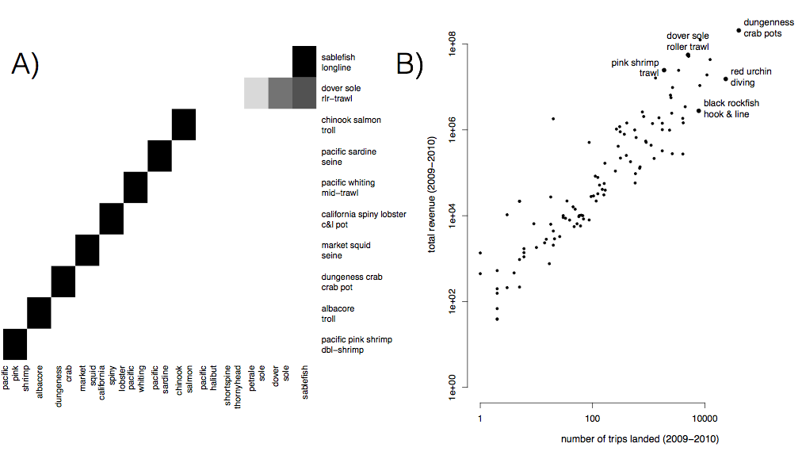
Figure S1. A) Species composition for top ten realized fisheries (rows). Cell color represents the proportion of landings for which each species (column) is responsible. Most of the biggest realized fisheries are composed of primarily a single species, but groundfish trawl is multispecies. B) Comparison of effort and revenue for all realized fisheries between 2009-2010.

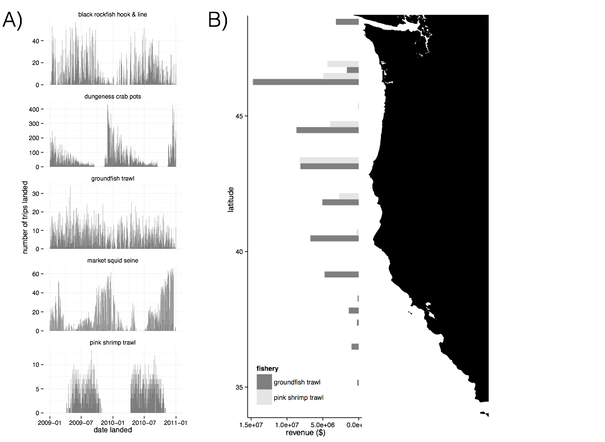
Figure S2. A) Seasonality of five major realized fisheries between 2009-2010. Distinct seasonal patterns are observed in dungeness crab, market squid and pink shrimp fisheries. B) Spatial structure of landings for two example fisheries between 2009-2010. Landings are binned by latitude. Pink shrimp trawl is landed further north, while groundfish trawl landings are distributed more evenly across the coast.

C) Port participation networks
[will be here eventually, makes word document unweildy at the moment, below is one as an example]
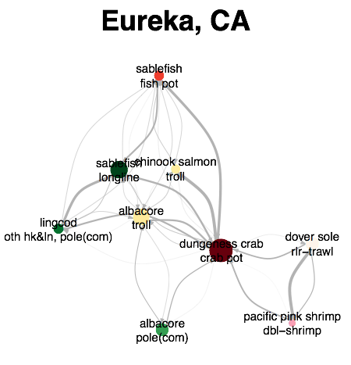
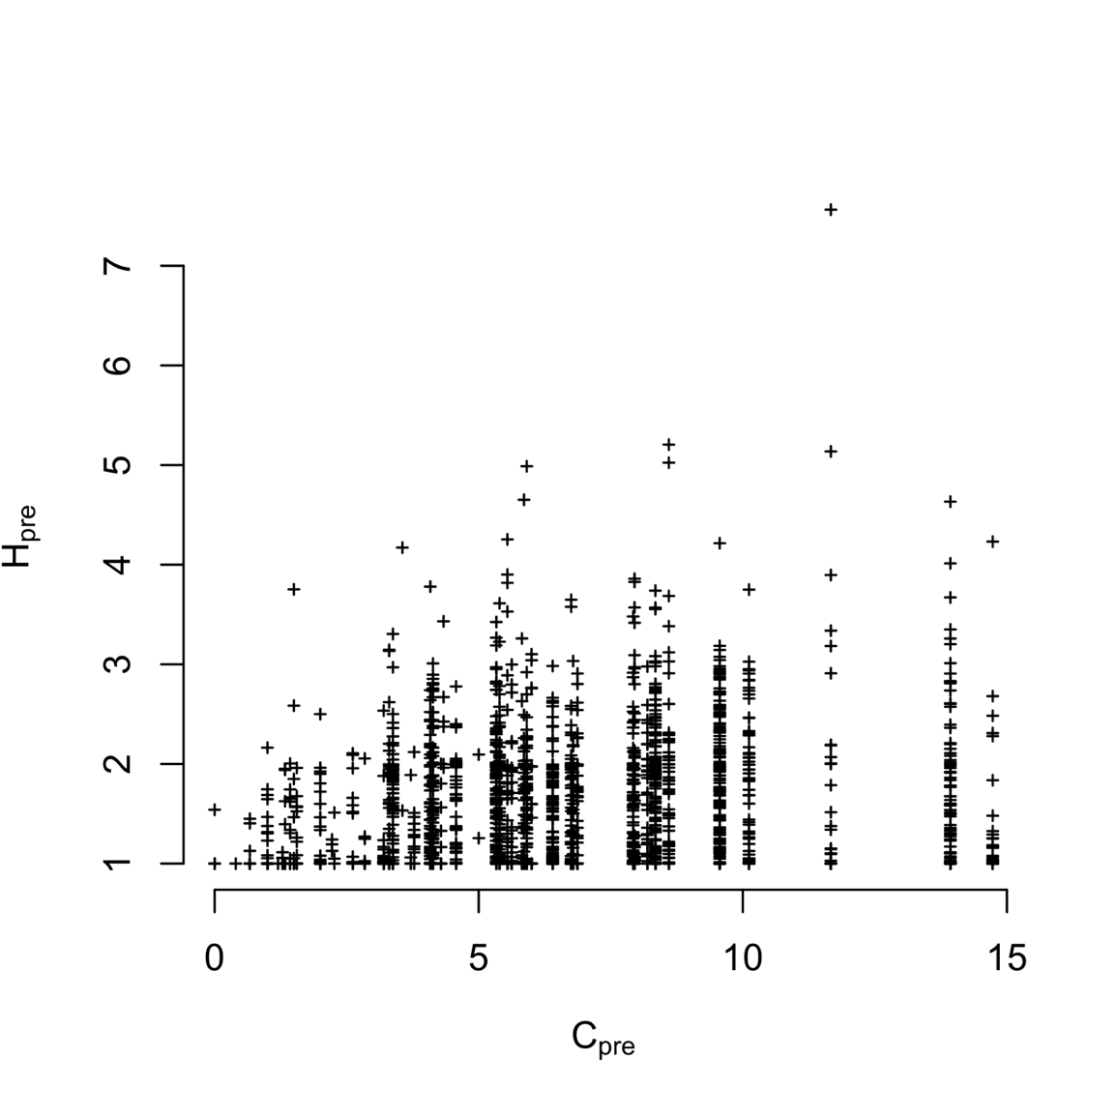
Figure S3. Plotting vessel participation diversity (H, 2009-2010) against port connectivity (C, 2009-2010). I find vessel and port level diversity weakly correlated (Spearman’s correlation 0.1849745, p < 2.2e-16). But the most diverse vessels tend to be found in the most diverse ports.

Table S1. Akaike Information Criterion (AIC) values for the models with and without terms for catch shares. Values for the best model at each level are in boldface.
Level | H_{pre} | Catch shares | No. Parameters (K) | AIC | ΔAIC | Adjusted R²
Vessel | Yes | No | 1 | 3140.767 | 30.916 | 0.2392
 | Yes | Yes | 2 | 3109.851 | 0 | 0.2471
 | No | Yes | 1 | 3643.718 | 533.867 | 0.01007
Port | Yes | No | 1 | 184.1367 | 0 | 0.8866
 | Yes | Yes | 2 | 186.5804 | 2.4437 | 0.8858
 | No | Yes | 1 | 325.8152 | 141.6785 | 0.2404

Table S2. Coefficient values for two best fit models for each scale of analysis
Level | Variable | Best model | Second best
Vessel | H_{pre} | -0.46 (0.02) | -0.46 (0.10)
 | General fleet | 0.74 (0.03) | 0.74 (0.03)
 | Catch share participant | 0.27 (0.07) | -
 | Limited entry exit | -0.24 (0.10) | -
Port | C_{pre} | -0.67 (0.03) | -0.66 (0.03)
 | General fleet | - | 0.29 (0.27)
 | Catch share participant | - | 0.19 (0.28)
 | Limited entry exit | - | 0.33 (0.33)

