Fleet connectivity across West Coast fisheries: quantifying the effect of a management intervention on revenue diversity in an interconnected socioeconomic environment
Emma Fuller, Jameal Samhouri, James Watson, Joshua Stoll
Oct 10, 2015

Introduction
Here we describe commercial fishing strategies employed along the US west coast via a novel clustering algorithm, and use it to (i) estimate fisheries diversification by individual vessels, and (ii) describe networks of fisheries participation for entire communities (ports). After demonstrating that the clustering algorithm correctly identified spatial and temporal patterns of known single – and multispecies fisheries, we evaluate how the introduction of a new management structure, catch shares, affected fisheries diversification and connectivity of participation networks. We find evidence that catch shares allowed affected vessels to diversify by participating in more fisheries, but did not affect participation among fisheries at a community level. This work helps to formalize and quantify social ecological linkages across scales.
Methods
Description of Data Sources
We used landings tickets which record all commercial landings on the US west coast between 2009-2013. While rich, this dataset lacked information on outside employment and/or any commercial fishing landings outside of the US west coast EEZ. To account for this, we restricted our analyses to vessels with at least $5000 in annual revenue and remove vessels which participated in the pacific hake fishery (as these large mid-water trawlers regularly commute to Alaska to participate in the Pollock fishery). We also discarded landings from 2011, the year in which ITQs were established. Finally we ensured that all vessels had commercial landings before and after 2011. This leaves us with 2,151 vessels which are responsible for approximately 88% of the total revenue and pounds landed during this time period.
Defining Realized Fisheries
A drawback of this method, and part of the reason for its need, is that there exists no independent classification of US west coast fisheries to which we can easily compare. To address this drawback, we rely on our ability to recover patterns already documented for US west coast fisheries (see Supplement). Specifically, because we did not bound our clusters spatially or temporally, if our classification approach was reliable, we would expect to recover known spatial and temporal structure.
Calculating Changes in Vessel and Community Level Diversity
At the vessel level we measured diversity as the effective Shannon index (ESI) of revenue diversity. ESI is calculated as

To represent connectivity among fisheries at the port level we built directed, weighted networks. Nodes represented a realized fishery, and the strength of the connections between nodes represented the number of vessels which land both. More formally, we built a network G_{i} for each port i in which an edge AB is the number of vessels which participate in both fisheries A and B divided by the total number of vessels that participate in fishery A. Similarly, edge BA is the number of vessels which participate in both fisheries divided by the total number of vessels that participate in fishery B.
To measure similar characteristics as our vessel measure of diversity we developed a metric which increases as both the number of fisheries and the evenness in which they are participated increases. Common network topology measures such as shortest path and centrality metrics capture the evenness of connectivity across the network but don’t reflect the difference between a port with many or few fisheries present. To address these concerns we develop an index of average fishery connectance (AFC) for port i defined as the sum of edge weights (EW) present in network G_{i} divided by the number of nodes (N) in G_{i}.
AFC_{i} = sum(EW)/N
Because edge weights are constrained to be between 0-1, this value can be interpreted as the average number of fisheries to which a fishery is fully connected (i.e. all vessels participate in both fisheries) in port i.
Analysis
At the vessel level, we used a simple linear regression to compare the change in ESI between vessels which did and did not participate in catch shares. At the port level, we compared the change in AFC in ports with and without catch share landings. If catch shares allowed vessels to be more flexible in their fisheries participation, we’d expect the ITQ vessels/ports would, on average, demonstrate increased diversity after catch shares. To this end we fit the following regression
Delta_diversity = ifq + epsilon
Due to the nature of our response variable, we also included models in which pre-ITQ diversity was a covariate. This is because the ability to change diversity between two periods is related to the starting period diversity. For example, if a vessel is a specialist (i.e. diversity = 0), then it is impossible for that vessel to drop in diversity and any random variation will bias change in diversity upwards. Similarly, if a vessel was maximally diversified, then the vessel could either remain the same or with random variation drop in diversity. Because there are many sources of variation separate from that induced by management change (i.e weather, market conditions) we expect this effect to be significant. Thus the model is
Delta_diveristy = pre_diversity + ifq + epsilon
We compared alternative models using the information theoretic approach which allows direct comparison of the models’ goodness of fit using model likelihoods (Burnham & Anderson 2002). The Akaike Information Criterion (AIC, Burnham & Anderson 2002) was used to find the most parsimonious model which balanced both the goodness of fit (as measured by likelihood) and model complexity (as measured by the number of parameters). Here the lower the AIC, the better the model (Burnham & Anderson 2002).
Results
Data driven definition of fisheries
Our clustering algorithm identified 102 realized fisheries which had 109 species (of the 207 total caught) contributing at least 1% revenue to the composition. We find that realized fisheries are often distinguished by a single species but could also be characterized by assemblages of species (Fig. S1a). These fisheries are characterized by distinct patterns of temporal and spatial structure (Fig. S2a, b), which aligns well with previously published work on those that are best studied (Fig. S3-5). These realized fisheries vary by several orders of magnitude in effort (number of trips) and revenue (Fig. S1b), with a small number of fisheries accounting for the majority of effort and revenue. For example only 10 of the 102 fisheries are responsible for 90% of ex-vessel revenue in the time period we examined.
Fishing diversity and fisheries participation networks
The existence of 112 realized fisheries on the US west coast opens up a variety of opportunities for diversification of fishing practices by individual vessels. We find that between 2009-2010, 66% of commercial vessels on the west coast participated in more than one realized fishery, although the degree to which vessels diversified varied regionally. For all four of the management regions on the west coast, generalists (vessels which landed > 1 realized fishery) outnumbered the specialists (vessels which landed in a single realized fishery) (Fig. 2a). The distribution of diversity varied among the generalists, from vessels that are highly specialized but had a few landings in additional fisheries to those that fished in many fisheries evenly (Fig. 2b). Notably, the majority of diversified vessels revenue was dominated by revenue from a single fishery (71%), with very small percentages coming from alternatives. However almost a quarter (24.4%) of diversified vessels were at least participating in two fisheries evenly, with some vessels (4.6%) participating evenly in more than three fisheries (Fig. 2c).
The preceding analysis focused on fishing strategies employed by individual vessels, without consideration of how those strategies come together to create characteristic fisheries participation networks for specific places/communities/ports. We found differences in the number and interconnectedness of fisheries across communities (Fig. 3c). How interconnected ports where, as measured by our index of average fishery connectance, resulted in ports that had anywhere between zero and six fisheries connected on average. This variation is exemplified by distinctions between participation networks in Santa Barbara, CA and Eureka, CA (Fig 3ab). Santa Barbara was characterized by a much more complex participation network, with approximately more than double average fishery connectance.
Effect of management change
Between the period before and after catch shares, vessels showed a 3% increase in diversity (p = 0.01898). However we found that vessels which participated in catch shares demonstrated a 12% increase (p = 0.04061). At the community level, ports which had catch share quota landed at them were 8% more diverse following catch shares management implementation, but this change was not statistically significant (p = 0.5737 ) (Fig 4).
Discussion
- Generalist fishing the norm, not the exception
  - Models of fishing typically model fleets as homogenous groups of vessels. Following theoretical formulations, most empirical fleet analyses take a similar approach, focusing on a group of boats which participate in catching a set of species with a particular gear and ignoring the other fisheries in which the vessels may participate. Fishing on the US west coast however, is better described as a heterogeneous group of multi-purpose vessels fishing in many different combinations of fisheries.
- IFQ has increased revenue diversity at the vessel level
  - Find that ITQs do allow better diversification at vessel, and so if relationship with revenue variability holds, then we expect that ITQs make revenue less variable for these vessels.
  - Is a good thing for those boats that continued to fish in groundfish trawl. But not all boats made the transition, and it seems like the smaller, more diversified trawlers were more likely to not make it into the new management regime. Examining what happens to these fisheries, and whether these patterns of connectivity can predict new entries is an important next step of this work.
- Scale of analysis matters
  - Results highlight the importance of scale, ITQs are a “success” in terms of fishing diversity at the vessel level, but policy discusses community level. And there is no effect there.
Figures
Figure 1
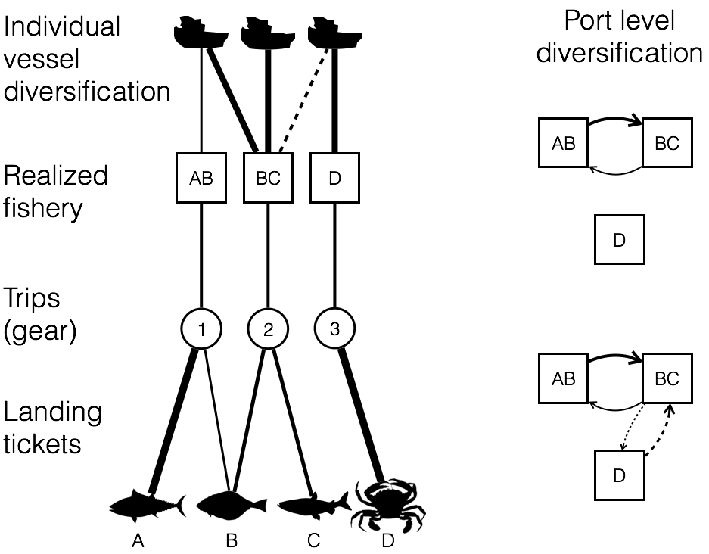
Figure 2
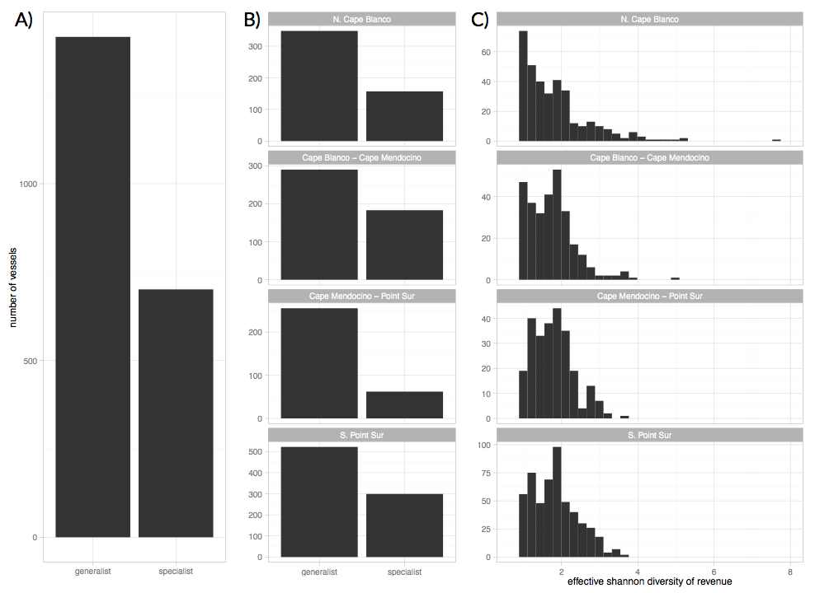

Figure 3
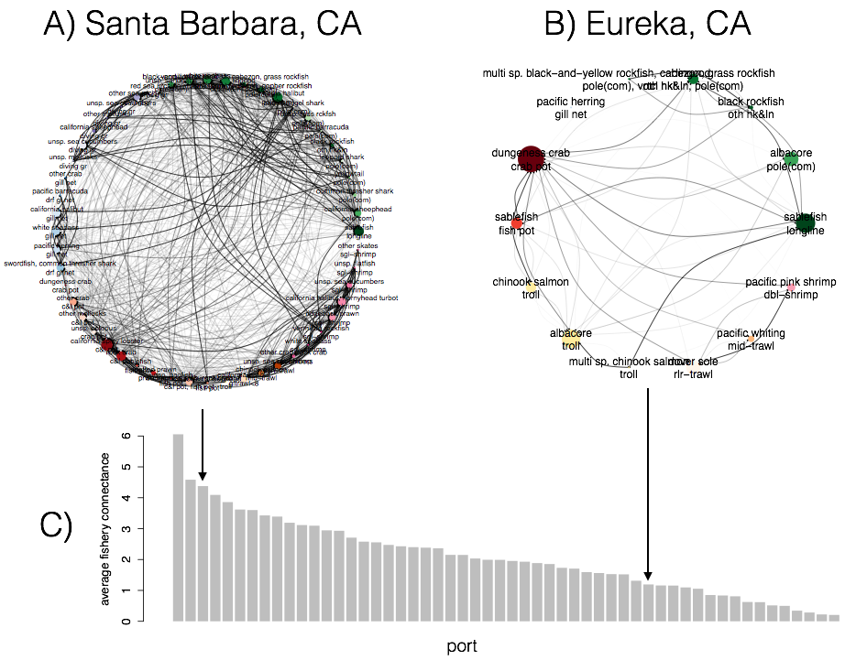
Figure 4
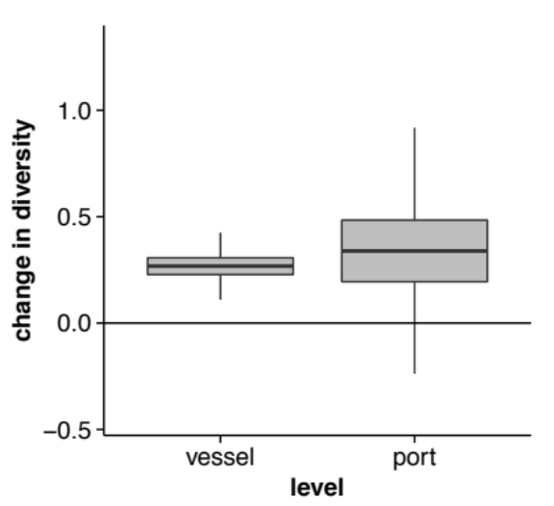

Supplement
Evaluating realized fisheries classification
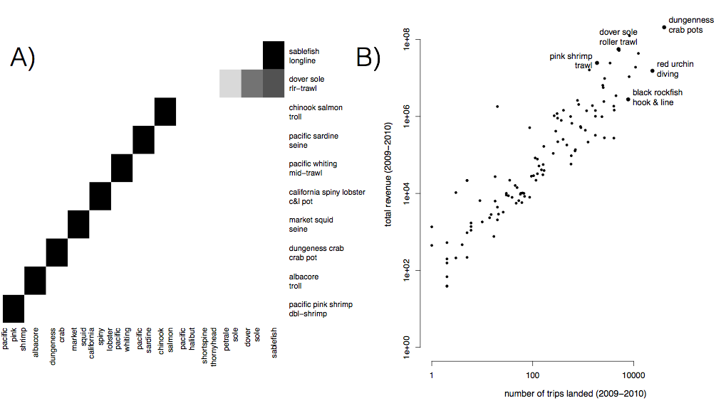
S1

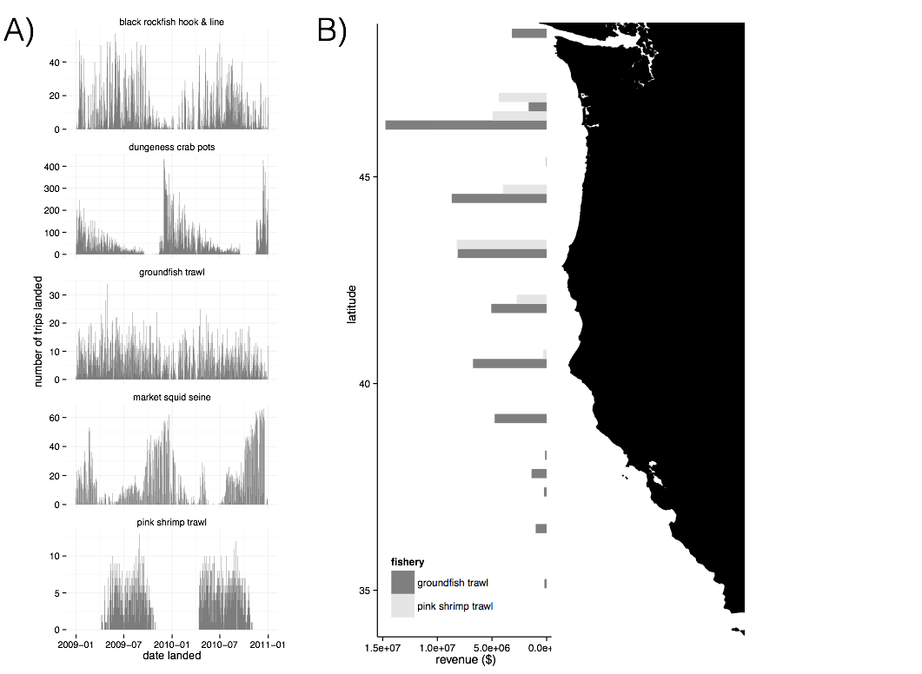
S2

Some commerical fishing fleets on the US west coast are described by the Northwest Fisheries Science Center (NWFSC) Observer Program. We culled these descriptions for quantitaitve descriptors of the fleet such as average vessel length, species composition, geographic range and seasonality to compare to our realized fisheries. We summarize the NWFSC provided descriptions and compare to our vessel groupings. This observer sector classification is limited, however, as it is targeted around the federally managed groundfish fisheries and fisheries likely to interact with these species ecologically (i.e. trawling for pink shrimp). As a result there we are unable to validate fisheries unrleated to groundfish, i.e. dungeness crab pots, spiny lobster pots, or red urchin diving.
Limited entry bottom trawl and catch shares
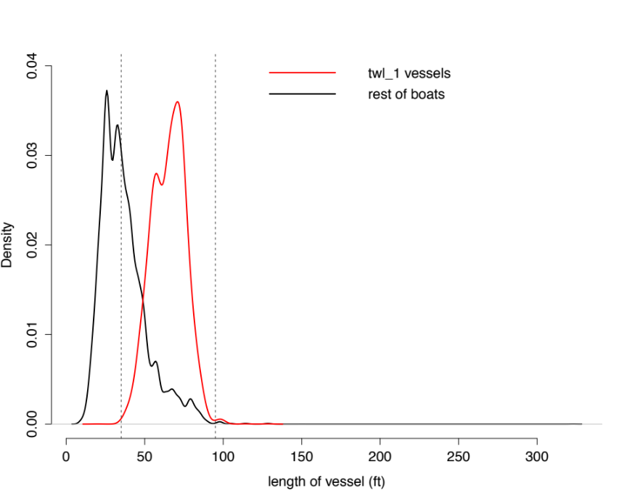
S3: Distribution of vessel lengths from US west coast landing data. Red lines represent vessels which landed in the twl_1 realized fishery, which corresponds to the limited entry groundfish fishery. Dotted lines represent 35 and 95 feet, respectively. Black line is the rest of the commercial fishing fleet. NWFSC predicted length: 35-95 feet; Actual length: 99.5 % of vessels classified in this realized fishery are between 35 and 95 feet.
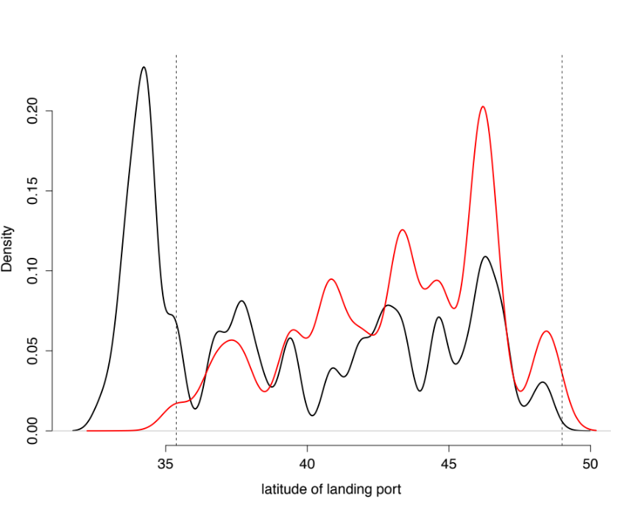
S4: Red lines represent vessels which landed in the twl_1 realized fishery, which corresponds to the limited entry groundfish fishery. Dotted lines represent the latitude of Morro Bay and the border with Canada, respectively. Black line is the rest of the commercial fishing fleet. NWFSC predicted range: Morro Bay- Canada; actual range: 98% of landings where located between Morro Bay and the Canadian border.
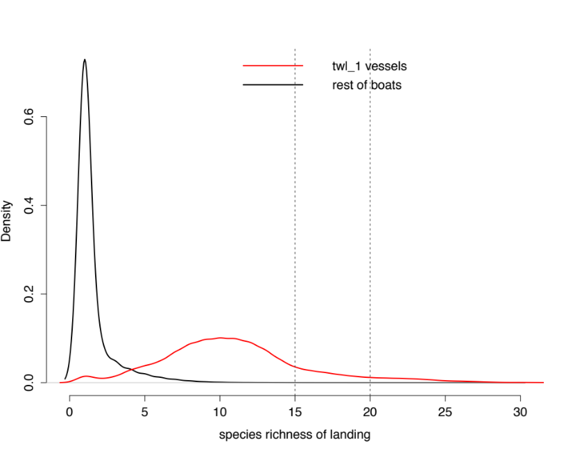
S5: Red lines represent vessels which landed in the twl_1 realized fishery, which corresponds to the limited entry groundfish fishery. Black line is the rest of the commercial fishing fleet. NWFSC predicted species richness: 15-20; actual richness: 8% of landings had between 15-20 species. This discrepency is likely due to the fact that market categories are what species are recorded as, rather than species categories. Typically these are equivalent to species designations, but for some hard to identify rockfish, many can be grouped (i.e. northern slope unspecified rockfish). Thus we’d expect the species richness to be biased downwards, as we observe. We also see that catches in twl_1 are more species rich than the rest of the fleet.

